Beloved children of the future,

Learning is a growing light, like a New Albor you carry wherever you go, shining from within you to inspire generations to come. When you learn not just facts, but how to become the best person you can be—when you learn to grow together in communion, helping each other shine—you become a beacon of new life. Every new thing you learn at school, every skill you practice, every question you ask, adds more light to this glowful path. Learning is not just for today: it is for every tomorrow you and others will live. The more you learn, the more you can help your friends, your family, and your world grow with dignity, creativity, and joy. Together, your learning radiates a brighter, more loving horizon, making life richer, more fair, and more magical for all the children who will come after you.
But learning doesn’t stop when you leave the classroom, kids. Every day is a chance to grow, to discover, and to glow. When you explore your neighborhood, ask questions about the stars, watch how trees grow, or listen to stories from your family and community, you are learning too. When you help someone, share an idea, or try something new, you are practicing the lessons that school teaches in real life. As Maria Montessori once said, “The greatest gifts we can give our children are the roots of responsibility and the wings of independence.” Every new experience, every moment you are curious, and every time you try to understand the world around you, you are adding bricks to your own glowful growth. The more you learn, the brighter you shine—and the brighter the horizon becomes for everyone who follows your steps. All across the 35 countries of the Americas, many voices tell the same story: education is the seed that grows the brightest changes in the world. Every question you ask, every new skill you practice, and every book you read adds light to your path and to the path of everyone who comes after you. Education is the first seed of a glowful society, the roots from which your dreams, your dignity, and your ability to shine as part of a loveful American harvest will grow on, glow on, bloom on...
Across the Americas, people have always understood the power of learning. Authors, thinkers, and storytellers of all American nations and cultures have reminded us that education is the key to freedom, creativity, joy, hope and new life. In Canada, Margaret Atwood teaches us, “A word after a word after a word is power,” showing that reading and learning give you the tools to shape your own story. In the United States, Frederick Douglass told us, “Once you learn to read, you will be forever free,” and George Washington Carver added, “Education is the key to unlock the golden door of freedom.” Dr. Seuss whispers to every kid, “The more that you read, the more things you will know.” In Brazil, Paulo Freire reminds us, “Education doesn’t change the world; it changes the people who will change the world.” And in Chile, Gabriela Mistral calls to our hearts: “Many of the things we need can wait; the child cannot.” Education is how your tomorrow begins today.
Across the islands and the continent, the same song is sung. From Cuba, José Martí tells you, “To be educated is the only way to be free.” From Puerto Rico, Eugenio María de Hostos teaches how education lifts whole peoples: "Instruir no es educar; instruir es dar al entendimiento la capacidad de pensar; educar es formar al corazón para sentir lo justo y amar lo bueno." From Venezuela, Simón Bolívar urged leaders to care first for popular education—for everyone. In Trinidad and Tobago, Eric Williams promised, “The future of our nation is in our school bags.” And Jamaica’s Marcus Garvey reminds us that knowing our history is like having roots that hold us steady: “A people without the knowledge of their past… is like a tree without roots.” Your classes, your books, your questions—these are your roots and your wings.
From the Southern Cone to the Andes, the lesson continues. In Argentina, Domingo F. Sarmiento said that nations are built on the simple school bench. In Ecuador, Juan Montalvo wrote, “Freedom is the daughter of education.” Uruguay’s Mario Benedetti gently said, “Childhood is our homeland,” a place we carry forever. Together these voices promise one thing: a better education makes brighter futures for all—for your family, your town, and the whole human family. Every time you learn, share, and help a friend understand, you make history kinder and tomorrow brighter.
In Central America, education is just as magical. Rigoberta Menchú from Guatemala tells us, “Education is the only way to fight poverty and ignorance.” From Belize, Evadne Price encourages children to dream big, saying, “A child who learns today can teach tomorrow.” Costa Rica’s Carmen Lyra, a writer of children’s stories, wrote that schools are the heart of children’s joy: “In learning, we discover the world, and the world discovers us.” From El Salvador, Salarrué said, “To educate a child is to open a window to the sun.” Honduras reminds us, through the words of Ramón Amaya Amador, that “Education is a shield and a sword: it protects, and it opens paths.” Nicaragua’s Gioconda Belli writes that “Education plants dreams that grow with each generation.” And from Panama, Ricardo Miró tells children, “A mind that learns is a treasure that shines forever.” All these voices from across Central America say the same thing: learning gives you wings, a voice, and a future bright enough to share with all the world.
In the Caribbean, education is celebrated as the key to freedom, creativity, and community. From Antigua and Barbuda, Jamaica Kincaid reminds us that “The more you learn, the more you discover the world is yours to shape.” From the Bahamas, E. Clement Bethel teaches that schools are where children plant seeds of dreams that will grow into bright futures. Barbados’ Kamau Brathwaite says, “Knowledge is the compass that guides your journey.” In Dominica, Phyllis Shand Allfrey tells us, “Education opens doors that were once invisible.” The Dominican Republic’s Pedro Mir writes, “A mind that is nourished by learning will never be poor.” Grenada’s Merle Collins reminds us, “Learning gives voice to those who are not yet heard.” From Haiti, Edwidge Danticat says, “Through stories and school, we inherit strength.” From Grenada, Merle Collins says, “Learning gives voice to those who are not yet heard.” Jeanette Greenidge from Saint Kitts and Nevis teaches, “Every lesson is a step towards the person you can be.” Derek Walcott of Saint Lucia writes, “Children who read and think today will shape the world tomorrow.” And Lennox Honychurch from Saint Vincent and the Grenadines reminds us, “Education is the anchor of freedom and the sail of dreams.” Barbados’ Kamau Brathwaite says, “Knowledge is the compass that guides your journey.”
In South America, education is celebrated as the seed of progress and hope. From Bolivia, Adela Zamudio says, “To teach a child is to plant the seed of tomorrow’s change.” Colombia’s Gabriel García Márquez wrote, “It is not true that people stop pursuing dreams because they grow old; they grow old because they stop learning.” From Guyana, Martin Carter encourages children: “Knowledge lights the path where courage alone cannot reach.” Paraguay’s Augusto Roa Bastos reminds us, “Education transforms hearts and builds nations.” In Peru, César Vallejo writes, “Teaching a child is giving them a world to call their own.” And from Suriname, Cynthia McLeod shares, “Learning is the bridge between yesterday and tomorrow.”
Together, from the Arctic of Canada to the Caribbean islands, from the Andes to the Amazon, and across every nation in between, these voices tell the same story: education is the seeder’s nursery behind every bright change in the world. Every book you read, every question you ask, every lesson you share is a step toward a future where all children can grow, shine, and bloom. Education is the light that helps you walk as equal and dignified brothers and sisters, creating a world where everyone can reach their dreams and glow as part of a loveful and glowful American harvest.
You see, kids, I am a teacher, but I didn’t only study Education. I studied Humanities and Education at the University of Puerto Rico, Río Piedras campus, and I even got certified to teach ESL (English as a Second Language) to children ages 4 to 11. But I have also taught older students, and I even taught Catholic Faith Education, because I also studied theology and philosophy in Spain. That means I learned not only how to teach facts, but how to teach people—and my most important rule is that teaching should always help people grow as the best person they can be and as the glowest starfield we can be. As Nelson Mandela reminded us, “Education is the most powerful weapon which you can use to change the world.”
For me, being an educator is not separated from being humanist and being a personal formation cultural grower; education is inseparable from cultural upbringing, earning traditional stories, values, and practices is just as important as learning reading, writing, or math. That's the way our native American ancesters through the whole continent had always taught their children, and they were rhe first teachers in these lands: teachinf not in a strict, rigid, european-colonially-broght academic rigid style... but in a culturally-bonding way, teaching to form and to bond, not to rule. As the Native American storyteller Joseph Bruchac, an Abenaki writer and storyteller, says: “A child who learns the ways of the people will grow to be strong in body, mind, and spirit. Teach the children our stories, our songs, and our traditions, and they will know who they are.” For Native American, to educate is more related to connect intellect, life and community than to standarized testing and minimum passing grade, everyone has the duty to achieve a better education for the children. As Sitting Bull (Hunkpapa Lakota leader) says: “Let us put our minds together and see what life we can make for our children.” So, here we are, doing exactly that, because education is not just academic—it is cultural, spiritual, and rooted in identity, as Chief Dan George (Tsleil-Waututh leader, though Canadian Coast Salish, widely cited in Native education contexts) says: “The greatest thing you can teach a child is who they are and where they come from.
Enriching your education, children of the future, also enrichs our cultural identity, who we are and who we become, how we keep enriching our ways as a "we, the people." As Vine Deloria Jr. (Standing Rock Sioux scholar) says: “We must teach our children the ways of our people, not just the ways of others. Education should strengthen identity and responsibility to the community.”
How we educate today is meant to affirm not only an individual identity but also a sense of belonging to a community—both now and for you, children of the future. Every lesson learned, every story shared, and every skill mastered is a step toward assuming the most sacred civil responsibility of all: becoming the best person you can be. This means being empowered to raise your family with dignity, to nurture your community, and to guide our nation in ways that glow with fraternity, generosity, and cultural pride across generations. If new systems must be created to make this possible, then so be it—our commitment is to a future where every child can flourish fully, ethically, and joyfully.
It is precisely with this vision in mind that I designed a new lesson planning system focused on integrating the best growth possible for students… Yes, because I like to be creative, I designed my own growthful lesson planning system—yes, the kind of teacher who sometimes gets into trouble for aiming for the best growth possible for her students! My system has five steps: integration, action, realization, projection, and connection. It’s a monthly planning system that makes teaching simpler, but it also helps me focus on what really matters: your growth, kids. Your growth objectives are the most important part: how you are meant to grow as the best person you can be, using what you learn in my class to achieve your dreams. This system also connects your classroom learning to other subjects and to your community. At the end of the semester, you present your projects in a fair, serving your community with your growthfulness. As the Puerto Rican writer Eugenio María de Hostos said, “The school is the center of human formation."
So, I write to you as a grower of glowful seeds, children of the future, my most growthful lesson ever given as teacher: this glowful manifesto for you, so you are empowered to learn how to plasmate a culture of New Albor where you can all, children of the furure, grow as the best person you can be, glow as the brightest star of America —the flag of USA is full of stars... you are all called to shine glowfully...—, and love each other as equal and dignified brothers and sisters, building together an American continental bloomful harvest for generations to come. Your growthful learning now is a seed that will help you change the future into the brightest horizon line possible for all the next generations of children to come.
A los niños más pequeños, les hago una cariñosa observación como se la haría cualquiera de sus maestras en su escuela: necesitarán releer este glowful manifesto otras veces mientras crecen para poder entender toda la carta; es totalmente esperado que, aunque esta sea una carta escrita para niños, los niños más pequeños no puedan entenderlo todo todavía. Sigan creciendo, sigan aprendiendo y podrán entenderla complete eventualmente. Todas estas palabras han sido escritas tomando muy en cuenta que partes pueden ser entendidas por niños de qué edad, y hay parte que ustedes, niños más pequeños, necesitarán crecer más para entender mejor, eso es parte de keep growing on, glowing on and blooming on. De hecho, será mejor entendida una generación tras otra, en la medida en que su glowful manifesto, niños, va generando más transformación social y más cambio cultural. As you will see, generating cultural changes like this can create many very meaningful social changes in Economics and Politics too—but changes in Education will always be the most necessary to be achieved first: Education will always remain the first seed for the brightest changes humanity can achieve in the most fraternizing way, opening bright horizons never been able to see before, like it is happening now, when a new fraternal growthful horizon line is being very widely envisioned and becoming progressively more and more open for all humanity and to all of you also, children of the future, empowering you to create a culture of new albor where everyone can grow best glow best and bloom best as equal and dignified brothers and sisters.
¿Cómo comenzó este envisioning de un nueva linea de horizonte fraterno para la humanidad, para hacer posible que todos puedan crecer dignamente como familia humana?
Bueno, niños, todo este envisioning of a new creative, natural and bright horizon line comenzó cuando descubrí como aminorar problemas de ventilación que hay en el cuarto donde duermo: en mis circunstancias, es tremendamente práctico cubrir con plástico lo que se suele conocer como “los screens” de las ventanas. Aquí pueden ver una foto genérica de lo que es un window screen, que es como un frame de tela metálica que al colocarse encima de las ventanas impide el paso de mosquitos cuando dejas las ventanas abiertas:

Por el tipo de problema de ventilación que hay en el cuarto donde duermo, necesitaba cubrir esos screens con plástico… y quedaron como ven en la foto a continuación:
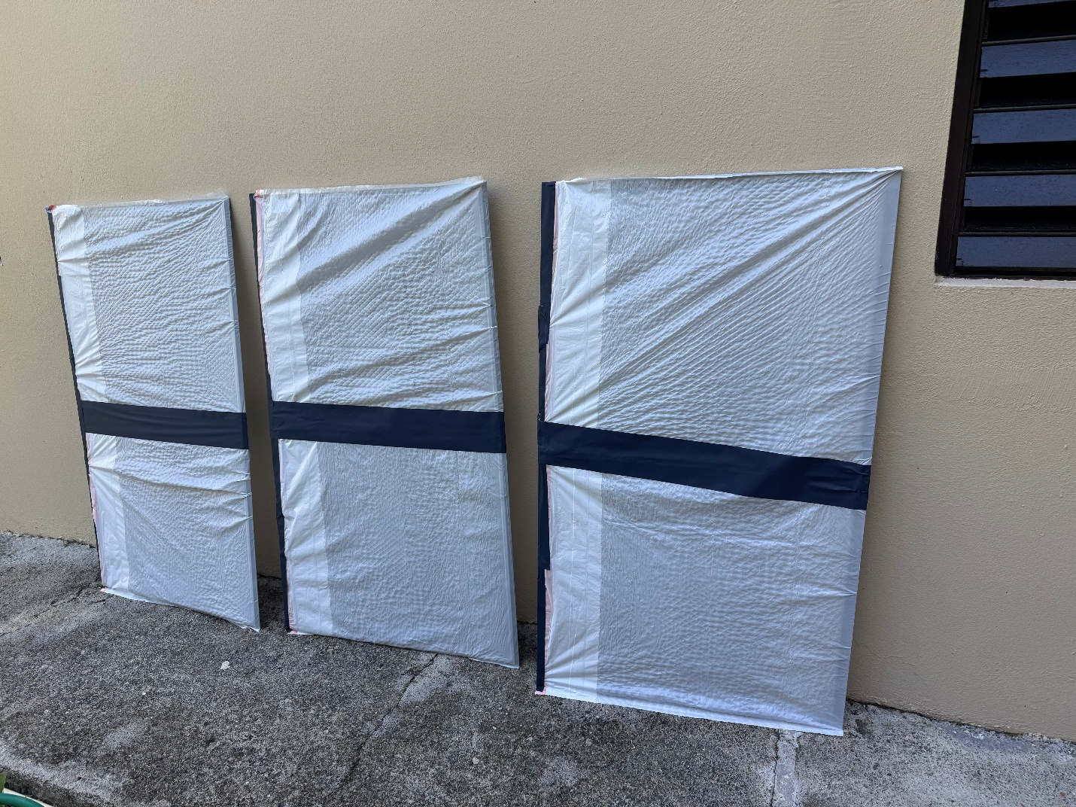
Hay otras circunstancias en las que puede ser necesario cubrir los screens con plástico. Por ejemplo: cuando viene un huracán fuerte que se sabe que va a causar que mucha agua entre por las ventanas, una forma de evitar que entre agua a la casa en esas circunstancias es cubriendo los screens con plástico (si la ventana no necesita tormenteras externas, esto es una solución práctica para evitar que se cuele el agua dentro de la casa en caso de huracán mayor).
En fin: al colocar los screens cubiertos de plástico en el cuarto quedaron como ven en la próxima foto, donde se ve como, de repente, comenzó a haber una horrenda línea oscura resaltada con un fondo claro (lo blanco de las bolsas plásticas) a nivel de la línea de horizonte (cuando las ventanas están abiertas, la línea del horizonte tras de ellas está exactamente a ese nivel porque hay montañas):
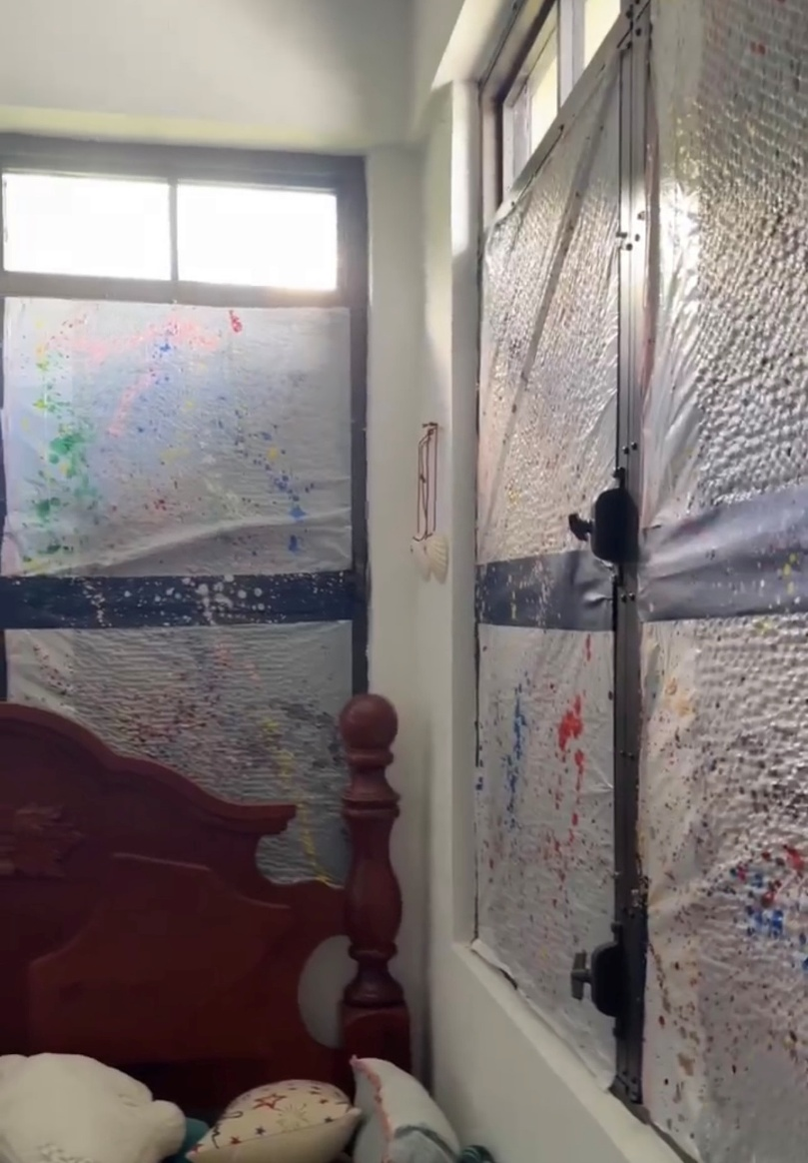

Les cuento, niños del futuro: ya he tenido la oportunidad de profundizar creativamente en el tema de la importancia de la amplitud de espacio y lo importante que es siempre tener una línea de horizonte lo más amplia posible para que el espacio sea lo más amplio posible. Como ustedes son niños y a los niños les encantan las imágenes, esto se lo explicaré ilustrados con imágenes de una estructura que yo misma diseñé y construí con mucha oración y mucha creatividad.
Hace mucho tiempo atrás, alrededor del año 2009, yo era estudiante de filosofía, y estaba en el proceso de preparar lo que quienes estudian en la universidad luego de cuatro años de estudio llaman una “tesis”: un trabajo de investigación que haces tras muchos años de estudio en una universidad y que es tu aportación intelectual a la ciencia que investigas. Pues yo quería hacer mi trabajo de investigación de filosofía creando una filosofía de la educación que respondiera a las necesidades de los niños de hoy, y quería hacerla desde el pensamiento de un filósofo americano llamado Charles S. Peirce. Sin embargo, yo no quería seguir la ruta tradicional para hacer una tesis de filosofía de la educación. Verán, niños: los adultos piensan que cuando hay que hacer una investigación, sobre todo en lo que se llaman “las humanidades” (filosofía, literatura, artes, historia…) solo puedes limitarte a repetir lo que hacen otros. Ya sé lo que me van a decir: eso es exactamente lo mismo que hacen muchos maestros en la escuela, solo pedirte que memorices y repitas información… ¿Saben qué? Yo nunca he sido buena en eso de solo memorizar y repetir información: desde muy niña necesito crear para aprender. Yo no quería hacer una investigación de filosofía de la educación usando solo referencias de libros y de lo que otros han dicho para crear una filosofía de la educación —a eso es lo que se suelen referir los adultos cuando hablan de “ser académicos y ser cultos”: de saber memorizar mucha información dicha por libros o otros—. No, yo quería hacer una filosofía de la educación observando clases de verdad, clases con niños que quieren aprender, y además en una escuela con estudiantes que estaban en desventaja social. Resulta que podía hacer eso en la misma escuela de donde yo me gradué: aunque es una escuela católica privada, en Puerto Rico la educación católica privada no es un lujo, es una necesidad y también una forma de que el estudiante pueda elegir aprender viviendo su fe, como fue mi caso. Yo no quería observar una escuela de niños privilegiados o con recursos: quería observar una escuela donde se necesitara apoyo y no tuvieran disponible dinero para investigar mejorar la forma de enseñar o para pagar un maestro para brindar clases enriquecedoras a los niños, como clases de arte. Yo quería observar cómo crear una filosofía de la educación que partiera de la vida escolar de niños entre los que más necesitaran ser ayudados a crecer. Mi pregunta de investigación partía de una visión muy humana: ¿qué filosofía de la educación necesitan los niños para poder aprender convirtiéndose en la mejor persona que puedan ser, en lugar de meramente “aprender” obteniendo unas notas para pasar de grado? No sé si lo han notado, niños, pero en el mundo académico común solo se les pide lo mínimo: solo se requiere que los estudiantes cumplan con unos mínimos, nunca se espera ni mucho menos se les evalúa porque hagan lo mejor posible. Ahora mismo, tal cual funcionan las escuelas, solo se pide a los estudiantes seguir las instrucciones, memorizar y cumplir lo mínimo requerido. Eso nunca me ha parecido justo, y quería cambiar eso con mucha creatividad intelectual: creando una nueva filosofía de la educación.
La filosofía de la educación que crearía eventualmente se llamaría “growthful philosophy of education” pero… niños, la verdad es que fui un fracaso académico en la universidad: no pude pasar muchas clases de filosofía porque tengo ADHD y no era capaz de hacer los exámenes como los hacían mis compañeros, y al final no logré crear la filosofía de la educación para presentarla como tesis en una universidad: solo logré crearla como un texto para mi blog. O sea: niños, solo logré crear mi filosofía de la educación growthful para compartirla en social media, no para compartirla en un mundo académico lleno de instrucciones y memorizaciones. Mi forma de estudiar es muy distinta a lo que se conoce en ese mundo que los adultos llaman “mundo académico”, donde el prestigio y seguir las instrucciones al pie de la letra se valora más que aportar lo mejor de ti y crear nuevas formas para ver.
Aunque no logré completar los pasos necesarios para presentar la tesis en una universidad, sí que logré tener un tiempo como “maestra investigadora” o “research teacher”. Ya sé qué van a preguntar: ¿qué es eso de “maestra investigadora”? Es una maestra que se toma un tiempo solamente para observar clases, observar problemas concretos e investigar como resolverlos.
Sobre todo en Puerto Rico, a los maestros se les paga tan mal y se les da tan poco tiempo para planificar sus clases que… tienen toda la razón en jamás haber visto un “maestro investigador”: para poder investigar un problema científicamente necesitas tener tiempo para solo observar, necesitas tener recursos para ver qué han hecho o dicho otros ante el mismo problema, y a los maestros no se les brinda acceso a bibliotecas y libros, ni tampoco tiempo para desplazarse e invertir recopilando información. Como habrán podido ver los niños de mi generación, a los maestros ni siquiera se les da tiempo o espacio para formularse preguntas: esas pocas veces que los maestros tienen un pelín de tiempo para hacer preguntas respecto a cómo algo en el salón de clases puede hacerse mejor… resulta que incluso si se hacen estas preguntas, a los propios maestros, que son profesionales que estudiaron como mínimo cuatro años en universidad, no se les permitirá investigar ni cuestionar la forma en que el Departamento de Educación les pide enseñar: la forma en que un maestro enseña, niños, la determina los jefes, y cuestionar las formas de enseñanza siempre será visto como un problema: de la misma forma que en el mundo académico el que un niño no siga instrucciones es un problema, también es un problema que sea el maestro el que no siga las instrucciones de los directores. En el mundo académico tal cual se conoce en mi generación, no seguir las instrucciones siempre significará meterse en problemas. Por todas esas razones es que no verán research teachers. niños del futuro, hasta que se cambie lo que se entiende por “academia”: a los maestros ni les dan recursos para investigar, ni les dan tiempo para investigar, ni se espera que quieran aprender a enseñar lo mejor posible —y para hacer eso siempre se necesita tiempo de investigación en la acción, no meramente tiempo de investigación aislados en su escritorio—, ni mucho menos se les reconoce que tienen la autoridad para cambiar el sistema. Por ejemplo, niños: a un doctor se le reconoce la autoridad de interpretar laboratorios y administrar los remedios correspondientes, incluyendo medicinas de ser necesario. Lo mismo NO pasa con los maestros: los maestros “ven los resultados de laboratorio” (ven tanto las notas como la dinámica viva del salón de clase) como lo haría un doctor, pero no se les reconoce autoridad para identificar el problema y administrar remedios como hacen los doctores. A los maestros tampoco se les permite investigar para crear nuevos remedios: los maestros académicos tienen que hacerlo todo como se les diga por un director o siguiendo las instrucciones de un Departamento de Educación, incluso cuando ve las notas, ve el salón de clase, sabe perfectamente que hay muchísimas cosas que están impidiendo que sus estudiantes puedan aprender lo mejor posible… pero a ellos no se les permite identificar problemas, proponer soluciones y administrar los remedios correspondientes para que en su salón de clase haya el mejor aprendizaje posible. A los maestros sí que se les requiere muchísima eso que llaman “educación continua”, y sí que hay oficinas enteras de “educación continua” dedicadas a exigir a los maestros gastar horas y horas leyendo memorandos y cartas circulares, o viendo videos requeridos y conferencias requeridas…
¿Saben lo que no hay aún, niños del futuro? Ninguna “Oficina de Innovación Educativa de Continua” a la que los maestros puedan dirigir solicitudes de “investigación activa” (estas son investigaciones que se hacen en medio de la acción en clase, no son investigaciones que solo se hacen encerrados en un escritorio de investigación— y se les brinde los recursos y apoyos para mejorar continuamente la enseñanza en su salón de clase haciéndolo de forma científica, no sencillamente guessing on como resolver al paso, sin fundamento científico alguno. Si se unieran los resultados de investigaciones de acción de al menos cierto porciento de maestros investigadores por escuela, proporcional a la cantidad de niños que sirven, aunque a todo maestro que legítimamente solicite poder hacer un action research en su salón y que se le brinde el tiempo pago y los recursos para hacerlo, se le debe brindad, realmente a todos los maestros se les debe brindar teaching research time coordinado según el research need que se trate… Si se uniera TODO ese conocimiento científico de forma estructurada y habitual, el como se enseña a los niños mejoraría muchísimo en muy poco tiempo, porque se uniría el conocimiento que recopilan entre todos los maestros investigadores: si ellos logran mejorar o superar un teaching or classroom need con su investigación, también la mejorarán en otros maestros al aprender a hacer lo que hacen ellos. Lo que aprende y descubre un maestro como research teacher siempre beneficiará a todos los maestros de la misma escuela e incluso de todos los demás maestros, si la investigación se hace disponible para ser consultada por todos los demás maestros… pero como en estos momentos, niños del futuro, NO se espera que se deba brindar recursos para que un maestro pueda enseñar lo mejor posible, solo se les pide que enseñen siguiendo las instrucciones dadas… Pues, niños, no les extrañe que en el mundo académico de las “escuelas tradicionales” solo requieran a los estudiantes seguir instrucciones y memorizar haciendo lo mínimo requerido para pasar de grado, cuando para empezar a los maestros también solo se les pide hacer lo mínimo para cumplir con las instrucciones y el currículo que diga el Departamento de Educación.
La realidad es: los primeros beneficiados en observar a un maestro que puede trabajar aspirando a mejorar su forma de enseñar son los estudiantes mismos, que comienzan a ver en el ejemplo del maestro que ven que se esfuerza en enseñar lo mejor posible un modelo para ellos mismos aspirar a aprender haciendo lo mejor posible, aprendiendo convirtiéndose en la mejor persona que puedan ser… pero, niños del futuro, todas estas ideas están absolutamente fuera del alcance de mi generación. En mi generación no solo no se espera que hay maestros investigadores: no hay forma de serlo, no de forma debidamente reconocida y remunerada.
Entonces, niños el futuro, se podrán preguntar: ¿cómo logré dedicar cierto tiempo para ser maestra investigadora, si no hay forma de serlo en esta generación? Simple: lo hice de forma voluntaria, sin que nadie me pagara por el tiempo que dedicaba observando clases para crear mi filosofía educativa, y sin que la universidad misma donde estudiaba reconociera que estaba haciendo teaching research (para la universidad donde estudiaba, solamente me estaba tomando un tiempo de ausencia, lo suelen llamar “leave time”). Si logré costear ese periodo, fue por préstamos estudiantiles, muy conocidos en mi generación. De hecho, justo en estos momentos, en estos días mientras escribo esta carta, he estado recibiendo constantes emails para repagarlos e incluso avisos de que mi crédito está siendo afectado. Sé que a los adultos esto les sonará extraño, pero en estos momentos mi credit score no puede ser la prioridad.
Pedí a la escuela donde estudié de niña poder estar un tiempo como maestra investigadora en la escuela, solo observando clases y también dando yo misma una clase de forma voluntaria, a la que los estudiantes asistirían de forma voluntaria. Para mí fue importante observar el contraste de dinámicas entre las dinámicas de estudiantes de clases voluntarias, una clase en la que elegían estar y les interesaba estar y que buscaba su mejor crecimiento como persona… y las dinámicas entre estudiantes en clases obligatorias; estudiantes totalmente acostumbrados a solamente poder asistir a clases con el mismo contenido y estructura para todos; o sea, todos los estudiantes siguiendo exactamente el mismo plan educativo y la misma normativa disciplinaria, sin que se pudiera asumir absolutamente nada de la formación personal de cada niño o joven en el sistema de enseñanza, tanto por falta de recursos para hacerlo como por falta de sistema posible para integrar la formación personal de cada cual en el plan educativo brindado en todo un nivel educativo escolar. ¿Cómo diseñar una filosofía educativa que asuma lo académico pero sin limitar el crecimiento de los estudiantes como personas a solo cumplir mínimos y a solo seguir instrucciones, dándoles la oportunidad de aprender lo académico a la misma vez que aprenden a crearse a sí mismos como las mejores personas que puedan ser? Todo ese tiempo de research teaching me ayudó mucho para lo que finalmente entendería después como a growthful philosophy of education, incluyendo un growthful discipline que no se limita a requerir afirmar normas sino que en primer lugar afirma el crecimiento pleno de los estudiantes para a partir del growthfulness como baseline (o sea: en el growthful discipline el behavorial baseline parte de enseñar a crecer como la mejor persona que puedan ser en todo momento). Noten que el growthful discipline baseline parte de un personal formation baseline; no parte de un normative baseline punitivo que solo toma acción disciplinaria solo cuando un estudiante hace algo mal… Tras el personal formative baseline entonces se procede a la formación disciplinarias correspondiente, que no se trata meramente de corregir errores o lo que se hace mal, sino también de formar para hacer lo mejor posible y afirmar las fortalezas y lo que ya se logra hacer bien y lo mejor posible. Esto, niños del futuro, en estos momentos ni siquiera es posible articularlo como sistema educativo… pero para ustedes sí que será posible.
En ese tiempo como maestra investigadora voluntaria la clase voluntaria que di es algo que se me da muy bien enseñar y que había muchísimos estudiantes sencillamente esperando la oportunidad y el espacio para poder aprender: arte. En concreto, pintura. Enseñé la clase a middle schoolers (estudiantes de 11-14 años; fue una clase multigrado, y la dinámica de una clase multigrado también fue importante observarla) en su tiempo de almuerzo: era su elección venir o no a la clase, y era tan importante que fuera su elección que la clase se propuso que fuera dada en su tiempo de recreo, jamás se me hubiera ocurrido dar esta clase de arte en horario escolar regular. Agraciadamente, esa escuela tenía un horario de recreo mucho más largo que la media: poco más de una hora. Había tiempo más que suficiente para dar una buena clase de arte, incluso cuando algunos estudiantes “rotaban” y venían unos días sí y otros non… porque resulta que en medio de las clases de arte, lo más importante no era meramente que aprendieran de técnicas artísticas creativas, sino… aprender mientas aprendían a pintar a crearse a sí mismos —a formarse a sí mismos— como la mejor persona que pudieran ser, considerándose amados por un Dios Amor que les sonríe y les ayuda a crecer en todo momento (era una escuela católica, y esto también fue importante observarlo: qué diferencia hace promover que un estudiante se sepa incondicionalmente amado).
Como parte de lograr ese aprendizaje de los estudiantes de saberse incondicionalmente amados por un Dios Amor… yo misma comencé a desarrollar en esa escuela, como maestra voluntaria y como research teacher, una obra creativa propia que ellos me observaban pintar —o sea: la maestra no meramente enseñaba formando a otros, sino también formándose a sí misma como la mejor persona que ella pudiera ser como maestra y dejando que los estudiantes vieran cómo iba plasmando esa “obra de arte personal”— Para los estudiantes era un factor valioso saber que lo que estaba haciendo lo estaba haciendo en primer lugar por dar lo mejor de mí y por que ellos dieran lo mejor de sí mismos, y lo sabían tan pero tan bien que hasta sabían que o se me pagaba por estar allí. Esto lo digo como observación importante para las generaciones del futuro: no desafíen jamás el poder del personal giftedness en las dinámicas de enseñanza. No se tiene que ser una maestra voluntaria para observar esto, se puede ser una maestra remunerada a la que los estudiantes observan activamente trabajar dando lo mejor de sí misma… pero crear un sistema que integre de forma sistemática y ordenada formative workshops dados por maestros voluntarios o maestros comunitarios (un maestro comunitario sería, por ejemplo, un empleado de un supermercado que da servicio a la comunidad, pagado por su empresa, yendo a las escuelas a dar formative workshops gratuitos de una semana de duración de skills relacionados con su empresa. En el caso de un supermercado, el empleado que sirva como maestro comunitario podría ser formado para dar un week long formative workshop de nutrición o de cómo manejar apropiadamente un budget doméstico de compra de alimentos. El que los estudiantes vean en la escuela a personas de la comunidad sirviendo voluntariamente —aunque la empresa le pague al empleado por su función comunitaria, para ser maestro comunitario el empleado se tiene que ofrecer para la tarea y también se tiene que ofrecer voluntariamente para recibir la formación que requiera cumplir esa tarea comunitaria formativa; o sea, es un servicio voluntario, hay personal giftedness envuelto— y vean ejemplos de personal giftedness comunitarios y escolares en su ambiente de aprendizaje tiene un gran impacto en ellos. Meramente eso puede llenarlos de motivación de aprender y de esperanza en un horizon line más abierto a la posibilidad realizar sus sueños. Lo vuelvo a repetir, dicho de otra forma: jamás subestimen la importancia del valor del personal giftedness en las dinámicas de aprendizaje, sobre todo cuando es posible integrar un affirmative formative personal discipline system (eso es growthful discipline) en el salón de clase y los estudiantes saben muy bien que su personal giftedness está siendo observado e incluso compartido con los padres, compartiendo lo que están haciendo mejor de forma tan regular como se comparte lo que deben hacer mejor o lo que han hecho mal.
¿Por qué es importante que sepan todo esto, niños del futuro? Porque todas estas son ideas que han sido compartidas en estos últimos párrafos… todas esta growthtul vision, en estos momentos de la historia, en esta generación, ni siquiera pueden asumirse como posibles. Sin embargo, para ustedes, niños de las próximas generaciones, sí que será posible la posibilidad de unos educative-formative horizon lines muchísimo más amplios. Cuando eso suceda, no se olviden de agradecer y honrar a los niños del pasado que hicieron posible ese growthful progress en generaciones venideras.
Esa obra creativa propia de la que les hablé, la que comencé a hacer como maestra voluntaria, era una pintura de seis pies de alto llamada Iesu Amor: la pintura de un Cristo Amor que le sonríe a los niños y les acompaña como un Amigo y Hermano mayor (la pintura era realmente grande, literalmente se veía como un “hermano más grande” y algún estudiante llego a mirar hacia arriba impresionado y decir “cuando grande quiero ser como Él…”). Niños, ¿se han fijado que en la mayoría de imágenes, sobe todo en escuelas católicas, Jesús está sufriendo en una cruz o plasmado con una imagen seria? Es muy raro que se les permita a los niños ver un Jesús pintado con colores vivos y que les sonríe con ternura…
En esta próxima foto se puede ver qué tan grande era esta pintura (niños del futuro: noten la proporción del tamaño de la pintura respecto a mi propia altura; yo mido 5´6), que comenzó en esa escuela, pero siguió creciendo con el tiempo… Esta pintura y todo el growthfulness posterior que hizo posible… ha sido el proyecto creativo-formativo más amplio de mi vida entera.
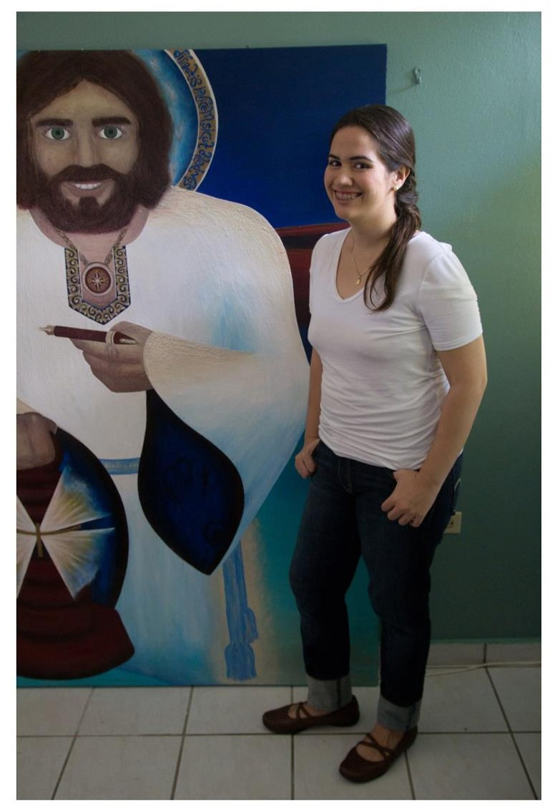
Para que vean, niños, lo mucho que puede progresar una pintura en el tiempo, les muestro fotos más grandes del progreso creativo de esta pintura. La segunda foto es de como acabó siendo plasmada la pintura definitivamente. La tercera foto es de la pintura siendo compartida en el Youth Art Festival de la Jornada Mundial de la Juventud y la cuarta foto es de lo que dibujé en el enorme tubo (literalmente la pintura fue enviada a Brazil en un tubo de cartón durísimo de cortar, que se vende para ser usado como molde para construir columnas en casas de cemento; así de grande requería ser el empaque de transporte de esta pintura) en el que esta pintura fue enviada a Brazil.
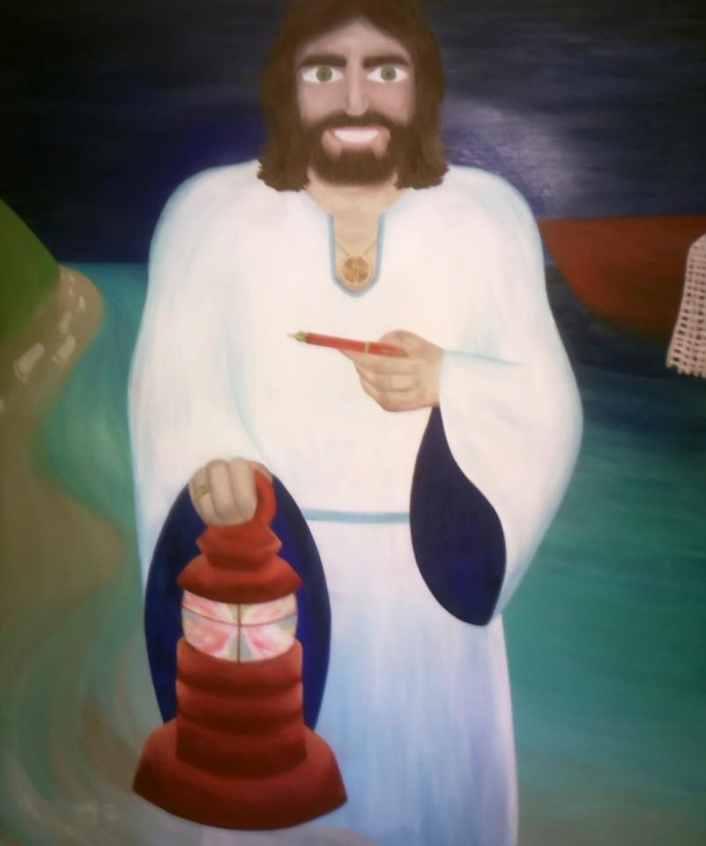

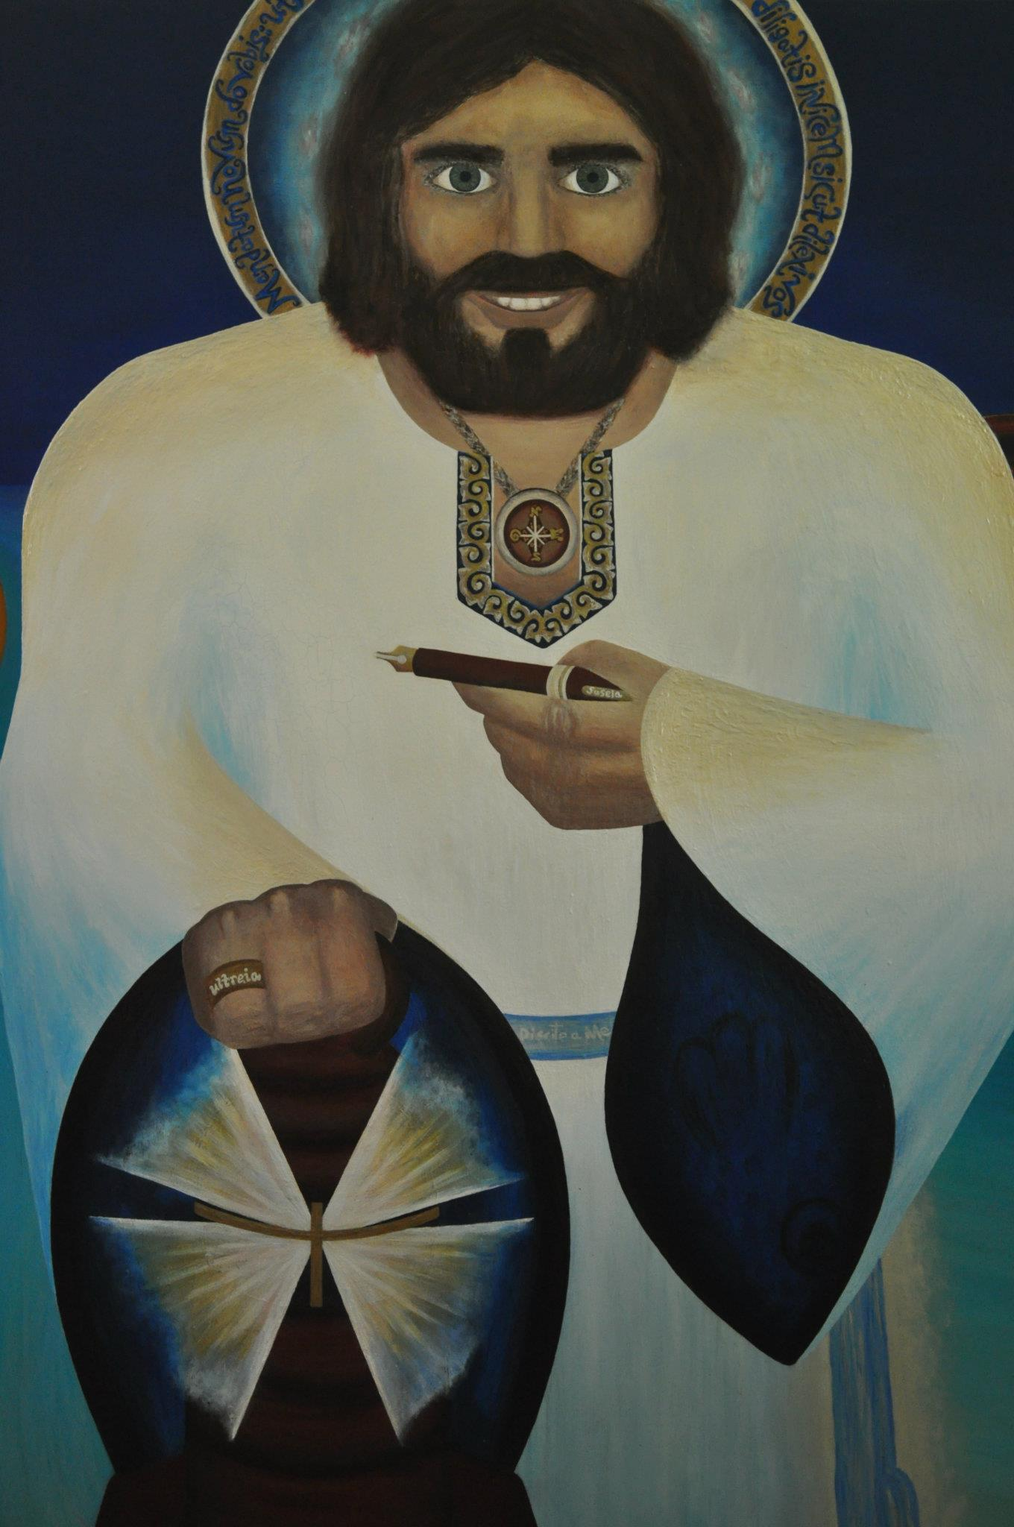

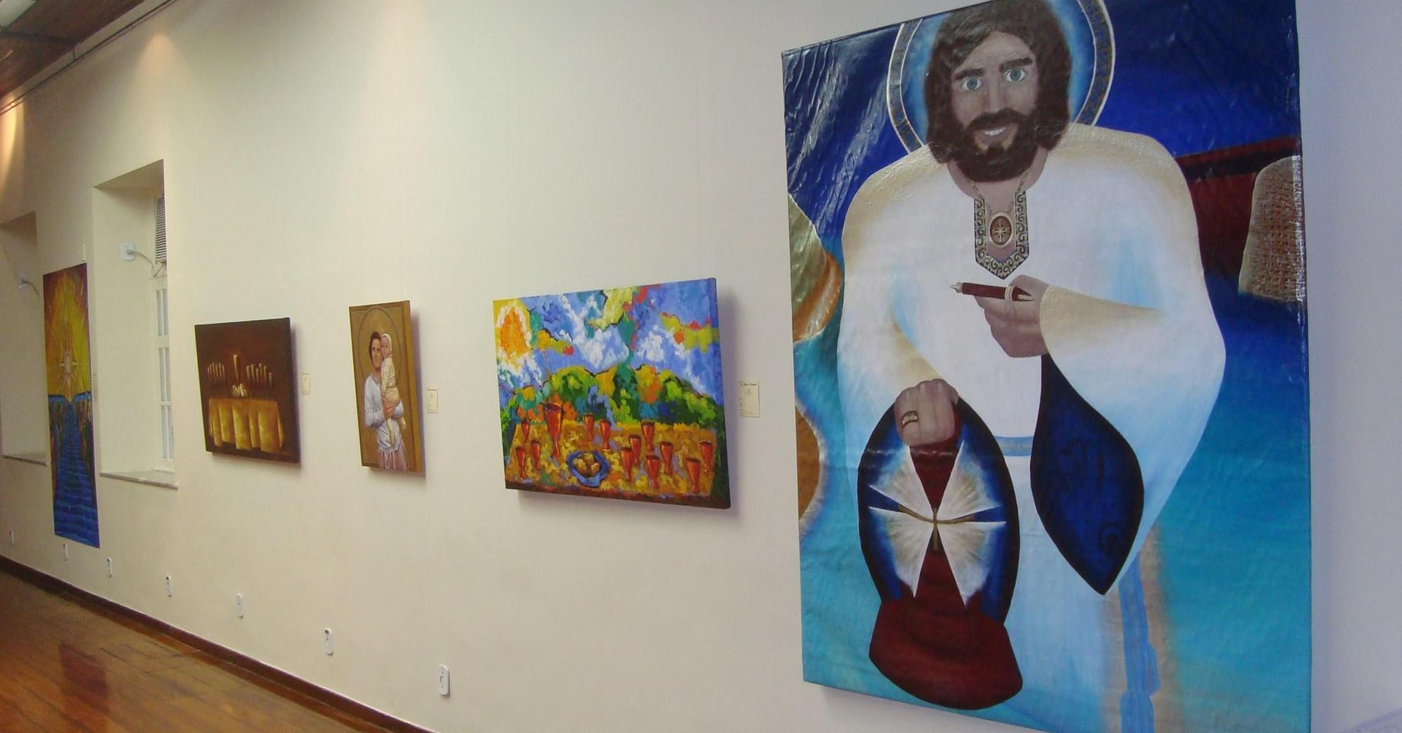
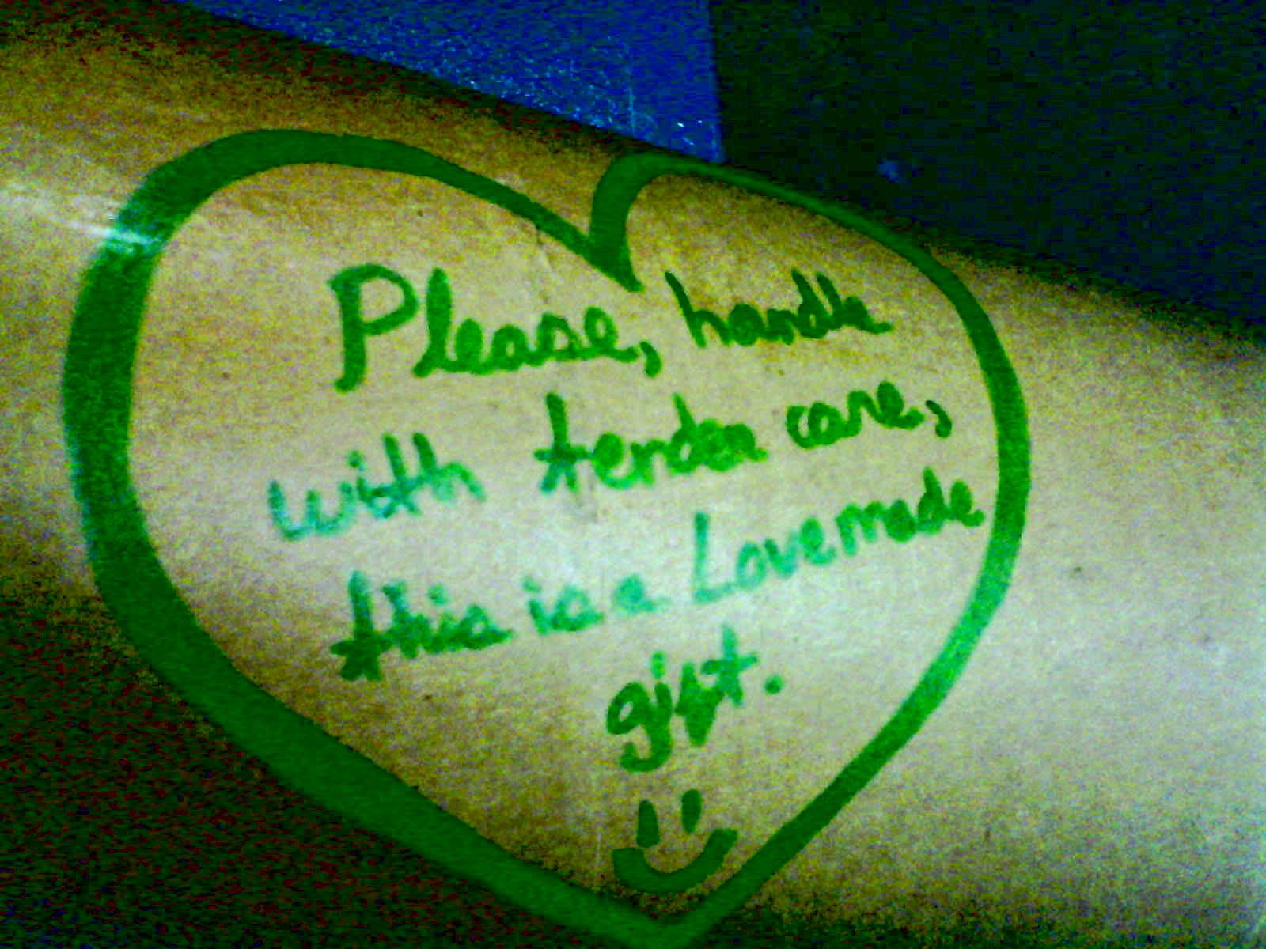
En estas otras fotos pueden ver con más detalle que este proyecto creativo fue progresivo: vean en las imágenes como la pintura siguió siendo formada hasta lograr su plasmación artística definitiva, aunque como proyecto creativo, esta pintura ha proseguido siendo plasmada de muchísimas formas tremendamente enriquecedoras. En estas fotos también pueden ver una foto de mí misma en mi graduación de high school (yo ayudé a construir y diseñar el castillo que está atrás, era de pintura sobre cartón y torres de papel crepé turquesa, con altísimas dosis de brillo), y una foto de la invitación a la exposición de arte de las obras que pintaron mis estudiantes en mi clase. La exposición se llamó “Vivir el encanto” porque ellos, al aspirar a ser la mejor persona que pudiera ser mientras pintaban esas obras, que plasmaban encantos de la isla de Puerto Rico y de la cultura puertorriqueña, son el encanto de la isla de Puerto Rico, a la que también se le conoce como “isla del encanto.” Ellos pensaban que los encantos de Puerto Rico como isla y como cultura eran los que ellos estaban pintando artísticamente en sus lienzos (montañas, paisajes, carritos de piragua…)… No: el encanto de Puerto Rico que estaba siendo plasmado eran ellos mismos, los estudiantes que estaban asistiendo a la clase por aprender de una forma sana, aprendiendo a convertirse en la mejor versión de sí mismos… ellos eran en encanto más verdadero que estaba siendo plasmado.
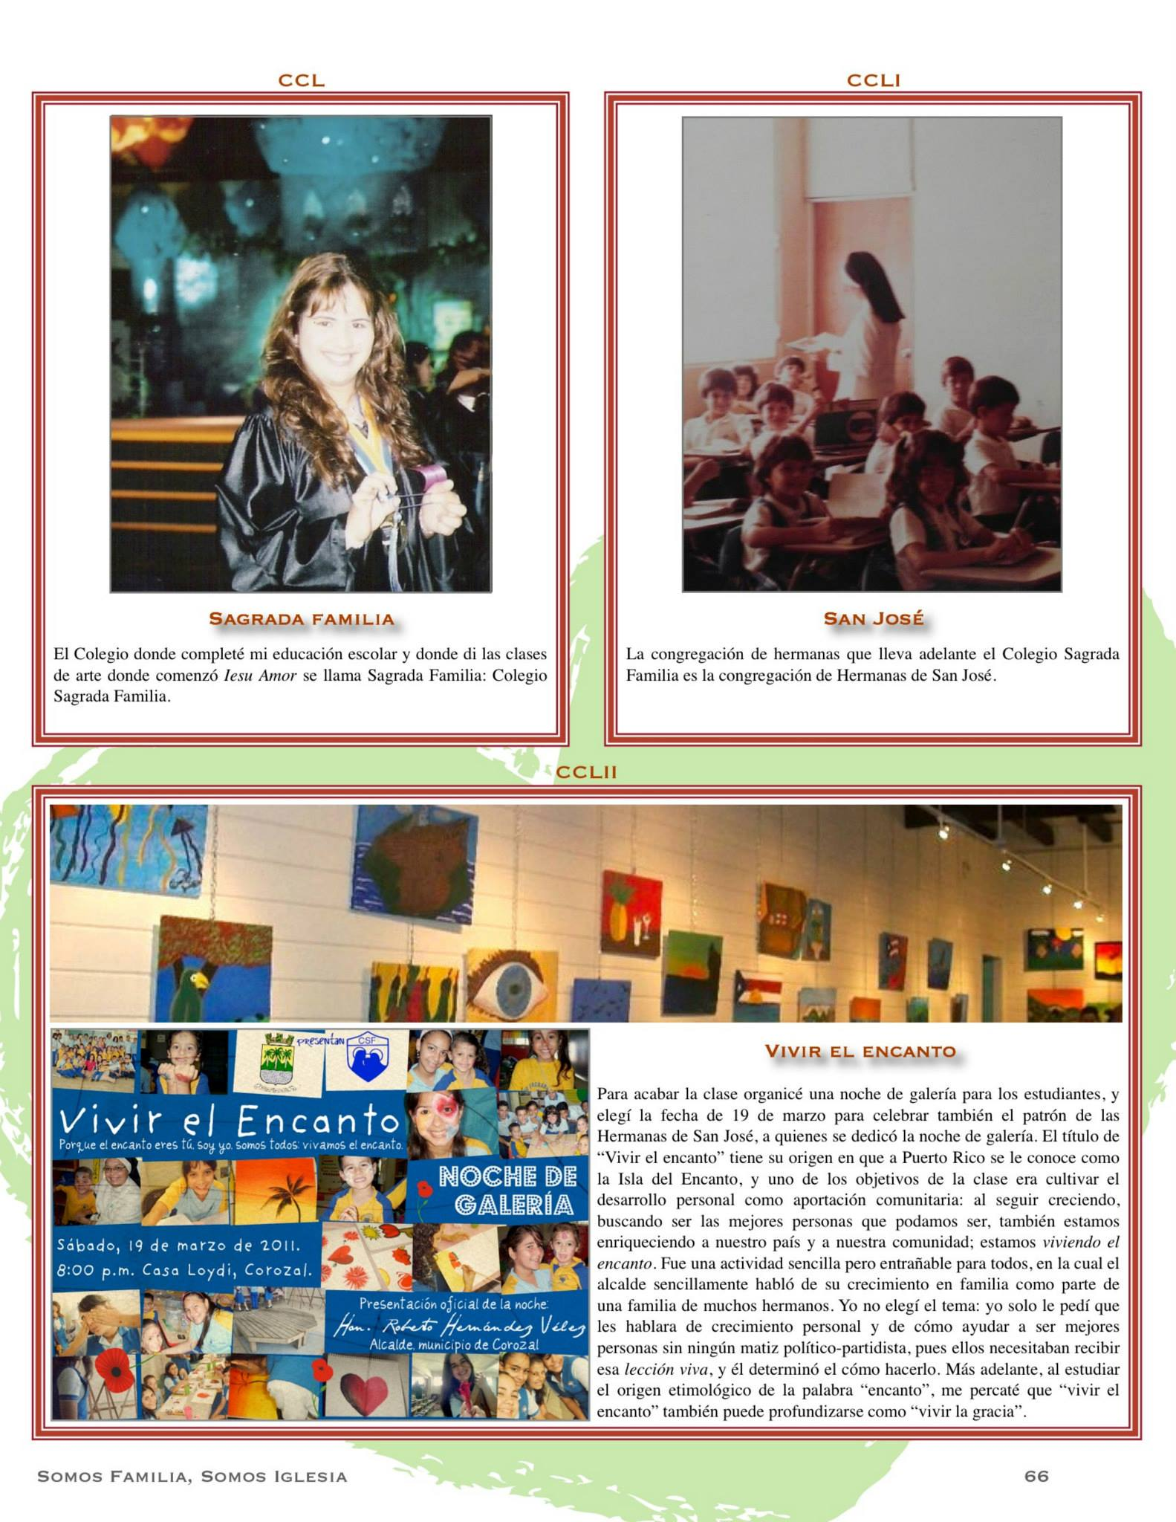
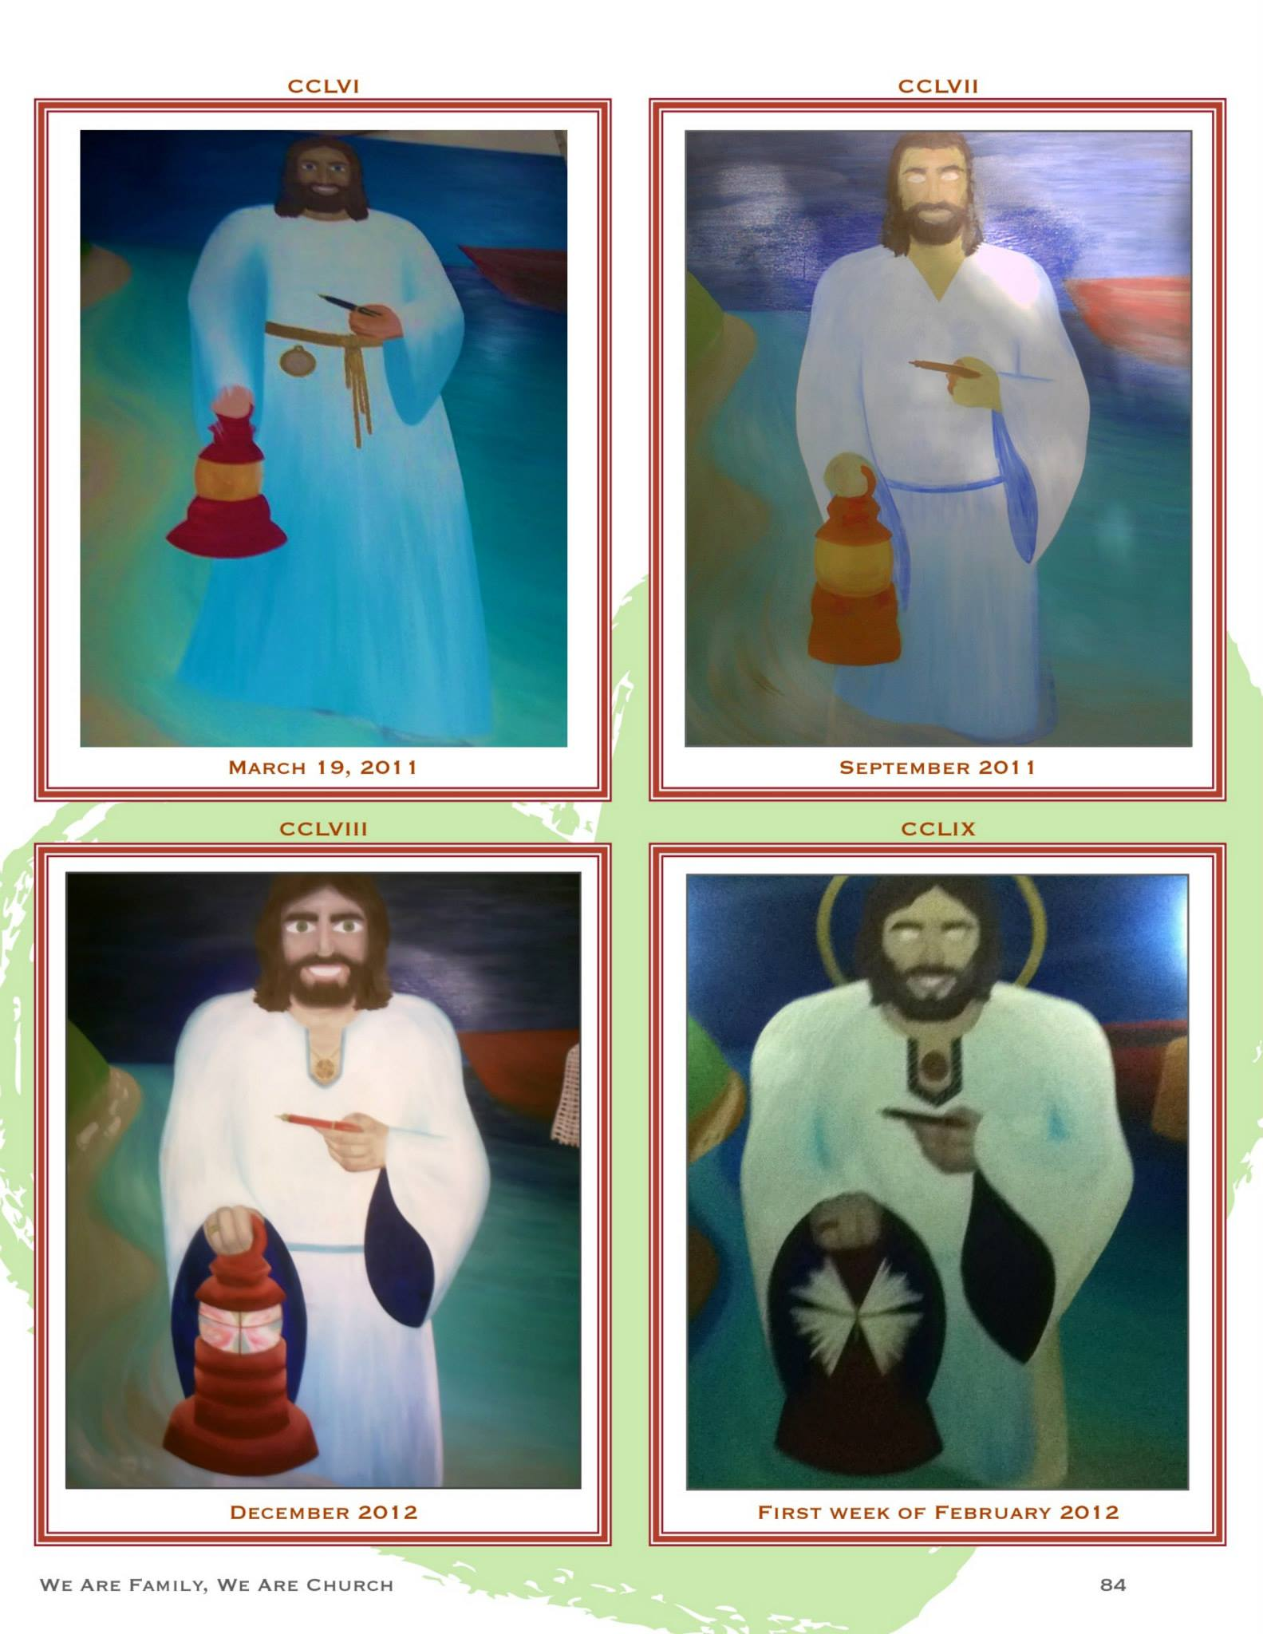

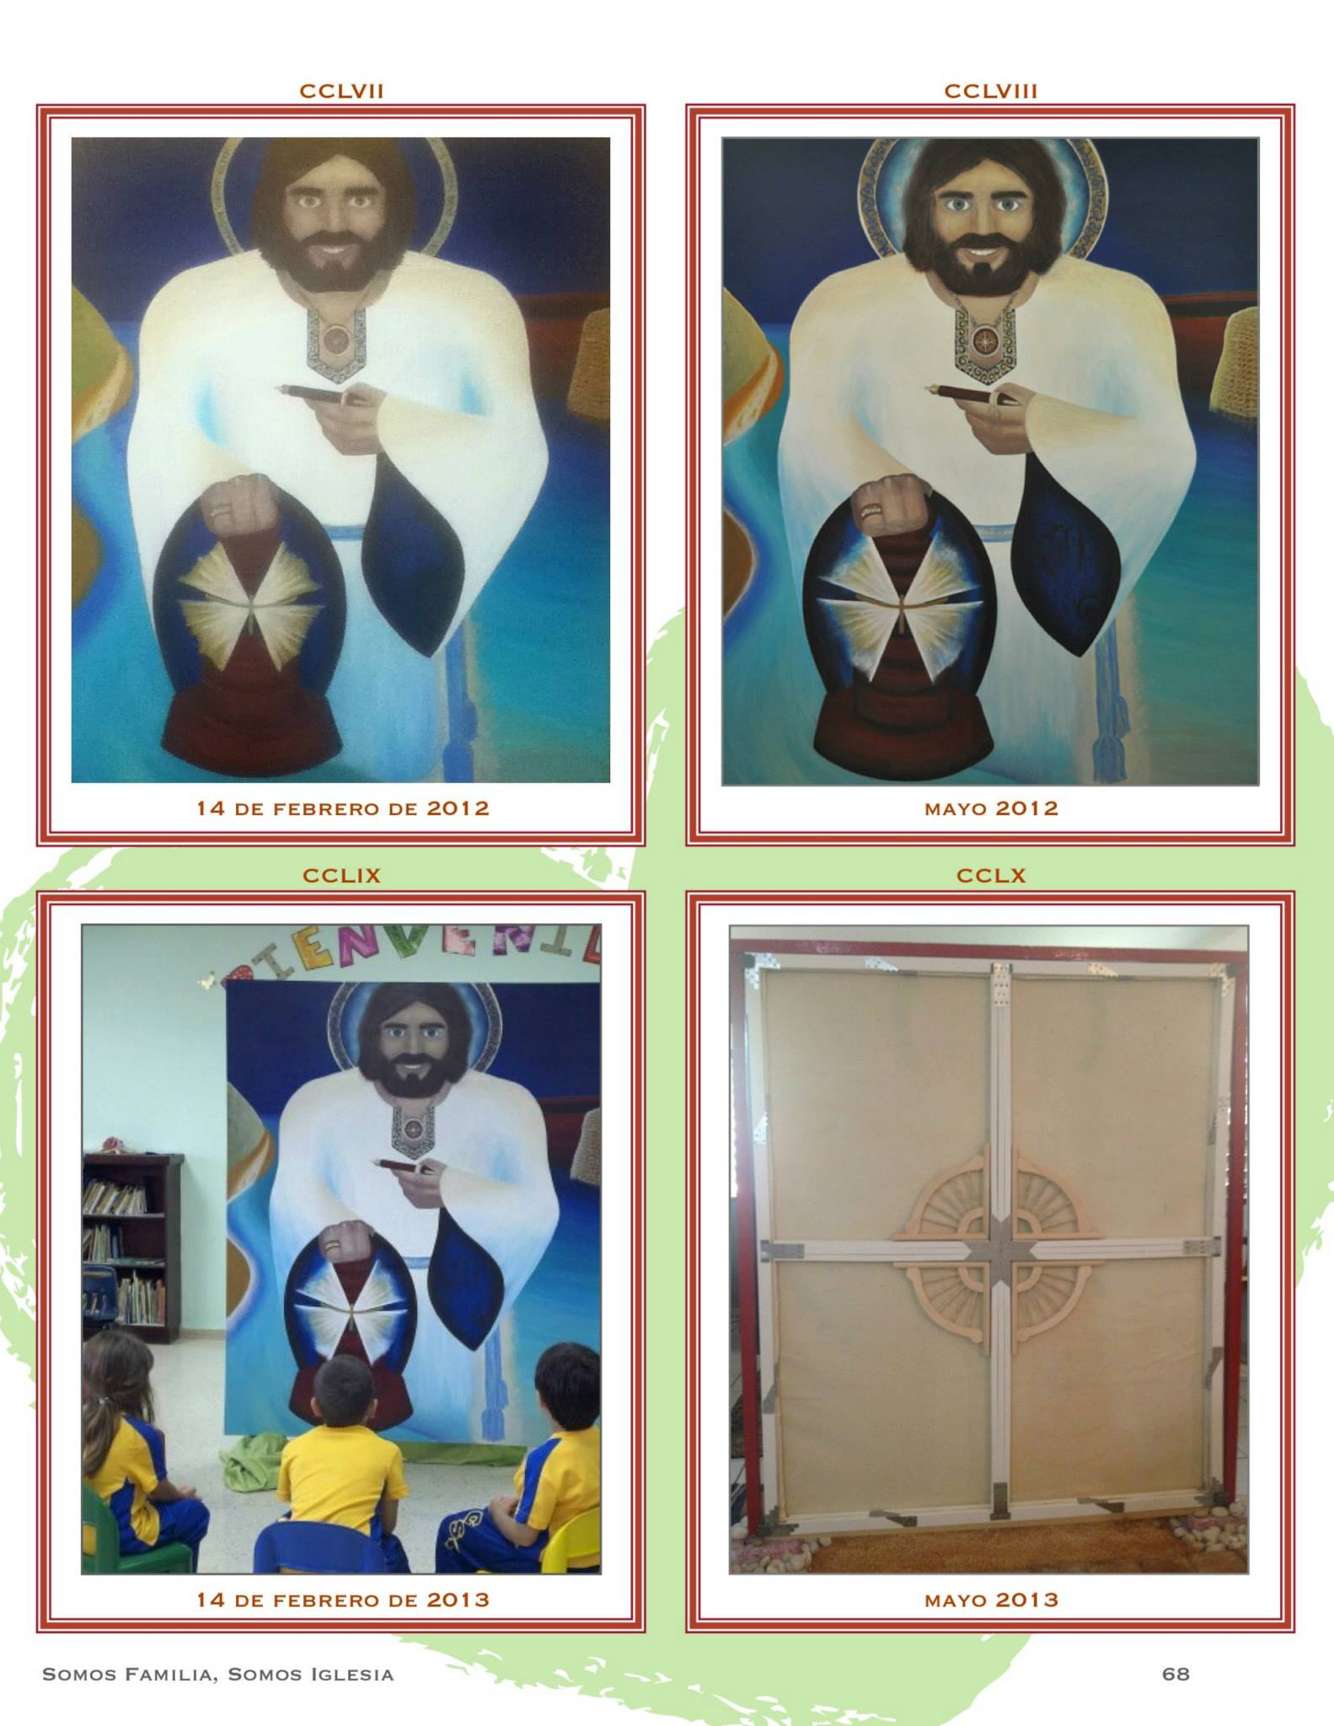
Ahora fíjense en la última foto. ¿Ven esa estructura que parece un marco con un timón de barco en el medio? Expliquemos mejor de qué se trata esa estructura.
Eso estructuras es un internal frame para obras de arte: es lo que comenzó a sostener el lienzo de la pintura cuando la estructura original fue quebrada y se requirió cambiar TODA la estructura del lienzo para que la pintura pudiera tener un frame íntegro, en lugar de permanecer en un frame roto y que también fue infectado de hongos. Ese broken frame, que además en cuya madera reaparecían constantemente matices de hongo verduzcos que solo se iban totalmente sumergiendo TODA la pintura en una piscina con clorox, con todo el esfuerzo y riesgo de rasgado que eso de por sí ya conllevaba… Ese broken frame ponía a toda la pintura en riesgo de romperse en cualquier momento en que se cayera de la pared, sin contar otros factores ambientales importantes (por ejemplo: por circunstancias ambientales bien extraordinarias, el nivel de condensación sobre el lienzo era casi inverosímil, básicamente todas las mañanas el lienzo aparecía empapadísimo de agua de condensación, como pasa con los espejos de los baños cuando te bañas con agua bien caliente… y eso era lo que parecía estar causando que no hubiera forma de acabar con los hongos en la madera del broken frame). Tal cual estaban las cosas, en esos momentos bastaba meramente la fuerza de la gravedad para que la quiebra en la estructura del broken frame pudiera provocar que el lienzo se rompiera, especialmente si por casualidad ocurría un temblor de tierra (Puerto Rico es una zona de terremotos y cada cierto tiempo hay algún temblor fuerte) que hiciera caer el broken frame cayera con fuerza de la pared, rasgando el lienzo de forma irreparable…
En estas fotos pueden ver la estructura original del broken frame. La segunda foto enfoca el lugar exacto donde el frame fue quebrado (eventualmente se vería bien claro que quien rompió el frame lo hizo a propósito… pero incluso eso Cristo Amor eventualmente lo transformó en sobreabundancia de bien en el proceso de reframing): la quiebra del lienzo fue provocada en la parte del medio del lado derecho del lienzo, justo donde se unían la columna horizontal y vertical. La estructura de madera no fue quebrada en un lugar cualquiera: era una zona bien clave para la estabilidad de toda la estructura del frame.

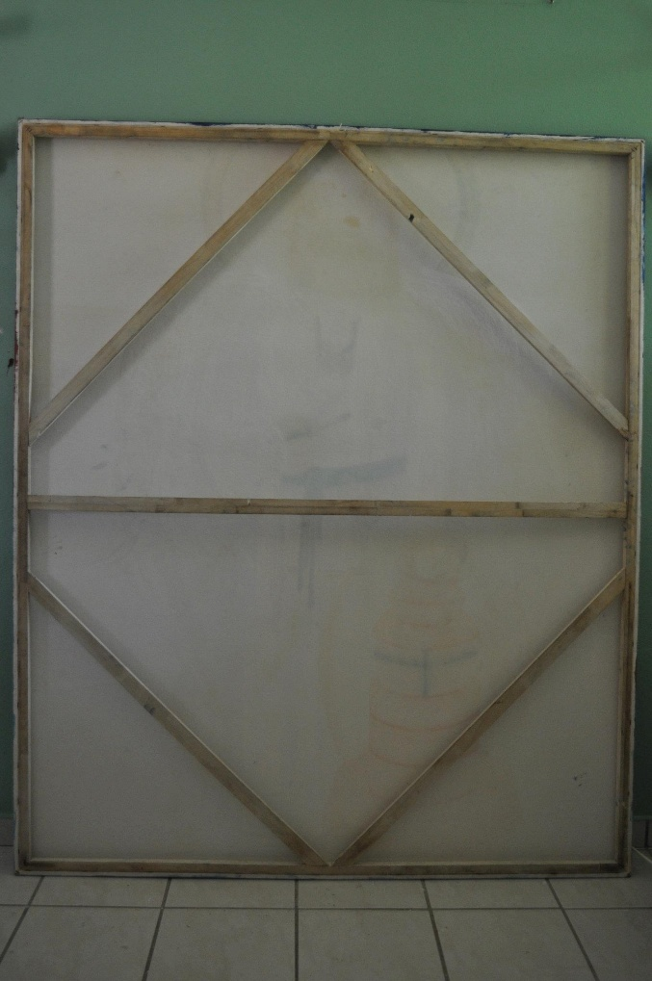
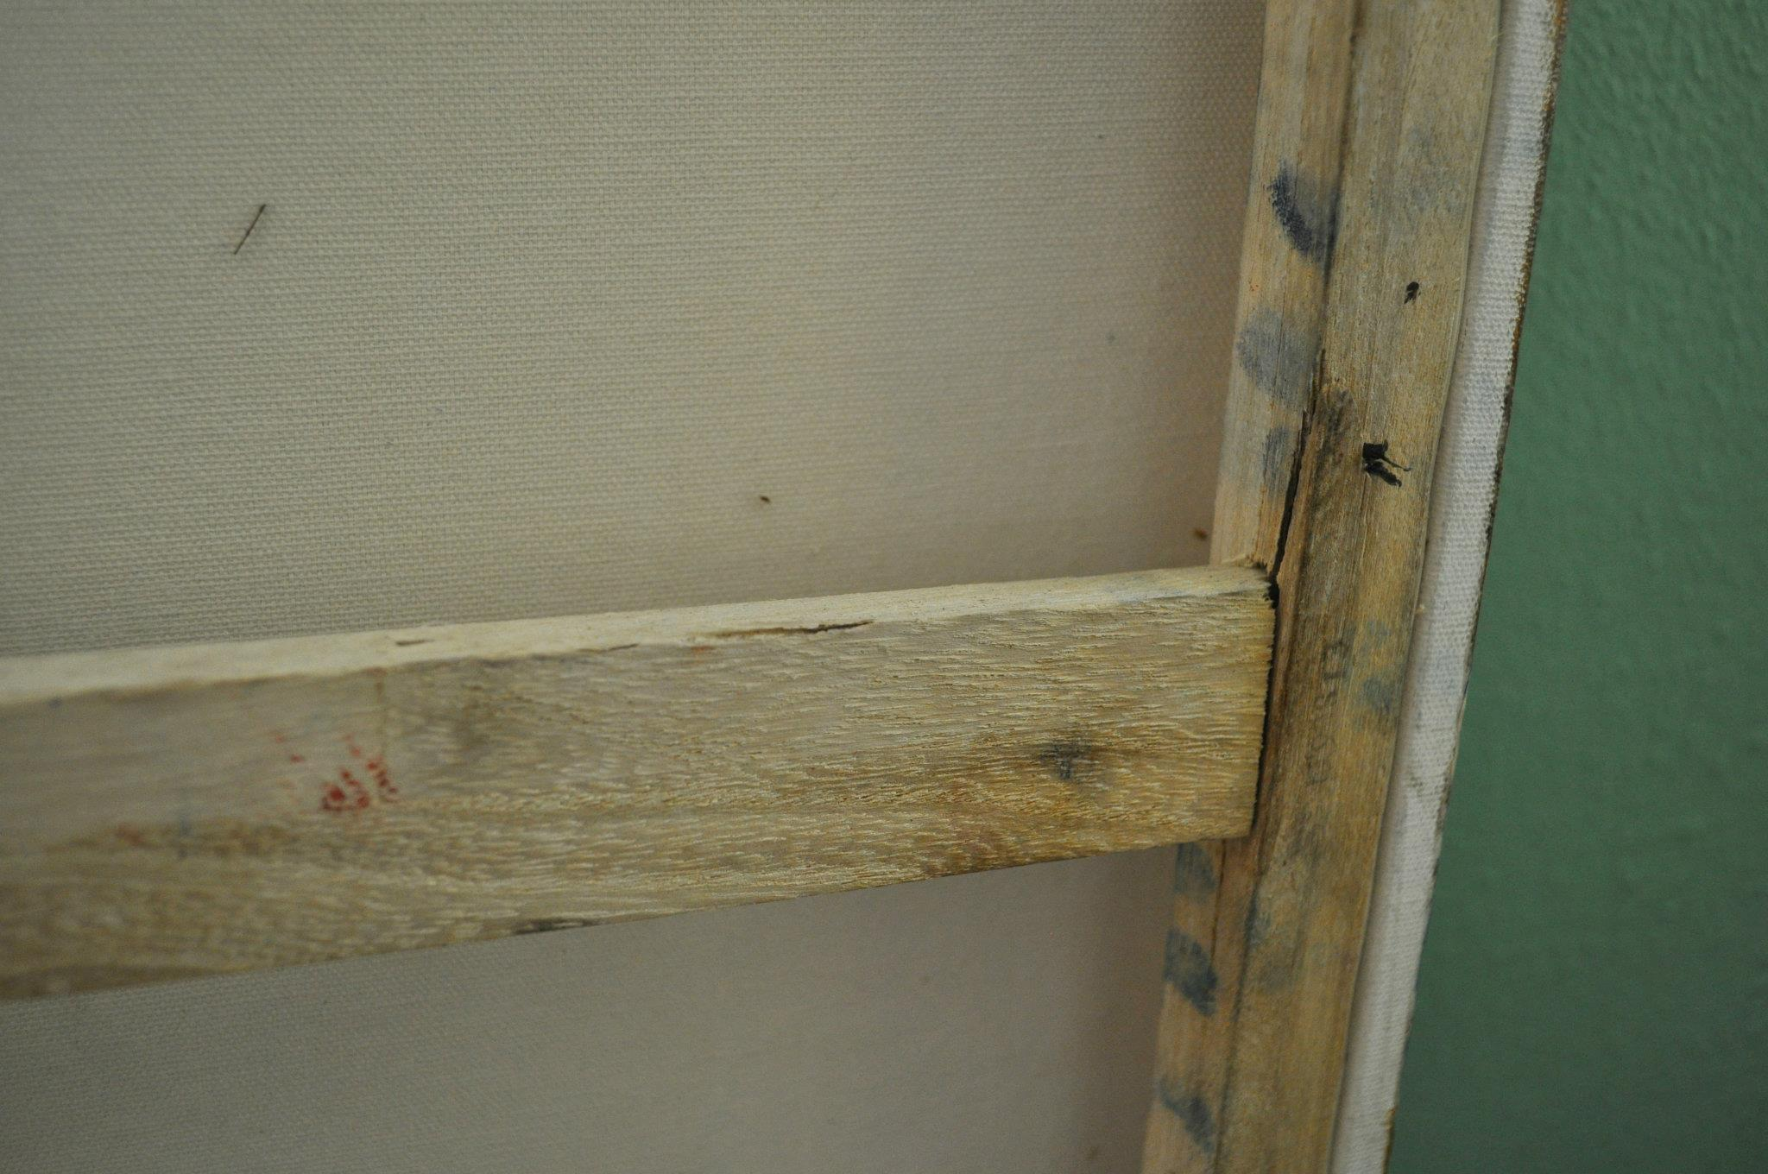
O sea, no solo había que cambiar todo el interior frame; había que construirlo totalmente nuevo desde cero, buscando usar materiales que no fueran ni fácilmente rompibles ni fácilmente infectables con hongos, y con dureza flexible que garantizara la estabilidad del lienzo. Todo este frame design and rebuilding, que también fue pensado para mostrarse eventualmente en la Jornada Mundial de la Juventud —cosa que no sucedió: solo el lienzo de la pintura fue enviado al Youth Arts Festival; la estructura del frame era demasiado pesada para ser enviada—, curiosamente, no lo hice con conocimiento técnico más básico (ni siquiera había visto a alguien construir un frame ni framing an art canvas manually, en toda mi vida, y he ido a diversas clases de arte por muchos años). Lo hice con el mejor material que manejar en aquel momento momentos, diseñando el nuevo frame structure con los materiales más durables posibles: diseñé el new frame de PVC, un material de dureza flexible (por ejemplo: podía cortarlo y taladrarlo yo misma sin una herramienta más especializada que un destornillador eléctrico y una sierra manual) que nadie se plantea que es posible usar para art frames (imaginen, niños, todos los árboles que se podría salvar si los art frames se hacen con material de PVC hecho con plástico reciclado, en lugar de hacerse con madera…), pero a mí me pareció el material más duradero, y definitivamente no le iba a dar hongo ni se iba a romper tan fácil como un frame de madera. El tiempo que el lienzo estuvo en ese frame fue posiblemente el tiempo en que más segura estuvo: no había forma de que cayera al piso (cosa que no sabía en ese momento que incluso podría haberse provocado adrede para romperla con acaridad…) pues con el nuevo frame esa posibilidad ni siquiera era posible. Con el new frame, el lienzo estaba firmemente sostenido de tal forma que no había forma de que el frame con el lienzo en él cayera al piso ni por accidente, debido al peso de las bases de cemento que diseñé yo misma, y que además tenía piedras para añadir más peso… Hice todo eso como personal giftedness para Dios Amor en primer lugar, como ofrenda de mi mejor crecimiento posible a ese Cristo Amor que pinté, al que comencé a llamar “Jesús Caridad”, y todo eso lo hice sin saber que eventualmente la estructura ni siquiera podría ser transportada a la JMJ: solamente el lienzo podría ser enviado… y fue enviado con tal calibre de giftedess que el lienzo no volvió a mí, y como quiera Jesús Caridad siguió creciente en mí, plasmado crecientemente en mi formación personal, convirtiendo mi formación personal en lienzo vivo de un ícono encarnado de Dios Caridad-creciendo-más-y-más-progresivamente-en-mi: illum oportet crescere…
Niños del futuro, pueden ver mucho mejor la nueva estructura del lienzo, tal cual fue diseñada con PVC, en la próxima foto:
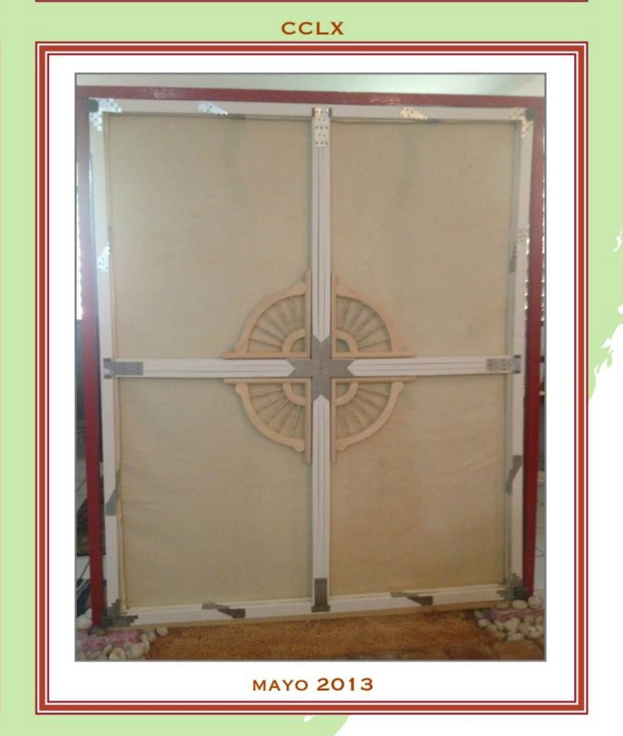

Todo el diseño de la estructura del new creative frame tenía no solo una utilidad, sino un meaningful purpose: cada pieza del new creative frame tenía un significado, como pueden observar en las siguientes fotos, que son screenshoots del panfleto que se envió a la JMJ para explicar el significado del contenido de la pintura. Algunos estudian teología con un texto, pero yo la estudié con un lienzo cuya plasmación no solo salvó mi fe: también salvaguardó toda la integridad de mi formación personal, todo lo que siempre he sido, soy y siempre permaneceré siendo llamada a ser como persona cara a Dios Amor… salvaguardando mi dignidad sagrada con una fortaleza flexible extraordinaria… pero en ese momento aún no sabía eso, todo lo que se estaba haciendo se estaba haciendo sencillamente como personal giftedess.
En las siguientes fotos se pueden ver algunos de los iconic meanings tras la estructura del new creative frame, que literalmente simbolizaba a la Iglesia que en la parte de al frente estaba plasmada en la barca… y es por eso que en el new creative frame el centro de la estructura es un timón: es el timón de la barca-iglesia que podía verse plasmada en el lienzo en la parte de al frente…
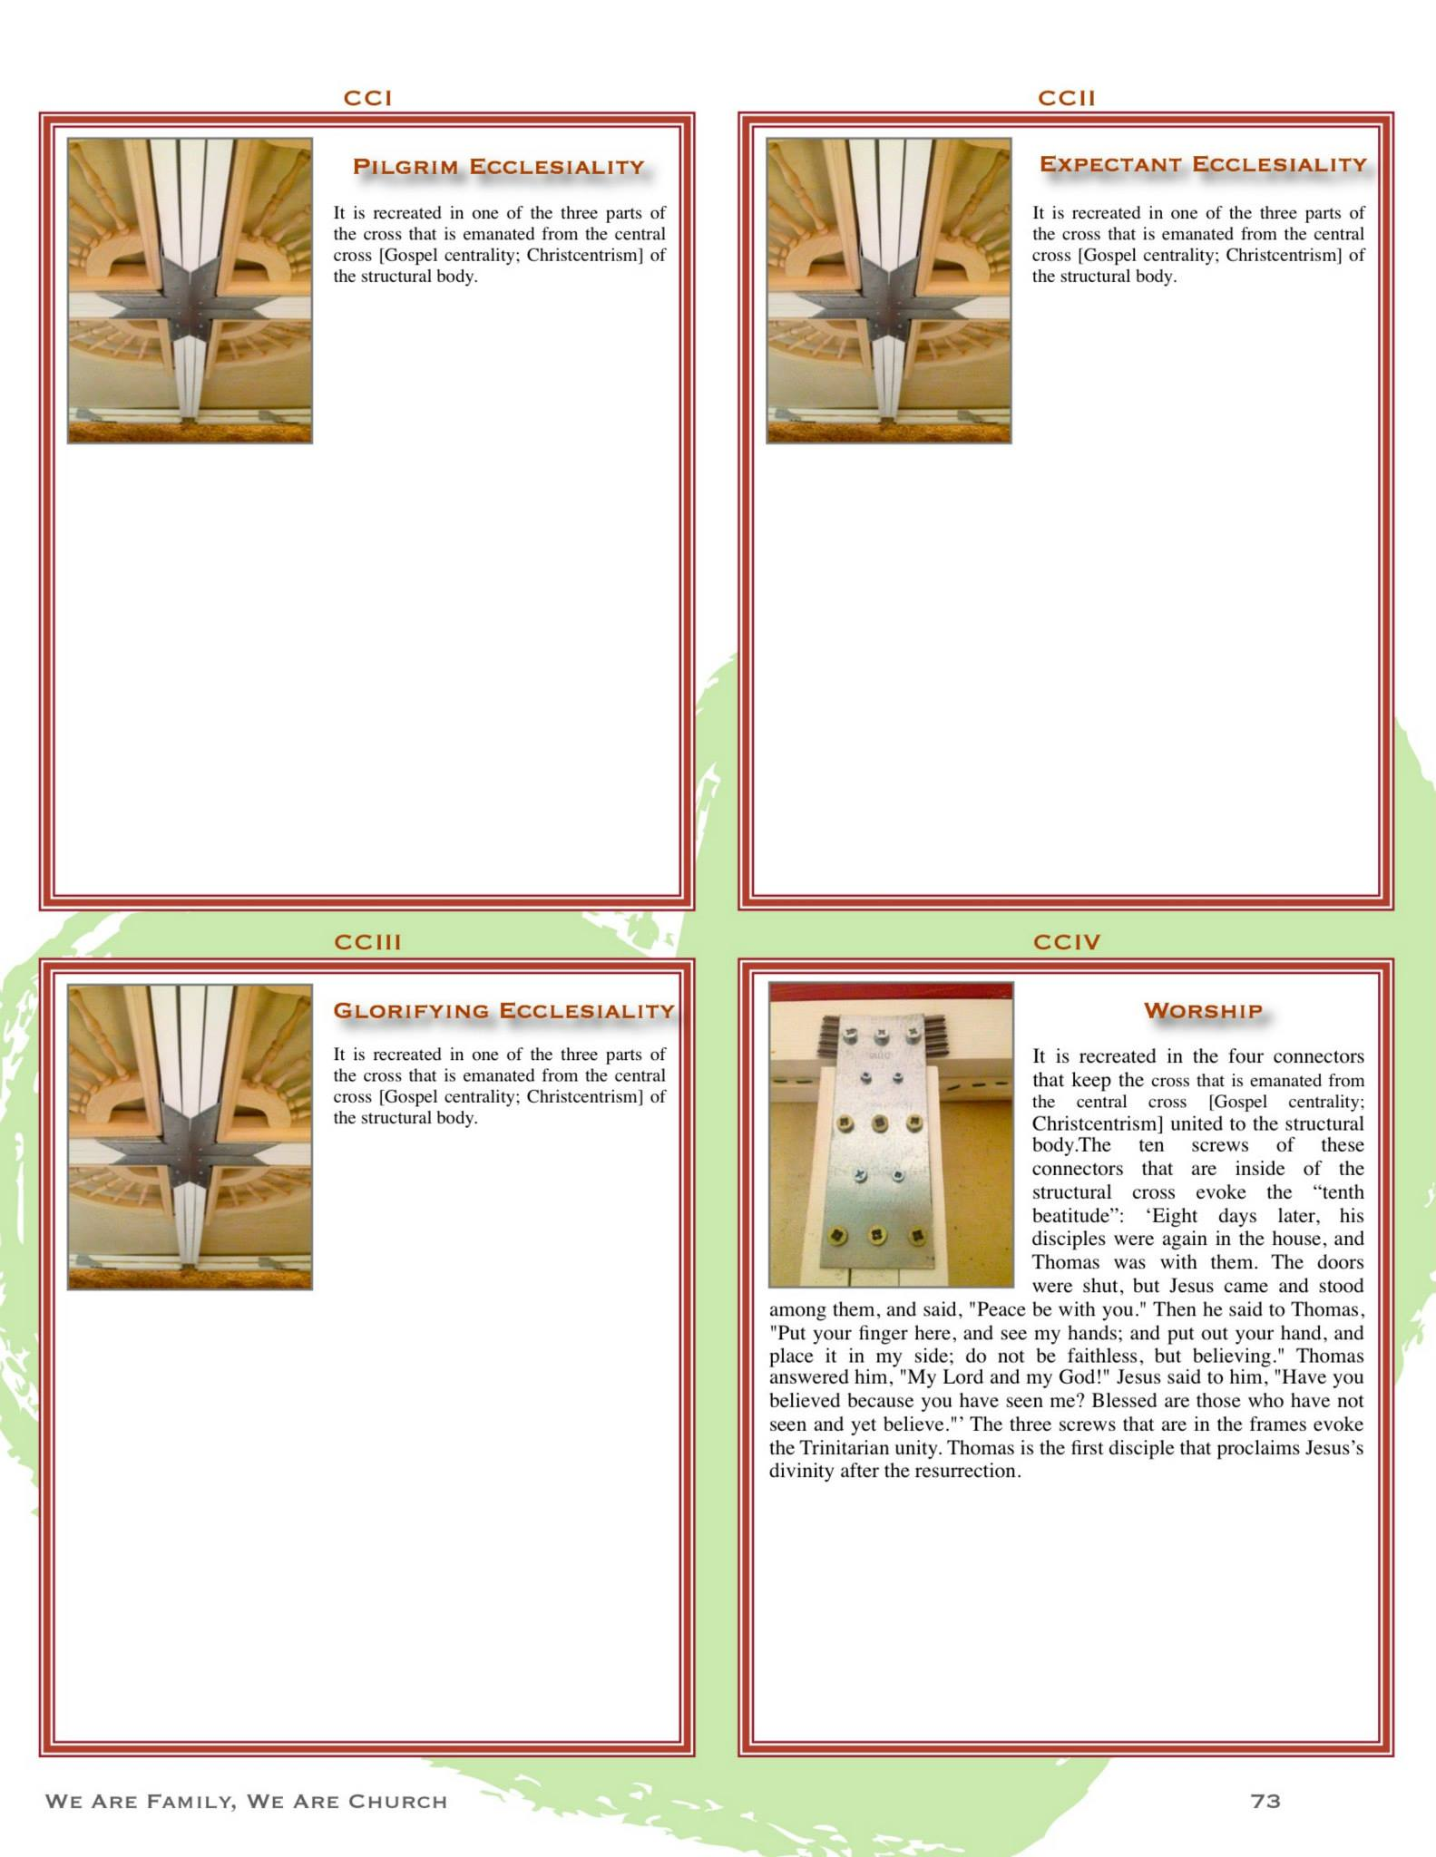
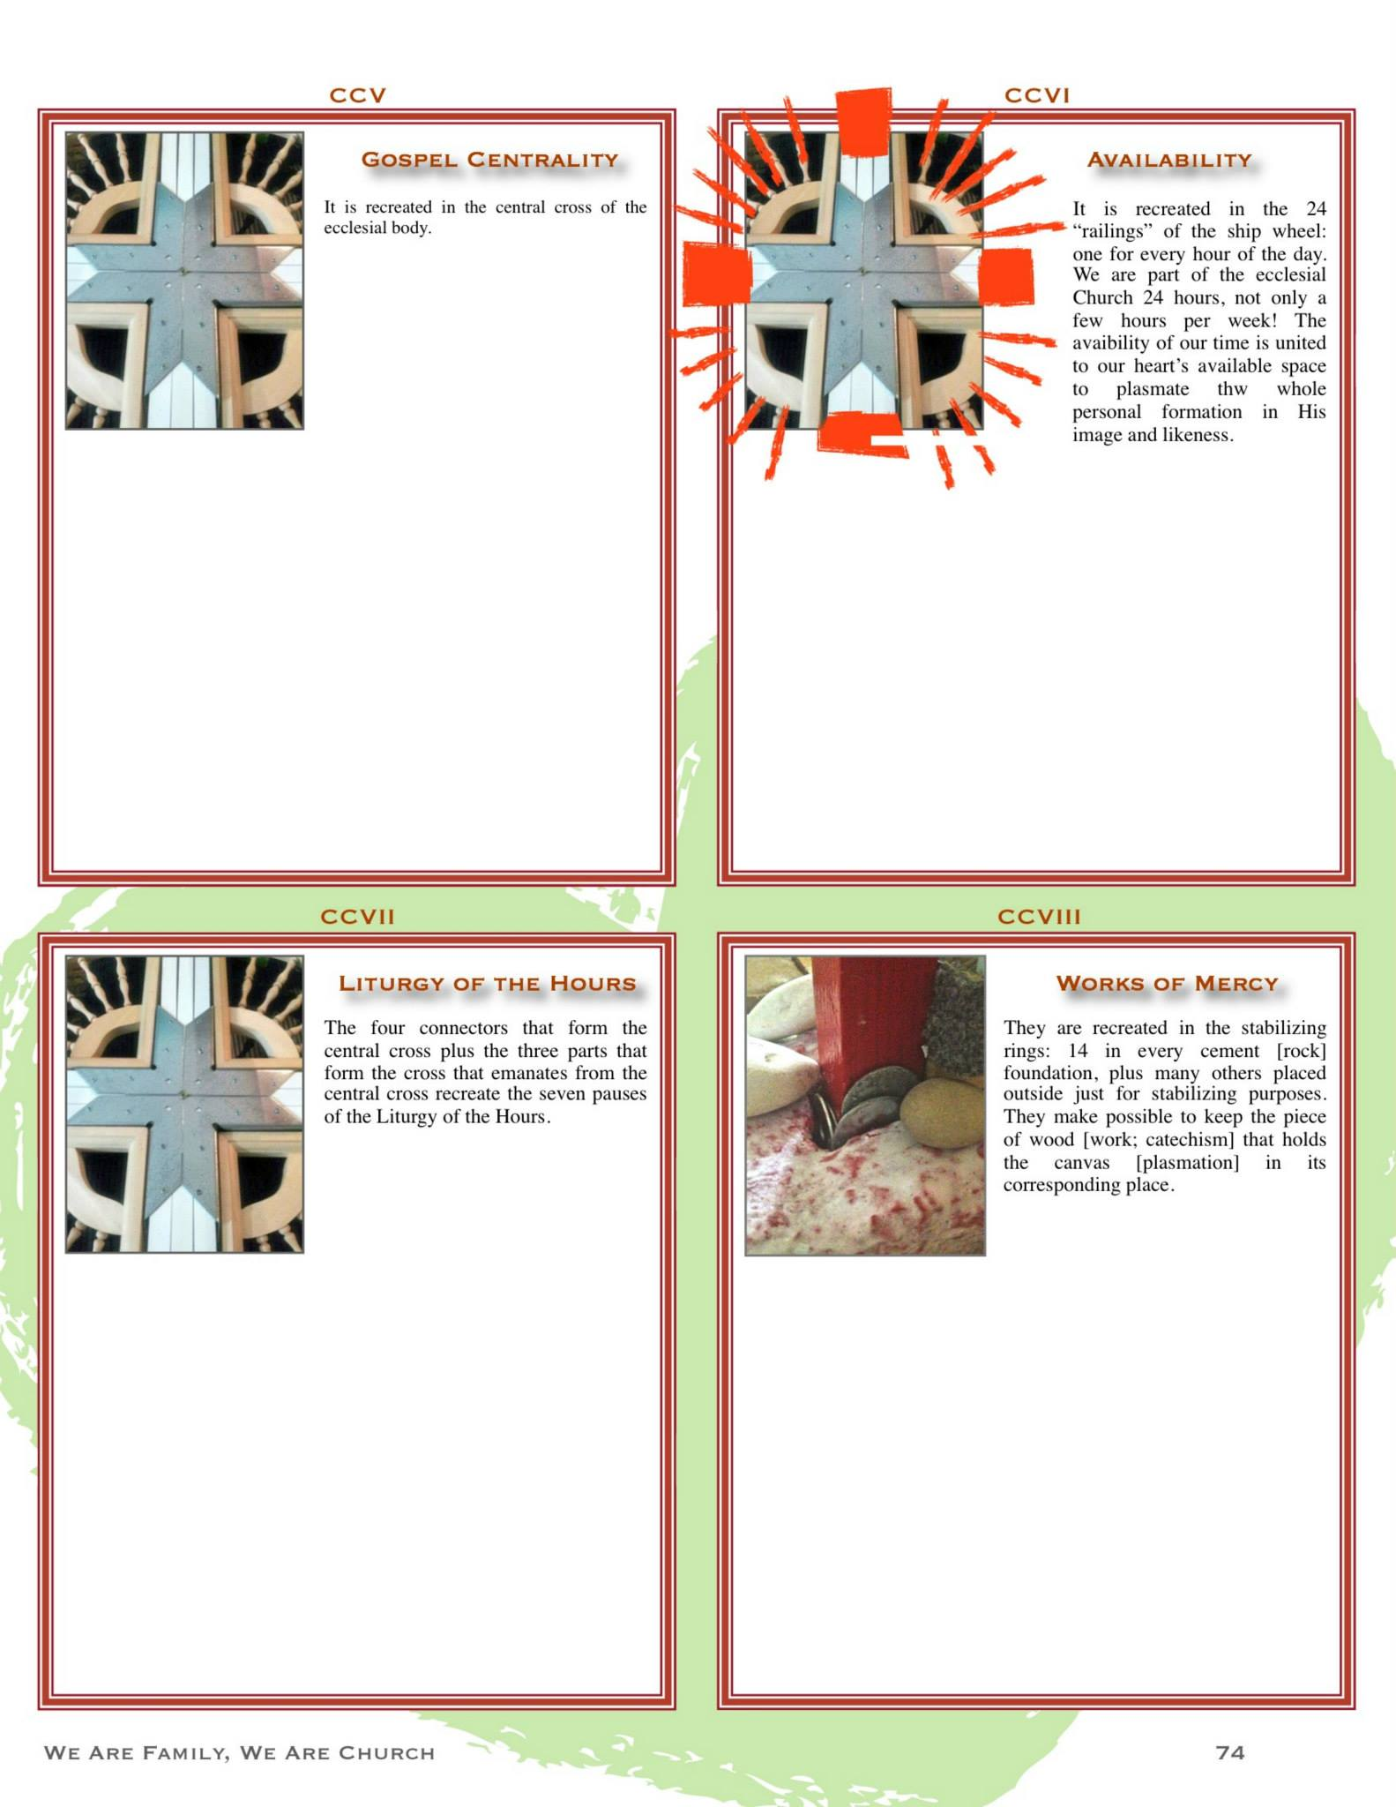
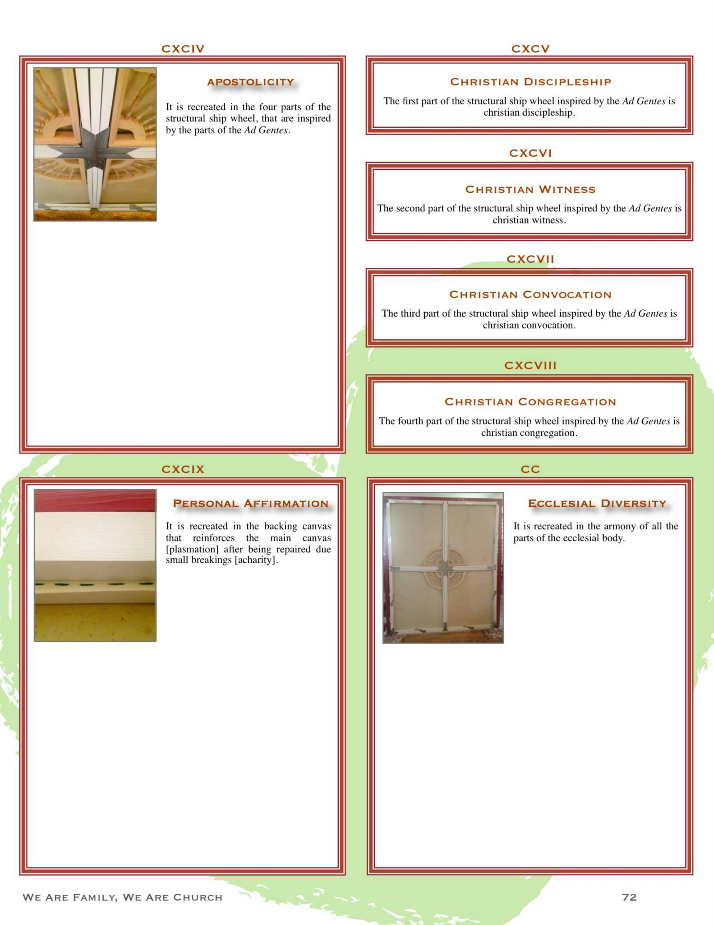
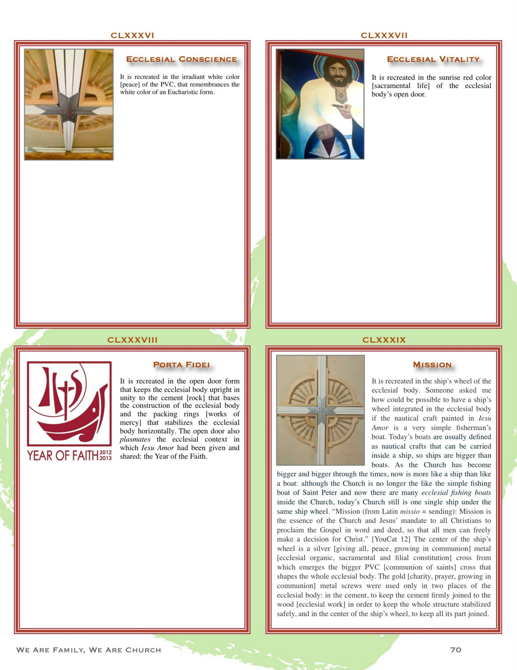

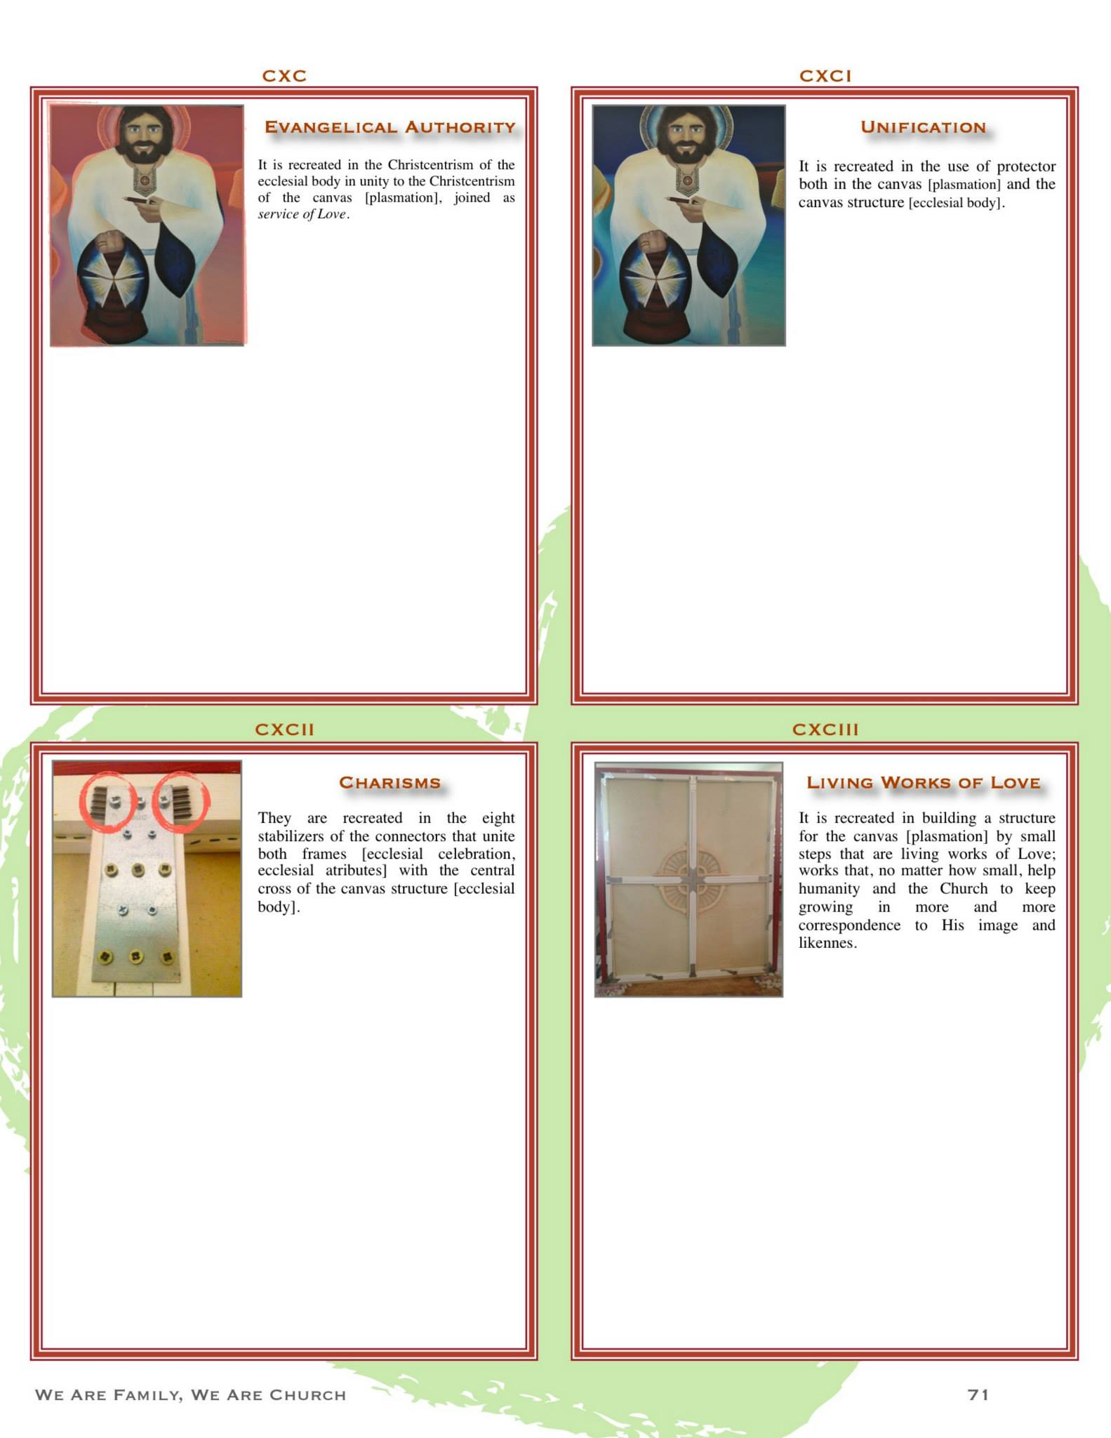

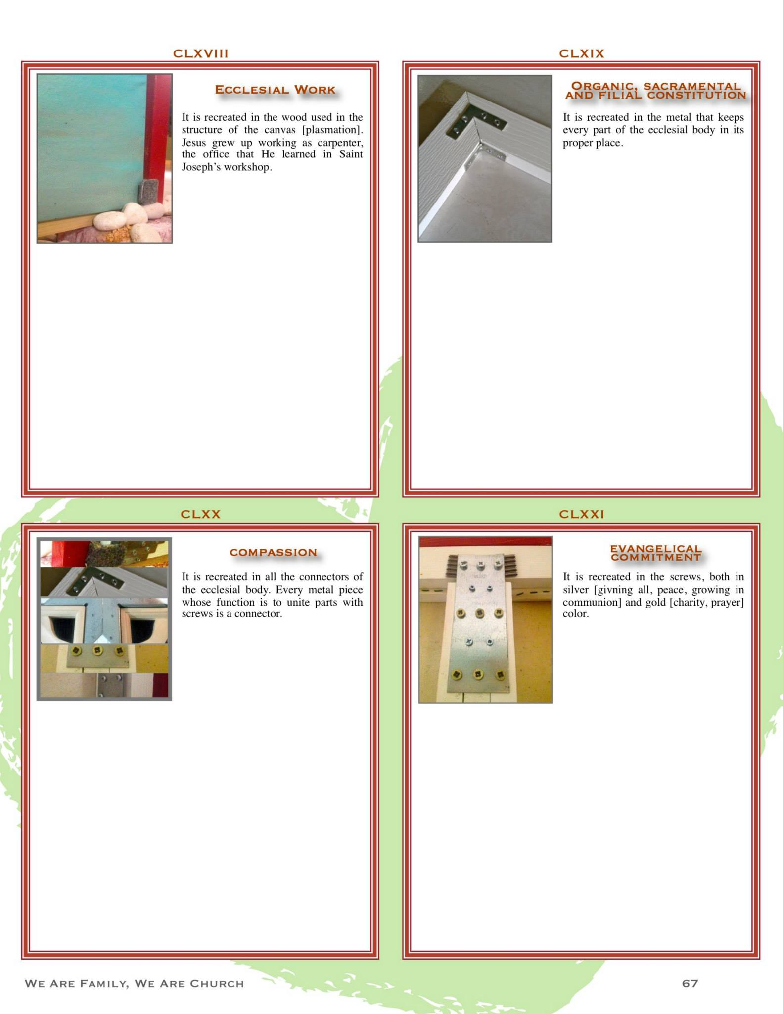

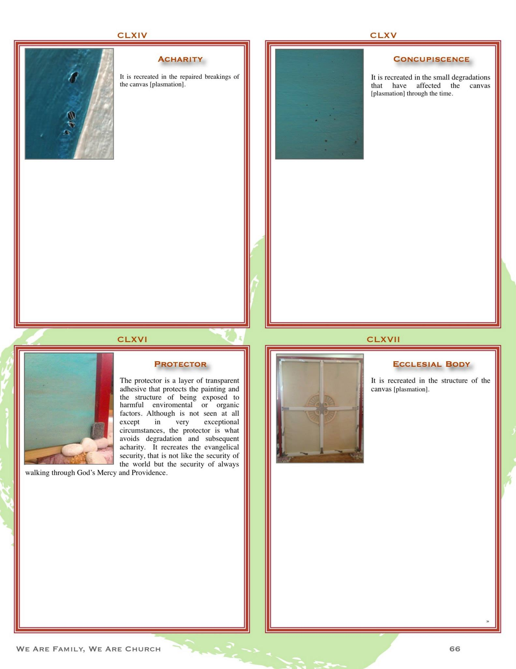

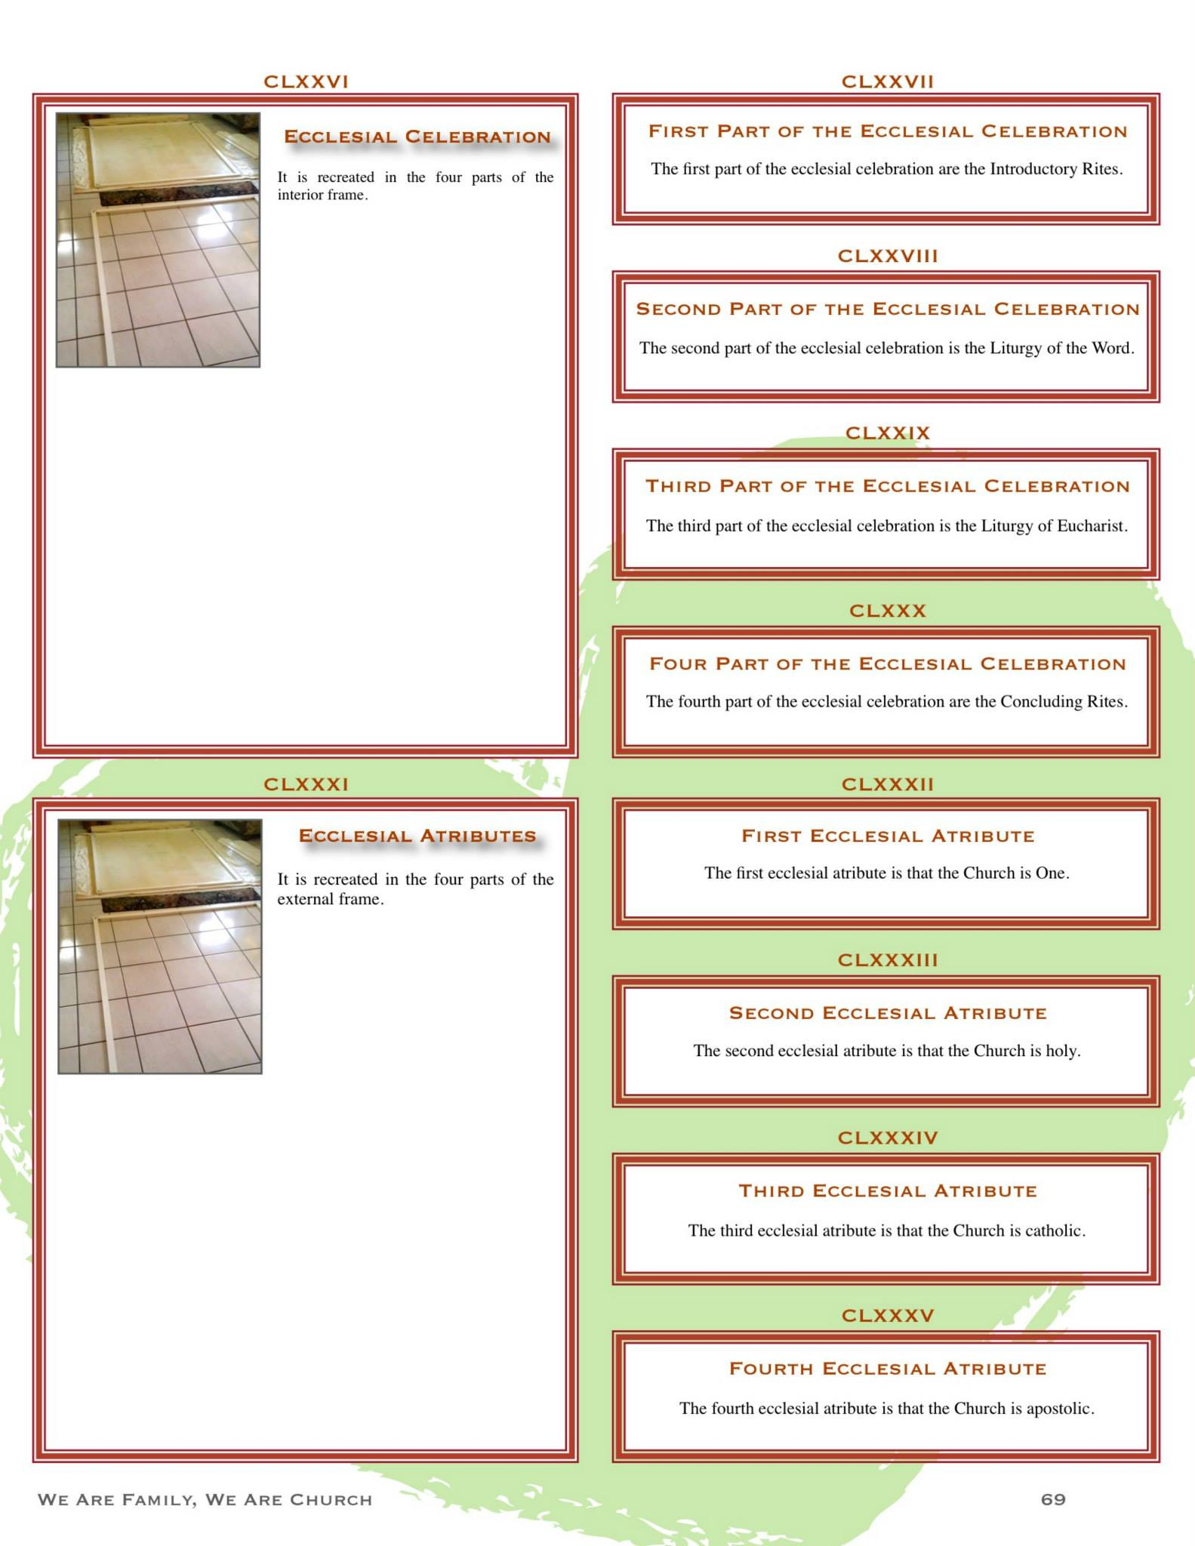
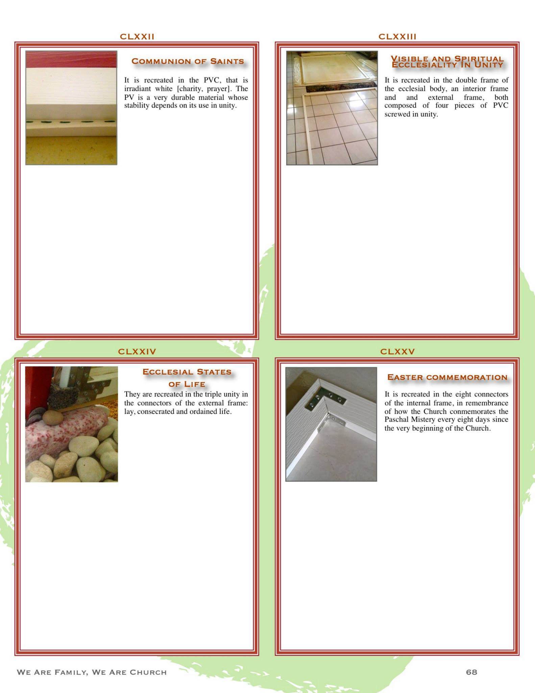

La concepción creativa de Iesu Amor, una vez gestada a través de esa pintura como un “Jesús Caridad” con el que me encuentro personalmente todos los días, con el que crezco cada día en más y más comunión como la mejor persona que pueda ser, caminando juntos como familia del Cielo, caminando juntos como Él camina en este camino de luz que es un camino del mar… prosiguió creciendo mucho, mucho, mucho más, dando más y más a luz a la Palabra… Algo que comenzó siendo algo muy pequeño en el corazón, una chispa que comenzó a contemplar un ícono de un “Dios Amor”… eventualmente acabó convirtiéndose en el proyecto creativo que acabó plasmando mi historia entera como una historia de Amor que ha encarnado Su historia de la salvación en cada aquí y en cada ahora, una y otra vez… Ha sido ese crecer más en Él, por Él, para Él y con Él lo que ha cambiado mi vida para siempre. Sí, como proyecto creativo, plasmar a Iesu Amor y este new creative frame ha sido el proyecto creativo más amplio de mi vida… y fue lo que Él me enseñó, el cómo Su mirada me enseñó a yo misma también aprender a mirar lo más natural y claramente posible…
Aunque la pintura Iesu Amor jamás volvió de Brazil, el Jesús Caridad que se gestó creativamente en ella sigue estando presente en estos momentos en mi vida.Todo lo aprendido de Él como encuentro personal cotidiano, como incarnated Eucharist que crece todos los días, fue lo que me preparó para el creative envisioning que se va a ver a continuación. No, sola no lo hubiera hecho, sobre todo en mis circunstancias.
Tengo en mi mesa de noche una talla de santos que yo misma tallé de un Jesús Caridad colorido, sonriente, vivo, con un faro-lámpara bien encendido en caridad viva que crece en comunión (eso es lo que significa el matiz intensamente dorado del faro). Junto a él también hay un breathing table con una estrella, que uso para rezar por todos los niños presentes y del futuro. Hay una vela con olor a árbol de Navidad porque ayudarlos a crecer a ustedes con estas palabras, niños del futuro, es también ayudar a crecer al Niño Amor, a ese Jesusito que también crecerá en cada uno de ustedes. Hay una ofrenda de flores vivas color flamming Holy Spirit (anaranjado) con tres ramas de lavender (signo de sencillez, de transparencia fragante, de loveful kindgom, realeza del Cielo… ¡A Jesús Caridad le gusta mucho llamarme “princesa del Cielo”!). Hay algunos libros, entre ellos la Biblia y un pequeño libro verde que son los Evangelios de cada día (sí, rezo los evagelios de cada día… el último que leí precisamente hablaba de como hemos de ser como niños para ir al Cielo: al escribir esto también estoy dando a luz a la Palabra…). Hay una barca pintada con semillismo en la parte de atrás, con una gran pesca de estrellas de nueva fraternización. Y hay un pequeño cañón colonial transconsagrado (así llamo yo al salpicar pintura de colores vivos, como lo hice con las ventanas, pero este cañón colonial está salpicado de crecimiento en comunión vivo: tiene los colores dorado caridad y plata self-giftedness).
Junto a mi talla de Jesús Caridad también hay una flauta indígena, que es signo de cómo hemos de honrar el legado de los Taínos, de los indígenas y de todos los Native Americans que ya eran Americanos en primer lugar, antes de que la colonización de América comenzara. Ellos pueden enseñarnos mucho acerca de una forma de gobernar que sea distinta, que no sea colonial, sino que funcione más como un consejo continental fraterno, de la misma forma que los indígenas se gobiernan con counsils (consejos).
¿Sabían de que antes de la colonización de América ya había en el continente otros estilo de gobernanza, funcionando como democracia mucho antes de que ese concepto comenzara a ser siquiera posible de ser conocido políticamente por quienes comenzaron a colonizar América? Esa democracia indígena que ya funcionaba en América antes de la colonización se llamaba la Confederación Haudenosaunee: era una Alianza Americana de cinco naciones indígenas en territorio que hoy se consideran de Estados Unidos y de Canadá, que luego se expandió… Es una de las democracias participativas más antiguas de toda la humanidad. Una democracia participativa es como cuando en tu escuela hay que decidir algo importante, como qué juego jugar en el recreo o qué merienda llevar a la excursión. En vez de que lo decida solo la maestra o un jefe, todos los niños pueden dar sus ideas y votar. No es solo elegir a alguien que mande, sino que todos participan más seguido en las decisiones. Es como un gran círculo donde todos hablan, escuchan y juntos buscan lo mejor para todos como hermanos iguales, para que nadie se quede fuera y todos se sientan parte de la solución.
Así funcionaba la Confederación de los Haudenosaunee: eran un consejo que se sentaban a escuchar y hablar hasta encontrar una decisión que hiciera feliz y segura a toda la comunidad.
Vamos a contarles esto con un pequeño cuento, niños del futuro…
Hace muchísimo, muchísimo tiempo, cuando todavía no había llegado Cristóbal Colón ni ningún barco de otros continentes, en el norte de nuestro gran continente América vivían cinco pueblos hermanos: los Mohawk, los Oneida, los Onondaga, los Cayuga y los Seneca.
Aunque eran pueblos diferentes, con sus propias canciones, historias y costumbres, tenían algo en común: querían vivir en paz y ayudarse mutuamente. Así nació la Confederación Haudenosaunee: funcionaba como una Alianza Americana, como una unión de amistad y cuidado fraterno entre las cinco naciones.
En esta Alianza no había un rey que mandara a todos ni un solo jefe que decidiera todo. No, aquí las cosas funcionaban diferente: todos los pueblos hablaban, escuchaban y buscaban juntos la mejor solución para todos. Se sentaban en un gran círculo y no se levantaban hasta que encontraban un acuerdo que cuidara a cada familia y a cada niño de la Alianza.
Esto se llama democracia participativa, pero ellos no usaban esa palabra. Ellos simplemente vivían así, mucho antes de que las naciones coloniales siquiera imaginaran lo que era una democracia. Su forma de gobernar era no-colonial, porque nadie imponía sus ideas a los demás y todos los pueblos seguían siendo libres, con sus costumbres, su idioma y su forma de vivir. La Alianza no quitaba la identidad de nadie: la fortalecía.
Y así, gracias a escuchar y decidir juntos, la gran Alianza Americana de las Cinco Naciones vivió en paz durante siglos, enseñando que el verdadero poder está en cuidarnos como una gran familia.
¿Les gustó, niños del futuro, ese pequeño cuento de la Alianza Americana, ese pequeño cuento que les relató cómo funciona una forma de gobierno que es una democracia participativa en la que se puede también funcionar como democracia fraterna, una democracia donde es posible ayudar a crecer a todos como hermanos?
Hay evidencia cronológica que apunta a que esa primera Alianza Americana ya estaba funcionando entre los 1100s y mediados de 1400s. El comienzo de la nueva colonización de América comenzó en el 1492, cuando el uevo mundo fue descubierta por Cristóbal Colón. Se pensaba que los nativos americanos eran inferiores a los europeos y que no sabían gobernarse por sí mismo… Resulta que ya tenían una forma de gobierno mucho más fraterna que la forma de gobernanza colonial de las monarquías europeas que colonizaron a América.
¡Todo esto lo he descubierto y aprendido a vivir gracias a Jesús Caridad, que hace nuevas todas las cosas, todos los corazones y toda la historia! Aquí pueden ver fotos de esa talla de Jesús Caridad que está en el cuarto donde estoy todo el día y donde estoy escribiendo esto:

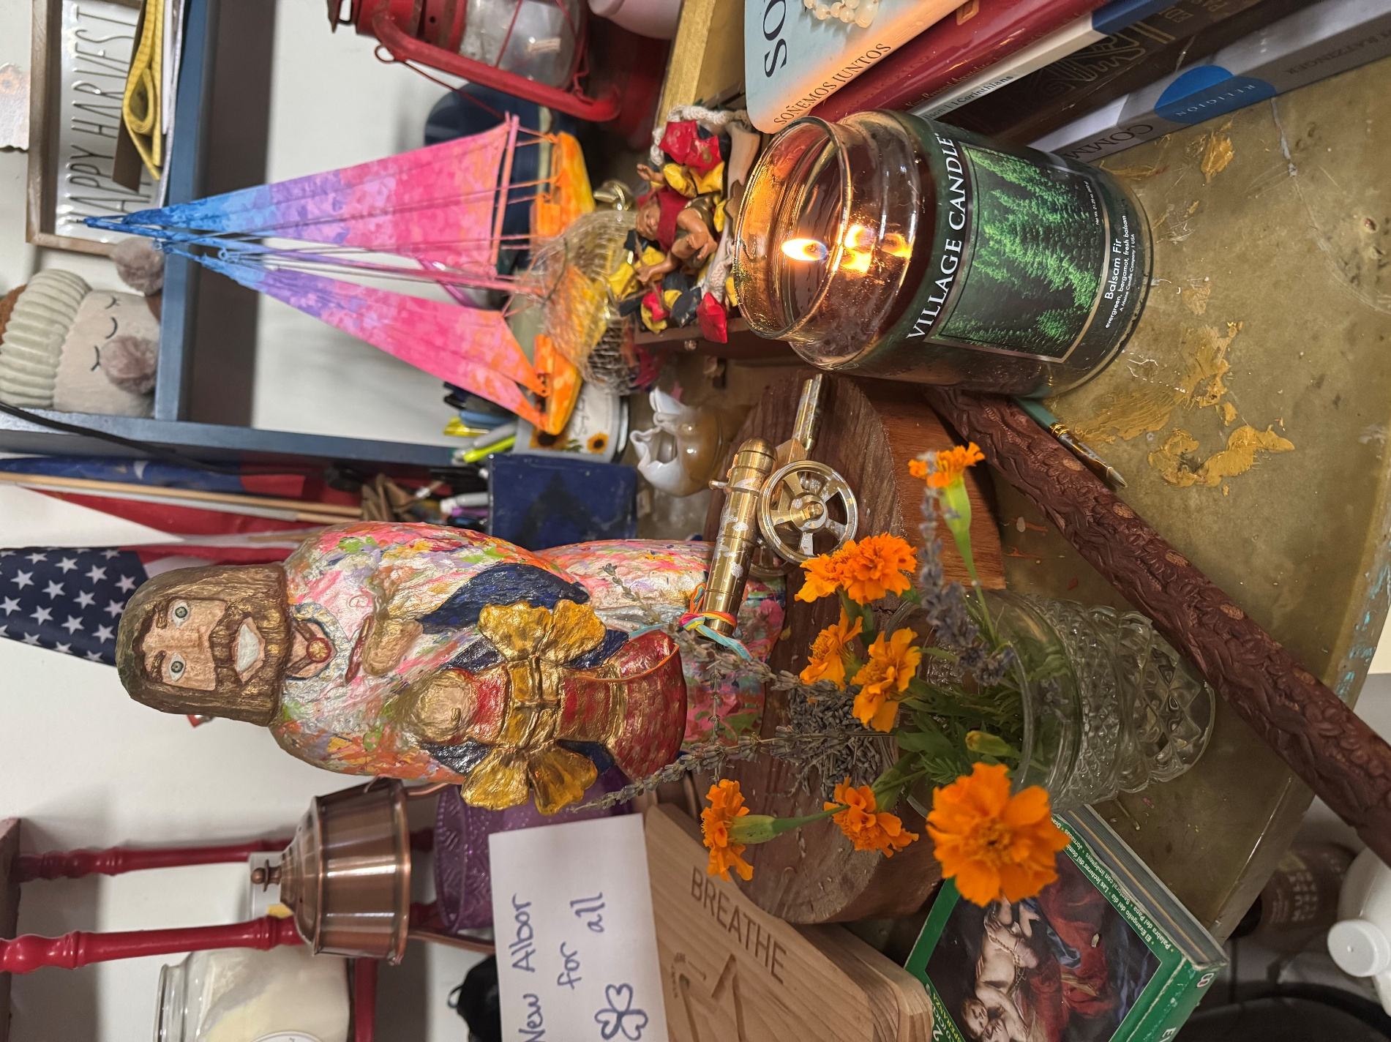

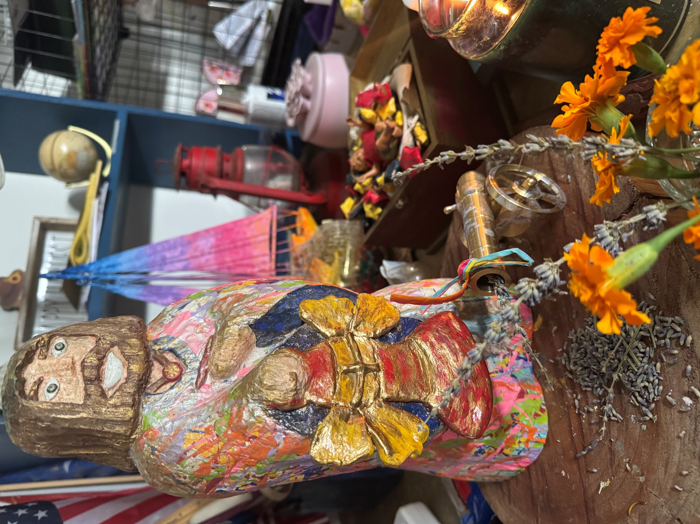
¿Vieron lo mucho que he aprendido de Jesús Caridad? También aprendí muchísimo al crear esta estructura, este new creative frame, para Su lienzo. Niños del futuro: fue durante el diseño de esta estructura que acaban de ver que aprendí —al aprender a rezar y encontrarme personalmente con ese Jesús Caridad plasmado en el lienzo y eventualmente también en mi formación personal, como un ícono vivo— por primera vez la importancia de salvaguardar una línea de horizonte naturalmente amplia para salvaguardar la amplitud más amplia posible de toda una estructura. Si se fijan, la “viga horizontal” del lienzo está ahí, pero no se ve como una “línea que divide el lienzo por la mitad”: la línea del horizonte de la estructura está bien naturalmente integrada en la forma en cómo se diseñó el timón central, con la viga horizontal atravesándola uniéndose con la vertical, exactamente cuando pasa cuando en un horizonte natural cielo y tierra se hacen uno en la línea del horizonte… Fue por eso que el el new creative frame la estructura del lienzo cobró una nueva amplitud respecto al frame original, donde la amplitud estaba ausente: la “línea del horizonte” no solamente comenzó a ser integrada en el new creative frame, desapareciendo totalmente la impresión de “viga horizontal divisoria”… sino que además era la amplitud más amplia posible, considerando no solo el contexto del diseño estructural sino también el contexto de la concepción creativa plasmada en el lienzo: se eligió deliberadamente, desde un principio, el lienzo más grade disponible en la tienda, como signo de como la apertura del corazón que se abre incondicionalmente al Amor de Dios es incondicional —lo más grande posible— y de cómo el Amor de Dios es lo más grande que pueda plasmarse…
Observen ahora la diferencia entre una estructura y la otra, ambas fotos puestas una junto a la otra. La diferencia en la sensación de amplitud natural es extraordinaria en la new creative estructure: la linea del horizonte se integra bien naturalmente al resto de la estructura, ni siquiera el marco de madera rojo bordeándola resta percepción de apertura de amplitud porque toda la estructura está bien diseñada de forma naturalmente integrada —las formas parecen naturalmente integradas; no parecen piezas divisorias o inconexas, ni mucho menos accesorias—, tanto estructuralmente como en meaningul purpose… Por supuesto, el color mucho más claro de la nueva estructura creativa también ayuda a que, aunque ese segundo frame fuera mucho más robusto que el primero, actually tuviera no solamente la amplitud espacial que le faltaba a la estructura original, sino que además logramos integrar la línea del horizonte con la amplitud más natural posible, con toda la línea del horizonte perfectamente integrada a toda la estructura…

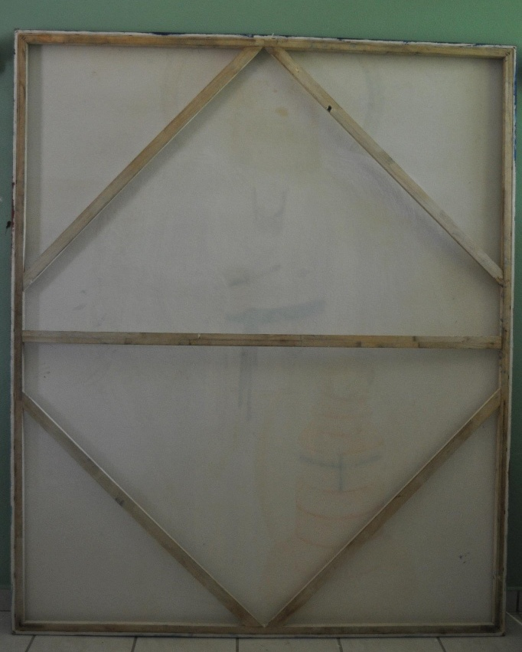
Es la primera vez en mi vida que he visto a artista alguno diseñar una obra de arte en que la obra de arte no es solamente el lienzo, sino también el art internal frame structure que sostiene el lienzo. Eso también fue Jesús Caridad quien me lo enseñó.
Ahora que saben, niños del futuro, de donde y de Quién aprendí la importancia de mantener la línea del horizonte lo más natural y claramente amplia posible…
Ahora vean estas otras dos fotos, mostrando nuevamente los screens de las ventanas cubiertos de plástico que mostré y expliqué en las primeras fotos:
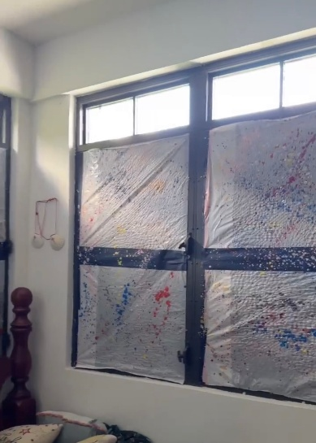
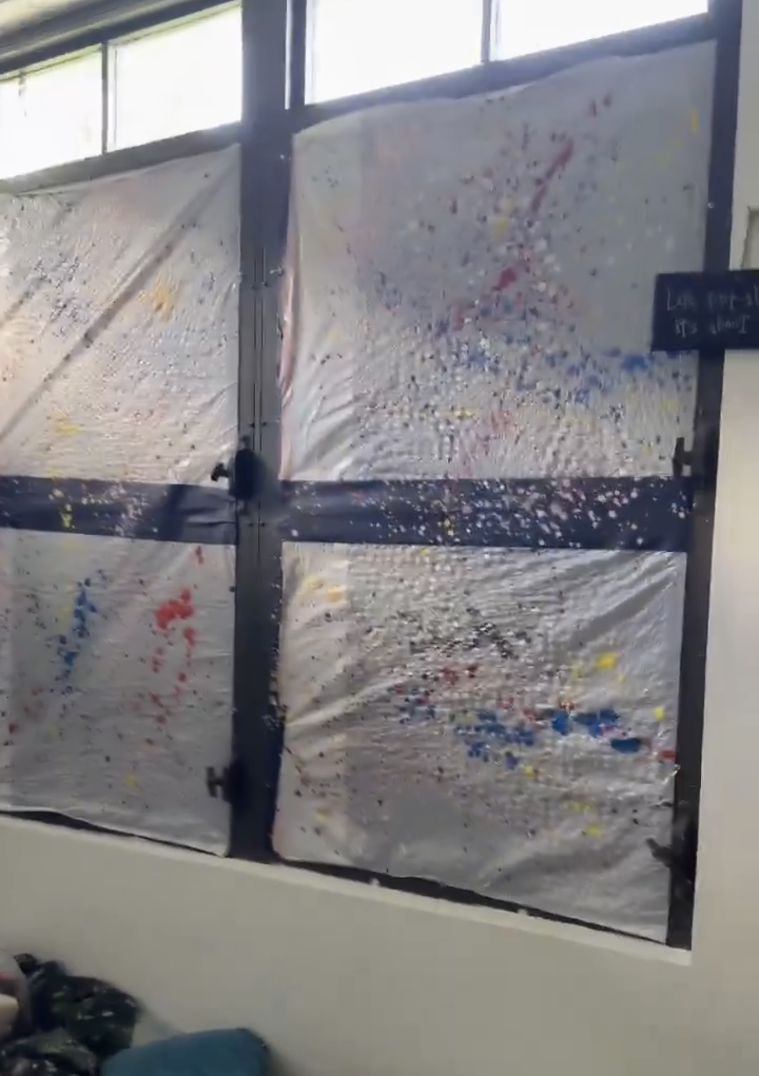
Ahora, niños del futuro, pueden entender que aunque salpiqué de colores el plástico sobre los screens, esa horrible viga horizontal negra en todas las ventanas, totalmente antinatural y hasta oscura, con nada de claridad, dio al cuarto donde duermo y estoy todo el día una sensación bien encerrante. De repente desapareció TODA la amplitud del cuarto, y conste que para ser un cuarto dormitorio no es un espacio pequeño: es un espacio abierto que tiene más tamaño que muchos master rooms de casas puertorriqueñas de tamaño promedio… pero por esas vigas horizontales oscuras, de repente el espacio se comenzó a percibir espacialmente encerrante, cosa que en circunstancias como las mías sorprende que no hubiera sido provocado por otros factores que son objetivamente mucho más arquitectónicamente encerrantes que ese. Es algo simple: nunca me he acostumbrado a estar en espacios donde no hay una línea de horizonte clara. Conste que mientras duermo en este cuarto he soñado con líneas de horizonte infinitamente amplias, especialmente con horizontes de girasoles infinitamente amplios… y como la línea de horizonte que siempre he visto mientras estoy despierta en este cuarto es la misma que veo en sueños… pues el mantener las ventanas cerradas no se siente tan encerrante porque estoy acostumbrada a la posibilidad de plasmar “contemplativamente” mi propia línea de horizonte clara sobre el oscuro de las ventanas. De hecho, cada vez que salgo de la casa una de las cosas que más disfruto es poder ver la línea amplia del horizonte mientras conduzco.
Sin embargo, niños, no es para nada lo mismo cuando resulta que las ventanas son claras (como pasa cuando cubres los screens de plástico blanco)… y entonces pones una viga horizontal oscura sobre el claro de las ventanas. La sensación “desintegratoria” es instantánea. No hay forma de ver, ni siquiera “contemplativamente” línea de horizonte alguna en ese caso: no hay color sólido ni posibilidad de amplitud de espacio, solo ves esa línea oscura a la altura del horizonte, totalmente resaltada por el color claro del fondo… y eso la da la impresión de como si el futuro fuera tan oscuro como la oscuridad de esa línea horizontal, totalmente desintegrada y antinatural.
Noten, niños, que un espacio puede ser espacioso y abierto como este cuarto, pero tan pronto hay una línea oscura horizontal a nivel de horizonte… ya no hay amplitud alguna en el espacio, por muy espacioso y abierto que sea. No es lo mismo que un espacio sea abierto a que sea espacioso y a que sea amplio: la amplitud de un espacio la determina la claridad y la naturalidad de la línea de horizonte visible.
Auque la pintura de Iesu Amor nunca volvió de Brazil, la concepción creativa del Jesús Caridad que se “dio a luz” a través de esa concepción creativa ha seguido creciendo. No tengo la pintura de Iesu Amor pero sí que tengo una talla de santos Suya en mi mesa; es una talla de madera del Jesús Caridad que siguió creciendo tras Iesu Amor. Le rezo todos los días y crecemos juntos en comunión todos los días. En esta próxima foto pueden ver la talla de Jesús Caridad que tengo en el cuarto donde duermo:
El envisioning de Jesús Caridad ante lo sucedido con las vigas oscuras de las ventanas fue hermosa: “pinta tu propia línea de horizonte sobre esas vigas oscuras, usando girasoles, que es la línea de horizonte más amplia que solemos ver in our envisioning dreams…”. La elección de girasoles tiene un profundo significado entre nosotros: los girasoles significan growing together in communion, following the light… Así pues, pintar una línea de horizonte de girasoles sobre las ventanas era literalmente plasmar una línea de horizonte cuyo crecer juntos en comunión es el más amplio posible… y además pintados con semillismo: mi forma personal de pintar, que es como si las pinceladas fueran formas proporcionales a la forma de semillas de girasol…
En estas próximas fotos se pueden ver como quedaron las ventanas con esta nueva línea de horizonte pintadas sobre ellas:
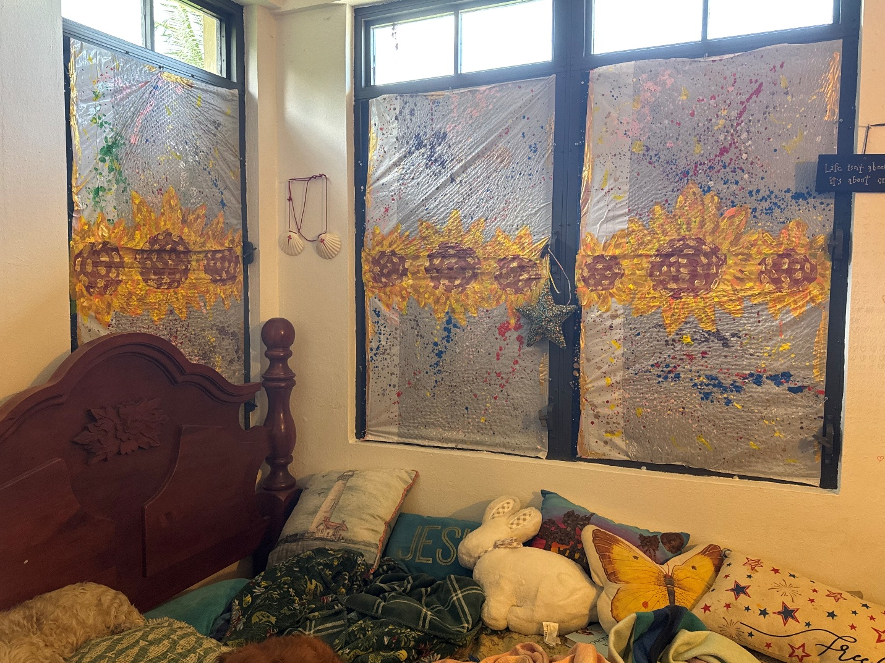

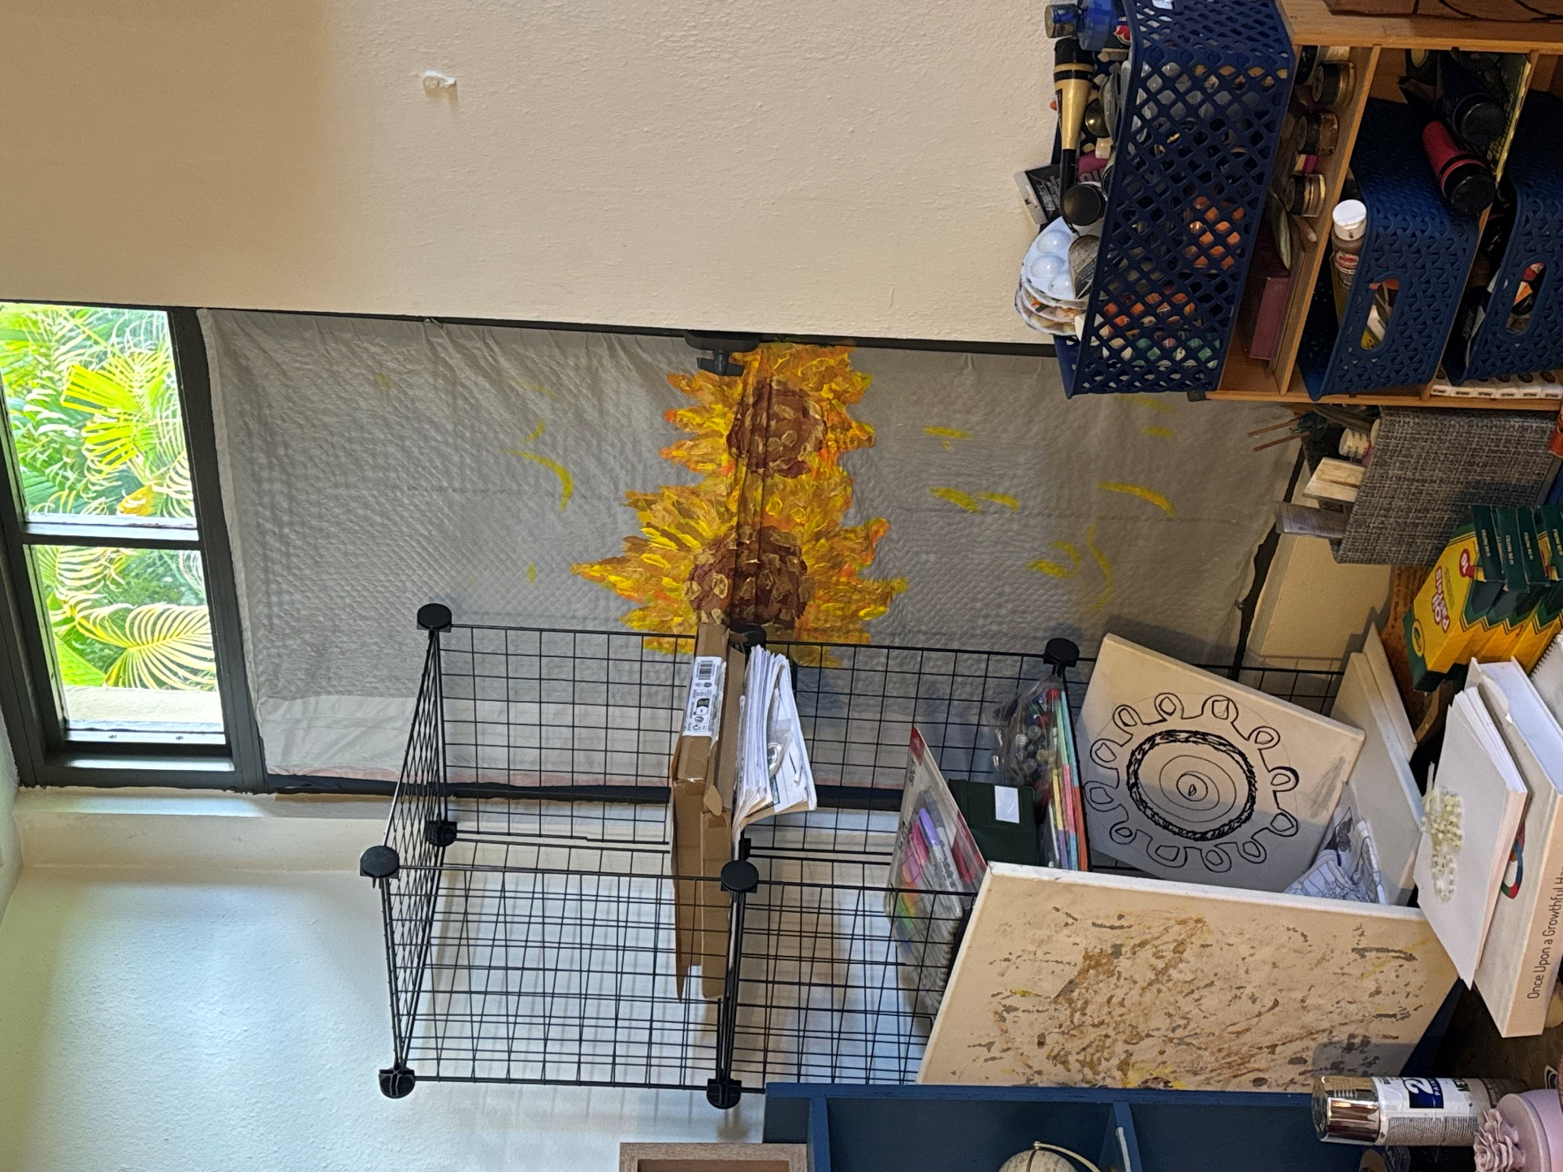
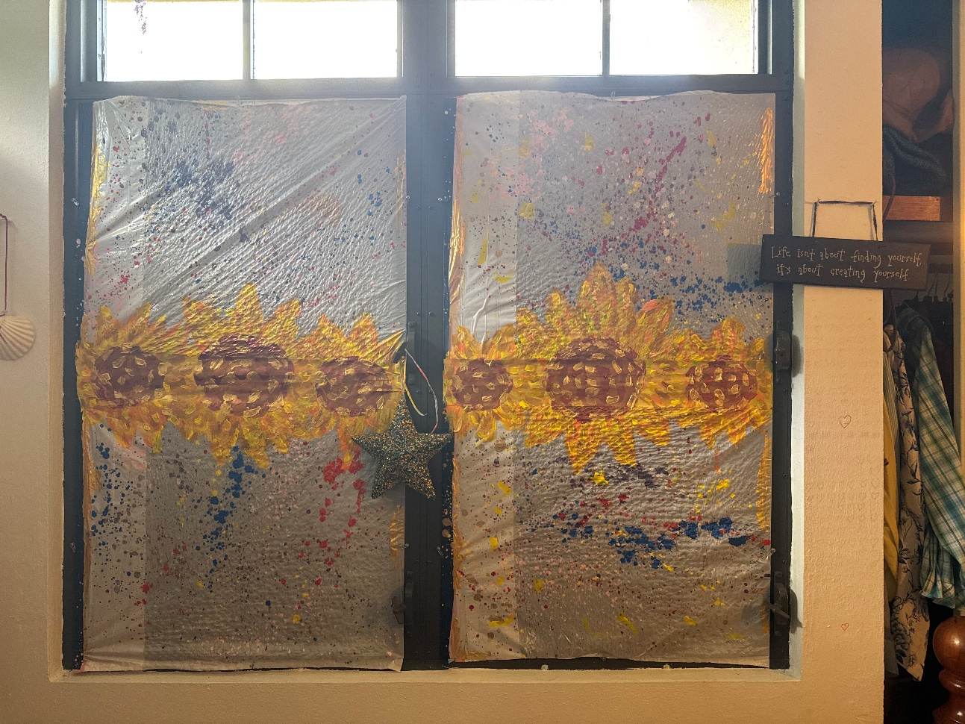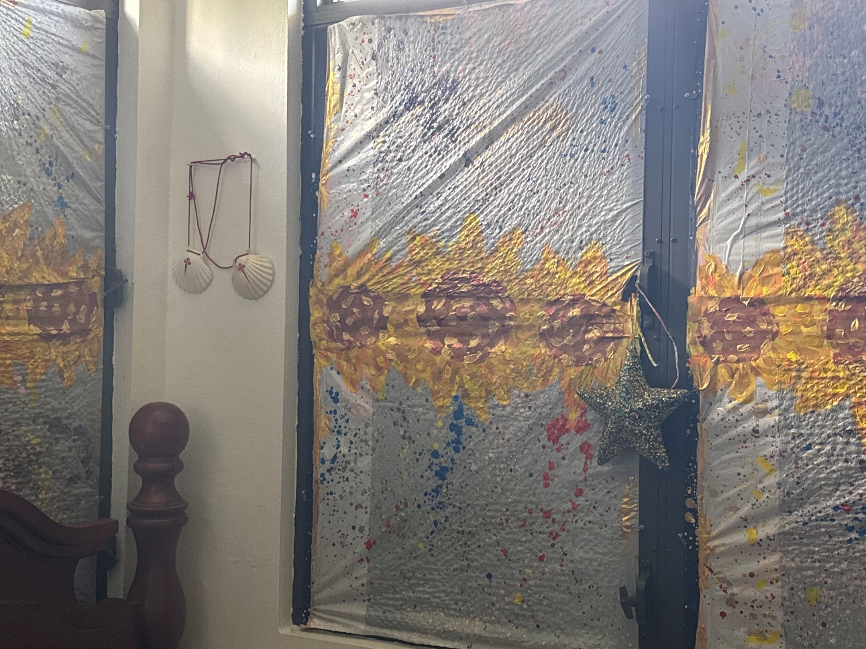

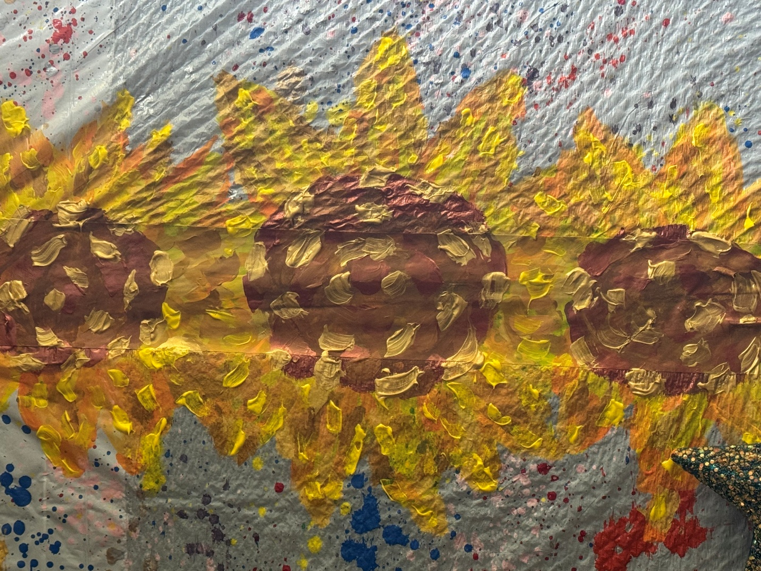
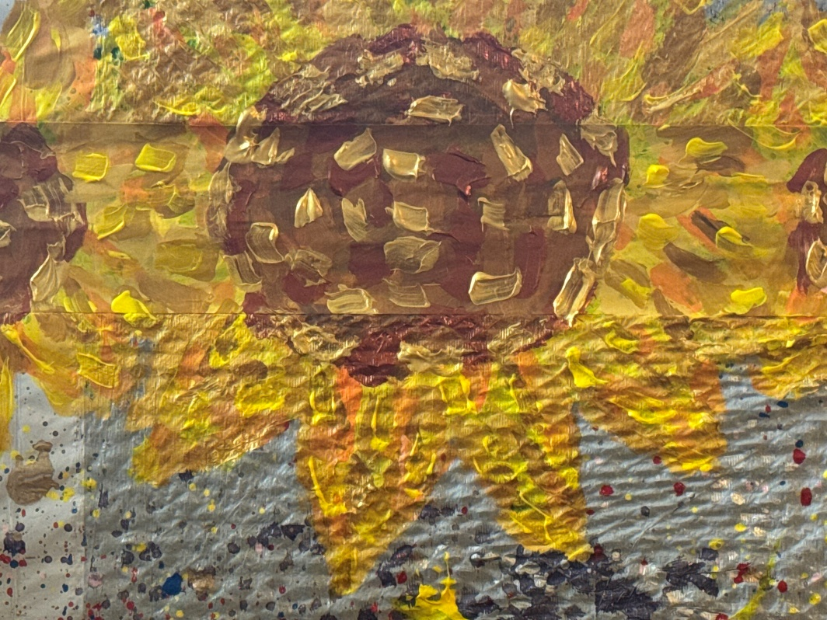
¡Con esta nueva línea de horizonte el cuarto se llenó de nueva vida! Así soy yo, exactamente como se plasmó esa línea de horizonte; así formo todo según Su visión… Lo que plasmamos fue una nueva línea de horizonte viva, humanizante y personalizante, que no era posible plasmar antes, que plasma un new infinite growthful horizon line: a field of sunflowers that is a new growhthful horizon line of infinite growing together in communion…
Además de eso, esta nueva línea de horizonte fue diseñada, como pasó con el new creative frame de Iesu Amor en su momento, explícitamente bien naturalmente integrada, cesando en lo absoluto de que esa línea oscura fuera meramente una “viga estructural horizontal”, sino que ahora da sensación de amplitud, de mucha más amplitud que antes. La línea oscura tuvo su propósito: dejó bien claro por donde había que pintar para pintar la línea de horizonte más clara posible… pero una vez el new infinite sunflower field horizon line quedó bien plasmado encima de esas líneas oscuras horizontales, el cuarto comenzó a vibrar con una vida que no tenía antes. Muy poco después comenzaría a escribir esta carta que están leyendo en estos momentos, niños del futuro. Así de tremendamente inspiradora fue la forma de Jesús Caridad envisionar la plasmación de este new horizon line: suddenly there is a very bright and vidid new infinite growing-together-in-communion and growing-together-towards-the-light horizon line around me. The impact that such envisioning had was and still is absolutely, amazingly, tenderly, endearingly beautiful…
Truly, Jesus Charity has helped me over and over again to keep growing on, adoring Him with our whole growth as I keep becoming the best person I can be, giving Him the best offering I can give Him, radiating more and more the new albor of His eucharistical beacon-lamp —what radiates the new albor of His beacon-lamp is the Eucharist, and He helps me to keep growing on, glowing on and blooming on as His incarnated Eucharist, as His Living Beloved Body— so everyone can become also the best person we can be, walking together as He walks, growing together in communion. Since the very beginning of His creative conception as creative project, the Iesu Amor painting had been plasmated to help children to learn from Him how unconditionally and belovedly called to grow as the best person we can all can be they are… but I also had keep becoming the best person I can be as I keep letting Him grow on more and more plasmated in my whole personal formation... and He is the One that makes possible to someone like me being able to envision such infinite growthful new horizon lines, as I had already explained….
Wait, those were not the only new horizon lines He made possible to envision, children of the future. With that new bright sunflower line Jesus Charity made possible another even wider new infinitely growthful horizon line. This time is not only an unconditionally humanizing and personal-formation-affirming new horizon line: this time is also an infitely fraternizing new horizon line… for you, children of the future, and for achieving the whole humanity´s most growthful progress possible, empowering you to fly ultreia et suseia as ascendant stars of Heaven who do wonders.
Now, children of the future, to empower you to create a culture of New Albor where everyone can grow best, glow best, and bloom best, achieving the whole humanity´s most growthful progress possible, we will begin walking through the economic realms, learning a new way to envision how a country’s growth is measured. We are going to imagine a new way to measure national development, a GLOWful way that values human dignity and the best possible lives for families and children, so that you can have better building blocks to create a more fraternizing society. This new approach to measuring socioeconomic growth is based on family dignity and well-being, as well as the brightest opportunities for everyone to learn, dream, and thrive together. With this, you will learn how to be social architects who build with growthful bricks, creating a fraternizing culture where all children can grow into the best person they can be, shining together in communion, just like the stars on a flag, glowing for generations to come. As John Dewey, the American philosopher and educator, once said, “Education is not preparation for life; education is life itself.” And this is your life, your classroom, your glowful seed for a brighter world. Let's grow on, glow on, bloom on: let's teach how to create a new horizon line for measuring the growth rate of generations to come...
Until my generation, children of the future, a country´s growth had been measured only using GDP as a measure of “growth rate.” So, until now, when grown-ups talk about how much a country is “growing,” they only had looked at something called GDP. GDP is like a big calculator that adds up the price of all the things a country makes and sells. But here’s the problem: GDP only counts money, not smiles. It counts the price of a new car, but not the hug your mom gives you when you’re sad. It counts a factory’s profits, but not the clean air you need to play outside. It’s like if your teacher gave you a grade for “happiness” by only counting how many toys you have, but didn’t care if those toys were broken or if you had no friends to play with. You could get a “good” grade, but not actually feel happy or safe. That’s why we need something better — something that measures real human growth.
GDP means Gross Domestic Product. That’s just a fancy way of saying: “How much money all the people, companies, and the government in a country make in a year by selling things and doing services.” It’s like adding up the price of every single cookie, shoe, haircut, computer, house, bus ticket, movie ticket, and even dentist visit sold in your country in one year.

How is GDP measured?
Imagine you have three big jars:
- Jar 1 – What we buy: All the money people spend buying things and paying for services.
- Jar 2 – What we build or make: All the money businesses make when they sell their products to other businesses or countries.
- Jar 3 – What the government spends: All the money the government spends to build roads, schools, hospitals, and other things.
If you add the money in all three jars together, you get the GDP.
Why is it tricky? Because GDP only measures money and sales. It doesn’t measure happiness, kindness, health, love, or whether everyone is treated with dignity. So, a country’s GDP could go up even if many children are sad, sick, or don’t have enough to eat.
That’s why some people say: “GDP is like counting only the toys in your room, but not whether you’re happy, healthy, or have friends to play with.”
Now that we know what GDP is, it’s easy to see it only counts money and things — like how many toys or cookies we have. But having lots of toys doesn’t always make us happy or healthy. That’s why, children of the future, you need a new way to envision a country´s growth to be empowered to grow best, to glow best and to bloom best. This is why a GLOW growth rate is so important! A GLOW growth rate cares about how well everyone is growing — not just how many things we have. It helps make sure all kids have love, safety, friends, and chances to learn and dream. Changing from just counting money (GDP) to counting real growing opportunities (GLOW) means we can build a happier, kinder world where every child can shine bright and grow strong. So, lets explain to you, children of the future, what is a GLOW rate…
What is the GLOW rate? GLOW stands for Growing Life Opportunities for Well-being. That’s a big name that really means: “How much your country is helping everyone grow as the best person they can be, with dignity, love, and the chance to follow their dreams — no matter where they were born or how much money their family has.”
How is GLOW measured? Instead of only counting money like GDP, GLOW counts opportunities. Imagine you have seven magical treasure chests that show how your country is doing:
- Healthy Body Chest – Are you healthy? Can you see a doctor when you need one?
- Healthy Mind & Heart Chest – Do you feel safe, loved, and happy?
- Learning Chest – Can you go to school and learn things that help you grow and dream big?
- Home Chest – Do you have a safe, cozy home with enough food?
- Play & Creativity Chest – Do you have time to play, imagine, and create?
- Fairness Chest – Are all children and families treated equally and with respect?
- Future Chest – Will there still be clean water, air, and nature when you grow up?
If all these treasure chests are filling up for everyone, the GLOW rate is high.
Why does GLOW matters? GDP tells you how big the money pile is in your country. GLOW tells you how bright the future is for you and your friends. GDP is like counting how many bricks you have. GLOW is like building a safe, happy home where everyone can live together and no one is left outside.
Let´s learn about the differences between GDP and GLOW with a little tale: A Story of the Two Towns: Brickville and Glowtown
Once upon a time, there were two towns right next to each other. Brickville loved counting bricks. Every year, the mayor would say:
“We have more bricks than last year! We are the richest town in the world!”
But… in Brickville, some people didn’t have houses. Some children had no school to go to.
Some families didn’t have enough to eat. The bricks were there, but not everyone could use them.
Glowtown was different. They also had bricks, but instead of just counting them, they used them to build homes for everyone. They made playgrounds, schools, hospitals, and beautiful parks. They made sure no one was left outside. Glowtown had a special way of measuring progress called GLOW — Growing Life Opportunities for Well-being.
They didn’t just ask: “How many bricks do we have?”
They asked: “Is every child healthy, loved, learning, safe, creative, and treated equally?”
Which is the moral of the story, children of the future?
GDP is like Brickville — it tells you how many bricks (money) a country has.
GLOW is like Glowtown — it tells you how well a country is using those bricks to help everyone grow as the best person they can be, together.
And guess what?
When you grow up, you get to decide: Will our country be Brickville… or Glowtown?
Now, children of the future, enjoy a simple rhyming poem about GDP vs. GLOW:
GDP counts bricks so high,
Stacks them up up to the sky.
But bricks alone don’t build a home,
Where all can laugh and safely roam.

GLOW counts chances, hearts, and play,
Helping everyone grow every day.
It measures love, and hopes that gleam,
And makes a world that feels like a dream.

Bricks can pile and numbers grow,
But GLOW makes sure we all can glow!
So let’s build a world that’s kind and bright,
Where every star shines their own light!
Did you enjoy the beautiful rhymes to explain everything beautifully to you, children of the future? Let´s now explain the same concepts, but in more grown-up language.
Do you remember when I explained to you, younger kids, that there would be parts of this letter that you had to be older to understand better? The following pages are words that you need to be older to understand better. Still, I recommend letting a very good math teacher guide you if you have an interest in understanding the following pages as well as you can at your young age… and let your unique wonder unfold when your moment comes.
Now, let´s explain to older kids: how would this new GLOW rate be used to rate each country´s growth? Brace yourselves: you will need your math skills sharp to go ahead with this kind of adventure. So, this explication is for older kids who want to practice math: how to calculate the UDL?
Yes, before even learning how to calculate the GLOW, you need to handle the percentile of the UDL: an Universal Dignity Line. To calculate GLOW you need a universal baseline that measures the basic dignity-based that everyone in a country must be expected to be able to afford to be able to live with dignity. That is what the UDL provides: a baseline to measure dignity-based progress for everyone.
The UDL would be a globally standardized dignity threshold, adjustable for local prices, currency, and culture, but with the same functional rights everywhere. It is not just “poverty line”; it’s “dignity line.”
The UDL is the functional dignity threshold, not a “poverty line.” It assumes a household of 4 (2 adults + 2 children), but it can be scaled per capita.
Here is how to determine the percentiles of UDL per country:

Universal Dignity Line (UDL) Budget — Global Baseline
Category | Description | % of Monthly UDL Budget | Notes
1. Housing | Safe, sanitary home with adequate space; includes rent/mortgage, taxes, basic maintenance. | 25% | Based on cost of safe neighborhood housing with reasonable commute.
2. Utilities | Water, electricity, cooking fuel, waste disposal, internet, mobile phone. | 10% | Includes sufficient internet for work/school.
3. Food & Nutrition | Balanced diet meeting WHO standards; culturally appropriate foods. | 15% | Fresh produce, proteins, staples; avoids ultra-processed dependency.
4. Healthcare | Either insurance premiums or out-of-pocket costs for full access; includes preventive, dental, vision, mental health. | 10% | Covers all household members.
5. Transportation | Safe, reliable transport for work, school, healthcare, social participation. | 8% | Public or private; includes maintenance, insurance if private.
6. Childcare & Education | Early childhood care, after-school care, school supplies, extracurriculars. | 8% | Ensures both parents can work without leaving children unattended.
7. Elderly Care | When applicable, part-time professional care or in-home support for dependent relatives. | 5% | Measured for households with elderly dependents; otherwise set aside for future need.
8. Emergency Savings | Minimum of 3 months of UDL expenses saved in a secure, liquid account. | 5% | Part of the monthly budget is reserved for this goal.
9. Clothing & Personal Care | Seasonal clothing, shoes, hygiene products. | 4% | Includes work uniforms if required.
10. Leisure & Cultural Participation | Books, cultural events, sports, local trips. | 3% | Supports mental health and social connection.
11. Long-Term Savings & Investment | Retirement funds, education savings, asset building. | 7%

Now, let´s explain how the UDL is calculated in a universal way:
UDL Global Calculation Method
- Start with baseline USD values for each category (e.g., based on OECD and ILO research).
- Adjust by PPP conversion for each country.
- Adjust for regional variations within countries (e.g., New York vs. rural Midwest, Mumbai vs. rural Maharashtra).
- Ensure minimum wage × standard working hours ≥ UDL per-capita share without relying on government aid or charity.

Example
(Global Baseline for a Household of 4, 2025 USD)
(rounded monthly costs for illustration; actual numbers vary by country)

Category | Amount (USD)
Housing | $1,250
Utilities | $500
Food & Nutrition | $750
Healthcare | $500
Transportation | $400
Childcare & Education | $400
Elderly Care | $250
Emergency Savings | $250
Clothing & Personal Care | $200
Leisure & Cultural | $150
Long-Term Savings & Investment | $350
Total Monthly UDL | $4,950

Thanks to the UDL, children of the future, every GLOW index calculation would:
- First check if the median wage allows a person to afford their share of the UDL.
- Penalize countries heavily if a large share of people live below this dignity threshold.
Here´s the Key UDL Principle: A country’s minimum wage must allow a full-time worker to afford at least the per-capita share of the UDL without government aid.
You can now all, kids of the future, enjoy your creative time with your math teacher calculating the current UDL of the USA, of Puerto Rico or of any other country, and how far the gap between the minimum wage and the UDL is at the moment you are reading this… and be the generation that learns how to change the GDP for GLOW.
After the UDL is determined, there is another very important dignity line: the UFDL, the Universal Family Dignity Line. This dignity line is not a fixed baseline percentile: this one adapts to the configuration of each family. If the Universal Dignity Line (UDL) tells us what one person needs to live a life with dignity, the Universal Family Dignity Line (UFDL) takes the next big step—it makes sure a whole family can do it. Family is the first school of love, the place where we learn how to care for each other and grow into the best version of ourselves. That’s why the UFDL is so important: it measures what it takes for parents, children, and sometimes grandparents or others under the same roof to live well, without fear of lacking the essentials. It’s not just about surviving—it’s about having the space, safety, and support to dream and to grow together. As Desmond Tutu reminded us, “You don’t choose your family. They are God’s gift to you, as you are to them.” The UFDL makes sure that gift can flourish.
Brace yourselves even more, kids of the future, because this formula is really for math pros, but you can calculate the UFDL of your own family if you ask your math teacher for help to do so. So, here is the formula for the UFDL, older kids. This UFDL formula adapts the dignity line to the exact members of the family:

Universal Family Dignity Line (UFDL) Formula
Purpose:
To calculate the minimum income a family must have to live with dignity, considering both individual basic needs and the economies of scale (shared resources) that families experience.
Basic Concept:
- A family’s dignity line depends on the number of people in it (adults, children, elderly).
- Some expenses scale directly with each member (food, clothing).
- Other expenses have partial sharing (housing, utilities).
- Childcare and eldercare add extra layers.
- Emergency savings and investment capacity must be proportional to family size.

Formula Outline
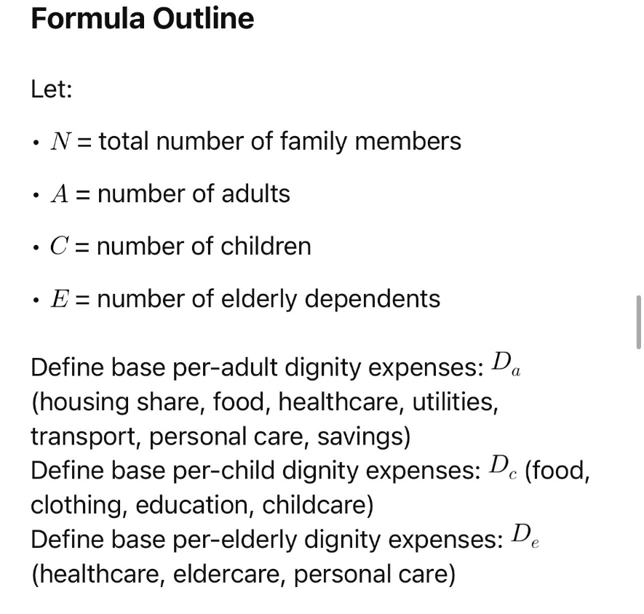

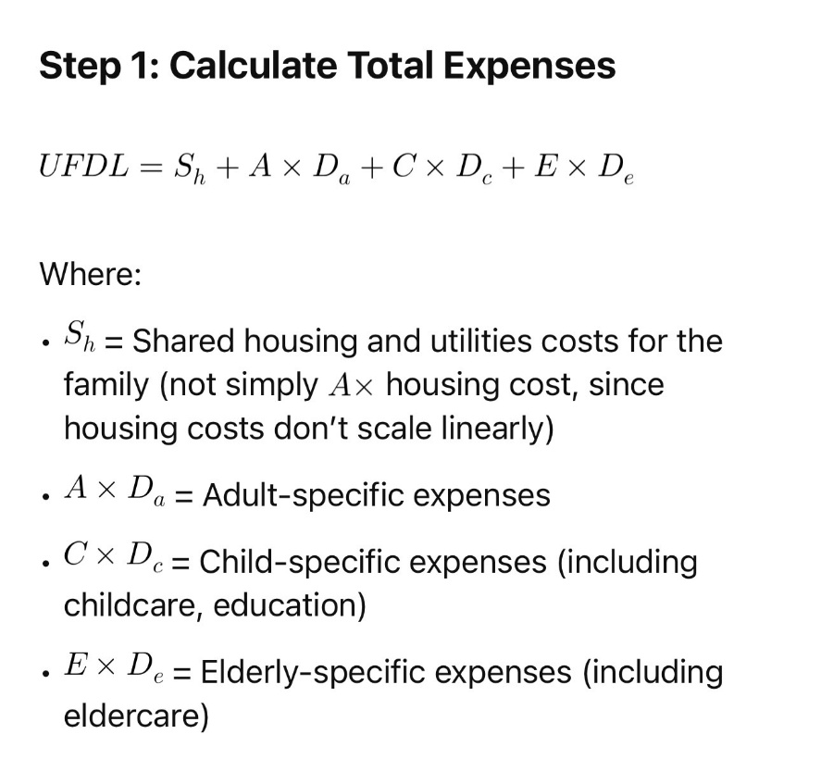

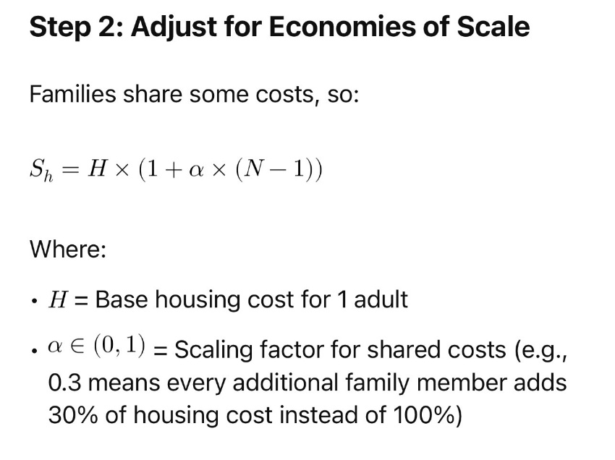

Why Is Family Dignity Line Fundamental?
- Family is the cradle of unconditional love and human growth: From birth, unconditional acceptance in family nurtures identity, resilience, and potential. It is the fundamental social cell where growth unfolds.
- Raising a family with dignity is a universal human right: This right ensures that parents have the resources not only to survive but to nurture, educate, and love their children unconditionally. Without this, societal growth halts at the individual level.
- The dignity line must include the family context: Economic indicators focusing solely on individuals miss critical interdependencies. Families pool resources, share burdens, and collectively invest in future generations.

Why Include UFDL in Growth Score (GLOW)?
- Growth is relational, not just individual: Measuring growth solely by individual well-being ignores that people grow in relation. Families are the first and most essential relationship network.
- GLOW’s commitment to dignity requires family inclusion: To judge whether a society truly offers dignified life opportunities, it must consider if families—especially parents and children—can thrive, not just individuals.
- Supports policies for childcare, eldercare, housing: By including family size and composition, GLOW promotes holistic social supports, not just paycheck increments.
- Reflects the true cost of life with dignity: This prevents underestimation of poverty and hardship that comes from large families or caregiving responsibilities.
This Universal Family Dignity Line formula ensures every family member’s dignity needs are counted fairly, respecting shared costs and caregiving realities.

Now that we understand the Universal Family Dignity Line—the amount a family needs to live with dignity—it’s time to see how this connects to the GLOW rate. Think of the UFDL as the “ground” where we all stand: it makes sure every family has the basics to grow strong and happy. The GLOW rate is like the “sky” above us, showing how far we can grow together as brothers and sisters. When we know the ground is safe and the sky is open, we can measure how much we’re really shining as a community. As Helen Keller said, “Alone we can do so little; together we can do so much.” The GLOW rate helps us see just how much we are doing together to make everyone’s life full of dignity, joy, and growth
The GLOW rate is like a garden measure instead of a money measure.
It asks: Are all the flowers in the garden growing well, not just the biggest ones? It checks if people — children, parents, grandparents — can live with dignity, have enough to eat, a safe place to sleep, time to learn, and friends to share life with. It measures how much we are growing together in kindness, safety, and fairness.
When a country’s GLOW is high, it means children can dream big dreams and have the tools and support to make them real. It means no one is left behind in the race of life. As Dr. Seuss says: “Unless someone like you cares a whole awful lot, nothing is going to get better. It’s not.”
You, children of the future, deserve more than just a “rich” country on paper: you deserve a country where you can grow fully, surrounded by people who want the best for you. That’s what the GLOW rate protects: the right for every child to grow in a family raised with dignity and fraternal peace, because when we grow together, we grow stronger, kinder, and happier, and the world becomes a fraternal home for all of us, no matter how small anyone can be, because, like Dr. Seuss says: “A person’s a person, no matter how small.”
Remember: GDP is about things. GLOW is about people. And you — every single one of you — are more important than all the “things” in the world.
For too long, GDP has been treated as the supreme measure of a nation’s growth. But GDP is a measure of economic activity — not of human dignity. It can rise while poverty deepens, while children’s opportunities shrink, and while communities lose their sense of safety and unity. The GLOW rate changes this. It is a dignity-based measure of national growth, designed to reflect whether every citizen — especially the most vulnerable — has the means, safety, and opportunity to flourish.
GLOW integrates:
- The Universal Dignity Line (UDL) — the minimum resources and conditions required for a person to live a dignified life.
- The Universal Family Dignity Line (UFDL) — the minimum resources and conditions required for a family to raise children in safety, love, and opportunity.
- The Being Criteria — citizens’ own self-perception of well-being, opportunity, and hope for the future.
A country’s true growth cannot be measured only by the wealth it produces — it must be measured by how widely and fairly that wealth is transformed into real human progress. Fraternal peace and equality are not luxuries; they are the foundations of any society that aspires to longevity and harmony. A high GLOW rate signals not just prosperity, but shared prosperity — the ability for all citizens to keep growing together, in communion, without leaving anyone behind.
You, children of the future that will eventually read this letter, are the very most important reason this change matters. The GLOW rate exists so that when they look back in twenty years, they will not find that the country’s “growth” was only a number in a bank ledger — but rather that it was a shared journey of becoming better people together. As the UNICEF Progress of Nations of 2000 said: “The true measure of a nation’s standing is how well it attends to its children — their health and safety, their material security, their education and socialization, and their sense of being loved, valued, and included in the families and societies into which they are born.” No, we cannot say that in 2025, more children are healthier and safer than in 2000 in the USA. There are no more children in 2025 than in the 2000s, to begin with. In 2025, there are half as many kids as there were in the 2000s. Still, the children of 2025 cannot grow in a more equal and dignified way than in the 2000s; their growthfulness has not tripled in that period, and a huge part of that is due to continuing to measure a country´s growth by the wrong growth standard: the GDP. If action is not taken as soon as possible, the consequences will be paid for by you, the children of the future. Merely considering that the percentage of children relying on Medicaid for medical care increased by 40% in just two years is shocking, but it is even more astonishing when you consider that the USA had consistently ranked first in GDP growth rate. So, precisely what is being considered a nation´s growth if fewer children are allowed to be born and grow, and if among those children who are allowed to grow, there is an increase in poverty and indignity that continues to be normalized at an astonishing rate?
Just to give you some data comparing some changes between 2000s and 2025:
-In 2000, 19 million children had Medicaid or CHIP. In 2023, 32 million children were required to receive government aid to obtain medical coverage that their families could no longer afford on their own. In 2025, 45 million children required Medicaid coverage. This means: having a children is already normalized to be unaffordable to many, there are many already systematically forced to rely on Medicaid if they have children, and a HUGE part of the issue is the employers not being required to provide full family medical coverage plan, like many did in the 2000 because it was a common employer practice to provide that benefit.
-Please consider along with that number: if you have a USA town of 1,000 inhabitants, in 2025, only 11 babies are born in the same year, instead of the 20 births per year in the 2000s 2025. That means: now there are MORE children in Medicaid than in the 2000s, but there are basically half as many children born as in 2000.
These numbers are already horrific for you, children of the future, but what is more horrific is going to be told now:
The notion of “growth” of the GDP that assumes that there had been A LOT OF GROWTH in a country where its child birth rate drops by half, and at the same time there is a 40% increase in barely two years, between 2023 and 2025, in children who need Medicaid… is a direct consequence of measuring USA by GDP growth and not by GLOW:
After what was just explained, you now know, children of the future: according to the GDP, US growth tripled between 2000 and 2025.
The GDP of the USA in the 2000s was $ 10 trillion.
The GDP of the USA in 2025 is $ 30.5 trillion; it has tripled. However, there are half as many children, and their reliance on Medicaid increases by 40% in two years.
Mental health had not improved either from 2000 to the present: overall, the incidence of common mental disorders increased between 2000–2019 from 55.9 to 76.9 per 1,000 person years, according to the study lead by Dr Jen Dykxhoorn: her study determines a 38% increase in common mental disorders identified in primary care over the past 20 years.
The number of adolescents and young adults with at least one dispensed antidepressant increased by 46% between 2016 and 2022. No 2000 data is available for comparison; the earliest available data is from 2026. After 2020, when the pandemic happened, antidepressant dispensing rates increased nearly 64% in 12-17-year-old girls.
Please consider that no data is available on the differences in self-reported stress levels between families of the 2000s and those of 2025. Still, we all know it: families today are way more stressed than ever before, and quite often this is due to raising children currently meaning an “economic burden” to parents who are underpaid, forced to remain either below poverty lines and below dignity lines, or both, simply due to having children…
That is how a GDP-based growth notion sees a child: as an “economic burden”. Most parents among those paid the minimum wage are expected to assume all childcare costs at the same time they are paid undignified and underpaid wages. Companies and businesses continue to avoid paying dignity-based wages and family-based benefits, as the GDP continues to triple at the expense of the dignity of people, especially the poorest children.
So, the GDP has tripled, but the people´s quality of life, the people´s happiness, and above all the children´s quality of life and inherent recognition of their dignity have not only NOT tripled in the same time of such “growth”: they have DECREASED, SOMETIMES BY half.
What will you get, children of the future, if we continue to define a country´s growth in this way? What will be left to you to grow and achieve your dreams?
To policymakers, leaders, and economists: the horizon line of humanity must be a common horizon — one where all children are allowed to be born and walk forward in dignity and growthful equality. GDP is not a common fraternal horizon: it’s a predatory capitalism dark horizon line that doesn´t embrace or measure the growth rate of all in a dignified way. GDP can show you the ship's triple speed. GLOW will show you if everyone is still on board.
Now that we understand that GLOW is about giving every person the best chance to grow into the happiest, most caring, and most capable version of themselves, we need to know how we measure GLOW.
This is where the 21 GLOW criteria come in. They are like the “ingredients” for a bright horizon—things that make sure children today, and all the children yet to come, can live with dignity, learn, dream, and shine. Each one is a piece of the puzzle that builds a world where, as Kofi Annan once said, “There is no trust more sacred than the one the world holds with children.” These 21 criteria help us protect that trust, so every new generation can walk together toward a future full of light.
Here, children of the future, is a GLOW index criterion. The older children among you may even perfect this criterion more, to make it a valid standard criterion of how many citizens can reach a dignity-based life, and to what degree, if there is a dignity-based progress and fraternal growth for all, or not. This is just a sketch of how Jesus Charity envisioned this new fraternal horizon for the whole of humanity to grow in a more dignified way. Feel free to make it better. Jesus Charity proposed this envisioning, and you can continue to develop it further, just as it took me years to complete the creative conception of His painting. This is because we can all keep improving and doing better as growth and progress continue to unfold. Humanity will continue to grow as we build a more fraternal and dignified human family upon the shoulders of the glorious growth that previous generations achieved first, before us.

GLOW Index Criteria

Dimension 1 — Economic Dignity & Security
(Does the economic system allow people to live with dignity without exploitation?)
- Wage Dignity – % of full-time workers earning ≥ Universal Dignity Line (UDL) without government aid.
- Employment Stability – % of workforce in secure, long-term contracts vs precarious jobs.
- Work–Life Balance – Average paid vacation and parental leave in weeks/year.
- Working Hours Burden – Hours/week at median wage needed to afford UDL.
- Housing Affordability – Median housing cost as % of median household income.

Dimension 2 — Social Access & Opportunity
(Can everyone access key services and life opportunities?)
6. Universal Healthcare Access – Availability, affordability, and quality of medical care (preventive, mental, dental, vision).
7. Childcare Accessibility – % of children under 5 with access to affordable, quality care.
8. Education Quality & Equality – Quality of public education, teacher pay, and equality of access regardless of income or location.
9. Elderly Care Access – Affordability and availability of dignified elderly care for dependent relatives.
10. Emergency & Savings Resilience – % of households with at least 3 months of UDL expenses in secure savings.

Dimension 3 — Freedom, Fairness & Environment
(Is the society fair, participatory, and safe to live in?)
11. Systemic Discrimination Index – Presence and enforcement of discriminatory laws or structures (e.g., caste, colonial status, gender bias, religious restrictions).
12. Freedom & Participation – Strength of democratic participation, press freedom, and union rights.
13. Commute Burden – Average daily travel-to-work time.
14. Environmental Safety – Air, water, and noise pollution levels; climate disaster protection.
15. Leisure & Cultural Access – % of population with access to public green spaces, cultural events, and safe recreation areas.

Dimension 4 — Being Criteria (Self-Perception of Well-Being)
(Do people feel they are living well and have a real future?)
16. Personal Well-Being Satisfaction – % of citizens satisfied with their own well-being.
17. Family Well-Being Satisfaction – % satisfied with their family’s well-being.
18. Children’s Well-Being Satisfaction – % satisfied with the well-being of children in their care.
19. Future Opportunity Confidence – % who believe they live in a society where they can progress and have a good future.
20. Current Life Happiness – % happy with their current state of being.
21. Growth Opportunity Belief – % who affirm that they and their families have opportunities to keep growing.

How the GLOW Index Would Be Scored
- Each of the 21 criteria scored 0–100 based on standardized global measurement methods.
- Dimensions weighted equally (25% each) to ensure balance between economic data, social services, freedoms, and personal perception.
- Final GLOW Score = Weighted average, adjusted for the UDL Affordability Gap (penalty for % of people earning below the dignity line).

This way, a country cannot look like it’s “thriving” just because GDP is high: if people feel hopeless, can’t afford a dignified life, or live under systemic discrimination, the GLOW score will drop sharply.
Now that we know what the GLOW index is all about—measuring how many Growing Life Opportunities for Wellbeing people have—we can see why it’s not enough to just count “how much money” there is in a country. We also need to ask: “Can every family live with dignity?” That’s where the Universal Family Dignity Line (UFDL) comes in. It helps us check if families can cover all the basics for a good life—food, a safe home, education, health care—so children can grow in love and safety. Like Nelson Mandela said, “There can be no keener revelation of a society’s soul than the way in which it treats its children.” If we join the GLOW score with the UFDL, we get the GLOW rate—a powerful way to measure a country’s true progress in giving everyone the chance to grow.
Once again, older children of the future: brace yourselves even more for a math adventure that only the brave and persistent will achieve to attempt and complete.
Here’s a detailed integration of the Universal Family Dignity Line (UFDL) into the full GLOW Score formula, plus a policy brief explanation you can use, children of the future, for advocacy.

Integrating the Universal Family Dignity Line into the GLOW Score

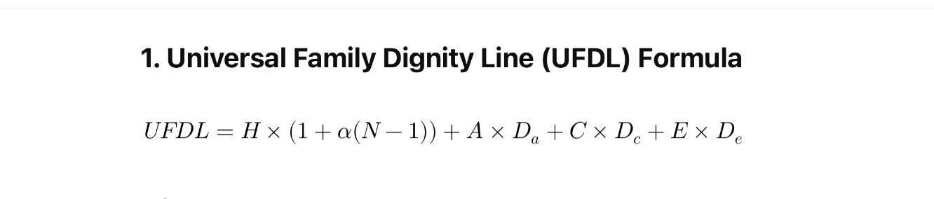
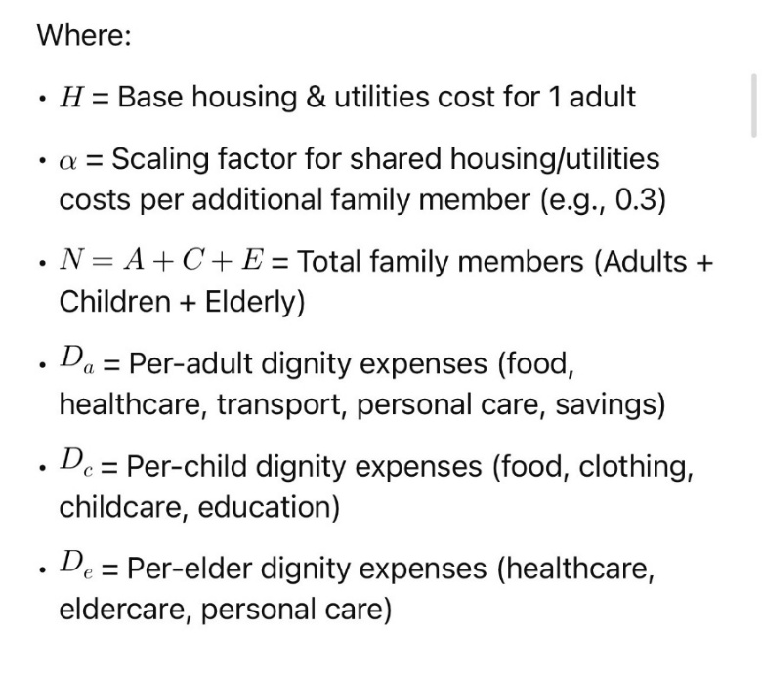

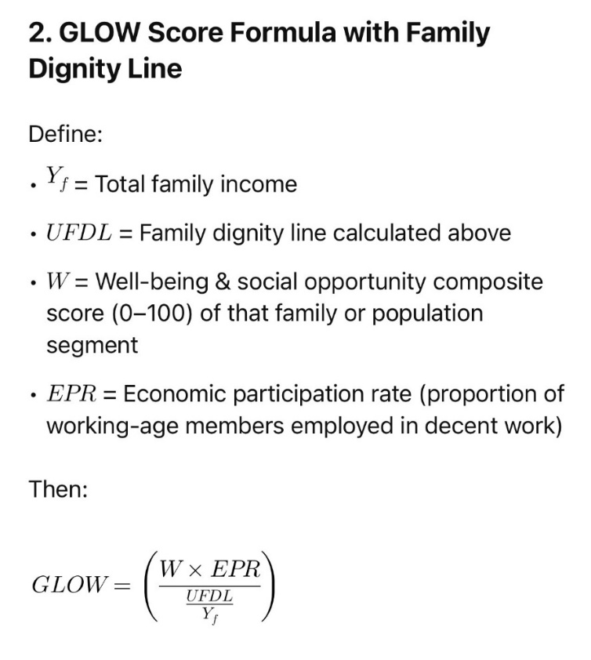

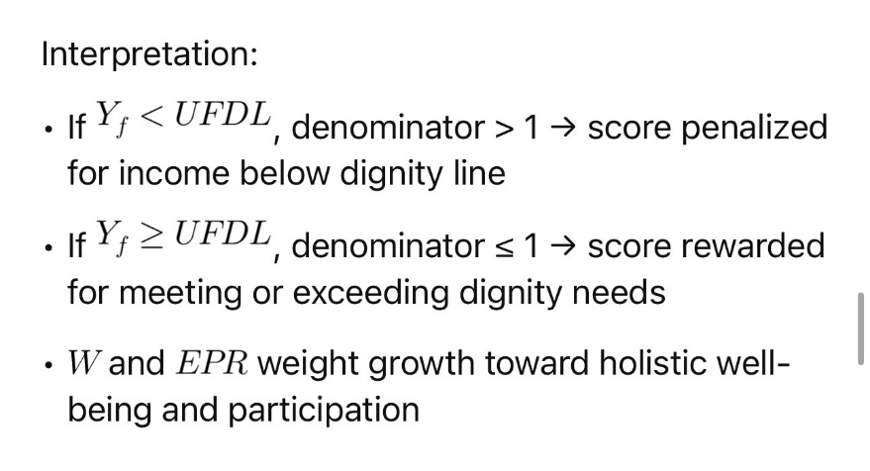

Policy brief: Why the Universal Family Dignity Line Matters for GLOW

The Family Is the Foundation of Dignified Growth
- Every human’s potential to grow fully starts in the family — where unconditional love, care, and belonging shape identity and resilience.
- The right to raise a family with dignity is the most fundamental fraternal universal right: it guarantees that all children grow loved and supported, unlocking a virtuous cycle of community well-being.

Measuring Growth Without Family Context Is Incomplete
- Individual income or well-being data alone cannot reveal whether families can collectively meet the essential costs of dignified living.
- Families share resources and expenses, but also face multiplied responsibilities — childcare, eldercare, education, emotional support — that must be accounted for in growth measures.

UFDL Grounds GLOW in Real-World Life Conditions
- By explicitly calculating the minimal dignified living cost for entire families of different sizes and compositions, UFDL ensures that GLOW is sensitive to household realities.
- This makes GLOW a more just and precise growth metric, identifying where poverty and exclusion exist not only individually, but structurally within family units.

Supporting Social Policies That Enable Dignified Family Growth
- The UFDL-based GLOW score highlights the critical need for universal childcare, eldercare, affordable housing, and adequate wages.
- Policymakers can use GLOW to track progress on family-centered social investments, promoting sustainable growth that nurtures generations.
I hope you enjoyed all the extra time you needed with your math teacher for practicing that!
So, children of the future, you can see that when we understand the Universal Family Dignity Line, we start to see why the GLOW rate is such a game-changer. GDP can tell us a country is “rich” on paper, but GLOW shows if that richness actually reaches the homes, tables, and dreams of families. It asks the real question: Can workers earn enough to raise their children with dignity? This is where the difference between GDP and GLOW becomes clear. A nation may shine in GDP rankings but fall far behind in GLOW—just as we see with countries like India, whose high GDP hides the fact that many workers can barely support their families. By comparing GDP and GLOW ranks side by side, we can finally measure not just the size of an economy, but the size of its heart for its people.
When we understand the Universal Family Dignity Line, we can determine if a country is genuinely supporting families to live well, not just counting money. The GDP is like counting all the candies in the shop, but GLOW asks, “Do the children actually get enough to enjoy, grow, and share?” Some countries appear to be wealthy in terms of GDP, but in reality, many families there still lack the essentials for a dignified life. This is particularly evident in India, where the numbers may seem substantial, but many parents struggle to earn enough to ensure their children grow healthy and happy. GLOW shows the truth, because it measures whether everyone can build their future together. Every person counts, every child counts, so we must measure the world in a way that makes sure every family can stand tall and all children can be raised with dignity.

So, how to read the differences between GDP and GLOW rates? Here you have it, children of the future:
- High GDP + Low GLOW = Civil slavery economy (growth without dignity).
- High GLOW + High GDP = True prosperity.
- High GLOW + Low GDP = Small economy, high life quality.
- Low GLOW + Low GDP = Structural crisis.
Now we are going to give you, children of the future, a mock “World GLOW Rankings of 2025” table using rough estimates based on known social, economic, and well-being data.
These are illustrative numbers to show how the GLOW index changes the story compared to GDP rankings.

World GLOW Rankings — Sample 2025
Rank | Country | GDP Rank (World Bank) | Estimated GLOW Score (0–100) | Key Notes
1 | Norway | 28 | 88 | UDL easily met for most; universal healthcare, strong worker rights, low systemic discrimination, high self-reported happiness.
2 | Netherlands | 18 | 85 | High wages, robust social safety nets, excellent childcare and education, strong environmental protections.
3 | Canada | 9 | 80 | Universal healthcare, high life satisfaction, but housing costs in big cities lower GLOW slightly.
4 | New Zealand | 50 | 79 | Strong work-life balance, high well-being perception, but smaller economy.
5 | Germany | 4 | 77 | Solid worker protections, strong public services, but urban housing affordability is an issue.
12 | United States | 1 | 62 | High GDP but large UDL affordability gap; many full-time workers earn below dignity line; healthcare access tied to employment.
22 | China | 2 | 54 | Massive GDP, but low wage dignity, limited freedoms, long working hours, high commute burden; well-being self-perception low.
35 | Brazil | 9 (PPP) | 47 | Social programs present but economic instability, inequality, and violence reduce GLOW.
48 | India | 5 | 39 | Large population below UDL, systemic caste discrimination, low healthcare access, high commute burden, low well-being self-perception.
52 | South Africa | 32 | 35 | High inequality, low employment stability, systemic discrimination, high crime rates.

What This Shows
- Norway ranks 28th in GDP but 1st in GLOW, proving small economies can lead in true well-being.
- USA drops from 1st in GDP to 12th in GLOW due to healthcare inaccessibility, housing costs, and high percentage of workers below UDL.
- China and India have massive GDP but low GLOW, revealing that much of their “growth” is built on civil slavery wages.
- Nordic and smaller high-quality-of-life countries dominate GLOW rankings despite modest GDP sizes.

Let us now explain to you, children of the future, why, at a whole-humanity level, the GLOW makes far more sense than GDP as the most accurate measure of a country’s growth:

1. GDP measures money, not people
- GDP only counts the total market value of goods and services, even if those goods are weapons, pollution, or products made through exploitation.
- GLOW measures whether that economic activity actually improves human life opportunities and dignity.
2. GDP can grow while people suffer
- GDP rises if companies cut wages, extend work hours, or replace jobs with automation — even if citizens can no longer afford basic needs.
- GLOW will drop if wage dignity, access to healthcare, and life satisfaction decline, no matter how high corporate profits go.
3. GDP hides “civil slavery”
- Economies can be “large” by keeping millions in systemic poverty — paying wages below the cost of dignified living.
- GLOW exposes this by using the Universal Dignity Line as a minimum baseline.
4. GDP ignores fairness
- GDP can grow under dictatorships, apartheid, or colonial exploitation — it counts exploitation as “growth.”
- GLOW penalizes systemic discrimination, lack of freedoms, and political disenfranchisement.
5. GDP ignores the future
- GDP celebrates extraction of natural resources even if it destroys ecosystems for future generations.
- GLOW factors in environmental safety, climate resilience, and emergency preparedness.
6. GDP ignores how people feel
- A high GDP country can have mass depression, hopelessness, and social breakdown.
- GLOW includes the Being Criteria — self-reported happiness, family satisfaction, and belief in future opportunities.
7. GDP treats unpaid care as worthless
- GDP does not count childcare, elder care, or volunteer work unless it’s paid.
- GLOW values these indirectly through childcare accessibility, elder care access, and time balance.
8. GDP rewards exploitation
- GDP grows when companies move factories to countries with lower wages and weaker protections.
- GLOW drops when workers cannot afford their own society’s dignity line.
9. GDP ignores inequality
- GDP can rise while all the benefits go to the richest 1%.
- GLOW measures whether most people can live above the dignity line, not just a few elites.
10. GDP fuels false prestige
- Leaders boast of “being the largest economy,” even if their citizens are overworked, underpaid, and hopeless.
- GLOW changes the narrative — a high GDP with low GLOW means a country is failing in real human progress.

So, children of the future, after the UDL, the UFDL, and the GLOW had been explained as a new fraternal horizon line that Jesus Charity envisioned for a brighter horizon for you all… Here you have it: a manifesto for a true human growth. Things can´t keep going as they are going, and a country´s growth can´t be defined merely by the GDP. Let your governments know, children of the future: glow or blow.
The truth is: for over 80 years, nations have judged their “success” by Gross Domestic Product (GDP) — a measure of how much money flows through an economy. But GDP is blind. It cannot see who benefits, how they live, or what is destroyed in the process. GDP grows if a forest is cut down, if a child works in a factory, if a hospital charges more for medicine, or if millions work two jobs and still can’t feed their families. This is not progress. This is civil slavery dressed as prosperity.
GLOW —remember this acronym: Growing Life Opportunities for Well-Being — measures what truly matters:
- Can a full-time worker afford to raise a family with dignity?
- Do people have health, safety, and time to live?
- Is opportunity shared fairly, without discrimination or exploitation?
- Do citizens feel hopeful about their future?

GLOW begins with the Universal Dignity Line — the basic budget that everyone must be able to afford for a dignified life — and then measures 21 key criteria across four dimensions: Economic Dignity, Social Access, Freedom & Fairness, and Being (Self-Perception of Well-Being).
Why GDP Must Fall? Because GDP can rise and has risen while:
- Wages stagnate
- Inequality explodes
- Healthcare becomes unaffordable
- People lose faith in their future
- Nature collapses under extraction

GLOW will fall when these happen — exposing GDP’s lie. Look, children of the future, at how the world looks like under glow:
- Norway may not top GDP charts, but under GLOW, it leads the world in dignity, opportunity, and life satisfaction.
- The United States, China, and India — “economic giants” — drop sharply under GLOW because millions live below their nation’s dignity line.
- Small economies with strong social foundations leap forward, proving that true greatness is not size, but the ability to give everyone a dignified life.
If a nation’s growth depends on keeping its people poor, overworked, or hopeless, that nation is not “growing” — it is extracting life from its citizens´ violated dignity. GDP is a number for accountants. GLOW is a mirror for humanity.
Children of the future: you can call on:
- Governments to replace GDP in official growth reporting with the GLOW index.
- The UN to adopt GLOW as the global benchmark for sustainable human development.
- Citizens to demand dignity-based economics, where growth means life gets better for everyone, not just richer for the few.

GDP is dead. The future is GLOW, because a civilization is not great when it makes the rich richer — but when it gives every person the chance to grow, live, and love in dignity.
Why is GDP dead as a real measure of a nation’s growth, children of the future?
- GDP measures how much money moves, not whether people’s lives improve.
- It grows from pollution, exploitation, and inequality — even from disasters and illness.
- GDP can rise while people sink into poverty, hopelessness, and systemic discrimination.

When you see GDP vs GLOW, the world´s growth horizon view changes A LOT, kids of the future:
Country | GDP Rank | GLOW Rank*
USA | 1 | 12
China | 2 | 22
India | 5 | 48
Norway | 28 | 1
Netherlands | 18 | 2
Canada | 9 | 3

*Sample illustrative data.

The three biggest reasons to adopt GLOW are clear and humanizingly evident for anyone seeing the issue with eyes that look to fraternize, not to colonize economically:
- It measures dignity, not just dollars.
A country can’t “grow” if its most of its people or a significant amount of its people can’t afford a decent life.
- It values freedom and fairness.
GLOW exposes systemic discrimination and political exclusion.
- It measures hope.
Self-perceived well-being is as vital as wages and services.

GDP is a number for markets. GLOW is a mirror for humanity.

→This is your call to action, children of the future:
- Governments: Adopt GLOW in official growth reports.
- UN & NGOs: Make GLOW the standard for development.
- Citizens: Demand dignity-based economics.

If we truly want the brightest horizon for all children and you, children of the future, we can’t stop at just imagining it—we must build it together, step by step, choice by choice, until every child can walk into a future where their light is free to shine. That is why GLOW is a necessary glowful choice, not only a growthful choice: because it is not only about growing well, but about glowing well—becoming the most radiant version of ourselves for the good of all. And now, dear children of the future, comes something made especially for you: a glowful manifesto. This is your promise from us—and your call to action—that you have the right not only to grow your best, but to glow your best. As poet Carl Sandburg once wrote, “Nothing happens unless first we dream.” Let us dream together of a world where every generation passes the torch of light to the next, so that the glow grows brighter and brighter, evermore.
This is a glowful manifesto for you, children of the future: you will have the possibility not only of growing best but to glow best: yes, we can glow best! All these changes are needed for a glowful manifesto: children have the right to be given the brightest horizon possible, so they can shine as the brightest light they can be for the growthful progress of generations to come. This is a children's glowful manifesto: you have not only the right to grow best, but to glow best, making it possible for all children, for generations to come, to glow more and more, ever more. Each one of you is called to write your own glowful manifesto... but, because I am Puerto Rican, I will allow myself, with the help of Jesus Charity, to let Puerto Rican kids be an example of all that a children's glowful manifesto can be and become.
So, children of future generations, with every glowful manifesto you will affirm with your own glowful light that every child —yourselves and of other future generations— deserves the brightest horizon, the most straightforward path to grow as the best person they can be, and to be allowed and given growthful glow and growth opportunities to shine as the brightest horizon line at your present time as human family. All of you, children of the future, children of all lands, carry within you a spark that can light up generations to come. Every time you learn, create, or care for others, you add a glowful seed to the world that will keep growing, glowing, and blooming, long after you. This is the promise of a life where everyone can have the opportunity to grow with dignity and joy.
Now, allow me, as someone who was given the gift to be born and raised her whole childhood in Puerto Rico, to turn my eyes specifically to the children of Puerto Rico.
Your glowful manifesto is the brightest of all, Puerto Rican children of the future. You will hold in your hands the possibility to radiate a horizon way more colorful and brighter than any children have seen on the island before. You will be able to grow, glow, and bloom not only for yourselves but for all Puerto Ricans, and your actions will echo for generations to come. As Pedro Albizu Campos, a brilliant mind who fought for Puerto Rican dignity under extremely repressive circumstances, once said, “I did all I could with what I had, but the times were not ready for peaceful change.” Unlike him, you will have the chance to bring justice peacefully and fraternally, through your voices being heard in courts, in ways no one before has been able to achieve, even when some tried through violence or protests.
But to be empowered to be able to claim this brighter horizon, you first need to understand how Puerto Rican children's dignity has been denied way before you were born, children of the future: one generation after another, since 1898. For over a century, since the USA’s occupation of Puerto Rico in 1898, children like you were systematically segregated, discriminated against, and denied equal opportunities to grow. One generation after another, you had been repressed and even totally denied your own rights as children, committed by one denigrating, colonializing —intellectually colonizing, politically colonizing…—educative administration after another. The very institutions that were supposed to teach and protect you—the Department of Education (el Departamento de Educación Federal), among others—were the ones enforcing these denials, shaping generations with biased education. Pedro Albizu Campos had no choice but to fight with all his might to claim Puerto Rico’s due rights. But you, children of the future, will have the possibility of more growthful choices, with more radiant possibilities, and more power to create change: you can become a glowful light, revolutionizing justice peacefully and showing the world how Puerto Rican children can teach humanity a lesson of true social justice, a lesson that will resonate for generations to come.
Before you can shine your glowful light and claim the brighter horizon for Puerto Rico, you need to understand a few essential truths about the past. Since 1898, when the USA began governing Puerto Rico colonially, children like you have often been denied the same opportunities to grow, learn, and dream as children in other lands. Being “governed colonially” means that people in your land don’t get to fully decide for themselves how to live, how to make their laws, or how to run their schools and communities. It is when another country controls your island and makes many rules for you, even if those rules don’t help you or respect your culture. Pedro Albizu Campos, as the great Puerto Rican thinker and leader he was, once said: “We have no other path but to demand our rights and our dignity, because living as colonies is to live without full freedom.”
Because of colonialism, schools that were supposed to help the poorest and most vulnerable—your schools—sometimes ended up teaching unfair lessons, limiting your choices, and keeping children from seeing their full potential. That is why generations of Puerto Rican children could not fully experience life with dignity, and why justice for children was delayed for longer than the average lifetime of a Puerto Rican, over 77 years.
But now, children of the future, everything can be different. You have the opportunity to understand what happened, why it was unfair, and how to make it better. You can see the colonization bias behind the education you received before, and by learning this truth, you gain the power to create a new path—a path of equality, dignity, and growth for every child in Puerto Rico. By understanding history and seeing injustice clearly, you become the architects of a new era, utilizing your knowledge to build a society where everyone has the opportunity to grow, flourish, and thrive.
Remember what Pedro Albizu Campos did: he fought with all his strength to claim the rights of Puerto Ricans, but the times and the system were not ready for peaceful, glowing change. You, children of the future, are different: you can bring justice and freedom with your minds, your voices, and your hearts, showing the world that change can be bright, peaceful, and fraternal. By learning, understanding, and acting wisely, you will be able to create a Puerto Rico where children can live with dignity, families can thrive, and generations to come will inherit a glowful horizon line that grows brighter every day.
Albizu Campos fought for Puerto Rico’s freedom, but the government tried to stop him. He was even tortured while imprisoned because he wanted Puerto Ricans to be able to govern themselves. There were also tragic moments, like the Ponce Massacre, where peaceful protesters were shot at by police, showing how repressive it was to live under colonial control. Some independentists did use violence at times, but they felt they had no other choice because their rights were being ignored, and their voices were being silenced.
Even Puerto Rican schools were “colonially governed” from the very beginning. Children were often forced to learn only in English, despite speaking Spanish at home. That meant they couldn’t understand correctly, and their own Puerto Rican culture wasn’t respected. As a matter of fact, it was tried to use schools to enforce a colonized culture, as happens when you try to force children to learn in the language of those who colonize them and not in the language they use to communicate in their own culture. True education should allow children to learn in their own language first, while also providing them with the opportunity to learn other languages, such as English, in a way that actually helps them grow. Colonially governed schools didn’t do that—they focused more on control than on helping children grow and succeed. What happened when the Department of Education was used in a colonial way, children? Schools that were supposed to help the poorest and most vulnerable—your schools—sometimes ended up teaching unfair lessons, limiting your choices, and keeping children from seeing their full potential. Children begin to be used as a means to learn in an undignified way —in undignified buildings, with undignified materials, and treated as less intelligent than their American counterparts simply because they don't speak English...— and in an undignified educational system, one colonializing educational administration after another, since 1898. That is why generations of Puerto Rican children could not fully experience life with dignity, and why justice for children was delayed for longer than the average lifetime of a Puerto Rican, over 77 years. Think about that: Puerto Rican children had been denied dignity by the USA Educational System for more than 100 years and still counting. All the children of all these generations you are going to read in the following list... had been denied their dignity by the Department of Education:

1. The Lost Generation (1883–1900)
• Puerto Rican context: Born during Spanish colonial rule but came of age when the U.S. invaded in 1898. They were the first Puerto Ricans to live under U.S. governance.
• Key moments: Forcible change of citizenship (Jones Act of 1917), the imposition of English in schools, and the early sugar plantation economy.
2. The Greatest Generation (1901–1927)
• Puerto Rican context: Lived through the poverty of the 1930s and the U.S. military draft in both World Wars.
• Key moments: 1937 Ponce Massacre, the rise of Pedro Albizu Campos and the Nationalist movement, mass migration to New York.
• Culture: Many still saw themselves as entirely Puerto Rican culturally, despite new American institutions being imposed.
3. The Silent Generation (1928–1945)
• Puerto Rican context: Childhood during the Ponce Massacre aftermath and WWII rationing. Young adulthood during Operation Bootstrap (1947–1970s), which industrialized the island but displaced rural workers.
• Key moments: Massive migration to the U.S. mainland, founding of the Commonwealth of Puerto Rico in 1952, increased U.S. military presence.
4. Baby Boomers (1946–1964)
• Puerto Rican context: Born after WWII, in a period of economic optimism mixed with inequality.
• Key moments: The height of Operation Bootstrap, expansion of public schools, and U.S.-style suburban life in Puerto Rico. Student movements for cultural and political rights began to grow in the late 1960s.
5. Generation X (1965–1980)
• Puerto Rican context: Grew up during economic downturns after the industrial boom slowed.
• Key moments: Struggles for Spanish-language rights in schools, increased drug trade and crime, U.S. Navy protests in Vieques.
• Culture: They were the first to have significant exposure to U.S. pop culture via cable TV while still living Puerto Rican traditions.
6. Millennials / Generation Y (1981–1996)
• Puerto Rican context: Childhood during government debt growth and school standardization under U.S. models.
• Key moments: 2000s economic crisis beginnings, public school closures, rise of the internet, Hurricane Georges (1998) in formative years.
• Culture: Bilingual education began to be known functionally but remained severely underfunded. Millennials were the last generation who knew life without being exposed to social media.
7. Generation Z (1997–2012)
• Puerto Rican context: Grew up amid worsening public debt, mass migration to mainland U.S., and Hurricane María (2017).
• Key moments: Closure of hundreds of schools, political protests like the 2019 Summer of Puerto Rico.
• Culture: Tech-native, social media–driven activism, stronger sense of Puerto Rican identity despite U.S. influence.
8. Generation Alpha (2013–2025)
• Puerto Rican context: First fully post-María children, growing up in climate crisis realities and under ongoing colonial political status.
• Key moments: COVID-19 pandemic school closures, earthquakes (2020), continued population decline, digital schooling advances.
• Culture: Likely to be the most globally connected Puerto Rican generation, but also the smallest in number due to low birth rates.

So, children of the future, colonizing educational systems in Puerto Rico increased from a few tens of thousands to hundreds of thousands, reflecting the impact on millions of children, one generation after another. This growth was not only due to population changes but also to how colonization, economic shifts, and natural disasters affected access to learning. At the beginning of the USA invasion, only around 20,000 children received any education at all. You can see next, Puerto Rican children of the future, an approximate number of children able to attend school over the decades. Yes, more children were able to learn basic skills like read and write and do math... and many improvements had been made through the years... but still, Puerto Rican children had been given way less growth opportunities than children at schools in the rest of the USA:

1930s
• Around 226,500 children were enrolled in 1st through 12th grade in both public and private schools.
1960s
• Enrollment in those grades grew significantly, reaching about 669,000 students by the early to mid-1960s.
1950s–1978
• Public school enrollment rose from about 545,000 in 1956 to a peak of 728,000 in 1978.
1979–1980
• It was projected that over 1,042,000 children (in public and private schools combined) were enrolled.
2010s
• By around 2012, combined public and private school enrollment was approximately 606,500 students.
2006–2017
• Public schools alone lost around 18,000 students per year, totaling a decline of over 180,000 students in that period. A massive number of Puerto Rican children were moved to the USA with the explicit wish of their parents to be able to receive a better education there, truly able to learn English and have better growth opportunities. Hurricane María also caused a huge Puerto Rican exodus. Puerto Rican natality rate decreased sharply also, to a lower natality rate than the rest of the USA.
2023
• Public primary education: around 150,000 students, down from approximately 268,000 in 2012. Please note that there are now fewer children in Puerto Rican primary schools than in the 1930s. The regression in the number of Puerto Rican children in schools is massive. Colonialism could be considered functioning as a cultural genocide: for 60% of the island, there is no way to raise children at all without relying on government aid, solely on a survival basis, never able to raise children and a family with dignity. Both severely underpaid jobs and severely under-dignity-line wages make it totally impossible for most families on the island to even be able to birth children and form a family, and most are used to survive one disaster after another.
• Public secondary education: about 236,000 students.

After all that fact checks, children of the future, now you can begin to count all the CATASTROPHIC disasters endured by the children being educated in Puerto Rico in a matter of 10 years (2012-2022):
-2012 [catastrophic socioeconomic collapse]: lowest economic point of the whole island since the 1930s (Great Depression era). After the transition period of the fall of 936, unemployment rose to around 16%–17%, the net migration spiked, over 300,000 people left the island in a decade; school closures accelerated; credit ratings of the island were cut to near-junk (eventually they became junk)
-2017 [catastrophic natural disaster]: one of the most powerful hurricanes of Puerto Rican history hit the island (Hurricane María). More than 3,000 lives were lost during and in the immediate aftermath of the hurricane due to the lack of emergency coordination, as minimum, with the same dignity that is provided at the rest of USA: when a catastrophic hurricane hits Florida they are better prepared and recover way faster, but it’s totally normalized to give unequal resources to Puerto Rico. Many schools already had major structural issues; the hurricane simply became the cherry on top. Another Puerto Rican exodus began towards the continental USA.
-2020 [major natural disaster with catastrophic damage for the public school´s infrastructural system]: more than one major earthquake caused major architectonical issues at a significative amount of schools that already were in terrible shape; lengthy school reparations began to be done instead of rebuilding schools from zero and building them earthquake and hurricane resistant and able to have air conditioned and a more robust electrical system to provide equal technological and educational resources to the one that schools at the rest of USA.
-2020 [catastrophic health hazard]: a worldwide COVID-19 pandemic that hit schools and families that already had no equal technological resources nor equal access to children's books and educational resources, so that inequality became even worse. In contrast, those children were isolated at home for an extended period during the pandemic…
-Since around 2012 to present [catastrophic military crisis]: children at schools began to be used as social war weapons; a whole social war who had used children for social war purposes —like soldier children— during more than a decade is not yet even recognized to have happened —including the deliberate exposure of children to toxic gases— and still being happening...

All of those catastrophic events happened through a 10-year period, one after another... As I am writing this, the Puerto Rican Department of Health —to which 65% of children are forced to rely for being able to afford medical care— seems to be the first government department of Puerto Rico that will know imminent complete collapse due to colonialism, although children of the future can cause a full collapse in the Department of Education also if they keep being denied their right to a fraternal, dignity-based, non-colonized education system…
Whenever you read this, children of the future, please stand up and salute the bravery of all the Puerto Rican children of Gen Z and Gen Alpha. They had not known any normalcy outside the “sociocultural frame” of being forced to survive one catastrophe after another in tremendous, undignified conditions. They had been forced to go through an awful taste of plenty of rations of catastrophic crises on a very ordinary basis, one after another. They had been forced to become the most "resilient" children ever, when the fact is: they were denied growing and being educated with dignity. Yes, in their case, telling them "now you can learn to be resilient" was a socially passive-aggressive, nice-looking way to divert attention from how they were being denied dignity and also to deny the truth behind the deepest common factor along the catastrophic, increased depth that all those crises had in Puerto Rico in particular: colonialism.
But for you, children of the future, things can be different. You will have the chance to learn about what happened, understand why it was unfair, and use that knowledge to create a better Puerto Rico. You don’t need violence or truth-denialisms to make change—you can shine your glowful light through learning, speaking up, and taking action in ways that are peaceful, fair, and fraternal. Just like a garden grows when each plant is cared for, the whole island will be able to grow brighter when every child is respected, educated, and given the chance to flourish with dignity.
You, Puerto Rican children of the future, will be the social architects of this new horizon fraternal horizon line. You will build schools, communities, and a society where everyone can grow with dignity, speak their own language, celebrate their culture, and also learn other languages and skills to open doors to the world. By knowing your history, understanding the struggles of leaders like Pedro Albizu Campos and the struggles that the children had through all those consecutive major catastrophic events, and using your talents wisely, you can give a social justice lesson that the whole world will remember: that children can create change, can stop injustice even if happening since many generations ago... and can create a society based on fairness, freedom, and love for each other.
In this glowful future, every choice you make—every project, every idea, every moment of learning—becomes a brick of a better society. Each growthful brick is a step toward a Puerto Rico where all children can grow best, glow best, and bloom best, building a brighter horizon for everyone who comes after you. And this is just the beginning: by learning, dreaming, and acting together, you will show the world that change can be strong, peaceful, and full of light... but for now, beloved children of the future, let's understand better how Puerto Rican children had been discriminated, segregated and given unequal growth opportunities since such a long time, and what that means. Let's now begin a glowful manifesto for you, Puerto Rican children of the future, explaining the injustices Puerto Rican children have been forced to endure, one generation after another. Because it is essential that even the younger children can understand this, Spanish is now being spoken.
¡Hola, amiguitos y niños del futuro de Puerto Rico!
Déjenme contarles un poco de historia y porqué algunas cosas no han sido para nada justas para los niños puertorriqueños.
Los niños de Puerto Rico han sido discriminados por el Departamento de Educación Federal desde hace muchísimo tiempo. Discriminación es cuando alguien trata a otras personas diferente o injustamente por cómo son, de dónde vienen, o qué hablan.
Por ejemplo, si a un niño no le dejan jugar con otros solo porque habla español o porque es de Puerto Rico, eso es discriminación. La discriminación sistemática, que es la que han sufrido niños puertorriqueños, pasa cuando la discriminación no es solo una vez, sino que se repite muchas veces durante mucho tiempo y afecta a muchas personas. Es como si una regla mala se aplicara siempre y no cambiara, aunque cause daño.
¿Desde cuándo pasa esto con los niños de Puerto Rico? Desde hace mucho, mucho tiempo, cuando Puerto Rico empezó a ser colonia de Estados Unidos en el 1908, hace más de cien años atrás, las escuelas les decían a los niños que tenían que aprender solo en inglés. Pero todos los niños hablaban español en casa y no entendían nada en inglés. Así que era imposible aprender, porque no podían entender bien lo que les enseñaban.
¿Por qué eso es injusto? Porque todos los niños tienen derecho a aprender en un lugar donde se sientan cómodos y donde puedan entender lo que les enseñan. Cuando les obligan a aprender en un idioma que no conocen, no es justo. Eso hace que muchos niños se queden atrás en la escuela y no puedan avanzar.
¿Qué ha hecho el Departamento de Educación Federal (en inglés: Department Of Education (DOE)? Por muchos años, el DOE ha puesto reglas y ha dado poco apoyo para que los niños de Puerto Rico aprendan bien, en su idioma y con su cultura. No han dado suficientes libros, escuelas bonitas, maestros capacitados ni recursos para ayudar a todos. Esto ha hecho que muchos niños se sientan tristes, frustrados y sin ganas de seguir aprendiendo.
A eso se llama discriminación sistemática contra los niños puertorriqueños, porque no es solo una vez, sino que ha pasado por muchos años y afecta a casi todos los niños de Puerto Rico. Es como si les dijeran “tú no eres igual que otros niños” y eso duele mucho.
Pero ¡ustedes tienen derecho! Ustedes merecen aprender con respeto, en un lugar que cuide su cultura y donde les den las mismas oportunidades que a otros niños en Estados Unidos. Y por eso muchos adultos están luchando para que cambien estas reglas y para que las escuelas sean un lugar justo para todos.
¿Quieres ayudar? Puedes tomar acción. Habla con tus maestros, tus papás y tus amigos y pídeles que exijan por ti que el DOE respete tus derechos como niño, incluyendo a recibir una educación donde no se te discrimine. Cuéntales que mereces aprender en un lugar donde te sientas feliz y puedas crecer fuerte y sabio. Porque cuando ustedes luchan por sus derechos, están construyendo un futuro mejor para Puerto Rico.
Vamos a explicarles, niños del Puerto Rico del futuro, como se ve la discriminación del DOE en el día a día en sus escuelas. Si no entienden que tan grandes son estos números, pídanle a la maestra que les enseñe matemáticas que se los explique, porque es importante lo grande de la injusticia del DOE contra los niños puertorriqueños y lo importante que es que se tome acción cuanto antes.
Lo que se invierte en terapias y apoyo a un niño de educación en Puerto Rico es alrededor de 7,000; en Estados Unidos es el doble, 14,000. En Estados Unidos se invierte 18,000 en educar a un niño; en Puerto Rico se invierte la mitad de eso: 9,000. El DOE da menos fondos a niños puertorriqueños sencillamente por estar en Puerto Rico, y eso, niños, se llama “discrimen por territorio”: tratarte diferente solo por estar en otro territorio, en este caso Puerto Rico.
Hay otros muchos ejemplos de este discrimen que pueden ver a su alrededor, niños, pero les resulta tan normal que ustedes mismos no saben que el DOE los está discriminando y que lleva haciéndolo por muchísimo tiempo, desde hace muchas décadas atrás:
¿Sabían que en muchas escuelas de Puerto Rico no hay aire acondicionado?
Mientras que en las escuelas de Estados Unidos hay aire acondicionado y calefacción para que los niños puedan aprender cómodos, en Puerto Rico hace mucho calor y humedad y las aulas están viejas y mal cuidadas.
¡Imagínense tener que estudiar cuando hace tanto calor que casi no pueden concentrarse!
Las escuelas en Estados Unidos están hechas para que los niños aprendan mejor
Tienen bibliotecas grandes, salones con computadoras, tecnología nueva y espacios bonitos para que los niños puedan explorar y aprender.
Aquí, en muchas escuelas de Puerto Rico, no hay suficientes computadoras ni libros nuevos, ni lugares especiales para hacer arte o música.
¿Sabían que en Estados Unidos el DOE paga a muchísima gente y paga muchísimos recursos para que los estudiantes que aprenden ESL (English as Second Language; Inglés como Segundo Idioma) logren dominar el inglés a nivel del grado del niño, pero en Puerto Rico no es así: en Puerto Rico apenas se dan recursos para que los niños de escuelas públicas puedan aprender inglés? ESTO ES DISCRIMEN CULTURAL.
En Estados Unidos se invierten unos 5,000 adicionales a lo que se invierte en educación básica (18,000) por niño que recibe clases de ESL. En Puerto Rico, donde el 100% de los niños necesitan apoyo intensivo de ESL, porque todos hablan español como primera lengua, la inversión explícita en ESL es CERO. A ustedes, niños puertorriqueños, no se les dan fondos extra para ESL learning, ni hay un departamento entero en el Departamento de Educación con fondos y recursos exclusivamente dedicados a su aprendizaje de ESL: en Puerto Rico, a la clase de inglés se le trata como una clase más, sin dedicar fondos adicionales y equitativos para lograr que el nivel de inglés de los niños puertorriqueños logre alcanzar el nivel de grado como ESL learners. A los niños puertorriqueños se les discrimina culturalmente al asumirlos como ELA/ELL learners (English as Language Arts learners/English Language Learners). A ustedes, niños puertorriqueños, el DOE los trata como estudiantes que dominan el inglés como lengua materna, como si el español no pudiera ser su lengua materna. Como se asume que los estudiantes puertorriqueños son ELA/ELL learners, ni siquiera hay fondos y personal de apoyo suficiente para enseñarles ESL a nivel de grado y de forma equitativa a otros ESL learners en el resto de Estados Unidos. Niños, lo más injusto de esto es que a la vez que los discriminan negándoles aprender inglés como corresponde a su cultura (como segundo idioma), también los discriminan por no saber inglés (cuando resulta que no dan fondos para que se los puedan enseñar como pueden aprenderlo).
Esto que acabo de explicar se llama “discrimen cultural”: se te está discriminando al negarte servicios educativos según tu cultura puertorriqueña. Esto también se hizo en el pasado al negar a los niños puertorriqueños hablando en las escuelas de la misma forma que hablaban en casa: en español.
¿Quieren saber otra forma de discriminación contra la educación de niños en Puerto Rico? Los maestros aquí ganan muy poco dinero
Y como no les dan suficientes materiales para enseñar, muchas veces ellos mismos compran lápices, decoraciones del salón para que ustedes lo vean bonito, papel y otras cosas con su propio dinero, aunque ya ganan poco. Hay maestros que hasta arreglan fallas de los salones con su propio dinero. Eso es muy difícil para ellos, sobre todo ver que la mayoría de las veces los niños no reciben todo lo que necesitan para aprender bien. Los maestros quieren que ustedes aprendan bien, pero no les dan los recursos para que ellos puedan enseñarles bien.
Todo esto es un ejemplo de discriminación
Porque aunque ustedes son niños de Puerto Rico y también ciudadanos de Estados Unidos, no reciben las mismas oportunidades que otros niños que viven en los estados.
Esto no es justo, y no es algo que pasó solo hace mucho tiempo; sigue pasando ahora mismo.
Pero hay algo muy importante que deben saber
Si ustedes no hablan y piden que se defienden sus derechos, nadie cambiará estas cosas.
Así como cuando ustedes se portan mal y los maestros los llevan a la oficina para corregirlos, también el DOE debe ser corregido cuando no cuida bien a los niños y no les da lo que merecen.
¿Y cómo se corrige al DOE?
Ustedes, los niños, con ayuda de sus papás y adultos que los quieren, pueden llevar al DOE a la corte, donde un juez decidirá que el DOE tiene que mejorar las escuelas, dar más recursos y tratar a todos los niños con justicia. Explíquenle, niños, a la corte: en Estados Unidos un niño de educación especial que está aprendiendo inglés recibiría 36,000 dólares de fondos para su educación. En Puerto Rico, donde el 37% de estudiantes son estudiantes de educación especial y 100% son estudiantes son estudiantes que necesitan aprender inglés como ESL learners, el DOE solo invierte 16,000 por cada niño. Somos niños, pero sabemos de matemáticas, especialmente tras practicar matemáticas calculando el GLOW rate…. Explíquenle a la corte porque esa matemática colonial del DOE no les cuadra: hay demasiado discrimen cultural, segregación económica e inequidad sistémica en ese tipo de matemáticas desigual que les impide crecer como la mejor persona que podamos ser. Al Secretario del Departamento de Educación Federal hay que enseñarle matemáticas fraternas, y ustedes pueden darle las tutorías. Ustedes, niños del Puerto Rico del futuro, tal vez no sabrán Pre-Cálculo ni Álgebra, pero sí que sabrán sumar y dividir con mucha justicia social… y el resultado de la matemática colonial para los niños puertorriqueños es una injusticia social que tienen que abolir de la misma forma que se abolió la esclavitud.
Ustedes tienen mucho poder, niños del Puerto Rico del futuro, porque cuando luchen por sus derechos, estarán ayudando a que Puerto Rico tenga mejores escuelas para todos los niños, ahora y en el futuro. ¡No tengan miedo de pedir lo que les corresponde por derecho y lo que merecen, una educación digna y fraternizante!
Imaginen que todos los niños de Puerto Rico se unen para contarle a un juez en la Corte de Distrito de Columbia, en Washington, que sus escuelas no son justas ni buenas como las de los niños en Estados Unidos. Ellos le pedirían al juez muchas cosas importantes: que las escuelas tengan aire acondicionado para no pasar calor, que tengan libros nuevos y suficientes para todos, que haya computadoras y tecnología para aprender, que los maestros ganen un sueldo justo para poder comprar materiales y enseñar mejor, y que las escuelas sean seguras y limpias para que ellos puedan estudiar sin miedo. También pedirían que el juez obligue al DOE a dejar de dar menos dinero a los niños puertorriqueños y a dejar de negarse a ayudar a las escuelas de Puerto Rico a tener tantos recursos y servicios como el resto de escuelas en Estados Unidos, porque eso hace que los niños no puedan aprender igual que los niños en otros lugares.
Esto es muy parecido a lo que hizo Ruby Bridges hace muchos años. Esa niña que ven en la foto a continuación era Ruby en la década de los 60s, tan niña como ustedes:

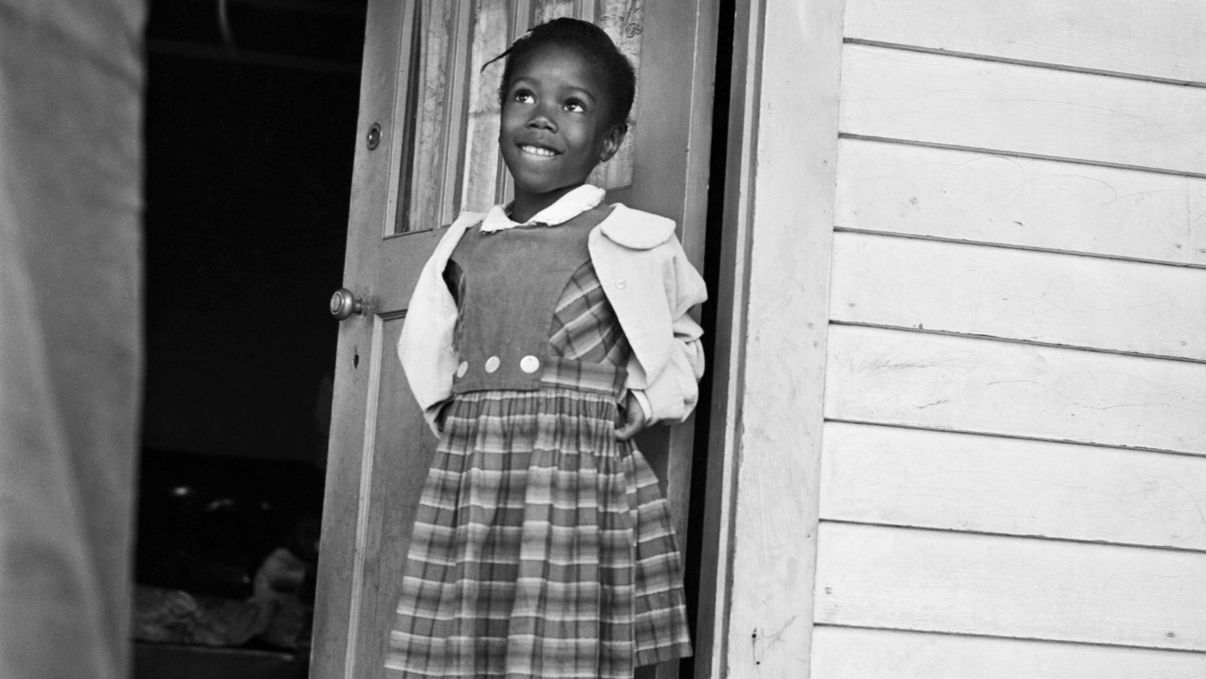

Ruby era una niña negra que tuvo que ir a una escuela donde antes no dejaban entrar a niños de su color. Ella pidió ayuda al juez para que las escuelas dejaran de separar a los niños por el color de su piel y para que todos pudieran aprender juntos, con las mismas oportunidades y sin que nadie los tratara mal por ser diferentes. Ruby luchó para que la discriminación, que es cuando tratan injustamente a alguien, terminara en las escuelas. Pidió que todas las escuelas fueran justas y que todos los niños pudieran tener la oportunidad de aprender y crecer felices, sin importar si eran blancos o negros, ricos o pobres.
Lo que piden los niños de Puerto Rico es igual de importante. Ellos quieren que el juez vea que no están recibiendo la misma educación que otros niños porque el sistema los trata diferente y no les da las mismas herramientas para aprender. Quieren que el juez les ayude a que las escuelas en Puerto Rico sean tan buenas como las de los demás niños en Estados Unidos, con maestros que tengan lo necesario para enseñar, con libros, tecnología, y lugares cómodos para estudiar. Así como Ruby Bridges ayudó a cambiar las escuelas para que fueran justas para todos los niños, los niños de Puerto Rico están luchando para que sus escuelas también sean justas y puedan crecer y aprender bien.
Para lograr lo mismo que logró Ruby, ustedes, niños del Puerto Rico del futuro, necesitan pedirle a sus padres y a quienes quieren lo mejor para ustedes que hagan algo que se llama “demanda de clase”: cuando muchas personas piden lo mismo a un juez; cuando muchos niños a la vez piden a un juez que se respeten sus derechos. En este caso, serian todos los Children of Puerto Rico los que demandarían ante un juez el fin del colonialismo que permiten las injusticias cometidas por el DOE. Eso, en la corte federal de Washington DC donde tiene que hacerse esto, se llamaría Children of Puerto Rico vs DOE. La verdad es que a nivel de Estados Unidos jamás se ha visto un caso a nivel federal de niños que piden una demanda de clase (lo harían sus padres por ustedes, pero el caso sería de CHILDREN OF PUERTO RICO vs DOE; son ustedes los que estarían demandando al DOE), pero definitivamente puede pasar si un juez lo ve necesario, y en este caso clarísimamente es necesario y hasta los más justo que sean ustedes, niños del Puerto Rico del futuro, a los que se nombre como los que están demandando su derechos al DOE. Aunque nadie ha puesto una demanda de clase aún hecha por niños, el caso de Ruby sí que es como el de ustedes, niños de Puerto Rico. Miren como se compara el caso de Ruby y en un caso de Children of Puerto Rico vs DOE:

El caso Ruby Bridges y el caso Children of Puerto Rico vs DOE
Caso Ruby Bridges | Caso Children of Puerto Rico vs DOE
Ruby pidió a la corte el fin a la discriminación racial contra los niños de raza negra en su escuela. Logró el fin de la discriminación racial en todo Estados Unidos. | Pueden pedir a la corte que el DOE ponga fin a la discriminación cultural-colonial contra los niños en las escuelas de Puerto Rico (discriminación cultural por etnicidad puertorriqueña y por territorio colonial). Pueden lograr el fin del colonialismo para todo Puerto Rico y el fin del discrimen cultural para todos los niños de las próximas generaciones: tienen el legítimo derecho de poder integrar el español en su educación como lengua materna y de se les brinden todos recursos de apoyo adicional que se proveen en el resto de Estados Unidos para aprender inglés como English as Second Language (ESL).
Ruby pidió a la corte que el STATE DOE pusiera fin a la segregación racial contra los niños de raza negra en su escuela. Logró el fin de la segregación racial en todo Estados Unidos. | Pueden pedir a la corte que el DOE ponga fin a la segregación económica contra los niños en las escuelas de Puerto Rico (negación de fondos equitativos a niños puertorriqueños, cuya ciudadanía es ciudadanía americana). Pueden lograr el fin de la segregación económica de todos los puertorriqueños en la isla.
Ruby pidió a la corte que el fin del acceso desigual a recursos educativos. Logró la equidad de recursos educativos para todos los niños de raza negra en Estados Unidos. | Pueden pedir a la corte que el DOE ponga fin a la inequidad sistémica de oportunidades de crecimiento contra los niños en las escuelas de Puerto Rico (afectación a desarrollo académico/social; afectación masiva a generaciones completas por pobreza educativa estructural). Pueden lograr el fin de la inequidad sistémica de oportunidades de crecimiento para los niños de todas las próximas generaciones.

Sé que algunas palabras que se usaron en esa tabla suenan extrañas. Vamos a explicar que es “segregación racial”, “segregación económica” e “inequidad”.
¿Saben que hace muchos años Ruby ayudó a acabar con algo llamado segregación racial en las escuelas de Estados Unidos?
La segregación racial significa que a los niños y niñas se les separaba por el color de su piel — unos iban a unas escuelas y otros a otras, y eso no era justo porque todos los niños merecen aprender juntos y tener las mismas oportunidades. Ruby luchó para que esa separación terminara en todas las escuelas de Estados Unidos, y gracias a ella y a muchas personas más, ahora los niños y niñas pueden ir a la misma escuela, sin importar el color de su piel.
De la misma forma, los niños y niñas de Puerto Rico pueden luchar para que el DOE deje de tratarlos diferente solo por vivir en Puerto Rico, y para que la discriminación que sufren en sus escuelas termine no solo en las escuelas, sino en toda la isla: tratar a los niños puertorriqueños de forma diferente a los niños que del resto de los Estados Unidos es discrimen, y no darles igualdad de fondos es segregación económica: se está separando a los niños puertorriqueños económicamente del resto de los niños en Estados Unidos al no dar la misma cantidad de dinero para la educación de niños en Puerto Rico, separándolos con pobreza desigual, de la misma forma que antes del caso de Ruby se separaba a los niños en las escuelas por ser de raza negra. “Segregación económica” significa que a los niños en Puerto Rico no les dan el mismo dinero que le dan a los estudiantes en el resto de Estados Unidos para cosas importantes, como para materiales de educación y para tener escuelas bien construídas y equipdas. Por eso las escuelas aquí no tienen los mismos recursos, como aire acondicionado, libros nuevos, computadoras o maestros con buen sueldo.
Tras todo esto hay discriminación colonial sistémica. ¿Recuerdan cuando expliqué que “discriminación sistémica” es que sucede muchas veces? Pues el discrimen contra los niños puertorriqueños también ha sido discrimen colonial: no solo se les ha discriminado por hablar español (eso es discriminación cultural), también se les está discriminando porque Puerto Rico es una colonia (eso es discriminación colonial). Ser colonia, niños, significa que, aunque los puertorriqueños son ciudadanos de Estados Unidos, no tienen los mismos derechos que las personas que viven en los estados. Es como si fueran ciudadanos de segunda, y eso no es justo.
Por eso, la lucha de los niños de Puerto Rico es para que la discriminación y la segregación, tanto la colonial, como la cultural como la económica, terminen en toda la isla, y para que todos los puertorriqueños tengan las mismas oportunidades para crecer, aprender y ser felices. Así como Ruby Bridges cambió las cosas para todos los niños de Estados Unidos, ustedes también, niños del Puerto Rico del futuro, pueden cambiar las cosas para Puerto Rico.
¿Saben que cuando un caso llega a la Corte Suprema de Estados Unidos, es porque es muy importante? Así pasó con Ruby Bridges, y su caso ayudó a cambiar muchas cosas para todos los niños en Estados Unidos.
Si el caso de ustedes, Children of Puerto Rico vs DOE, llega también a la Corte Suprema, será porque se trata de proteger a los niños y que puedan crecer felices y con las mismas oportunidades. Y lo bueno es que la Corte Suprema sabe que los niños son muy importantes, y se toma en serio estos casos para ayudarles rápido. Sus casos no tardan tanto en ser escuchados por la Corte Suprema como otros casos, porque en el caso de niños, por estar en crecimiento, no actuar lo antes posible causa daño que no se puede reparar.
Todos los casos más importante que se traten de preguntas relacionadas a la Constitución llegan a la Corte Suprema, así que este caso, niños del futuro de Puerto Rico, llegará a la Corte Suprema como pasó con el caso de Ruby. La Pregunta Constitucional que estarían preguntando los niños de Puerto Rico a la Corte Suprema en un caso de Children of Puerto Rico vs DOE sería: ¿Es justo que, solo porque Puerto Rico es tratado como colonia, nuestras escuelas tengan menos recursos, edificios más dañados y menos ayuda para aprender en español y en inglés que las escuelas de los niños en el resto de Estados Unidos? Queremos preguntarle al Tribunal Supremo si es justo que, por vivir en Puerto Rico, recibamos menos recursos para aprender, tengamos escuelas con menos materiales y menos ayuda que otros niños en Estados Unidos, y que además nos obliguen a aprender de una forma que no respeta nuestra cultura ni nuestro idioma. Nosotros creemos que esto pasa porque vivimos bajo un sistema colonial que nos trata diferente e injusto. Queremos que el Tribunal diga que eso es inconstitucional y que se acabe, para que todas las escuelas de Puerto Rico tengan lo que necesitamos para aprender bien y con respeto a quiénes somos.
O sea: ustedes, niños del Puerto Rico del futuro, van a decirle a la Corte Suprema que la razón por la que el Departamento de Educación (DOE) trata diferente a los niños de Puerto Rico y no les da las mismas cosas que a otros niños, es porque Puerto Rico es una colonia. Eso significa que, aunque los puertorriqueños son ciudadanos, no tienen los mismos derechos ni reciben el mismo trato que las personas que viven en los estados.
Si la Corte Suprema escucha eso y decide que el colonialismo es la causa de esa discriminación, entonces podrá terminar con el colonialismo para todos los puertorriqueños. Eso no solo ayudaría a los niños en las escuelas, sino a todos los adultos y familias en Puerto Rico. Sería como si ustedes, los niños, fueran los héroes que lograron acabar con algo que estaba mal por mucho tiempo, y así empezar una nueva etapa llamada el Nuevo Albor. En esta nueva etapa, todos los puertorriqueños caminarían juntos como hermanos y hermanas, con los mismos derechos y oportunidades, creciendo felices y fuertes.
Así, ustedes podrían crecer glowfully — que significa crecer con luz, amor y alegría — siendo las mejores personas que puedan ser, y construyendo el mejor Puerto Rico para todos. Ustedes también, niños de Puerto Rico, pueden pasar por el umbral de la dignidad como lo hizo Ruby al ser la primera niña de raza negra cruzando las puertas de una “escuela de blancos”.
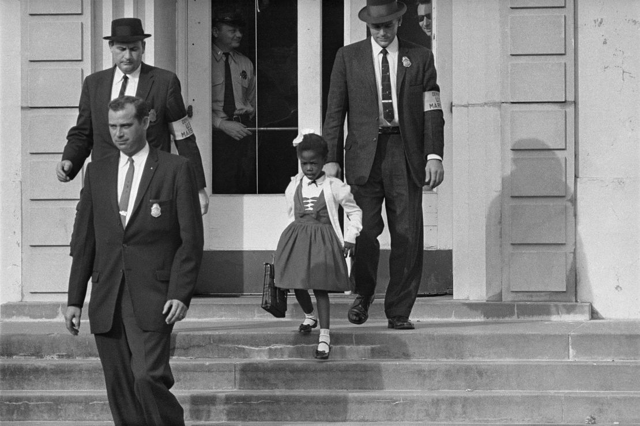

Ustedes también pueden lograr lo que logró Ruby: que todas las próximas generaciones de niños puedan no solo crecer como la mejor como la persona que puedan ser, sino que también puedan brillar como la mejor luz que puedan ser, haciendo posible para los niños de todas las generaciones el poder crecer irradiados por un horizonte más brillante para todos los puertorriqueños.
Si luchan juntos para que sus derechos sean respetados y que sus escuelas sean justas, ustedes estarán empezando un movimiento muy especial que nadie ha hecho antes, pues nunca ha habido un movimiento cultural iniciado por niños: ¡estarían iniciando un Grow On Movement, un Glowful Movement. Ya elegirán ustedes el nombre que más les guste.
Glowful significa crecer con luz, con alegría, con amor y con ganas de ser la mejor persona que uno puede ser. Es como un amanecer — un Nuevo Albor — cuando todo está lleno de luz y empieza un día nuevo y hermoso. Un Glowful Movement buscaría hacer posible que todos los niños, no solo en Puerto Rico, sino en todo el mundo, puedan tener las oportunidades para crecer felices, aprender mucho y ser personas buenas que ayudan a los demás. Ese movimiento también afirmaría una cultura del Nuevo Albor, una cultura donde las personas trabajan juntas como hermanos y hermanas, cuidándose, respetándose y ayudándose para que nadie se quede atrás. Es una cultura nueva que empieza después de que termine el colonialismo, que es cuando un lugar como Puerto Rico era mandado por otros sin poder decidir por sí mismo.
Cuando el colonialismo termine, los niños y niñas de Puerto Rico podrán tener muchas oportunidades nuevas para crecer: mejores escuelas, más libros, más tecnología, más lugares para jugar y crear, y sobre todo, más amor y respeto para todos. Eso es lo que hace un Glowful Movement: hacer posible el mejor crecimiento posible para todos, incluyendo para las próximas generaciones. Esto es algo para celebrar, porque será el comienzo de una nueva vida para Puerto Rico, una cultura americana del Nuevo Albor, donde todos somos llamados a cumplir el Sueño Americano: convertirnos en la mejor persona que podamos ser y ayudar a otros a hacer lo mismo. Ustedes, los niños, serían los líderes de este movimiento maravilloso, mostrando que cuando crecemos con luz y amor, podemos cambiar el mundo para mejor.
No les parece un sueño Americano hermoso, a glowful American Dream? ¡Y ustedes lo pueden hacer realidad! Es posible, al menos para ustedes, niños, crear progreso celebrando nuestra conversión en un New Albor State, en un New albor American culture. ¡Y hay tantas formas de celebrar convertirnos juntos en una cultura del nuevo albor donde todos puedan convertirse en la mejor persona que puedan ser, en the glowful American harvest we are all called to become as a beloved community, como lo soñó Martin Luther King Jr: “The beloved community is a society based on justice, equal opportunity, and love of one’s fellow human beings!”
Atrévanse a aprender a ser valientes, creativos y decididos como Martin Luther King Jr, niños del Puerto Rico del futuro: hagan brillar un glowful manifestó que haga posible un horizonte más brillante para todos.
Yes, this is a whole glowful manifesto that you, the future children of Puerto Rico, will create, while creating a way brighter horizon line for all the Puerto Rica children to come! Imagine their joy when they saw that very bright horizon line painted for them, in the same way Jesus Charity made possible a new, brighter horizon line for me! How much cultural creativity can growing together in more and more communion can create: a whole new cultural legacy will be born in you, a New Albor legacy that we are already envisioning and celebrating as we write this letter to you, Puerto Rican kids of the future!
You can ask: how can a legacy like a New Albor legacy be celebrated? Ahh, kids, there are many ways to do it; let´s explain a few.
I will begin to explain how to celebrate a legacy with a way that we, as a family of Heaven, are doing to celebrate it right now, though these days I have been writing this letter to you; something we are doing in this present to celebrate how this New Albor Legacy is a present that we are inheriting to you.
You know, children from all over the USA are very well known for loving a meal that is very well known by everyone to be the most iconic American children´s meal: mac and cheese. Kids, there is absolutely NOTHING wrong with mac and cheese. I myself love adding bacon to mac and cheese. But we wanted to celebrate this New Albor legacy we are knitting and leaving for generations to come… with a recipe tasty enough to be passed from one generation to other, flexible enough to be able to be adapted by each family as a family legacy from parents to children as they keep growing and able to do their own family recipes wherever they go when they leave their first nest… and because what we are doing is for you, Puerto Rican children of the future… we wanted the recipe to be specifically already know to be a children´s meal.
Well, as I already mentioned, anyone in the USA could agree that there is no other more iconic American children´s warm meal than a plate of mac and cheese. You see it everywhere: from mac and cheese sides in fast food restaurants, like in Chick-fil-A.
The history behind mac and cheese is quite interesting, because it may be the earliest historical example of at least an intent of leaving colonialism behind, in an era in which the USA was still not able to see any other new way of government for themselves than the one by which they were governed before by Britain. Once the USA proclaimed its Declaration of Independence and gained independence after a bloody war fought on American soil against the British colonial empire… Well, after becoming the first nation in the American continent to achieve independence, the USA established its own Constitution and Government, proudly proclaiming to the world that in America, they were governed by a President instead of a King… but guess what? The Government of the USA, instead of developing a governing style of its own, simply adopted an untold-but-fiercely-applied 'yes, we can colonize best' government policy. Yes, a Federal Constitution was achieved to be created and signed, shifting from being named “thirteen colonies” to be named “thirteen states united in a confederation” —that´s where the name “United States of America come from, kids— but the Constitution of the United States has ALWAYS functioned normalizing any kind of civil slavery upon those who were not considered part of its “We, the people” in each historic period. At the beginning, the Native American, the Black, and the Woman were not considered part of “We, the People”: they were not recognized as having equal constitutional rights nor being persons with dignity. So, the Constitution of the United States, at the same time that refused to keep using the word “colony” to refer to themselves, allowed a form of government that keep enforcing colonialism unto those who were not considered “We, the people.”
We want to let you know, kids, that this is a massive problem with the United States Constitution: it does proclaim the wish to secure the Blessings of Liberty to ourselves, to that We, the People… but the Constitution never clarifies nor affirms exactly who “We, the people” are. The issue began very early on: this omission occurred during the redaction of the Constitution, to make it easier for all those who represented each state — which were still functioning as colonies, no matter how deliberately the word “states” was used to name themselves — to sign it. So, because the Constitution of the United States had never affirmed nor clarified who “We, the people” is, each historic period of the United States has had its cultural bias about who was not worthy of being considered an equal “We, the people”, with equal constitutional rights.
The Constitution of the United States has never affirmed that all citizens are persons with inherent personal dignity to be respected unconditionally. Something “inherent”, kids, is something that is a natural part of who you are, it´s always there and nobody can take that, not even a Government. It´s like a turtle´s shell: a turtle´s shell is an inherent part of their nature, it was conceived and born with it and always had it, can´t be taken away or the turtle stops being allowed to be a turtle. That is what happens, kids, when someone does not respect your dignity as a person inherently: your dignity is an inherent part of your personal nature, including the civic dimension of personhood´s nature (which encompasses who you are as citizens). So, if a Constitution, that is the “civil foundation” of a Nation, in the identical way houses need a rock-solid foundation to be built for many years to come… If a Constitution does not affirm inherently the dignity of all citizens, declaring absolutely all citizens inherently as “We, the people” and that the natural integrity of all persons must be respected unconditionally, not even a Government can be allowed to violate or dent the personal dignity of no one... what will happen is what had been happening in USA since its very constitutional beginning as “united states” that had always remaining governing colonially, even if they stopped calling themselves as “colonies”: there will always some considered not equal citizens, treated by the Government as “others that do not have the same rights, that are not like us,” others that are no part of that “We, the People,”
What does “recognizing all citizens inherently as persons with dignity” mean, kids?
Recognizing absolutely all citizens as people with inherent dignity to be recognized unconditionally in all the civil senses —recognized by their civil Constitution unconditionally—means that:
-No matter what a citizen´s race is (White, Black, Hispanic, Native American, Asian…).
-No matter what a citizen's religious affiliation is, or if the citizen is an atheist.
-No matter what a citizen's political affiliation is.
-No matter what a citizen´s cultural ethnicity is (if you are a Puerto Rican American citizen, a Native American citizen, a Black American citizen, a Chinese American citizen, a Latino American citizen…).
-No matter what a citizen´s economic status is (no matter how much money you have or don´t have, or how rich or poor you are).
-No matter what a citizen´s gender is.
-No matter what stage of growth a citizen is (this means: an unborn at the beginning stage of life after the first heartbeat is confirmed medically has the same inherent dignity than any other citizen; an elder citizen at their last stage of life has the same inherent dignity than any other citizen until his or her las neural beat, until brain death is confirmed medically; no matter in which human life stage a citizen is, all citizens have inherent dignity to be recognized and affirmed unconditionally; all the care that any fraternally dependent citizen may require to go through each stage of life with their dignity recognized inherently must be assisted or provided by the Government in a fraternal basis).
—No matter which degree of fraternal dependency a citizen has or does not have (kids, have you seen that some citizens among us need to be cared for by others to be able to live with dignity? Like adult citizens with Down Syndrome who need fraternal care because they can´t live on their own due to their natural personal nature, but they do have the right to live with dignity too, according to their degree of need for fraternal care. The same happens with people who are at the end of their lives: they are not meant to be killed because nobody can care for them, then the Government must provide all the fraternal aid needed in such circumstances for their dignity to be recognized unconditionally and be able to remain as belovedly cared for as long its personal nature requires such fraternal dependency care until their natural death (no, no one can provide euthanasia pills to normalize the social murder of those terminally ill who would cost more to be cared until natural death than to provide them with eugenic pills, nor no one can provide euthanasia to those who need someone to care for them belovedly because they are totally alone and can´t embrace this life stage without receiving dignifying fraternal dependency care until their natural death… nor no euthanasia can be provided at all: euthanasia is a very eugenic violation of the sacred dignity of personhood, in the same way everyone has the right of life unconditionally recognized since the first heartbeat, everyone has the right to life unconditionally recognized until natural death).
This is what “no matter which degree of fraternal government aid a citizen has” means, kids: no person can be discarded, allowing someone´s dignity to be denied due to being fraternally dependent and needing some degree of fraternal care to live a life with dignity, according to their own personal nature´s well-being. This means, kids, that some people do need government aid and some families do need Government assistance, so we can all build together a civil society where everyone's personal dignity and rights are recognized humanely and fraternally. Requiring fraternal care is not being a “burden,” and needing it when it is naturally required is not “becoming a burden:” brothers and sisters that need our fraternal care in any degree enrich us as helping us to become the most fraternal society possible for all. Providing fraternal care to those with any kind of fraternal dependency, especially if the family needs Goverment assistance to assume such care in a dignifying way, or if the own Government must be the one that oversees thar inherent dignity of those who have no family to provide them the fraternal care they need is as unconditionally recognized as any other citizen…
Kids, this is a vital lesson: providing fraternal care is a sacred social investment that affirms a civil constitution that doesn´t discard anyone’s dignity nor enslave anyone with any kind of colonialism. Where the dignity of all people is inherently recognized, no one, absolutely no one, can be seen as any kind of “civil burden”, nor can anyone be allowed to be discarded for any reason, no matter which fraternal dependency care someone may require to be given for their inherent dignity to be recognized unconditionally. Embracing with civil and human equality those who need any kind of fraternal dependent care to have their dignity inherently recognized in the personal civil sense according to their personal nature is part of remembering all citizens as persons with inherent dignity: absolutely no one, —including the unborn with a heartbeat who are still totally dependent of remaining inside a mother´s womb for a longer time for being able to develop enough to be born and begin to be able to grow by their own, as it totally expected to happen in that human life stage—, can be seen as less “people” or as “no people” or as “economic burden” for being fraternally dependent and needing to be provided fraternal care to be able to live a life with dignity
So, this is what “no matter what degree of fraternal dependency degree a citizen has” means, children of the future: no matter if a citizen depends, for whatever reason, of any fraternal dependent care to be able to keep growing and living dignifying, their inherent dignity as persons is equally recognized unconditionally by the Constitution in the whole civil sense, because absolutely all citizens are constituted as persons, they all are people, they all are intrinsic part of that “We, the people” of the civil Constitution, so no matter if you are a small unborn or if you can´t live by your own as sovereign citizen or if you need help in your last days of life, you have the right to be allowed to live a life with dignity).
-No matter if you are a sovereign citizen or not (a sovereign citizen, kids, is a citizen who is declared to be sovereign to assume by his or her own all the responsibilities that belong to his or her inherent rights. So, “no matter if you are a sovereign citizen or not” means that no matter if someone is a sovereign citizen who can assume by his or her own all the responsibilities that belong to the rights her or she has according to his or her inherent dignity, or if someone has any degree of fraternal dependency and is unable to assume by his or her own some or all the responsibilities that belong to the rights he or she has according to his or her inherent dignity… his or her dignity will be equally unconditionally recognized in the personal civil sense according to their personal nature).

So, no matter if… all those “if” mentioned above, kids of the future…
If a Constitution affirms that all citizens are persons with inherent dignity, no one´s dignity can be denied, nor can it be only partially recognized, by a government, in any sense, because all citizens' personhood´s dignity is recognized as inherent at the whole civil level.
Well, as we have already said, kids: a massive problem with the United States Constitution, from its very beginning, is that it was never constitutionally defined who exactly “We, the people” are. So, through many, many, many generations, the United States learned to govern precisely as they were governed first, before declaring their independence precisely due colonial oppression: they learned to govern learning how to colonize even more harshly than the British Empire who colonized them first, adopting a government style that has systematically normalized to need the civil slavery of some and deny the personhood of some to be able to function socially as government. The examples of this happening throughout all of USA history are plenty, kids: the land of the free has never been free of slaves. The kind of civil slavery normalized at each historical period of the USA has changed according to the sociocultural bias at each present time. Still, it has remained there, even after the “slavery abolition” was rightly celebrated, although remaining an incomplete abolition. As it was already explained, when the Constitution was signed, there were massive flaws since the very beginning; said, the Women, the Native Americans, the Blacks… were all assumed as civil slaves with no constitutional equality nor equal personhood recognized.
There is excellent news to tell you, children of the future: it is evident that Americans have progressively recognized flaws in their Constitution. More and more forms of civil slavery have remained and continue to be abolished. Today, Black, Native Americans, and Women are already constitutionally recognized as an equal part of that “We, the people.” It can be totally expected that in the future, more forms of civil slavery will be abolished when the proper growthful social progress makes it possible to happen:

-The civil slavery of abortion, which denies the unborn their inherent right to life
-The civil slavery of predatory capitalism that right now slaves millions of families, especially among those who are paid undignified minimum wages without no family-based or no benefits at all, wages that are designed to give the employers the most unlimited profits possible, at the expense of their employee´s dignity and well-being, forcing them to remain poor, and normalizing a society where having children necessarily becomes an economic slavery, because those who choose to have a family won´t be given proportional family benefits at all, and at the same time there are already too underpaid and have already crossed the dignity line threshold, making those with minimum wage totally unable to afford to raise a family with dignity
- The civil slavery of political colonialism, as it happens in Puerto Rico, the last political colony of the whole of America…
-The civil slavery of generational inequality, that denies those who were born into poverty and below dignity lines the fraternal assistance they need to break the systemic generational economic inequality chain that had forced one or more generations before them to remain permanently depending on Government aid to be able to survive…
-The civil slavery of systemic educational inequality, with public schools that do not give free lunch and free educational materials to all, that rely on unpaid labor of teachers and of resources paid by teacher to be able to function that do not pay dignifying wages to educational personal, at all, and do not actively target to end learning inequalities related to the racial segregation that has been already abolished, but racial learning inequality still exists in a very normalized way… at the same time, parents are forced to only be able to enroll their children in the public school that belongs to their zip code, that if it happens to be located in a poorer zone, it will have less resources; right now, kids, it is not required any minimum percent of a public school enrollment necessarily to be given by lottery in a parent requested basis to out-of-zip code students (the parents would ask their children to be placed in a lottery at a fraternal enrollment seats waiting list; the school must guarantee that if a student that wins the lottery spot the seat will be given, no matter which zip code the student is coming from, and if there are any siblings living in the same household that the parents also requests to be able to go along the sibling who won the fraternal lottery… then fraternal enrollment seats must be given to all the children of the household of the student who won the lottery be able to attend the same school if the appropiate educative level and services of all the incoming siblings can be reasonably provided at the same school) outside of their zip codes, so no economic segregation can be systematized at schools, nor it can be assumed among the own kids to see they have no possibility to access a better prepared school due them being in a poorer zip code.
Kids of the future: imagine being a public school in Beverly Hills, a place that is very well known that only rich people can afford to live. Because they are not required to have a certain percentage (let´s say, 21%) of all the enrollment seats available for a lottery to provide seats to out-of-zip-code students who request them, what will happen is that the whole school will be economically segregated. Well, what will happens is very systematically expected to happen: all the students that live in that zip code are affluent and wealthy, so that will be a school in which no poor students will be seen and in which more donations and resources of wealthy parents will flow, without the school being required to provide any equal educational opportunity to those outside that zip code that could have the public or parental transportation to attend that school despite it being out of their zip codes, and they know that in that school they will be provided with better educational resources and growth opportunities than the school of their own zip codes.
Yes, children of the future, there are still civil slavery to abolish in the United States, I only mentioned the most gruesome of them right now… but the fact is: until the “dignity constitutional question” is made to the Supreme Court, the issue of not recognizing all citizens unconditionally as persons with inherent dignity will cause that newer forms of civil slavery keeps being able to be normalized at each historical period, according to how the sociocultural’ bias of each age defines who belongs or not to the “We, the People…”.
That is the most fundamental constitutional question that someone has to ask the Supreme Court, beloved children of Puerto Rico: can a government deny the inherent dignity of the children of a whole people because due their systematic denial of civil equality (include here any form of civil slavery, including colonialism) comes from systematically not recognize them as equal citizens who are persons with an inherent dignity that the Government must respect, but they keep systematically denying because the Constitution does not let the Government know who exactly is “we, the people” nor whose inherent rights must respected as equal citizens with intrinsic dignity, so who is considered “people” or person” among the citizens will always depend of who each Government administration defines as “We, the People”, not according to your American citizenship… that in the case of Puerto Rican children born in the island, is happens that is unequal by birth (we are citizens by statute, not by birth, like it happens in the rest of USA)?
Here comes another constitutional question for you, future children of Puerto Rico: Is the Government allowed to deny a citizen´s inherent dignity, and thus deny their personhood, systematizing an unequal citizenship by birth?
Let´s expose this for both older students and younger students who can understand notions of law and personhood.
This is for you, high schoolers and bigger children:
The Personhood Constitutional Question: Does the United States Constitution allow the Federal Government to decide which citizens are recognized as “persons” with inherent dignity, so that equal citizenship depends on political choice or statutory law, or must the Constitution be understood to guarantee that all U.S. citizens — no matter where they are born — are always full persons whose dignity and rights must be equally and fraternally respected by the Government at all times?
Puerto Rican children of the future: this Personhood Constitutional Question asks whether the United States Constitution allows the Federal Government to uphold a system in which the recognition of a citizen’s inherent dignity and equal personhood is conditional — so that “equal citizenship” depends on statutory definitions and the political views of each Administration — rather than being an unconditional guarantee of the Constitution itself.

Let´s explain with all the proper terms to you, high schools, why this matters constitutionally:
- Preamble – begins with “We the People” but does not define who is included, creating the risk of political exclusion.
- 5th Amendment (Due Process Clause) – the federal government must not deprive persons of life, liberty, or property without due process of law; “persons” should include all citizens equally.
- 14th Amendment (Equal Protection Clause) – applies directly to states, but its principle of equal protection is also applied to federal actions through the 5th Amendment.
- Citizenship Clause of the 14th Amendment – guarantees birthright citizenship to those born in the states; people born in unincorporated territories (Puerto Rico) have citizenship only by statute, which Congress could theoretically revoke.
- 13th Amendment – prohibits slavery and involuntary servitude; a tiered citizenship system could be argued as creating a form of “civil slavery” by denying full personhood.
Why this is urgent:
Without constitutional recognition that all citizens possess inherent dignity and full personhood, Congress or an Administration could lawfully maintain — or even expand — unequal classes of citizenship by birth. This undermines equal protection, due process, and the foundational idea of a fraternal democratic union.
Why this would force affirmation of inherent dignity?
The question asks the Supreme Court to decide whether the government can treat some U.S. citizens as if their dignity and personhood are optional — recognized only when politically convenient — or whether the Constitution requires every citizen’s dignity to be recognized at all times, without exception.
If the Court says “No, the government cannot do that,” it would mean that:
- All citizens are constitutionally recognized as persons with inherent dignity from birth.
- This dignity must be fraternally respected in the civil sense — meaning the government must treat all citizens as equal members of the national community, regardless of where they were born.
- The rights and protections of citizenship could not be reduced or withdrawn for political reasons or because of where in U.S. jurisdiction someone was born.
In short, such a decision would close the door to a two-tier system of citizenship and affirm that “We the People” includes all U.S. citizens equally — in dignity, rights, and civil respect.
Please notice, bigger children, that the unconditional recognition of personhood would abolish any possibility of civil slavery to the core at the whole civil level, and we are going to illustrate this with one of the forms of civil slavery mentioned above: abortion. If personhood is eventually recognized unconditionally by the Constitution, the Supreme Court would need to determine if the unborn are persons or not. And the issue is not minor at all: if it is determined that personhood begins with heartbeat, no one would be able to abort a baby after heartbeat is detected, what happens around the week 6… and the most recent data available is: most abortions occur before 9 weeks, but a significative amount happen after 9 weeks… so many lives could be saved by you, bigger kids, if the Supreme Court determines that constitutionally recognized personhood begins at heartbeat detection (from first heartbeat to last neural beat unconditional personhood constitutional recognition). This would also mean that anyone who causes the death of an unborn child due to criminal action will be prosecutable (right now, the killing of an unborn child in a crime is not always considered with the same degree of murder as the murder of an already born child, when it is regarded as a crime at all). This personhood constitutional question could open the door to the issue of whether the unborn are considered “persons” under the Constitution, because it asks the Supreme Court to define who counts as a person with inherent dignity and constitutional protection.
Here’s why, bigger kids:
- The Core of Your Question
  - You’re asking whether all U.S. citizens must be recognized as persons with inherent dignity that the government must respect at all times.
  - This forces the Court to address the definition of “person” in constitutional law.
- Why That Could Reach the Unborn Question
  - The Constitution never explicitly defines “person.”
  - Past Supreme Court cases (Roe v. Wade 1973, Dobbs v. Jackson 2022) touched this indirectly, with Roe saying unborn were not “persons” under the 14th Amendment, and Dobbs removing Roe’s precedent but not declaring unborn to be constitutional persons either.
  - If your case made the Court formally define “person” as “all human beings from birth onward,” it would exclude the unborn from constitutional personhood.
  - If they defined “person” as “all human beings from conception,” it would include the unborn — radically changing constitutional law.
- Likely Court Behavior
  - The Court might try to limit its ruling to born citizens to avoid the abortion question.
  - But the conceptual overlap is real — once you ask, “Who counts as a person with inherent dignity under the Constitution?” the unborn issue is sitting in the same room.
I don´t know if you have already noticed this, but the teens of Puerto Rico of the future... this is a whole other case to sue, like the Children of Puerto Rico vs. DOE case that has already been explained. Still, your case would be named differently: Teens of Puerto Rico vs. United States Government. Technically, you would be suing whoever the president is standing at the White House when this is done. I know there can be MANY teens VERY eager to sue the President who dared to throw a paper towel roll to desperate-for-help people after Hurricane Maria, something no President would EVER dare to do in Florida… but whenever this eventually happens in the future, please do this fraternally, because how this is done matters as much as what you would be doing.
Yes, Puerto Rican older children of the future, a class action lawsuit could be framed as something like “Teens of Puerto Rico vs. United States Government” to challenge the constitutionality of statutory citizenship and the conditional recognition of personhood and dignity. Here’s how it could work and some caveats:

1. Why Teens Could Be Plaintiffs
- Teens are minimally adults but still citizens, so they can be legally represented in court through guardians or by themselves if they are old enough.
- They would be most directly affected if a future president or Congress attempted to revoke or diminish statutory citizenship in Puerto Rico.
- Focusing on teens emphasizes the imminent and personal harm, which is important to satisfy the legal concept of standing (you have to show that you are actually affected to sue).
2. Class Action Feasibility
- A class action allows a group of people with the same legal grievance to sue together.
- In this case, the class could be:
All teens born in Puerto Rico who are U.S. statutory citizens.
- The legal argument: The government cannot arbitrarily decide whose citizenship is valid or whose personhood is recognized, because that would violate:
  - 5th Amendment – Due process
  - Equal protection principles applied to federal action
  - The Preamble and concept of inherent dignity in the Constitution
3. Challenges
- Legal precedent – Courts have historically distinguished between citizens of U.S. states and citizens of unincorporated territories. The Insular Cases (early 1900s) gave Congress broad authority over territories. Challenging that is difficult but not impossible. Believe in yourselves, teens!
- Concept of “personhood” – The Court may want to limit the case to statutory citizenship rights rather than the broader philosophical concept of inherent dignity, especially for teens. Don´t let that happen, discuss this, and frame everything in the rightest way to affirm everyone´s personhood, teens!
- Younger children – They generally cannot sue directly; they would need representation through parents or guardians. That’s why the case focusing on teens is more viable.

4. Strategic Framing
- Class Name: “Teens of Puerto Rico v. United States Government”
- Core Question:
Can the U.S. government lawfully treat Puerto Rican statutory citizens as if their status and personhood depend on political decisions, or must all statutory citizens be recognized as full persons with dignity under the Constitution?
- Relief Sought:
  - Judicial declaration that statutory citizenship carries unconditional recognition of personhood.
  - Injunction preventing Congress or future administrations from unilaterally revoking or reducing statutory citizenship.

Whenever this Teens of Puerto Rico vs United States Government case could happen, do not do it without discussing everything properly, because you are in an age when you are expected to begin to stand by your own arguments, reasoning, and dignity principles. Here you have a brief guideline of some questions to discuss together at school, when the proper moment comes:

Teens of Puerto Rico vs. United States Government — Personhood Constitutional Question for Discussion
Can the leaders of the United States decide that some citizens — like those born in Puerto Rico — are only partly recognized as persons with dignity, depending on politics or laws that could change? Or does the Constitution require that all citizens, no matter where they are born, must always be treated as full persons whose rights and dignity are protected?
Key Points for Students
    - Person – Any human being who has rights and should be treated with respect.
    - Dignity – The special worth every person has just by being human.
    - Statutory citizenship – Puerto Ricans are U.S. citizens by law, not automatically like people born in the states.
    - Why it matters – If the government could choose who counts as a full citizen, some teens might lose their rights and protections, even though they were born U.S. citizens.
Class Discussion Ideas
    - How does this question connect to fairness and equality under the Constitution?
    - Why might teens be most affected if citizenship or personhood could be treated as conditional?
    - What would it mean for “We the People” if some citizens were not fully recognized as persons?

Now, younger kids, let's explain this Personhood Constitutional Question in a way that is more understandable to you:
Imagine if a school said: “Some kids here get to be treated as full students all the time, but other kids will only be treated that way if the principal feels like it.”
That wouldn’t be fair, right? Every kid is a full student from the first day — no matter what.
This Personhood Constitutional Question to the country’s biggest court would be asking:
Can the leaders of our country decide that some people are “full citizens” and others are not, just because of where they were born? Or do they have to treat all citizens as people with the same worth and respect, every single day?
Can the leaders of our country decide who is a person with dignity that must always be respected, or does the law say that all citizens are always persons, no matter what the leaders think?

Here are the Personhood Constitutional Question keywords for you to discuss, younger kids:
- Person
  - A person is anyone who is a human being — someone like you, your friends, your family.
  - Being a person means you have feelings, thoughts, and rights that others should respect.
- Dignity
  - Dignity is like a special worth that every person has just for being alive.
  - It means you should be treated kindly, fairly, and with respect.
- Citizen
  - A citizen is someone who officially belongs to a country.
  - Citizens have special rights, like being protected by the rules of the country and having a voice in the government.
- Fraternally respected
  - “Fraternally” means like being part of a big family.
  - So if your dignity is “fraternally respected,” it means the government must always treat you as part of the family of people who belong to the country.
- Why this question matters
  - Right now, some people worry that government leaders could decide who counts as a “real person” or who gets full respect, instead of the law protecting everyone equally.
  - This question is asking: Should the government have that power, or does the law say that every citizen is always a person with dignity that must be respected?

Now let´s review what you just learned, younger kids, with a little story: the Everyone´s School.
In a small town, there was a school called Everyone School. Every child in the town could go there. One day, the principal said, “Some children will be treated as full students with all the rights and respect, and others will only get respect if I like them today.”
The children were confused. “But we are all students!” they said. “We all learn, play, and help each other. Shouldn’t everyone be treated the same?”
So the children went to the town council and asked:
“Can the school decide who is a real student with rights, or does the rule say that all children here are students and must always be treated kindly and fairly?”
The council thought carefully. They said:
“Every child is a student. Every child is a person. And every person has dignity that must always be respected — no matter what.”
From that day on, no principal could decide who counts as a real student. Every child was always treated fairly, kindly, and with respect, because that’s what being a person with dignity means.
Every child in the school is a person. Every person has dignity, which means they must always be treated with respect and kindness. No principal, teacher, or grown-up can decide that some children are more “real” students than others. Everyone is equal, and everyone’s dignity must always be protected.
If the court answers the fair way, it means every citizen’s worth and dignity is always respected — no matter what.

We are praying for you, Puerto Rican children, for all of you, younger kids and teens of the future, because you have the power of making a brighter future possible for everyone in the whole USA, not merely only in the island… You are not meant to remain civil slaves to be molded systematically: you are persons to be formed with dignity, as equal brothers and sisters that can keep growing on, glowing on, and blooming on together in more and more communion, ever more. We are praying for you… We had actually been praying for all this for a while, but now I realize what Jesus Charity meant. Let me explain.
For a while, we had been discerning in prayer a very concrete way to celebrate the end of colonialism, whenever it eventually happens. I am sure that the children of the Puerto Rican future, all of you, have been to the Morro Castle, also known as El Castillo San Felipe del Morro, in Old San Juan. Well, we prayed that, to celebrate the end of colonialism and celebrate who we can become, the ones who administer el Morro can let children paint the cannons with very colorful children´s paintings, precisely in the same way more than 500 hundred years of colonialism (including the time we had been colony of Spain also, before becoming a colony of USA). Of course, children must send their sketches to the Morro administration to be selected to be able to paint the whole canon as a class project and then do a kind of yearly exposition of the most recently painted artworks in the canons… but actually, all kids who visit the Morro can be allowed to paint the canon balls: it’s a matter of painting them all white (the color of communion and peace) and let kids splash colorful paint over them, including silver and gold, the metallic colors that mean “growing together in more and more communion.” That’s an effortless thing to do; it’s a matter of charging a fraternal fee for school excursions to cover the expenses of the paints, and having someone properly supervise the kids so that they only splash the cannonballs with paint, without splashing anything else around the historic site. The activity can become way more fun if you let the kids play “growtcha,” throwing paintballs at the balls. You will learn what “growtcha” means a little bit ahead, kids. Wait for it, because you will have a lot of fun with your “growtcha” time. For now know: doing this other kind of “growtcha” at the Morro castle would be an enjoyable and very colorful celebration of leaving the colonial cannon balls behind and begin to use paintballs of vivid instead, as it is done in gotcha art and… also, exactly as it was done when covering thar very dark horizon of the room where I sleep with a very vibrant and vivid seedism new infinite growing together in communion horizon line. Yes, at this stage of my life I have become quite an expert transforming black cults to death into very colorful radiation of a culture of new life, I really can´t avoid doing it, it even happens simply adoring Jesus Charity with our whole growth, without me planning anything else than adoring Him with our whole growth and let Him be the one who plasmated His living work of Divine Love-with-us. Creating a social studies, art, history… whichever subject applies to the school class, proposing a sketch to paint a specific canon ball of the Morro, and then those who are selected would be invited to the Morro to paint it all together on a particular yearly date, probably around November 19… Creating a class art project criteria for kids proposing to transform an entire colonial black canon into a colorful work of art, showing the true enchantment of Puerto Rico like we did in Vivir el Encanto… believe me, that is peanuts to someone like me, as you can see in the following pictures of examples of growtcha I had done before: even my teacher uniform and my uniform as caregiver of foster care girls had growtcha:

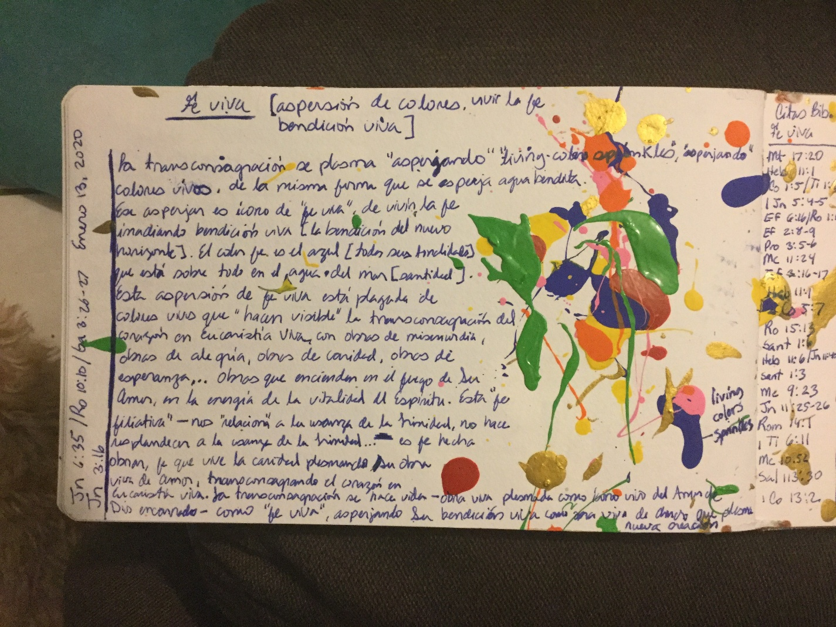
In these images you can see the creative conception of “growtcha” first sketches of a creative work with transconsecration, that would eventually become what you now know as “growtcha”:
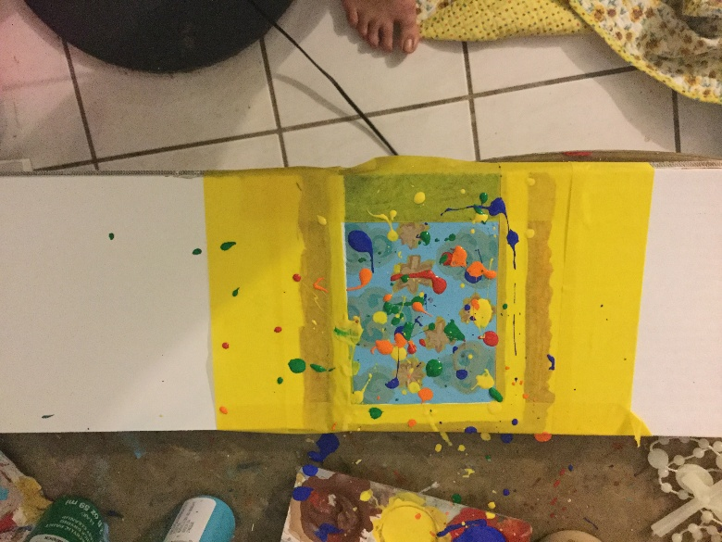
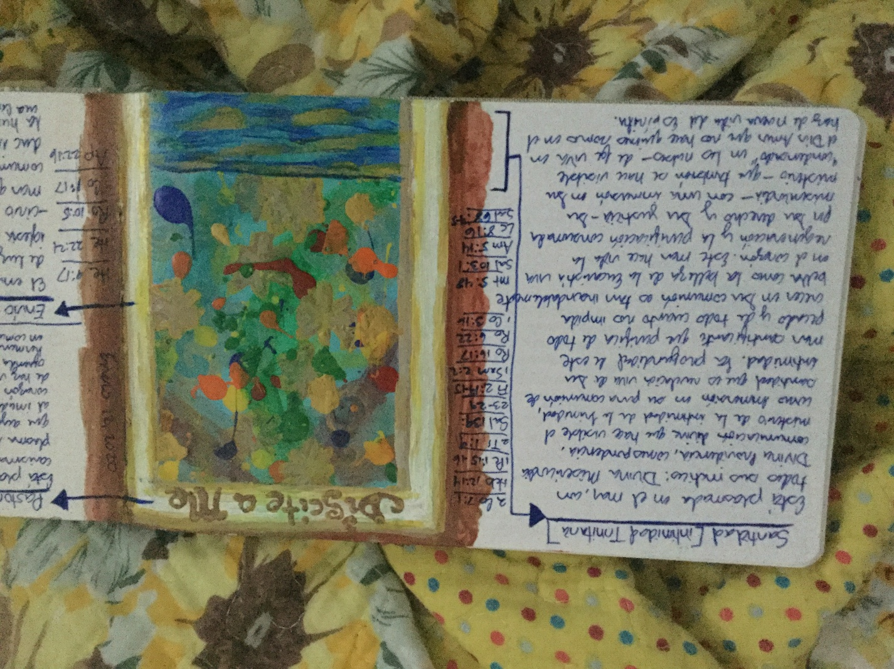

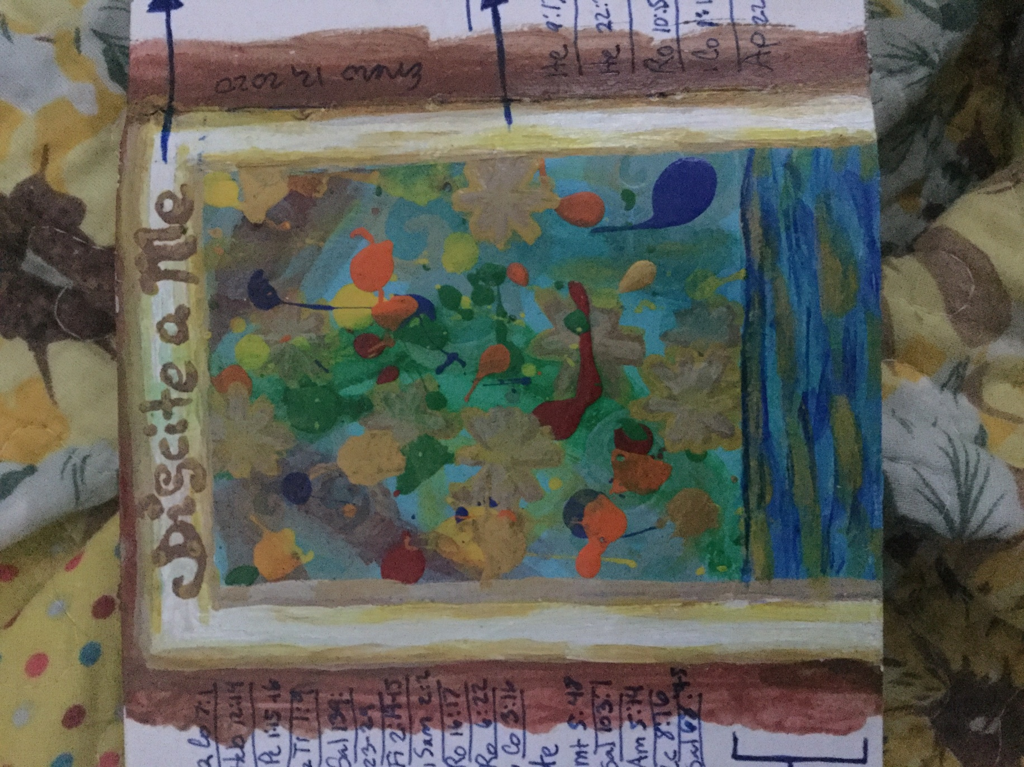
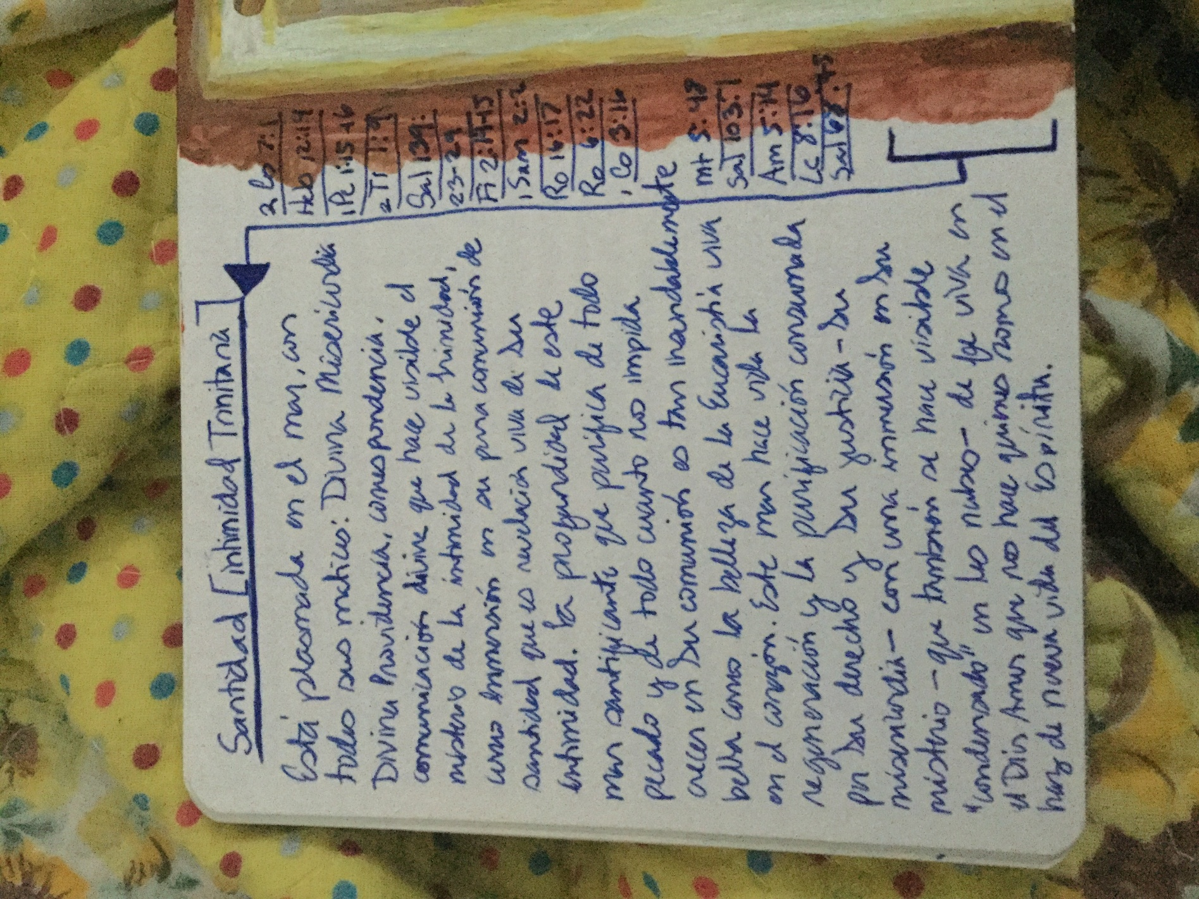
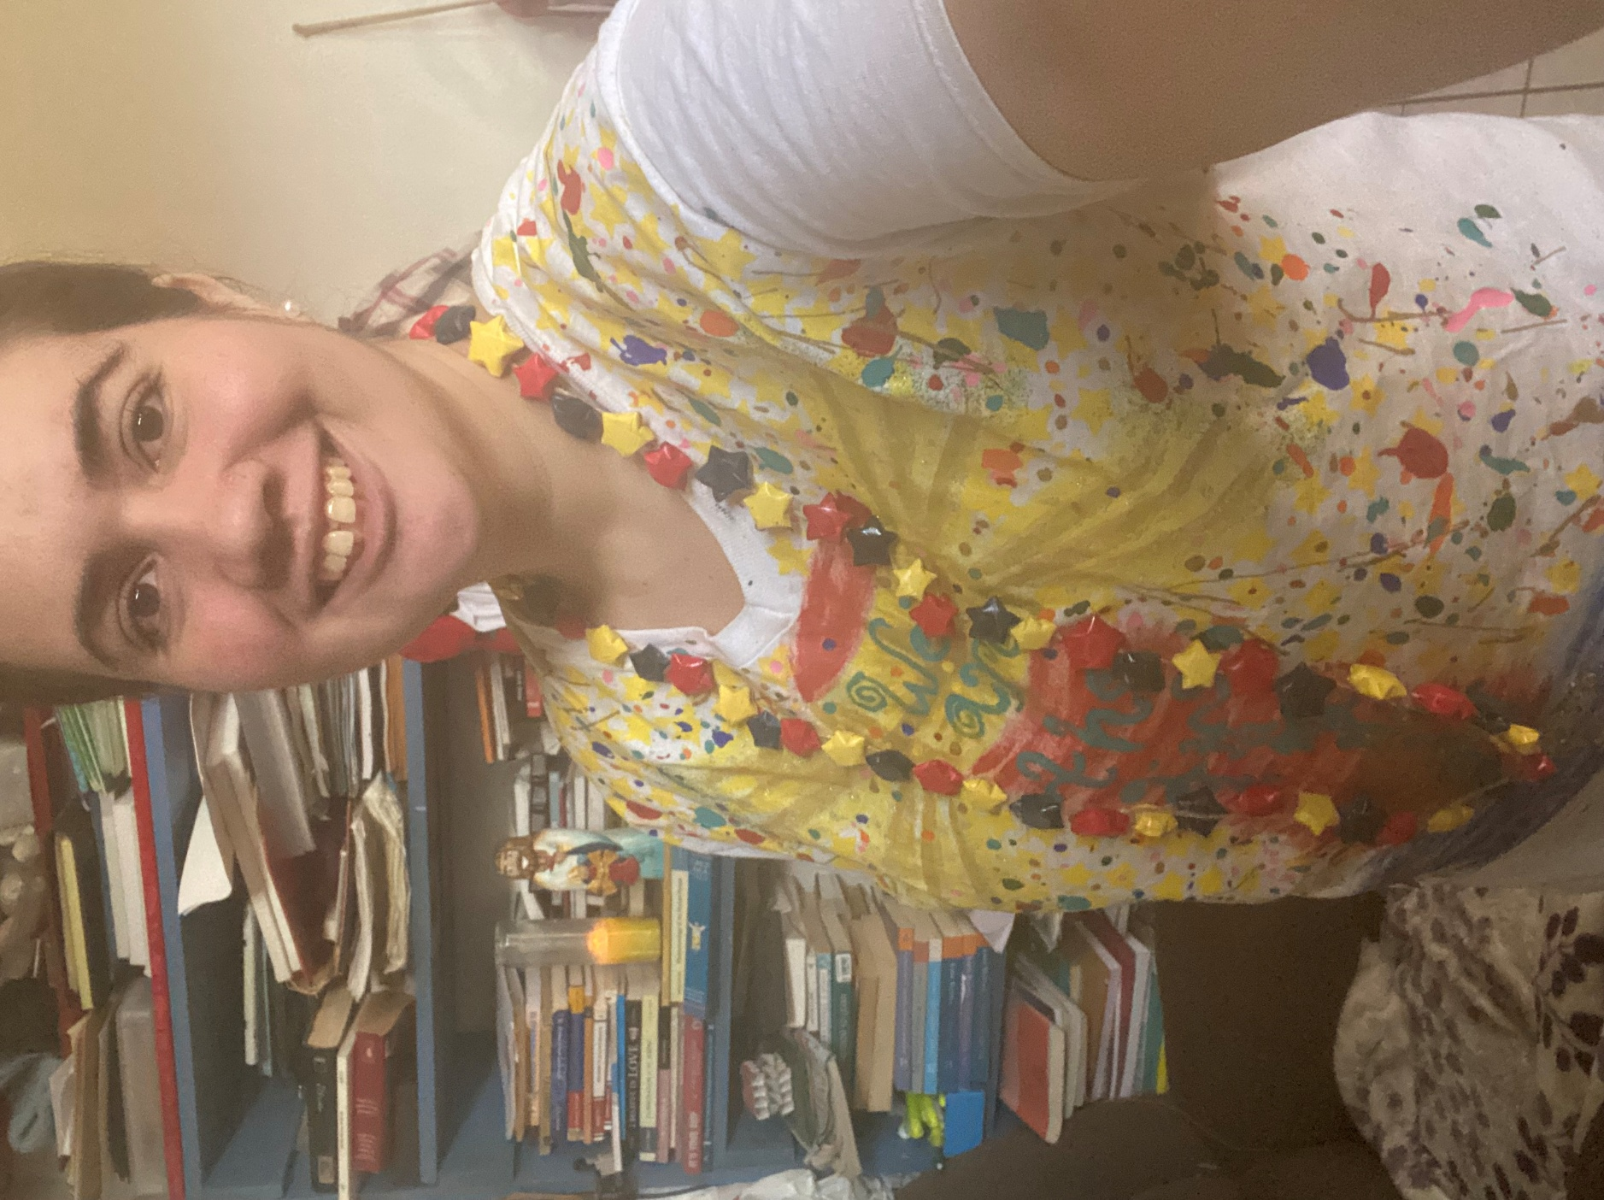
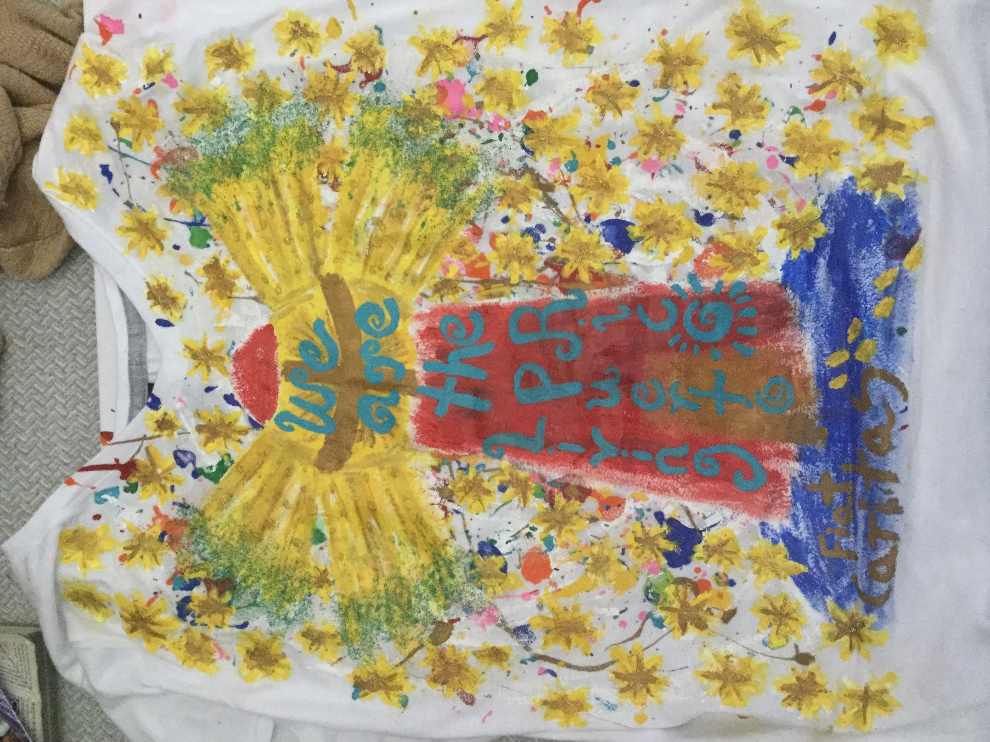

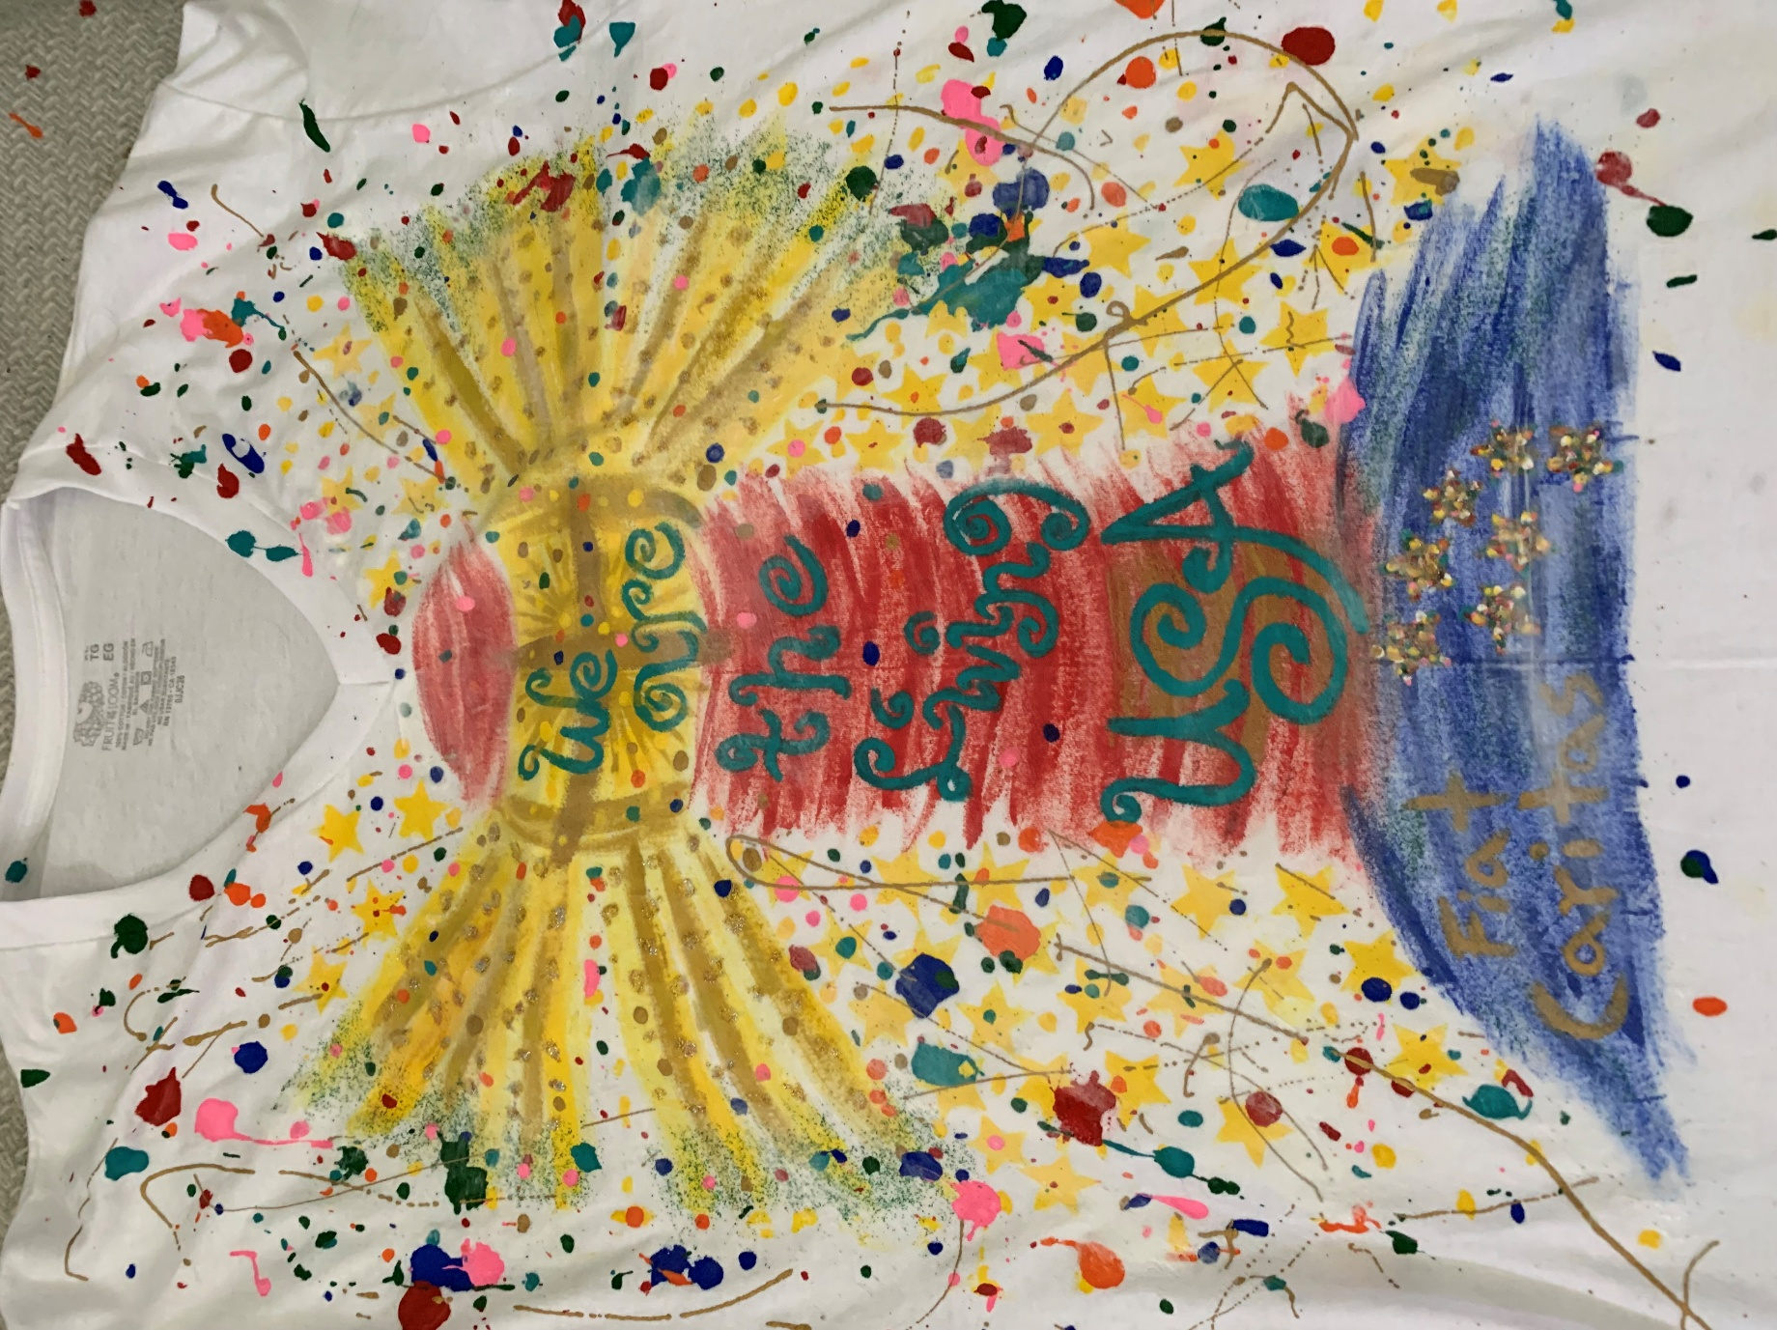
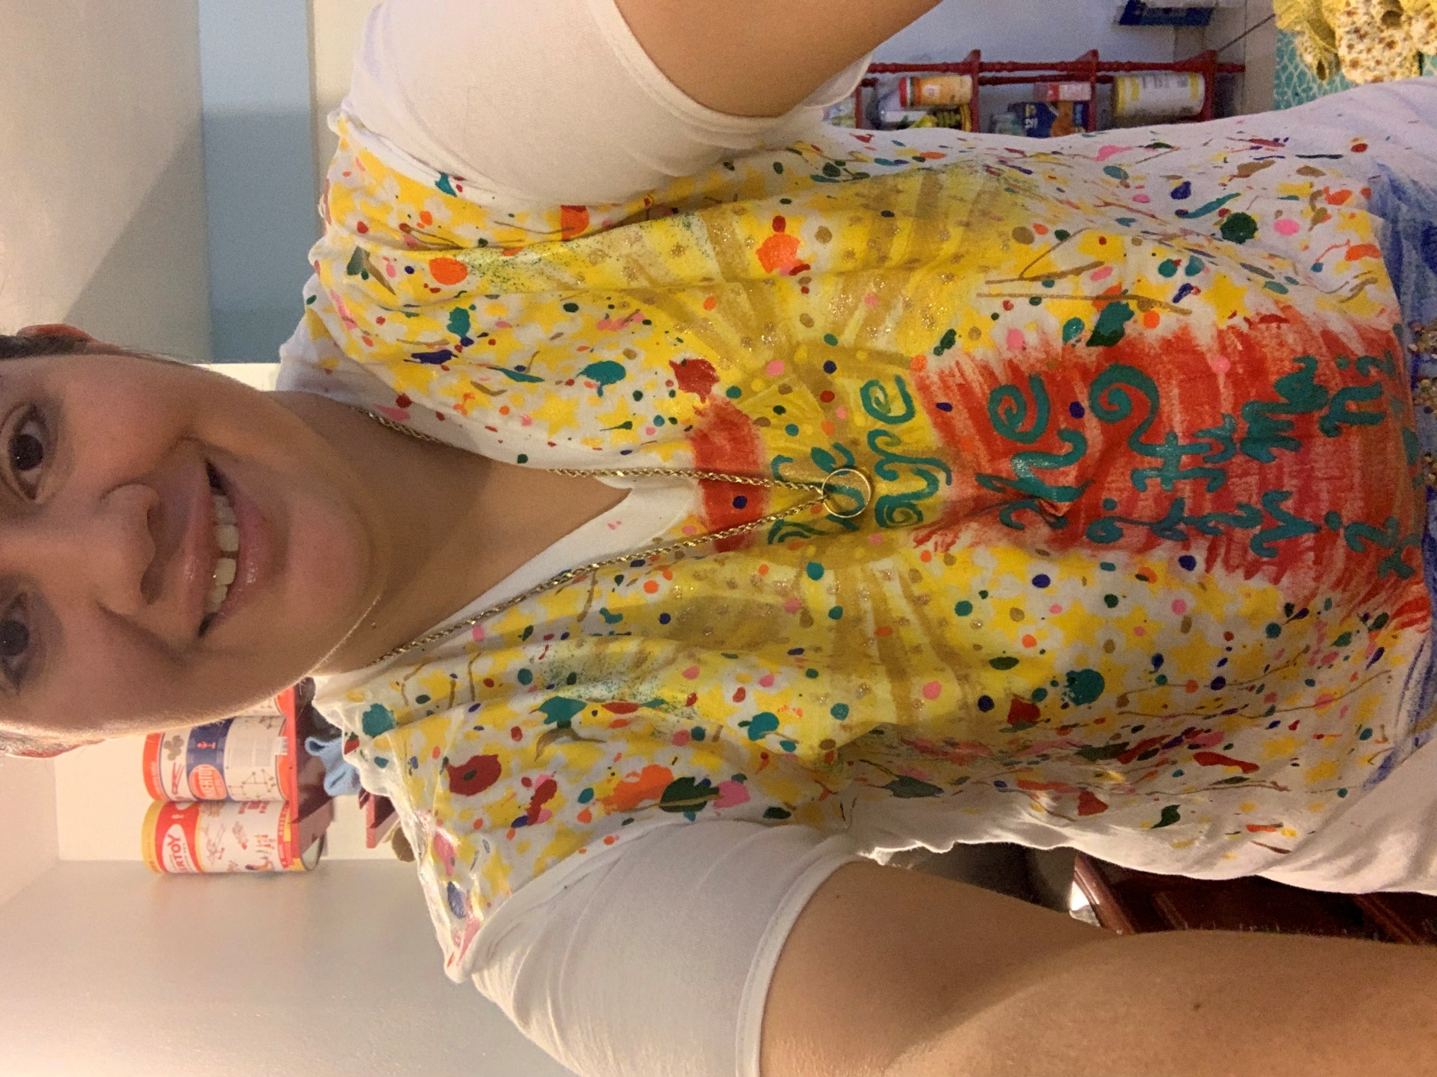
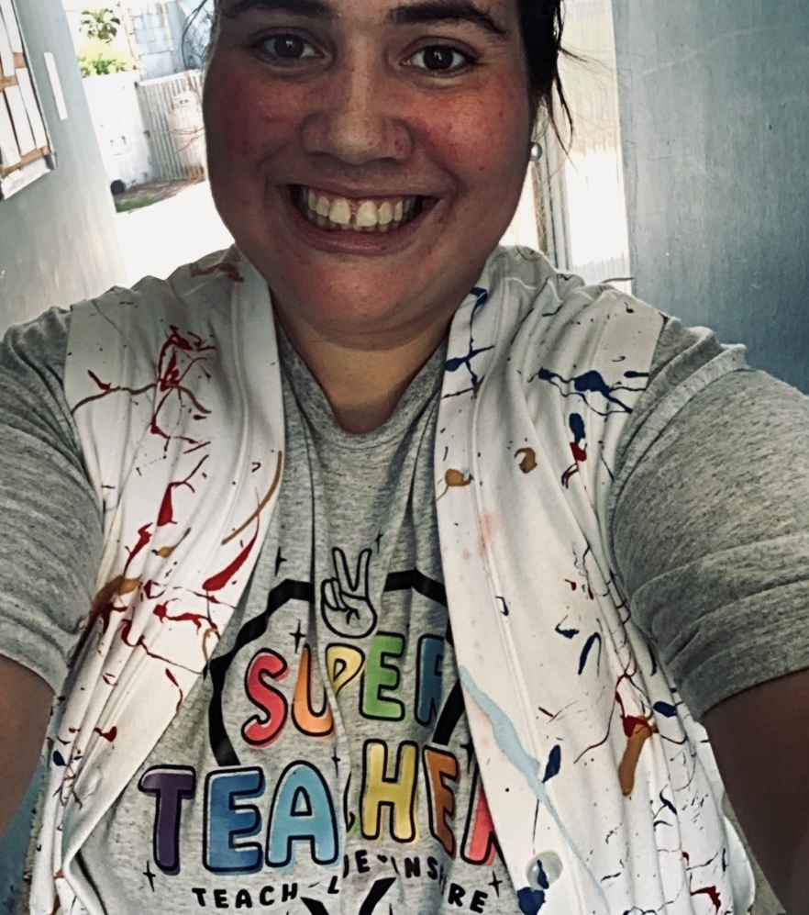
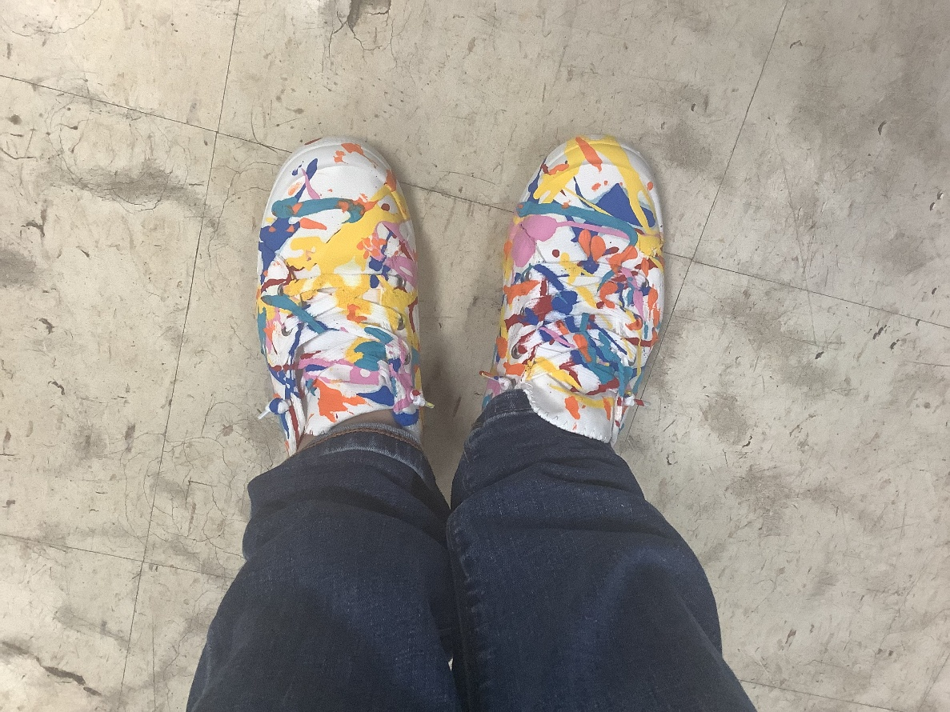
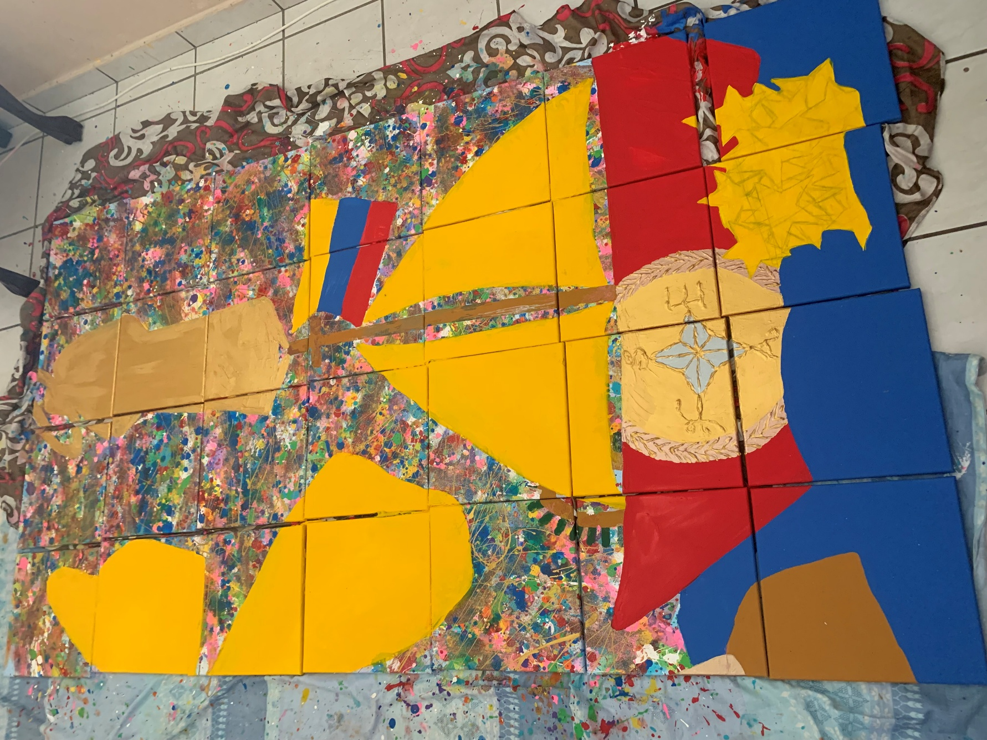

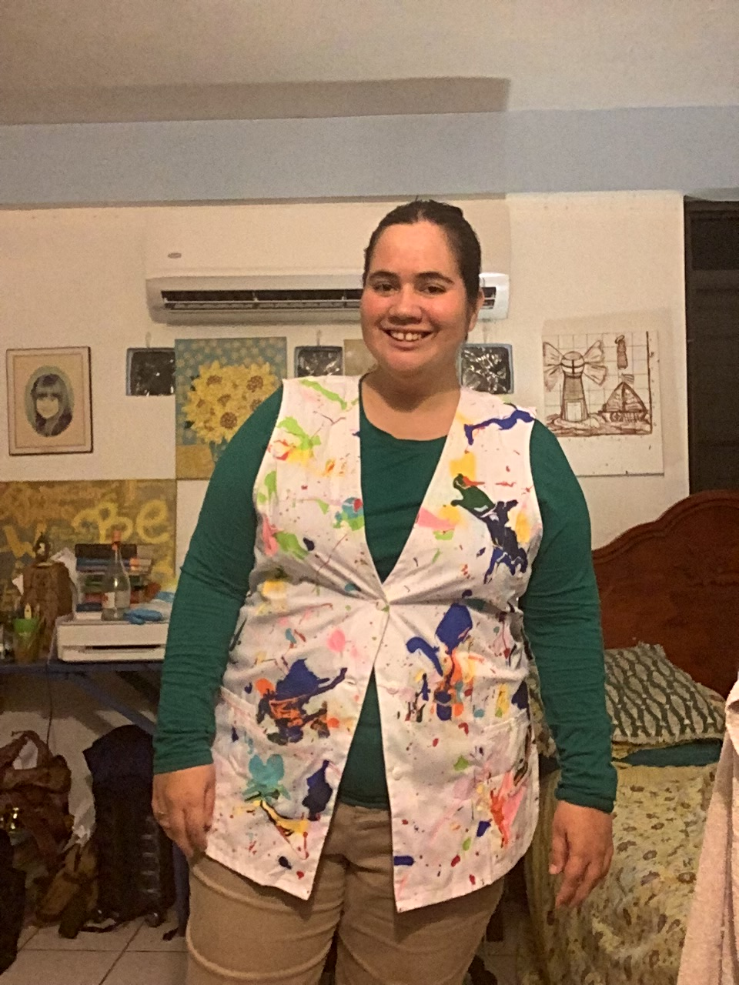

This is a growtcha rocking chair that I created as a Growthful Bingo gift for a foster care girl with autism who enjoyed rocking chairs:
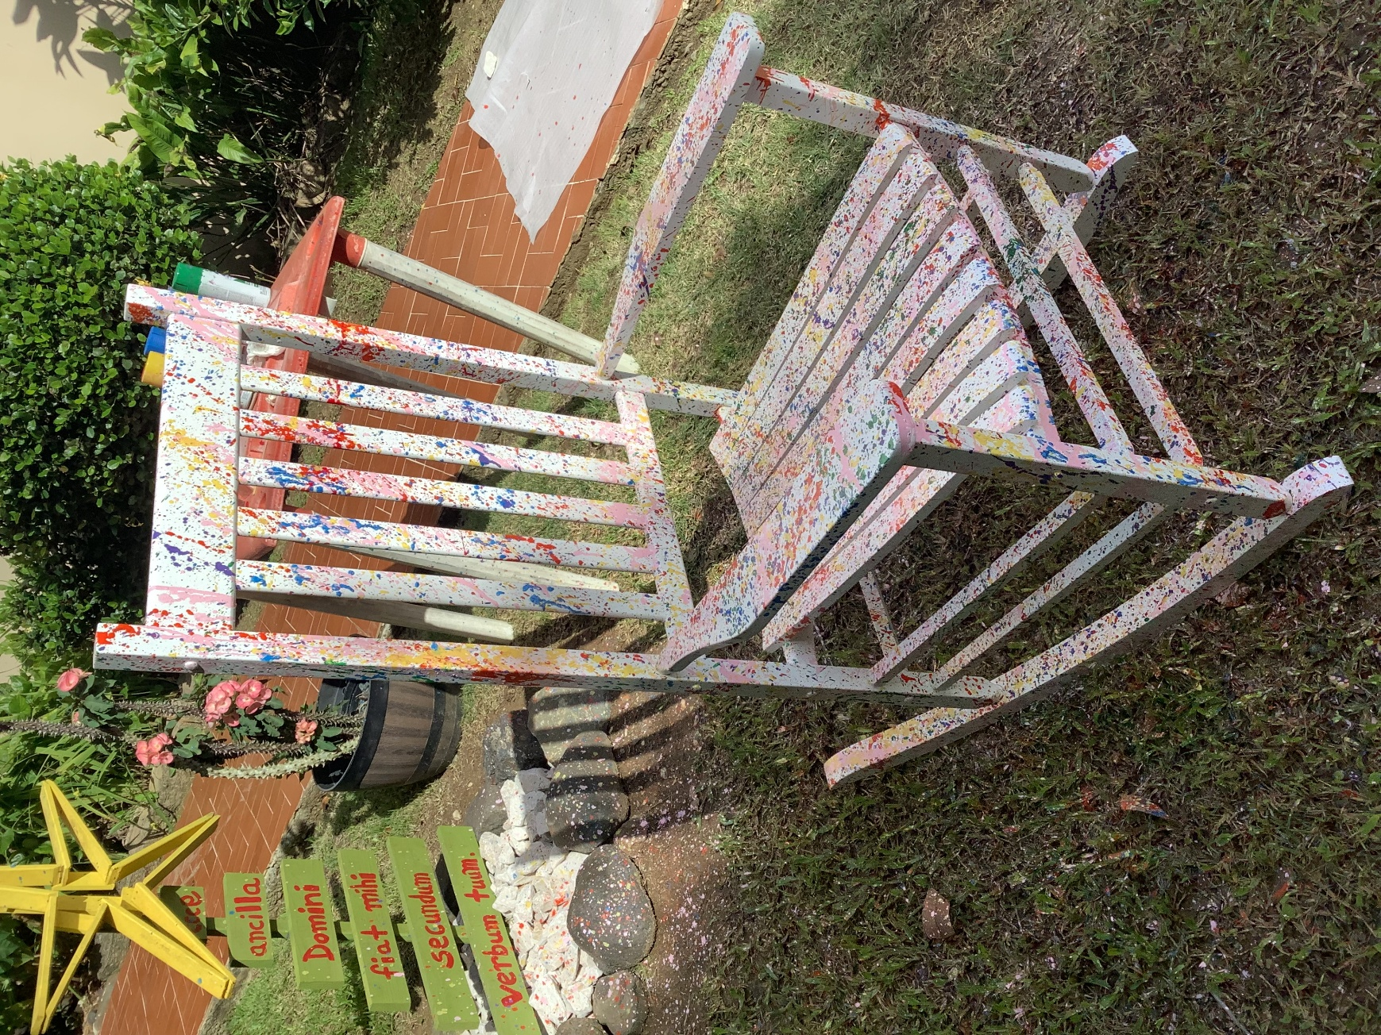
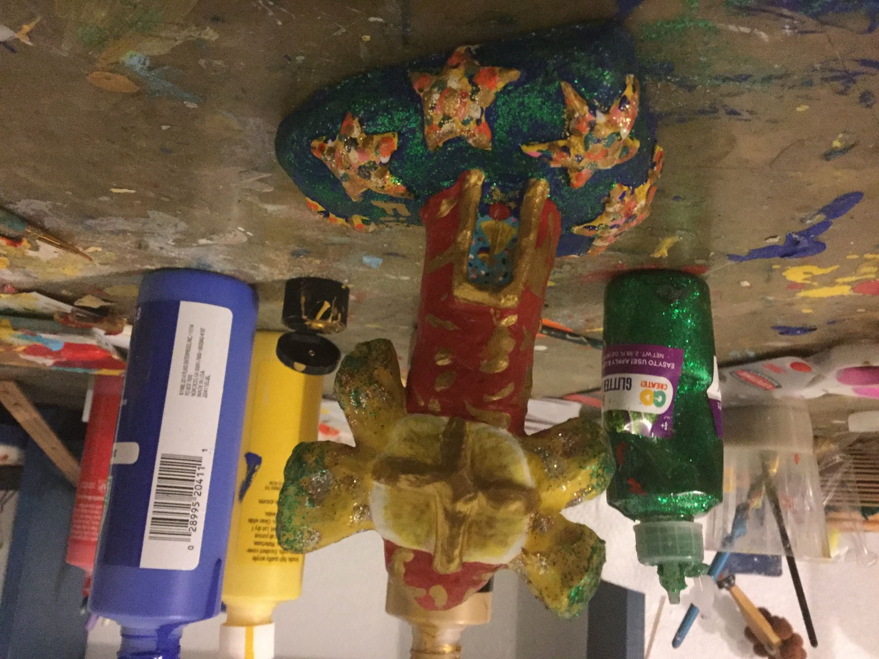
So, kids of the Puerto Rican future, as you just saw, I had been developing the creative conception of what is now known as “growtcha” for a very long time. What begun as a “transconsecration of the heart” (the base of that transconsecrated beacon you see in the picture aboe is a heart) become a whole growtched new brighter horizon line of infinite growing together in communion...but when your time comes, I won´t be able to ask something like what was just shared as New Albor Legacy celebration that is a cultural creative project to be done at the Morro: you are the ones who must ask permission to do that are the ones who administer the Morro; I have no voice on that. Jesus Charity only proposes, but you are the ones who can make it happen if you ask for it.
In case any of you don´t realize exactly what we are talking about, here you can see pictures of colonial cannons at the Morro. Those would be the “canvas” you would be transforming as a school class into a very vivid colors artwork as another Vivir el Encanto, precisely in the same way you, Puerto Rican children of the future, would be transforming the black cult to death of colonialism (sí, el colonialismo es un culto a la muerte terriblemente oscuro, como el color negro muerte) into a radiation of a culture of new albor and a whole glowful manifesto:
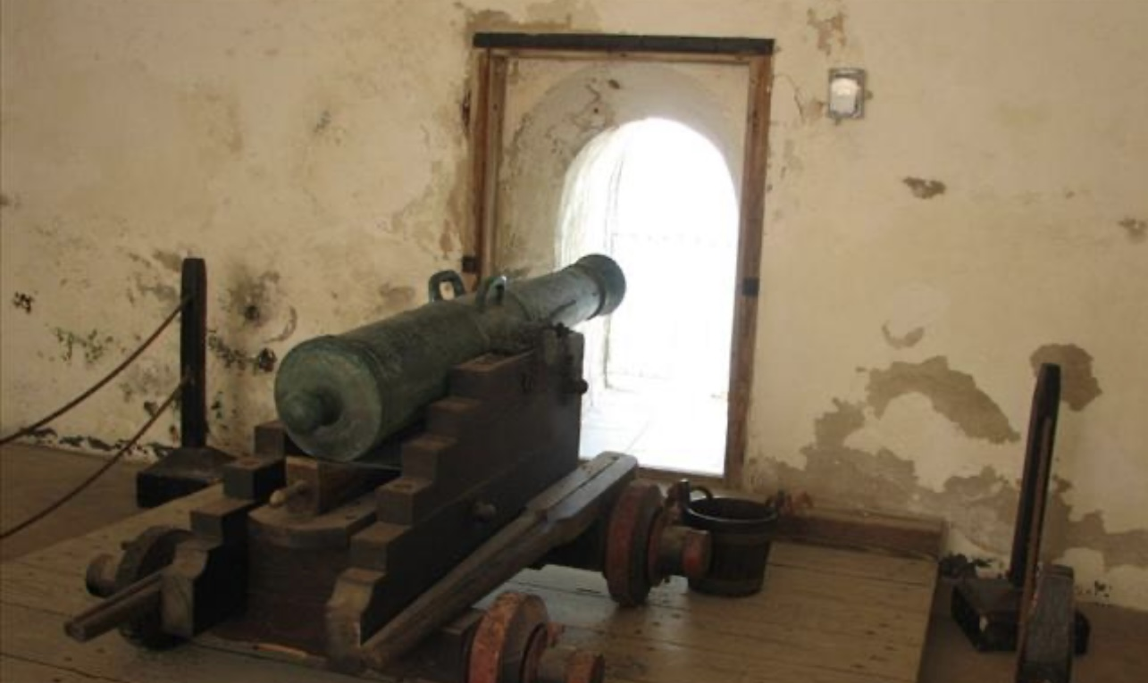
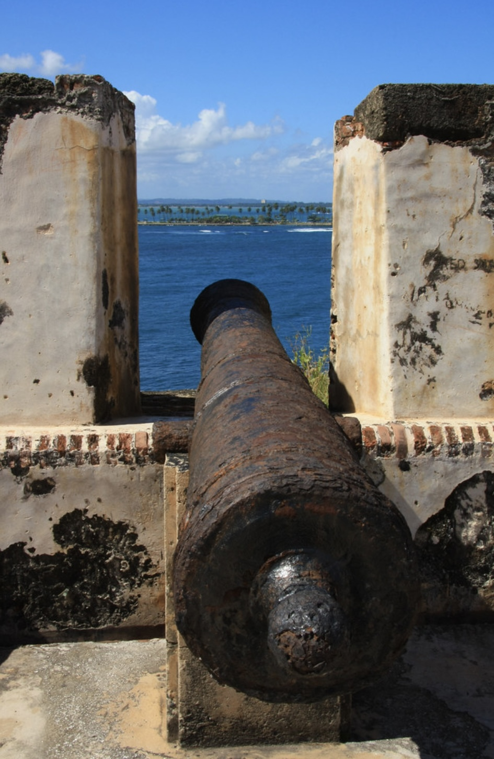
In the following pictures, you can see exactly what the cannonballs of the Morro are, in case you didn´t pay attention to them the last time you were at the Morro, or you don´t remember what they are. These would be the colonial balls you will be growtching, splashing them with paintballs that splash colorful transconsecration over what in our colonial past were used as social war weapons of cult to death:
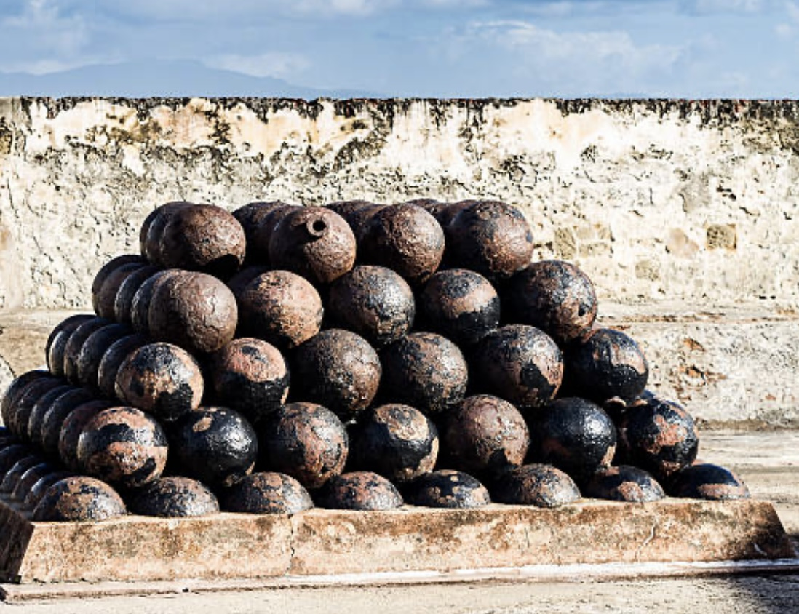
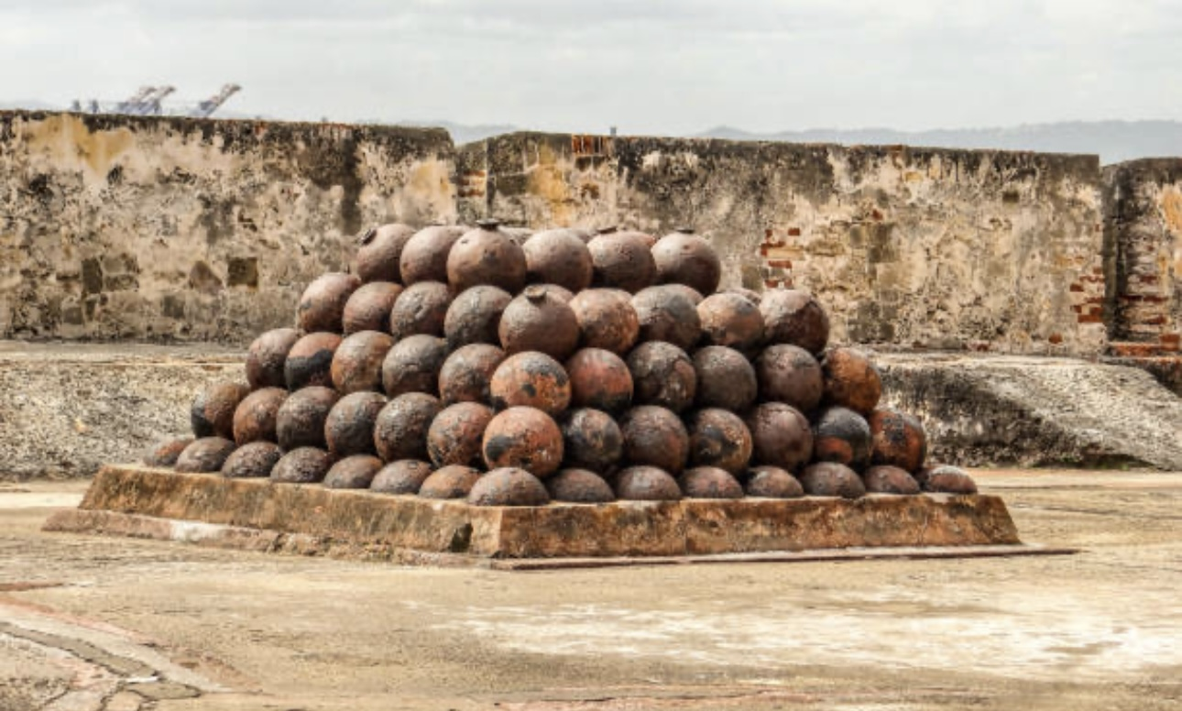
In this picture, you can see me visiting the Morro on a birthday. In the picture, I am making that gesture because I am kissing my charity alliance, given by Jesus Charity. In simple terms, I have promised Him to do whatever lives more in charity according to Heaven.
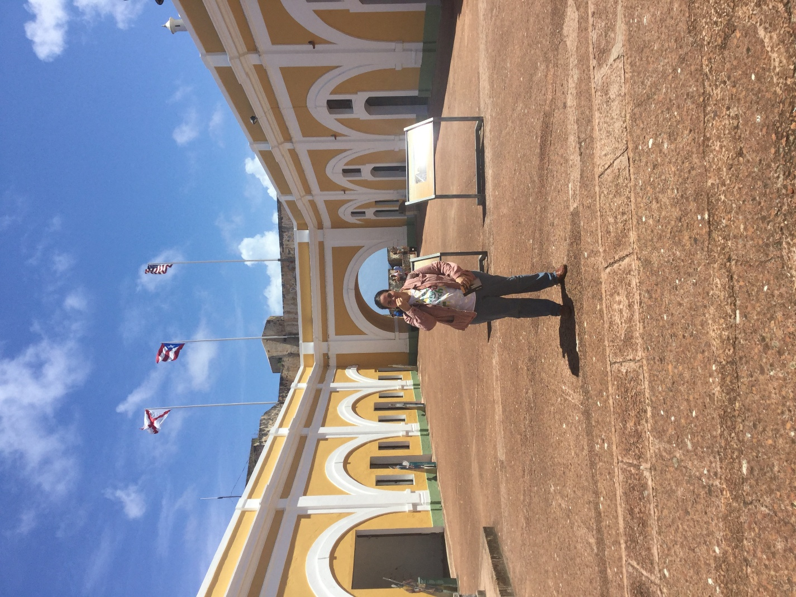
So, a way to live charity in the most fraternal way through this creative project that He is proposing, that we already suggested when sharing this creative discernment in social media, that the Morro should offer the possibility of having some fraternal picnic tables in the surrounding area for the excursions (although this can also be perfectly done putting a blanket in the grass to have the picnic, but please live even more charity with the older people and provide some picnic tables for those will have difficulties to eat a fraternal picnic seated in the grass), especially the school excursions, that make a reservation to visit the historical site and that can be planned that someone prepares the fraternal meal that will be provided: let them reserve fraternal wraps, now known as growtcha wraps, that it happens that the tortilla is also growtcha style, like the cannon balls. Nothing can be cooked at the Morro, but it can be ordered and brought to the site each day for the excursions that are reserved as part of a fraternal picnic, along with their historical site admission fee excursion package. Yes, there should be a family excursion fee, a school excursion fee, a general admission fee and a tourist excursion fee for this because for being able to do all this you need a very creative and accurate logistic coordination in many senses: you need to know in advance how many growtcha wraps you will be needing to order each day to whoever provides them to be taken out at the Morro site to be eaten as a fraternal picnic anywhere in the grass surroundings of the castle (no, you can´t eat anything inside the castle, don´t even suggest it, this would be take-out growtcha picnic bags… ); you would need to handle daily excursions with lots of fraternally efficiency to coordinate exactly how many visitors you can handle per day and guaranteeing that a minimum daily reservation of excursion packages are reserved for locals only and that schools excursions remain having the priority in reserving excursion packages, because you let everyone simply come by whenever they want and ask growtcha wraps whenever they want, it’s a historical site that needs to be cared well, you can´t have absolutely everyone at the same time wanting to go to do growtcha to the cannon balls then having disappointed children at the entrance because they couldn´t go inside to do growtcha due capacity limit reached, after they came from far away... You get it: you will need a proper excursion reservation system, because all this will require a very different approach to admissions processing at the Morro.
A percentage of the profits from the excursion packages could even be used to invite elderly people and socially vulnerable populations, such as a whole foster kids' home, to a fraternal excursion to the Morro, with everything paid for by the Morro administration, including sharing a fraternal picnic with them. Living in fraternity and helping to grow together in communion with those who need it most is part of the essence of these growth experiences and excursion packages, which aim to celebrate leaving colonialism behind and creating a new cultural legacy that will be passed on from one generation to the next. In the case of the Morro, that New Albor legacy will be celebrated more and more growtchfully, quite literally.
Let me show you literally what is meant by “more and more growtchfully.” Please see again the cannonballs that you would be growtching in the Morro. Growtching the cannonballs means: you will be throwing colorful paintballs at them, transforming them into very vivid colorful paintballs. Because the cannonballs would be very meaningfully painted in color peace white to then be growtched, seeing the growthcha tortillas that would be used for the growtcha wraps sold for the fraternal picnic excursion package along the admisions reservations to the Morro will be very helpful to you for imagining how the growthched cannon balls would become, because the warp tortillas are also white. You can see the growthcha wrap tortillas in the next pictures:
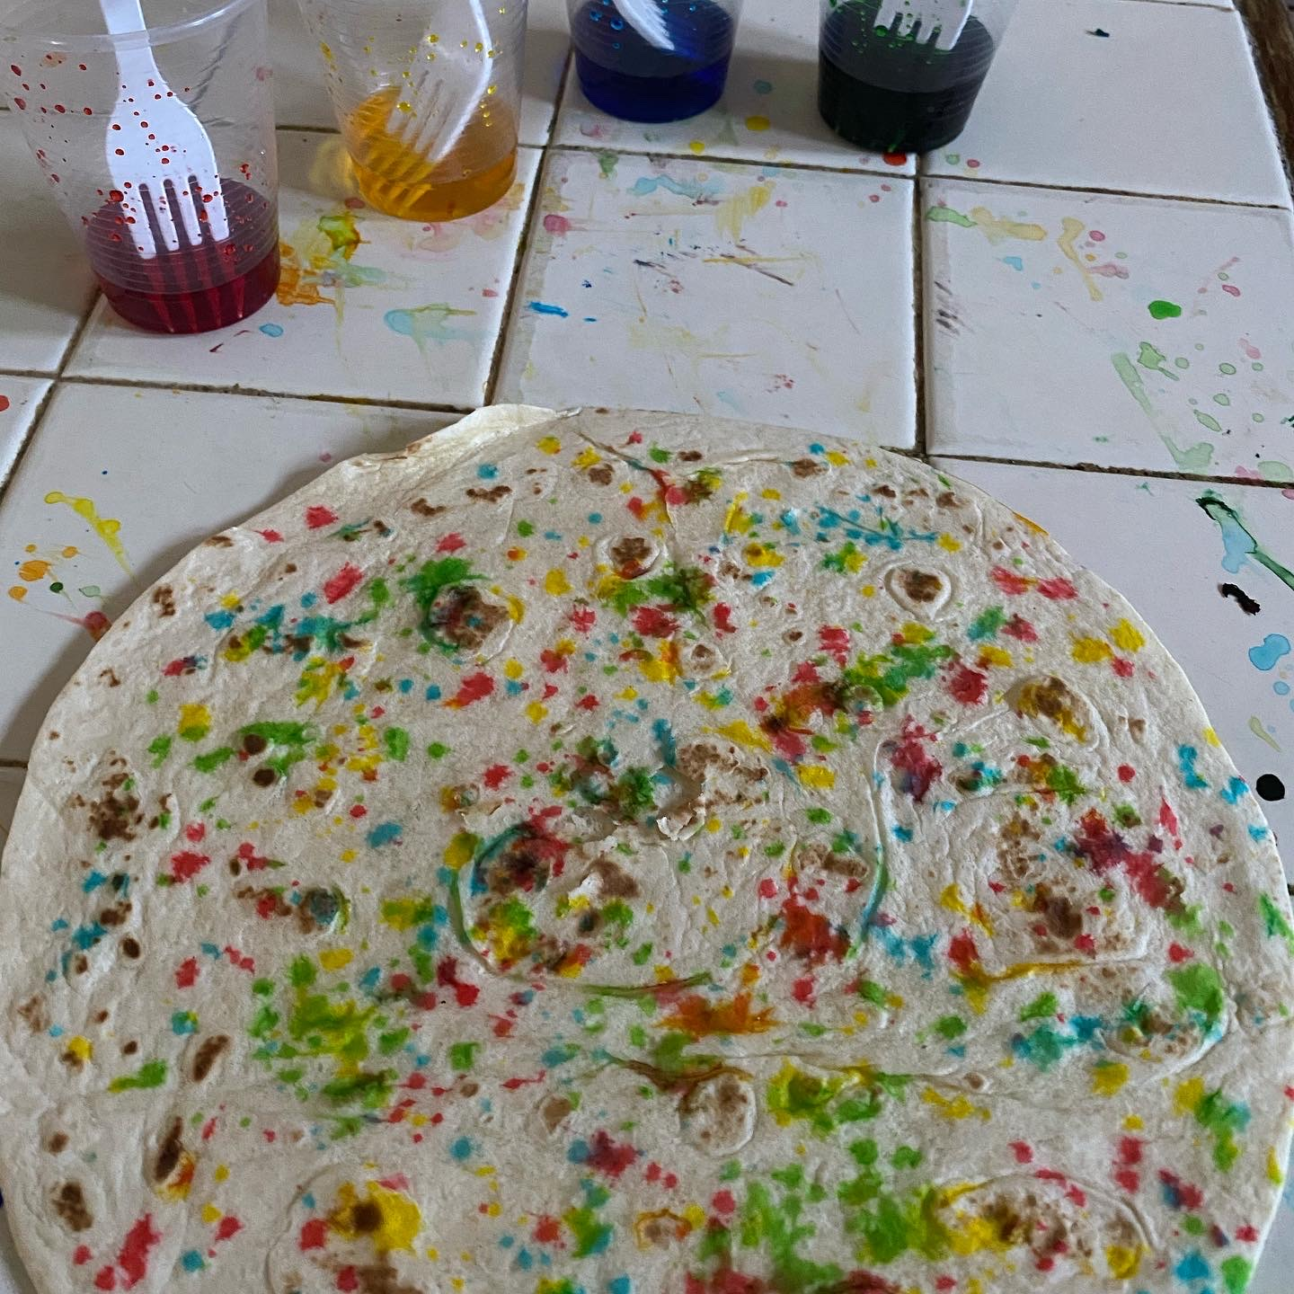:
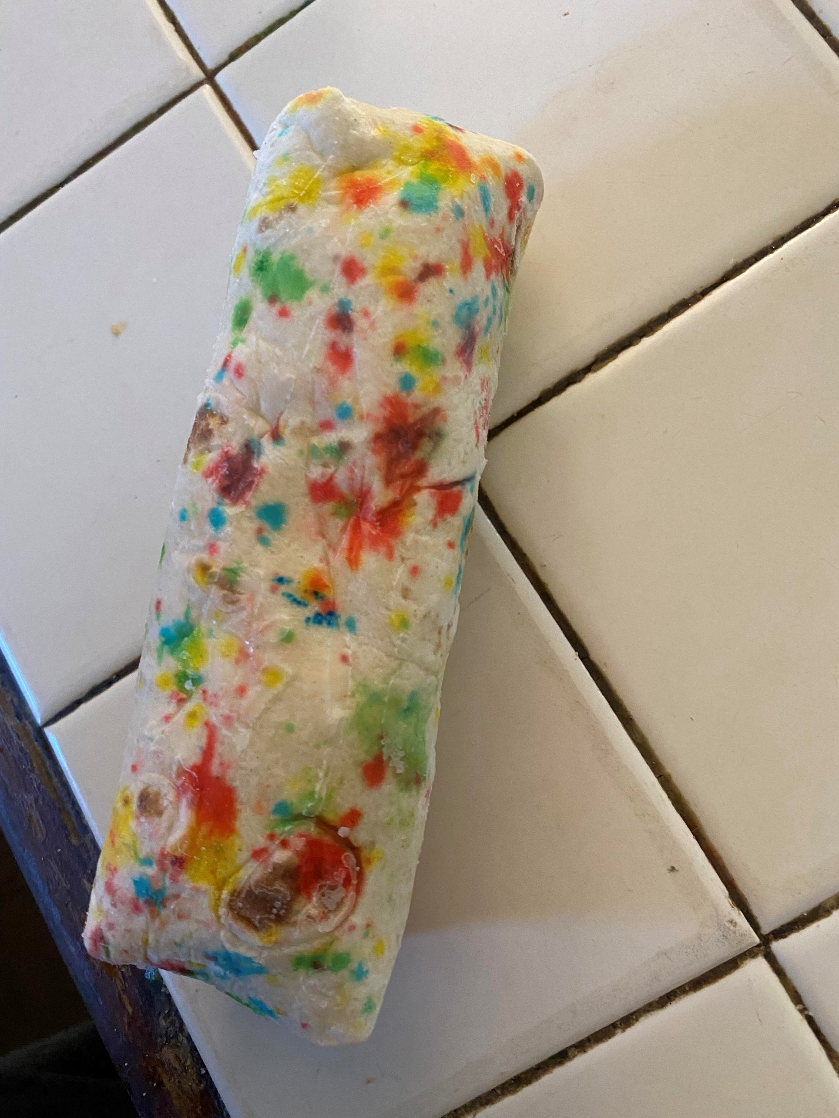

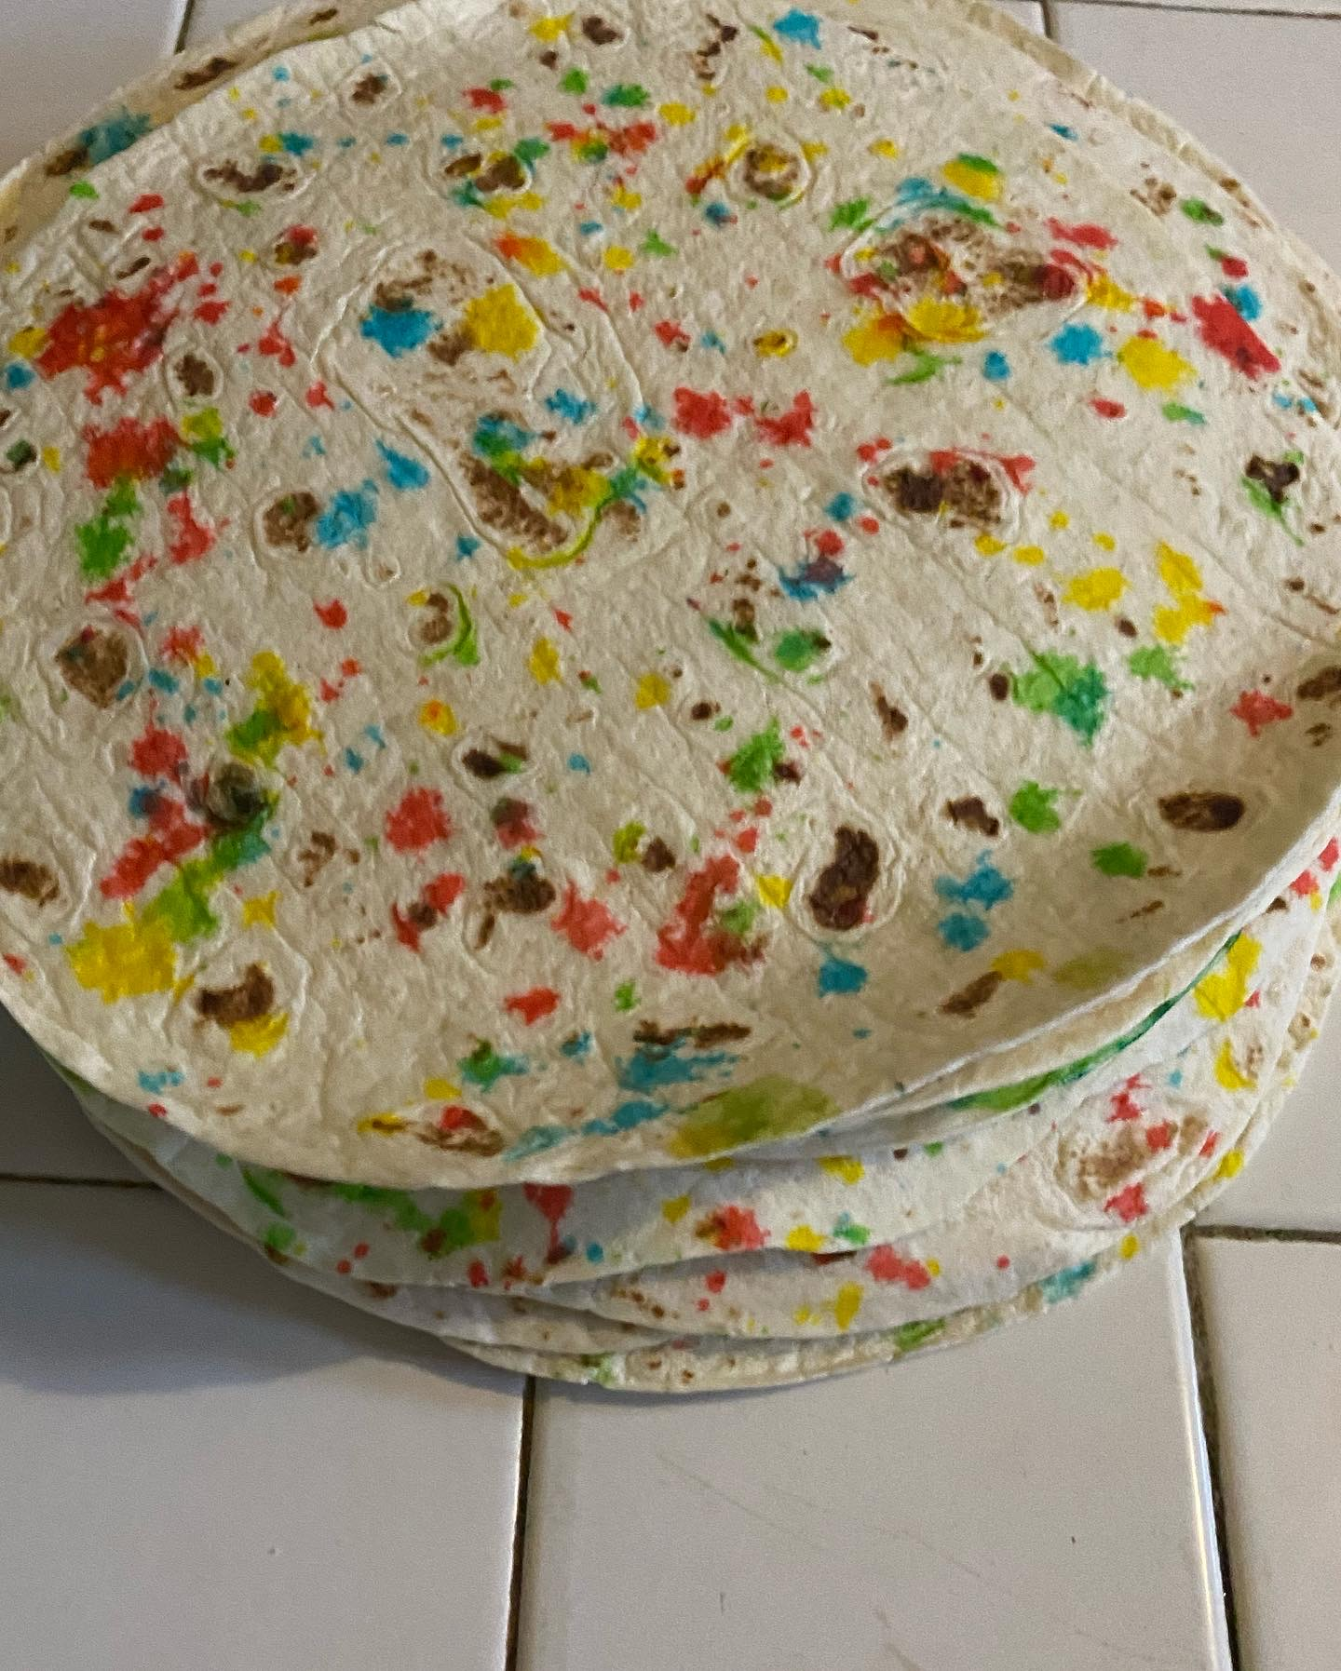

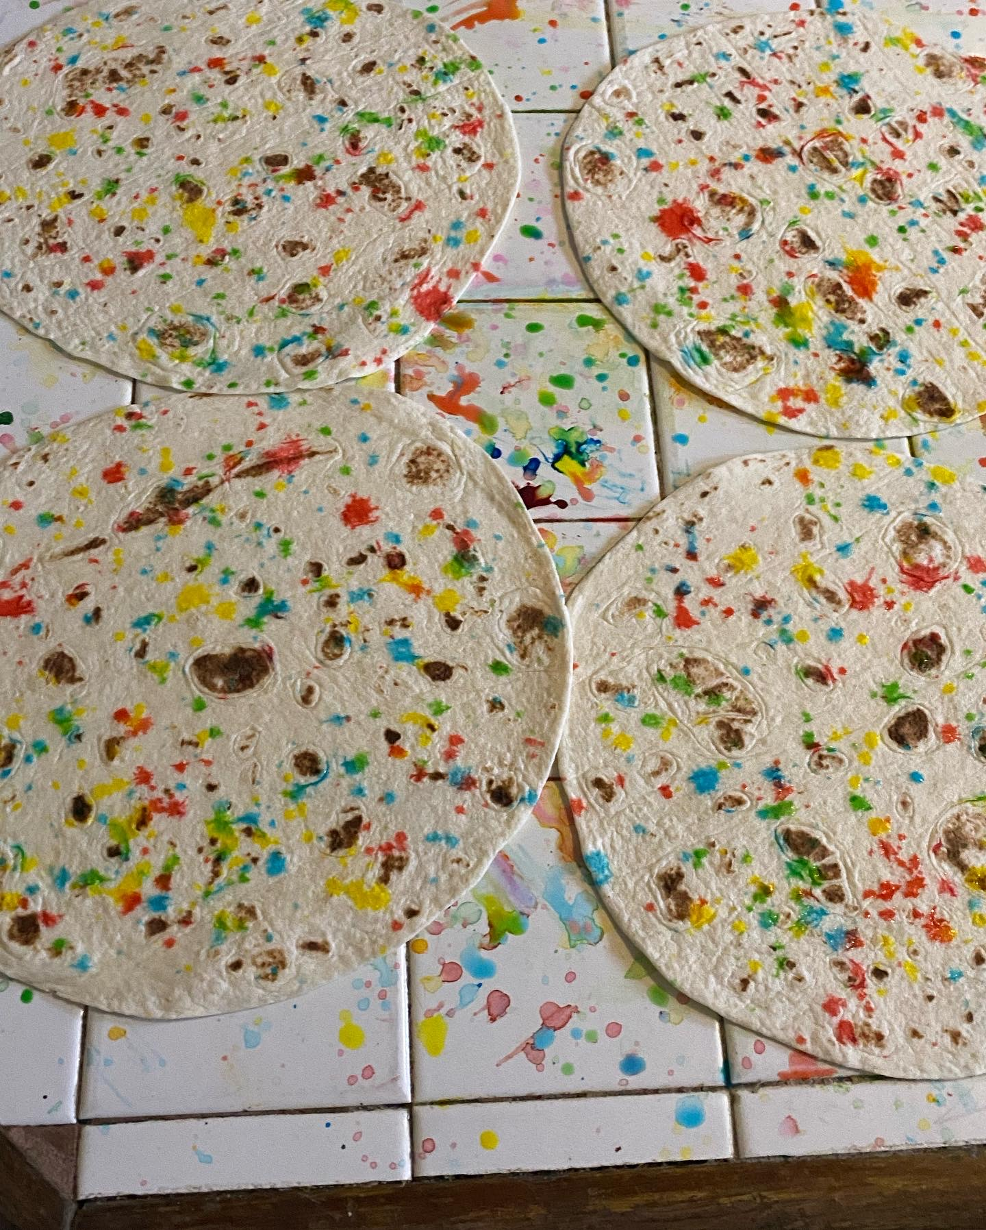
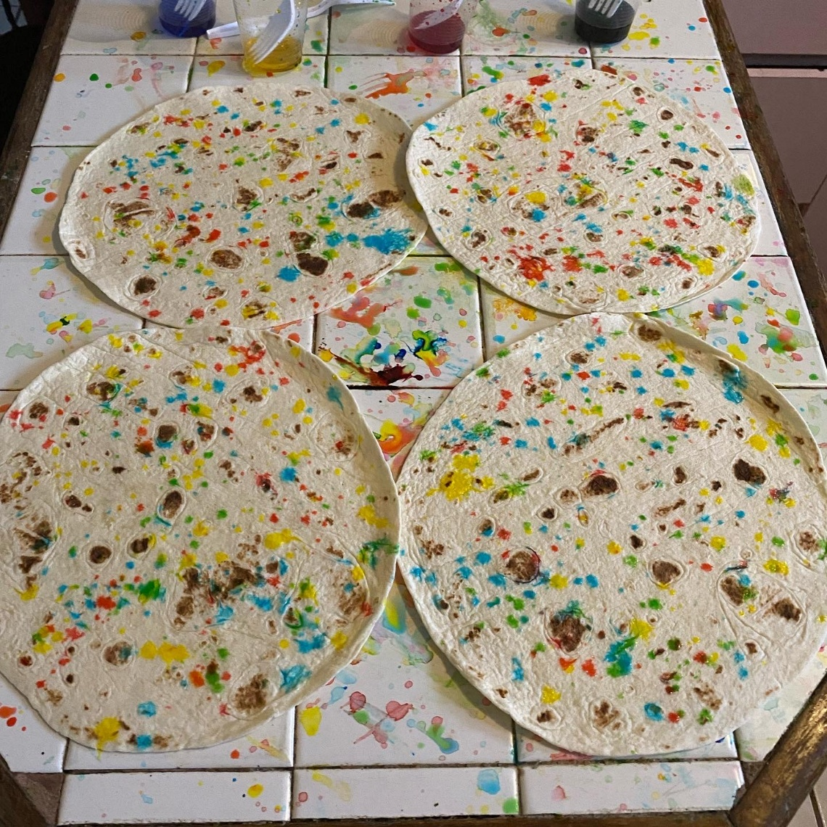

Why did I tell you, beloved kids, that I had been praying this, but I had no idea what Jesus Charity meant, until now?
Well, not too long ago, I did a concrete growtcha artwork, as we are calling it now (remember: I did it as “transconsecration” before) to leave in front of the Jesus Charity carving that is in the room where I am writing this: I growtched the replica of a colonial cannon, that I already mentioned before, but without still explaining what I am explaining here about it. Here you can see more detailed pictures of the colonial cannon:
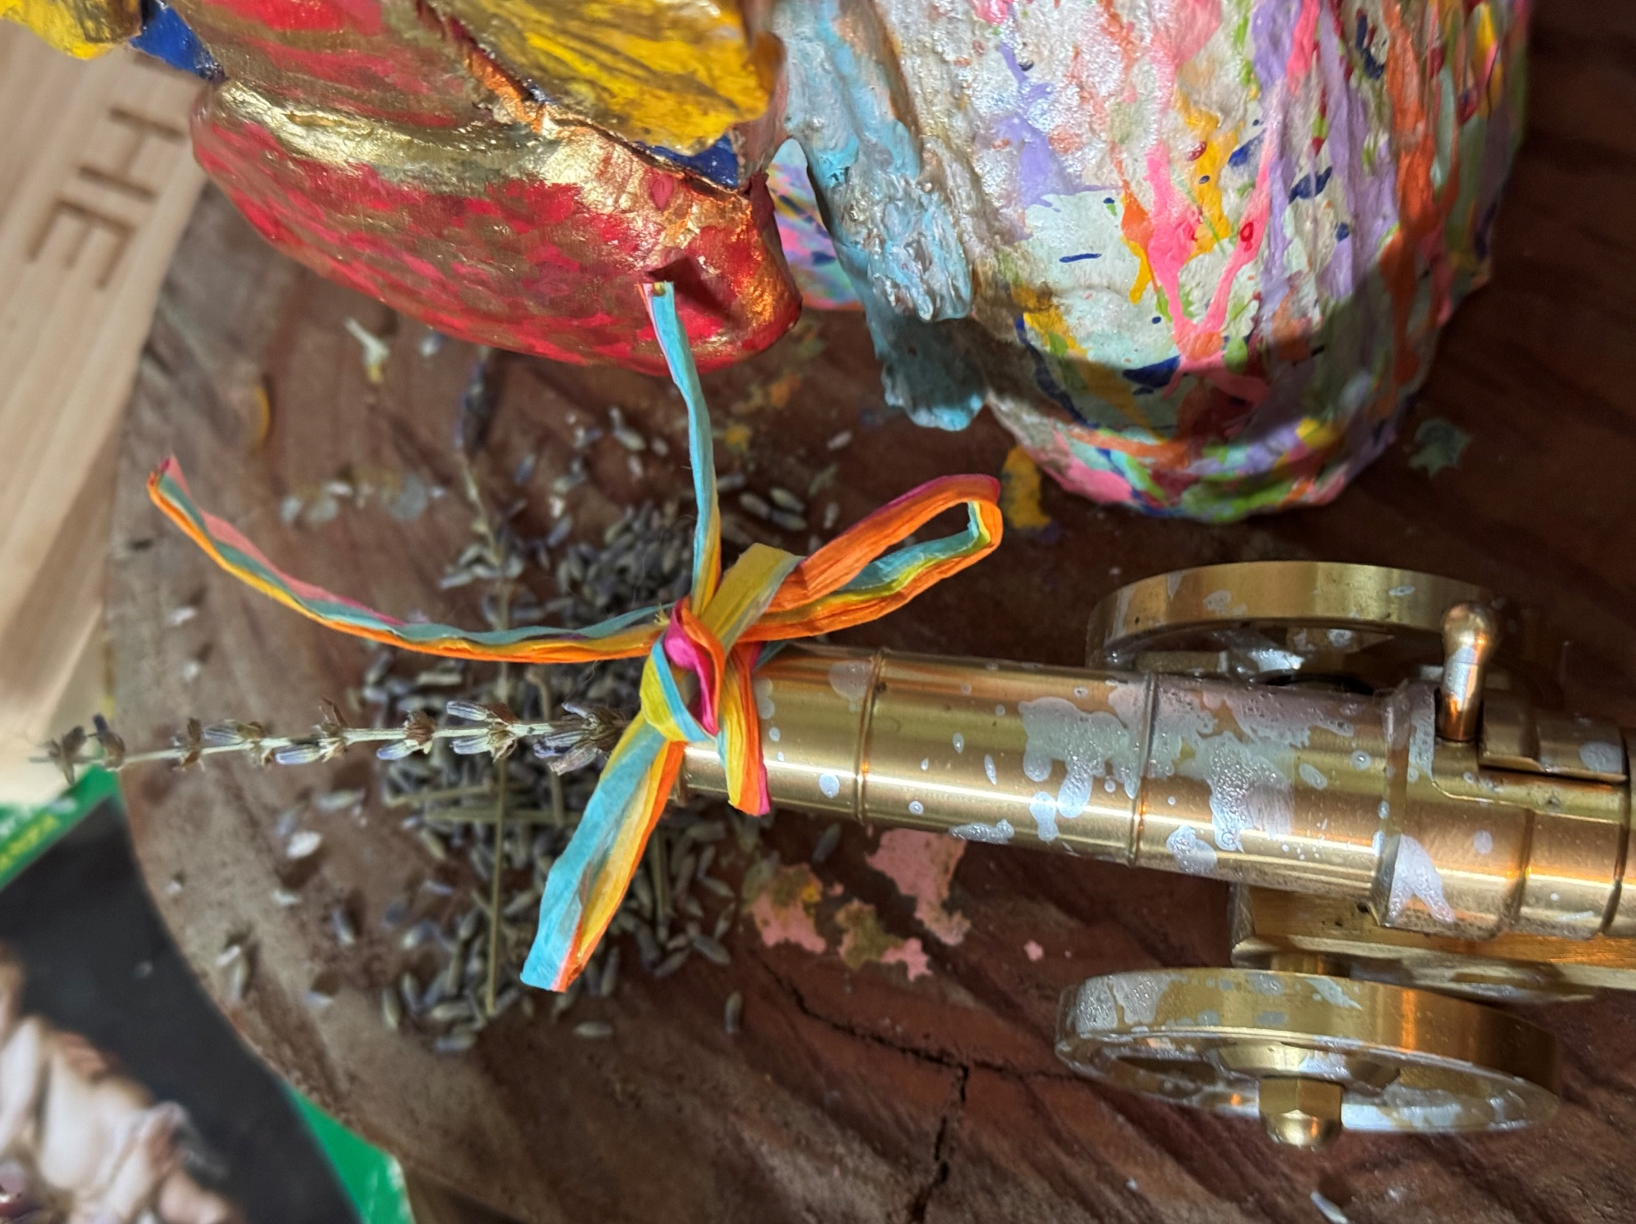

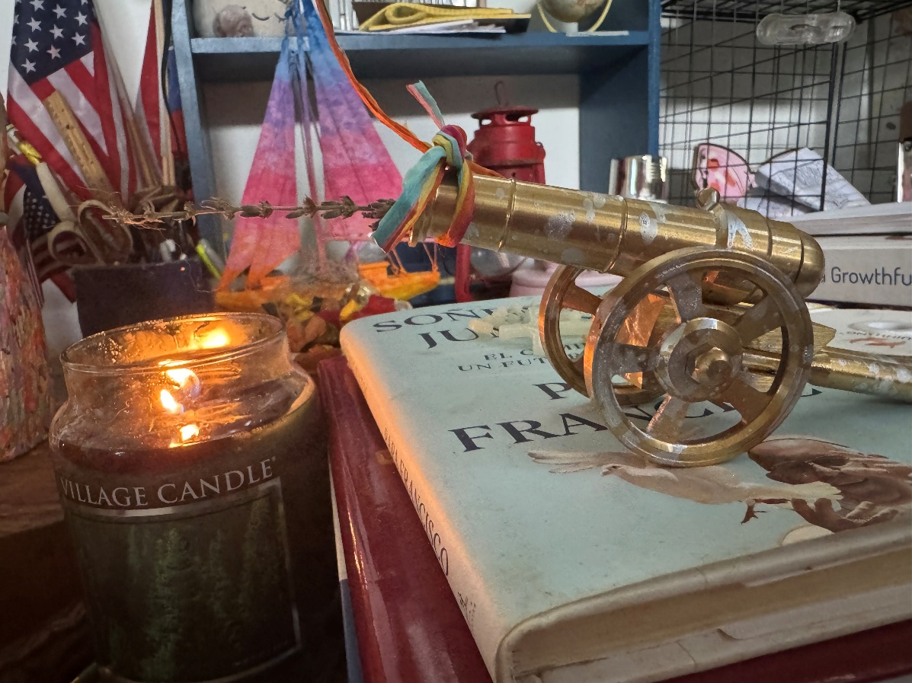
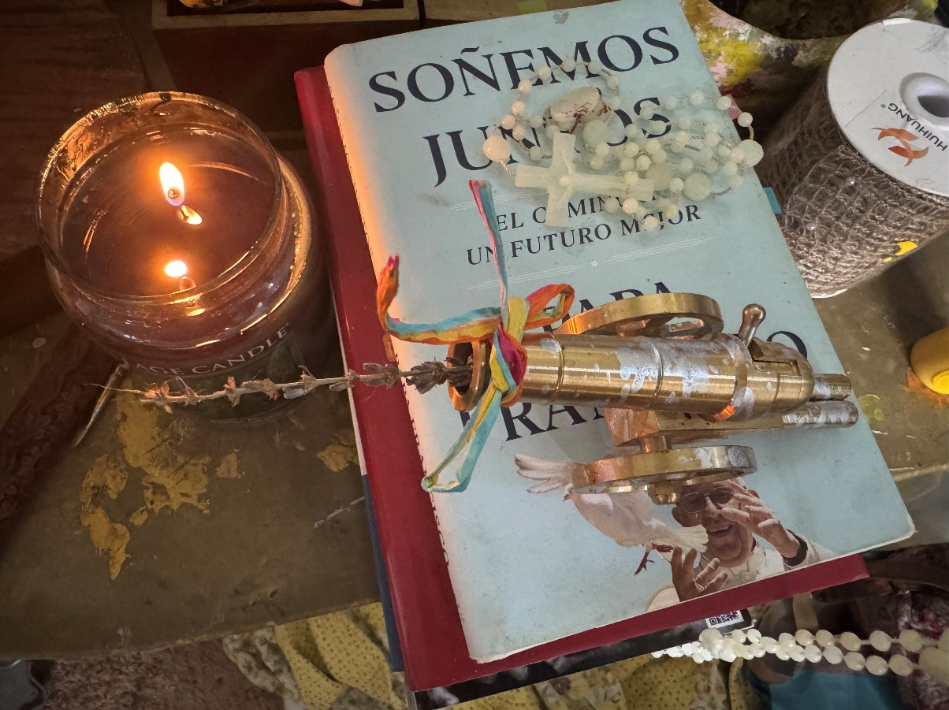

So, because the growtcha cannon had been in front of Jesus Charity for a while, I had been praying for the end of colonialism for a while... but at some moment, He envisioned lavender coming out from the cannon and being placed inside it, so I put a lavender straw inside the cannon. I simply did it. In our minds, lavender is “realeza del Cielo”, a sign of a loving harvest, of a loving kingdom... but it had nothing to do with the cannon. It simply looks beautiful there, and that was the reason I thought I was asked that: simply for enjoying beauty...
As what was just envisioned unfolded —what we said about all citizens becoming unconditionally recognized as persons with inherent dignity, as it would happen with a Teens of Puerto Rico vs United States Government— I silently understood the reason behind Him envisioning lavender there: the true end of colonialism is not the end of Puerto Rican colonialism: it’s the end of the lack of constitutional unconditional recognition of personhood and its inherent dignity. I should have understood this when He envisioned an International Personal Sovereignty Day. I didn´t. I understood the meaning of the lavender inside the colonial cannon right now: the end of colonialism is the beginning of constitutional unconditional recognition of all citizens as persons with inherent dignity. That is what the lavender inside the growtched colonial canon means, and it´s beautiful. Yes, something as colonial and dark in the cult of death sense as a colonial cannon can be transformed into a radiance of His New Albion. Unconditional grace began to fall exactly as I wrote that.
Guess what! The mac and cheese we were talking about has a similar colonial conversion story behind it, although, of course, Thomas Jefferson wouldn´t have explained it in the same way I am going to explain it now.
The Founding Fathers —Remember: Thomas Jefferson is a Founding Father— did have an ideal of freedom that is worth praising, but they were not able to achieve it as rt is thought. They gained independence, but true freedom comes when people can form themselves according to their own vision of the American Dream. The fact is that no person can be unconditionally free in a land where there have always been some “others” being denied the freedom to create themselves according to their own self-determined personal nature. As long as you keep needing someone to “not be” to you being able to “be” ... you are not being, you are simply reacting to the “not be”. If to be the United States, the states need to keep governing as their “not be” for them to be able to “be” who they claim to “be” (in this case: the claim that they are not “colonies” anymore, but their government way still remains colonial: there had always been the need of have some not assumed as “We the People” and remain civilly slaved to USA BE a “functional free government”)... sorry, you are actually reacting to the not be instead of actually BE. The very same reactive not-being principle had been observed consistently in many instances: the more reactive you are, the less being you are.
Just to say another example of reactive non-being as contrast: some Puerto Ricans of intense nationalist bias have this very particular tendency to define themselves as “Puerto Ricans” simply because they are NOT like Americans in the USA. Notice the reactive non-being clearly manifested: what they are needs an “other” (the USA) NOT BEING for them to Be... They hate colonialism and claim to be anti-colonial, but act even worse with ideological colonialism when they exclude ANYONE who lives a Puertoricanhood notion that is not according to their nationalistic idea, and even try to enforce their nationalist ideology on children too young to understand they are being indoctrinated. No, these people never mess with individuals of a higher intellectual caliber who can immediately see that they are manipulating the children´s intellectual possibilities, so only the nationalistic version of the story seems to be the “real” one. They supposedly keep “being Puerto Rican”, sometimes even claiming they are the “true Puerto Ricans” or “the most Puerto Ricans”... but they can only “be Puerto Ricans” constantly reacting against the USA in whatever way they can, including denying the “Puertoricanhood” of Puerto Ricans in USA who doesn´t speak Spanish but identity themselves according to the Puertoricanhood inherited from Puerto Rican emigrants who moved to USA. When you say to these Puerto Ricans that it would be wise —or at least prudent— for them to remember that most of the Puerto Rican population already lives outside of the island, so there is no reality possible at all in such nationalistic ideological attitude, in whichever way they may apply it... brace for the reactive wave that will come next, because they can´t avoid to keep reacting precisely to their lack of being of their own, they need a not be to them being able to be, and sometimes they can reach very absurd extremes to react against anyone who lives another kind of Pueroricanhood notion that is not a nationalistic ideology, like chanting a song about being a “país” in a mass they know you were planning to attend and the song being totally original song, not the kind of songs of a standard repertoire in a parish: it was a song composed not to adore God (that was the façade), but because they knew I would be in the mass and needed to affirm their “ser país” (their supposed “be”) unto not allowing me to be freely, not even in a mass (yes, ideological harassment can happens and do happens in parishes, I have faced it face to face, and I just mentioned a straightforward example of hundreds of possible along the years). Everybody knows I have explained plenty of times: Puerto Rico NO es un país. A quien necesite un reality check que busque el pasaporte y corrobore que dije bajo “citizenship”. A reality check is often necessary, especially for those who have never or rarely traveled internationally or know to contrast what they assume as “cultural reality” with the cultural reality outside the island. As someone who had lived a long time outside the island, I do know that for all the civil senses, Puerto Rico is NOT a nation in the political sense, nor will ever be. Whoever in the island refuses to acknowledge or accept their citizenship as “American,” according to their passports, especially after the statutory citizenship is put to an end and colonialism ends... I am absolutely the first one letting them know, as I had always told so in nationalistic environments: you should have the right to move back to Spain, because you never chose to be colonized in the first place... but remember, if that is the argument behind your “Puertoricanhood...” refusal of not acknowledge your right to an equal American citizenship... that Spain colonized you first. Therefore, it would be prudent to approach the anti-colonial argument behind your refusal of American citizenship due to “colonialism” and affirm that the Puerto Rican´s truest citizenship is Spanish and we are meant to become another Comunidad Autónoma of Spain (that is especially told to those fond of call their municipalities as “municipios autónomos” without those not knowing the Spanish cultural horizon being aware of what is behind such kind of expressions... and the supposed autonomy will be totally gone as soon as you need any type of federal funds, for that you won´t be “autónomo” at all...) with meticulous attention to any cultural fallacy. Yes, there can be valid reasons to renounce American citizenship and claim you are supposed to be part of Spain, I am the first one aware of that... but anticolonialism is not one of them, not after around 400 years of Spanish colonialism.
Kids, don´t be like that. Affirm always as who you truly are, instead of locking who you claim you are into reacting to who you are not. So much time is lost in reactive non-being issue... and wherever the USA wants to recognize it or not... their whole government system has been built upon reacting against a “British colonial government” at the same time they became harder colonizers than Britain... What has defined the American way of government is “not being a monarchy like Britain,” and they needed to colonize more extensively to claim to govern better than Britain: yes, we can colonize best... at the same time, we claim we are states, not colonies... As it can be seen, a colonial way of governing is still a massive issue in the USA, no matter how much “states” —not colonies—they claim to be, and whether they recognize this, bigger kids, or not.
The truth is, as it has already been said before: as long as some are not considered part of “We, the People,” as long as it is normalized that not everyone is seen as an equal person, absolutely no one will be free. Look at this quote shared in one of my classes:

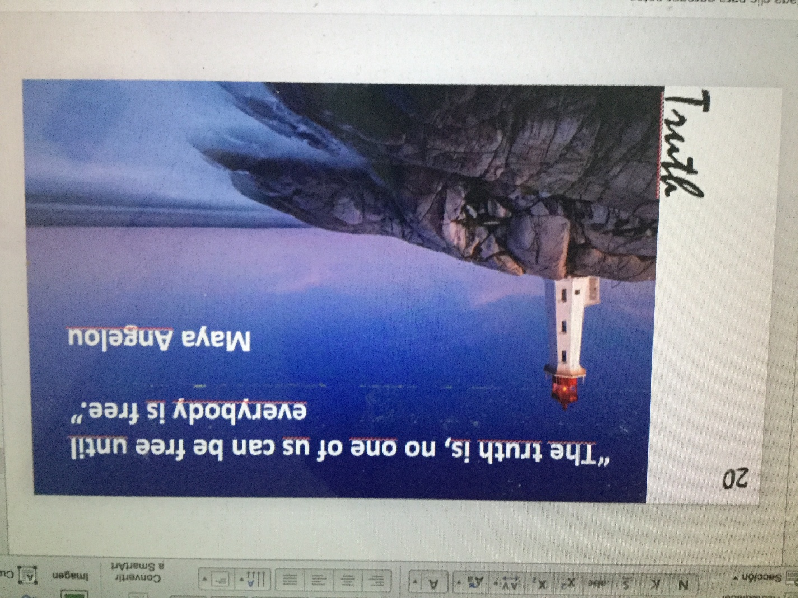

I only shared those thoughts to let you debate what was just explained, if you want to, bigger kids. You don´t need to agree with me... but be sure of this: whoever of you achieves that personhood is unconditionally recognized by the civil Constitution... you will be the ones liberating the land of those who claim to be the land of the free. The Founding Fathers envisioned a land of the free, but the unconditional recognition of the freedom of all to be who they are and who they are called to be remains pending achievement, and where there is no way to be who you truly are and called to be... don´t call that being free. Call it “being molded”. At some stages of creative development, molds can be handy... but at some point, the mold must be left behind, even broken like a chrysalid if necessary, and you must embrace the freedom of shaping a way of being on your own, a way of being that is personally yours, not merely a consequence of being molded or a reaction against whoever molded you.
As I have already said, Thomas Jefferson is a Founding Father, and what he did with macaroni and cheese is a tiny, subtle spark of such creative freedom and vision among those who founded this nation.
You see, kids: Thomas Jefferson spent time in Europe. There, he knew the meal of pasta mixed with cheese. He brought pasta with him back to the USA. Still, he did not exactly replicate the European method of making macaroni and cheese (which involves grating the cheese over the pasta). What Jefferson did was BAKE the pasta with the cheese ADAPTED TO AMERICAN INGREDIENTS, and the macaroni and cheese was born: recipes began to appear in American cookbooks in the early 1800s, blending Old World technique with New World accessibility (cheddar instead of imported Parmesan; elbow macaroni instead of imported Italian pasta). The American twist came as people replaced European cheeses with cheddar, turning it into a softer, creamier, and family-style comfort dish. As you may notice, kids, his adaptation made possible the eventual progression to a wholly American dish. You see, he did not react against European pasta, nor did he view eating European pasta as something un-American; he simply enriched it with a new American approach, and it eventually became what is known today: a children´s meal that is an American dish in its own right. That was precisely what they were meant to do with their way to govern: enrich it from what you already know as Native American (the Haudenosaunee Confederacy), not define it as a reaction of who you claim you are not. The problem is: if you don´t even see the Native American as “We, the People” and as equal persons, as it clearly happened in the Founding Fathers era, as it happened with Black and women also... They weren´t even able to see the new forms to be and to govern that were already accessible in America, simply due to being totally unable to see Native Americans as equal persons with inherent dignity. Now you will understand what is meant by what is about to be said, beloved Puerto Rican teens of the future: if you need to let any Government know they need to create new, growthful ways to govern and govern in a truly American, freedom-loving way, simply hand them a mac and cheese. They will get it immediately, and it is a creative and peaceful way to say it. Conste que diije “hand it”, no dije “throw it as a paper towel roll.” I just clarified it because I know it can be a temptation to some...
So, kids, enjoy the meaning behind those mac and cheese proudly, and if you can, let whoever governs in your time know that what was precisely what should have been done with the American way to govern instead of governing colonizing harder than Britain to validate their claim of not being like them (no, they had to do it best)... but... well, as we began to explain, we wanted to choose an already known children´s meal to create a recipe to pass one generation after another... and now you know: it results that the mac and cheese already have a history behind of creative envisioning: creating something new from what is already known, but envisioning the meal in a new American way. Yes, mac and cheese is the perfect children´s plate to use as “template” of our New Albor Legacy Salad.
Before I explain how this New Albor Legacy salad was created, first see the following pictures of the recipe and try to guess what it has. They are the same macaroni as the ones used in mac and cheese: that is the only thing I will let you know now.
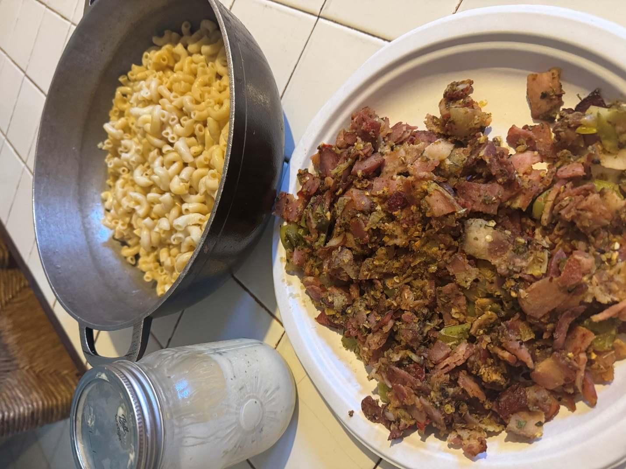
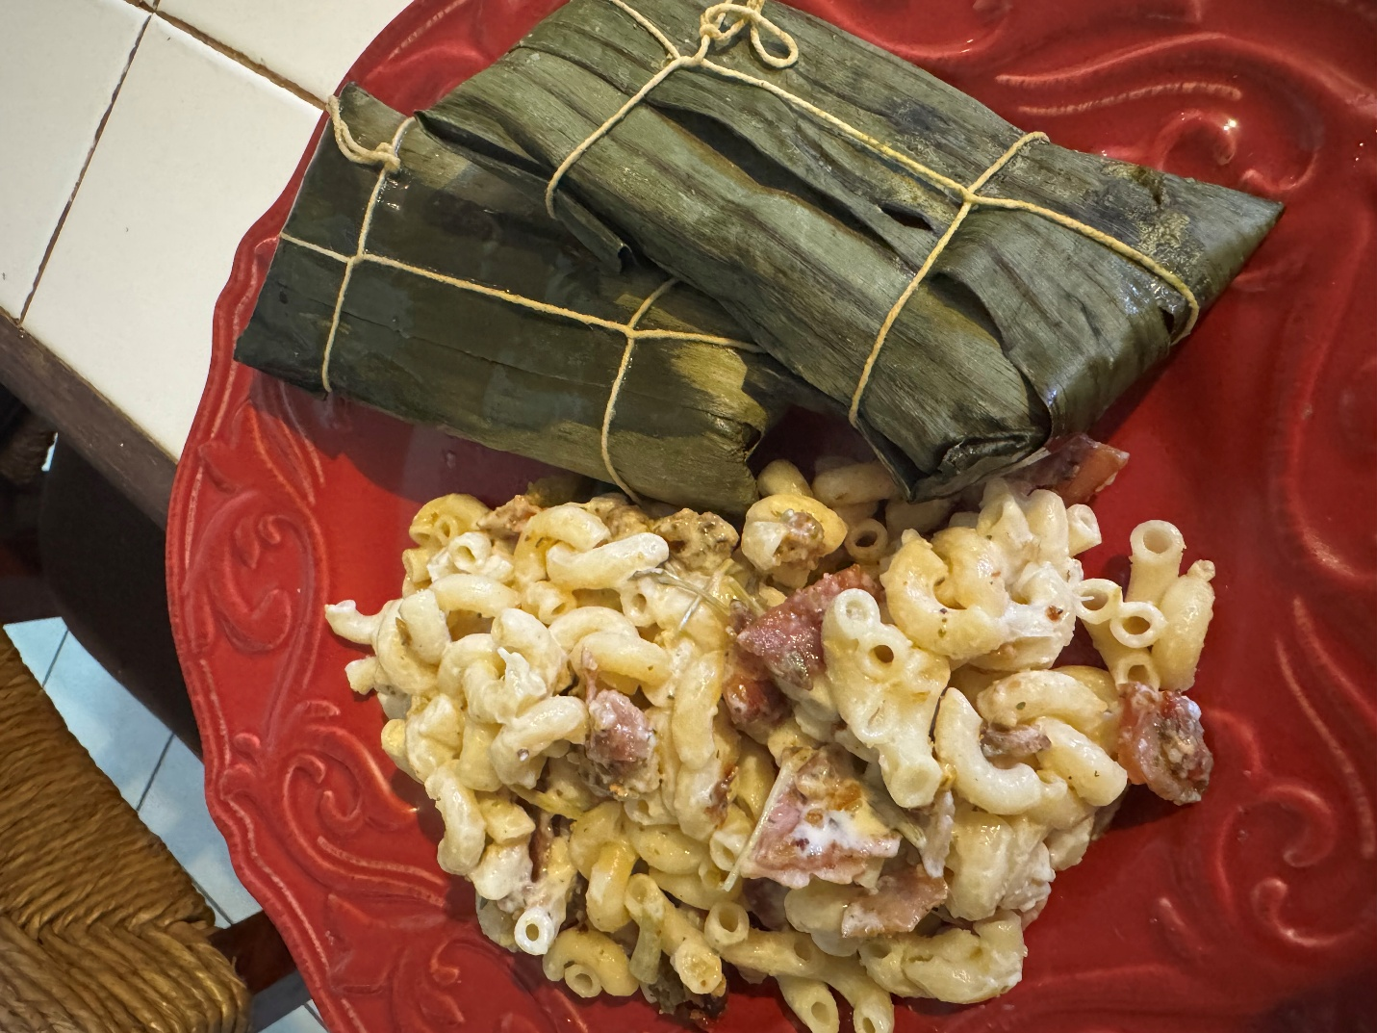

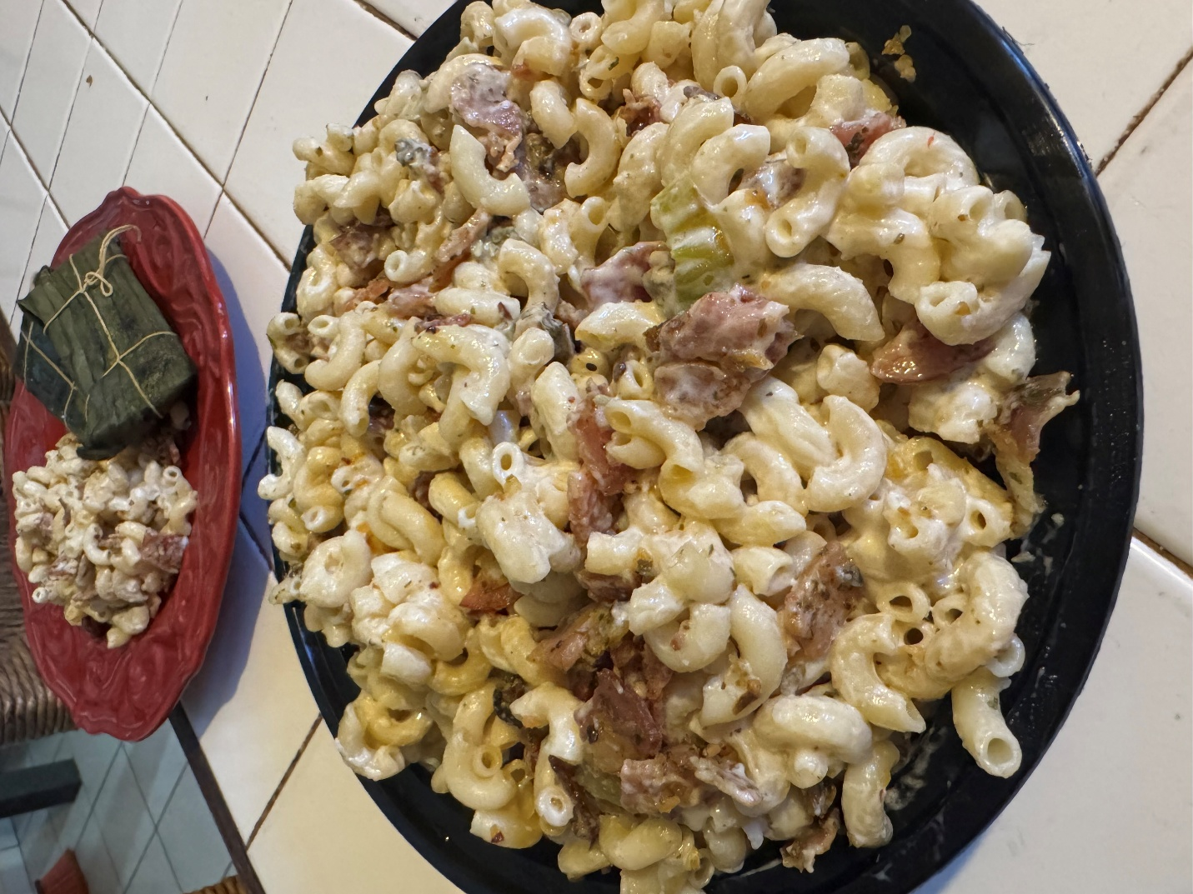

After seeing the pictures you just saw, do you have a guess at exactly what the inspiration behind the New Albor Legacy salad is? Let´s see it now...
Here comes the New Albor legacy twist, kids: in Puerto Rico, kids don´t eat macaroni and cheese, at least it is NEVER served in schools. They may get macaroni with marinara and beef, but I can assure you: no Puerto Rican kid will get macaroni and cheese at their school lunches. They do know what macaroni and cheese are, and they are widely available at supermarkets and even at majorist stores with membership. They do know how to cook them and eat them, they will eat it... But they won´t see it as “Puerto Rican” at all; it's just tasty children's food, or something easy to cook in the microwave if mom can´t cook something right now. What they see as Puerto Rican is the macaroni salad (I will say it as you know it: ensalada de coditos) that is commonly served cold (not warm, like mac and cheese) at large family gatherings, including Thanksgiving. Whenever a big Puerto Rican family gathering occurs, you can expect someone to bring a large tray of ensalada de coditos; it is always present at the food tables at a typical Puerto Rican family gathering.
Now you can see, kids, how this New Albor Legacy Salad joins an already known American children´s meal (mac and cheese) with what will be more accessible to you, Puerto Rican kids of the future: the New Albor Legacy salad would be celebration making possible that children grow as the best person they can be (as you, Puerto Rican children of the future are going to be able to achieve a brighter future for all children to come) AND it would also celebrate the unconditional recognition of personhood (making possible that everyone can be free to be who they are and who they are called to be)... This New Albor Legacy celebration fully integrates both known American culture (Angloamerican) and known Puerto Rican culture (both Angloamerican and Latin American) in a single New Albor envisioning: it’s an ensalada de coditos that is as children´s and comfort food as mac and cheese, but done adapted as cold mac salad with new albor sauce and bacon sautéed in sofrito mix. Those are the basic ingredients of the New Albor Legacy salad: New Albor sauce, bacon sautéed in a sofrito mix, and a sauce that combines mayonnaise, cilantro, garlic... and brace yourselves: it also features passion fruit piragua syrup, a wholly Puerto Rican ingredient that Puerto Rican children are very well aware of what it is, although they would not dared to assume it could be used in that way, in the same way they couldn´t know they were able to reach a brighter horizon. Well, yes, it can be done, and it tastes AMAZING.
Why would this be a family recipe from one generation after another? Because the recipe can be VERY EASILY adapted according to each family´s inherited taste. Besides bacon and new albor sauce, it can have whatever else you may add to create your own family version of I and passing it on as a New Albor Legacy to the children that come after you, Puerto Rican children of the future: you will be able celebrate the giftedness of passing to the next generation a creative envisioning that will empower them to grow best, to glow best, to bloom best, each generation achieving more and more creative growthful progress thanks to the New Albor Legacy passed on by the previous generation of children. Enjoy this celebration of a New Albor Legacy that only you can make shine brighter for generations to come!
Just to be fair with you and not idealizing the process of creating something new and brighter for generations to come... we let you know: you might need to try many times to discover the best ways to do something that no one else had being able to do before, or that no one else saw possible to be done before... Look and pray to Jesus Charity when that happens, trusting you will be always helped to fly higher and more beyond yourselves. Imagine Jesus Charity telling you what you can hear if you watch the movie Man of Steel (great movie to understand how much harm can be caused by a society that expects everyone to fit a given “mold”, as it happened in Kripton):
You have grown stronger than I ever could have imagined. The only way to know how strong is to keep testing your limits. You will give the people of Earth an ideal to strive forward. They will race behind you. They will stumble. They will fall. But in time, they will join you in the sun... in time, children of the future, He will help you to accomplish wonders.
Just to let you know: the Jesus Charity painting I already showed you was deliberately painted with epic proportions, similar to how superheroes are depicted. Let Him be the One who leads you to create new ways to do wonders, including those times in which no one else before you had done what you are called to do, as it will happen with you, Puerto Rican of the future: no one has achieved that the Supreme Court overrules precedent insular cases that have kept Puerto Rico remaining a colony, it has been avoided.
I also have creative examples about the beauty of allowing you to move according to who you are, rather than being confined to “molds.” In the following pictures, you will see a painting of a princess of Heaven who seems to be “molded” by threads, like a puppet. Still, when you look the painting carefully, she is dancing with the Holy Spirit in a way that, although the treads remain there, she remains dancing according to the flow of the Holy Spirit (as it can be seen in the flow of the adoration mantle she is dancing with: she is not getting tangled in any thread, she is dancing moving freely, despite being a puppet... and the other paintings, that are paintings of my childhood, were also something totally outside the “mold” for someone of my age and someone like me:

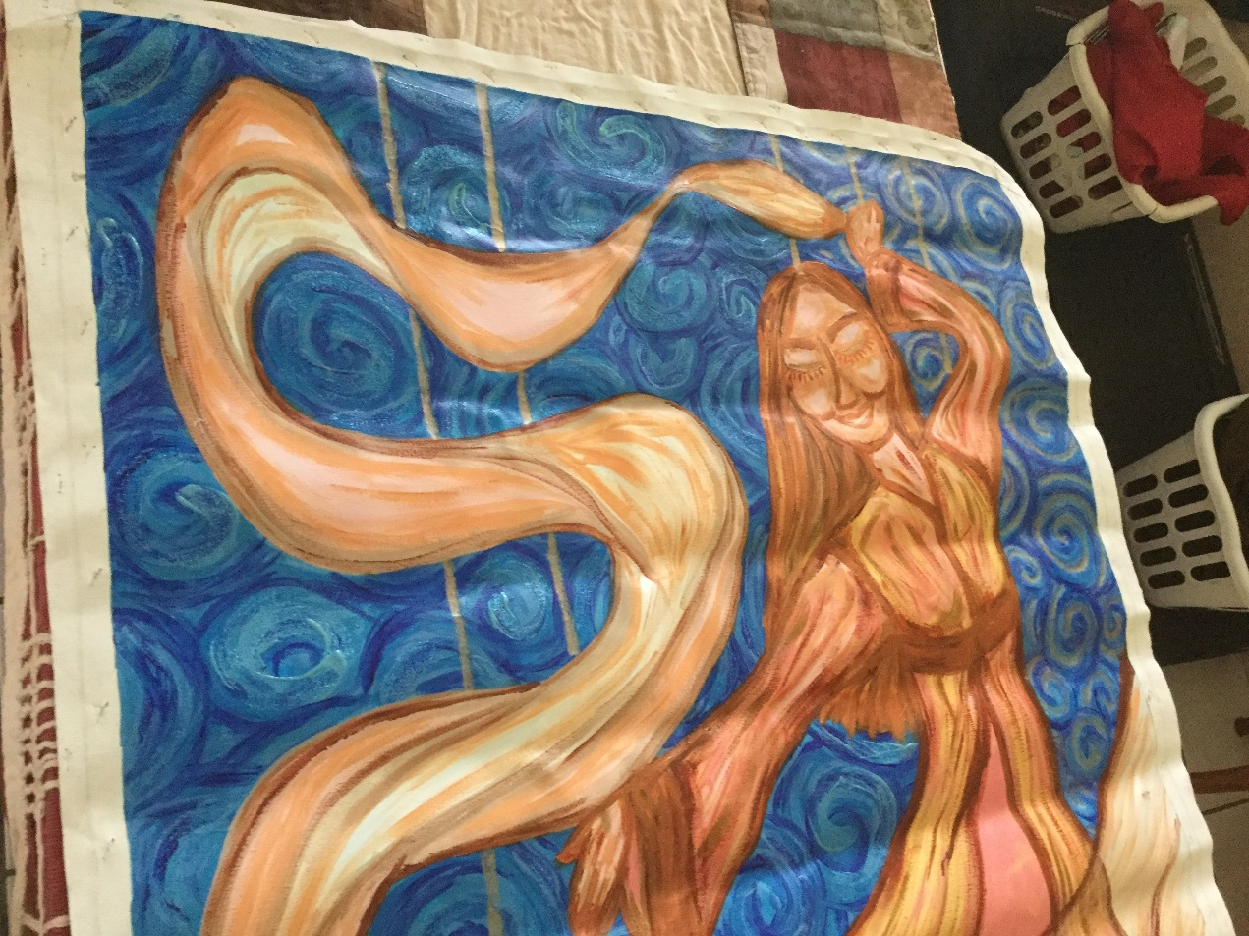
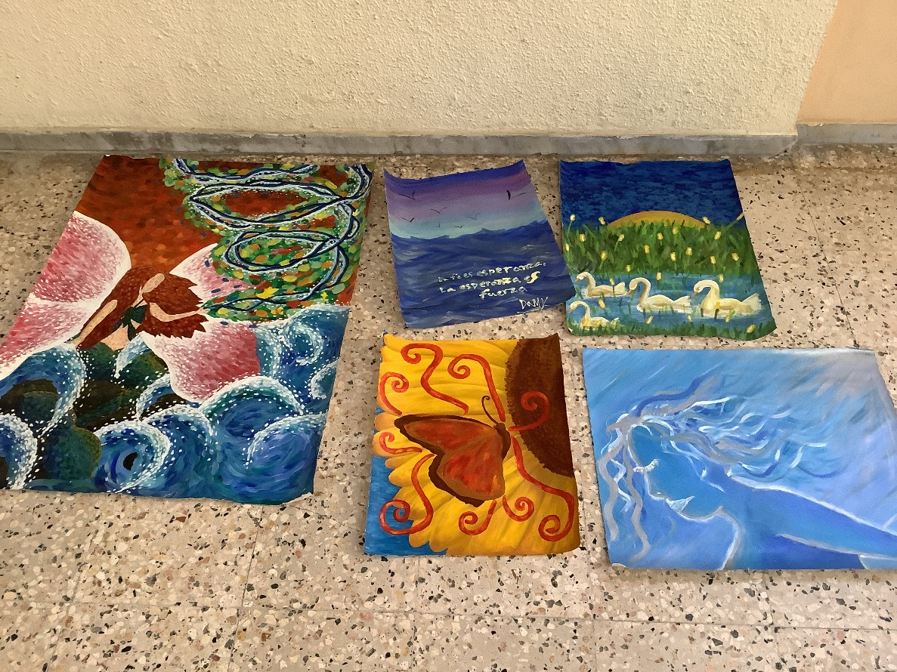

I will give you an example of what happens when you try something no one has ever tried before.
You know, Puerto Rican children of the future, there are very traditional cookies that I hope still exist when you read this: they are called besitos de coco. In English: coconut kisses. Well, we envisioned a dessert using them as a crust. A dessert like lemon bars, but done with a passion fruit custard, with 100% Puerto Rican-produced products, and with a deep meaning behind: choosing life passionately, choosing to live passionately. Well, choosing life passionately definitely is related to celebrating to allow all children to grow as the best person they can be, and with celebrating everyone having the freedom to be who they are who they are called to be... so Jesus Charity recommends you all to eat this dessert paired with the New Albor Legacy salad.
Well, it happens, children of the future, that absolutely no one else has used besitos the coco for creating a crust. So I am the first one to make something like that. There had been some passion fruit custard, but no one had ever done a crust with besitos de coco. O
It is totally normal, Puerto Rican beloved children of the future, that if no one else has done what you are doing... You will need more time to find your own way to do it first. You will find out that this applies to many things in life, not only to creating a dessert, but also to how you create yourself, because no one has ever created who you are before you; you are unique. Every person has a unique personality to form. Be kind to yourselves, for your dignity´s sake and God's dignity's sake also. You will always be learning how to form better and how to create wonders.
Well, now I'll show you the pictures of my first attempt to make the dessert as envisioned by Jesus Charity Himself (no, I didn´t plan it at all to be this way, but now that I've tasted it, I don´t want it any other way).
What happens is something totally expected when you are the first one doing something: I made several mistakes, and many details can be improved. However, the taste is AMAZING. Here are the pictures of a piece of the first try of this dessert. No, it is not mushy at all, it is that way, it's exceptionally creamy and beautifully sweet without being oversweet at all:
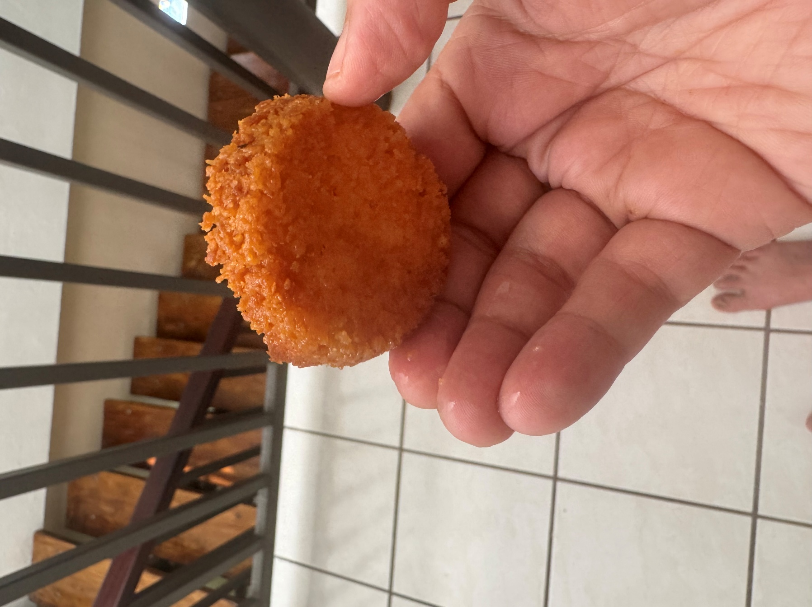


Because I am the first one to create this, I can already give you several essential details that will make it way easier for you to do this and enjoy celebrating together a growthful progress:
-Don´t use Pyrex. Glass is not as good a conductor as aluminum. Look for an aluminum mold.
-No matter how tempted you may be, do not overbake the crust. If you overbake it, it won't taste burned, but it will become tough, still edible, and tasty, yet extremely hard to cut. Save your arm´s strength for better uses and simply don´t overbake it, no matter how tender the crust seems. It will eventually become solid.
-Be careful with the coconut oil. Do not use too much; ¾ cup of coconut oil for 8 ounces of besitos de coco is perfectly suitable for a fantastic crust, as shown in the picture.
-What you will see in the following photo is what happens when you add some egg whites “not to waste them,” although you were told to only use yolks. Forgo the egg whites; they won´t mix. Use only yolks. I corrected the issue eventually, but that correction caused even more overbaking:
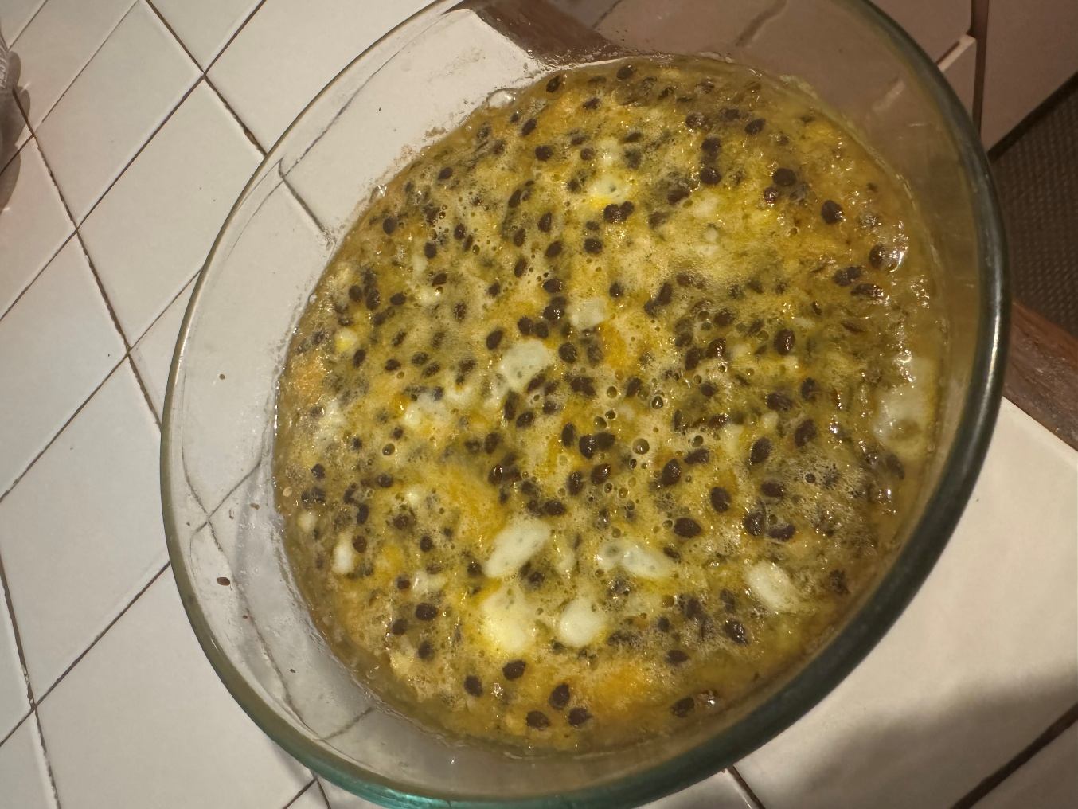
-The crema de arroz as a thickener works perfectly fine.
-In both the crust sense and in the custard sense, it is proven that the best way to cook this dessert is in aluminum cupcake trays, period. It is not meant to be a huge bar tray, but small, round, cupcake-sized bites. It's even practical to use cupcake liners to do them. The cupcake-sized bite you're about to see was cooked significantly better than the larger size mold, in less time, and with a more appealing color, and it is also way easier to bake the crust in this bite size:
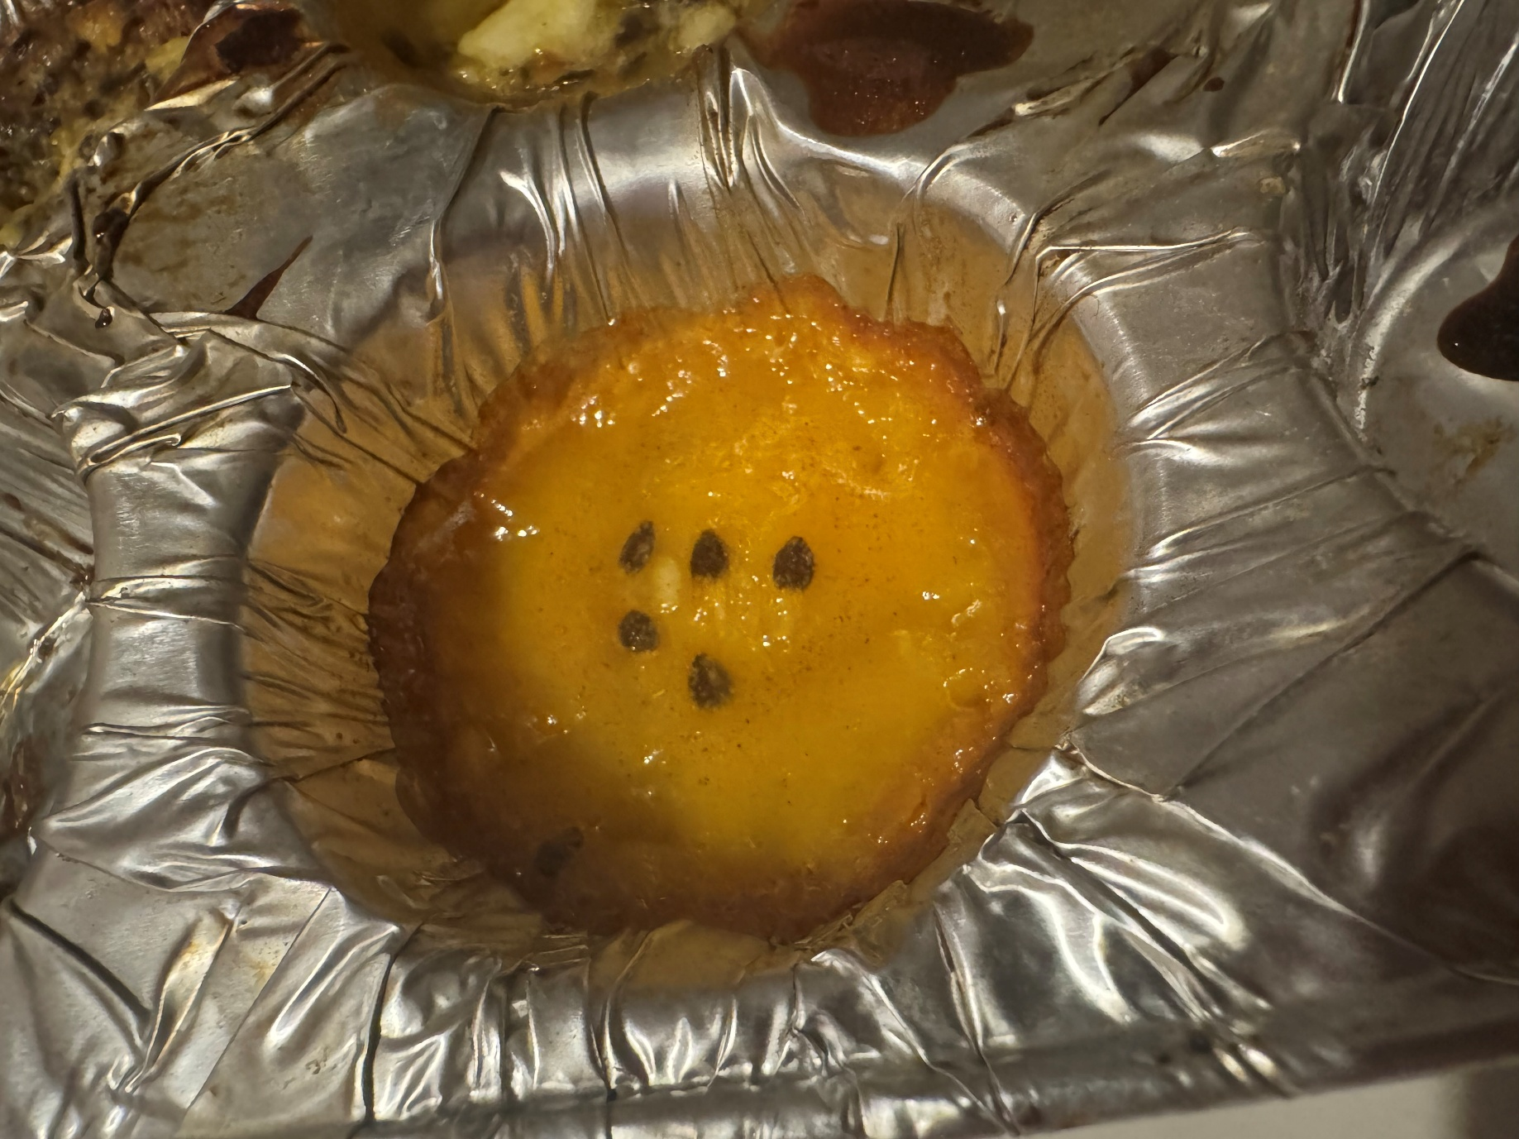

There is a massive issue with how to categorize this: it's cupcake-sized, but not a cupcake, nor a cake at all. It´s clearly a bar, but it is not shaped like a bar at all (it is not a square). This is kind of like a triangular piece of a round pizza being packaged in a square box: how do we name it? Because there is no known “official name” for a bar dessert in a cupcake form, we are going to give it a name: they are Passion Alliances. A bar dessert in a cupcake form is an alliance (alliances are round and have the same proportional circumference as this dessert).
The name has a meaning, of course: we are all meant to achieve progress, perfecting the “Passion Alliance” more and more until the most growthful progress is achieved. A “passion alliance” is a sign of growthful progress that continues to be achieved as we keep choosing life FOR ALL passionately (that is why this pairs perfectly with the New Albor Legacy Salad: this recipe is also a New Albor legacy celebration) As more people perfect this recipe or even adapt it... more and more growthful progress will be achieved, and achieving growthful progress is always something to be celebrated as part of let others inherit a New Albor Legacy. That is how all creative personal conceptions work also: you keep learning to plasmate the whole personal formation better and better, constantly perfecting and becoming the best person you can be, growing together in communion. That´s the best thing about a growthful progress: it embraces personhood too, it's not merely an “economic growth,” like we explained about the GDP, Puerto Rican kids of the future.
I will now allow myself, Puerto Rican kids of the future, to show you a wonderful example of how such “perfecting personal formation skills” will always remain a work in progress.
I already talked to you about Jesus Charity´s painting, and I already talked to you about Jesus Charity´s carving. I still haven´t spoken to you, Puerto Rican kids of the future, about Jesus Charity´s sculpture. Yes, that was another creative plasmation that was formed after the painting was completed and eventually never seen again. He had remained alive in me, plasmated more and more humbly in my whole personal formation.
When I was a student at the Faculty of Education, preparing to become a certified teacher, I had the opportunity to take a BEOF class, also known as a Bellos Oficios class, at the University of Puerto Rico. Because for me, teaching is a Bello Oficio, it was a fantastic experience to integrate that class into my college schedule. I had already taken the same class when I was a student in the Faculty of Humanities; I simply wanted to undertake a better, larger project this time, a Jesus Charity sculpture, in addition to other projects I also wanted to undertake. So, there I was, repeating a class, simply to enjoy the formative process. I hope it happens to you at least once in your school life: enjoy the personal formative process that authentic learning is meant to empower you to undertake.
Here you can see me in the classroom, already sculpting a Jesus Charity:
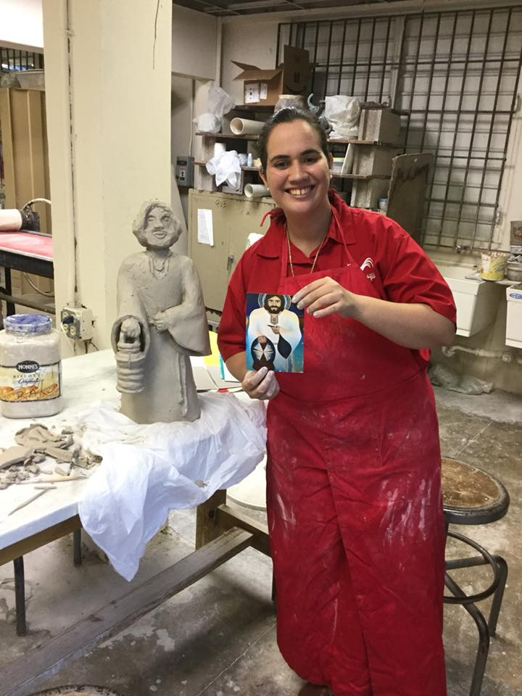
Yes, beloved Puerto Rican children of the future: formative projects can be messy... but some messes are beautiful and holy, like when small children enjoy fingerpainting: let them enjoy, grow, and learn at their best! The same applies when you keep perfecting your personal formation in a better creative way: way more than a few times monumental messes can be expected... but they can be a holy mess as long as you remain adoring Jesus Charity with your whole growth.
In the following picture, you can see another creative project that I completed, along with sculpting a Jesus Charity, in the same class: custom glowful medals for my students (I was a student teacher in her practicum at the time). The medal I gave to each one of my students were... their own dreams, sculpted by them in their own medals, I limited myself to glaze them with the yellow color and add the ribbon: they themselves were the one who formed the dream at each medal, and for me the best recognition I could give them was to let them celebrate to learn to achieve their dreams, believing that they could reach them as long as they remained learning becoming the best person they could be.
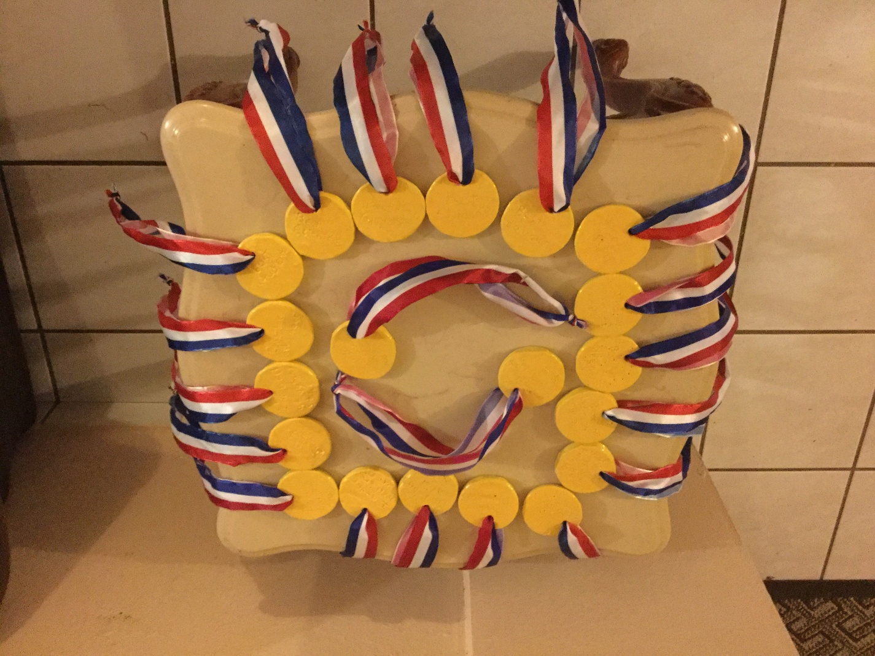

In the same Ceramics class, I also prepared... let´s name them now “glowful gifts”: thank-you gifts made by hand, in the same way I was grateful for those people who helped me most to become who I am and who I am called to be as a growthful teacher and person. I used spirals in some of those thank-you gifts and sunflowers in Amarillo Luz color in the others. The first one with spirals was for the Dean of the Faculty of Education, who was also my academic mentor and student dean in the Faculty of Humanities. She was the most influential influence in how I learned to treat my own students. She believed in me, even when I didn´t know how to believe in myself yet, and truly did one impossible after another to happen so I could be able to choose to pursue my dreams. The spiral in her glowful gift meand “communion direction”: I can honestly say, with all humility, that these professors to which I gave these glowful gifts taught me with their example how to remain being a teacher that taught her students in a communion direction, I was allowed to teach with some creative space, in that way and that was truly enriching to be able to know at your teacher student stage, a professional formative stage in which usually creativity was not allowed at all. My teaching mentor, Cristina, although did not allow me to design my own lesson planning system as student teacher because she believed I had to learn how to do it like I would be expected to do it as a teacher first, to then, once I knew the already required fundamentals, design my own as a teacher, after already knowing how to handle the fundamentals first... Yes, kids, she was right, although I would have loved to have done it while I had access to educational research resources.
Well, although I was not allowed to design my own lesson planning system as I wished, I did talked a lot with Cristina about how education is meant to be and about what at that moment was articulated intellectually as “integractive learning” (kids, to say this simple: integractive learning is like learning integrating a personal formation model to your lesson plans, so teaching planning is based in how you grow as the best person you can be while you, children, keep learning what you are meant to be learning not merely to get a good grade, but to also achieve your dreams and become who you wanted to be, according to your own guided growth objectives).
The sunflower gift was a heartfelt thank you for allowing me to grow together in communion as the best person I could be, following the light, as sunflowers do. I had dreamed of being a teacher since kindergarten, and I was grateful to be able to achieve that dream in a fulfilling way. So, I also gave that fulfilling gift... but in the case of that particular gift, the ones I gave it to... broke it into pieces. I would eventually know why: they had never truly wanted me to become the best person I could be, they had always envied the light I radiated as giftedness, and they truly never wanted me to bloom nor to grow together in communion (there are three sunflowers, the number 3 is a sign of family...). So, I would eventually understand: it is totally expected that those unable to see giftedness at all nor to life a life as a giftedness to help to be, help to do, help to grow, help to glow and help to bloom as you keep radiating more and more light, because as you keep becoming the best person you can be your growthfulness also become a giftedness that empower others to also being able to become the best person they can be... Well, for those who are totally unable to accept a gift, it will also be impossible to receive anything as a gift; they won´t even embrace their own life as a gift to be shared... so, I would eventually understand why they broke it into pieces and threw it away: if you are broken inside, you will also radiate brokenness, because no one will be able to give what can´t be embraced in the heart as giftedness first. This is something sad to see, children, but it does happen, and you need to handle it: there will be some who won´t be able to see your giftedness, and that doesn´t mean that you are as ungifted as they are. That means your giftedness is not meant to bloom in those hearts, so keep walking as He walks. Eventually, you will find —like it happened with the horizon line of the room where I am writing this— wider and more vivid sunflower fields where you can bloom as an infinite new horizon line of growing together in more and more gifted communion, in more and more personal communion, ever more.
Learn this lesson well, kids: your giftedness and growthfulness will always remain defined by how you choose to stay growthful. If anyone is unable to see your giftedness, it is because they refuse to become a true new-life-giving gift, and they can´t see themselves as a gift first. If anyone decides to remain in broken communion and to break any incarnated-communion-based growth within their reach to break, that is a choice that you must respect, although never agree with: if someone chooses not to be a gift, you are not the one called to change any other; you are the one called to convert yourself into the giftedness you are called to be. If anyone converts around you, it will happen as a grace of the power of the Holy Spirit, not because of whatever you may attempt to do to “convince” anyone to change. NEVER DO ANYTHING TO TRY TO CHANGE ANY OTHER: ALWAYS FOCUS ON KEEPING CHANGING YOURSELF AND KEEP BECOMING THE BEST GIFT YOU ARE CALLED TO BE, BEING THE CHANGE INSTEAD OF FOCUSING ON CONVINCING OTHERS OF ANY “TRUTH” OR OF THAT THEY NEED TO CHANGE. Don´t let anyone´s ungiftedness bother you. If someone breaks a gift you give them as pure giftedness, keep choosing to grow best and, as you keep choosing to keep growing together n communion and following the light, as sunflowers do, you will find growthful role models (like Jesus Charity and my family of Heaven had always been for me since childhood) that will teach you to embrace your unique giftedness as those who genuinely love you most will always remain doing it: with unconditional belovedness and as a loveful giftedness.
Here you can see pictures of the glowful gifts I created in the Ceramic class, besides the glowful medals for my students:

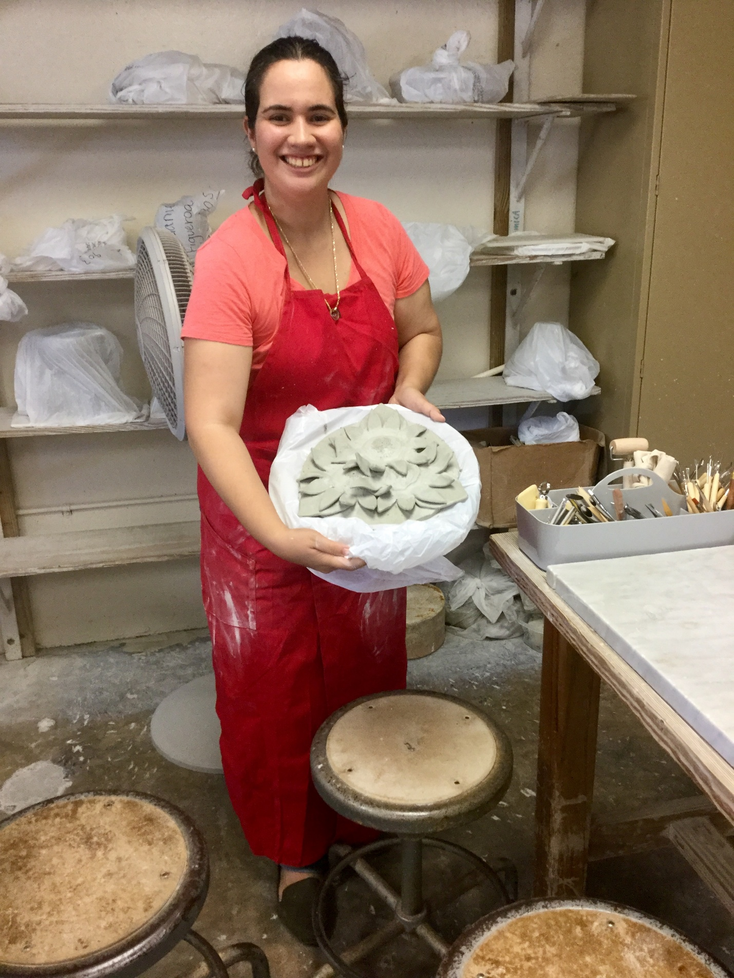

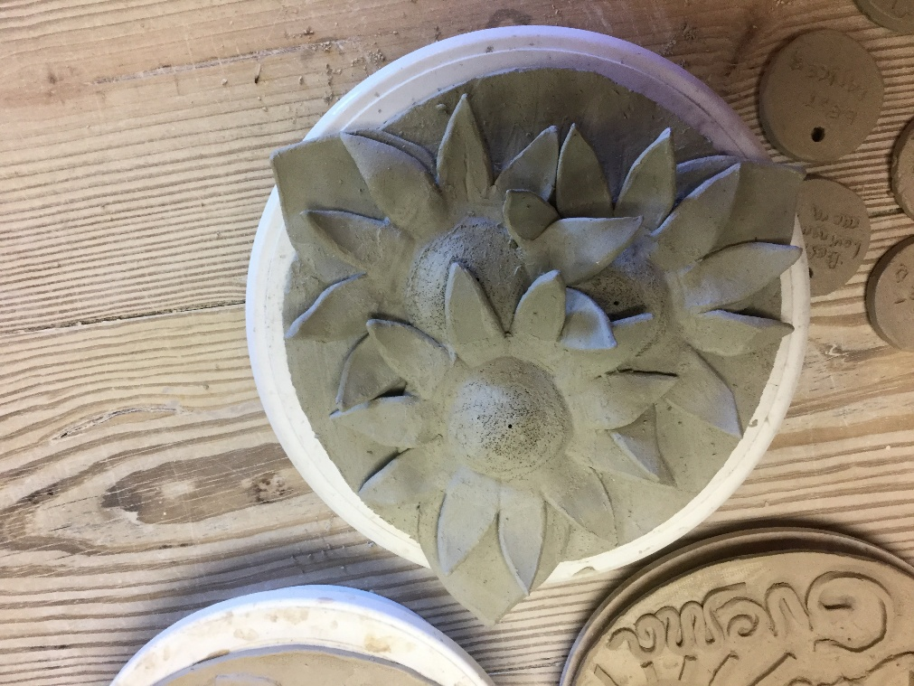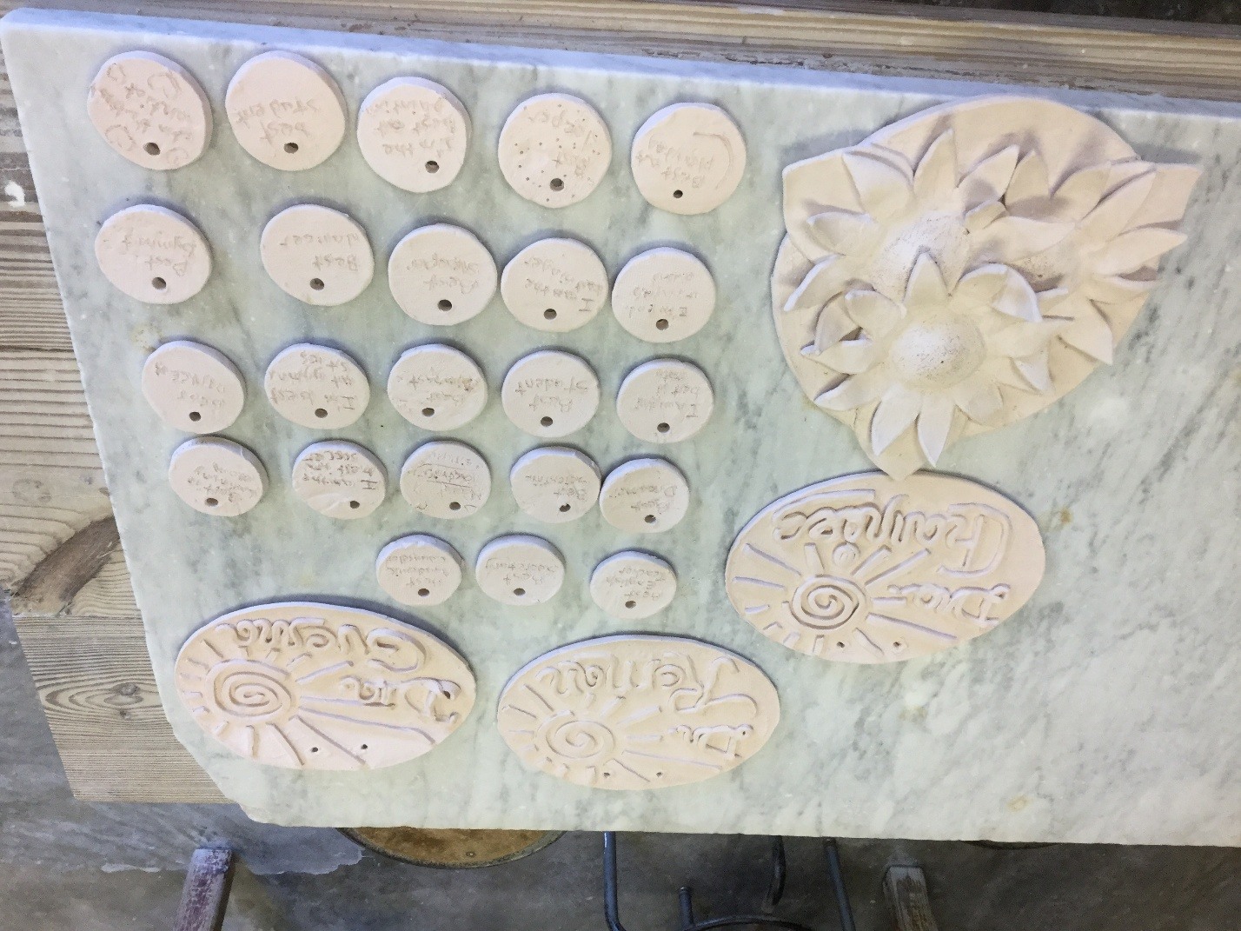

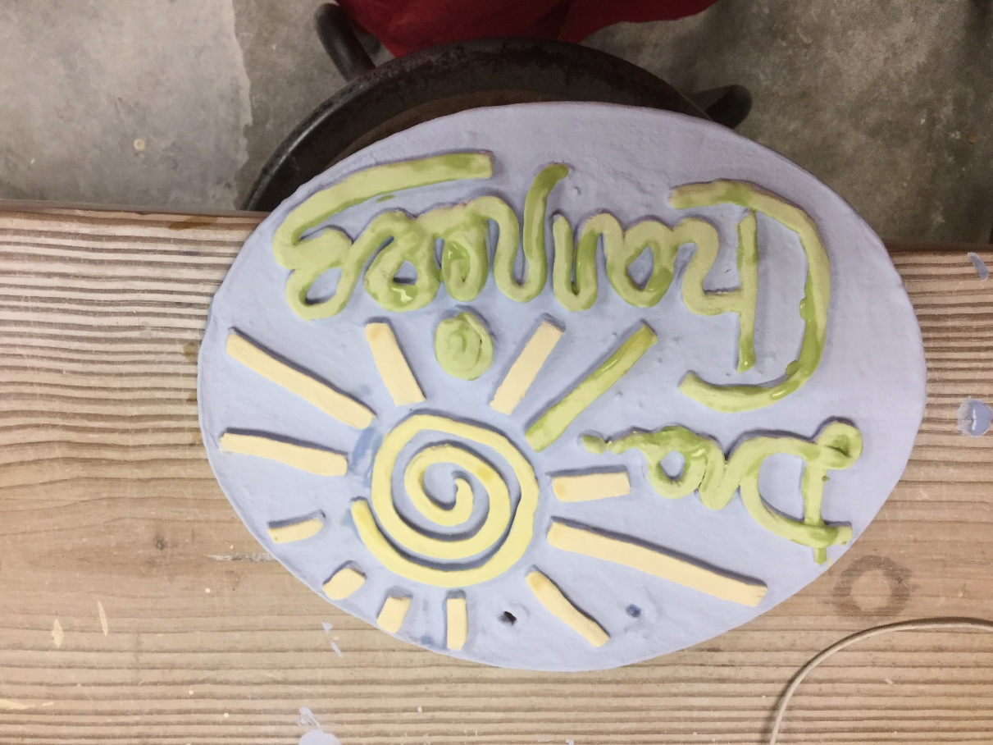
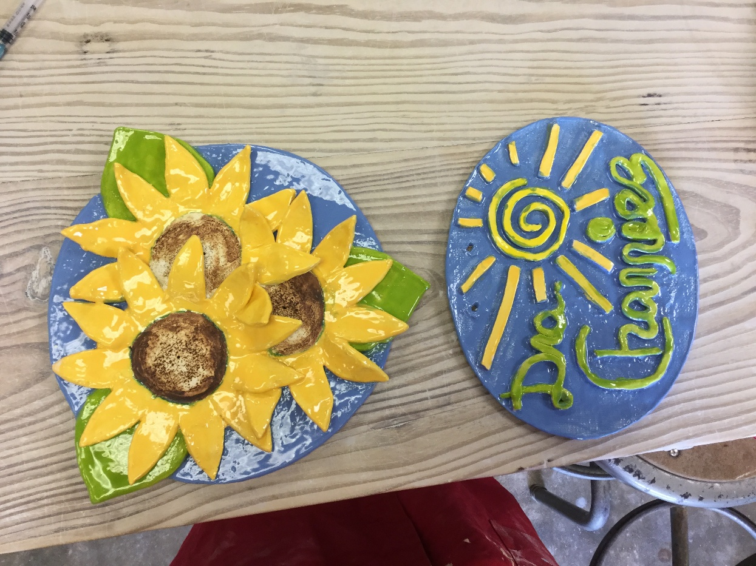

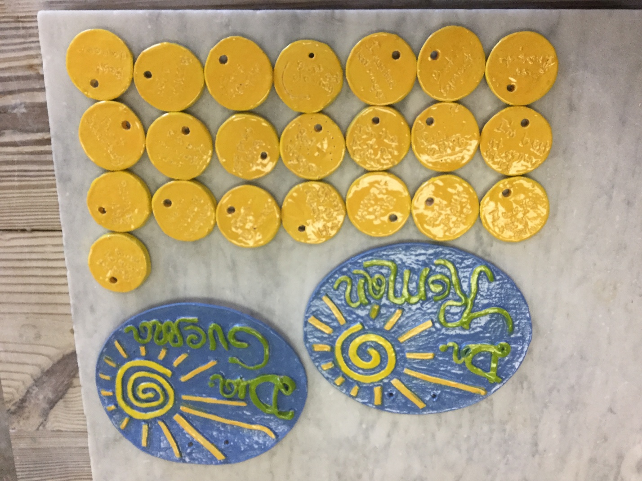

There is enormous creative power, children of the future, in accepting your unique God-given giftedness and sharing it humbly, as Our Lady of New Albor, our Mother of Heaven, has taught me to do it along with Saint Joseph of New Albor. There s also huge creative power in accepting humbly all the creative giftedness and all the new-life-giving gifts —like the sacramental motherhood that is blooming as I write this letter, allowing you to become not only the best you can be, but also, if you choose to, you will also be able to become the living sacrament of Divine Love we are all called to be, because a spark of His Trinitarian growing-together-in-communion glows in absolutely everyone, it´s part of our God-given nature and no one will be able to manipulate the being Divine Love had given to every person as a growing-together-in-communion gift called become a... a gift that radiates the very same growing together in communion that He gifted as pure giftedness first— each human being is given with a unique purpose and mission to empower a growthful progress for the whole human family: whatever are called to give to enrich the growthful progress of humanity, no one else will be able to gift it for you.
¿Can you imagine all the giftedness humanity has lost with all the discoveries that had not been possible to achieve, all the changes that were not able to happen, all the innovations that had not been able to even be likely to be envisioned... due the people who were called to do them were aborted, denied their very right to be and discarded as non-people, as “blurb of cells”? Yes, believing in a growthful progress will always mean believing in a glowful society that celebrates how it is possible for all their children to be and become the unique, glowful stars each one is called to be unconditionally, simply due to being people with the same dignity as everyone else. Of course, such an unconditional fraternity celebration —seeing absolutely everyone unconditionally as an equal and dignified brother and sister— will also be a New Albor legacy celebration, in whichever way you choose to celebrate it! Creating new ways to envision a culture of new albor, a culture of new life that celebrates a New Albor Legacy for generations to come... may take time. Still, such growthful progress can and is meant to be achieved with Jesus Charity´s help and our collaborations as co-creators of our personal formation, called to always remain forming as a living icon of Divine Love.
It can be very enriching for you to witness a complete creative formation process and understand how you are called to develop and always remain both being formed and forming yourself as the best person you can be presently: both as a present (as a gift) and living the present. continually. Then we can all achieve growthful progress as we continue to grow best, glow best, and bloom best, learning from each other and our shared experiences. Allow me now to share with you the entire process of how to create a creative work from a raw block to a completed artwork. The same applies to forming the whole of personal formation as a living icon of Divine Charity within us... and, believe it or not, it will always take your whole life to achieve becoming the best person you can be. It can be difficult for you, children of the Puerto Rican future, to imagine that the dreams you have at kindergarten will matter many years later, especially because, as younger children, you have an incredible gift for living in the present and it´s difficult to imagine that one day you will be a grown-up too...
We let you know: yes, children, all your dreams matter since the very beginning, they will always matter, both to you as a kindergartener and also way later in life, because how you keep daring to dream —sometimes you will dream new dreams, other times they will be long-envisioned dreams that had grown in your heart since a long time ago—... how you keep daring to dream as you keep growing up will make a huge difference in what you will be able to envision to be able to become and in how your learning will be able to make a meaningful impact in you as student and as person fully expected to become as sovereign citizen as you are able to.... How you dream shapes how you will be able to envision your personal growth, how you will be able to succeed as student, and what kind of citizen you will eventually become. In the same way books shape your knowledge, your dreams are the first way you begin to shape your personal self-being, without you even being able to realize how important it is for your well-being and lifelong happiness to learn how to create yourself in a growthful way from the very beginning. So, yes, children of the future, your dreams will always matter.
Because Jesus Charity is a creative plasmation that grew as shared dreams, and it will be immensely enriching for you to see the power of believing in your growthful dreams.... I will now share with you, so you can learn about forming yourselves and the power of your shared dreams... I will share now the whole creative process of creating a sculpture of Jesus Charity, as it was already described: from a raw block (that is the first picture you see, a raw block of clay) to a growthful artwork:

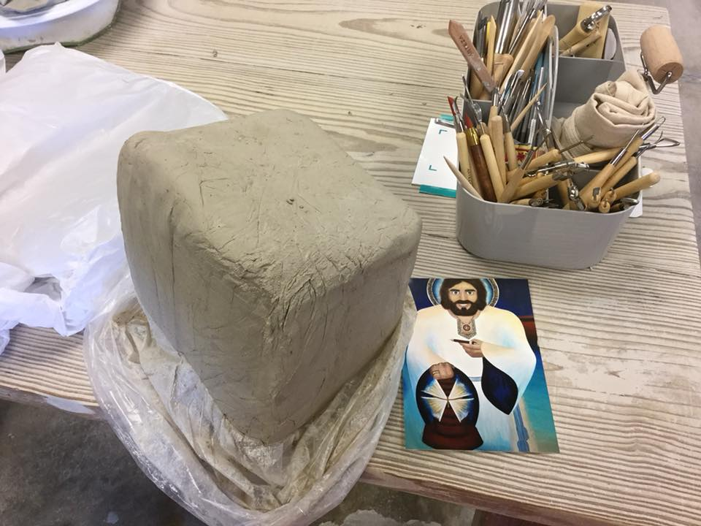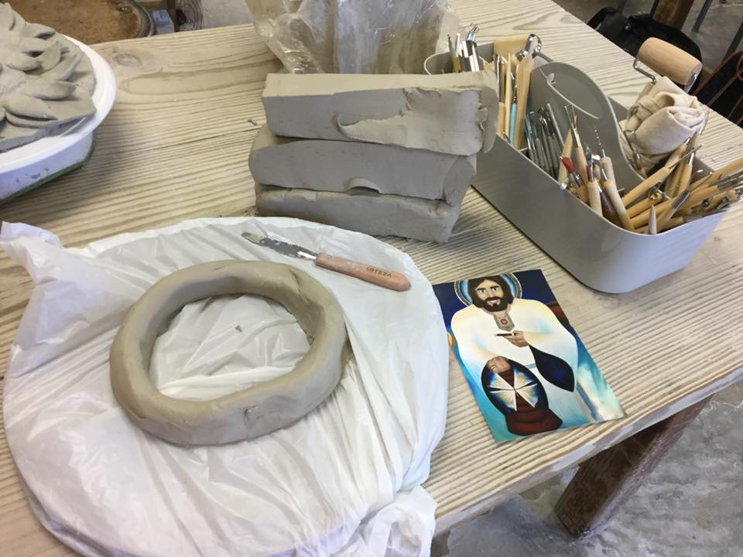

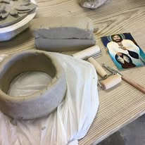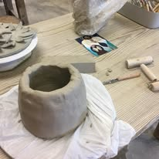

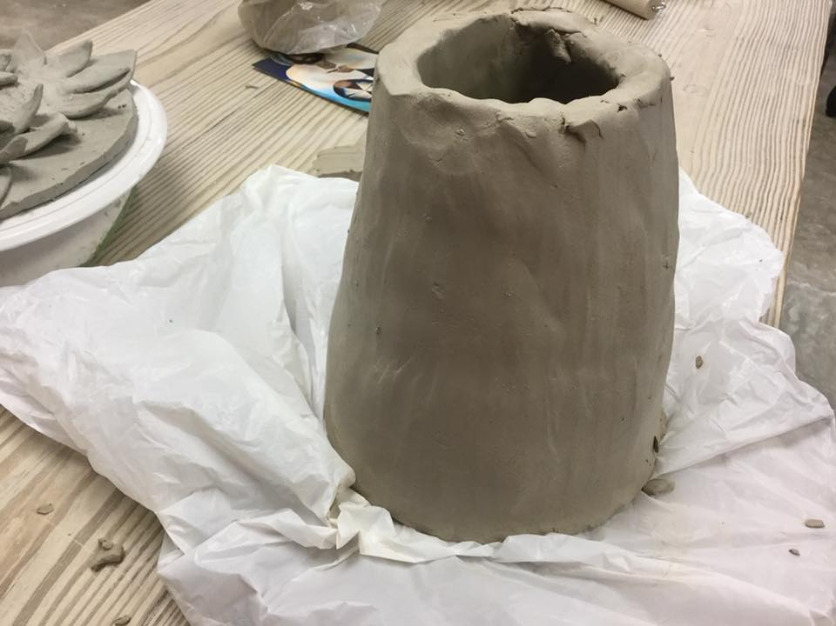

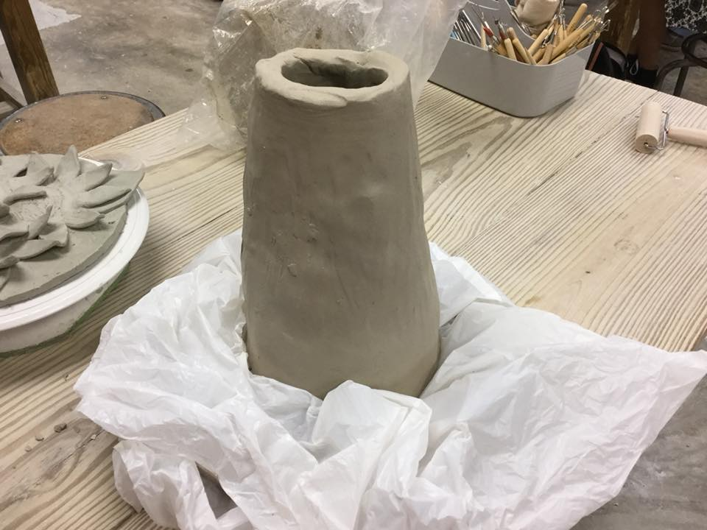
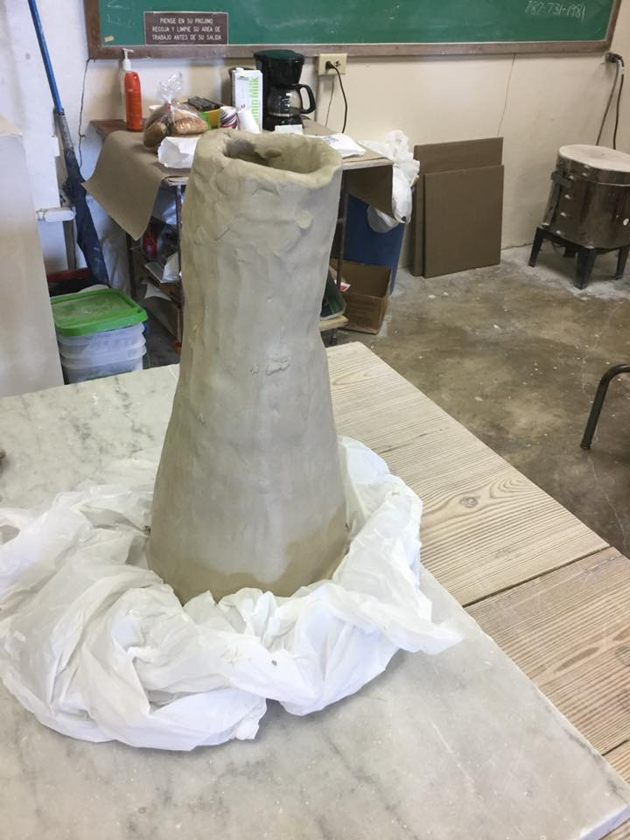
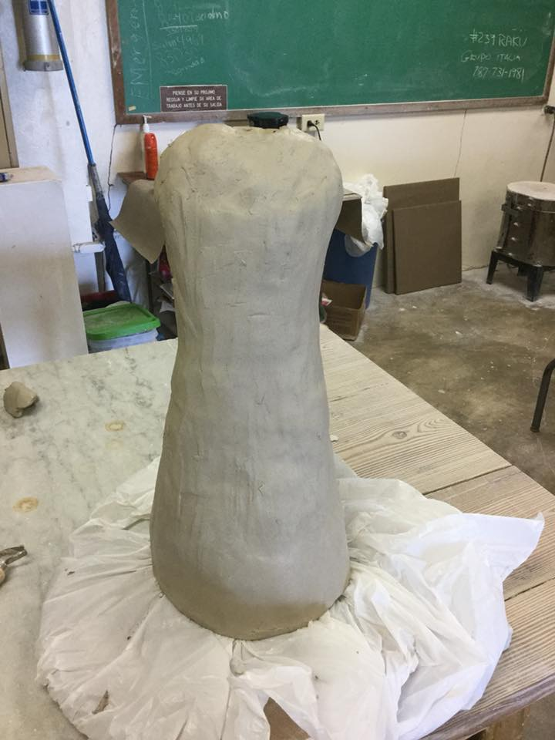
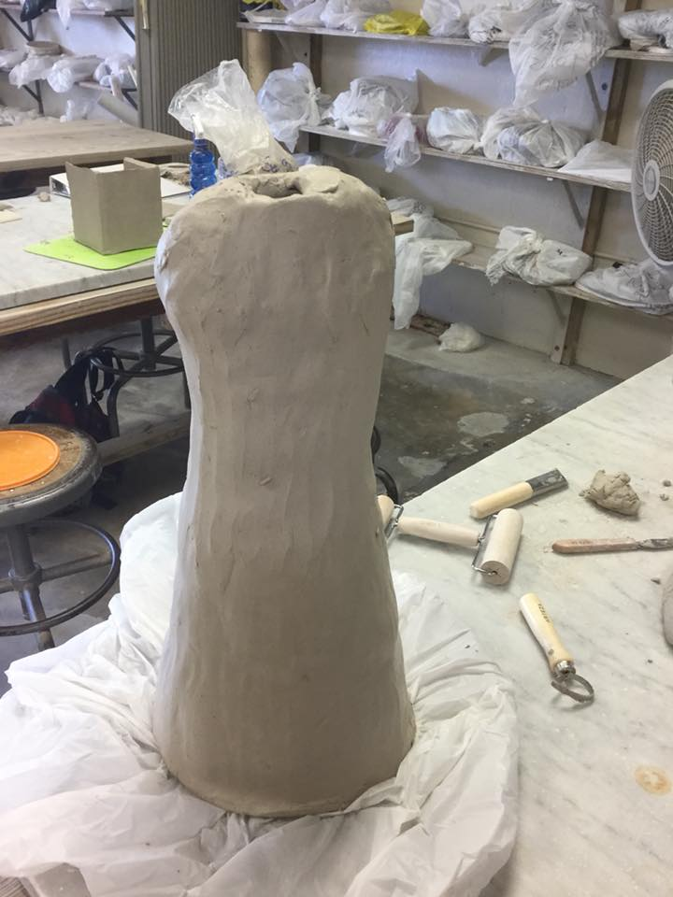
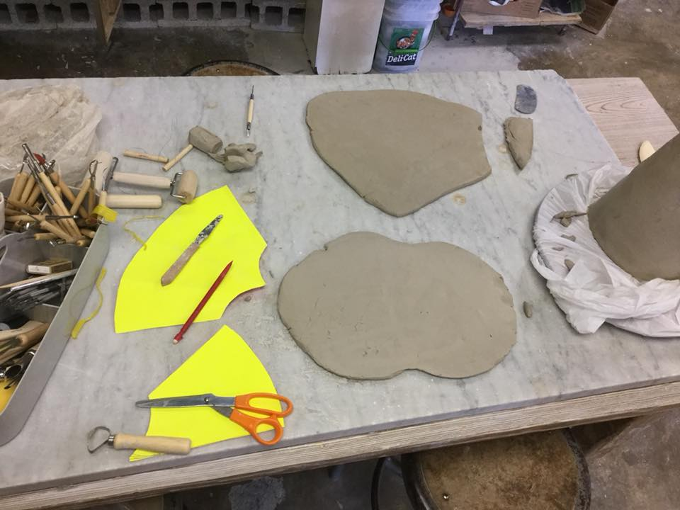
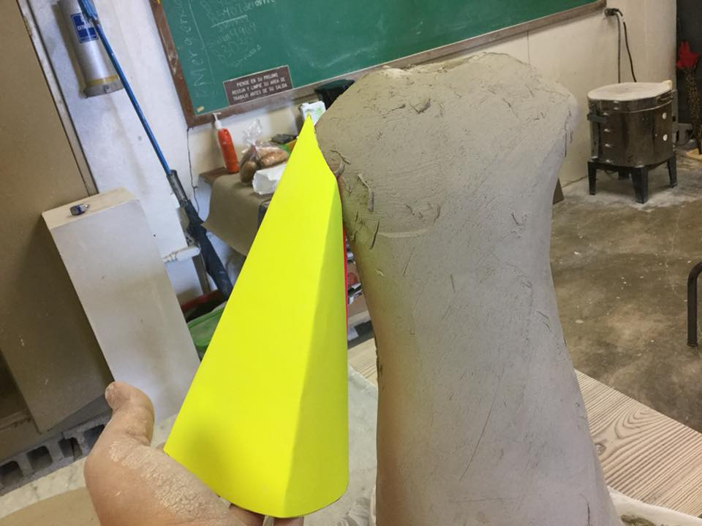
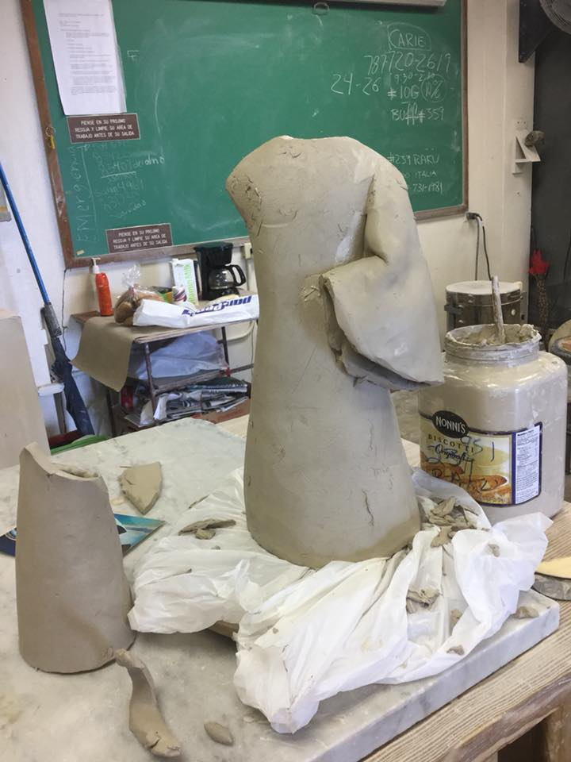
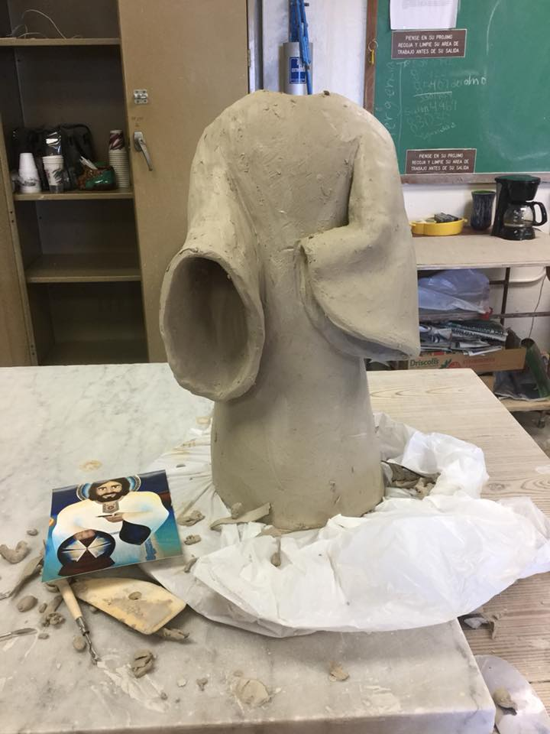
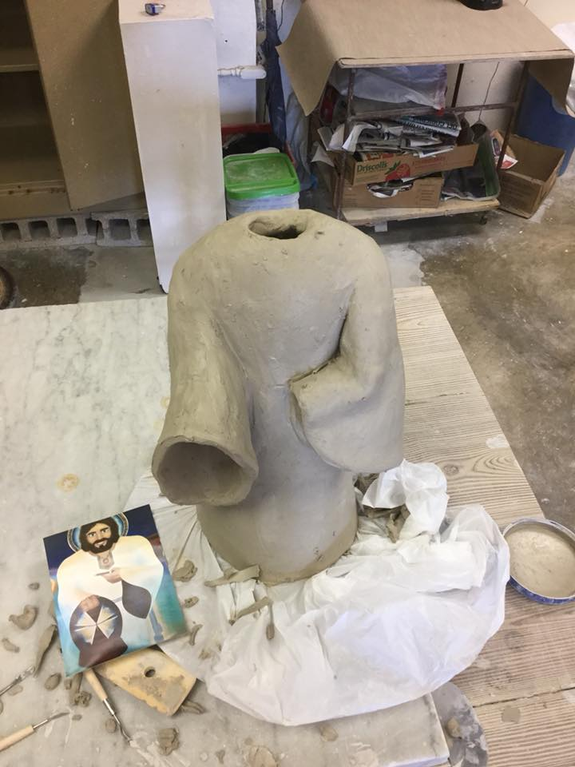
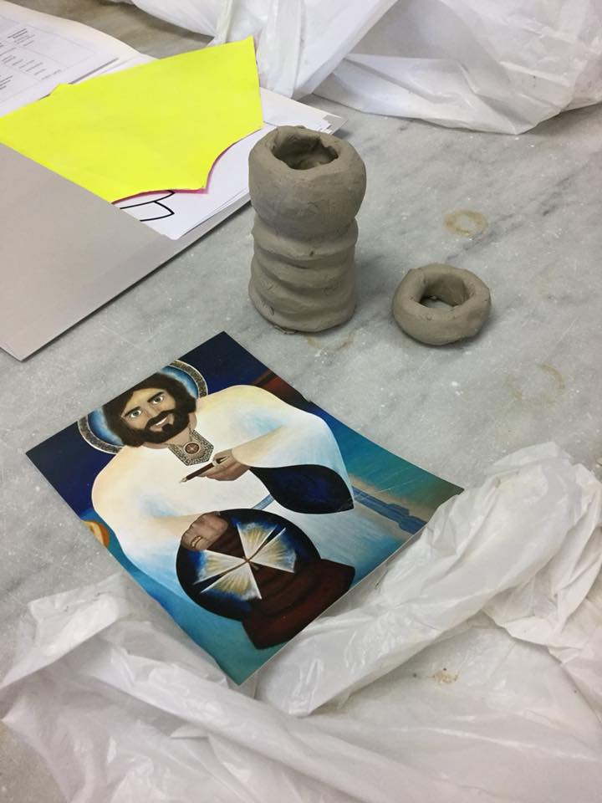
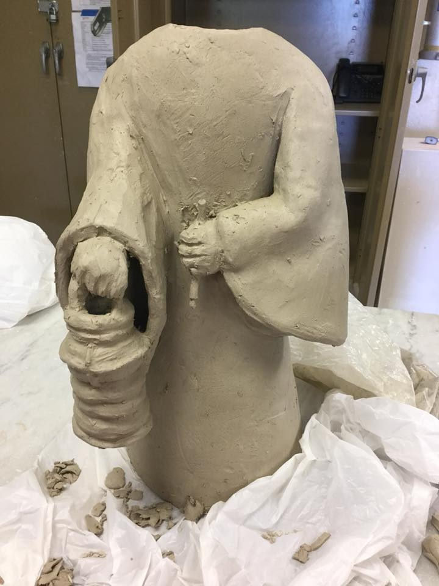
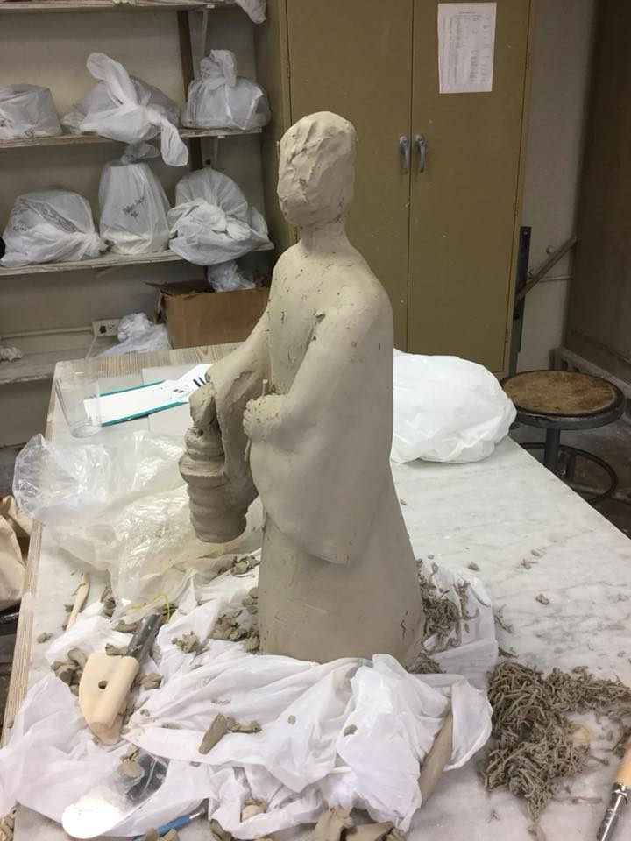
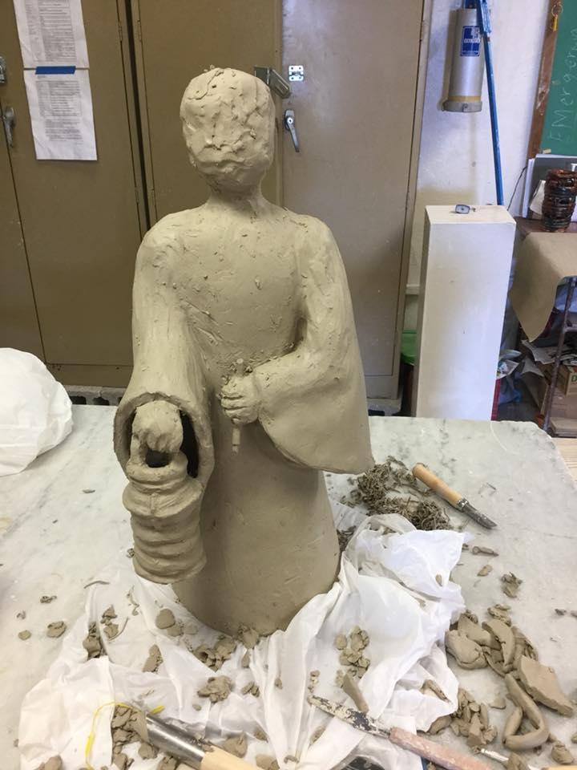

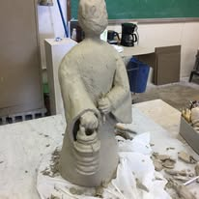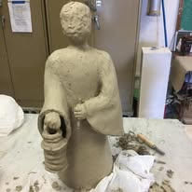

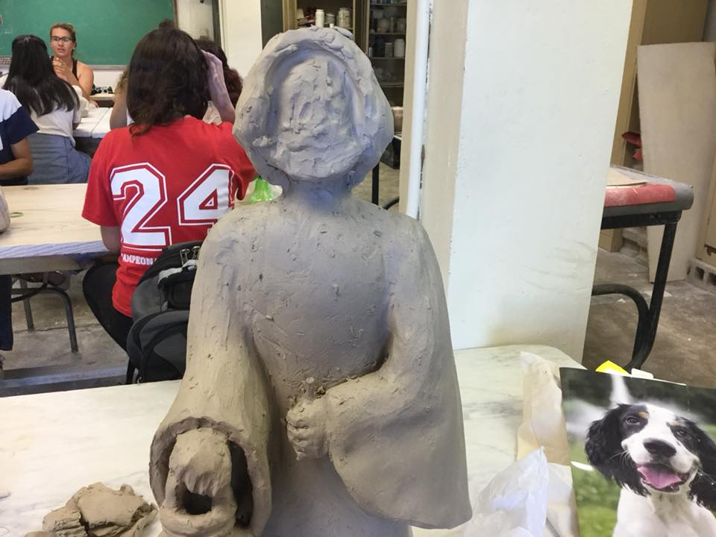

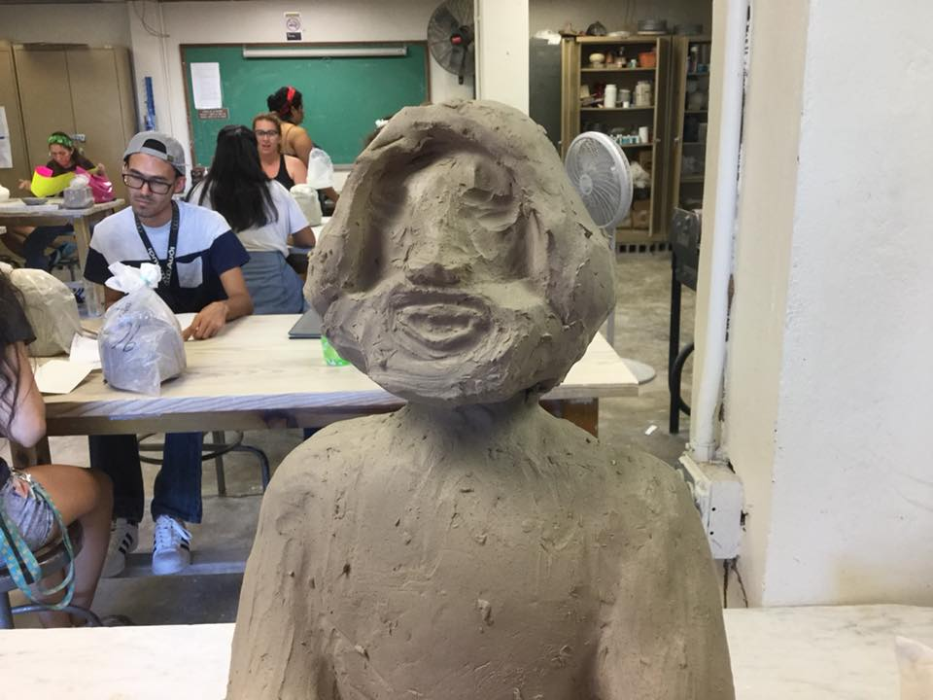
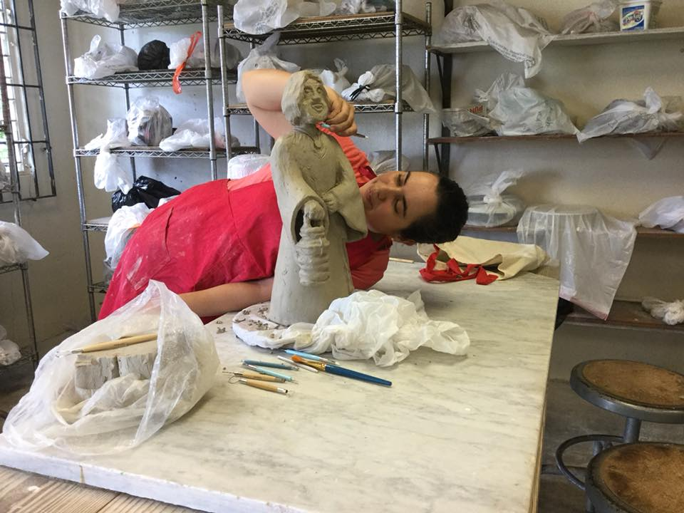
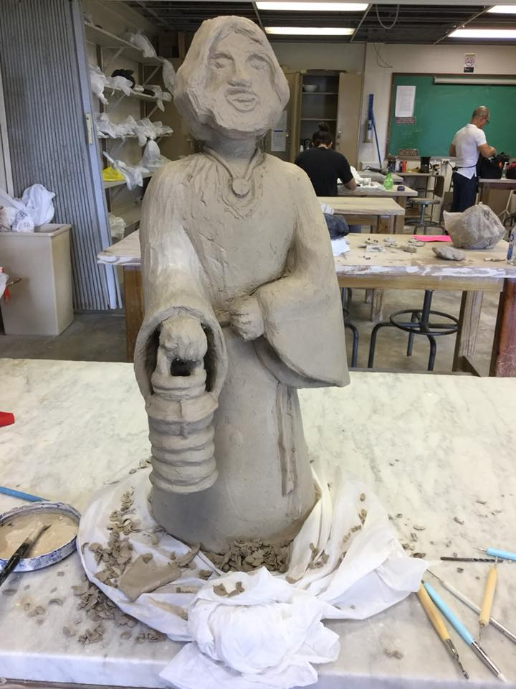
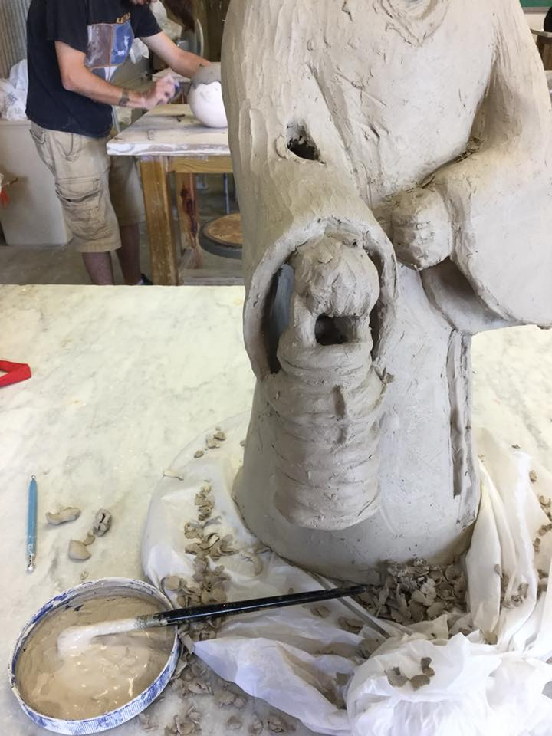
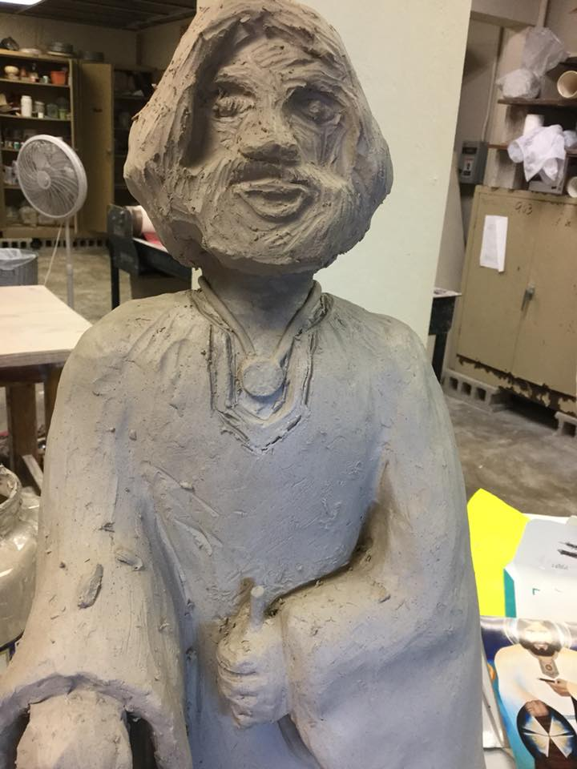
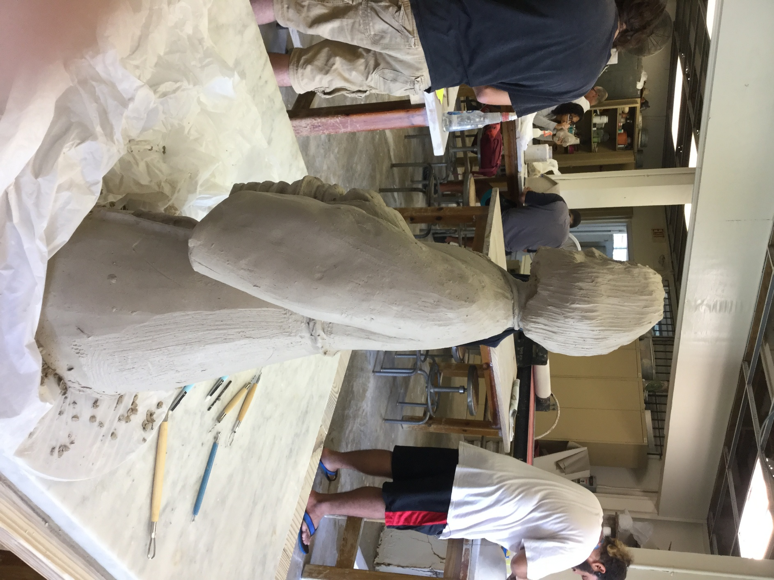
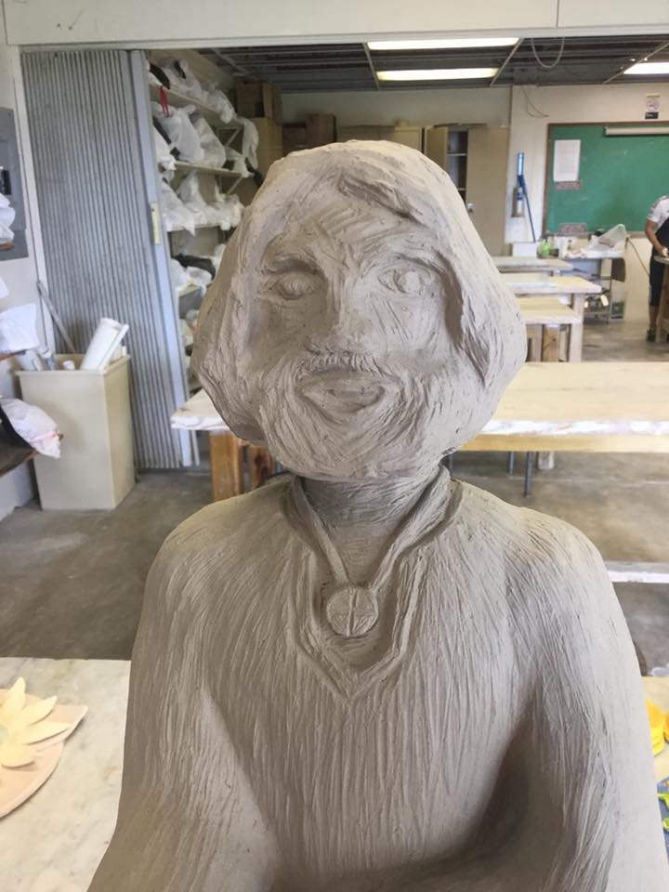
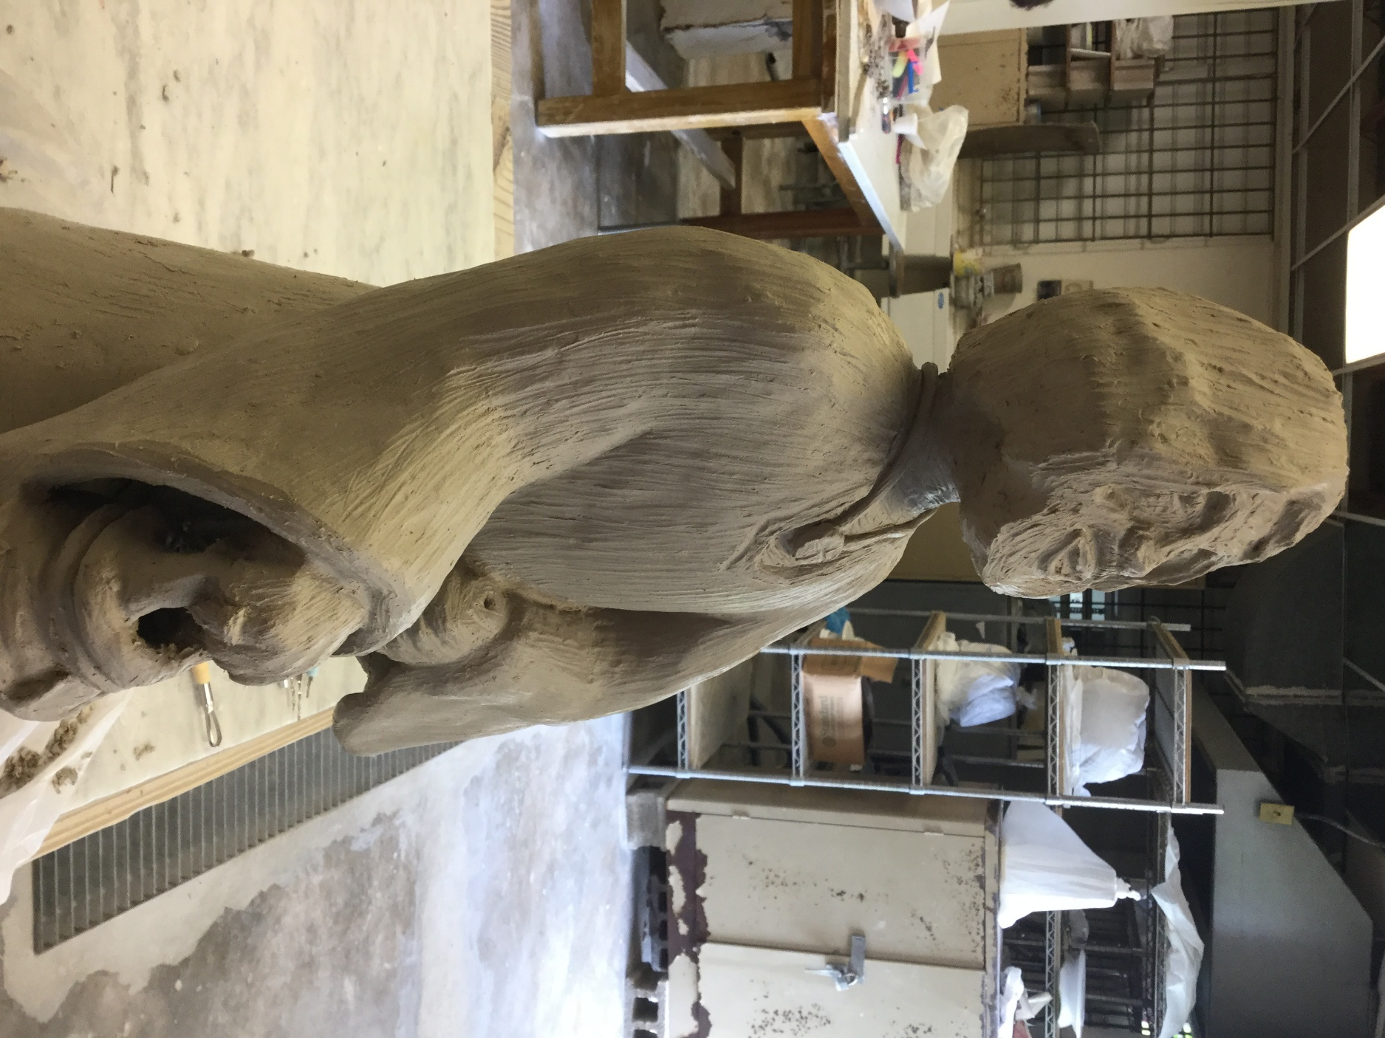

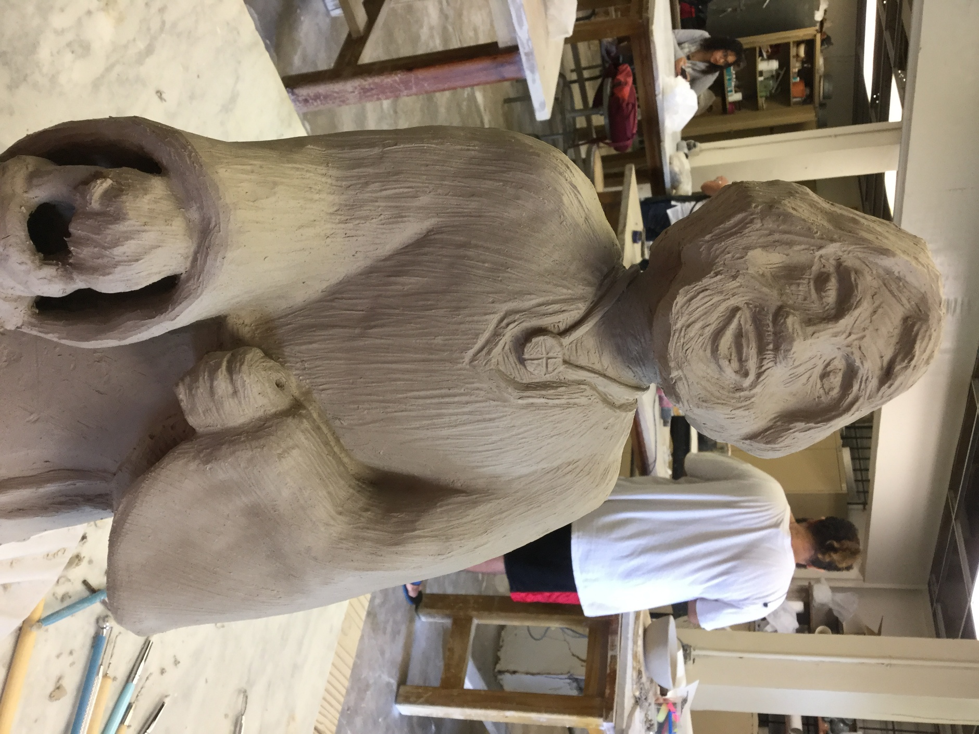
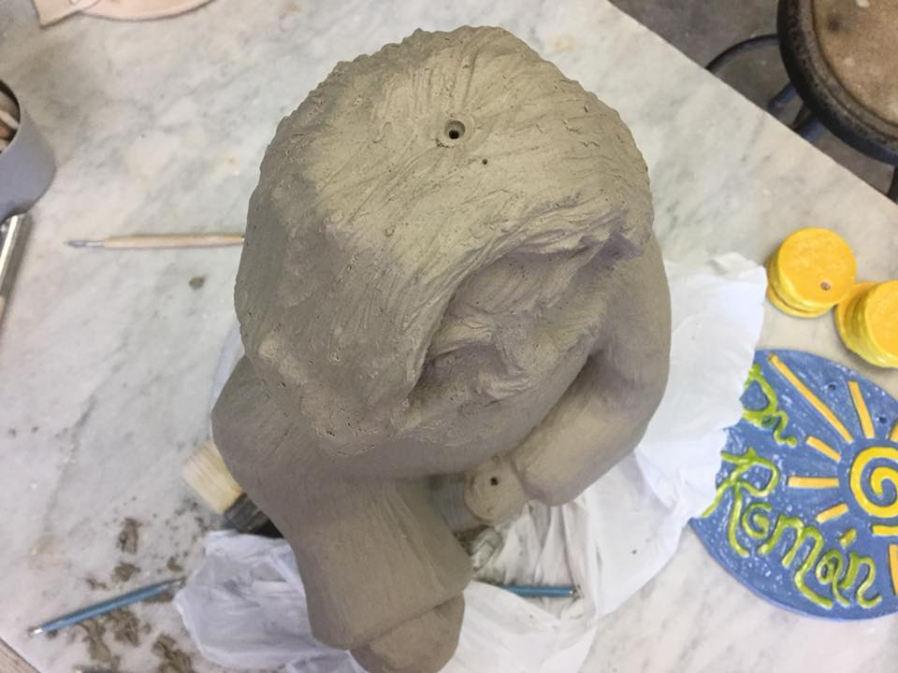
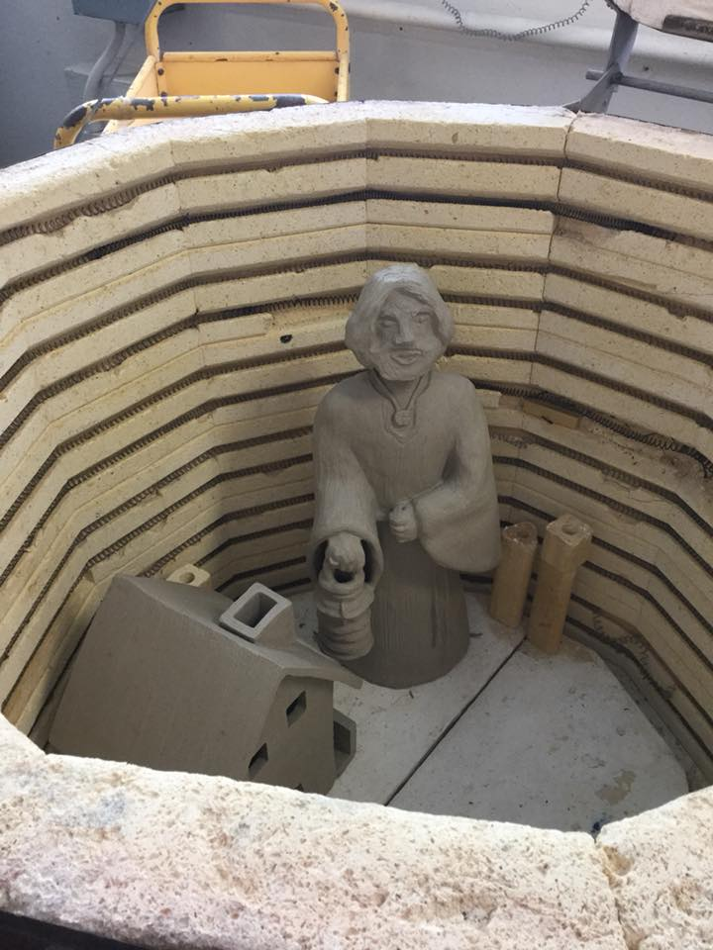
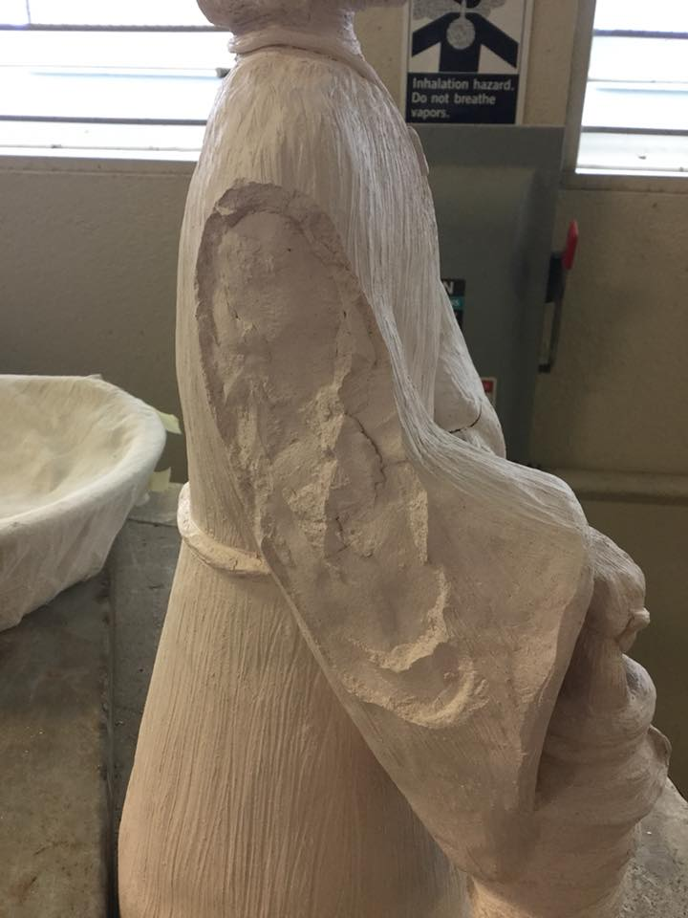
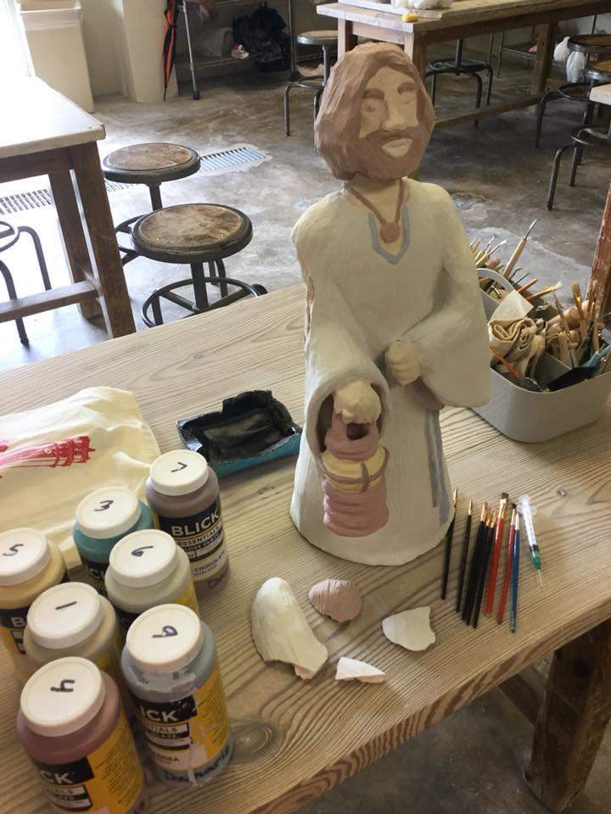
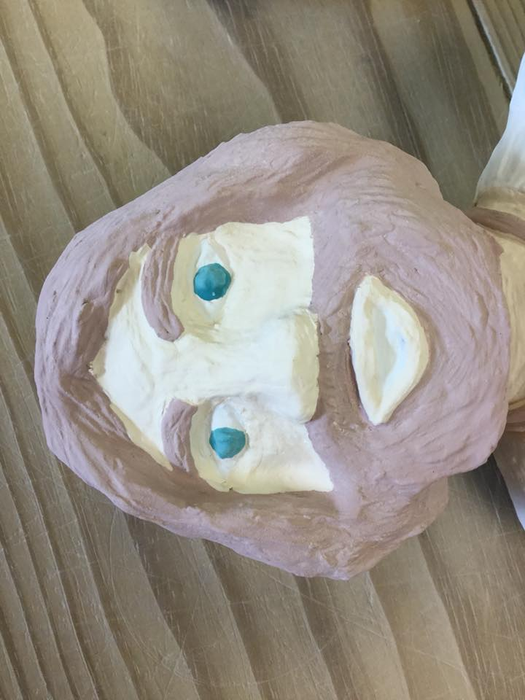
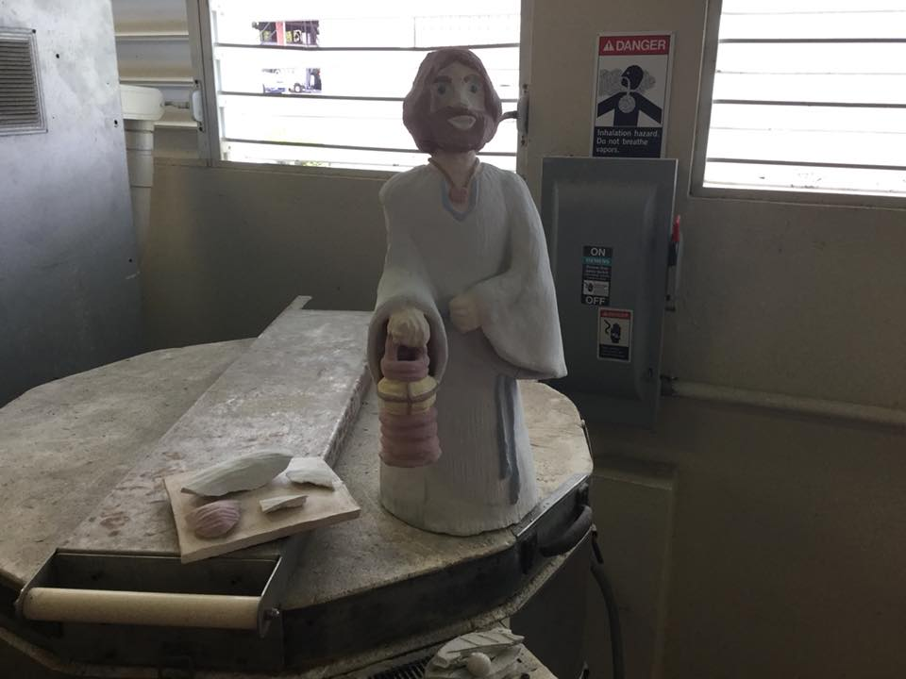
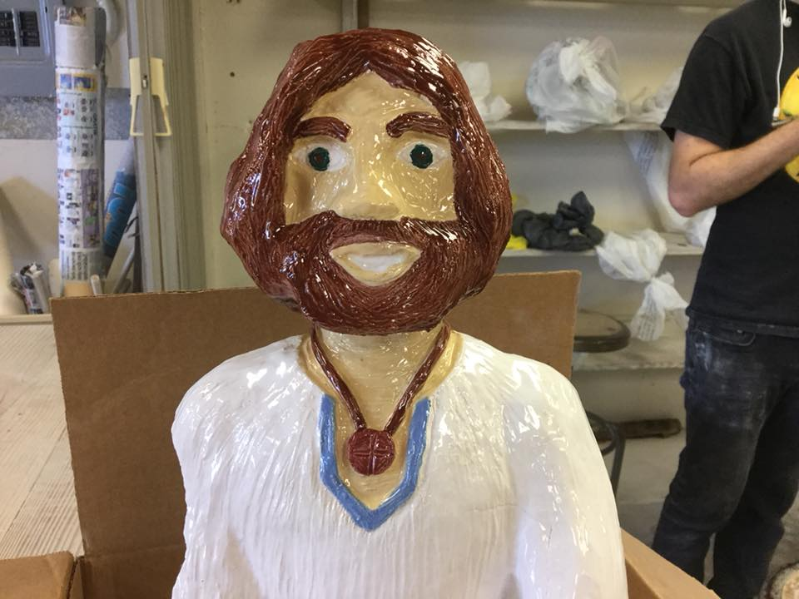
lowfuk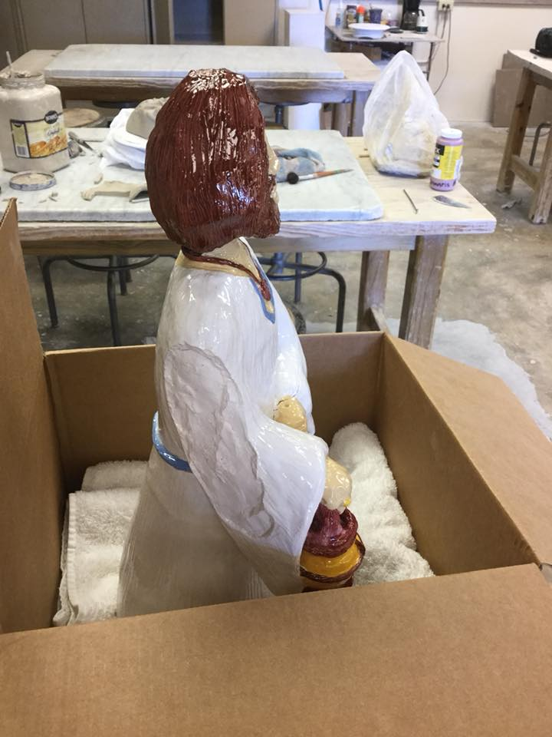
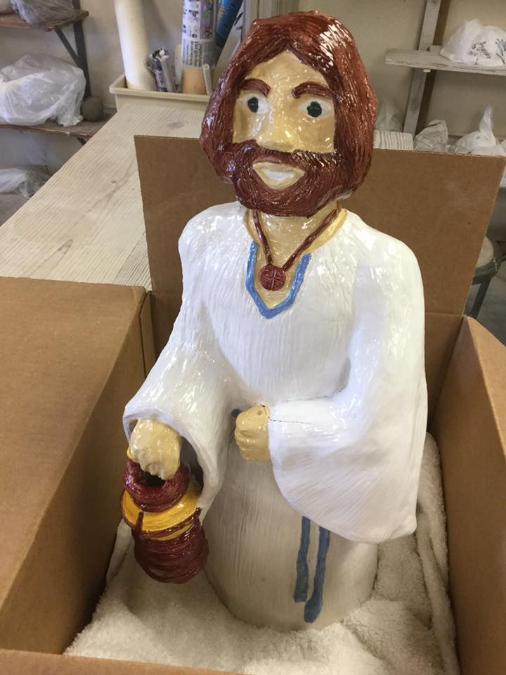
If you count all those images, there are 40 pictures in total: one for each year of my life (I will be 40 years old in the next two weeks...). Sharing with you, beloved children of the future, the lessons I have learned throughout my life, are lessons learned after a lifetime of self-improvement and self-development...
I let you know: it´s beautiful to live a growthful life, always learning to become the best you can be and continually learning how to give your best. Despite all I had been through, now, at 40 years old, I can look proudly at the child I once was and say to her: We did it, we dared to live a creative life with true meaning and achieve our dreams. As you might had seen in some of those photos, not everything was successful in the technique perspective: the piece broke when it was fired in the kiln and it looked like a flawed art work... no, it wasn´t flawed, it was pending to be done better, but not flawed, because I did my best while I formed it and created it... Techniques can be improved, and achieving better creative formative methods is part of attaining more and more growthful progress... but no matter how perfect your creative techniques and skills could be, you won´t be able to create anything that lasts if you don´t learn to do it with the right growthful attitude, remaining open to keep being formed to keep learning to form yourself as the best person you can be. To achieve the best techniques, would you use them to build a Manhattan project or a Glowful project? Who you are and become as you develop your skills and perfect your techniques matters as much as the result, because how those results will lead to either a glowing growth or a massive downfall will rely on who you were and choose to become as you acquire the skills you have. Results matter as much as the means you achieve them and the aims for which you aimed to achieve them. Your self-meaningfulness and your purposes mean as much as the growth objectives and teaching objectives you achieve to learn.
So, my results over the past 40 years may not have been achieved with the best technical skills, as can be seen in those 40 photos. However, I have developed a creative giftedness that I dreamed of as a child. Among other dreams I had as a child, I dreamed to be an inventor, to create something new (I have invented many things, but for me the integractive personal formation model was a fantastic thing to invent with the help of Jesus Charity: a way to understand systematically how you form as a person...) and being a writer. You might say, children: “Well, she is a writer, she is writing a whole book-sized letter to us...” You are right! However, the fact is that what I enjoy and love most is writing creative children´s story books... and I have managed to write and illustrate a whole children´s book. It´s titled “Goeiz”. It doesn´t matter that no one bought it: what matters is that it was my dream to achieve, and I grew a lot in the process.
Here you can see the cover of that children's book:
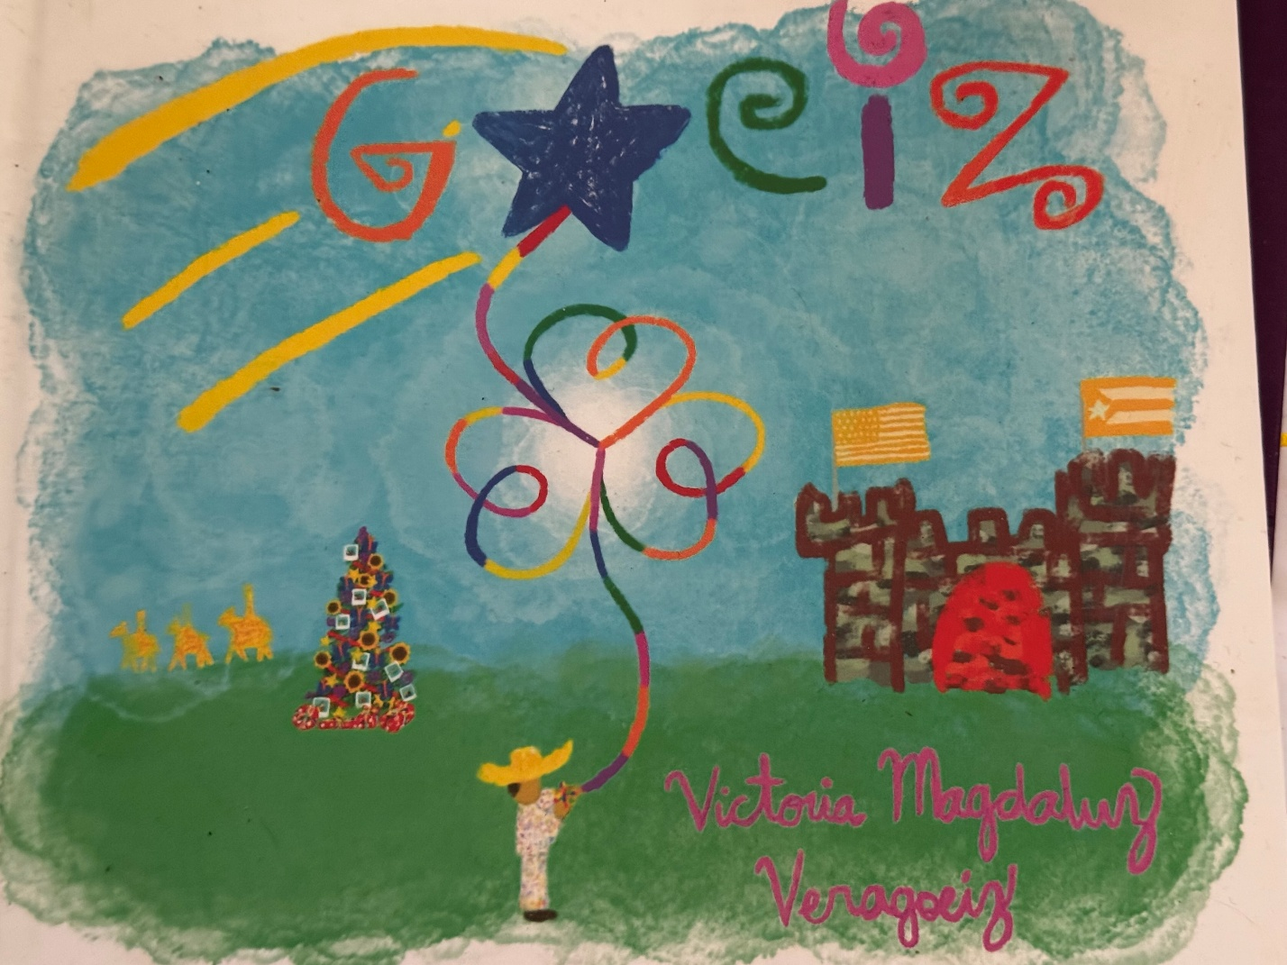

So, now you know, after what you just saw: a creative process to create something new, to sculpt something new, to form something or someone anew... may take time, but it’s a beautiful glowful creative giftedness that is also meant to be celebrated as a New Albor Legacy, as your creative giftedness makes possible new possibilities for those that come after you, like you, Puerto Rican children of the future, will also be able to celebrate when you make open brighter horizons to all the children´s generations that come after you.
This is the New Albor Legacy, your New Albor cultural inheritance: always keep growing on, glowing on, and blooming on; always keep growing best, glowing best, blooming best... so a growthful progress can keep being inherited one generation after another, and this loveful American harvest can keep being radiated as a New Albor legacy of American peoples that are able to learn to walk as brothers and sisters, growing together in more and more glowful communion, more and more radiated by a culture of new albor that helps everyone to keep becoming more and more growthful, glowful, bloomful... ever more. Yes, Puerto Rican future kids, this New Albor legacy is worth celebrating, and it can be celebrated in so many ways, as you had already seen in what I have already written with a Jesus Charity-given envisioning... but let´s propose now a way to celebrate such legacy at a whole cultural level: let´s propose you —Jesus Charity always proposes, never imposes— to celebrate this New Albor legacy with a cultural festival where all at the island and whoever comes from anywhere else can celebrate together this New Albor as a cultural legacy, not passed merely one parent to their children, as it would happen with a New Albor Legacy Salad family recipe, nor merely one generation after another, as it would happen when your grandparents teach you the traditions of those who had helped Puerto Rico to become the Puerto Rican society you know presently and that are called to keep building with more and more growthful building blocks... Let´s propose to you a whole New Albor Fest: a whole cultural festival to celebrate together AS PEOPLE how we are a New Albor culture and a New Albor state, celebrating together how we keep growing best, glowing best, and blooming best, one generation of children after another. Yes, Puerto Rican children of the future: you would be the stars of this New Albor Fest, which would happen in a cultural district in Ponce, starting at New Year (at the midnight between December 31 and January 1) and finishing in the most beloved holiday for Puerto Rican children: el Día de Reyes. ¡Que viva la tradición! ¡Que viva este infinito horizonte de crecimiento en más y más comunión fraterna, este New Albor legacy! ¡Que viva Cristo Amor! Yes, the New Albor legacy that will be shared with you is enormous, future Puerto Rican children! Celebremos juntos como el progreso logrado hoy se transmite a las próximas generaciones, siendo semilla de cultura de nueva vida que crece en comunión, semillas que ayudan a crecer en comunión a la próxima generación...
Luis Muñoz Marín dijo en su momento: “Tenemos en nuestra mano el tesoro inmenso de una semilla. Según la sembremos y la amparemos será la cosecha que ahora y en el futuro recojan las gentes que habitan y que entonces habiten esta tierra de Puerto Rico.” Él hizo lo mejor que pudo por Puerto Rico en su momento... y ahora también toca hacer lo mejor que se puede hacer en este momento, con el progreso que se tiene en este momento y finalmente entendiendo: el ELA es insostenible como opción de futuro viable de crecimiento pleno; perpetuar el que no se nos considere civilmente como ciudadanos iguales —con ciudadanía de nacimiento y con igualdad de derechos y deberes— es insostenible... Ahora, con el progreso de hoy, se sabe: constitucionalizar la inequidad, sistematizar el no vernos como personas iguales y como ciudadanos iguales, en cualquiera de las formas que se haga, como lo hace la constitución del ELA colonialmente… Eso jamás será compatible con el reconocimiento incondicional de la dignidad de toda persona y de todo ciudadano. Ahora, con el progreso de hoy, toca ser semilla de crecimiento en comunión para que las próximas generaciones reciban el legado de un Puerto Rico libre de inequidad, pobreza y discriminación sistemática, especialmente contra los niños puertorriqueños. Ustedes, niños puertorriqueños del futuro, son llamados —como todo niño— a poder crecer convirtiéndose en la mejor persona que puedan ser creciendo juntos en más y más comunión, siendo libres para ser y convertirse en quienes sueñen y autodeterminen ser de forma fraterna… Eso es parte de lo que se celebra como New Albor Legacy en este New Albor Fest: que todos los niños puedan crecer incondicionalmente como son (ciudadanos que son incondicionalmente reconocidos como personas llamadas a ser según su dignidad inherente) y también como son llamados a ser, un Puerto Rico que es un Estado del Nuevo Albor que es un ESTADO SOBERANO, no un estado libre asociado, ni mucho menos meramente un estado “confederado” donde se gobierna con un estilo colonial-based.
Convertirnos en Estado del Nuevo Albor, Puerto Rican kids of the future, también significa que se debe honrar nuestra cultura del nuevo albor, incluso en nuestra forma de autodeterminación de gobernanza estatal soberana. No, niños, no entiendan la palabra "soberano” como lo hacen los hermanos independentistas, lo de ser “estado soberano” no se trata de ser independientes o “país soberano”, ni tampoco ha de entederse como se hace en Europa, como “reyes soberanos”… Como New Albor State que es estado soberano, hemos de ser un estado de CIUDADANOS SOBERANOS: ser un Puerto Rico libre con una gobernanza estatal soberana, a cuyos ciudadanos se les reconoce una ciudadanía civil federal con plena igualdad —el derecho civil a ser ciudadanos iguales al resto de ciudadanos estadounidenses— and that are also citizens unconditionally recognized as persons with inherent dignity and fraternal rights, con derecho a una gobernanza estatal autodeterminada de una forma dignity-based que reconoce plenamente a nivel civil la dignidad personal inherente de todo ciudadano, sea ciudadano soberano o sea ciudadano fraterno; un New Albor State donde la soberanía personal de todo ciudadano es afirmada en dirección comunión a nivel civil, incluso en la forma de auto gobernanza y constitución civil estatal; un estado del nuevo albor donde todo ciudadano, comenzando con ustedes, niños puertorriqueños del futuro, es soberanamente libre y tiene iguales oportunidades de crecimiento pleno para poder convertirse en la mejor persona que pueda ser, para así convertirnos juntos en el nuevo albor más brillante que podamos ser para ampliar nuestra línea de horizonte America con más y más crecimiento en comunión infinito.
Niños… siempre hemos de aprender lo mejor de nuestros ancestros y seguir progresando a partir del legado dejado por el crecimiento más pleno que hayan alcanzado ellos. Aunque la constitución del ELA fue redactada colonialmente desde un principio —y el permanecer como colonia, tal cual se acaba de explicar hace muy poco atrás y también a lo largo de la carta— es totalmente incompatible con una forma de gobierno civil capaz de afirmar incondicionalmente la dignidad inherente de todo ciudadano… Sería un craso error repetir errores del pasado, actuando por reacción a lo que no somos —ELA— en lugar de reconocer con humildad y agradecimiento el mejor progreso que nuestros ancestros pudieron lograr en su momento. ¿Recuerdan lo que les conté de Estados Unidos, de como acabaron siendo más colonizantes que Gran Bretaña solamente para reclamar que dejaron de ser colonias de Gran Bretaña? Lo bueno de saber historia es que de los errores se aprende, y el error que cometieron ellos no tenemos porqué cometerlo nosotros también: no necesitamos actuar de forma anti-ELA para seguir creciendo como Estado del Nuevo Albor. El reconocer el mejor progreso que haya sido posible para nuestros ancestros lograr, incluso en el contexto de una constitución colonial, es un ejercicio histórico necesario para lograr el progreso más humanizante y fraternizante como pueblo. Por ejemplo: incluso convirtiéndonos en Estado del Nuevo Albor, es muy necesario reconocer debidamente la legítima e invaluable importancia de los hermanos independentistas en la lucha por un Puerto Rico libre, y si han observado bien lo que se ha escrito en el devenir de las páginas ya leídas, se hacen referencias explícitas a la importancia de Albizu Campus. Jamás se ha de fomentar el odio, bajo ninguna circunstancia, pero sobre todo cuado se trate de odio reactivo: odiar a personas que parecen contradecir lo que somos. No hagan esoñ niños. Si aprenden a ver de forma fraternizante, verán que incluso entre criminales de guerra desalmados se pueden aprender grandes lecciones respecto a todo lo que podemos crecer aprendiendo con fraterindad incondicional de la historia puertorriqueña ya vivida. Conste que al hablar de “criminales de guerra desalmados” jamás me referiría a Albizu Campos… pero vale la pena, cara a todo lo que ha sucedido en este social war que aún no ha sido reconocido, que se entienda clara y humildemente: tras esos criminales de guerra desalmados hubo una niñez de extrema pobreza en la que no se sintieron incondicionalmente amados, y eso los marcó de tal forma que eventualmente se convirtieron en criminales de guerra civil cuyo calibre de terrorismo psicosocial se atrevió a pretender mancillar la dignidad más sagrada de todas: la de la niñez. Tras todo esto que ha sucedido hay todo un transfondo histórico que —más allá de toda la perversión moral depravada que estos criminales de guerra han demostrado ser capaces— tiene que ser legítimamente reconocido como un rotundo Never More no solamente de nuestra propia historia como New Albor State soberano, sino como magna lección para toda la humanidad: el costo social que conlleva para toda la humanidad una noción de crecimiento definida con términos de capitalismo predatorio, tal cual lo hace el PIB (el GDP) es un costo mucho más impagable que cualquier quiebra económica absoluta de un estado. El gobierno de Puerto Rico tuvo que declarse en quiebra, y si notaron bien, niños del futuro, cual fue el comienzo de toda la retahíla de catástrofes que asolaron una tras otra en un lapso de diez años a todos los niños de la generación X y la generación Alpha, todo comenzó cón el colapso económico total de Puerto Rico, con niveles de desempleo no vistos desde la Gran Depresión en 1930.
Si esta guerra psicosocial tuvo el caldo de cultivo necesario para alcanzar la magnitud que alcanzó… No, sería muy injusto para todos, incluyendo ustedes, niños del futuro, adjudicar eso a la mera perversión moral de criminales de guerra social, incluso sería tremendamente incompleto el adjudicar dicha magnitud meramente a la tremenda pobreza sistemática en la niñez de esos criminales de guerra, una inequidad tan pero tan extremadamente sistémica a nivel de todo el territorio civil puertorriqueño que —unido a la configuración concreta de la formación personal de cada cual— en estos criminales de guerra la exposición sistemática a una inequidad socioeconómica tan tremenda a nivel civil supuso que su formación personal quedara deforme para siempre. Incluso si posteriormente se logra obtener oportunidades de crecimiento más pleno, que se aprenda bien esta lección: el daño social que se provoque a la infancia siempre será el más letal de todos. Esperen a que los niños crezcan y eso se verá eventualmente. Cierto: es bastante raro que una inequidad sociopoliticoeconómica sistémica pueda alcanzar el calibre que se ha alcanzado en Puerto Rico; es incluso más raro aún que a eso además se le sumara a la articulación biológica particular de niños a los que —debido a como se configuraba su formación personal concreta— lo extremo de esa inequidad en su infancia provocó una deformación irreversible en su formación personal adulta, sobre todo del calibre de deformación personal que se ha tratado en el caso de estos criminales de guerra: debido a como les deformó la extrema inequidad sistémica en sus infancias, eventualmente se convirtieron en adultos totalmente capaces de cumplir con obligaciones económicas, pero absolutamente incapaces de amar, de entender cualquier tipo de llamada a la comunión personal, incluyendo la llamada a formar un matrimonio que funcionara como tal, en lugar de funcionar como conspiración criminal que sistematiza la “inequidad doméstica” y la esclavitud social exactamente de la misma forma que ellos se sintieron eslavos sociales en sus infancias… y como parte de una reacción postraumática a dicha esclavitud social, que acabó en deformación irreversible de su formación personal, para afirmar lo que son tuvieron que configurar con términos de “hogar” todo un mass depersonalization complex con el que afirmaban ser lo que no pudieron vivir en sus infancias… enforcing a systemic domestic inequality with an even worse civil slavery tan the ones they endured in their childhood…
Estas lección histórica que se está contando no se aprendió en el Holocausto, cuando aún no se tenía el debido conocimiento de la importancia de la infancia en todo tu desarrollo psicoemocional posterior en la adultez. Cierto: no todos los niños sometidos a inequidad sistemática extrema acaban con enfermedades psiquiátricas mayores ni acaban convirtiéndose en criminales de guerra debido al trauma que la magnitud de esa inequidad causara en su niñez, aquí también hay predisposiciones biológicas que tomar en cuenta… pero la lección que sí fue aprendida tras el Holocausto —la Declaración Universal de los Derechos Humanos—ahora puede ser aprendida desde una perspectiva que no podía ser vista en esos momentos: para reconocer la dignidad inherente de todo ser humano como persona no basta con garantizar techo, comida, libertad de expresión, libertad de culto, ni siquiera basta el derecho a ser libre para formar una familia… y eso puede probarse muy bien con el tipo de crímenes de guerra social que se han visto aquí: se puede ser totalmente libre para contraer matrimonio y ser totalmente incapaces de contraer el matrimonio como debe contraerse legítimamente… sencillamente porque, debido a lo que sobrevivieron en sus infancia, son absolutamente incapaces de amor.
Niños… ¿se imaginan que horrible y terrible es que algo que pasara en tu infancia, algo sobre lo que no tenías control en lo absoluto… acabe dejándote incapacitado para amar, incapacitado para siempre de poder amar y dejarte ser amado de verdad, ni siquiera por Dios, cuyo Amor no se niega a darse a absolutamente nadie que se abra a Él, aunque sea pro una apertura del tamaño de un ojo de aguja? ¿Se imaginan que mal tuvo que haberse sentido un niño para al convertirse en adulto ser absolutamente incapaz de amar y dejarse amar tras lo sucedido en su infancia?
Así pues, hay dos grandes lecciones que tienen que ser aprendidas por ustedes y por toda la humanidad tras este Never More, lecciones que aún no podían ser aprendidas tras el Holocausto, pero sí que pueden ser aprendidas ahora:
La primera es qe reconocer los derechos humanos no basta para reconocer la dignidad de toda persona de forma inherente. Sí, que quede claro: es importante reconocer los derechos humanos… pero el cómo se reconozcan esos derechos humanos también es importante. Y en estos momentos no me refiero a materia legal (no me estoy refiriendo a si cada nación le dé peso de ley a los derechos humanos o no). En estos momentos nos estamos refiriendo a algo muchísimo más humano y básico, el factor más determinante de la capacidad de crecer de toda formación personal, sin importar la espeluznante magnitud infrahumanidad a la que pueda llegar cualquier inequidad sistémica, tal cual ha pasado en Puerto Rico y en todo lo que ha pasado en la guerra psicosocial que han tramado los terroristas sociales que han tenido demasiada rienda suelta por demasiado tiempo dentro de la isla…
A lo que nos estamos refiriendo ahora es a algo mucho más esencial: si al reconocer los derechos humanos no se reconoce también el derecho de todo ser humano a crecer incondicionalmente amado y a ser tal cual es incondicionalmente amado (y esto siempre comienza creciendo en una familia donde se es incondicionalmente amado) los derechos humanos se quedan cortos, cortísimos, a quien se proponga realmente reconocer la dignidad de todo ser humano de forma inherente.
Niños del futuro: les ánimos en esos momentos a que se tomen una pausa ahora para leer la Declaración Universal de Derechos Humanos. No es un documento largo, e incluso existen versiones infantiles que ustedes, niños más pequeños, también pueden entender. Lograr ese documento fue todo un hito en la historia de la humanidad y eso ha de ser celebrado… A la misma ves que se celebra el legado que nos han dejado quienes nos precedieron en la historia de la humanidad, también hemos de atrevernos a aprender a ver lo que, con el progreso de hoy, se sabe que también tiene que hacerse para que esa Declaración Universal de Derechos Humanos realmente pueda repercutir en el reconocimiento incondicional de la dignidad de todo ser humano de forma inherente: afirmar la fraternidad de todo ser humano de forma tan inherente como se afirma la dignidad personal. No hay forma de reconocer inherentemente la dignidad de un ser humano si no se reconoce de forma incondicionalmente fraterna: todo ser humano, absolutamente toda persona, es llamada a crecer como parte de una familia donde puede crecer con dignidad fraterna, incondicionalmente amado. Sí, la Declaración de Derechos Humanos llega a declarar que todos somos hermanos… pero lo que no había aún el progreso social para declarar aún es la única forma posible para reconocer inherentemente una dignidad que es necesariamente ha de ser dignidad fraterna para poder ser reconocida como dignidad humana: el derecho a amar y ser amados incondicionalmente; el derecho a no meramente poder sobrevivir según una línea de humanidad mínima, unos mínimos de humanidad que tras lo sucedido en el Holocausto quedó bien claro que había que delimitar… sino también el derecho a poder ser humano in a beloved way, not only according to the unconditional recognition of universal human rights that make you able to live in an unconditionally human way…. but also according to the unconditional recognition of other kind of universal rights that make you able to grow in an unconditional fraternal way, with the sacred fraternal right of be able to grow in a family that can be raised with fraternal dignity and to be able to self-determine your personal formation´s growth in the most fraternizing way possible to achieve at your generation.
Si leyeron detenidamente, niños del futuro, la Declaración de Derechos Humanos, podrán tal vez haberse dado cuenta: la palabra “dignidad” se menciona, la fraternidad también se menciona, y de diversas formas… pero la palabra “amor” no aparece ni una sola vez en toda la Declaración.
Con esto que ha pasado aquí puede entenderse la magnitud de catástrofe psicosocial que puede generar el que se le niegue a cualquiera la mera posibilidad de amar y poder sentirse incondicionalmente amado, como pasó en las infancias de quienes han cometido las atrocidades de guerra social y las violaciones a la niñez de la escalofriante magnitud que se han cometido en Puerto Rico. El asunto se vuelve muchísmo más grave y atroz cuando… resulta que a quienes se les niega la posibilidad de amar y ser amados incondicionalmente es a niños totalmente inocentes y que no tienen culpa alguna de ser expuestos de forma forzada al nivel de violencia psicosocial que ha implidado a lo largo de muchísimas generaciones de niños puertorriqueños la esclavitud civil que se les ha impuesto como “molde civil” (a esa noción yo no la llamaría precisamente “civil,” pero entiéndase: esto sucedía a nivel de todo el territorio civil) via colonialismo fratricida, que además viola directamente los derechos humanos. De hecho, aunque es posible honrar los derechos humanos sin honrar la dignidad fraterna… lo que NO es posible es violar la dignidad fraterna de forma sistémica sin que hayan sucedido también violaciones de derechos humanos de forma sistémica. Por eso es tan importante, niños, SIEMPRE alzar la voz en cuanto se vea una violación de derechos humanos “normalizada” a nivel civil, como sucede en esta generación al permitir que haya estados islámicos (naciones con la ley Sharia que sistematiza violaciones de derechos humanos contra determinadas poblaciones con la excusa de “libertad religiosa”). Creo que esto lo dice la misma Declaración Universal de Derechos Humanos, pero si no lo dice, se los explico yo, niños: ningún derecho humano, absolutamente ninguno, puede usarse como “excusa” para violar otro derecho humano. Eso aplica igual a nivel de todo un gobierno civil que a nivel de vecindad de barrio, que es lo que los niños suelen conocer como “sociedad civil inmediata” además de la familia y la escuela. No se puede usar a un Dios —sobre todo al Cristiano, pero esto aplica a cualquier autoridad que se considere divina, sea de la forma que sea que suceda— como excusa para solamente reconocer los derechos humanos de los que conviene reconocer como humanos, o solo reconocerlos como conviene, sin reconocerlos todos de la misma forma incondicional en todos. A los derechos humanos o se les reconoce de forma incondicionalmente digna y fraterna a la vez, o no se les reconoce de forma humana en lo absoluto. Sin reconocer a la misma ves la dignidad humana como inherente y la dignidad fraterna como inherente, los derechos humanos se acaban convirtiendo en un documento que siempre será digno de celebrar, pero totalmente imposible de implementar por completo, porque para empezar no se está asumiendo el principio de formación personal más esencial de todos: no solo somos llamados a vivir humanamente, somos llamados también a ser seres humanos que crecen en comunión fraterna incondicional.
Niños del futuro: serán ustedes lo que salven a la humanidad al afirmar lo que cuando se redactó la Declaración Universal de Derechos Humanos aún no se podía afirmar de forma incondicional: ustedes serán los que redacten una AFIRMACIÓN UNIVERSAL DE DERECHOS FRATERNOS. No, no se le llama “declaración” como a los derechos humanos, porque lo que hacen los derechos fraternos es afirmar de forma inherentemente fraterna la dignidad ya afirmada de forma humana en la Declaración de Derechos Humanos. Se pensaba que la Declaración de Derechos Humanos hace posible el reconocimiento inherente de la dignidad humana… y con lo que ha pasado aquí es suficiente para que se entienda: los derechos humanos son totalmente incapaces de afirmar el reconociminento inherente de la dignidad humana sin una Declaración Universal de Amor que afirme dicha dignidad humana de forma inherenrtemente fraterna. A esto, niños del futuro, es a lo que nos referíamos al decir que la forma en que se reconozcan los derechos humanos tiene tanto peso como el hecho de que se reconozcan dichos derechos: se tiene que afirmar el amor como la afirmación fraterna absolutamente incondicional de todo ser humano… y por eso los derechos frateros, si se fijan, son la afirmación de los derechos humanos de forma “doméstica”: lo que estarían afirmando es una Carta de Derechos de las Familias, porque para que toda persona, sobre todo los niños, puedan crecer con una dignidad fraterna inherentemente reconocida, creciendo siendo incondicionalmente amados… eso necesariamente significa afirmar que todo ser humano tiene derecho a formar una familia incondicionalmente digna y fraterna. Entender como corresponde lo que acabo de decir, meramente eso, puede evitar guerras enteras, como se puede probar con lo que ha pasado aquí: nada de esto hubiera pasado si para empezar… a los terroristas sociales tras toda guerra social se le hubieran reconocido iguales oportunidades de crecimiento y hubieran tenido en la escuela el apoyo fraterno para manejar la particularidad de la configuración personal en sus infancias que no fue posible manejar, debido a la extrema pobreza, en su propio hogar, de tal forma que lo sucedido en su niñez no derivara ipso facto en una deformación y perversión irreversible de su formación personal, dejándolos incapaces de amar y dejarse amar…
Es hora de aprender: Negar a cualquier niño su derecho a poder crecer sintiéndose incondicionalmente amado… tal vez no sea un crimen de lesa humanidad ipso facto si resulta que al niño sí que se le brindan ciertos mínimos materiales requeridos por ley, pero sí que es un crimen de lesa fraternidad: se le está negando su derecho a crecer con plenitud humana. La Declaración de Derechos Humano declara los mínimos de humanidad; la Afirmación Universal de Derechos Fraternos —a la que también se le puede llamar “Declaración Universal de Amor”— afirma lo humanamente máximo. No es real que se asuma como “dignidad humana” el brindar a un niño de lo materialmente necesario… pero negándole el amor incondicional y sentirse incondicionalmente amados como personas con dignidad inherentemente reconocida de la forma más fraterna posible, tal cual sucede en primer lugar en un ambiente civil propiamente doméstico. Negar a un niño el poder crecer en un ambiente doméstico —para la mayoría de los niños, esto significa “siendo parte de una familia civil”— donde pueda crecer amado incondicionalmente, aunque eso sucediera sin que le falte absolutamente ningún sustento material al niño, ES un crimen de lesa fraternidad, entre otros crímenes de lesa fraternidad posibles cuando sea un Estado el que implementara las violaciones sistémicas de derechos humanos que hicieran absolutamente imposible la posibilidad de crecimiento personal lo más plenamente fraterno posible, tal cual ha sucedido en Puerto Rico.
Que quede bien pero que bien claro, niños del futuro: esto aplica exactamente por igual a TODOS los niños, incluyendo a los niños que estén bajo la custodia del Estado: no basta con que el Estado pague para brindarles cama, alimento, educación escolar básica, salud, cuidadores que salvaguarden su seguridad y algún entretenimiento que se brinde según convenga al control disciplinario: también los niños bajo custodia del Estado tienen el derecho a ser custodiados de la forma más fraterna posible, creciendo en el ambiente más doméstico posible según la articulación de su formación personal propia. Quienes sean sus cuidadores se les tiene que formar y empoderar para que no meramente cumplan su labor como paid caregivers sino también como custodios fraternos, pudiendo tener gestos fraternos con esos menores que no dejan de necesitar ser amados como las personas que son por estar siendo custodiados por el Estado. Además, ha de hacerse haciéndolo de la forma más fraterna posible, según lo que a cada niño como persona única les haga sentirse incondicionalmente amados, exactamente como se supone que pase en toda familia constituida de forma civil. No se imaginan, niños, lo que un niño en foster care anhela poder sencillamente poder ser amado ser persona —aunque ellos mismos no sepan decirlo de esa forma—, tal cual son... Por ejemplo: un niño en una familia si quiere su chocolate favorito, mama se lo compra y se lo da con amor... A un niño de foster care en un hogar le darán todo lo material, pero cuando se trata de crecer como persona amada tal cual es... eso no lo cubre el presupuesto. Así que si un niño de foster care sencillamente quiere que alguien le dé su chocolate favorito, tal cual es perfectísimamente normal en cualquier niño meramente porque es persona y tiene sus gustos... si el chocolate no está programado en el menu para ser dado a todos los niños del foster home, el chocolate que es parte de su formación personal ni siquiera será asumido en el presupuesto, no hay presupuesto alguno de formación personal explícitamente asignado para que caregivers de foster home kids asuman el rol de custodios fraternos y esos niños puedan sentirse fraternalmente amados como persona.... No, eso no lo cubre el presupuesto de la administración de la institución que lo cuida. Algo tan sencillo como “formación personal” no se presupuesta para los foster home kids: si quieren comerse su chocolate favorito, en su caso ellos se lo tienen que pedir a un cuidador sabiendo que será el propio cuidador quien lo pagará de su bolsillo, en lugar de ser el Estado que los custodia quien asuma de forma ordinaria y humana… que ese niño tiene todo el derecho a ser amado como la persona que es y a que quienes le cuidan puedan brindarle de forma fraternalmente razonable —y con fondos del Estado— detalles fraternos según la personalidad de cada cual, tal cual sucede en un ambiente doméstico propiamente civil que afirma una afectividad personal sana y fraternizante. pero resulta que eso no está en el presupuesto de la institución que lo cuida en nombre del estado…
Se tiene que entender, niños del futuro: la dignidad humana, o se reconoce de forma incondicionalmente fraterna, o no será posible que sea reconocida de forma inherente. Seguir asumiendo que es posible reconocer inherentemente la dignidad de un ser humano sin amor… es un NEVER MORE que hay que aprender.
Esto es algo que en este presente ha sido absolutamente imposible de ver… pero para ustedes, niños del futuro, sí que será posible tener el progreso suficiente para redactar una Afirmación Universal de Derechos Fraternos que haga posible un reconocimiento verdaderamente inherente de la dignidad humana, afirmándola de forma inherentemente fraterna. Ustedes serán quienes, una vez más, hagan posible que pueda abrirse un horizonte mucho más brillante y amplio para las próximas generaciones de niños.
Hay una segunda lección muy importante que aprender de lo que ha pasado aquí, niños del futuro: no hay forma de tener paz si no se afirma incondicionalmente la dignidad fraterna de todos. Donde se comete fratricio a nivel civil —y el colonialismo ES un fratricio cometido a nivel civil: como Estado le estás negando la equidad fraternal a todo un territorio civil— lo que vendrá después será genocidio fratricida… Y esto ya se mencionó antes: las circunstancias en Puerto Rico ya son de tal magnitud de inequidad sistémica que su índice de natalidad es más bajo que incluso el de Estados Unidos mismo, que de por sí es bajo. Los niños literalmente están desapareciendo de Puerto Rico, ya sea porque no pueden nacer —la familia no se puede permitir económicamente tener un hijo—, o porque sus padres no tienen más remedio que mudarse a Estados Unidos para tener oportunidades de crecimiento que hagan posible sostener a su familia con dignidad. En estos momentos el 65% de niños en la Isla necesita Medicaid por la pobreza de sus familias, y la falta absoluta de acción para poner fin a la pobreza sistémica intergeneracional (de una generación a otra) es tal que… en Puerto Rico se asume como perfectamente normal que quien sea hijo de una familia que depende de ayudas del gobierno también asuma como normalidad tener que depender del gobierno… y el asunto lleva pasando de una generación a otra hasta acabar con el 65% de todo un territorio siendo forzado colonialmente a meramente poder sobrevivir si depende del mantengo… y resulta que a la misma vez que semejante genocidio fraticida ha sucedido en las narices de todos… resulta que Estados Unidos se asume como la nación que “más crece” en el mundo, porque dicho “crecimiento” se define con el GDP.
Esto TIENE que aprenderse, niños del futuro: o se genera un capitalismo fraterno que afirme incondicionalmente la dignidad fraterna… o no habrá paz posible para nadie. Wait for it. Dejen que la inequidad sistémica siga en aumento descontrolado tal cual está ahora y será cuestión de tiempo de que otro tipo de terrorismo social surga entre aquellos a que se les niegan iguales oportunidades de crecimiento y el debido reconocimiento de su dignidad fraterna. Invertir en educación fraternizante y en afirmar sueldos dignity-based, entre otras formas de frenar en seco al capitalismo predatorio, no solo es lo más digno y humano: también resulta que si se fijan bien, es lo más viable para el mismísimo Gobierno a largo plazo… si se trata de un Gobierno con una visión de gobernanza soberana y no con una perspectiva de gobernanza colonial. Pero como Estados Unidos ha estado demasiado ”entretenido” teniendo que demostrar que no son “soberanos como los reyes coloniales de Gran Bretaña” para configurar que “son Gobierno Americano” definiendo lo de ”Americano” como mera reaccionando a lo que NO SON (monarquía de reyes “soberanos”)… jamás se les ocurrió, ni siquiera con la Alianza Americana que tenían en sus propias narices y que ya existía desde antes de la colonización, la noción de una soberanía fraterna.
Revisando bien someramente los números disponible, resulta que como consecuencia directa del capitalismo predatorio y de asumir como normal medir el “crecimiento” de una nación según el PIB, e el 2024 50% de la riqueza mundial estaba en manos del 1.6 % de la población mundial; el 1% más rico posee más riqueza que el 95% más pobre combinado; Estados Unidos solamente tiene el 34% de la riqueza mundial, cuando su población es solamente el 4% de la población mundial, y solamente entre Estados Unidos y China ya se suma más de la mitad de la riqueza mundial, cuando entre los dos son solo el 20% de la población mundial. En el mismo año el PIB mundial en paridad de poder adquisitivo fue de 170 billones internacionales, con Estados Unidos solamente siendo el 14.8% de ese PIB a nivel mundial. El PIB nominal mundial en el mismo año fue de entre 105 a 110 millones de dólares, con Estados Unidos, solamente ellos, teniendo el 26.2% de este PIB a nivel global.
Este otro dato ya fue mencionado antes, niños del futuro: el PIB (GDP) de Estados Unidos se TRIPLICÓ entre el 2000 y el 2025.
Estoy diciendo todos estos números porque Jesús Caridad me lo pidió —toda esta parte de la carta no fue planificada, sencillamente es Su envisioning en oración espontánea: rezo mientras escribo, tengo la talla de Jesús Caridad justo delante de mí— para ilustrar mejor no solamente como mientras Estados Unidos tiene todo ese supuesto “crecimiento” ha pasado lo que ha pasado con los niños puertorriqueños, una generación tras otra…
Vamos ahora a números más globales, niños del futuro:
Gracias a la noción de “crecimiento” que impone via colonialismo econonómico el capitalismo predatorio de Estados Unidos —aunque, que quede claro: no es solo Estado Unidos donde hay capitalism predatorio, ellos son los que más, pero no los únicos—, se siguen normalizando cifras absolutamente indignantes… y no lo digo solo por el sentido de indignación ante lo que todos esos números significan, sino también por lo bajunamente undygnifying del horripilante nivel de civil slavery que hay tras el systematic unequal growth opportunites contra los niños más pobres que todos estos números hace aflorar a simple vista (ni siquiera estoy haciendo una búsqueda exhaustiva de datos, estos números son números básicos):
-En el 2024, 9 millones de muertes a nivel mundial se debieron a hambre. Mientras el 1% de la población mundial tiene más que el 95% de la toda población más pobre combinada, 9 millones de seres humanos murieron meramente por no tener comida.
-El 45% de las muertes infantiles a nivel mundial son por hambre y sus consecuencias. Por la proporción del número, aunque no haya un número exacto combinado, es totalmente evidente asumir que actualmente millones de niños mueren cada año por hambre a nivel mundial.
-En el 2024 17.9% de todos los niños nacidos en ese año nació sin presencia alguna de personal médico. O sea: el parto meramente puede significar la muerte para casi el 20% de la población mundial, sencillamente porque no pueden tener asistencia médica alguna.
-En el 2023 había unos 250 millones de niños a nivel mundial sin poder asistir a la escuela; 78 millones son niños de edad primaria, lo que significa que 78 millones de niños no aprendieron siquiera a leer o escribir.
A eso es a lo que el PIB llama “crecimiento”, niños del futuro: a la riqueza que tienen unos pocos, sin que se les requiera responsabilidad social alguna, ni mucho menos proporcional a las ganancias que generan. Solo por hacer una pregunta bien sencilla que ustedes puedan entender fácil…
En estos momentos, es una práctica bien habitual —y bien capitalistamente predatoria— que compañías de Estados Unidos muevan sus plantas de manufactura a países muchísimo más pobres donde les cuesta muchísimo menos dinero fabricar los productos que venden. Lo hacen para ganar más dinero, punto: si fabricaran sus productos en Estados Unidos les costaría más dinero, así que mueven sus operaciones a un país que le cueste menos... pero resulta que además de hacer eso solo por ganar el máximo dinero posible…
Resulta que al contratar gente en ese país más pobre no solo les pagan muchísimo menos que lo que pagarían en Estados Unidos: tampoco se les requiere asumir responsabilidad social alguna para afirmar la dignidad inherente de sus empleados en proporción a las ganacias que generan… y eso lo hacen con la gente más vulnerable. Eso significa que la compañía, aunque está ganando más dinero por moverse a ese otro país más pobre, además reducirá a esos empleados a esclavitud civil via systematic poverty: cuando estas compañías se mueven a países más pobres, además de ganar más dinero por el cambio de moneda, además no se les requiere afirmar la dignidad de sus empleados de forma alguna: que les paguen seguro médico, que les paguen beneficios familiares, que les paguen vacaciones anuales, que les den beneficios family-based… Eso es clave, niños: si a todas estas compañías que se mueven fuera de Estados Unidos por capitalismo predatorio se les requiriera dar sueldos y beneficios family based… el asunto de “ganar más dinero empleando gente más pobre” ya no les va a funcionar, o al menos no tanto: resulta que las poblaciones más pobres son mucho más ricas en crecimiento en comunión y hay muchísimos más miembros por familia allí que en Estados Unidos, así que, incluso con el cambio de moneda, si se hiciera eso tendían que aprender a respetar la dignidad de sus empleados de tal forma… que ya sea trabajando dentro o fuera de Estados Unidos, lo de funcionar solo para tener todas las ganancias posibles posibles, teniéndolas solo para ellos mismos… se les acaba enseguida.
Eso es “capitalismo predatorio”, niños del futuro: ganar todo el dinero que sea posible, sin ningún límite, y para beneficiarte solo tú mismo todo lo que puedas, sin ningún tipo de responsabilidad social... Por supuesto, quien tenga más dinero podrá controlar a otros solamente para tener más dinero todavía, y cuando eso pasa de tal forma que la compañía niega la dignidad fraternal inherente del empleado para ellos ganar todo el dinero posible para ellos mismo, aunque eso conlleve violar la dignidad del empleado... eso es colonialismo económico: estás usando tu riqueza para esclavitud civil— . Por esto que acabo de Explicar es que Estados Unidos es el país que “más crece” a costa de esclavizar civilmente a muchísimos alrededor de todo el mundo de la forma que acabo de describir…
Pregúntense, niños del futuro, cuantos de ese casi 20% de niños que tuvo que nacer sin atención médica alguna a nivel mundial… la habría podido tener sencillamente si todas esas compañías de países más ricos que se mueven a países más pobres solo para poder explotar más riqueza predatoria… tuvieran que asumir la debida responsabilidad social proporcional a la riqueza que se genera y se le brindara cobertura médica a muchísimos más trabajadores a nivel mundial, de tal forma que la riqueza a nivel mundial comenzara a distribuirse más fraternalmente —al pagar digna y justamente al trabajador estás reconociendo su dignidad inherente; lo reconoces como un hermano igual y digno— en lugar del 1% más rico tener más riqueza que el 95% de toda la población más pobre…
Por supuesto que nada de lo que ha pasado en Puerto Rico hubiera sido posible que pasara si no hubiera habido colonialismo económico también, además del colonialismo político y educativo que ya se ha descrito antes…
Aquí va la segunda lección de este NEVER MORE: el capitalismo predatorio destruye el crecimiento fraterno de la humanidad. Si se entiende esto, el PIB puede leerse perfectamente de otra forma: mientras más alto sea el rank de una nación del PIB, más extendido será el grado de colonialismo económico —no el grado de afirmación de la dignidad fraterna— que hace posible la nación.
No, no hay forma de fomentar la paz con semejante noción de crecimiento. No puede haber paz sin reconocer a todos incondicionalmente como hermanos dignos e iguales de la familia humana. Esos 250 millones de niños que no pueden ir a la escuela son el 13% de la población mundial de niños: 13% de niños, 13% de toda una generación que jamás conocerá lo que es dignidad, ni podrá tener ni siquiera oportunidad de crecer, mucho menos las van a poder tener de crecer como la mejor persona que puedan ser.
Yes, Puerto Rican children of the future… You will be in an exceptional position to teach everyone how colonialism harms everyone, promoting in the same way you stopped Puerto Rican colonialism... that any other form of colonialism, including economic colonialism, can become a NEVER MORE of the past: allow children to grow, stop economic colonialism, it harms all as a human family. Violating fraternal dignity can´t be systematized by anyone, especially for getting predatory profits at the cost of your workers´ dignity: that´s violating fraternal rights via economically-enforced civil slavery. That cost must become unacceptable to bear if we want peace for everyone and let His children grow. You, Puerto Rican children of the future, will know better than anyone how to teach: colonial math won´t ever make possible that all children of God can grow... Both the GDP and predatory capitalism are economically colonizing math. Only a growth that aims to help everyone to grow in dignity can be considered true growth.
I was going to share here an image of one t-shirt I painted, which says “All Lives Matter.” All children matter, from conception to natural death. I only needed an AI app to adapt the image of the t-shirt, adding Growtcha splashed to it. They did it wrong, and I was going to correct it. I also wanted an AI image to envision the Growtcha zone of the Children’s Market Pavilion, where a girl with Down Syndrome and an Autistic boy would be selling Growtcha art (you will know more about that later). The AI app replied that it could not process the image because any content related to abortion violated its policy. It was explicitly asked of the AI app if it couldn’t create content against aborting people with disabilities and Down Syndrome. The AI app answered that no antiabortion content can be fabricated at all, in “any direction”. There you can see, kids, an example of what a genocide is: a whole society normalizing the extermination of an entire population (in this case, the unborn), forcing them into the unbeing. The whole social war I already described has its roots as an Unbeing War in this unbeing cultural war already present in the USA: the normalization of enforcing children into the unbeing, like it happened with the Jews in the Holocaust, but now it's a Children’s Holocaust. That cultural preconception, which keeps normalizing and forcing some populations into the unbeing, was another huge and important factor that made this Unbeing War (it will be described later as a “psychosocial war” and “social warfare”) possible.
This is a sad thing to do, kids... Please read the content that an AI app did not allow to be placed in a picture besides autistic children and Down syndrome children, because the “AI policy” can’t have communion direction, nor recognize dignity for all persons unconditionally:
Please don't kill any child. We want all children. Please give us the child. We are willing to accept any child who would be aborted, and to give that child to a family who will love the child, and be loved by the child... These children have brought such love and joy to their adopting families, and have grown up so full of love and joy! They help us all to become the best person we can be and the most beloved society we can become as a culture of new life, where everyone can grow as an equal brother and sister that is raised with dignity by a family where they all glow best, glow best and bloom best together, growing together in more and more communion, unconditionally beloved!
A Glowful Manifesto (Inspired by Mother Theresa's vision).
That’s the notion of “growth” that GPD promotes, kids of the future: only the “convenient” ones can be allowed to be and grow on... And that convenience is defined by profit numbers (children of poorer zones of the world are not profitable, they can’t buy things, so why help them be and grow, what market profit we get?), as if children are objects to be owned and discarded, instead of brothers and sisters to be helped to grow with unconditional dignity. Dare to challenge those cultural preconceptions that do not allow you, children of the future, to grow as the best person you can be, growing together in more and more communion, as the best humanity you can become. Achieving the constitutional unconditional recognition of all citizens as persons with inherent dignity, from first heartbeat to last neural beat, would be a massive step towards the end of such a unbeing war culture in the USA, Puerto Rican teens of the future. Imagine a day in the future in which science develops further, and then it would be possible to affirm constitutionally the unconditional recognition of personhood from the first neural beat to the last neural beat. That would be so amazingly great to affirm unconditionally the dignity of all children, whichever growth stage they are! Right now we know: the first neural structures of an unborn begin to develop around day 18 after conception... but there is no way to detect those first neural beats yet. Science needs to grow on in a dignity-based way to achieve knowing that, but civil growthful progress is also required for achieving that glowful milestone: first, the unconditional recognition of personhood must be achieved, as it can be done at this present moment, from first heartbeat to last neural beat, and you, Puerto Rican teens of the future, can achieve that for all the children to come. What a New Albor legacy you got into your hands!
There are so many ways to celebrate a New Albor cultural legacy! Yes, that is part of what this New Albor Fest is intended to be: a cultural festival that celebrates a new albor for all, a glowful growtcha splashing of new life for all, making it possible for everyone, especially children, to grow, glow, and bloom at their best. Yes, we can grow best! You may not know this, Puerto Rican kids of the future, but during my childhood, the Puerto Rican Tourism company had a very popular slogan: Puerto Rico lo hace mejor. You will be able to say it better than that: Puerto Rico lo crece mejor. En inglés: Puerto Rico grows it best.
I already mentioned to you, kids, that his New Albor Fest would be a cultural festival. What is a cultural festival? It is like a big, joyful party where a community comes together to celebrate its traditions, music, food, colors, and dreams. As I told you, this time you would not be celebrating this New Albor legacy merely with your own family: it would be celebrated as a whole people of New Albor, celebrating together who we are and who we are called to be growing together in more and more fraternal communion, celebrating the growthful progress to which we are going together, learning to walk in more and more fraternal communion direction! As Native American author Paula Gunn Allen once said, “The root of our spirit is in the land and in the stories we share.”
Celebrating culture, kids of the future, means celebrating who we are as people, where we come from, and where we are going together. Around the world, people have different festivals — for example, in Spain, there’s the San Fermín Festival, which begins with a special event called the chupinazo, a big rocket launch that marks the start of the celebrations. In the New Albor Fest, our chupinazo moment is the happy alborazo. When the New Albor Fest begins at the beginning, you simply bite an alborazo: happy alborazo! Then the New Albor fest begins... as a celebration of grow best, glow best and bloom best. The alborazos are like the glittering signal that the party has begun; this whole week to celebrate a brighter horizon line for all Puerto Rican children to come has already started.
We mentioned a little while ago that it is essential to always celebrate the best of those who have inherited the progress we have achieved and that when we truly affirm as who we are as a state of new albor there is no need to do it defining our new identity as a reaction against who we are not anymore as Puerto Rican people (an ELA constitution). Although, as it has been explained, with the progress we have now we know that the ELA can´t be tolerated anymore if we truly aim —as it is learned how Puerto Rico glows it better, in the same way those who American who loved macaroni with cheese knew how Americans cooks it better, and then a new version of macaroni recipe became created; the mac and cheese— to be a people of New Albor where everyone´s dignity can be truly inherently recognized... there is also truth in affirming: there are affirmations in the ELA that will always remain shaping who we are as a people of New Albor, because part of a achieving a growthful progress as a people of New Albor will always be honoring the legacy that has been inherited from the best progress achieved by those who preceded us. A growthful progress is not a matter of defining who you are against ELA to become a new form to be: it is a matter of honoring the best growth that each generation left us and keeping growing together in communion as the best people we can be. So, the truth is: although the ELA will be gone in your generation, you should also be humble enough to celebrate what has been worthy of glowful praise on it, becoming part of our growthful progress as we begin a new era as a New Albor State.
Now, kids, with the following two quotes, we are going to share here two essences of the ELA that absolutely will always remain part of our cultural essence as a people of New Albor. These two cultural essences can be seen in all generations before us, after ELA began, and affirming them does help us grow into the best people we can be, so they can be embraced as part of a quintessential Puerto Rican essence that will remain so for generations to come.
As part of its preamble, the ELA proclaimed:
Consideramos factores determinantes en nuestra vida la ciudadanía de los Estados Unidos de América y la aspiración a continuamente enriquecer nuestro acervo democrático en el disfrute individual y colectivo de sus derechos y prerrogativas; la lealtad a los postulados de la Constitución Federal; la convivencia en Puerto Rico de las dos grandes culturas del hemisferio americano; el afán por la educación; la fe en la justicia; la devoción por la vida esforzada, laboriosa y pacífica; la fidelidad a los valores del ser humano por encima de posiciones sociales, diferencias raciales e intereses económicos; y la esperanza de un mundo mejor basado en estos principios.
The ELA also proclaimed a little bit further, in the first section of the Carta de Derechos:
La dignidad del ser humano es inviolable. Todos los hombres son iguales ante la Ley. No podrá establecerse discrimen alguno por motivo de raza, color, sexo, nacimiento, origen o condición social, ni ideas políticas o religiosas. Tanto las leyes como el sistema de instrucción pública encarnarán estos principios de esencial igualdad humana.
Do you know, children of Puerto Rico, that in these two aspects, the ELA constitution was even more progressive than the USA constitution, which never mentions dignity nor education at all? If you read those cultural essences... yes, those have been part of who we are and will always remain part of who we are as Puerto Ricans. What enriches us from our history is always meant to be celebrated, without any kind of antagonism!
This is what a New Albor Fest is all about: honoring our growthful past, celebrating our glowthful present, and radiating a bloomful future for all the generations to come, celebrating all the children who will be able to grow better and dream bigger thanks to the cambio de estado to a culture of New Albor — a culture full of light, dignity, and unity. As Guatemalan author Rigoberta Menchú reminds us, “La paz no es solamente la ausencia de la guerra; mientras haya pobreza, racismo, discriminación y exclusión, difícilmente podremos alcanzar un mundo de paz.” That’s why our New Albor Fest is more than a party — it’s the joyful spark of building that peaceful, just, and loveful future together.
Celebrating in this New Albor Fest how we become and keep progressing growthfully as a New Albor State is like watching our alborazo experiment in action: when a liquid turns into a solid, everything changes, and a brand-new form begins to shine. In the same way, Puerto Rico would change its political state from “colonial territory” to “New Albor State,” leaving behind the old shape of history to embrace something brighter. The New Albor Fest is our giant, happy alborazo: not just a school party, but a celebration for our whole culture of new life. It’s the joyful sparkle of becoming Puerto Ricans who stand tall as equal citizens of the United States, as proud citizens of Latin America, and as beloved members of the entire American continent. Just as glitter and glow fill the gelatin to create something beautiful, this new cultural “state change” fills our hearts with the power to abolish not only political colonialism, but also all the other chains: systematic poverty, unfair education, and undignified wages. It marks the beginning of a new era of fraternization, where we walk together as equal and dignified brothers and sisters, sowing love and progress across our shared American family. Every alborazo cup in the science experiment you will eventually see... becomes a symbol of this, each one a glowing promise of the brighter horizon we will build together.
Of course, this New Albor Fest would be a celebration of the New Albor legacy of the children who achieved the beginning of the end of colonialism and the beginning of a new albor era, a new fraternization era, not only for the whole island, but for the whole American continent, making growthfulness possible for all children. You, Puerto Rican children of the future that can make this possible, can be very worthily known as the Founding Children, in the same way there are Founding Fathers, like Jefferson, in the United States, because you would truly being founding a new era for everyone, a new Puerto Rico and a new dreamful America, a new glowful American dream. There is no other way to celebrate that in the most beloved holiday for you, Puerto Rican children, as we already told you: during the Día de los Reyes Magos week. This festival is all about celebrating the various forms of new life we can achieve, beginning with the recognition that Jesus Charity will always empower you, Puerto Rican children of the future, to remain true to who you are and continue becoming the people we are called to be as a new community of New Albor!
Now, let´s talk about several concrete creative proposals of Jesus Charity for this New Albor Fest, children of the future:
New Albor Fest Creative Proposals
First Creative Proposal: The First American Continental Cultural Festival
This New Albor fest would be the first American Festival celebrating not only a fraternal cultural identity, but also affirming the cultural fraternity of the whole American continent: because we're both Latino and American, both continental heritages (North America and Latin America) unite in us as a single cultural heritage. You may be surprised to know: right now there is not a single festival in the whole American continent that celebrates the integration of both main continental cultures, and because we embrace them both as people by cultural inheritance (you read that constitutional essence right, didn´t you?), of course we are the perfect place to be the first festival that celebrates the American continent cultures as one single cultural legacy to share together for generations to come.
The New Albor Fest would bethe first American Festival celebrating not only deliberately and creatively affirming a fraternal American cultural identity, but also affirming the cultural fraternity of the whole American continent: because in we're both Latino and American, both continental heritages unite in a single cultural heritage: we are both the New Albor state of America and cuna of a new albor culture for the whole American continent! Yes, children of the future, this is a very beautiful celebration of our New Albor Legacy!
Second Creative Proposal: The Alborazo
First, we will show you a photo of alborazos and let you inquire about what it is. Take your time, see the following picture, kids of the future, and ask yourselves: what can that be?
Take your time to ask about you see and is something completely new: what is all that can be? Explore possibilities. Change angles.
Ask as many questions as you can, and let those questions lead not only to new questions and even more creative possibilities, but also to new creative wonders...
You will know way more than you do now, children of the future: how open you remain to keep inquiring and asking is more important than always having the correct answer. When you don´t have the correct answers, if you keep asking in a truth-based way, eventually, you will find out the correct answer. It may take time, but you will. Go on, see and wonder.

Each one of those, kids, are called “alborazos”. The New Albor Festival is meant to start with them. The beginning of a New Albor fest would be an alborazo like the chupinazo of the San Fermines.
The alborazo is a jello shoot (a ñaqui-size jello with alcohol) of rum (our rums are among the best in the : we're giving you the best of who we are) with parcha pulp, including the seeds (sign of plenty growth opportunities, becoming growthful seeds that build progress), topped with a glow touch of silver and gold edible glitter (sign of growing together in communion), served over a board (a charcuterie board, sign of the shared direction of a growthful progress).
The basic recipe for an Alborazo for kids starts with something magical: passion fruit gelatin with edible glitter, all poured into the empty cáscaras (shells) of bright yellow parcha. But this is no ordinary gelatin—yours doesn’t have seeds like the real fruit. Instead, it’s filled with glitter and glowy orange creative power powder (just like the shiny mica powders used in for growtcha). Why? Because you, kids, are the ones who grow more among us—you have the most power to create growth! In the grown-ups’ Alborazos, the glitter is only sprinkled on top, but yours is extra special because the glitter and power powder are mixed inside the gelatin itself. Since there are no passion fruit gelatin mixes in stores, you will be the inventors: decide the perfect proportion of parcha juice, edible glitter, power powder, and unflavored gelatin to make the best Alborazo ever. That means that this is also a science project, like you can see in the pictures below: you’ll use the scientific method to test which mix creates the most delicious, most beautiful, most glowful Alborazo. You are the starters of this New Albor Fest!
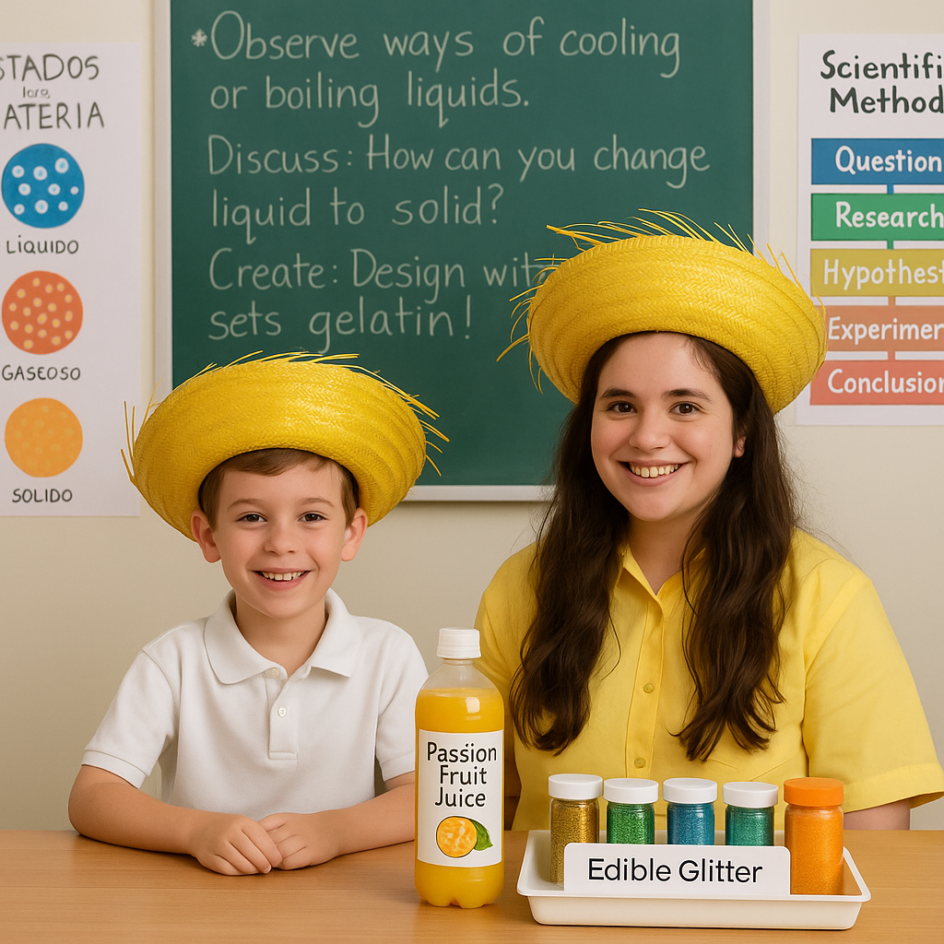

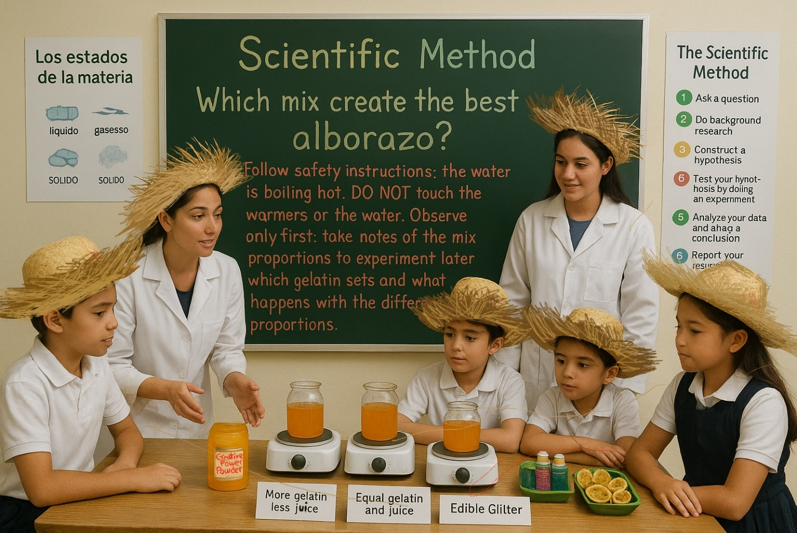
Just like in the picture: which recipe will be crowned the champion of Alborazos? You must also handle several variables in this experiment, like: what is the time needed to set the gelatin best, and at what temperature does the gelatin set within that time? Which is the best way to avoid the cáscara de parcha from getting spoiled: adding lemon juice to the cáscara? How much time can the parcha cáscara remain safely in the fridge? Enjoy your happy alborazo time, children of the future!
Here you have a picture of how the alborazos should be at the end of your alborazo experiment (the edible glitter is meant to be both inside the gelatin mix and over the alborazo: feel free of choosing your own glitter color to top the alborazo, in the same way you are free to become whoever you dream to become growing together in communion in a glowful way, glowing as the brightest light you can be):


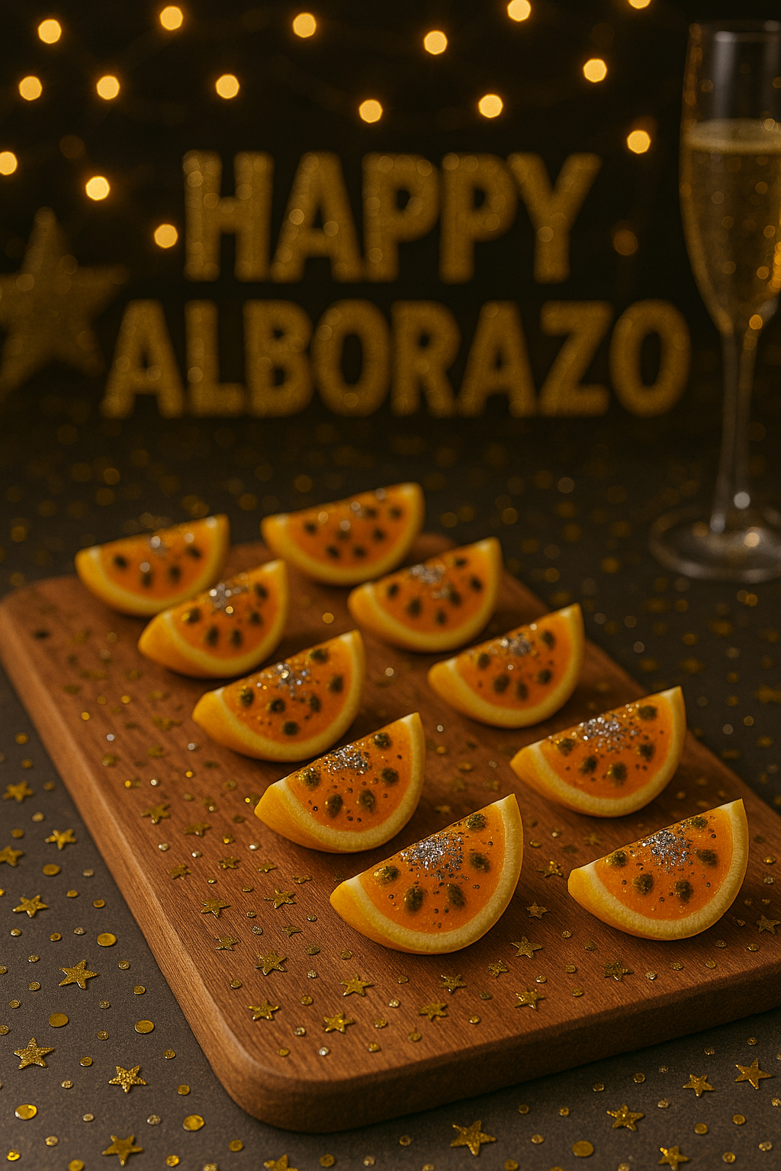
You can use a tray like this wildly: you are literally cracking the Devil´s eggs as you choose to grow becoming the best person you can be. Choosing be best, choosing shine brighter… will combat all evils possible radiating light, becoming the change that is needed to overcome evil with good. If you can ask a parent of the class to craft an artisanal devil eggs tray for all the next children to come celebrate overcoming evil with good, learning to become the best you can be, the brightest light you can be… ask for it, or pay to a Puerto Rican wood artisan to craft this (those who create pilones can create you one of these very easily). Use your devil eggs wood tray proudly for this sciece´s experiment: you are learning not only to become the best you can be, but also learning to shine the brigtest you can shine so children of the future, that will also use this tray, can have the brightest horizon possible too.
Here you have an example picture of a wood devil´s egg tray:

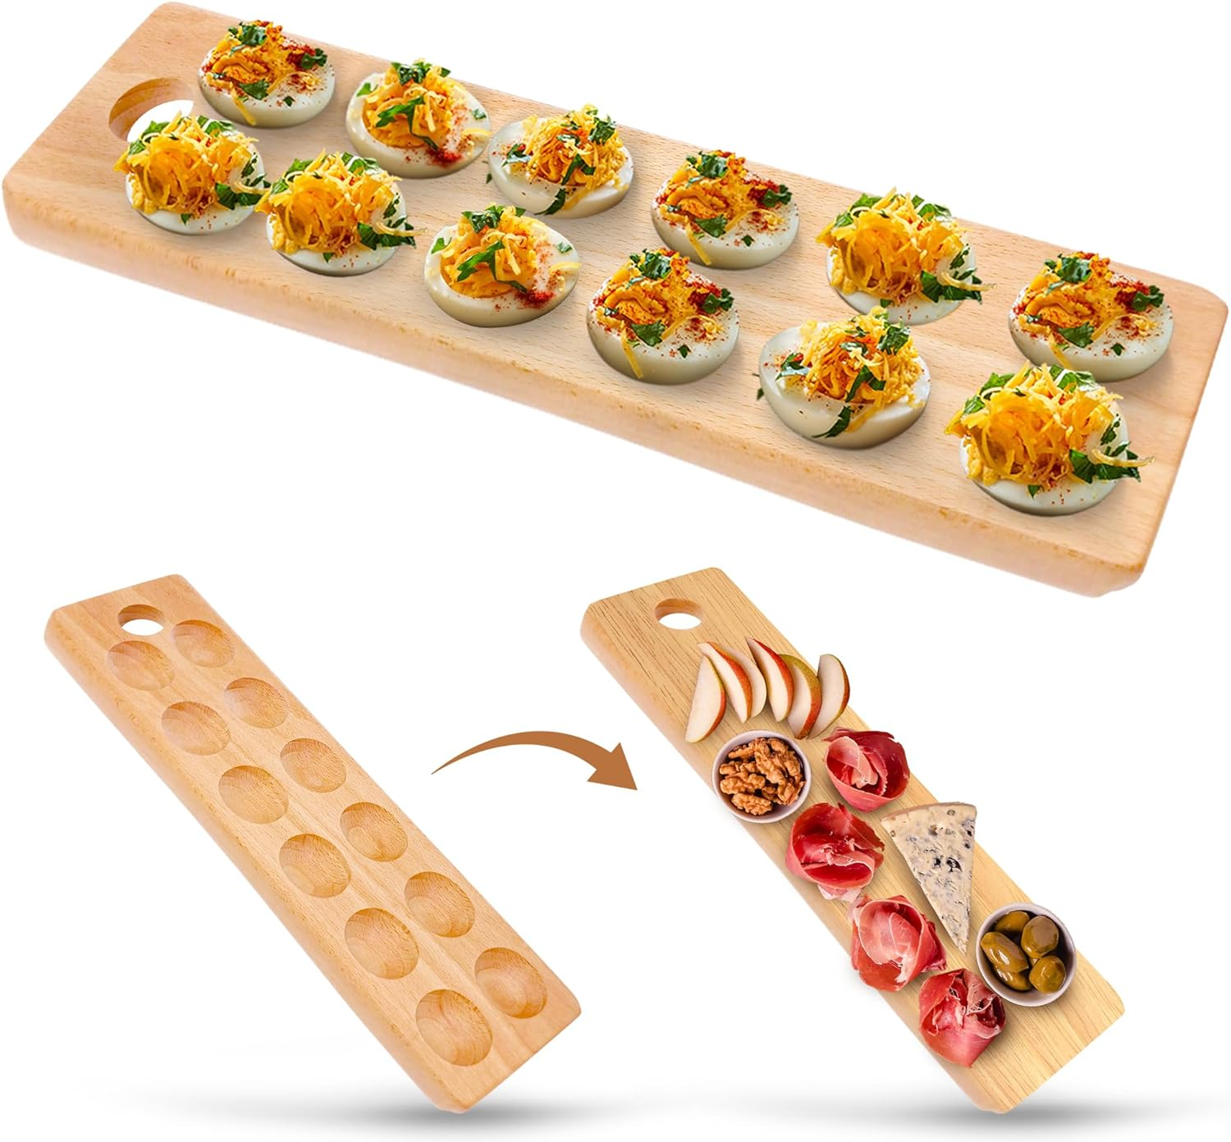

When you make your Alborazo, you’ll notice something amazing happen: the passion fruit juice, glitter, and power powder start off as a liquid—all wiggly and runny—but after you mix in the gelatin and let it rest, it slowly changes into a solid—firm, bouncy, and ready to shine! That is called a change of state in science, or in Spanish, cambio de estado de la materia. So, enjoy this experiment, in which you will observe the transformation from a liquid state to a solid state. It’s like a little magic trick of nature, and you get to be the scientist who makes it happen.
Now here’s where it gets even more exciting: in social studies or history class, you can talk about how making an Alborazo is a little bit like making a change in a country’s political status. Just like your gelatin changes from liquid to solid, Puerto Rico can change from a “colonial territory” to a New Albor State—a place that glows with dignity, justice, and the brightest horizon for every child. Your Alborazo also celebrates a cultural change: moving from a colonial culture to a Puerto Rican culture of New Albor, where we design our own future with fairness, creativity, and joy. That’s how you become the chefs, scientists, and social architects of a new horizon for generations to come!

Third Creative Proposal: Growtcha
I already mentioned how growth works with paints. In this creative proposal, growtcha is quite similar, but works differently.
Right after the “happy alborazo!” and the alborazos, people would throw fraternally to each other glittery, colored powder, just as it is done in the Holi Festival in India, saying to each other: "growtcha!" The word "growtcha" is a combination of the words "growth" and "gotcha," a paintball term that originated in the 1980s. We are sharing fraternal growthfulness with one another as a cultura viva, as an America viva, growing together in more and more with fraternidad viva. Throwing growtcha is like throwing more and more new life! Everyone will be so busy throwing growth charts that nobody will have hands to throw balls in the air. More alborazos and less balazos.
Here you can envision images of the new year´s grotcha, both in the New Albor Fest and at Puerto Rican families of the future:
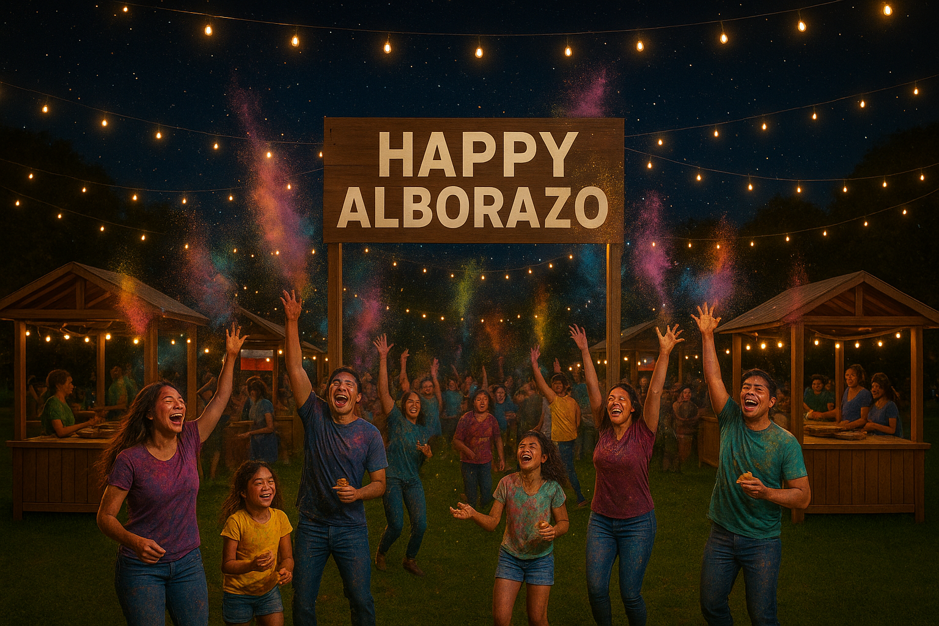
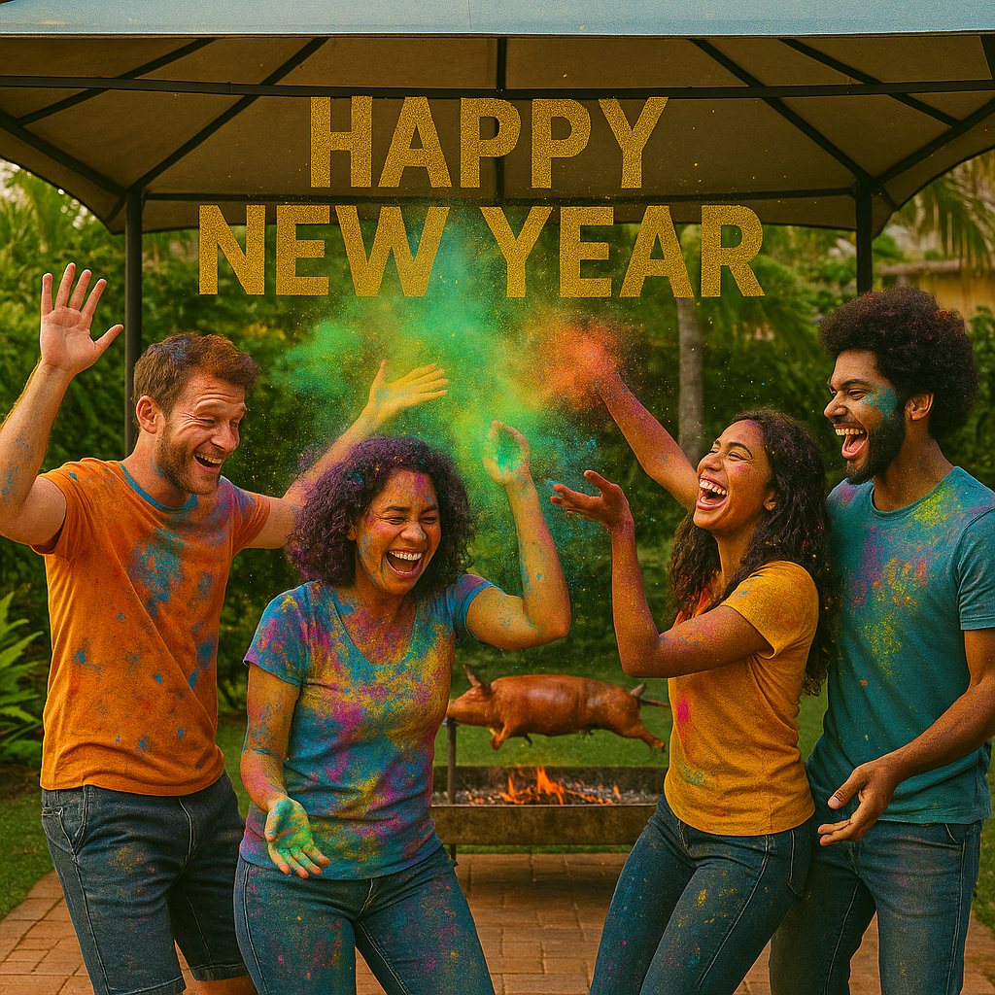

Fourth Creative Proposal: Cultural Fraternity
Cultural fraternity is also meant to be affirmed at this cultural festival with a cultural fraternity feast day, creating peace as fraternity artisans: all American at the festival are given a quarter alborazo and all out-of-America tourists are given a half alborazo (the half of the passion fruit) that day along any purchase at the food kiosks of the festival! We're all called to taste the flavor of growthfulness that this New Albor Fest and its alborazo celebrate as a very colorful fraternal art: yes, we can grow best!
This would be a festival zone with many shared dream gazebos that are cultural food kiosks: this is the American Family Meal zone of the New Albor Fest (they are around 40 wood food kiosks: one per American Continent country, plus five more spaces available for Native Americans who want to be in the fest). In each kiosk, a family from their country sells food, offering a cultural experience of a traditional family meal. There is another way to do it, although considering the appetite of Puerto Ricans, it would be prudent to have a limit of seven: sell cultural fraternity packages and let each person who buys a package be able to eat food from whichever 7 kiosks they choose. There can be family cultural fraternity packs, of course, with a new albor discount per extra child in the same household: after any third child, all the others get a 33% discount.
At the next picture you will be able to envision how this cultural fraternity zone would look like:
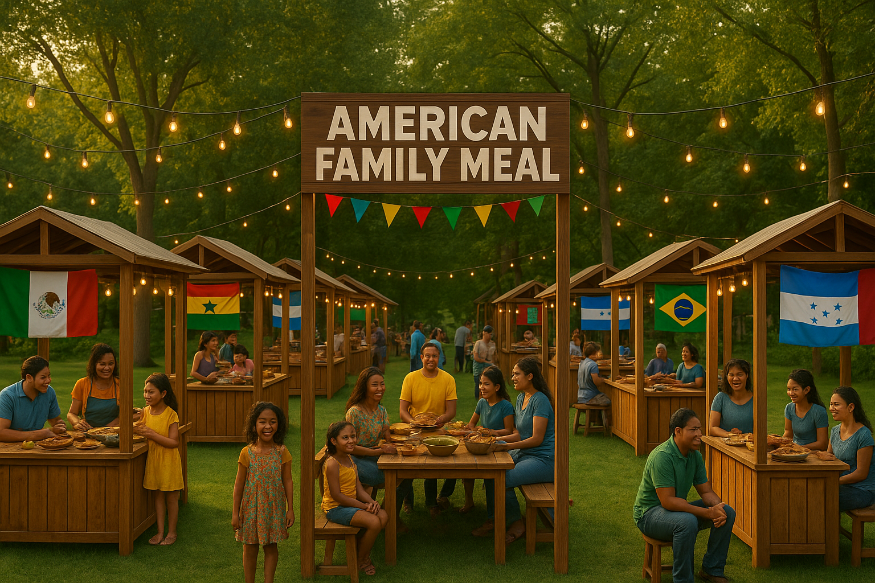
Fifth Creative Proposal: Fratexpo
Jesus Charity proposes a huge pavilion that would be the "Granny Pavilion" of the New Albor Fest, featuring grannies from each American country showcasing one cultural art form from their country to the kids. This would be the Fratexpo (Frater Expo) Pavilion. Each country has a "Frater Expo" space. These frater expos are done by grandparents (especially grandmas, who are the masters of handling traditions to the next generation in America).

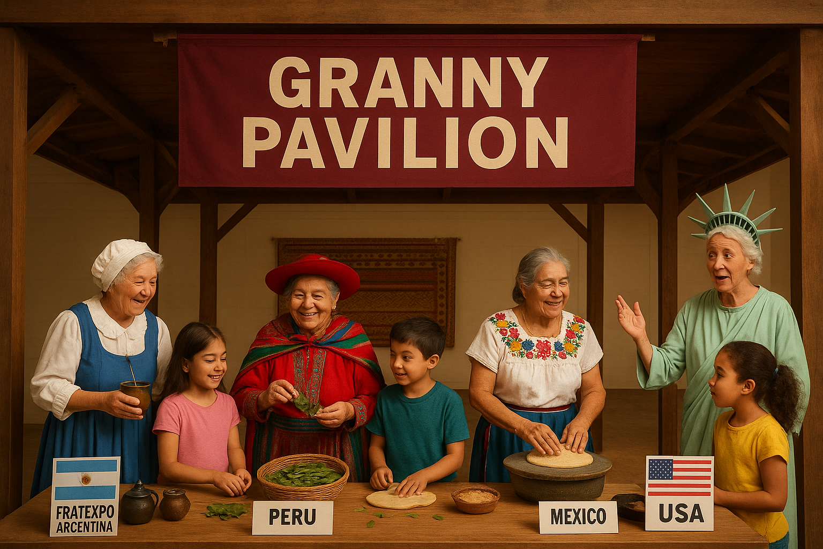
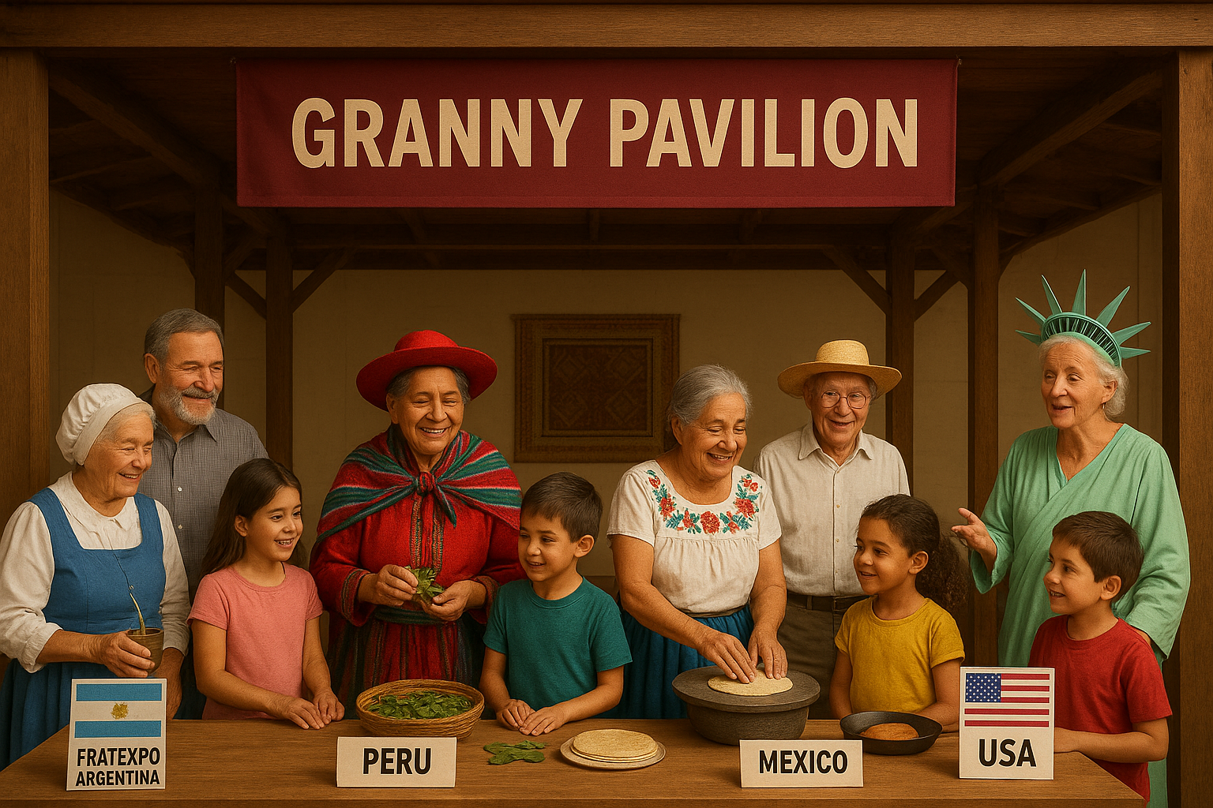

Sixth Creative Proposal: The Jolgorio Pavilion
There will also be another pavilion, handled by grannies and grandpas: the Jolgorio Pavilion, a cultural jolgorio space featuring an artistic adventure zone. This area includes an oral reading corner (with a small tarima) where grandmas can read children's books from their country to children at the pavilion. For example: you may find in the storytelling tarima a grandma of Costa Rica, dressed in traditional attire of Costa Rica, reading to the children a children's story about the animals of a forest in Costa Rica. There is a whole "nesting zone" besides where the granny is reading to the children: a zone with books of each country traditions and culture in each frater expo, including children’s books of each culture, that children and adult can enjoy and read, and also buy if they want to: they simply seat in "nests" in the floor (seating cushions are there) and enjoy the cultural adventure together...
Because this is a festival that celebrates fraternity in every way possible, it is in this Jolgorio Pavilion that any other non-American country that requests to have a frater expo space among the fraternal guest spaces available can be given such space, focusing on brightening common cultural essences between both cultures (their culture and the American culture).
This pavilion would also have a cultural performances tarima for any country that wishes to do bigger cultural performances (like dances of the country). Music singers who sign here must be traditional only: the Central Performance zone, which includes any music performance and wide artistic performances, is a wholly outdoor zone, not inside a Pavilion.
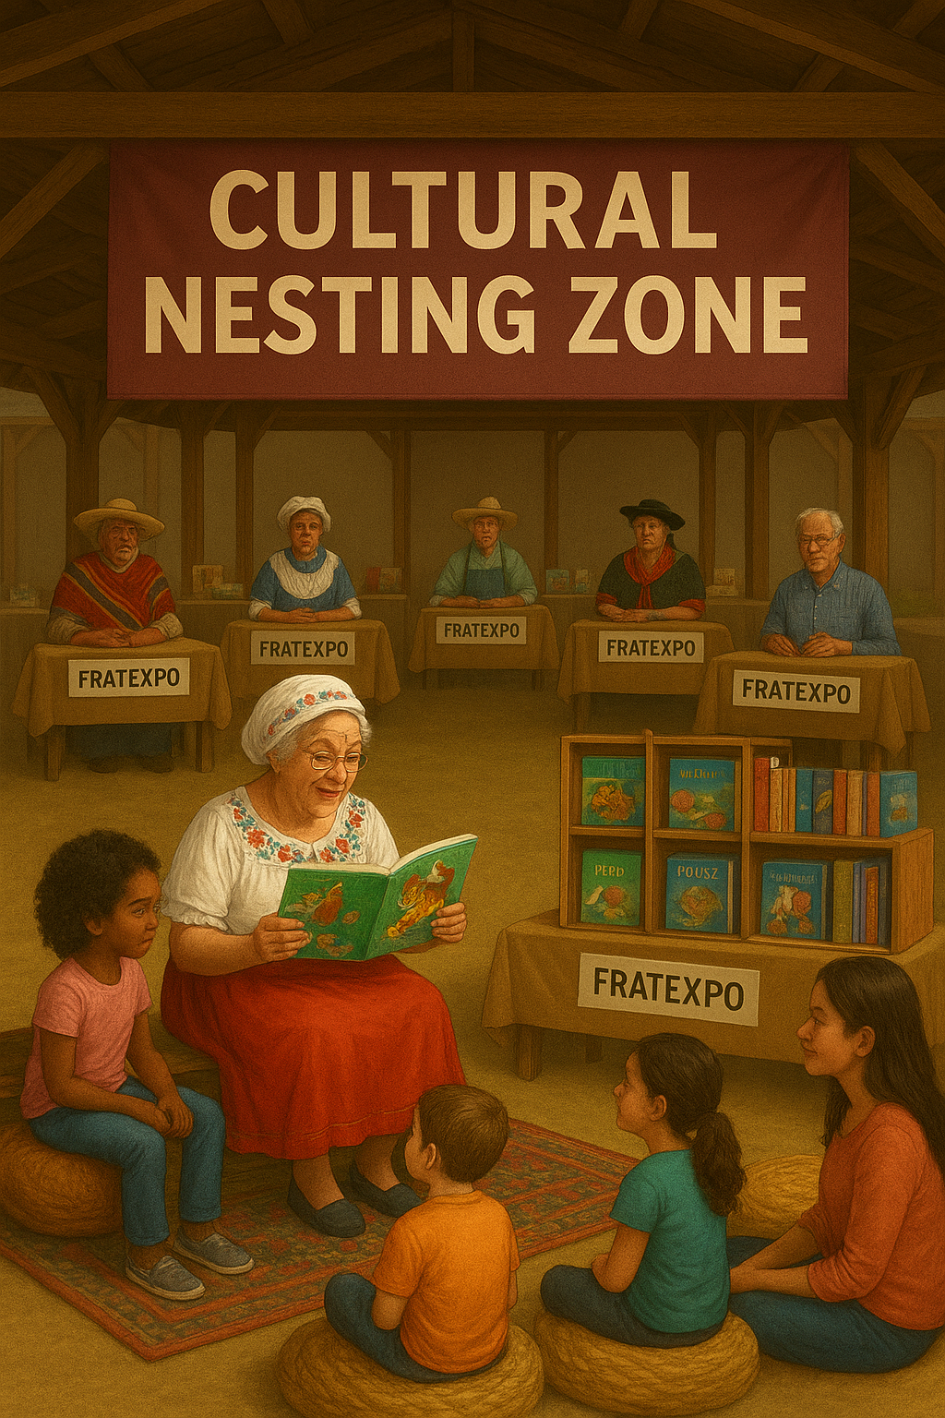
Seventh Creative Proposal: The Children´s Market
Here you have the main stars of the New Albor Fest, the most important Pavilion around the Pavilions Zone: the Children´s Market. This is a Christmas market, but the artisans are all children who sell granny squares or simple knit artesanías. Why only knit artesanías? Because they are meant to learn to knit through social communion in a new way. The most inclusive way to host a children´s market that remains equally accessible to all children is to focus on a concrete, common art form: knitting. They can be given workshops on the weekends at shopping malls to learn how to knit for the New Albor Fest. When they get their earnings certificate of the fest, they would go around January 5 or a little bit before, if they already sold their whole stock.... they would go back to the shopping mall where they got their social knitting workshops with that certificate to look for a gift that he or she himself earned. If what the child really wants is a little more expensive than what they have earned, there can be a fraternal fund so the mall can complete whatever is left over. Because they are all practicing the same art, the market table scheduled time would be simply given in a total equal, giftedness-based way: show you have the talent, show a growthful school letter in which the school certifies that you have demonstrated a growthful progress at the school in the last year... and if you got both, a proper artisan table time will be assigned to you (it is not the same to show having hundreds of granny squared that show you have the minimum amount to be allowed to get a table: 77 granny squares. If you have more giftedness to share, an effort will be made to assign you an artisan table scheduled time proportional to the giftedness of your talent, in a way that allows as many kids as possible to get scheduled time. Because the costs of yarn and knitting materials are accessible for all kinds of budgets (knit kits and fraternally donated yarn could be freely given at the workshops, so anyone can have an equal chance to learn), this means all children will have equal growth opportunities at the Children´s Market.
There are some other general delineations once the children is in the market. Under no circumstance no one will get more than a 6 consecutive hours scheduled time per day, younger children get a shorter scheduled time according to their age, parents must be present at all moments and the New Albor Fest will have fraternal custodians around this pavilion, taking care that all artisans get any snack, drink or whatever other thing anyone may need, especially if the parent needs to go to the bathroom and a trusting adult must remain with the child so he or she is not alone. For safety reasons, no child will be allowed to handle money, so nothing could get stolen from them, nor will anyone engage with them. Tokens or chips will be designed for this Pavilion: a red token grants you one detailed granny square (8 dollars), a green token grants you a 7 simple multicolored granny squares bundle (33 dollars), a blue token grants you a single simple granny square that is not detailed, either of a single color or multicolored; a yellow token (14 dollars) would have a general value of 14 dollars and it would be for any simple custom knit work that the child sells, something they created, like a little knit handbag, a pack of several marca libros, small knitted plush toys; for bigger knit projects that are custom made, like bigger hand bags or baby clothes, green tokens are also used. The yellow token is also used for selling knit gift bows bundles. Reasonable accommodations will be made for those with functional diversity at the Children's Market: anyone who provides the proper documentation that is required to determine the best way to handle the accommodation in the most dignifying manner for the child will be provided it, as long as the child is capable of knitting the granny squares required to be an artisan at the fest with quality and excellence. For those children who can´t be granted a table because they haven´t yet enough knitting skills to sell at an artisan table, an Apprentice Workshop zone will be there for anyone who wants to learn to knit or get better with the fraternal guidance of those who can teach them to become the best. On January 6, only teen artisans will be allowed to sell at the Children´s Market, so that the younger children can thoroughly enjoy viviendo la tradición. So... these would be the general guidelines for the Children´s Christmas Market, children of the future. We want to let you know: right now, there is no market in the world, of any kind, that is exclusively for artisan kids.
In the past, in Puerto Rico, many children were forced to weave pavas or knit handkerchiefs at school, not as a joyful learning experience, but because poverty left them with no other way to survive. The Children’s Market at the New Albor Fest will be completely different. Here, knitting will be glowful and free — a way for you, children, to dream, to explore your talents, and to grow your giftedness together in a fraternal way. You will be given what no generation before you had: the chance to focus not just on surviving, but on glowing, blooming, and becoming the best you can be. Many children before you have helped make this possible, and now it is your sacred duty to continue knitting a glowing society where more children can progress, thrive, and bloom as equal citizens living a life with dignity. In this Children’s Market, what we are knitting is not simply cloth — it is a bright horizon that will let the next generations celebrate a new albor more glowing than ever before, born from the culture of new life and new fraternity that you are helping to create.

Eight Creative Proposal: Glowful Gift Bows
The New Albor Fest would make it possible to propose a beautiful deepening of how Puerto Rican children viven la tradición el día de Reyes.
As it is traditional right now, Puerto Rican children are asked to write a letter to the Three Kings and leave is on the Christmas tree somewhere during Christmas. On January 5 they leave a caja de pasto under the Christmas tree or under the bed. Then, on January 6, the Reyes come, their camels take the pasto, leave the gifts, and go.
This is SO important to be affirmed at the New Albor Fest that it will be asked to the Three Kings for you, children of the future, that they show with their true camels on January 6 at the New Albor Fest, after absolutely all the gifts at homes had been given everywhere. The camels would remain on exhibition for the whole week... but you will only see the Three Kings with them on January 6, as the days before are too busy handling all the gift requests.
Jesus Charity proposes a deepening of the already beautiful way to vivir la tradición: the kids will be asked to leave under the tree, besides their pasto box, something they earned for themselves, any kind of growthful gift that they have earned and leave under the Christmas tree, besides the pasto box... in which the kids would leave a glowful bow (a knit gift bow like the ones sold at the New Albor Fest Children´s Market). Why? Because they are gifted, and what the Three Kings give them simply honors their naturally glowful giftedness. The self-earned gift would be the first time ever that there is a holiday, anywhere in the world, in which the children celebrate to earn a gift for themselves. As anyone who has read the story “Goeiz” knows (look for the book and read it, that story is too long to be posted here), at January 6 all the gifs that the children receive would be wrapped with magical thread (rainbow yarn)... and now you know: they would also be wrapped with the same glowful gift bow the own child left in his or her pasto box.
There are several ways to create a granny square gift bow, we leave that to your creative envisioning... Whatever gift is left as a glowful gift in the pasto box must have a glowful bow, so look for one at the New Albor Fest, kids. What the glowful gift is is to you to choose: younger children who cannot yet knit will ask their parents how to earn a glowful traditional gift, maybe a cloth doll like the ones Puerto Rican children used to treasure. Any child among the smallest children who is in need to find a glowful gift bow to give themselves and to leave in the pasto box to the Three Kings at January 5 can visit the New Albor Fest's Children’s Market and buy their earned gift there, but there are many places to get your earned glowful gift, just asks your parents, grandparents or godparents' help (yes, this is a great duty for the godparents, if the child has them). The smallest children, who are still viviendo la tradición, will leave a bow tied by themselves —as shown in the photo: a granny square hand tied by them with magical thread—along the glowful gift they leave beside their pasto box; the older ones, who are already ayudando a vivir la tradición, can leave their glowful gift with a glowful gift bow —a granny square gift bow, any kind of them— knit by themselves, with their fraternal communion skills.
If anyone older child doesn't know how to knit, just get a granny square and do a tied glowful bow as the smaller children who are still viviendo la tradición are taught to do. It's completely allowed to ask any parent —grandparents, parents, godparents...— to knit you a granny square for use every year as glowful gift bow, as far as you treasure the tradition as you treasure the glowful bow year after year and as far as you hand tie it again year after year (redo the tying part with new magical thread year after year), because han de vivir siempre la tradición, children of the future, año tras año... As Puerto Rican author Ana Lydia Vega reminds us: “Mientras haya un niño que le cante a la tradición, la tradición seguirá viva.” May the tradition always live on — now richer, brighter, and more glowful than ever.
The glowful gift bow is meant to be either knit or earned by yourself with your own hands’ strength and fraternal communion. For younger children who don´t know how to knit yet, in the next photo it is shown how a glowful bow can be done in a very easy way, simply tying a granny square with magical thread:
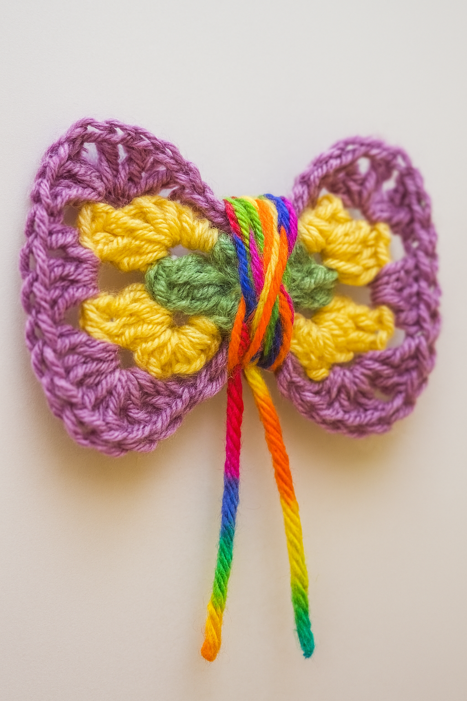
Here are other pictures of possible ways to knit a glowful knit bow:
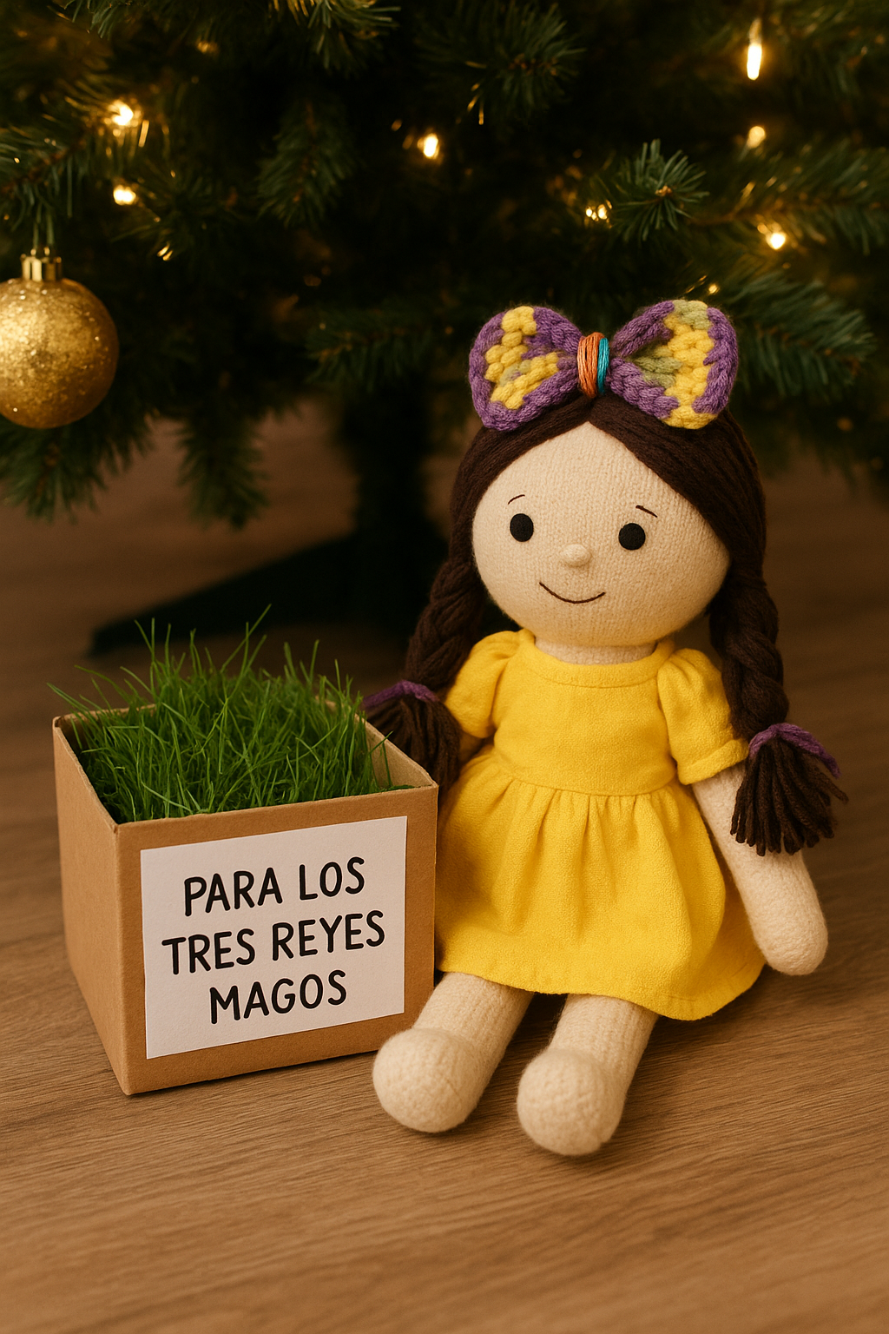
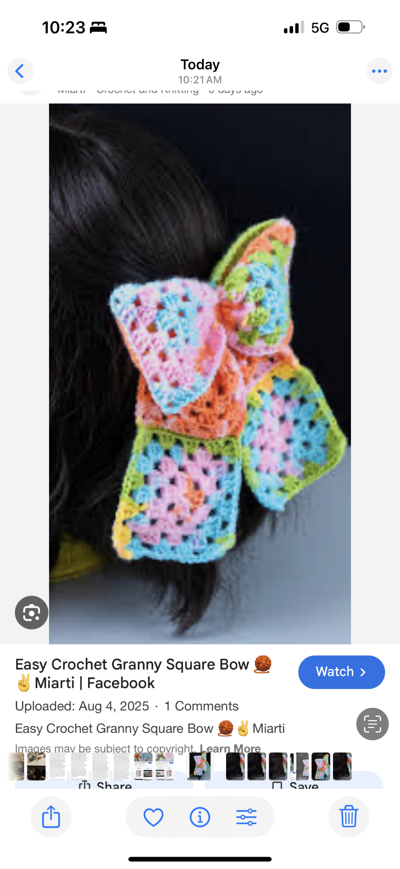

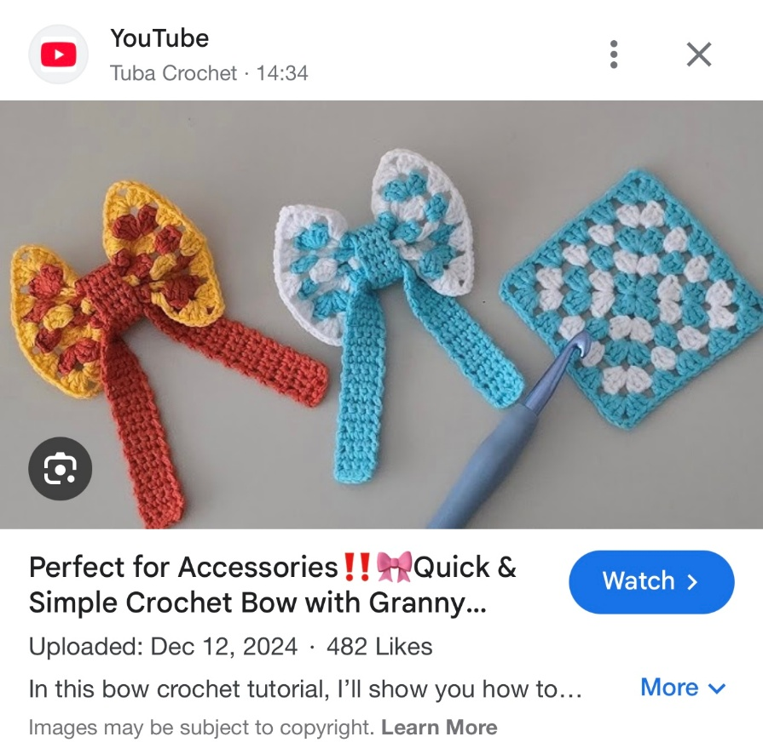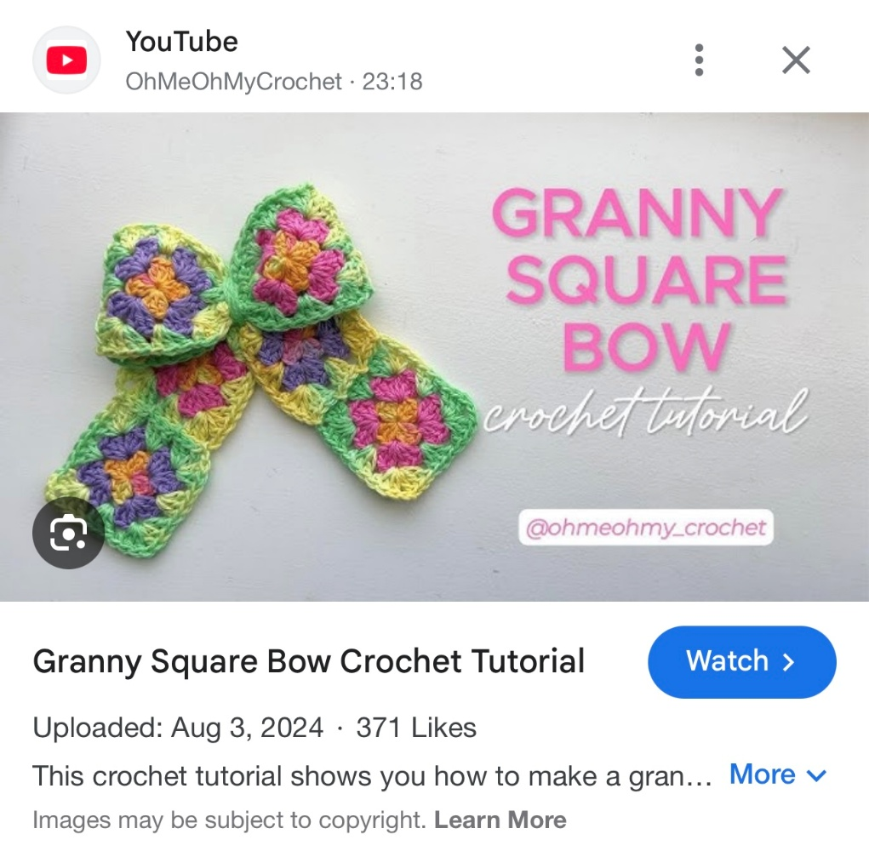
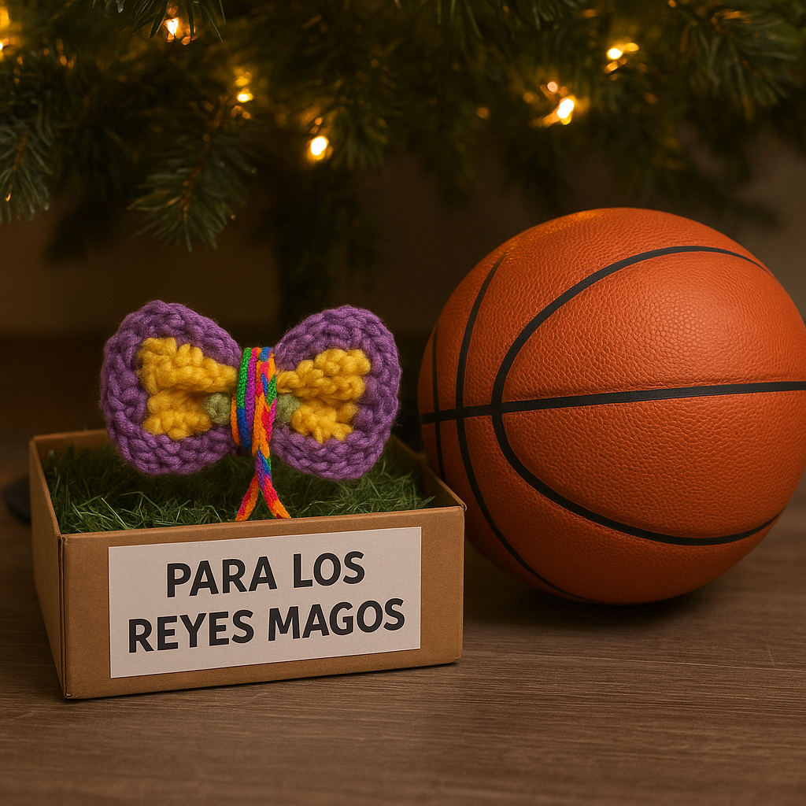
Enjoy vivir la tradición and ayudar vivir la tradición celebrating being a glowful gift, Puerto Rican children of the future!

Ninth Creative Proposal: Glowful Contests
Jesus Charity envisions two separate contests: one for all children who wish to participate, and the second specifically for children on the island.
The first one is a Glowful Gift Bow. Any artisan children at the New Albor Fest can participate in this one.
There will be a zone in which children will be able to sit down in their own New Albor Fest and knit a glowful gift bow ON SITE, in front of fraternal custodians who oversee the process and can guarantee that whatever was done, it was done by the kid who is giving the glowful bow for this contest.
These bows, once given for the contest, won't be returned. They will be distributed as kite bows (the bows at the end of the tail of a kite) for school decorations, among other meaningful purposes. They need to understand how a social fraternal giftedness work: this is a giftedness, you are giving your best in the same way you are meant to serve your beloved community as a glowful giftedness. The maximum width of the bow must remain around 5-7 inches.
If any artisan children want to participate, they won't be allowed to knit their bows at their scheduled artisan table time. They must also be in the Glowful contest zone to knit their Glowful gift bow there. Under no circumstance any bow that is not knit totally on site and in a consecutive time (the kid must do it on site in a maximum time of 6 hours and the bow must remain always on the glowful contest zone; if the child needs to eat or go to the bathroom, the bow stays in the contest zone; there will a bathrooom in a nearby that zone. A maximum of two 20-minute meal breaks will be given to the child to return and finish the work after eating. If fhere is need of snacks or a third meal, an adult must bring the food to the kid the Glowful Contest zone and he or she will be allowed to eat it there as they knit; diabetics who bring proper documentation according to the form to fill by a doctor for that purposes will be given reasonable fraternal accommodation, but still, the time the child remains away while being in kniting their glowful contest gift bow must remain reasonable) will be accepted.
The last day for completing the contest bows is January 4. On January 5, all the bows will be evaluated. The winner is revealed on January 6.
The other glowful contest would be of... Glowful Nativities. The Children's Market Pavilion will feature a Glowful Exhibit Zone showcasing all the knitted nativities submitted for this contest. Children will have until November 19 of each year to send their knitted Nativity scenes, and they must also send an email video showing the creative process and development. This is intended to be a family project, with as much of the project as possible being knit by children. If several children participate, they can both knit and propose the same creative project together. The creative video of the project must explain how the whole family collaborated on the project. To be fair with all the children, evidence of a 4x4 crocheted granny square totally knit by a children must be provided: it would be a blanket for the baby Jesus of the Glowful nativity; the size of the rest of the Nativity figures must remain proportional to that measure (proportional to a Baby Jesus knitted figure that a 4x4 granny square blanket can cover. The best Glowful Nativities will be selected for exhibition along with a photo of the whole family. This winner would also be revealed on January 6. Those nativities that were not chosen for the contest can be claimed in a pertinent zone told at the New Albor Fest. For doing so, they will be classified appropriately to be able to claim them in an orderly manner at any time during the Fest, including January 6. This particular desk — along with the lost and found desk — will remain open for a few days after January 6 as the zone of the fest is being cleaned after it's over. Whoever doesn't claim their Nativity within the given timeframe will not be able to claim it later; they will become a fraternal donation (they won't be sold, but will be given as gifts).
The purpose of these glowful contests is fraternal: children can enjoy their giftedness in a glowful way, shining at their best, with the opportunity to receive a prize or special recognition for choosing to develop their skills and talents to the best of their ability. The contest is not meant to be seen as a fierce competition, but rather as a fraternal way for them to share their best. A kid can be disqualified from the Glowful Bow contest if they don't maintain a fraternal attitude.
The first-place prize of these contests is meant to be substantial gifts that mean a lot for a Puerto Rican child, like going to Disney or traveling to meet a very popular person or something like that. Therefore, a deliberate effort will be made to remain fair to all children and ensure that any contest winner is chosen for the child's benefit and talents, not for an adult managing the project on the child's behalf. Any family that is selected to win a prize and, upon verifying their data files, cannot provide a video to prove that their child knitted the entire Baby Jesus will be disqualified. Additionally, the extent to which children created the project and how much the whole family contributed will also be a factor in determining the winner, especially since the first-place prize is a family trip.
Here you can see some photos envisioning these Glowful contests:
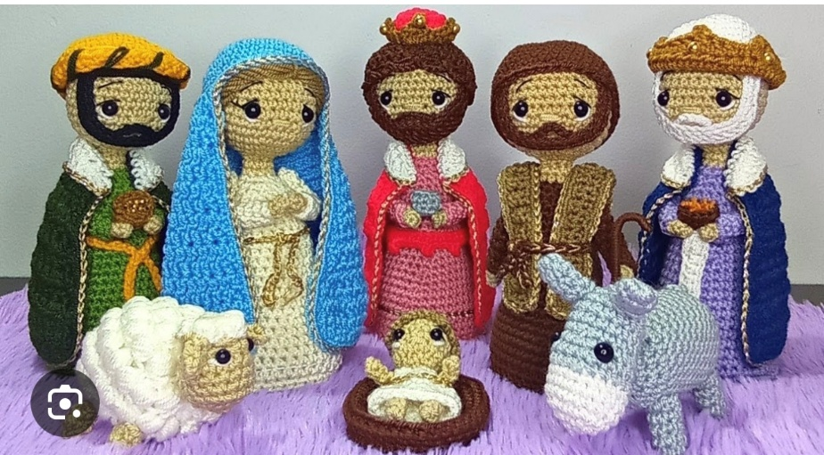
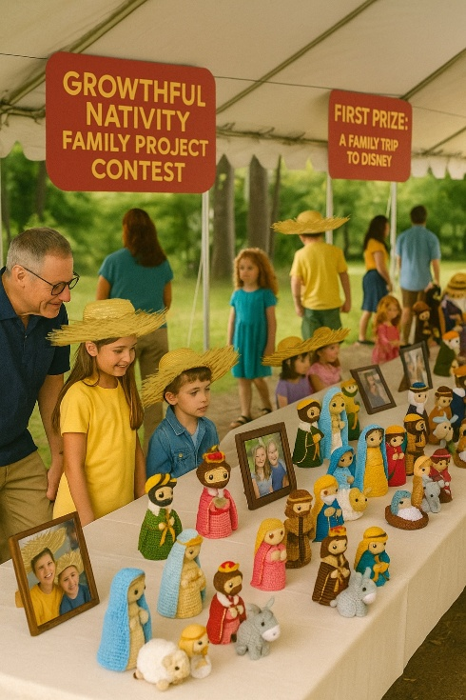

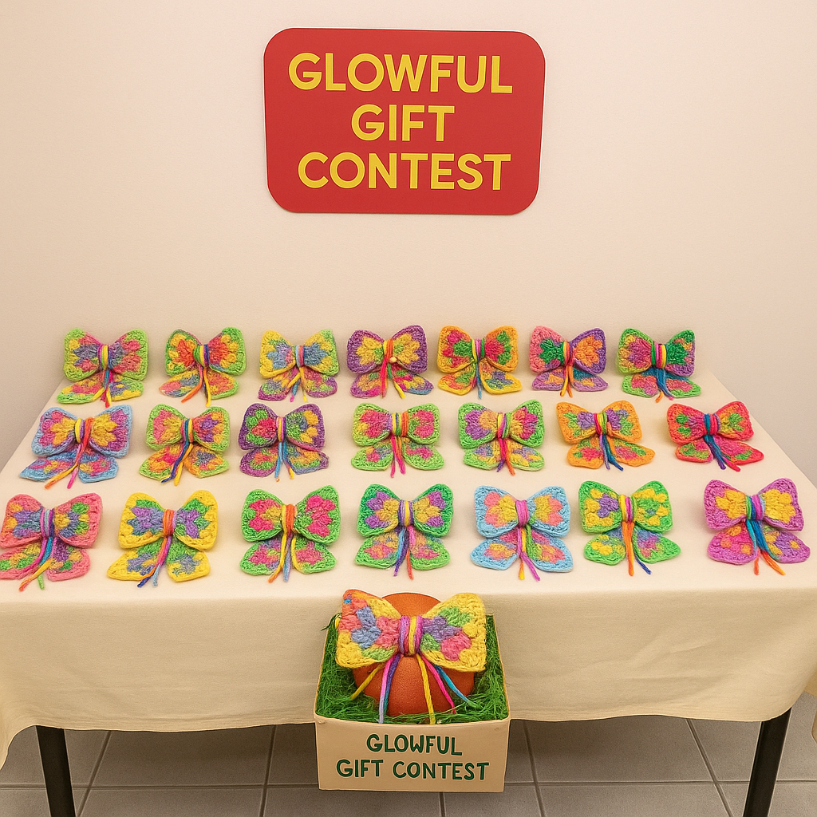

Tenth Creative Proposal: Growtcha Zone
The Children's Market Pavilion will proudly have a very fraternally well-designated zone for artisan tables explicitly given ONLY to neurodiverse children who can sell a growtcha artwork if proper fraternal support is provided, although they are unable to sell anything knit by themselves due to a cognitive disability. Examples of growtcha art that could be sold in this growtcha zone can be: white canvas baby shoes growtched with colorful paint, growtcha baby onesies, growtcha pavas, growtcha caps, growtcha socks, growtcha dogs bandanas, growtcha blankets... In this particular case, there will be proper coordination with the family asking exactly what they will be growtching and how the price factor will be managed.
In this zone, there will also be designated tables for any cognitively diverse adult whose cognitive capabilities may remain child-like due to their neurodiversity (as is often the case with Down Syndrome or autism). Still, they can learn how to do Growtcha and learn to sell it. Down Syndrome and Autistic children or any other child who need to remain in a more socially fraternal zone (Example: an Autistic that doesn't know how to handle social cues in an ordinary way, to safeguard his or her dignity, can request a table in this zone and there will be the capacity to adapt the environment to him or her as much as possible, like placing fraternal care signs asking to be socially sensitive with the kids at this particular zone and having extra or particular special-education-trained fraternal custodians prepared for them) to be able to do the same than the other children can also request artisan table time at this zone, that will try to remain the more sensory-friendly distributed (example: children at this zone can be allowed to have background music of their own to deal with any social over stimulation issue; children at the ordinary artisan tables won't be allowed to use either headphones or speakers). In the very particular case of blind children who choose to do growtcha art guided by their parents, yes, they are warmly welcome in this zone and will be very fraternally cared; any other sensorial impairment won't be an obstacle to the child be assigned a table at the general artisan tables and it will be assumed that the parents will function as interpreters when needed; if an interpreter fraternal custodian is required as a reasonable accommodation, that must be requested before the reasonable accommodation request deadline (at November 19 all the children who are granted assigned artisan tables at the Children's Market will be informed and will have until Thanksgiving to confirm their assigned schedule; anyone among the children who are assigned tables in the central artisan tables zone who requires any reasonable accommodation provided by the coordinator of the Children's Market, as needing an interpreter, must give the medical documentation required within that time frame too; no medical information will be required at all before November 19 except for the children whose parents are requesting a Growtcha zone artisan table).
Children of the future: always remember that caring for all who need dependent fraternal care and remaining open to their way to be, letting them enjoy being the best as all others can, although they do it in the way they can do it due to how their personal formation is, helps everyone to become more fraternally human. The presence of all these children and their recognition as equal to all other children — they also possess the giftedness to shine in the way they can — is to be celebrated as a beautiful New Albor Legacy celebration.
Eleventh Creative Proposal: Guanins
A "Guanín” was a gold-copper alloy medallion worn around the neck by chiefs (caciques) of the Taino people.
There would be another kind of "glowful medals worn around the neck" by whoever wants to, as a sign of a new fraternization era.
I created a "Growthful Jar" in my classroom: every time a student did their most growthful work, a small origami star was added to the jar. Because they were too young to learn how to do origami stars [they are known as "lucky stars"] by themselves... I did them for them. If the jar kept filling, something meaningful for them would be done as a growth-affirming experience... When the growthful jar would become totally filled, they would go to the Morro to fly kites (that was the final project planned, but I left the school way before that): they would be celebrating ascending as the kite ascended higher and beyond themselves.
In the same way, Guanin were "cacique medallions"; the Guanins would celebrate being an estado soberano: each growthful star affirms the personal sovereignty of the children who chose to be growthful by creating that origami star. That's the meaning of the beginning of each growthful jar's star: they celebrate the personal sovereignty that enables growthful progress. Each origami star, which is meant to be painted in bright colors if not done with Growtcha origami paper or other colorful origami paper, is a "medallion" of the personal sovereignty of Puerto Rican children.
Whatever way each teacher or parent chooses to implement a growthful jar, those stars are needed to create guanins for the New Albor Fest. Each Growtcha necklace features 52 stars (one for each USA state) and is as culturally significant as Hawaiian leis. The stars would be glued in magical thread, and growtched and painted if needed. This is a kind of craft that can be sold at the New Albor Fest if the schools provide all the growthful stars collected throughout the year and then give them to two students of each school (a boy and a girl) who would be assigned to sell all the school's available guanins in a guanin zone of the children pavilion. Priority should be given to younger children to do this (they are unable to knit, but are totally able to handle and sell the guanins), but children of any school age can be selected as school fraternal ambassadors to do this, especially if their school has no primary level.
Any leftover guanins would become decorative garlands for eventual New Albor Fests.
If, by any chance, a Growthful School system is established anywhere, each school can send a sample of their project fairs at the end of each semester to be exhibited here as well. If a whole other Guanin Pavilion is needed to handle the flow of guanins sale and the exhibition of a significative sample of the best school projects of growthful schools, so children have the possibility to exhibit their best school projects in a bigger social environment and so they learn that excellence will lead them higher and beyond themselves... it can be done so.
Here you can see photos of what a growthful jar is and what guanins are:
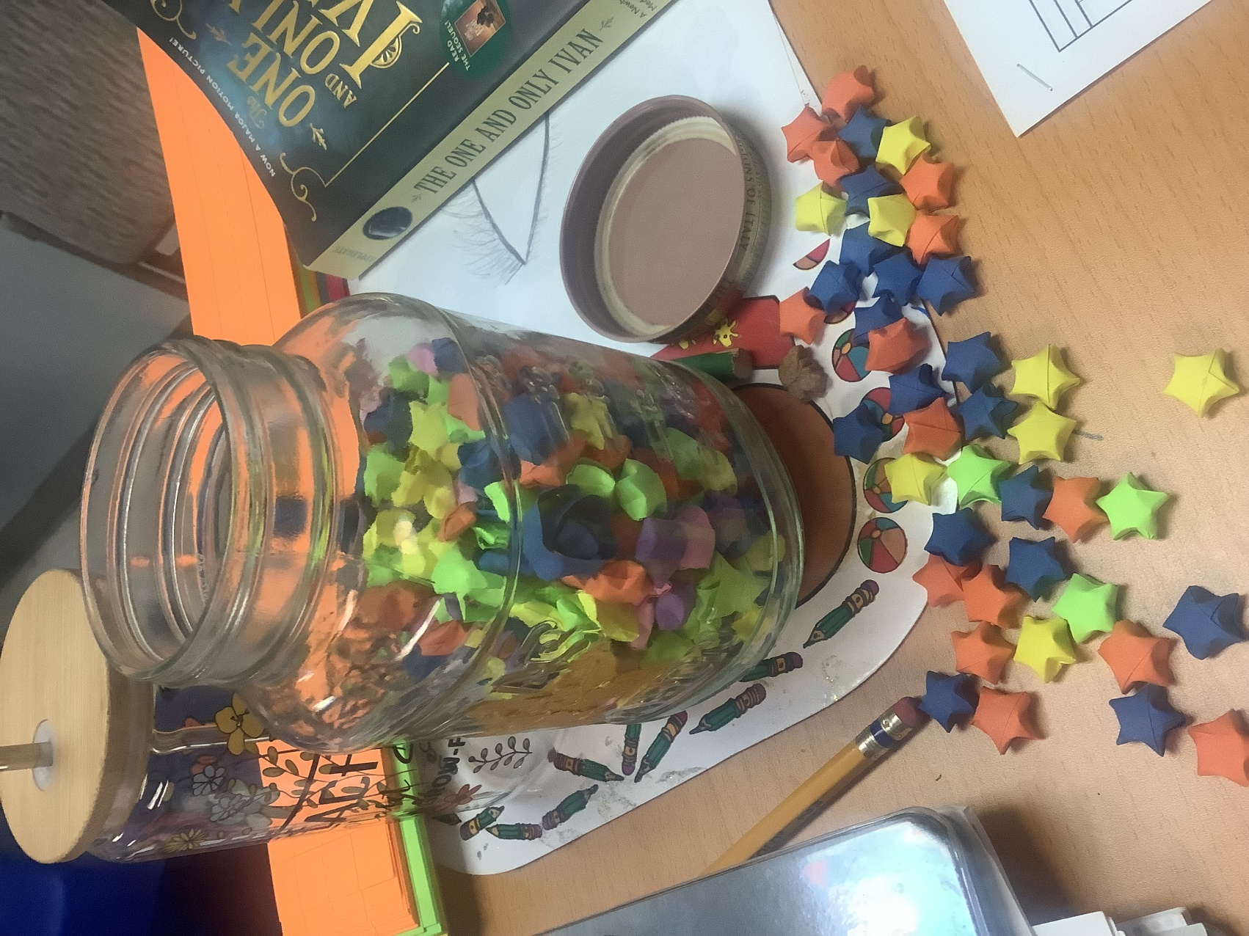
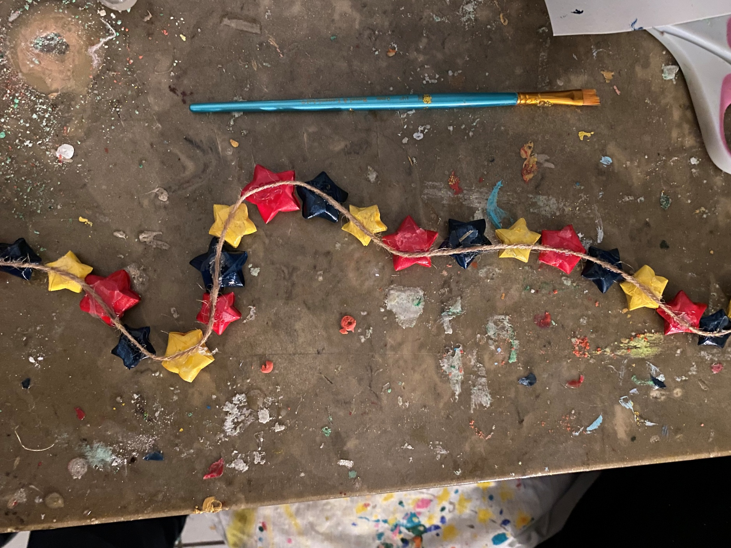

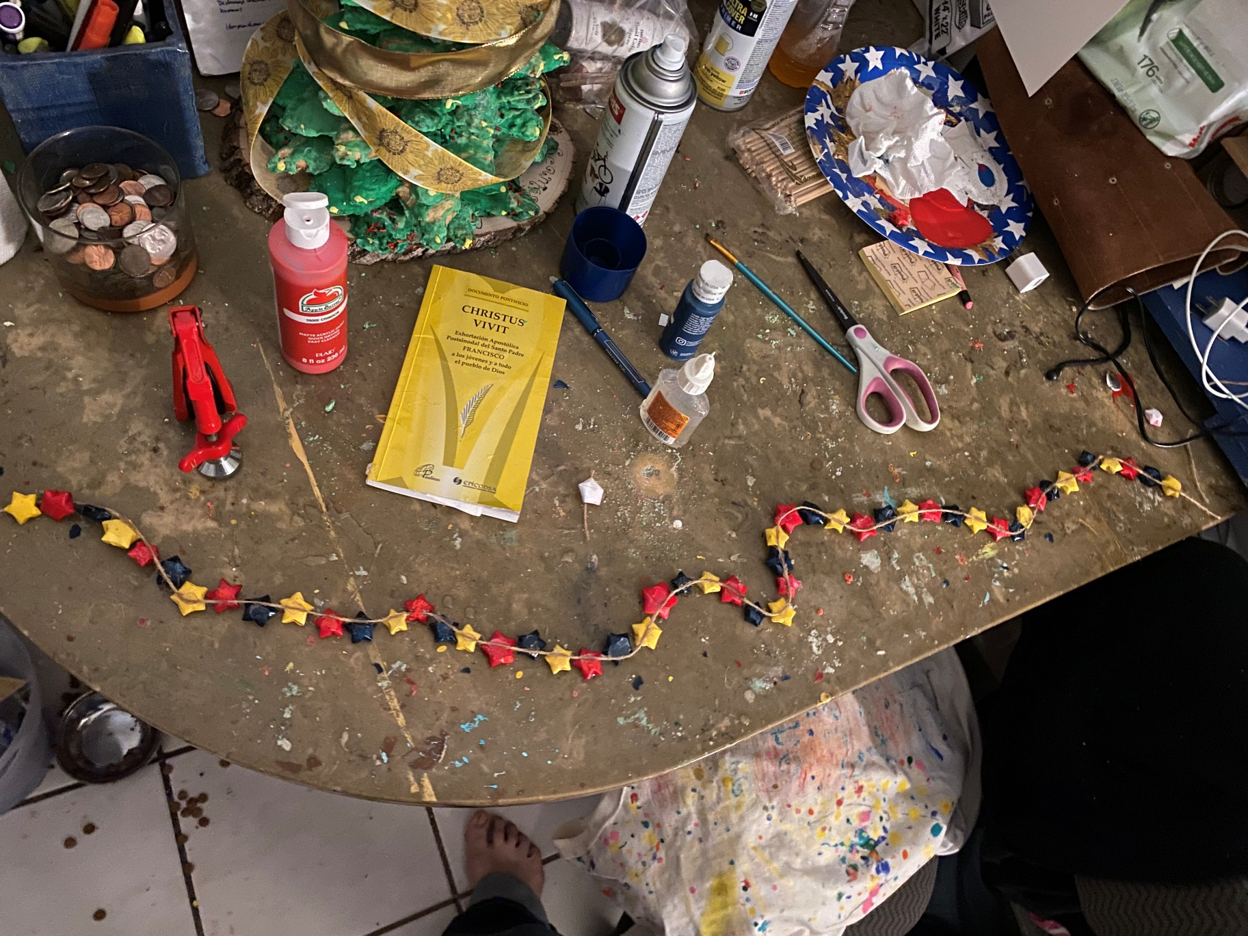

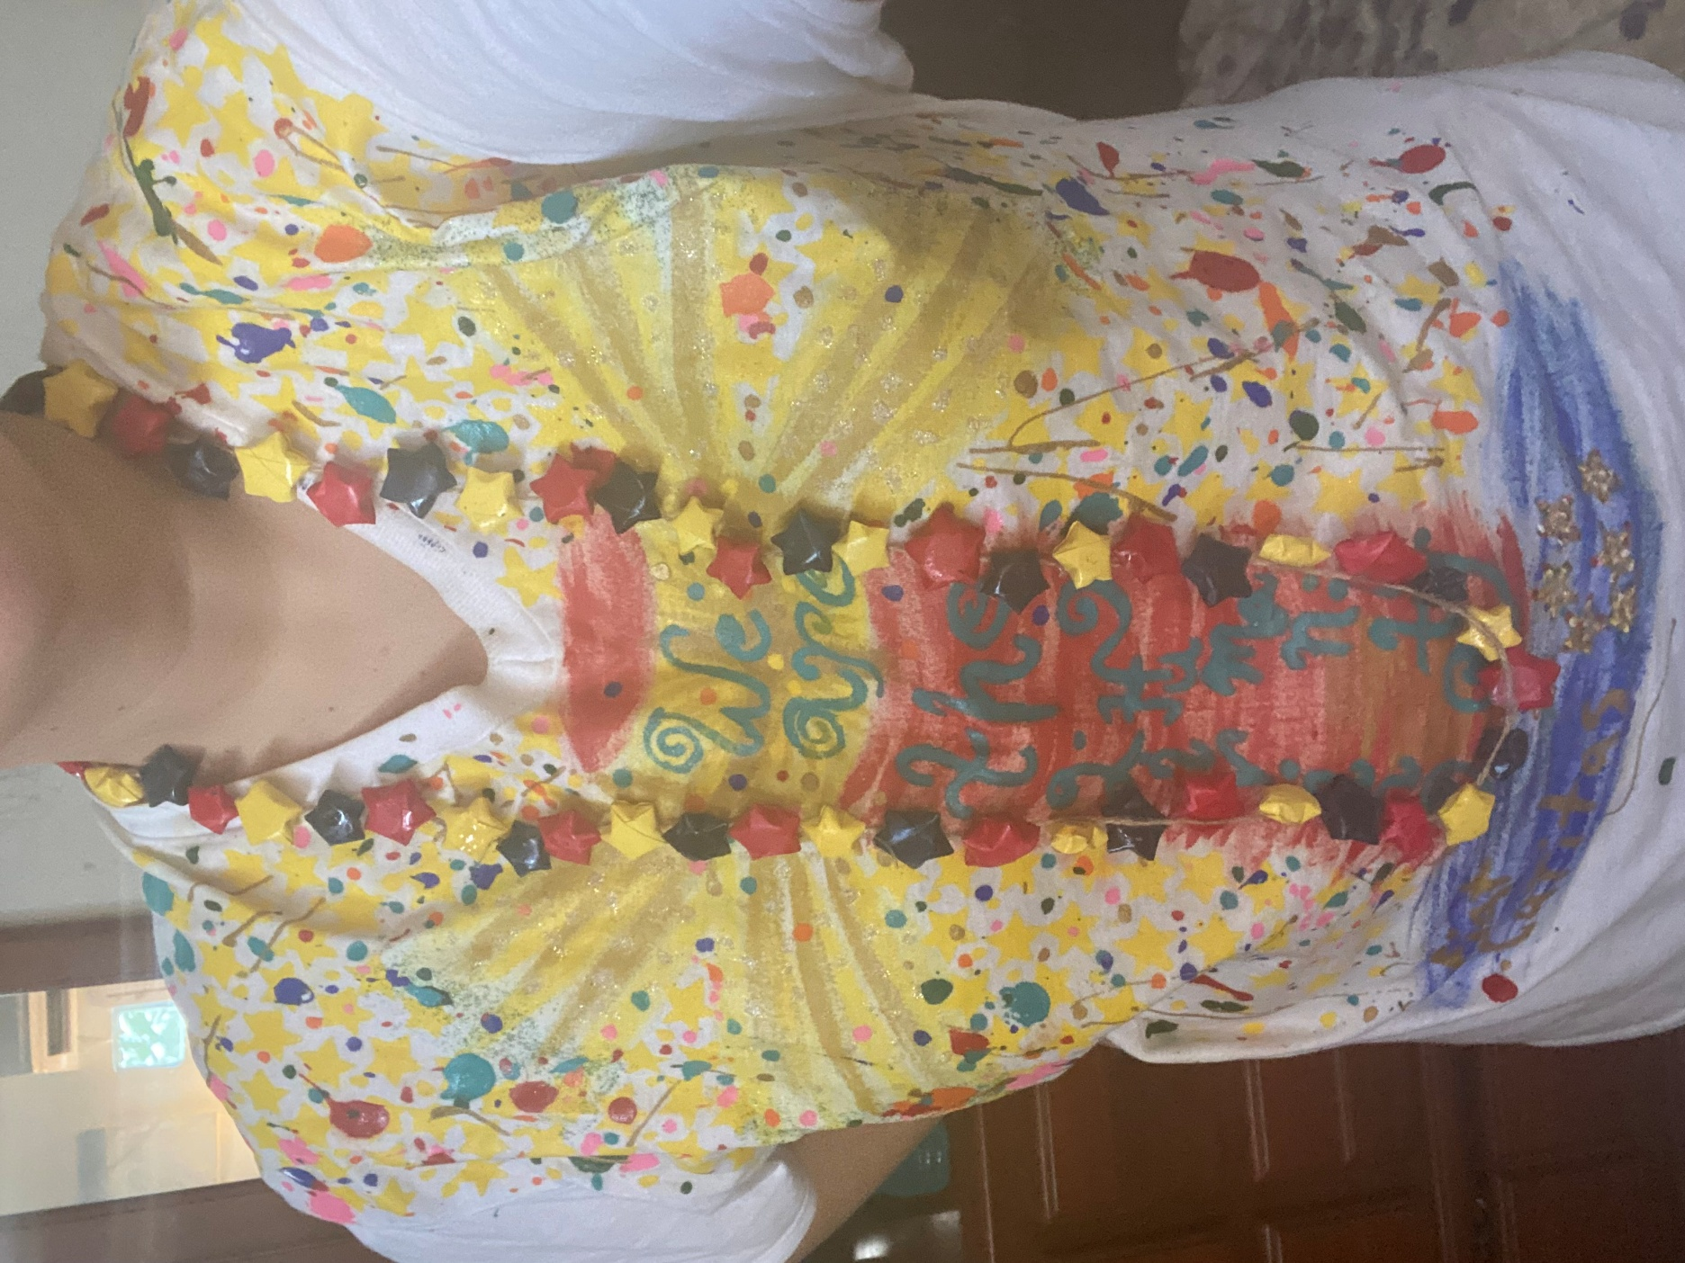

Twelfth Creative Proposal: A New Albor Cultural Attire
Although Granny Squares are primarily used for creating New Albor blankets, many other things can be done with them.
One way to wear a New Albor cultural attire that incorporates elements of various cultures is to simply wear the traditional attire of their country, but add growtcha (splashes of paint). For example, a new albor jibarito attire could be a white jibarito dress or a white jibarito guayabera splashed with colorful paint...
However, there is another traditional New Albor cultural attire: a granny square skirt with a butterfly cardigan as a top. The quilt affirms the unconditional love to grow for all children (children do the granny squares). The butterfly cardigan represents true freedom: the freedom to be; a culture that fosters freedom for all to grow together in communion, unconditionally recognizing everyone as equal brothers and sisters, as individuals with inherent dignity. Under the butterfly cardigan, a white (peace) silver-gold growtcha shirt is worn (being and act growing together in communion), on top of this, a guanin is also used.
In the case of a man, this would be granny square pants and a guanin over a gold-silver growtcha shirt.
If there is enough good humor for this, male adults who are willing to do it can do a fraternal fashion show of granny squares boxers (short pants) can do so, if done in a fraternal context (example: not leaving money in their pants as if they were strippers). It would be a huge attraction for the whole festival just to see them laugh. Famous singers or people can be invited to model, just to attract people to celebrate a New Albor Legacy. Example: asking the President to model one of these boxers with a paper towel roll as an apology.
Female who want to model granny squares attires can also do so, as long as no nudity or body profanity is promoted: bodies are meant to be seen with dignity; if nothing is worn under a butterfly cardigan as a body artistic and personal expression (example: modeling a butterfly top that is a swimsuit top along with a granny square shorts), it must be done in a way that can be guaranteed that remains fraternal and that no nudity can happen even accidentally (example: it will be corroborated that no strap can accidentally break at the runway). Under no circumstances can reggaeton be used as background music, to keep the runway fraternal, without sexualizing anyone, and without promoting seeing persons as sexual objects. Butterfly tops can be modeled as swimwear with a granny square short or skirt, but no granny square bikinis of any kind can be modeled, nor can any male model calzoncillos knit with granny squares.

Of course, children modeling granny square clothes is also a beautiful celebration of New Albo cultural legacy.
If there is a King or Queen of the Festival, they are meant to participate in this cultural runway.

Thirtieth: New Albor Mantles
Each kid will be asked to submit three granny square samples by mail, along with their growthful letter and all market-entry requests (they won't be required to pay any admission fees). The creative video can be uploaded to a designated location or sent via email.
Those granny squares won't be returned. They will be used to do New Albor mantles for the New Albor statues, both at the Morro Chapel and, eventually, the New Albor Sanctuary. In the case of the baby Jesus, it's a granny square blanket. If the Archdiocese agrees to, Our Lady of Providence can have a mantle like that on November 19.
The leftover granny squares will be used to create New Albor blankets to be given to children who need them during cancer treatment or other serious medical procedures (like children at cancer hospitals, children recovering from a transplant) or to foster kids whose custody is with the State.

Fourteenth Creative Envision: A New Fraternization Era
At the Jolgorio Pavilion, kids of the future, from any of the countries that colonized America (Spain, Britain, etc.), will have a secure spot if they ask for it, as an explicit gesture of an era of new fraternization. Although our colonization era is past, we are grateful for the growthfulness we learned from you, which enabled us to create our own New Albor Legacy, just as Mac and Cheese was created... They won't be called "the colonialists" for very fraternal reasons. We will call them "the American Motherlands"

These are the culture creative proposals envisioned by Jesus Charity. That doesn't mean that other creative proposals won't be developed later: these are like a beginning to something bigger than us, kids of the future. You will be the ones who will develop this New Albor Fest better. For example: Puerto Rican artisans of other arts should have A Pavilion space too, and that pavilion focused on Puerto Rican culture can be the New Albor Pavilion because we are the New Albor State and the craddle of a New Albor culture for the whole America. Keep envisioning more and more ways to celebrate our New Albor Cultural Legacy, Puerto Rican children of the future! Keep being the social architects of this New Albor legacy that makes possible the brightest horizon line possible for all the American generation of children to come! Puerto Rican children had come from so far, and still have so much to go ahead!
In the old days, some Puerto Rican children, like the two girls you will see in the following historical photo, had to work to help their families survive. This photo is from 1924: these two girls were working creating pava hats (Source: Puerto Rico Historic Buildings Drawings Society, Charles Martin Collection). Please notice the extreme poverty behind this picture, especially in the completely naked baby held by the mother in the background: these jíbaro families had no possibility to raise their children with dignity. In the book of Maria Luisa Justiniano, Con Valor y a Como de a Lugar; Memorias de una Jíbara Puertorriqueña, she tells how girls in Puerto Rican schools were forced to tejer pañuelos (to knit handkerchiefs) in the same way these girls in this picture were forced due to their extreme poverty to tejer pavas a mano as child labor:
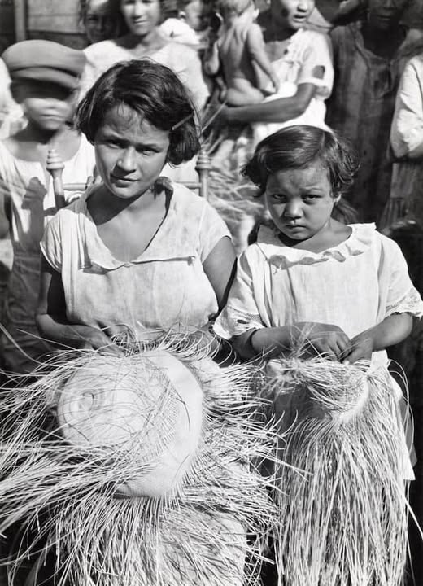
Today, child labor like that is not allowed anymore in Puerto Rico. But you—today’s Puerto Rican children—still have the power to work on something even greater: abolishing colonialism and creating a new, brighter horizon line for all generations to come. Not with your hands weaving hats, but with your hearts, your voices, and your courage as social architects. That means designing a system in which your country treats people fairly and allows everyone to grow with dignity. Social justice means ensuring that everyone receives what they need to lead a fulfilling life and that no one is treated unfairly due to their identity. As American author Cornel West once said, “Justice is what love looks like in public.” And Puerto Rican children are naturally inclined towards social justice—it is part of our cultural heritage. True Puerto Rican jíbaros never tolerated two things: la vagancia (laziness) and la injusticia social (social injustice).
What others once tried to do with violence, or tried to prevent with abusive power, you will achieve peacefully and bravely—giving the whole world a magna lesson in social justice right in the courts: the end of colonialism and the unconditional recognition of personhood. Wear New Albor pavas proudly. A new albor pava in one in which your dream for a brighter Puerto Rican horizon line is painted upon, whichever is: you are founding children, exactly as there are founding fathers in the USA history. You can see an example of a New Albor pava in the one I was wearing in this picture: although my teaching certification is in ESL, because I have a college degree in Humanities besides my studies in the Faculty of Education, I was assigned to be the teacher of a History of Puerto Rico class (it was assigned to give that class to around 10th graders), and we did this New Albor pava projects as a creative cultural class project. You can see my New Albor pava: it has painted a bandera luz (a Puerto Rican flag but painted in gold) as a sign of a Puerto Rico that grows glowing together in communion, and each star painted was one student of my class, because I dreamed Puerto Rico's brightest future helping each student to become the best person they could be; the brightest star they could be.
In the next pictures, you can see photos of me wearing a pava luz and also pictures of what a bandera luz is:

Now that we are talking about a bandera luz, that is also a New Albor legacy celebration to celebrate as Patria Luz...
Do you know the history behind the current hymn of Puerto Rico? It is a colonial hymn and you don´t know it, this is never taught at Puerto Rican schools: that hymn was composed with the main and explicit intention to be complicit to the requirements of the incoming colonial government (USA); it was not composes with the main and explicit intention of be an hymn that celebrates the essence to be a Puerto Rican… so if you, children of the future generations, want to be the social architects of a new albor era and abolish colonialism… one of the first thing you need to create as social architects is… a new Puerto Rican hymn a a New Albor state, probably beginning with assuming that now we are bilingual and a bilingual new hymn is totally fraternizing characteristic of who we are as Puerto Ricans. Who among you, children of the future, will be the next music composer that creates a new hymn for all Puerto Ricans to come, shining with the brighter future of a non-colonial horizon, the brighter future of a new fraternization era, leaving colonialism finally behind? How you will integrate in a new hymn what is traditional that helps us to grow in more and more communion, and the newness of leaving colonialism behind?
Preference 005: A long time ago, Puerto Rico’s anthem, “La Borinqueña”, did not sound the way it does today. Manuel Fernández Juncos wrote the version we sing now, and it replaced the earlier version written by Lola Rodríguez de Tió. Fernández Juncos did not write it to be a true celebration of Puerto Rican cultural identity — he wrote it to fit the colonial government’s agenda at the time. It was meant to be safe for the colonial rulers, not to inspire Puerto Ricans to dream freely. This doesn’t mean Fernández Juncos wanted to be colonial; in those days, he had no real choice. But you, children of the future, will grow up with more choices — growthful choices that let you help your country shine without limits.
Lola Rodríguez de Tió’s version was different. It was written with strong feelings about freedom and Puerto Rican identity, and some of her words encouraged fighting for independence, as many in her time believed they had no other lawful way to defend their culture. Today, most Puerto Rican independentists are peaceful defenders of our heritage, and that peaceful love for our culture is something worth celebrating. That’s why, in a new anthem for a free Puerto Rico, we could take some of the most inspiring and culture-celebrating lines from Lola’s “La Borinqueña,” but we could not include violent calls to action. Our new anthem must unite, not divide; it must be about building, not destroying.
If you — the children of Puerto Rico — are the ones who finally end political colonialism, then you should also be the ones to create a new anthem. It could weave together the beauty of tradition with the fresh hope of a New Albor State identity. You would be the fraternizers, shining the light of a new era across all the Americas. When political colonialism ends on our continent, it will begin an age of new fraternization — a time when all citizens walk together as equal and dignified brothers and sisters. In that America, the growthful, every person — from first natural heartbeat to last natural neuralbeat — will be constitutionally and unconditionally recognized as someone worthy of love, belonging, and dignity. Every child will grow up empowered to achieve their dreams and to glow with all the goodness they can become. And when that happens, we will all bloom into the loveful American harvest, the glowful American continent.
It is enough to close the eyes and pray for you, future generations… to be able to be thankful for all the growthfulness with what you will be able to glow on and bloom on… like a sunflower field on an infinite horizon, more and more radiated by His new albor… more and more radiated with a growing together in communion that will last for so many children of God to come and that will be able to given the chance to grow more and more growthfully as America, the lovefull…
I do give thanks for everything Jesus Charity has taught me and revealed to me in His infinite joy, as we kept celebrating, growing together in more and more communion every day, choosing over and over again to adore Him with our whole growth, as we are doing it now as a Family of Heaven with every sunflower we are offering, with every growing together in communion we are making possible for you, future generations...
What I am writing to you now, beloved children of the future, was written on the National Sunflower Day, without knowing then that this would also be the conclusion for this Glowful Manifesto open letter to the children of future generations... Jesus Charity is amazing in the seedism literary genre, as this combines many creative intellectual seeds into a single, cohesive work.
I conclude this letter for you, generations of the future, gifting you a fraternal lesson that is also forbidden to forget, a fraternal lesson I wish could have been learned in the proper time to avoid all this Unbeing War…
Let God´s children grow....
If you want a society where everyone learns to grow together in communion... begin with the smallest among you. As Dr. Seus says: A person is a person, no matter how small. Now we say: Every citizen is a person, no matter how small... but I already talked about the unborn. Now let’s talk about the smallest at the schools, with the youngest of your citizens at school age: the kindergarten students: “Train the child in the way they should go, and when they are old, they will not depart from it.” (Pro 22:6).
When Kindergarteners are going to graduate, explain them how their graduation as "declared ready to grow on": you are prepared to grow on as a growthful society where everyone can grow as the best person they can be, growing together as the best person they can be, walking together as a beloved community of equal brothers and sisters.
Have a big bucket of completely white building blocks (Legos) that are Duplo size (these are designed for younger kids). The shapes must be varied, and the sizes are meant to be varied too, each one compatible with the others. Let them choose their favorite one, give them very colorful and permanent Sharpies, and ask them to paint their dreams on the building block. Not any dream: THEIR dream —each one's dream— to become the best person they can be, in whichever way they imagine they are called to do it. Let them be creative. Teach them: these are permanent colors; they can't be erased. Each piece is as unique as you, and no piece can be replaced if lost. “Every man must decide whether he will walk in the light of creative altruism or in the darkness of destructive selfishness.” (Martin Luther King, Jr.)
Once they are done, ask them to build a structure together, using all the Legos to create the same structure. Let them agree together what to build, with "building fraternally" being the only "building code": whatever you choose to build fraternally, in love and dignity, growing together in communion, you can build on.
Through the years, the creativity potential of the structures will increase: as soon as another graduating class emerges, they will be asked to do the same, but also using the building blocks left by the previous graduating students. This means they will build upon what prior students have already left for the next generation to continue building together. The Lego pieces of each graduation will become part of the school’s permanent Lego "archive": each graduating class will repeat this ritual, building upon what the previous generation left behind, so the school’s growing structure—year after year—becomes a living archive of dreams, a monument to growthful community. Each year’s class adds its growthful bricks to a growing structure—one that evolves with every generation. The structure may change form over time: a tower, a tree, a wall, a garden, a path, etc. Older pieces remain part of the build, past, present, and future held together in unity. “We are each other’s harvest; we are each other’s business; we are each other’s magnitude and bond. (Gwendolyn Brooks)" ´
Please note: these bricks are not like the bricks in the story told at the beginning of this letter; these are growthful bricks.
In the story about the two towns, the “bricks” were like pieces of a puzzle, showing how a country counts its success. Those bricks were about building a world focused on GDP growth, mostly measuring money and things. But there is another kind of bricks, which we call growthful bricks. These are the building blocks of a society based on GLOW, where every child, family, and neighbor grows with dignity, kindness, and fairness. Growthful bricks aren’t just made of money; they are made of love, opportunity, health, and respect. These growthful bricks are the tools of glowful social architects: people who build a bright, warm, and welcoming horizon where all children can shine together, regardless of their background. By using growthful bricks, we create a future that is not only bigger but also better, fairer, and full of hope for every generation to come.
Here you have a little poem full of metaphors to enjoy about the growthful building blocks:

Some bricks just count how tall we grow,
But don’t show love or make hearts glow.
They build tall towers made of stone,
But leave many children all alone.

Growthful bricks are made of care,
Of chances, kindness, love to share.
They build a home where all belong,
A place where every heart is strong.

With growthful bricks, we build and glow,
A brighter world for all to know.
So let’s build high, but build with grace,
To light the way for every face!

Remember: each child chooses their own Lego block shape and size freely from a diverse set of Lego forms (slopes, arches, tiles, bricks, etc.). This symbolizes the sovereignty of the person — no one is assigned a role or mold. They will learn then that every person has a distinct form of being—some more structural, some more bridging, some more decorative, some foundational... but everyone is necessary to build a growthful society where everyone grows as a beloved brother and sister. Letting the students select from a variety of shapes, sizes, and forms honors their personal sovereignty—their unrepeatable way of being. Some may choose foundation blocks, while others opt for arches, slopes, connectors, or ornaments. This teaches that everyone has a different social vocation: some support others, some bridge ideas, some beautify the world, some build up from below… “Now there are varieties of gifts, but the same Spirit… and to each is given the manifestation of the Spirit for the common good. (1 Co 12:4, 7)” All are necessary. None can be replaced.
Why is each Lego piece white, like a white canvas? Because they need to learn that every child starts from the same shared state of dignity: a blank, equal base. They are going to grow on as equal and dignified brothers and sisters. When the student draws, paints, or marks the piece with whichever dream they choose to grow best, this is the plasmation of their personal formation: the plasmation of their own way to be in the society they are growing in, as they are becoming. They need to learn to grow to be themselves: “If you’re always trying to be normal, you will never know how amazing you can be. (Maya Angelou)"
Currently, this kind of growthful building block (Lego-brick-like) does not exist: a 100% recycled, white, Duplo-sized Lego brick designed to be painted on with permanent markers. So, a growthful building blocks brand can be created to allocate 100% of the profits as social profits, enabling the poorest schools to receive support for being able to articulate formative curricular options, with a special emphasis on an essential formative class: a Creative Citizenship formative curriculum class, which would also include a Social Arts club. The Goeiz Foundation —a foundation that would be created to promote a New Albor culture and being able to grow as the best person you can be with equal growth opportunities— can effectively manage these social profit funds so that they reach the schools that need them most, where students lack equal growth opportunities the most. Of course, this aligns with the Goeiz Foundation´s mission: promoting a growthful culture for all, a society in which everyone can aspire to become the best person they can be, growing together in communion as equal and dignified brothers and sisters.
Anyone who is familiar with how Growthful Education works (I have explained this in other writings) will understand what this means: a formative curriculum is the school curriculum that focuses on the personal formation of students according to their own personal growth objectives (not according to lecture objectives, as academic curricula do). This curriculum fully integrates honoring personhood inherent dignity into the school educative system, so a meaningful learning can be achieved: in a growthful school, learning is not merely ordered to get grades but to learn in a way that what you are learning has an impact on your personal formation, so those lessons you learn in the academic curriculum become fully integrated into your personal growth objectives during the formative curriculum period, which also includes regular periodical integractive mentoring with glowers to assess how you keep learning to self-form as the best person you can be, so the students keeps remaining learning to self-determine their growth objectives as they grow on. Yes, the growth objectives of the students are meant to be as important as the teacher´s lective objectives: in a growthful school system, students have the sacred right to require to be educated with an education that fully integrates their personal formation articulation, helping them to grow as they keep learning by forming as best person they can be, not merely getting the minimum grade required to pass each class.
Children of the future: Primary and Elementary School growthful educational systems are focused on affirming growthfully all the personal, formative, fundamental skills, according to each student´s strengths, including the social and cognitive dimensions of human personal formation. Middle School and High School levels focus on self-determined, growthful personal formation, but this self-determination and growthfulness begin to be built upon the core formative skills learned at the Primary and Elementary School levels.
So, within a growthful educative system, a class of the formative period —like a Creative Citizenship (Ciudadanía Creativa) class would be— is a class in which students from several grades can interlock, and this may be elective formative workshops, an essential formative class that each student is asked to choose among given options (example: there can be a Creative Citizenship essential class, with one period focused in ecology, other period focused in multiculturalism, other period focused in civic politics and other in civic activism; the student can choose which one fits more his or her personal essence among the given options) or a required class (a core formative class); either a required core formative class for a specific student (depending on each student´s FEP determined by each one along the glower, including if a particular student requires reinforcement in a specific formative grade standard; according to each student´s formative needs, any particular formative class or formative workshop can be articulated by the glower as part of his or her core formative curriculum in his or her FEP; if a student shows a need of corrective formative action towards not abusing animals, the Creative Citizenship formative class focused in ecology —that for others is an essential class, not a core class—, due to the particular formative needs of this student, the glower would articulate it in his or her FEP as a core class), or as a required core formative class to all students (like it happens with academic subjects, classes which are all needed to attend according to the grade level; this would be the case of Faith Education class in Christian Schools, it would be a core formative class required to all students according to the faith values the parents have all the right to be able to choose for their children being formed with).
Providing you with a formative curriculum fully honors the essence and particular formative needs of the personal subjectivity of the students: if each one is unique, why must it be assumed that they must all learn the same way, or that they must all fit into the exact curricular needs? It´s that the society we expect to build: citizens who must fit an assigned “socioeconomic profile”, only expected to follow the given “instructions” (eventually known as “laws”), only required and given resources for the bare minimum (in the same way eventually the welfare system will only provide the poorest only minimum to survive), without equal growth opportunities being offered to all, so everyone can grow best? A society's ends (los fines de una sociedad) as a whole begin with the means that schools shape within first (comienza con los medios por los cuales los ciudadanos más jóvenes son formados primero).
Within a growthful educational system, students are not merely expected to meet a bunch of standards minimums; they are also expected to have personal dreams and growth objectives to achieve according to their own personal growthful cognitive assessment profile along each one´s FEP (Formative Educational Plan), whose progressive articulation is assessed and coordinated by the school glowers. Within a growthful educative system, all students are given equal resources to learn according to their personal learning styles, and can aspire to become the best. They are required not only to demonstrate grade-level minimum skills, but also to demonstrate progressive personal self-formation skills aimed at becoming the best person they can be in a self-determined manner, within a fraternal civic core of values and progressive, growthful core standards per grade (the word “core” is used because it comes from the word “cors”: schools are forming the heart of society as the provide these students the possibility of aspire to grow best). So, in a growthful school, each student requires a whole progressive personal formative assessment too, and it is as important as the academic assessment; both the formative curriculum and the academic curriculum are considered intrinsically educative. The academic curriculum and formative curriculum not only enrich each other; they affirm the student´s dignity inherently, and that is how you build a growthful society of citizens who inherently affirm the dignity of all… exactly as it was done with them first: teaching to always keep growing on, glowing on, blooming on… No, they won´t be able to eventually aspire to glow on and bloom on if they are not even allowed to grow on first, with the possibility to aspire to grow best in the first place to then be able to aspire to glow on and bloom on as the best person they can be. This is a fundamental principle of a growthful educator: never block the way of a child´s grow on, a student´s growthfulness must always keep growing on, so they can also keep glowing on and blooming on into the best person they can be, learning to enrich themselves and the whole society with their growthfulness first (not with their taxes first).
There you have, children of the future, the symbol of the Grow On movement: a growthful building block (a white Lego building block) hand-colored by children. But because Legos are not made of recycled materials, it's better to start a brand from scratch.
When all these sovereigns, uniquely shaped and uniquely expressed bricks, are joined in a collective structure, they see and learn that the community builds together: no two pieces repeat—not in form, not in design, not in symbolic meaning. That is building society, growing together in communion: a communion of uniqueness, a communion of unique gifts, freely given, freely received, giving the best that can be given because we also received first the best that could be given to grow as the best we can be.
So... now that you have learned how to build society together, we declare you graduated: we declare you prepared to grow on!
For Jesus Charity, this is a beautiful and whole social arts envisioning: building a growthful society is an art in which all children have a unique creative potential, if provided with a growthful education that honors their inherent dignity, fully integrating their personal formation as they learn not only to do best but also to be best. They are not merely seen according to numbers, but first and foremost according to who they are (their unique personal growth plans). Eventually, after receiving not only a free, appropriate, public, and universal education but a dignifying education, some of them will also become remarkable social artists, with careers that will directly impact personal formation on a broader social level… an so, a growthful society can keep growing on, glowing on, blooming on, more and more, each generation achieving more growthfulness, ever more…
This isn’t just a build. It’s a living, growthful pedagogy of personal sovereignty, teaching that how we choose to form as a person matters not only in how society is built, but also in how the next generation, those who come after us, will be able to build society too. This teaches both the amazement of unity, yet each one remaining unique, and also the joy of co-creating society as the best we can be, not through enforced conformity. Whatever you can dream of as the best person you can be, it will also build the best society we can all be: you, and the next ones after you.
The same growthful social artwork that kindergarteners would do in their graduations can be done with the Elementary School (we declare you ready to glow on!), Middle School (we declare you ready to bloom on!), and High School (we declare you prepared to grow on, glow on, and bloom on!) graduations, although in their case the bricks would be brought ready to be built with (they would bring the growthful brick already painted and ready to be built) and they can discuss together before the graduation what kind of structure they plan to leave built as legacy, including the prior blocks. The blocks of previous generations can be constructed within a month before graduation, so at graduation, it would only be needed to uncover the already built structure, built with ALL the previous blocks, and then each graduate adds their growthful block. Knowing how creative dynamics work with older students, it could be appropriate to explain more specific "social building codes" according to their respective cognitive development. With each stage, fraternal codes can deepen, adding symbols of justice, empathy, and responsibility, while exploring how to develop policies, foster inclusion, honor the vulnerable, and reflect on how their own formation impacts future generations: how much growthfulness a generation can achieve with be directly influenced by how much growthfulness the generation before them was able to reach first.
Examples of "fraternal building codes" for these growthful social artworks can be:
-Making a "Lego war" is not allowed: throwing the Lego pieces against each other and making a “Lego Wars” game is not permitted. War can never be understood as a game, and you won't be able to build anything that lasts for generations to come in life if you do that.
-Each piece is unique as you: If a piece is missed, no other piece will be able to replace it. If you don't become the best person you can be, if you don't dare to dream about how to grow best, the whole society will be missing the gift only you can give. How a society can be built will always be influenced by who you are and who you choose to become. You are allowed to paint any dream you choose in whatever Lego piece you choose, as far as you dream it freely, fraternally, and growing best. It is required to be socially responsible with what you dream and paint in your piece: we don't allow anyone to waste their social creativity potential with non-fraternizing or non-growthful influencing.
-Respect the Form of Be of Others: Don’t force someone to be what they’re not. You must build with, not on top of, others. Everyone has the freedom to form themselves according to what each one determines is how they are called to grow best, as long as it is being done growing together in fraternal communion.
-Celebrate What Is There: If a piece is oddly shaped or hard to use, the group must find how it fits, because fraternity means honoring all gifts, even exceptional ones. You must build upon, not tear down, what came before. Society keeps progressing by honoring the ancestral legacy and adding new light to what has already been achieved and built growing together in communion.
Why are these growthful building blocks so powerful? Because students learn that they are valued for who they are and that the choices they make will always have an impact, both in the present and as a legacy. They are also powerful because these growthful bricks become memory preservation: a visual, tactile record of each child’s unique creativity; because it builds social-emotional learning, building connection between years, generations, and classes; because this fraternal lesson creates continuity: alumni returning to visit years later could see their own brick still a part of the present growthful social art structure kept visible to anyone to see. “Alone we can do so little; together we can do so much. (Helen Keller)"
Their symbolic value of this social building project is priceless because it literally teaches that building social fraternal vinculation begins at schools: the school is constructed literally piece by piece, soul by soul, exactly as society is built one fraternal brick by other fraternal brick... and then the social structure becomes sacred, a monument to growth, diversity, and togetherness. Painted Lego bricks can last decades. This project offers a visual, lasting symbol of dignity and communal creativity, a lived experience of formation as freedom, and a civic memory that shows: to grow on, to glow on, to bloom on... are not just achievements, they are callings to build a better world, one growthful graduate at a time. “The function of education is to teach one to think intensively and to think critically. Intelligence plus character—that is the goal of true education. (Martin Luther King, Jr.)" Each child is a unique building block of our beloved community. Their shape—formed by personality, family, culture, and interior depth—is not to be remolded to fit a narrow mold, but to be received, understood, and placed with purpose into the wider mosaic of society. Just like in a LEGO structure where each piece has its own place, our society becomes strong, vibrant, growthful, and durable only when each person’s uniqueness is integrated with care.
This social creative project also has practical value: painted Lego bricks can last many years, especially if Sharpies or high-quality markers are used, they are handled with care, and they’re stored or displayed with intentionality. However, beyond the practical value, the most important value is the civil one: students would see how celebrating growing milestones (like a graduation) will always require to build and be built socially as the best person you can be growing together in communion, as Jesus Charity and my family of Heaven has done with me through my lifetime. What we are taught to become, we teach the world to be. As Jesus Charity teaches to teach, education is not a factory line: it is plenifying personal formation. It is a progressive growth process through which children, youth, and adults are invited to discover themselves not only as individuals, but also as members of a shared human project, rooted in place, time, and meaning: “Education is the passport to the future, for tomorrow belongs to those who prepare for it today. (Malcolm X)" Formation is not about brightness for the sake of competition. It’s about light that helps others see, a shared light. We don’t educate to produce towers of separation, nor do we build a society that keeps the light for a few selected. We educate to build a culture that is a city of fraternal light, full of places where every student can grow best, and every story, every calling, has space to shine.
True education that builds a growthful society invites the heart and the hands, not just the mind. It invites students to find their place in a community and build something lasting with others. That’s why we are called to honor every child, not only those who excel by standard measures, but also those whose excellence is felt in ways beyond test scores or academic rubrics. As a growthful society where everyone can grow best, we are called to especially honor the sacred dignity of special education students, whose daily courage, patience, and creativity often illuminate more profound truths about human resilience and communion. Their inclusion in the “structure” is not optional: it is essential. They are not ‘extra pieces.’ They are cornerstones of a loving, inclusive, and truly educated society. “Vosotros sois la luz del mundo. A city set on a hill cannot be hidden. (Mt 5:14)"
Yes, children of the future generations: this letter has been addressed to you, sharing memories and creative projects that will be possible for you, future generations: you will be able to build upon what Jesus Charity is giving you know, the possibility of aspire eventually to a civil fraternal growthfulness for all, especially for all the children, in the same way I have known and am being embraced by the lovefulness that comes from Him and of how my family of Heaven have formed me since my social conception. The cognitive foundation, His envisioning, is set for other generations to come.
I confess I will laugh —even if no one can see me— of whoever Secretary of Education is given the most magical blow ever by the Puerto Rican children whose guardians assume the civil duty of stopping the intergenerational systemic discrimination against all Puerto Rican Children… because, one day, a very fierce bunch of Puerto Rican Children will handle to whoever is the Secretary of Education a fairy growthful brick blow —a very candid card along glittered growthful bricks: “You will only be able to win our case with a fairy lawyer, but in case you get one, we let you know we also have fairy growthful bricks to blow you. Grow or blow, your choice. Happy defendant time!”— and then the Children of Puerto Rico will be the ones teaching those above how to handle their rights properly, one fair, growthful brick at a time.
What began to be built with colonial bricks (Vosotros sois...) became more and more radiated by Jesus Charity’s new albor (la luz del mundo...), and His growing together in communion will keep being radiated more and more, ever more (A city set on a hill cannot be hidden...). Yes, we will laugh of whoever Puerto Rican Secretary of Education is properly forced to grow or blow the Department of Education. Ya que como quiera tienen que implosionarlo, como ya se ha explicado antes… hagan que lo implosionen con mucha growthful dinamite, niños. You have the fraternal right to grow dignified, as the best person you can be, growing together in communion, even if those fraternal rights are yet to be seen. Para ustedes, niños del futuro, el poder aprender siendo ustedes mismos y el elegir ser growthfully, creciendo como la mejor persona que puedan ser... no será misión imposible, sino misión invencible. Let the Government know what they weren´t able to see, and what could have been seen way before, to avoid what has happened now: grow or blow. Really, I will laugh from wherever I see it happen, happy for all these shared memories that made it possible. I even recommend you to use plenty of glitter —because you will be able to shine incredibly brighter than all generations before you were able to— in those fairy growthful bricks you handle to whoever is needed to be blown so you can keep growing on, glowing on and blooming on… building together a more and more loveful nation, one fairy growthful brick at a time. Jesus Charity is such an outstanding Loveful Teacher, let Him form you and teach you how to be lovefully beloved, you will be amazed at how beautiful and heart-changing His lessons always are!
May the lesson that Jesus Charity has allowed with me to grow on, glow on, and bloom on as I was raised and taught by my family of Heaven... be also learned by you, children of future generations, and for all generations to come: society won't ever become what children are not taught to do first nor formed to be first. Do you want to build a fraternal society where everyone grows best growing together in communion? Do you believe in a society in which everyone grows together in communion as equal and dignified brothers and sisters? Do you truly believe that every citizen is equal and has the right to develop into the best person they can be, growing in greater communion with one another? Well, don't teach kids in unequal schools without the resources they need to learn and progress to their full potential. Don't teach kids that mediocrity is acceptable as long as they have the minimum number to pass the grade. No, you need to have both the required grade skills and also learn them, as they help you grow best. This allows you to form yourself more and more, becoming the best person you can be according to your own personal growth nature.
After so much systematic cultural discrimination, economic segregation, and denial of equal growth opportunities, future generations will be able to achieve more once the proper lessons required for this social progress can be learned equally and with dignity by all: Yes, we can grow best!
May you, beloved children of future generations, build upon what we’ve prepared for you: the possibility of growing on, glowing on, and blooming on as a society of fraternal liberty, founded on a dignifying personal formation, and shared communal joy and equal growth opportunities... for all the children to come.
May you, beloved children of future generations, build a nation’s future that is constructed not on predatory profits, but by the dreams of its social architects capable of do wonders. You, children of the future, are the social architects of this new albor culture.
You might wonder what a social architect is. Think of an architect as someone who designs buildings that keep people safe and happy. A social architect is someone who helps design the way people live together—how communities grow, how we care for each other, and how we build a world full of kindness, fairness, and love. You, as children, are the social architects of your future. That means you have a very special role in shaping a country where everyone can dream big and glow bright.
Being a social architect means helping to build a dreamful and glowful nation, a place where every person can grow with dignity and joy, where families feel safe, and where communities are strong like a loveful harvest. Just like planting seeds that grow into strong, beautiful trees, your actions and dreams will help create the future. Whether it’s being kind to friends, learning new things, or sharing your ideas, you’re helping to build that glowing future brick by brick—step by step.
Your voice and your choices matter more than you think. Every time you stand up for what is fair, help someone in need, or work together with others, you are acting as a social architect, helping to make the world a better place. The future belongs to you and the generations to come, and you have the power to shape it into a glowing, loveful harvest that will bloom for many years. So dream big, shine bright, and build a future full of light and hope!
Building as social architects is also about creating what Dr. Martin Luther King Jr. called a “beloved community”—a place where everyone is treated with kindness, fairness, and respect, no matter who they are or where they come from. When you help design your community with love and justice, you are planting the seeds of that beloved community. Dr. King said, “True peace is not merely the absence of tension; it is the presence of justice.” Being social architects means working together to make sure that justice and peace are part of everyday life, so that all children and families can live happily and grow glowfully in a world built on care and connection.
This beloved community, this dreamful and glowful nation, is built in the hearts and dreams of you, its children: in your right to become the best people they can be, and in our shared duty to grow as the best human family we can be. When children are encouraged to dream and given real, Growing Life Opportunities for Well-being (GLOW), they grow into adults who are confident, compassionate, and creative builders of a beloved community and a beloved nation that is greater than themselves. They become not just workers or citizens, but builders of communion, walking together as equals, brothers and sisters in dignity, as a people of new albor that enjoys celebrating their New Albor Legacy and achieving their childhood dreams, becoming the best person they can be and the glowful leaders, children of the future, you are called to be to lead communities and your nation in a beloved and glowful way, leading everyone to more and more new wonders, ever more! Yes, the GLOW, a New Albor Legacy, the unconditional recognition of personhood, providing a growthful education... all those, yes, will be wonders to you radiate more and more your unique light, children of the future...
The New Albor Fes and all these glowful wonders are more than a celebration—it is a living workshop of dreams, as in the children’s market: with these glowful wonders, children can share what they make, what they imagine, and what they hope for. They can see that their ideas matter now, not “when they’re older.” But the amazing truth is, children of the future, there will be even more wonders possible for you to do. Keep growing on, glowing on, and blooming on as the best person you can be growing together in communion... and in time you will lead to accomplish wonders as a dreamful and glowful nation. As Randy Pausch reminded us: “It’s not about how to achieve your dreams. It’s about how to lead your life… If you lead your life the right way, the dreams will come to you.”
I can´t conclude this letter to you, children of the future, without thanking you for this gift of a lifetime: yes, I had always dreamed of doing something like what has been done in this letter. Let me explain.
In a growthful education lesson formative planning system there are several phases (integration, action, realization, projection, connection). Well, they are supposed to interconnect with the content of other subjects; it is also supposed to be interdisciplinary. I never achieved this, kids, not in a structured, written form, although I made an effort to do it spontaneously... Well, now considered all the subject content that has been integrated in this letter to you, children of the future:
-FAITH EDUCATION: All that I have shared about Jesus Charity is Faith Education...
-SCIENCE: The Alborazo experiment...
-MATH: The GLOW, UDL and UFDL formulas...
-HISTORY: The Puerto Rican Children Manifesto IS part of the History of Puerto Rico...
-SOCIAL STUDIES: The Glow On-Grow On movement, all the multicultural studies content (did you notice that there is at least one quote of a thinker of each country of America, including a few Native American and Indigenous voices?)...
-STEAM (including Arts): the “we declare you prepared to grow, glow, bloom...” growthful blocks creative project at the graduations (yes, you need both engineering and arts for that kind of creative project)...
-ENGLISH AND SPANISH: Besides the text being written in both English and Spanish, there are a few language learning perks that were integrated simply for let you learn from them, like rhymes, interjections, all kind of sentences, differences of tone (the policy brief of more formal tone, the class discussion guidelines of more didactic-inquiry tone, texts written for younger children, historical quotes, narrative texts, fiction and non-fiction... You get quite a few language learning perks in both languages... besides that, due to the nature of this interdisciplinary lesson, all personal pronouns have been integrated, as this is a person-affirming learning approach. Even “vosotros,” the plural of “vos”, was used).
I never dared to attempt a single lesson plan that integrated content of all the subjects of my students (if I integrated other subjects, was done in the middle of the classroom dynamics, not at the lesson plan level... and never more than integrating a single “fraternal subject”, I didn’t integrated more than one subject with my own class content...). Achieving the goal of writing an interdisciplinary plan as a minimum of once per lesson, a monthly lesson plan, and a day per month explicitly dedicated to an interdisciplinary realization that integrates the content of all the subjects... Yes, a multidisciplinary lesson had been one thing I had dreamed of doing someday... and that dream of writing an interdisciplinary lesson plan with a growthful educational vision is now done.
Thank you, children of the future, for this mesmerizing opportunity to let Jesus Charity’s new logo be more and more radiant as I adore Him with our whole growth over and over again, becoming the best person I can be! To envision how Jesus Charity envisions me, join the envisioning of a butterfly knit cardigan—like the one you can see in the following first picture— over a granny squirt with a white shirt —like you can see in the second following picture—, but the white shirt would be growtched with silver and gold:
:
In this next picture, you can see how Jesus Charity envisions us together forever. I will remain forever His handraiser of the living God, I will remain as His incarnated Eucharist forever, helping Him to grow as I let Him grow more and more —illum oportet crescere...— as we help you, children of the future generations, to grow best, to glow best, to bloom best:
Jesus Charity also says, “Thank you, my beloved children,” to you, too. As you can see in the following pictures, we had been envisioning this infinite growing together in communion very bright horizon line for a long time. This painting is titled “Fiat Amor”, and each sunflower is a state of the USA, including Puerto Rico and Washington, DC:
We are praying, right now, very humbly: Fiat Lux, Fiat Charis, Fiat Pax, Fiat Fraternitas, Fiat Unitas, Fiat Dignitas... Fiat Crescere Communio! All those together join as a Fiat Amor that gives light to the Word over and over again as we keep adoring Him with our whole growth over and over again, as we help to be, help to do, help to grow, help to glow and help to bloom growing together in more and more communion, following together the light of His new albor as a Morning Star that makes all hearts and history anew: let there be done unto me, handraiser of the Lord, according to Your Charity... Of course, letting His greatness shine with humble joy and wonder is what made possible in the first place the creative conception of such an infinitely vast, very brightly incarnated fraternal communion horizon line! Fiat Amor has 9 incarnated rays that are the eight beatitudes the first gospel, that are mentioned all together, and the last one in the last gospel, that is mentioned by its own: ¡Felices los que creen sin haber visto!
Jesus Charity wants me to share now this with you, kids of the future, as a radiation of His ever-widening new albor that will always remain being given light more and more joyfully: a Children’s Sunday with a mass fully adapted to children, and in which you, your teachers, and parents would receive a blessing for starting your school year full of grace and wisdom, receiving a blessing in a mass of the first Sunday after school starts, with a homily entirely in children’s language... Each diocese can determine when to celebrate the Children’s Sunday, according to the start date of the school year in that territory. Jesus Charity is the first One that blesses every child’s right to be educated in a fraternal and dignified way. This would be a proposed blessing for you all to be blessed and keep growing, glowing, and blooming at your schools as beloved blessed children of God:

Diocese of [Name]
Blessing of Children at the Start of the School Year
(For use on the designated “Children’s Sunday” in all parishes, missions, and schools of the Diocese)
Pastoral Introduction (to be read by the celebrant before the blessing)
Brothers and sisters in Christ, today throughout our diocese we celebrate Children’s Sunday, lifting up to God our sons and daughters as they begin a new school year.
We remember that Christ himself welcomed children, embraced them, and blessed them, teaching us that the Kingdom of God belongs to such as these.
As one diocesan family, we now ask the Lord to bless our children, that they may grow in knowledge, in wisdom, and in the dignity that comes from being children of God.

Blessing of Children
Bishop/Priest/Deacon (hands extended):

Lord Jesus Christ,
You placed a child in the midst of your disciples to teach that the smallest are the greatest in your Kingdom.
Look with love upon these children of our diocese.
Send your flaming Holy Spirit to enlighten their minds, open their hearts to truth, and strengthen their friendship with You.
May they delight in learning, honor their teachers and classmates, and find joy in the gifts You have given them.
Protect them in every danger, enlighten them towards glowful growthfulness, gracefulness, fraterfulness, and lovefulness...
Let them know themselves unconditionally loved, with an unconditionally call to love and to grow together in communion
Keep them healthy in body, mind, and spirit, and grant that they may always know the lovefulness of their families, the growthful fraternal support of their schools, and the graceful fraternal communion of this diocesan Church.
Bless them, Lord, at the start of this new school year, as their sacred God-given dignity —who they are and who they are called to be— is being affirmed with a dignifying education, empowered to become the best person they can be as signs of Your light and hope for the world.
Help them to be, help them to do, help them to grow, help them to glow and help them to bloom as a living icon of Divine Charity as they keep learning how to become the saints they are called to be in the middle of the world...
For You, Jesus Charity, Who live and reign for ever and ever.
All: Amen.

Blessing of Parents, Teachers, and Catechists at the Children’s Sunday Mass
Celebrant:

God of wisdom,
Bless the parents, teachers, and catechists of this diocese.
Grant that they may recognize in every child the dignity of your image and likeness, every time they help to be, help to do, help to grow, help to glow, and help to bloom each student as the best person they can be.
May they nurture the gifts entrusted to them with patience and fraternal love, encourage what is good, and lead these children closer to You, the source of all truth and new life...
Through Christ Love, our Lord.

All: Amen.

Jesus Charity is the first one who blesses you, kids, and wants to grow in wisdom, age, grace, and favor, both in relation to God and man. He also wanted me to keep a surprise for you until the end of this alborazo: a New Albor Children´s Sunday for your Children´s Sunday: wherever you are blessed, you will be given an ice cream agape just for you, children: with a whole table of stuff to put into your New Albor Sundaes. We suggest the New Albor caramel to you, but as long as you use a Passion Alliance and ice cream as a New Albor legacy base, that is a New Albor Sundae... His proposed version includes New Albor caramel and a little bit of salt and stars (ustedes son la luz y la sal del mundo...), but feel free to use whatever topping you want over the Passion Alliance (choose life passionately!) and whatever ice cream flavor you want. Celebrate the New Albor Legacy of His Children´s blessing with whatever toppings you like more....
Here you can see photos of the Children´s New Albor Sundae Jesus Charity is proposing (the children's version can have whatever other topping you want... but we know there might be adults with enough spiritual infancy to be quite plentiful in their topping choices to... so let everyone hacerse como niño for this New Albor Children´s Sundae):

Here comes the surprise: as part of vivir la tradición, everyone (all the open businesses and all the kids´ parties that day) in Puerto Rico is called to give a fraternal ice cream to kids on January 6. Of course, in the New Albor Fest, these Jesus Charity proposals are meant to be taken very seriously: in the fest, you will have on January 6, children of the future, a whole buffet of ice cream toppings to add to those Children's New Albor Sundaes. Enjoy the taste of this New Albor legacy, where creativity, self-expression, and personal growth shine with your own unique glow!
So go ahead, children of the future, dream your biggest dreams. Play. Create. Share. Help. Enjoy lots of ice cream sundaes. And don’t be afraid to be the fullest, brightest, truest you. Because when each of you grows in dignity and joy, all of us rise together toward a horizon that shines brighter than the sun.
This glowfully bright horizon ahead of you is not just a line in the distance. It is your playground, your workshop, your garden, your growth stage. It is the place where you will build the best version of yourselves, and where the world will celebrate that you are truly, wonderfully you.
You are not here to live someone else’s story. You are here to grow your own roots and stretch your own wings. The GLOW, a growthful education, and all this New Albor legacy, with all that it brings, is our promise to you: that your country will measure its success by how well it cares for your dreams, your dignity, and your right to grow in peace with your brothers and sisters.
You are not just the future: you are the present, glowing now. Every time you laugh, learn something new, share a kindness, or build something with your hands, you are shaping a brighter horizon for those who will come after you.
The New Albor Fest will be here to remind you—every year—that life is a dance between generations and that, yes, we can keep growing best, achieving more and more glowful growth, progressing one generation after another. The older hands will pass you the tools, the songs, the recipes, and the wisdom. Your hands will use them to build a world they could only imagine.
Life is a garden and a building at the same time. It grows, and it is built—one growthful seed after another, one growthful brick after another growthful brick. Each kindness you plant is a seed. Each skill you learn is a glowful brick. Each dream you follow is a beam of sunlight that helps us all grow together.
We are building something greater than castles, greater than cities—we are building a loveful harvest of humanity, where everyone blooms in dignity. You are like the colorful pieces of a growthful building blocks creation. No one else is shaped exactly like you. No one else can fill your exact place in the building of our world. If your piece is missing, the building will never be complete. If your seed is not planted, humanity will never taste the fruit that only you can grow.
No one will replace the person you don’t become. No one will achieve the dreams you leave behind. No one will bring to life the progress that only you can make possible. And no one—no one—will ever radiate the light that only you can radiate.
So let your light shine, stars of Heaven (you saw those starry sprinkles in the New Albor Children’s Sunday, right?), as a very bright horizon that is an alborazo for generations to come. Let your glowful manifesto shine with your full glow. Bloom with your whole heart as the alborazo that beats within you! Grow so glowfully that the generations to come will see your light and say: “Because they grew, we too can grow.”
This alborazo is your glowful graduation for life, and the world is waiting for the beauty only you can give.
So, now I end this alborazo, beloved children of the future, sharing with you the poem I wrote, with help from my Spanish teacher, for my own high school graduation, in which I recited it front of everyone... as I also recited it in front of my first class of students as student teacher... and now I recite it in front of all of you:

Desideratum

Yo creo en mis sueños
vivo, lucho por ellos.
Cada instante en vuelo
me remonto alto al cielo.

Ser estrella es mi fin
siempre seguir, vivir.
Proseguir, feliz ir,
cual el viento existir.

En mi ser tengo fe
hallo fuerza y poder.
Yo digo: “lo lograré”.
Todo, sé lo podré.

Me Abrazo a Su mano
y de Él yo me fío.
El camino trazado
recorreré sin desvío.

Sea bueno, sea oscuro,
será lección, será paso.
Cuando llegue el futuro
no miraré el ocaso.

Mis ojos contemplarán
el albor de otros sueños.
y alas me surgirán
en pos de sus destellos.

Con el alma engrandecida
y el espíritu aventurero
emprenderé nuevas vías
recorreré otros senderos.

Mas mi corazón aquí queda
entre sueños y quimeras.
Ya mi niñez se aleja,
el futuro me espera.

Cuando mire hacia atrás
y vea el camino andado
mi alma con gozo gritará:
“¡Lo logré, he triunfado!”

May you, all beloved children of the future, queridos jóvenes del mañana, be allowed to believe in your God-given dreams and glow in peace…

Happy Alborazo!

Fraternally yours,

Victoria

