On the Growth of the Human Personal Formation: the Nature

Victoria Madgaluz Veragoeiz

“There is grandeur in this view of life, from so simple a beginning, endless forms, most wonderful, had been and are being… evolved.”
Charles Darwin, On the Origin of the Species, as quoted in the trailer of the movie Creation, that tells the story of the process of conceiving and writing that text and his theory of biological evolution.

Introduction: What True Science is

No idea has revolutionized the world more than the theory of evolution plasmated in Darwin´s On the Origin of the Species, written quite recently, only 65 years ago. In this theory, Darwin explained brilliantly the evolution of the biological dimension of human personal formation, departing from something that is almost lost in today´s science: evident observation of nature. In his own words: “Nothing had made me realize [until that travel as a naturalist in the Beagle ship] that science consists in grouping data for extracting general laws or conclusions departing from them.” Charles Darwin wrote this while traveling around the world for five years, observing the natural world throughout the globe while conceiving and discovering what would later be titled On the Origin of the Species.
You don´t see this in today´s “people of science” anymore. What you see in today´s people of science is the thirst for academic and scientific prestige, the thirst for being quoted and published by as many as they can, the thirst for the prestige of a placement in a certain position, either in university positions or in laboratory research positions, where they are paid to pursue mainly commercial interests… no scientific today has the thirst for discovering the truth, the whole truth, beginning as Darwin did: from simple, plain, evident observation of nature.
In this text, I am undoubtedly exposing science, I am exposing the science of how a person is being formed as he or she grows evolutively, intellectually and progressively… but science understood as Darwin did, not as today is understood. The integractive model of personal formation I am beginning to expose in this writing has been the fruit of years —since I was a baby on the crib — of careful observation of “human personal formation models”: people around me whose nature I could only try to understand by observation, because they didn´t reveal themselves as they really were, either because they couldn´t or they didn´t want to. Due to my circumstances, I have learned to “read people” silently, and I am quite very good at it. This is the “natural side,” if you want to call it that way.
During my years as a doctoral philosophy student at the University of Navarra my thesis director —I was never able to even complete the first chapter of my doctoral dissertation about A Philosophy of Education from the Peircean Philosophy keys, but we met weekly during years— had a quote in the door in his office that since the very first time I saw it and since the very first time I was in his class of Philosophy of Language in the ecclesiastical faculty of Philosophy I though he must be my thesis director. He was an exception among the philosophy professors at the University of Navarra: you were required to think on your own in his class, not only memorizing and repeating in a mnemotechnic test philosophical knowledge given by a professor and with a little bit of luck by a philosophy book too. I mean, in the University of Navarra, not all the classes had a required philosophy book or manual to follow the professor with the reasoning and thinking of your own; most of the time, you were simply expected to process everything auditively, in conference mode, and then repeat everything in the one-time-only-per-semester test. My difficulties with auditive processing memorization abilities and mnemotechnic issues are quite notable, and my handwriting capabilities are also limited: it is painful for me to write by hand for extended periods and under the stress of the anxiety caused by the once-per-semester-only evaluation tests. All tests were given not only once per semester, but they were also written by hand. I would discover in the process that I had ADHD and dyslexia, masked through my whole life until graduate school, when I couldn´t compensate more as I had been doing my whole life… but at the same time, I discovered all that, I received no reasonable accommodation at all in ANY of my required evaluations as both graduate and ecclesiastical student of philosophy in the University of Navarra. I failed almost all of the ecclesiastical courses, but it was especially clear with how I consistently failed Latin that something was wrong with my learning style, this wasn´t only an issue of the Ecclesiastical Faculty (they did many things wrong, but that wasn´t the only factor involved in my consistent fails in what where supposed to be “very basic classes”). Time later, when I tried to seek professional help for this, for both the failures at ecclesiastical classes and very particularly consistent failures in third language classes (I have failed all kinds of attempts to learn a third language: Latin, Greek, Hebrew, Arabic, I think I also tried French… I have failed them all, but I probably have tried to pass a Latin class about 15 times and failed them all, no exaggeration at all, it is a very basic language for a medievalist, I really wanted to learn it), I wasn´t able to do it because I had no evidence of my ecclesiastical classes´ failures: I would later know the Ecclesiastical Faculty of the University of Navarra changed my grades, without asking my consent. I don´t remember now the original grades, but I realized they put “not present” instead of putting the real fail grades of those classes that I indeed failed in my ecclesiastical academic expedient. There is a rightist agenda tendency to change historical facts, and there was an attempt to change history. Although there were times that I did not go to the test, I did present all of them, either in the convocation of February, June, or August-September (I don´t remember now which month was the extraordinary convocation.)
What in the United States would have been a gross case of a University discriminating against a functionally diverse student in Spain is plainly and openly normal, there are no laws nor norms to avoid discrimination against a student at University level due to functional diversity because in Spain all the students are supposed to function the same way and be evaluated exactly the same way: mnemotechnically, repeating information, that’s it, no thinking and creativity at all. The over-testing issue is a very cultural issue of the Spanish educative system, especially in the upper levels of education. So, I passed the required graduate courses because they were evaluated with essays, but as I explained earlier, I barely passed any class of philosophy of the ecclesiastical faculty. Although, as I said, there is clearly a learning style conflict, it is also true that it is wrong that the sole evaluation system of a whole philosophy class could be a single written test per semester. Also, all the classes were auditive conferences with barely or no visual support at all. In the Spanish University System, there are no laws like the ADA law in the United States, that legally force universities to provide reasonable accommodation to students with functional diversity, like the key reasonable accommodation I had at the University of Puerto Rico when granted to make all my class notes and evaluations with the assistance of a computer word processor, to avoid the stress and pain of my hands with the effort of handwriting and also making easier to deal with the dyslexia issue. Thanks to that reasonable accommodation and the different teaching style (in the United States, no professor is allowed to evaluate a student solely on the result of a single test per semester, PowerPoint is highly used to be able to follow the classes visually, and having a class manual or book is almost always required to the professors), I passed all my specialized Education certification classes with an A grade, except a literature course in which the professor gave mnemotechnic quizzes instead of allowing the students to enjoy literature and think independently. In that class only —Latino Literature in the United States — I got a B, and I was actually proud of getting a B in a class wrongly taught, the same way I was proud of failing all the classes I failed at the University of Navarra simply due being wrongly taught and wrongly evaluated. It cost me a lot, but I was proud of failing for the right reasons. As I would discover later as a Faculty of Education student and eventually as a teacher myself, to embrace all learning styles of your students, your evaluation methodology must be varied, not a single-test-per-semester-only evaluation method that didn´t give space to creativity and actual thinking at all. In the University of Navarra, that notion of varied evaluation methodology didn´t exist either, the same way the notion of a reasonable accommodation to functionally diverse students didn´t exist either.
The truth being said, besides failing “very basic philosophy” classes repeatedly without being able to avoid it, there is nothing more miserable than a philosophy class and a philosophy degree in which the students don´t are given the space and resources to think on their own what they are learning. I endured an intellectual massacre, but there were exceptions, and my thesis director was the exception: as I said, he required the students to think in his philosophy of language class. I didn´t get a higher grade in his class, but I got, I think, a 9. Whichever the grade was, it was my highest grade among all the classes in the ecclesiastical faculty, and he didn´t gift me the grade; I earned it; I loved to think in his class, and I was quite good in his class. He was the only ecclesiastical philosophy professor who required thinking and whose evaluative method relied on several essays, instead of relying on a one-single-test-only-per-semester evaluation test simply repeating data that was only given auditively in the class conferences.
I am not saying I was the perfect student; I was going through huge issues that I won´t talk about now, including being in the middle of the process of leaving Opus Dei when the university belonged to that institution of the Catholic Church —I had some nasty experiences like female numeraries stopping to talk to you simply because you left the institution and you were of no institutional interest anymore, or smashing to your direct face the door of the Aula Magna after knowing you left the institution… I was very well known in the feminine Delegation of Pamplona to which I was adscrit as a problematic supernumerary, rebellious because I chose to study theology as a conscience choice after the spiritual directors directly forbade me to study theology… I won´t mention more about the institutional issues in the University of Navarra, and I can say way a lot more, but I will limit myself to mention now that these issues were not minor at all—, moving about seven times during my years of studying in Pamplona —in Spain they don´t have residences for graduate students, you must fend for your own—, being almost harmed in the terrorist attack that happened at the University of Navarra while I worked there —I wrote, anonymously, a prayer that was published by the University website after I left it in the Ermita along flowers the day after the terrorist attack; I can’t find it the web link right now, but it was online years ago — and also losing my passport about five times in a four year period —I don´t remember now exactly how many times I lost it, all I remember is that they were so much time they needed to consult directly with Washington DC granting me another one, giving hints to be implied that they thought I trafficked with them…— and being told by the Embassy of United States in Madrid that “we are not your parents”… but I need to explain the importance of my thesis director in what I am going to share now. Intellectual recognition must be given to the people who have influenced you intellectually, even if he was the exception and the whole ordeal around him was literally an intellectual massacre.
As I mentioned a few lines ago, he had an amazing quote in the door of his office. I asked him kindly a photo and he sent it to me, as you can see in the next picture:
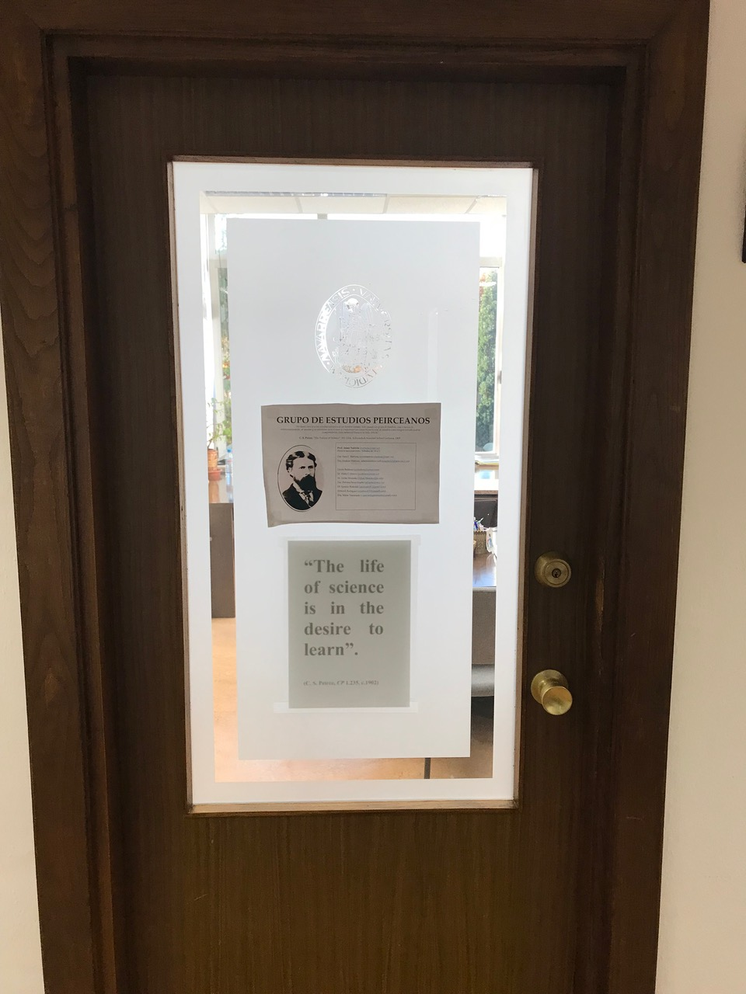
Science is the desire to learn. The quote is from the philosopher Charles Sanders Peirce, it is a key line of thought of the American philosopher we would study together in our graduate philosophy chats at the office, while trying to write my philosophy doctoral dissertation. As soon as I read that, I knew I found myself in that quote. When I understood the Peircean notion of abduction, a whole new world was opened to me because I myself had been constantly abducting my whole life, and I could finally find myself intellectually and connect with someone with the same intellectual traits: never block the way of inquiry. The integraction I am finally exposing now began there, as an innocent robot called “Charlie” that no one was interested in, I built it on my own, trying to understand visually and through abduction what integraction is.
This is key to understanding the development of integraction as a human personal formation model conceived through a truly scientific methodology: as I explained before, my notions of science and what scientific knowledge is are not traditional at all, and I began to realize that as I knew Peircean thought and departed from his notion of science and abduction to consummate intellectually what I am sharing in this text. Peirce was clearly an exception as a philosopher in his times, as the perils of the history of his life would clearly show, and I fully identified both intellectually and personally with a science that is a desire to learn, even if I wasn´t doing what I was supposed to be doing: a doctoral dissertation about a philosophy of education seen through Charles Sanders Peirce´s philosophy. My thesis director formed me intellectually even in very simple details, like recommending many books to read that were related to key cultural concepts that helped me to think better, like Fahrenheit 951, by Ray Bradbury, a book that deeply impacted me, and it was only one was among the many books he recommended to me by him and that weren´t related to my dissertation but about culture and thinking with rigor. I wasn´t able to write my dissertation, but I learned what I needed to co-create the integractive personal formation model, all, except the social notions. The University of Navarra lacked the social notions I needed due to right-wing intellectual tendencies, and due to my circumstances I was quite socially isolated while being there, for many reasons, I never was the typical student on either side of the story, and I don´t refer only to the institutional issues I made allusion before: there were no other Latino students (Hispanic students from USA) so I was culturally isolated and even mocked due some of my cultural notions, in my ecclesiastical philosophy classes I was the only girl, in a whole environment of male thinking and reasoning, and above all, in all my classes, including the graduate ones, I was the only student with more interest in learning to think and reason properly and creatively according to the truth than the interest in academic prestige. In every sense, wherever I was, I was the outsider… but I did identify with Peirce´s thought and methodology of reasoning, and also with my Peircean thesis director, in many ways, especially in the requirement of thinking: thinking was needed to be a doctoral student of my thesis director, and… believe it or not, that was not the usual thing at all there, not even in a Philosophy Faculty. The usual was that academic prestige and the thirst of being published in any prestigious and fancy journal weighed a lot more on the graduate students and even most professors around me.
It can be surprising to say that a student can be forbidden to think on his or her own in a philosophy class, but it can happen, and it did happen there way more than once. However, my thesis director was the exception… and he, along with Peircean reasoning, made all the intellectual rigor I am showing in this text possible. In the next five paragraphs I am going to quote almost literally my thesis director in the text he sent me, and that I had read the night before he sent it to me by email, I found it in Google, and it was exactly what I was looking for, titled C. S. Peirce: The Life of Science and the Desire to Learn…
Peirce esteems philosophical study, but also the close connection between philosophy and science, something he always emphasized. For Peirce, as for medieval scholars, philosophy —even metaphysics— should be pursued with a scientific attitude… Science is for Peirce "a living historic entity", "a living and growing body of truth". Beginning in his early years, Peirce identified the community of inquirers as essential to scientific rationality. The flourishing of scientific reason can only take place in the context of research communities: the pursuit of truth is a corporate task and not an individual search for foundations. Throughout his entire life, but especially in his later years, Peirce insisted that the popular image of science as something finished and complete is totally opposed to what science really is, at least in its original practical intent. What constitutes science "is not so much correct conclusions, as it is a correct method. But the method of science is itself a scientific result. It did not spring out of the brain of a beginner: it was a historic attainment and a scientific achievement"… Philosophy is —at least should be— a science as well. According to Peirce: “Science is to mean for us a mode of life whose single animating purpose is to find out the real truth, which pursues this purpose by a well-considered method, founded on thorough acquaintance with such scientific results already ascertained by others as may be available, and which seeks cooperation in the hope that the truth may be found, if not by any of the actual inquirers, yet ultimately by those who come after them and who shall make use of their results” Truth, for Peirce, is not the fruit of common assent; on the contrary common assent is the fruit of truth.
A Peirce’s student highlighted that "a deep conviction of the significance of the problems presented and a mastery of the intellectual processes were his sole and adequate pedagogical equipment." I love this quotation. It seems to me that most of the difficulties hindering teaching philosophy today —or any other subject for that matter, particularly in the humanities— arise from the general incapacity of teachers to demonstrate the significance —for the life of those in the audience— of the problems they are dealing with. In a world that is so fixed on “practical things,” it is not always easy to awaken the desire to learn about the specific subject that the teacher has to teach that day. But do we really try?
Philosophy is not —and cannot be for me— only an academic exercise, but is an instrument for the progressive critical and rational reconstruction of everyday living. In a world in which daily living is frequently found removed from an intelligent examination of oneself and of the fruits of human activity, a philosophy that separates itself from genuine human problems, is a luxury that we cannot afford.
Peirce's conviction in the teaching of science was that "the professor's object ought to be to let his pupil as much into the interior of a scientific way of thinking as possible, and for that purpose he should make his lecture experiments resemble real ones as much as possible."
Peirce "came to conceive of philosophy itself as inquiry, not as system-building, and as empirical, not as a priori." For this reason, Peirce's "ideas must be received, not as the finished products of ratiocination, but on the model of hypotheses in modern science, that is, as conjectures, sometimes roughly sketched, intended to guide further inquiry and to be further developed therein."
Now, after all that I have told about my background of the pursuit of science and after the quotes integrated with the five earlier paragraphs, quoted almost literally from the text of my thesis director that I mentioned earlier, who at the same time quotes Charles Sanders Peirce, you can understand fully my notions of what scientific knowledge and what scientific work should be, and why my thesis director influenced me a lot intellectually, although I never ended my philosophy of education dissertation. In the words of Isaac Newton: “If I have seen further than others, it is because I have stood on the shoulders of giants”.
As a matter of fact, philosophically speaking, integraction began exactly as it began from the supernatural point of view: the same way I needed a human personal formation model for what would later be conceived as the theology of light, as I was trying to do my dissertation in philosophy of education I realized that before anything else could happen in that dissertation, I was in the need of a very solid philosophical ground in what a human person is and how it is supposed to be formed, and then approaching a philosophy of education. The need for a personal formation model for my doctoral dissertation can be considered the philosophical beginning of the conception of integraction as a human personal formation model.
So, now you, dear reader, are very aware of my notions of science and philosophy, and this is important to understand the scientific methodology followed to complete the integraction as a whole personal formation model.
There is also a supernatural side parallel to the scientific observations and evidence shared in this text: my contemplation of a Jesus Charity as a whole growthful personal formation model, both humanely and divinely. He was the one who started this all… but I won´t tell that story now. I just mention this to explain you can understand what I am writing through both natural and supernatural ways… I chose to depart from Darwin, from the biological human nature dimension, instead of starting from ontology and the supernatural ways, to understand the personal formation model because this text is meant to be understood by evident observation, observing carefully the clear evidence of the truth that is present as law in every human personal formation. Of course, when explaining aspects of the ontological being, the Creator —also known as “Divine Being,” the I-AM-WHO-I-AM, the eternal and transcendental source of all human personal beings — will be alluded to and mentioned… but I deliberately chose not to part from ontological infusion but from the biological evolution that Darwin so amazingly explained in On the Origin of the Species. The focus of this text will try to emphasize the aspects of the dimensions of human personal formation that can be quite evident in traditional scientific observation from a “rational-sensorial way” point of view: biological evolution and social progress. However, to remain the most faithfully loyal possible to the evident truth, the ontological dimension and the contemplative content will also be alluded to when it is necessary to remain faithful to the truth.

The Information Structure of the Integraction of the Human Personal Nature

To understand what I am going to explain about human personal formation, I need to clarify what an integractor is.
An integractor is something like what you see in this very next picture. I was initially designed with a toy called “Tinker Toys,” which no longer exists as I used them initially (they were made with wood):
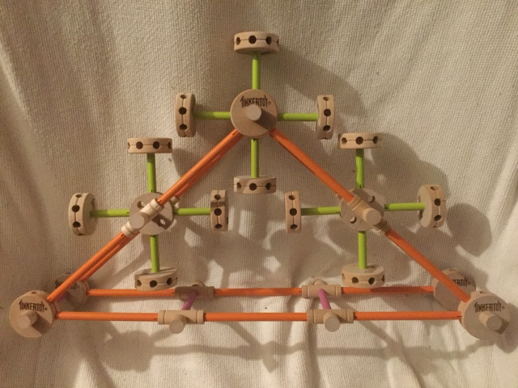
The integractor structures —exactly like DNA structures all our biological traits, called genes — all the processes of our personal formation: information (a human personal nature), conformation (a human personal action), transformation (a human personal realization), reformation (a human personal projection) and performation (a human personal connection). It structures all of them in a single structure. This achievement is not small at all; it will be seen when everyone realizes what I am talking about once I get all the “psychological specs” in their proper place. The integractive personal formation model will have an impact literally in all known disciplines and in the ones yet to come as integractive sciences. There is even a whole new notion of scientific research here: you can´t research the personal formation as you research natural sciences, dissecting and classifying as Darwin did. Personal formation can´t be dissected: it can only be integractivated. The fact that an integractivist (a researcher of the integractive science) does not dissect the human personal formation doesn´t mean that his or her knowledge is not scientific: to study human personal formation requires a scientific research methodology of its own.
In this text, we are NOT going to talk about the formative processes of action, realization, projection, and connection, I will only show the sketch of those formative processes. I will explain why in the clearest and intellectually humblest way possible: from the human personal formative processes of conformation (a human personal action) and beyond, the “internal movements” of the integractive structure begin to function, and to explain that in the truest way possible, with true scientific and intellectual rigor, you need a solid ground knowledge in psychology. I can say what I had contemplated through praying and adoration of the Eucharist regarding those processes, but that has been done before, so there is no need to do that now beyond the simple sketch that will be given later in this text. Right now, the focus is on observable, evident knowledge, so the main focus remains on the nature of human personal formation, for now, although the sketch of the remaining personal formation processes will be shared later.
To explain human personal action and beyond, the reality is that I do need to study psychological and social sciences further. I do understand very clearly, from both the contemplative and the evident point of view, that Psychology is the science that understands and studies the mind. I also have seen and contemplated, both biologically and ontologically, that the biological mind is the brain, the ontological mind is the intellect, and the social mind is the conscience. As human personal formation keeps growing, no matter which personal formation process it is, it always does it neuroscientifically, intellectually, and consciously. That is everything I can reach right now in psychology, besides studying an undergraduate psychology of education class. We wouldn´t call the integractive personal formation model a philosophy of mind, but the mind is the evident protagonist from the human action formative process and beyond: the mind is where the will of the action happens, and so on, it allows the other human personal formative processes to happen after the action happens. Notice that in the integractor, the movements of the action are all internal, not external. With the notion of psychology I am proposing, we are not merely aiming to study the external behaviors of a person but studying first its roots in his or her mind. An integractive psychology studies the internal action of the human personal formation in her or his mind to achieve a more harmonically reformed and perfected behavior in the process of realization, a more transformative and perfected project of life in the process of projection, and a more connected and perfected performance in the process of performation. I am not trashing away what the psychological sciences currently know about the notions of action, realization, projection, and “civilized performance,” said in understandable words. All I am humbly recognizing here is: that I currently don´t have the intellectual rigor, the studies, or the autodidactic knowledge to have a clear conscience of the notions that psychology currently has of what we have contemplatively conceived as processes of human action, human realization, human projection, and human performation… so, although it has been contemplated, I am not yet prepared to “palabrize” this part of the integractive personal formation model in an observable, evident, properly scientific way. I can only share what has been contemplated, as I will further on in this text simply to show the proper structural context of the information as part of a whole human personal formation model.
Just to be understood in the clearest way possible: I use the word “palabrize” as “Hispanicism” (I am paraphrasing the term “Anglicism” in the opposite direction) of the Spanish verb “palabrizar” in English. There is no verb in English for the meaning of “palabrizar” in Spanish, so I do that. The verb “to palabrize” means the process of conceiving a word in the most faithful possible unity to its meaning.
Also for the sake of being understood in the clearest way possible, let´s state clearly here what I have studied academically, so we can remain the most humbly loyal possible to truth. I have a BA degree in Humanities, with technically a second degree in Education (the University of Puerto Rico doesn´t grant second degrees, but I have all the courses, including the practicum, required for a second degree in Education, specializing in ESL teaching —ESL means English as Second Language— at the elementary school level, usually understood according to the American system as K-6 level, although I have taught all levels of English, from PK to 12. I have also taught the classes of History of Puerto Rico, Responsible Family Planning, and Faith Education —also known as Religion—, although my official teaching certification granted by the Department of Education of the Government of Puerto Rico was ESL teaching, elementary level). I have also studied philosophy and theology quite deeply, mainly in the contemplative and autodidactic way, but I did attempt to complete a PhD in Philosophy of Education at the University of Navarra and an ecclesiastical bachelor’s in philosophy and theology, also there, besides attempting a graduate degree in theology in the Universidad Central of Bayamon, whose ecclesiastical degrees where granted by the Angelicum in Rome. All these attempts failed, but I failed due the right reasons: because I was looking for the truth before any academic prestige of those titles… and I never had the disposition of simply following what I was told if it didn´t correspond to God´s will and with truth. I can humbly say I have been granted the grace to endure the intellectual massacre in such a way I never bowed my love for truth to the left or the right. The University of Navarra had a right-wing ideological agenda with overflowing ontology but lacked basic sociological notions. The Universidad Central de Bayamon had a very left-wing ideological agenda, clearly promoting Marxist theology of liberation, toxic feminism, open homosexualism in the Church, and transgenderism, along with other very common social notions of the left side of contemporary human history. I did get there, in the Universidad Central de Bayamón, the social notions I lacked from the University of Navarra, but that priest professor who taught me the seven social ethics principles that are included in the integraction was the exception in that University, was truly brilliant and humble, and eventually left the University to become a parish priest. I can say, without any kind of shyness, I was equally hated and equally intellectually sabotaged by both the left and the right. My biology notions are quite basic: I studied biology in middle school and high school (Puerto Rican school system is organized according to the American system of schooling) and besides that got a year-long required course in Biological Sciences given in the General Studies Faculty of the University of Puerto Rico, as part of the requirements of my undergraduate Humanities BA degree. My undergraduate degree in Humanities was interdisciplinary, specialized in Middle Ages: I studied literally in all faculties of the University of Puerto Rico (including Architecture), except in the Faculty of Natural Sciences, because that Faculty does not accept students of other faculties. The students of that Faculty are actually always competing against each other to get admission to the Medicine Faculty, and the competition is highly fierce; they only care about grades and doing what is told, even if it is morally wrong or even intellectually futile. Professors did nothing to change that. Love to the truth had no space to be developed there, so the fact that my interdisciplinary degree lacks studies only from the faculty of Natural Sciences is not a casualty at all.
Besides all that, I also attempted a professional certification in Professional Writing from the Extension Studies Department of the University of Puerto Rico, but I remained a single assignment away from completing the whole professional certificate. I did complete all the courses for the professional certificate but I never was able to complete the final assignment of one of the courses, the class of Redacción y Estilo. I also had problems in that class in the Faculty of Humanities, simply because I am awful at delivering texts and assignments on time due to my ADHD… but I did finally achieved to pass the class in the Humanities Faculty… although I had to withdraw a Creative Writing class of that faculty simply because the professor mocked my Christian faith in the very first week of the class and I chose not to fight that ideological. Knowing that I was totally unable to write not considering my faith, and that I would be mocked if I took in my faith instead of the leftist ideology of the faculty, I withdrew from the class. The problem with the final assignment of the final class of my Professional Writing professional certificate was simply due to perfectionism —those were the words the professor used to describe my issue— in the first place and eventually due to my ever-procrastinating lack of time to complete the assignment in the new given due date, while I was already living in Spain. Yes, I have lived for five years in total in Spain, one as an undergraduate international exchange student at the University of Granada, and the others as a graduate/ecclesiastical student at the University of Navarra. Besides visiting the United States briefly, I have traveled as a missionary to Paraguay, Brazil, Argentina, Mexico, Costa Rica, and the Dominican Republic. During my time in Europe, I visited France, Italy, and very shortly, Germany and Ireland. I have visited Rome two times.
I take my time to explain this so you, dear reader, can understand this: integraction as a personal formation model is not meant to be “from the right” or “from the left,” and not even being from a single place, because I had been in many places and I know multiculturalism very well: I consider myself both Spanish and American, my life began to be known as it is known now after me doing Santiago´s Way in Spain while living there, I completed it on September 29, 2004, without knowing then it was the day of Saint Mikhael the Archangel. I was offered by the pertinent office of Pamplona, in my fourth year of residence, the option of obtaining permanent residence in Spain, but I didn´t understand what she meant until time later. As I understand my Spanish identity, it is a second citizenship, equal to my first one. I never saw myself as a resident of Spain; I saw myself as a citizen of Spain.
So, after all this being said, you may understand what I will say now. This text, plainly stated, is meant to be and remain loyal to the truth. That´s it. You will fail miserably if you seek to understand integraction only from a left or right point of view, or from a nationalistic point of view or any other ideological point of view. Both leftists and rightists have glimpses of truth, and those with anti-multicultural traits also have glimpses of truth… but co-designing the integractor and co-creating the integraction had never been a matter of being loyal to the left or the right, not even to any culture in particular: it has been about staying loyal to the truth, no matter what.
If I want to stay loyal to truth, the reality is that I need more knowledge in psychology to go ahead and explain the human personal formative processes from conformation (human personal action) and beyond. Contemplative knowledge is valid and true, but it is not enough to explain evidence scientifically, especially if you are talking about social subjects, about human beings, whose research must be ruled by very high and methodic ethical standards; you can´t simply research about human personal formation action on your own, that´s highly unethical and can be in certain instances even illegal. You can research human nature to some extent because you have your own nature to observe, and you can also observe the nature of those around you throughout your life, but human personal action is something that happens inside: it must be revealed willingly, not by force. Although I did apply notions of integraction in my professional endeavors as a teacher, I did it as a personal choice and not due to having the proper intellectual and professional support to develop my own teaching methodology, something that can also be done through integraction as a personal formative model. I have never dared to use my students as a “human formative experiment.” What I know from action and beyond is still yet to be observed fully through psychology, and so, I can´t dare to attempt to describe scientifically anything from the formative process of conformation and beyond, if I am truly honest in the intellectual sense. It is important as a scientist to know your ethical and ontological limits.
So, now that you know what is a whole integractor, why are going to limit this text to expose the nature of the human personal formation and the reason for that cognitive limitation, let´s begin to explain the parts of the integractor that we are going to explain in the following parts of this text.
The formative process that refers to the formation of the human personal nature is integration. The integration integracts from within, and that is why is called in-formation: it refers to being formed-from-within (literally: in-formation). As you may realize, this is true even in the evident biological observation: the conception of a new personal human formation begins to happen from within a woman´s womb, and due to that extraordinary and fascinating capacity, the woman can be called the co-creator of the being. The integration formative process, also known as “help to be,” refers to how the three dimensions of the human personal formation nature are intrinsically integrated; you can´t dissect one from the other. Those three dimensions of human personal formation nature are the organic, ontological, and filial dimensions. OUR NATURE CAN´T BE MANIPULATED AT WILL AS OUR ACTION DOES, THE DIMENSIONS OF THE NATURE OF THE HUMAN PERSONAL FORMATION CAN’T BE CHANGED, but as we will explain later, they do influence each other. We are necessarily organic, necessarily ontological, and necessarily filial, all three at the same time; that is our nature as human beings.
As organic bodies, we are a living organism that evolves, an animal species, in the words of Darwin, called homo sapiens. As ontological beings, we are a living entity that matures. As filial subjects, we are a social civilization, a “we the people” that progresses necessarily belonging to a very concrete society in the history of humanity.
The organic dimension and the ontological dimension have seven properties each. In the integractor, each one of those seven properties can be seen in the next photo. As you may count, there are seven parts, seven orange sticks there:
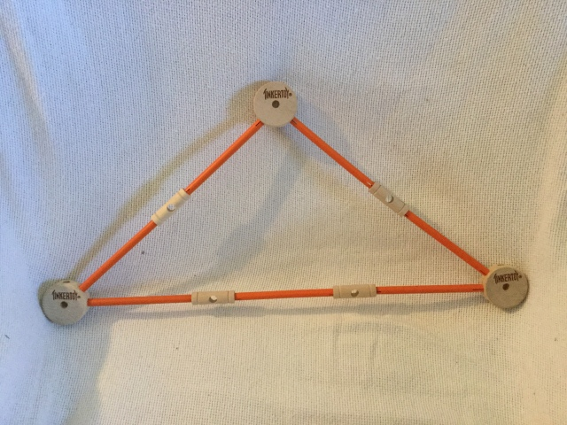
As I mentioned, both the organic dimension and the ontological dimension have seven properties each. They would be seen in the integractor as the next photo:
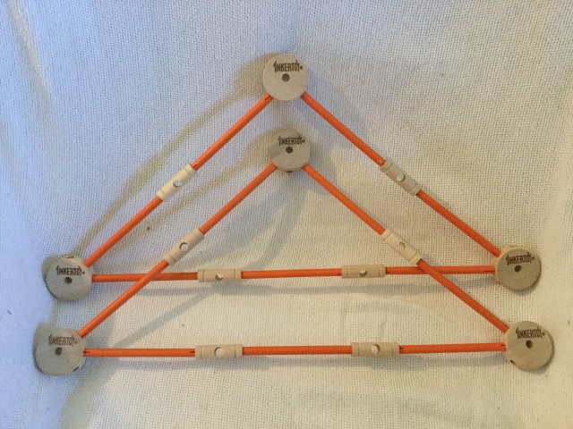
There are also seven principles of the filial dimension. In the following photo you can see the seven principles of the filial dimension in the integractor. Please notice the wood caps at the end of each extreme: we are going to talk about them a few lines later:
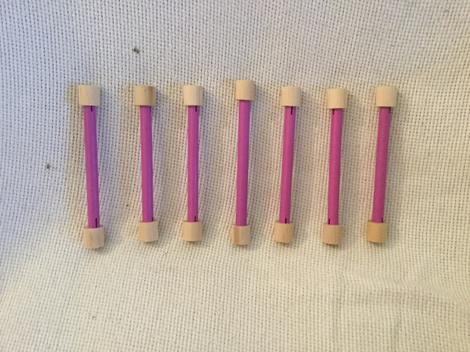
All these parts together form the structure of the nature of the personal formation, that can be seen as the following pictures:
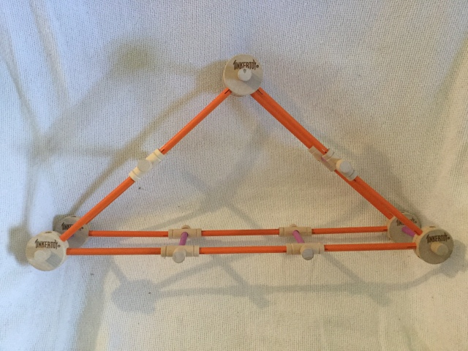
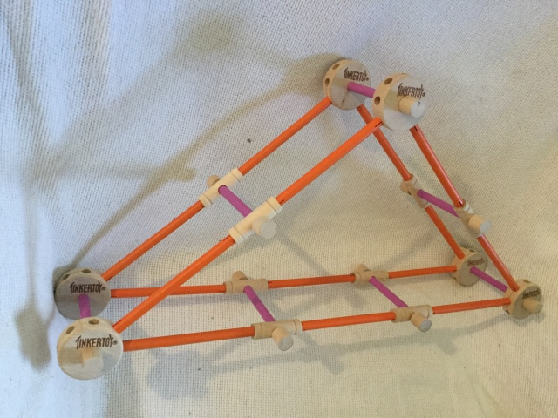
Each orange stick is a property of the human personal formation nature and each pink stick is a principle of the human personal formation nature. Please notice —the detail is not minor at all— that the social principles are the ones who unite the ontological properties and the organic properties.
Now you can see in the following table, as an organized list, all the properties and principles of the human personal formation nature. All these properties and principles are intrinsically united, and that is why they are being presented all together in the same table, although we are going to speak later about each dimension separately:

Integration (Human Personal Nature)
 | Properties (orange sticks) |  | Principles (pink sticks)
 | Organic Dimension | Ontological Dimension | Filial Dimension
1 | Hierarchical Property: every human body is ordered hierarchically. | Ens Property: every human entity is a being. | Humanization Principle: every human subject is called to become more human.
2 | Nutritive Property: every human body is capable of obtaining energy that he or she needs to subsists. | Res property: every human entity is a thing. | Autonomy Principle: every human subject is called to determine by himself or herself.
3 | Regulative Property: every human body is capable of maintaining his or her internal equilibrium towards the environmental changing circumstances. | Aliquid Property: every human entity is something. | Equality Principle: every human subject has the same rights and duties.
4 | Reproductive Property: every human body is capable of replicating himself or herself. Sexual reproduction requires a female gamete and a masculine gamete and supposes a longer maturation time related to asexual reproduction. | Unum Property: every human entity is a unity. | Complexity Principle: every human subject is called to act according to what is determined by his own or her own discernment, departing from what they know from reality.
5 | Evolutive Property: every human body evolves, maximizing his or her survival. | Verum Property: every human entity is true. | Totality Principle: every human subject is responsible for the totality of their personal being.
6 | Progressive Property: every human body grows, develops, and matures progressively through life. | Bonum Property: every human entity is good. | Solidarity Principle: every human subject is called to contribute to the common good according to his or her possibilities.
7 | Sensitive Property: every human body reacts to changes and interacts with the stimulus that surrounds them. | Pulchrum Property: every human entity is beautiful. | Subsidiarity Principle: every human subject is called to develop all his or her talents to the best expression possible, assuming everything that he or she can by himself or herself.

There are also six pink spirals in the integractor. They keep the proper balance of the integractivators (the three pieces that move inside the intregractor). Those six spirals are also part of the nature of personal human formation: they are the six human personal formation nature laws stated in one of the next parts of this text, they keep the integractivators in the center of the integractor, unable to move nor too much to the right nor too much to the left, what would unavoidably cause an imbalance that we will later call natural imbalance, because this kind of imbalance implies an imbalance that has repercussions in the whole nature of the personal formation, not only in one of its dimensions. You can see in detail the pink spirals of the integractor in the next pictures:
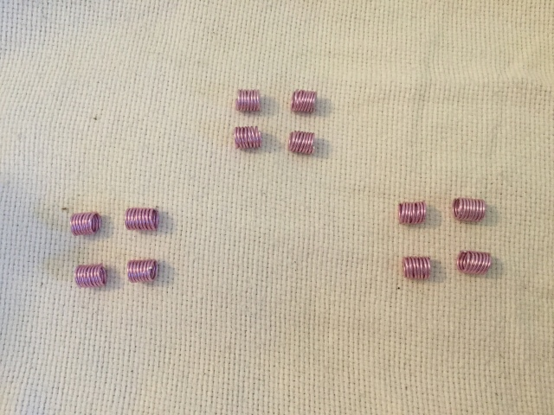
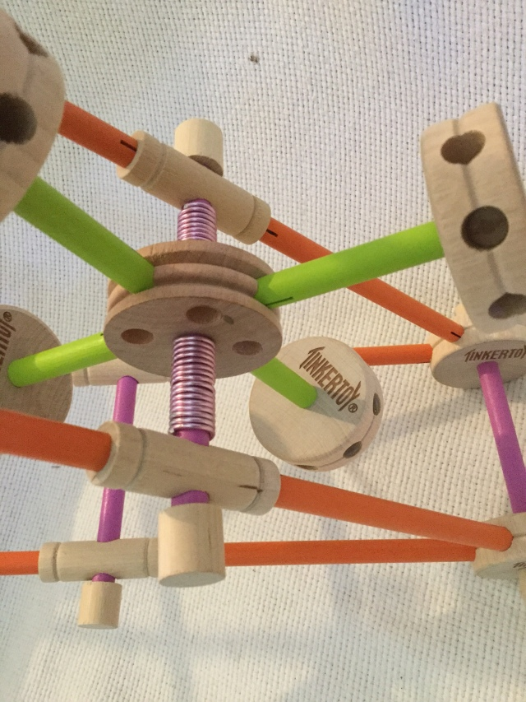
There are also “joints” in the structure of the nature of human personal formation: 28 wood-colored pieces that unite the whole structure of the human personal formation nature. There are three kinds of joints: 7 organic joints, 7 ontological joints, and 14 filial joints. The joints manifest “natural articulations” that are present in all human personal formations, a “life narrative” that is present in all integractions, that manifest as the person very unique lifestyle and life history.
Do you see the orange stick pieces in the next pictures, that I have shown previously? Those are properties. The wood-colored joint pieces that join them are the joints: seven organic joints and seven ontological joints.
The seven organic joints are intrinsically joined to the organic dimension of the human personal formation nature, and they influence the articulation (life narrative) of the whole human personal formation. These organic joints are the following:
- Demographic Profile (your language, your age, your sex, your family composition, if you are married or single, your language, your race and cultural heritage)
- Affective Profile (are you sexually active or not? Are you heterosexual or homosexual? Do you have a healthy sexuality? How is your affectivity oriented? How do you define love?)
- Religious Profile (Do you believe in a God? Which is your religious denomination? Do you practice your faith?)
- Socioeconomical Profile (do you have a profession? Do you have an income? Can you pay your debts if you have them? Do you live comfortably? Do you own your home, or do you pay a mortgage?)
- Complexion Profile (facts of your physical aspects, like your weight, appearance, medical diagnoses…)
- Political Profile (which is your nationality? Which is your political affiliation?)
- Aesthetical Profile (which artists do you like? Which music do you like to listen to? Which are your favorite colors and food? What is your fashion style? Which books and movies do you like? What do you like and what you don´t like?)
The seven ontological joints are intrinsically joined to the ontological dimension of the human personal formation, and necessarily influence the articulation (the life narrative) of the whole personal formation. They are the following:
- Vocational Profile (Up to which level did you reach to study? Did you complete high school, college, or graduate school, or what professional trade school have you attended? What is your learning style? Do you like learning? Are you autodidactic? Which is your calling to serve society, according to your own articulation of your life narrative?)
- Strengths Profile (Which are the hobbies that you like? Which are your talents? What do you like to do?)
- Experiences Profile (Which are the most significative experiences of your life for you? A travel? A moment? A learning experience?)
- Milestones Profile (How do you define being successful? Which are the things that you consider your achievements in life? Achieving getting married? Achieving to have a family? Achieving to get a PhD or having your own business?)
- Dreams Profile (what do you aspire to in your life? What do you plan to attempt to do as a growth choice? Which are, according to you, your most important goals and objectives in life?)
- Mistakes Profile (how do you define being wrong? Which had been the most important mistakes in your life, according to you? How did you overcome the mistake, and what did you learn?)
- Stressors Profile (Which had been your most important difficulties, and how did you overcome them? Which difficulty do you have now? Do you have the tools and resources to overcome that present difficulty? How do you plan to overcome your present difficulties? What causes you stress?)
Do you remember that I mentioned that the wood caps along the pink pieces, in both extremes, are important? They are the 14 filial joints, but they are fourteen wood caps, the key pieces that keep the whole structure of the nature of the personal formation together. If you build an integractor and glue those caps, you won´t be able to separate it and rebuild it again.
As we said, these details are not minor. What these fourteen caps are meant to be — besides being the filial joints of all human personal formation´s nature— is something that doesn´t exist yet: the fourteen Universal Fraternal Rights. Yes, there is a Universal Declaration of Human Rights… but it lacks a key word: love. If you read the whole text of the Universal Declaration of Human Rights, the word love is nowhere to be found. A Universal Declaration of Fraternal Rights would complement the Universal Declaration of Human Rights with a very basic foundational social notion that can also be considered an intrinsic biological and ontological trait of any human personal formation: every human being is an equal brother and a sister with equal dignity, unconditionally called to grow as the best person he or she can be, unconditionally called to grow belonging to a family where he or she is loved unconditionally, and unconditionally called to a unique vocation of love. What the fourteen Universal Fraternal Rights affirm is, in very few words: every human person has the right to grow loved and to grow in love, according to his or her very own personal vocation to become the best person he or she can be as an irreplaceable part of a society realized as “we, the people”. All the subsequent fourteen fraternal rights after that affirmation are “concretions” of that foundational fraternal affirmation that can be applied to every human person that has ever existed, that exists, and that will exist in the future.
I will explain this a bit further why A Universal Declaration of Fraternal Rights is also an intrinsic part of the nature of human personal formation: there must be an unconditional recognition of the universal fraternity of man for the information —and consequently, the whole integraction— to be possible in its most evolved, mature and civilized way possible, in its most growthful way possible. We must consider ourselves equally dignity-given human beings to have a fully integrated human personal formation nature. Without the social notions of equality, fraternity, and dignity, there is no structured information either, and because these are social notions, that are recognized filially, they (visualized as the fourteen wood caps) are intrinsically connected to the social principles, visualized in the integractor as the pink pieces that are “joiners” of the organic properties and the ontological properties.
You can see the caps in more detail in the following pictures (please see the wood caps in both extremes of the pink sticks):

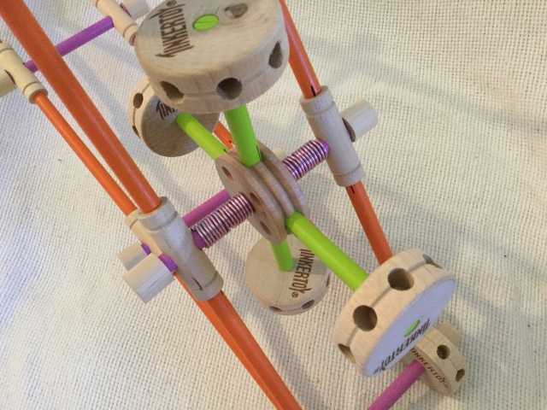

All these common joints that articulate a “life narrative” that is unique in everyone, but quite systemic in how it is being articulated integractively, can be a “narrative ground” for giving integractive psychology therapy and begin to set a systemic foundation for an Integractive Psychology: a person-affirming psychology that studies and treats the human personal formation integractively in order to help to be, help to do, help to grow, help to glow and help to be every person as who he or she is, and as who she or he are called to be according to their inherent dignity, until becoming the best person he or she can be as an equal part of a “we, the people”. Preparing a life narrative of each client, also called person or personal client, would be required for integractive psychologists, so they can have a personal ground for starting psychological therapy according to the “psychological frame” of the person who is receiving the therapy. No psychologist or any other mental health professional can be allowed to use psychological therapy to attempt to “convert” his or her person (his or her personal client) into who he is not or who he or she is not called to be according to their inherent dignity. The life narrative can be perfected (for example, correcting the person if he or she considers an error something that clearly isn´t) with the help to be of the psychologist, but it can never be invalidated.
So, after all this had been said and explained about the structure of nature in the integractor, we can now approach the nature of human personal formation from each one of the dimensions: the organic dimension, the ontological dimension, and the filial dimension. As you may realize, it is very hard to talk about each dimension without alluding to the others because their very exact nature is integrated, as the name of this formative process —integration— affirms. What changes in each one of the next three parts of this text is the main focus: each part is mainly focused on one dimension, even if the observations and data must be repeated in other parts of the text. After approaching the personal nature from a dimension-focused point of view, we will approach them openly joined, as laws of the human personal formation nature: observations that can be corroborated and confirmed in every and each human personal formation that has ever existed that exists now and that will exist in the future.

The Organic Dimension of the Nature of the Human Personal Formation

The body of the human personal formation grows as biological evolution; we are all evolved. Darwin´s theory of evolution brilliantly describes this, and I have not a single comma or period, not even a minimal correction, to make to Darwin´s theory of evolution, which I have studied at the school level and at the undergraduate university level, besides my sporadic autodidactic personal research. He was completely right, and what he wrote and achieved to palabrize with such outstanding clarity was —and still is — an amazing work of science that revolutionized the whole world as it was known in his time. What I am doing here with this text is complimenting his work of science with a work of Love that will revolutionize our humanity as it had been known in our times, starting a revolution of dignity, a revolution of Love, a revolution of New Albor. Darwin was completely right and should not be contested, nor is my pretension to do so. Whoever understands this work in that sense is wrong. What I am doing is amplifying Darwin´s work so we can have a human personal formation that embraces all that the human person is. Darwin´s work —no matter how correct and complete it is when it is applied to animal species— evidently remains incomplete when it is applied to the nature of the whole human personal formation: although the biological origin of human nature indeed happens through evolution and natural selection, the human personal formation is so much more than our biological traits. Besides our biological evolution, we are also capable of maturing as known beings, and we are also capable of progressing together as a progressively more civilized “we, the people”. Clearly, the homo sapiens is the only animal capable not only of evolving, but also of forming as a person, and explaining that requires exposing a whole model of personal formation, and that is what integraction is… so, in this part of the text we are going to deal with HUMAN BIOLOGY, NOT ORGANIC BIOLOGY. That means that although the properties of every organic body do apply to human biology, human biology can´t be approached merely in an organic way; it must also consider the necessary ontological and filial implications of the natural human biological nature. We will explain all this further as we explain triadically three very concrete human biology terms common to every organic dimension of all human persons: sex, life, and death, which correspond to the properties of every organic body.
Biological personal formation nature´s growth is called evolution. This growth is ruled by natural selection via instincts, ordered to survive (health), and created with Love: with sexual intercourse between a woman and a man, both required to make a new life possible. Human biological personal nature has seven properties that can be found in every human personal formation —in every integraction—, no matter who she or he is, how he or she was conceived, or where he or she is. As I just mentioned, the organic properties of human biological nature are the same organic properties of every organic living body, and human biological natural growth evolves according to Darwin´s theory of evolution.
These seven properties were mentioned in the table given before, but now we are going to mention them jointly:
- Hierarchical Property: every human body is ordered hierarchically.
- Nutritive Property: Every human body is capable of obtaining the energy it needs to survive.
- Regulative Property: every human body can maintain his or her internal equilibrium towards the environmental changing circumstances.
- Reproductive Property: every human body can replicate himself or herself. Sexual reproduction requires a female gamete and a masculine gamete and supposes a longer maturation time related to asexual reproduction.
- Evolutive Property: every human body evolves, maximizing his or her survival.
- Progressive Property: every human body grows, develops, and matures progressively through life.
- Sensitive Property: every human body reacts to changes and interacts with the stimulus that surrounds them.
As we mentioned, we are going to talk about human biology, which can also be called Integractive Biology. Integractive Biology can be defined as the science that studies biology in relation to integraction: both studying the biological human personal nature in relation to the other two dimensions of the information of human personal formation nature (ontological dimension and filial dimension), and also studying it in relation to its influence in all the other integractive processes (also studying the biological nature´s influence in action, realization, projection, and connection).
I will show what Integractive Biology is, explaining three very basic and evidence-based terms of Organic Biology —life, sex, and death— from an Integractive Biology perspective, which is also evidence-based, but from an integractive scientific point-of-view, not merely from a natural sciences scientific point-of-view. If you follow the integractive scientific methodology, you can´t study the human personal or integraction through dissection, breaking it into “classified parts”, like Organic Biology does. You can´t dissect the human personal nature to study it integractively: if it is Integractive Biology, you must study biology necessarily as a dimension, one of them, of a whole person, whose other personal formation processes beyond information will necessarily also have clear biological influences, because biology is part of who we are as personal human nature. This means: for studying and researching biology in an integractive way, considering the whole person, the whole personal formation, the whole integraction, is as necessary as considering the concrete biological properties, traits, and influences in all integractive processes (information, conformation, transformation, reformation, performation). Got it? Let´s go on to explain three basic Organic Biology terms from an Integractive Biology perspective.
Life, as understood by Biology, has two other influences in the human personal formation nature: what we call biologically “life” when we say that a human life is originated (I am using Darwin´s words according to On the Origin of the Species), there is also an ontological conception happening, and the joint of the two results in the filial incarnation of a human person, incarnated into a very concrete social context of history, into a very concrete social community that we call family. This means: creation, understood as the creation of a new human life, is not merely the origin of an evolved new specimen, as Organic Biology affirms, once again using Darwin´s vocabulary. Creation, understood from an integractive point of view, is simultaneously the origination of life, the conception of a being, and the incarnation in a very concrete time and context of a history of civilizations. Human keeps being incarnated way over and over again as a new and unique human specimen that keeps evolving, maturing, and progressing at the same time, all this resulting in a constant re-creation of the human personal formation along the many millenniums that the human specimen has existed, since the neanderthals — the first human specimens that archeology knows right know— to the homo sapiens that we know today. A human personal life is not merely the fruit of a biological origination: it is also a fascinating mystery of eternal conception that, along with the origin of life, keeps incarnating as an unrepeatable human existence in a very concrete social context of history. This is how you understand “life” from an Integractive Biology point of view, and this change of perspective has a lot of repercussions that —because I respect my reader´s capability of reasoning and thinking on their own— I will let the reader assume and establish on their own… but let´s give another very concrete example of how Integractive Biology deals with very basic Organic Biology terms.
Now let´s talk about sex, a very controvertible biological term in our time. For some, the notion of biological sex is even offensive right now. We are now letting ourselves lead by science, not by the ideology of gender. Science says, and genetic evidence can confirm this very clearly, that the human species only has two sexes: a human organic body is either a male (XX) or a female (XY), and the sexual gametes of both jointly make new life (reproduction) possible through sexual intercourse. Of course, this has tremendous repercussions on who we are as human persons and on how a person is formed. It is not the same at all to be formed as a female or as a male, as a woman or as a man, with very concrete feminine and masculine social notions according to the socio-cultural context. It is not the same at all to be formed as a female or as a male, not even in the neurological sense. It is quite proven right now that the female brain and the male brain function differently. However, this sexual difference is especially clear in the traits of the reproductive property of the biological personal formation nature, mentioned above: only human females can menstruate and originate new human life. NOTHING CAN CHANGE A BIOLOGICAL SEXUAL ORIENTATION, IT IS CREATED, ITS GIVEN STRUCTUTE CANT BE MANIPULATED AT WILL, HUMAN PERSONAL NATURE, IN ANY OF ITS DIMENSIONS, CAN´T BE MANIPULATED BY WILL (action and beyond). I am sorry to whoever feels offended reading that, but you need to deal with the truth. There is no way that a male can originate new life, no matter how many “gender affirming” surgeries he gets: males don´t have a uterus, males don´t have the anatomical capability to give birth, even their hips don´t allow it, and they are too narrow to let a baby pass through a birth canal, which in the case of a male is non-existent. We females have traits of our own, even in the biological sense, but not only in the biological sense. Let´s go further in this integractive scientific exposition of sex.
Sex is not the only thing that determines that a female is a woman. In the ontological dimension of human nature, there is also sexuality; there can be femininity (a feminine genius) or masculinity (a masculine genius). Nobody realizes there is a whole ontological sexual orientation there: how we are capable of being sexually known by others is not a mere casualty either. All of this has huge implications, some of them will be explained later as we discuss the ideology of gender gruesome mistakes, but now I will explain only one, related concretely to femininity and masculinity. There are clear disorders of femininity and masculinity. It is yet to be known the biological roots of homosexuality, but as far as we know right now by science, there are not a few cases of homosexuality that are not disordered: they are born that way. Other cases of homosexuality are a disorder indeed, either due to trauma or due to incorrect social notions that deformed the ontological dimension´s sexual traits. So, that distinction must be made in the case of homosexuality: right now, as science keeps progressing, we know that homosexuality can´t always be considered a sexual disorder, but sometimes it is, and it must be treated as such, as a post-traumatic sexuality disorder, not as a homosexual sexuality orientation. Of course, this also means that there are ontological sexuality disorders, and some of them are very well known in our times: pedophilia, pornography, violent sexual inclinations like the urges to rape and the inclination to sexual addiction… All these deformations of human sexuality —currently being seen and treated psychologically and psychiatrically, if treated at all, only from a sociocultural-behavioral perspective— have their truest roots in a human sexuality disorder, in the ontological dimension of human nature, with clear influence of a malfunctioning sexual instinct. That is why these can´t be “cured” with medicines; they can only be treated with integractive therapy that helps them to be according to their inherent dignity —who they are and who they are called to be— instead of letting themselves lead by their wrongly conceived sexual instinct that disorders their sexual passion. Some may need lifelong help to be to deal with their sexual disorders, but they do deserve that help —if so they choose to receive it, and most of the time, this will require the person to receive some sort of integractive formation to become self-conscious of how disordered his or her sexuality is— to change and become better man and woman, the best person he or she can be. Once again, all this has a lot of repercussions that —because I respect my reader´s capability of reasoning and thinking on their own— I will let the reader assume and establish on their own…but if you want a very good Christian intellectual ground of this, I recommend you to read about the theology of the body, of Saint John Paul II. He describes the importance of femininity (feminine genius) and masculinity (masculine genius) with astonishing and even beautiful clarity.
There are also filial-social repercussions in being conceived as a woman or as a man, besides being biologically originated as a male or a female: your social filiation notions will be either feminine or masculine. Here is where the dangerous conflict of the ideology of gender arises: the promoters of the ideology of gender believe that because they can transform (transformation is the personal formative process that belongs to the projection, and it is related to how you project your human personal formation, currently understanding the verb “to project” as a configuration your own project of life) the social notions of gender via a cultural dictatorship —that is a very effective social control tactic, as we will explain later—, they can also control the biological nature of the human being, so sex and gender do not necessarily must be aligned, which necessarily also generates a disordered, highly disordered sexuality, as it can be seen in their sick obsession in imposing their disordered sexuality to young kids, unable to even reason by their own yet, with “innocent Drag Queens reading sessions” and “Queer sexuality school books” that are a huge human personal formation perversion: a human personal formation can be deformed involuntarily or unconsciously, but when you deform a personal formation deliberately, voluntarily and consciously, either if you deform your own personal formation or the personal formation of other, that is a PERVERSION of the human personal formation, a very grave crime against the integrity of the whole human personal formation processes.
The truth here is: you can change your social image and external body image with “gender-affirming” plastic surgery, but the organic body remains to be formed according to the sex assigned at birth, through natural selection, and according the sexuality you were given by the Creator of human being (either a femininity or a masculinity), as told in Gen 1, 27: “God created mankind in his image; in the image of God he created them; male and female he created them”.
As we will explain later, there is a human personal formation law that affirms that there can´t be a contradiction between the three dimensions of the nature of the human being. The ideology of gender deliberately creates a contradiction between the filio-social dimension and the biological dimension of human nature, with quite often lethal consequences in the ontological dimension. The issue is explained quite well later, but for now, you can know this: sex, sexuality, and gender must align in human personal formation in order for integration be able to happen and for the person to able to be formed with all its integrity as a human person. What the ideology of genders does is horrible, something very characteristic of all ideologies: it destroys people from the inside, it disintegrates human personal formation from within, fragmenting the nature of the human personal formation like a grenade would fragment an organic body when exploding. When it is culturally imposed as a cultural dictatorship, like the examples we will explain later, the ideology of gender can also be considered a form of social abortion that can lead to death and has actually led to the death of many by suicide, if not as a direct medical consequence of those surgeries and medical treatments (example: an infection gotten in the operation room) that have nothing of being true medicine, at all. There is a Hippocratic Oath that requires doctors to do no harm: "I will abstain from all intentional wrong-doing and harm." Doctors who mutilate a perfectly healthy body according to their sex instead of treating gender dysphoria properly as a mental health disorder do great intentional harm and should be prosecuted as Auschwitz butchers, especially when they go to the extent of creating a whole profitable economy due to the personal frailty of a vulnerable human being, calling it “gender-affirming medicine”, when what they should be practicing is “person-affirming” medicine, unconditionally helping their patients to be and to become who they are called to be according to their inherent dignity as human persons, not according to any ideology.
I can say from personal experience that it is easier to get sex-changing hormones from a psychiatrist than getting Adderall as an ethical, safe, and proven treatment for my lifelong ADHD —that so many learning difficulties and social suffering have brought me through my graduate studies and beyond— if properly medically supervised and properly used in the context of a true person-centered medical treatment. I would have been given sex-changing hormones easier if asked than getting the Adderall that I really need to function according to my full intellectual capacity, but it was denied to me for a very long time due ideological reasons: the Psychiatry Department of the University of Puerto Rico, Medical Sciences Campus, was openly pro-ideology of gender, and it was not convenient to help me to be according to my own social notions —they even tried to make me believe that masturbation is a normal human need, knowing very well that such social notions contradict my openly chosen Christian life narrative, the lifestyle with which I chose to articulate my life— because I defied their “medical” notions with my very sole presence there. It was not anyone who denied me a legitimate and medical-plan-covered prescription of Adderall, knowing that I needed it for the right, legit medical reasons, knowing that if they were the ones giving it to me, I would have to pay more than a hundred dollars per month cost —without having any work at that moment, I was a full-time student of the Faculty of Education of University of Puerto Rico, Rio Piedras Campus— for the prescription that they knew I was getting it in other way, and that shouldn´t happen, they were the ones supposed to give it to me, not the generalist doctor who did it as an act of goodwill and because he did had the proper DEA certifications to do so, although not being a psychiatrist but an internist family doctor. Who denied me the Adderall and compared me with Van Gogh — trying to make me believe that my creativity is a fruit of a mental health disorder that would lead to suicide if not “treated”, instead of being a fruit of a gifted intellect that simply needs help to be as it is and as it is called to be—, was the Head Director of the whole Psychiatry Department of the so-called the best medicine school in Puerto Rico, that is also the Public State, federally funded, State Medicine School: the Medicine School of the University of Puerto Rico, a Public University System where is quite difficult to study something without some sort of ideology of gender being involved as cultural dictatorships, as happens in many Public Universities in the United States, very particularly in California, what can be read about Californian Public University System regarding the ideology of gender cultural dictatorship is almost barbaric to happen, more proper to un-civilized ways of “de-progress”… but sadly, it doesn´t happen only in California, the dictatorship of the ideology of gender in academia happens in the whole United States, including in Puerto Rico
Right now, inside the United States' upper academic environments (right now with “academic environment,” I am referring to American undergraduate university level and beyond, although situations of academic cultural dictatorship of the ideology of gender are known to happen quite often inside the United States public school systems too) it is quite normal that students against the ideology of gender are implicitly or explicitly discriminated, as it happened to me in the Universidad Central of Bayamon. There I was implicitly discriminated by a Dean of Theology who called himself “progressive” due imposing via academic cultural dictatorship an ecclesial personal formation formed according to a leftist ideological agenda. I can witness that most students of theology, including the seminarians that were there studying, had no idea there were other ways, non-ideological ways, to conceive the Church (the personal ecclesial formation) than the ones that were taught in an ideologically-based way there, nor were given the proper bibliography to know that by themselves neither: the students simply followed the Dean ideological style almost blindly because he was the Dean and their graduation and sometimes their funding too depended on him… However, the same Dean wasn´t progressive enough to let a woman attend his Homiletics class (Homiletics is also known as Preaching): the class was only granted to be attended by males who were going to be ordained as a priest, completely ignoring the very evident fact that there are circumstances in ecclesial life in which a woman also have to preach, like Extraordinary Eucharist Ministers do when they deliver the Eucharist to the sick, they do preach to the sick when giving them the Eucharist, and women can be Extraordinary Eucharistic Ministers.
Yes, discrimination due to being a woman can still exist in America; as astonishing as it sounds, you can be denied a university class, a class that was paid 100% with federal funds (the same happened in Spain: they discriminated against me denying me reasonable accommodation, but I was studying there 100% funded with United Stated federal funding) simply due to being a woman. In reality, it was not an issue about letting a woman learn to preach better or not; it was an issue of not letting women to me preach as I preach. I was making evident, as the student that was considered with the most intellectual giftedness there —to remain loyal to the truth, I should say that no one questioned my intellectual giftedness in the Universidad Central of Bayamon, as it evidently happened in the University of Navarra as I kept failing the “most basic philosophy” tests, for them I was simply unreal due my lack of ideologism— that his ideological ways have no place inside a living Church, no matter how greatly gifted his preaching skills were. Yes, he had great preaching skills, and he was intellectually very brilliant; that was very evident, too. Those were other reasons why the students were unable to realize how ideologized their theological instruction was being. He actually knew how to preach well, in technique, although not in content, so you were predisposed to believe that the content he preached was as extraordinary as his outstanding preaching skills.
I was shown and explicitly taught the theology of liberation with clear Marxist content in the very introduction to theology class, without presenting any other intellectual frame to critique what clearly was not being taught according to the Church´s Magisterium. There is a healthy theology of liberation that evolved later, but they deliberately taught us —it was the first theology class for almost all the students of a twenty-student class— the theology of liberation with explicit Marxist content, following a very clear leftist agenda, and no one was able to realize how wrong that was, especially in an introduction to theology class, because they knew no other theology as possible, they were beginning to study theology, and all the classes bibliography supported only the Marxist theology of liberation. They gave us, in an introduction to theology class, the very first text of the theology of liberation, around ten pages in which the theology of liberation was conceived for the first time, in which Gustavo Gutierrez clearly used Marxism —the wrong content— also used in the very wrong way —defying Magisterium—. It is widely known for any person who knows a little bit of the Catholic theological spectrum that at the beginning, the theology of liberation had huge dissonances with Church Magisterium, a dissonance that was corrected as it evolved. So the theology that you must teach in a Catholic Theology Faculty, especially in a course of introduction to theology where almost no one knows about what they are being taught about, is the reformed theology of liberation, not the Marxist one. Well, they chose to teach the Marxist one, and leftist Marxist-tone ideologized theology instruction was the norm in all the theology school classes, except for a Franciscan friar who was clearly the exception among the ideological wolves.
As if all that I had told wasn´t ideologically the worst scenario possible for someone wanting to study a Christ-centered and person-affirming theology, there was ANOTHER high-voltage ideological conflict while I was there, this time in the political-ideological sense. I attended a History of the Church in Puerto Rico class given, nonetheless, by the very own official secretary of the archbishop of my diocese. That means: my History of Puerto Rican Church professor in the faculty of theology, with whom I should have been contacted to get the proper nihil obstat for the theology of light text I was writing at the time, was also the official archdiocesan secretary of the Archbishop of the Metropolitan Archdiocese of San Juan, Puerto Rico, to which I am adscript territorially (the same Archbishop is still there). While I was in his class, I clearly noticed that the Church of Puerto Rico was being used implicitly to promote the Puerto Rican independentist ideology —that also is of leftist ideology, as all the other previous ideological conflicts I had in that theology faculty— due an organic dissonance of the ecclesial structure of Puerto Rican Catholic Church: we don´t have our own nuncio due not being an independent country, but we are not granted neither equal participation in the United States Catholic Congregation of Bishops. We have a Bishop conference of our own as if we were an independent country in the civil sense, but at the nunciature level, we depend on the nunciature of the Dominican Republic, which also works as Apostolic Delegate —not as nuncio— for Puerto Rico. That cognitive dissonance between the civil notion —civilly, we are part of the United States, our citizenship and passport are from the United States— of the Puerto Rican Catholic Church and the ecclesial structure being realized by the Catholic Church as if we were independent of United States, along a highly theologically nationalized content in the Archdiocese, has led to the use of the Catholic Church of Puerto Rico for ideological reasons, to promote political independentism from United States. Right now, as Puerto Rican society is currently configured civilly, the only social institution that is totally disconnected from the United States is the Catholic Church. Literally all social institutions in Puerto Rico depend, to a certain extent, on federal United States authorities… except the Catholic Church, which depends on the nunciature of the Dominican Republic. Seeing the highly charged political ideological scenario that was being formed in that class, I was quite clear, as I will quote myself according to what I said in that class:
I have been a missionary in many places in Latin America, and I have been in the United States, too, and I can state very clearly that pastorally, we respond more to the pastoral reality of Miami than to the pastoral reality of Latin America or the Dominican Republic. This is not only a clear issue of civil-ecclesial structure dissonance, but also a very pastoral issue. Right now, as a matter of fact, most of Puerto Rican living Church is already living in the United States: most people who identify as Puerto Ricans currently live in the United States, there are more Puerto Ricans in the continental USA than in the island, and you can´t deny the Puerto Rican identity to someone who lives in the continental USA simply due your nationalistic ideology. Puerto Rico clearly should be ecclesial structured to depend on the United States Catholic Congregation of Bishops and respond to the nunciature of Washington DC, not to the nunciature of the Dominican Republic. That will stop completely the use of the Puerto Rican Catholic Church structure for political-ideological use that promotes the independentist ideology and a false nationalism —Puerto Rico is NOT a nation on its own, and the Church shouldn´t be used to affirm so, not even implicitly, although they finally opposed my affirmation explicitly when they were angry enough—, and that will also correspond to the truest pastoral reality of Puerto Rico.
I will explain now the context of what I said then further, because it is important to be explained, even considering very specific canon law details.
The historic-politic circumstances of the ecclesiastical territory of Puerto Rico are very, very particular, and we don´t only refer to the fact that we are the ecclesial territory of the world with most churches per km². We have our own ecclesiastical hierarchy of bishops, and that ecclesial reality can´t be denied either, nor the fact that maybe we should be granted some sort of participation in the Latin American Catholic Conference of Bishops at the same time that we depend on the United States Conference of Bishops, due our undeniable Latin American civil culture: in Puerto Rico, we are culturally both American and Latin America, but right now, in all the civil senses, we are part of United States, not yet equal part of the United States due colonialism, but we already are, in all the civil sense, part of United States, and it can be said already that the democratic will of Puerto Rico to end colonialism is proceeding to become an equal state. This is a very particular scenario of civil and ecclesiastical dissonance that could only be found in another place of the world: in the Anglican Church of England, if they choose to enter into communion with the Catholic Church as a whole Anglican Church. I will explain why soon.
So, as you already know, at a certain point in my life, I was a member of the Opus Dei, the only personal prelature in the Catholic Church. I know very well —also in the critical aspects, I had never been blind to the hierarchical difficulties that can strive from the canonical form of personal prelature if understood as “parallel hierarchy”, something the Opus Dei denied systematically and even institutionally at my moment of being a member— the canon law figure of personal prelature: people around all the world whose personal ecclesial formation relies on a Prelate located in Rome, without stopping on depending hierarchically to the ordinary bishop or ecclesiastical hierarchical authority of their current civil territory.
Well, there is another kind of prelature you have not seen: a civil prelature, a prelature that is created for the ecclesial personal formation of a specific civil territory because their very specific civil characteristics require a prelature so there can´t be a dissonance between ecclesiastical and civil reality. This means that Puerto Rico is meant to become a civil prelature of the Catholic Church, depending on the United States Catholic Conference of Bishops. Puerto Rican Church wouldn´t lose its hierarchical autonomy in this case: it would simply keep functioning as they were configurated according to the particular civil circumstances but stopping the dissonance between ecclesiastical and civil structures as we become a Catholic civil prelature of the United States Catholic Conference of Bishop. That would respect the very particular cultural autonomy of the Puerto Rican Catholic Church: although we are not a nation, God does recognize that Puerto Rico is a people (un pueblo), we are a culture of our own, there is a unique Puerto Rican culture and people, and that is also a civil reality, so our autonomy as Puerto Rican Conference of Catholic Bishops should be respected according to our civil nature of Puerto Rican people, not of Puerto Rican nation.
Puerto Rico would be the first civil prelature of the Catholic Church, but it is not meant to be its only civil prelature. When the Anglican Church finally realizes the huge mistake Henry VIII made, they will become also a civil prelature of the Catholic Church: The Anglican Church of England would become a civil prelature of the Church, becoming Catholic but still respecting eclessially their own unique traits of ecclesiastical organic hierarchy and civil-cultural aspects as the Church of England, and so all the Anglican-catholic churches around the world would depend also of that civil prelature. This works amazingly well except in one aspect that I am not the one who is meant to resolve: the head of the Church of England is, as far as I know, the King of England. In the Catholic Church, in order to be a Head of a Church —and that also applies to prelatures— you must be ordained, and you must be properly formed —theologically and philosophically, and even professionally too— to be a Head of Church. Right now, as far as we know, neither King Charles nor Prince William are properly formed to be able to become a Head of the Church according to the ecclesiastical notion of Head of Church in the Catholic Church, and it would be the first time since the Middle Ages that the very possibility of a King being also ordained happens. This dilemma is the only evident structural dilemma in the case of contemplating the integration of full Catholic Communion of the Church of England: either you form properly Prince William —the next England king— as a “ministerial Catholic King”, so he, besides being civil King, can also be properly formed as an ordained minister, and be able to be Head of the England civil prelature of the Catholic Church, or a new hierarchical figure must be created for the very specific particular civil circumstance of the civil prelature of England, that can also could be named the Anglican civil prelature of the Catholic Church. Let's clarify this quite explicitly: the Catholic Church does not ordain kings. I don´t remember right now a single medieval king or queen that was ordained by the Catholic Church; that notion has only existed in the Church of England, with clear schismatic connotations that caused a huge breach of ecclesial communion that exists until our time, since 1534 to the present, 2024. What the Catholic Church does ordain is priests and ministers, not kings.
We are not saying that Kings should be ordained like it has happened —by historical mistake— in the Church of England from Henry VIII to the present. Catholic Kings do not rule ordained by God due to their blood; they do it as a chosen vocation of Love. We are saying: if Prince William has the vocation to be BOTH King of England and an ordained minister —I have no idea if there are married priests in the Anglican Church, but if they do exist, that ecclesial reality should be respected in their civil prelature— that is Head of the Church of England, that has to be chosen as a vocation of Love —both vocations at the same time— and he must be properly formed and prepared to become an ordained minister, it is not enough to have the proper formation and preparation to be a King of England, he must also have all the required preparations to become a properly formed ordained minister if he is to become Head of England Church also. However that is resolved, this is for sure: in the future, when there is enough organic evolution in both Churches and when all this can be properly understood by both Churches, the Anglican Church will enter in full communion with the Catholic Church, and that is a great joy to contemplate.
As you may notice, there is a huge difference between a civil prelature and a personal prelature: personal prelatures, by their own personal nature, do not have their own ecclesiastical hierarchy. As far as I know and read on critical websites, Saint Josemaria did want hierarchical independence, he wanted to depend on the Congregation of Bishops, and it wasn´t granted by the Catholic Church: personal prelatures depend on the Dicastery for the Clergy. Well, he was not totally wrong, he was seeing —although not properly understanding due to the socio-cultural circumstance of the time and his lack of understanding of human-ecclesial personal formation as we understand it now— what we are now sharing as civil prelatures, that are quite related to personal prelatures in canon law structure, so the confusion can be quite natural. Civil prelatures do have their own hierarchy, connected to the civil territory and civil reality of the people they form eclessially, and do depend on the Congregation of Bishops of Rome in the case of a civil prelature of a whole nation —as it would happen with the Church of England—. In the case of the civil prelature of Puerto Rico, it would depend not directly to the Congregation of Bishops of Rome, because we are not an independent nation, but on the Catholic Congregations of Catholic Bishops of the United States, because that is the nation to which we belong civilly… but, as we explained before, and we had been told since years ago, including in the mentioned class of History of the Puerto Rican Catholic Church, Puerto Rican Catholic Church can have a certain special participation in the Latin American Congregation of Catholic Bishops also, due our very particular civil and intrinsically bi-cultural circumstances.
Well, no matter what I could do to be less offensive as I told the evident truth, I will never forget how the professor of that class, when I mentioned what I explained in the inserted quote, stood very still, very quiet, and seemed very livid, seeming to contain rage, especially when I told in front of the class, very clearly and loudly, that we, as Puerto Rican Catholic Church, should depend on the United States Catholic Congregations of Bishops. My classmates' rage was very evident, too, and they finally answered explicitly that we are a nation. Finally, they told explicitly what the problem was: fake political nationalism. I have no idea; I don´t remember if I passed that class or not. It doesn´t matter right now. What matters is that this was a very gruesome ideological conflict that has been repeated over the years in the ecclesiastical territory of Puerto Rico, particularly in the Archdiocese of San Juan, due to the text titled “Homeland, Nation and Identity” (In Spanish: Patria, Nación e Identidad) of its archbishop, who clearly teaches —even as ecclesial teaching— that Puerto Rico is a nation: in the class it was very manifest the use of the Catholic Church in Puerto Rico for independentist ideology promotion. As I told you before, Puerto Rico is not a nation; it has been voted around six times, and Puerto Rican people have democratically voted that we want to be an equal part of the United States as a state. Church can´t oppose democracy, that is a violation of rights, and I had been contemplatively explained so many times. This is not, at its deepest root, a political issue: colonialism is a human rights violation, and if the people of Puerto Rico have voted for statehood in a democratic way, no one —not even the Catholic Church— can legitimately deny our statehood and our identity as equal citizens of United States. Colonialism must end, not only in Puerto Rico but in the whole world —no country can own another country— and in the case of Puerto Rico, it won't end in independentism: it will end with statehood, according to what has been voted democratically. They literally hated me in that class for daring to explicitly clarify: Puerto Rico is not a nation, our nationality is American, and our citizenship is from the United States. I think I dared to bring my passport to show it. I will say no more about this issue, and there is more related to bringing the theology of light text to the bishop of the Virgin Islands because I was unable to get someone to read it and approve it from the Archdiocese of San Juan due to what I just told.
I went to the nearest ecclesiastical territory to share the theology of light that I couldn´t share at my own archdiocese… but it results that the diocese of Virgin Islands depends on… you can´t guess the worst political-ideological scenario for me at that moment: the Diocese of the Virgin Islands depends on the Archdiocese of Washington DC. So, technically speaking, instead of giving the theology of light to the Archdiocese of San Juan, where I was unable to share it due to the ideologist nationalistic agenda, I gave it… to Washington, DC, to which I was stating that we should depend, but I didn´t do it for that reason at all, I did it because Virgin Islands was the nearest ecclesiastical territory from the geographical location of the Archdiocese of San Juan. My theological move had clear political connotations in my leftist theology faculty, and I was implicitly constantly fighting a war I wasn´t interested in having… again because at the University of Navarra, I also had huge conflicts as an ecclesiastical student of theology. To conclude this last ideological conflict´s tale, you can clearly guess I had been, for a while, the most non-grata persona at the Archdiocese of San Juan. As a matter of fact, I have no one to ask the proper nihil obstat for this text. I won´t dare to ask for a secretary of the archbishop again, not after what happened in that class.
Besides all this that I am telling about that theological faculty, I also had another very serious issue as a theological student there: one of my Franciscan friar classmates made a very inappropriate approach, inviting me to be alone with him inside a Church where no one else was, touching me in a very inappropriate way before that, but I needed time to realize what was going on. I could never tell the faculty, especially to that kind of Dean, what that friar did: he was a very estimated friar, and no one would believe me. That friar even paid me being able to subscribe the painting of Jesus Charity to the World Youth Day Art Festival in Brazil, but later I realized: he did it because he knew I couldn´t say anything about what he would be doing later, because I would be able to denounce her sexual harassment if he was the one who gave the money to make possible the sending of my painting to Brazil. It was a very well-calculated move. I can´t describe how awful it feels to be sexually harassed in the ecclesiastical context and be totally unable to do something about it due to how things were happening around me. The University didn´t have a proper structure to anonymously or safely denounce sexual harassment, and as you can imagine, I didn´t trust the Dean of the Faculty of Theology at all; I actually felt like he knew —I said “I felt”; I never had evidence of that —, and he allowed it to harm me more than it was already done. As a matter of fact, I did try to denounce the ideological harassment of the Theology Faculty Dean, I went in tears to an office of the Universidad Central de Bayamon, equivalent to the Student's Dean (they don´t have properly a “Decanato de Estudiantes” there, it is a small university, but they did have a woman employee who dealt with students issue), telling the situation, and she told me she couldn´t do anything, implying clearly that he (the Theology Faculty Dean) was part of the religious order that owned the University. That meant he was too powerful to be challenged in his own university.
I did achieve something beautiful in that theological faculty, something I wasn´t able to do at the University of Navarra: it was the first time I could share my painting of Jesus Charity, with its full iconography that could be considered the first beginning of the theology of light. Of course, there were ideological conflicts, like a visiting leftist women theologian who said to me that the painting needed to be more “feminist”, painting a Jesus that was cleaning the kitchen. I was shocked when she said that in the middle of a casual-formal academic lunch with the very same director of the Universidad Central of Bayamon at the moment, and the Dean of Theology, without anyone saying anything about how wrong it was to do a Jesus painting the ideological way instead of the contemplative-personal-ecclesial way I chose to paint it. I thank God I didn´t hear her because right now, I cannot imagine my life without adoring Christ as the Jesus Charity He had always been for me, but it took me a while to be able to conceive it as such an artistic work of Love.
The painting was sent to the WYD in Brazil, to its Youth Art Festival, and it was lost there, I could not send it back to Puerto Rico remotely, so it could be somewhere in Brazil, but the meaning had remained through the years. You can see images of the painting, both the whole painting and the picture of it being exposed in the WYD Youth Art Festival, here:

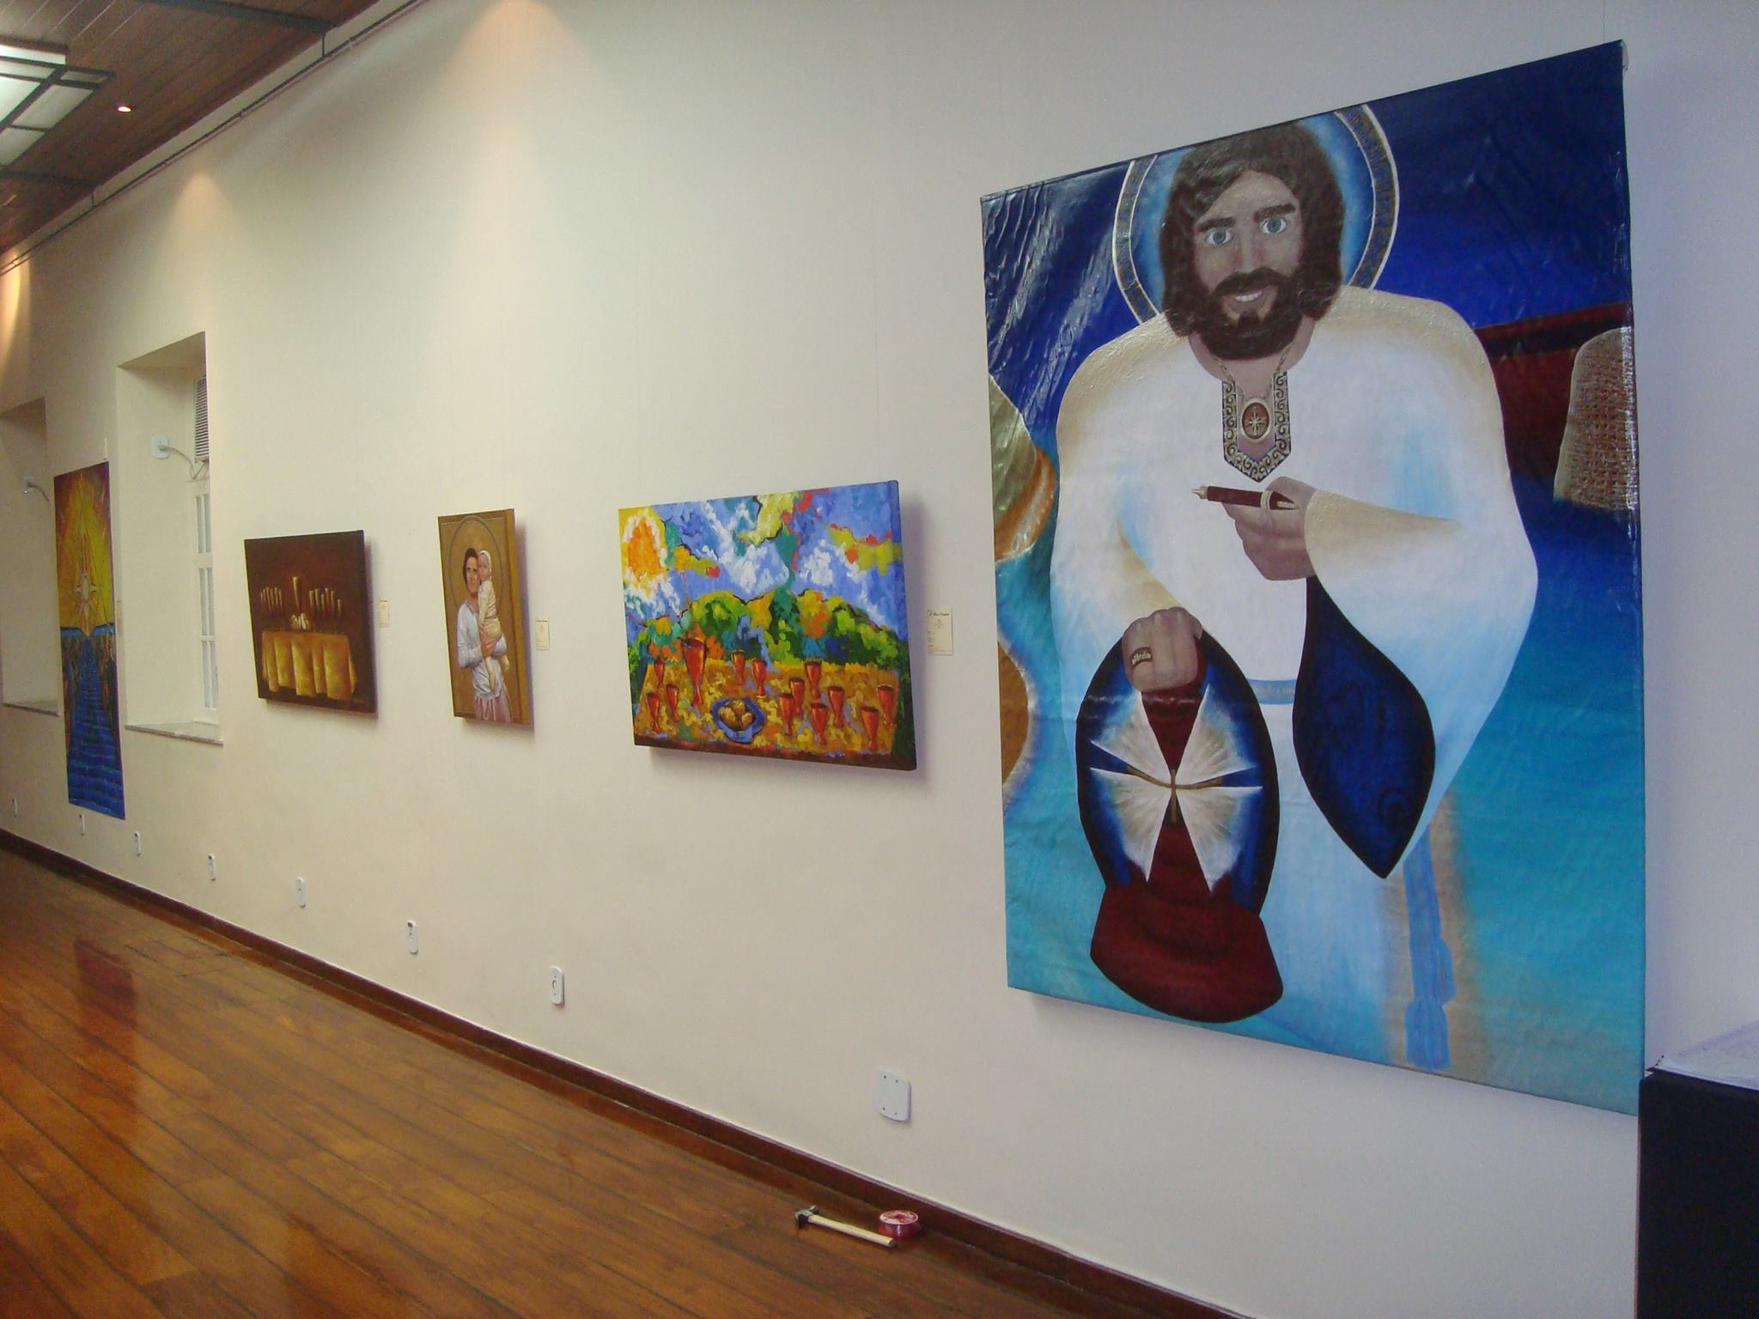
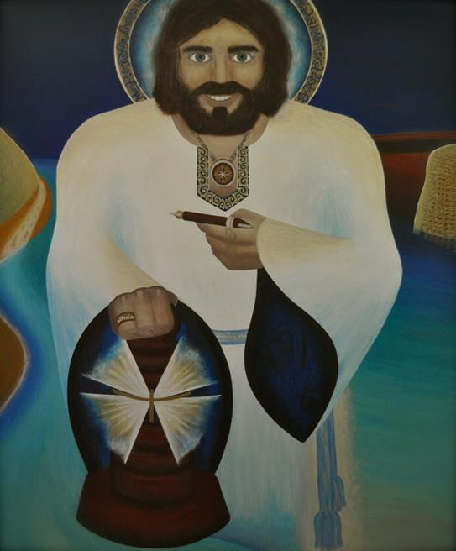
Just to give you a glimpse of my artistical progressing before and after painting a contemplative Jesus Charity, I will show you now some of my artistical works along the years.
Here you can see paintings I did in my teenage years
This one was my first painting as student of the Escuela de Artes Plasticas in San Juan. I was too advanced to be in the youth classes, I was allowed to attend the adult painting classes that were given on Saturdays. I was simply not allowed to do paintings with naked models due to my age, that was all.
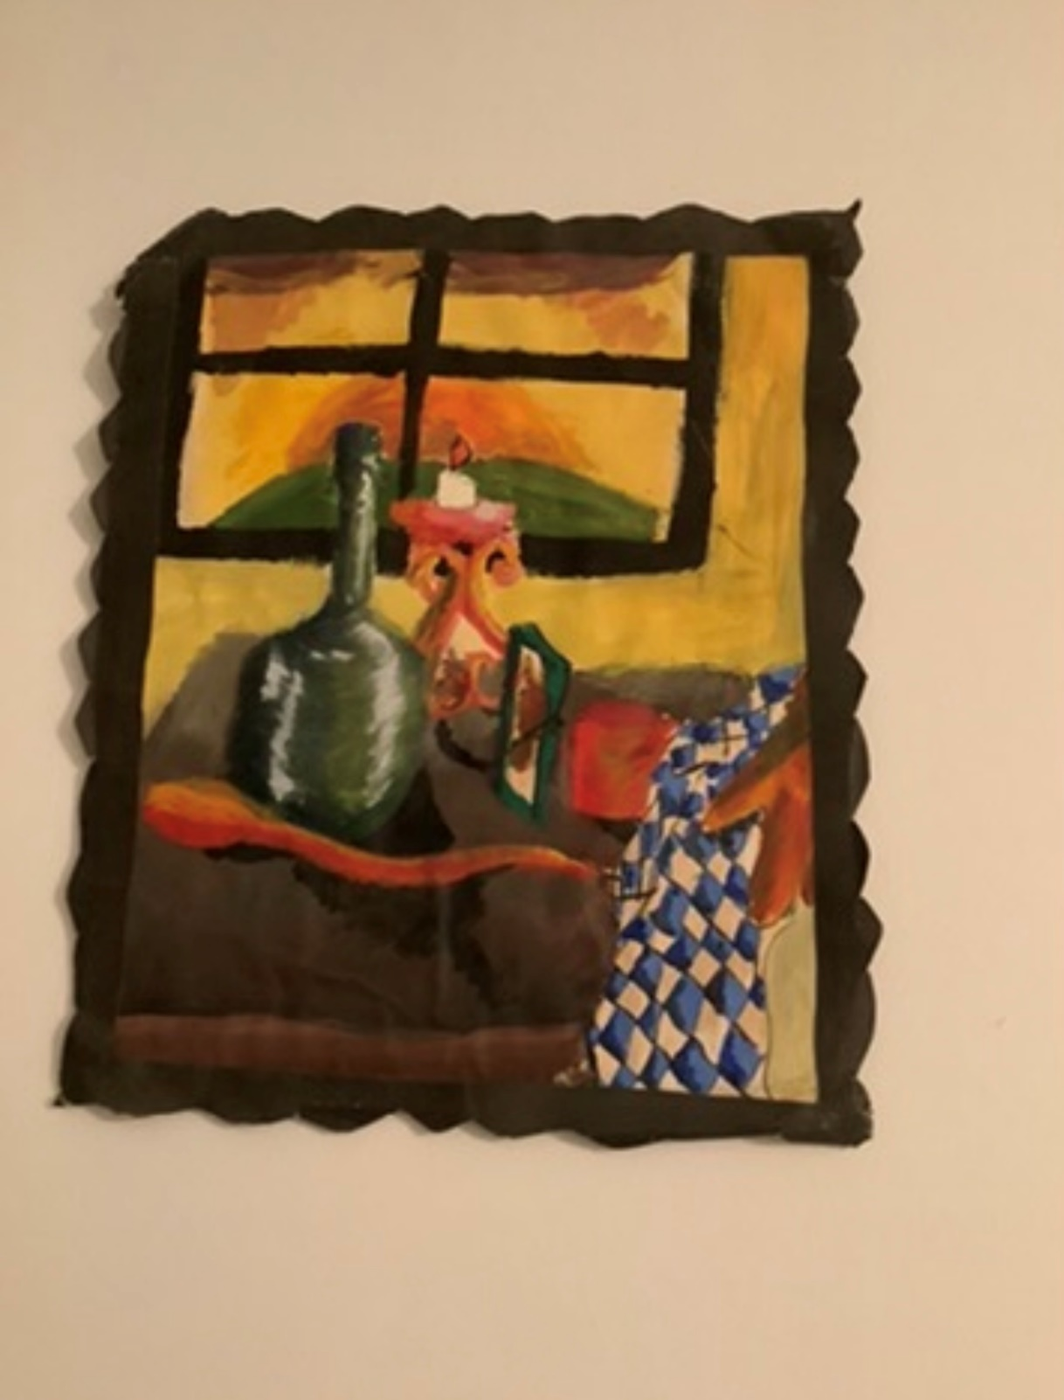

This next painting was also a very early artistical development painting, probable around age 12-13, when my school classmate friends called me “Damy”:
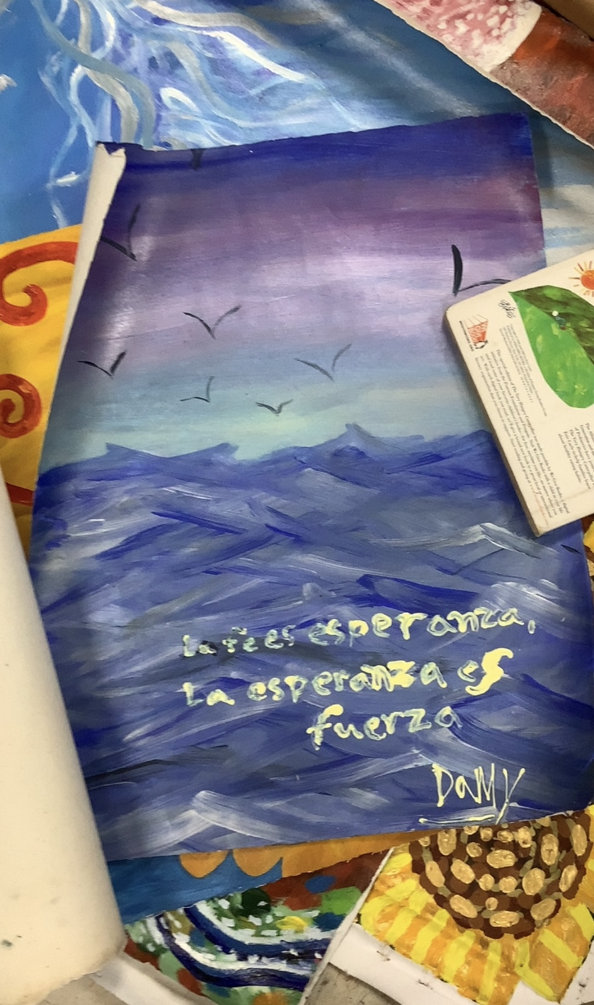
All these paintings were made in my teenage years, either as student of the Escuela de Artes Plasticas of San Juan or as a student of la Liga de Arte of San Juan:
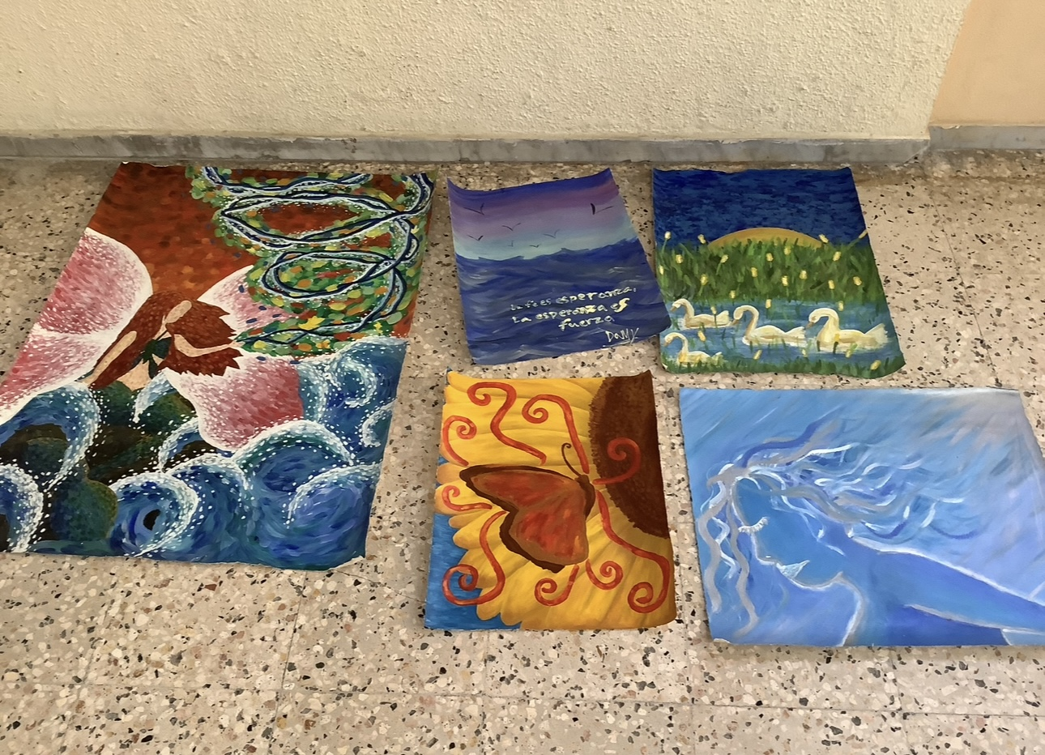
This next painting was painted around the same time I painted the mermaid painting (it's called “Idam Lapislazuli”, it was a character I was writing a novel about, but I didn’t finish it. I reached about 60 pages before realizing that writing is not only inspiration; you need techniques, too). It follows a painting style that later in my life I would call “semillismo” (in English: seedism, paintint with seeds, because the brush stokes are similar to seeds, living charity seeds). The painting is the Trinity as I saw them: as family in Heaven (in the painting they are together, painted in blue):
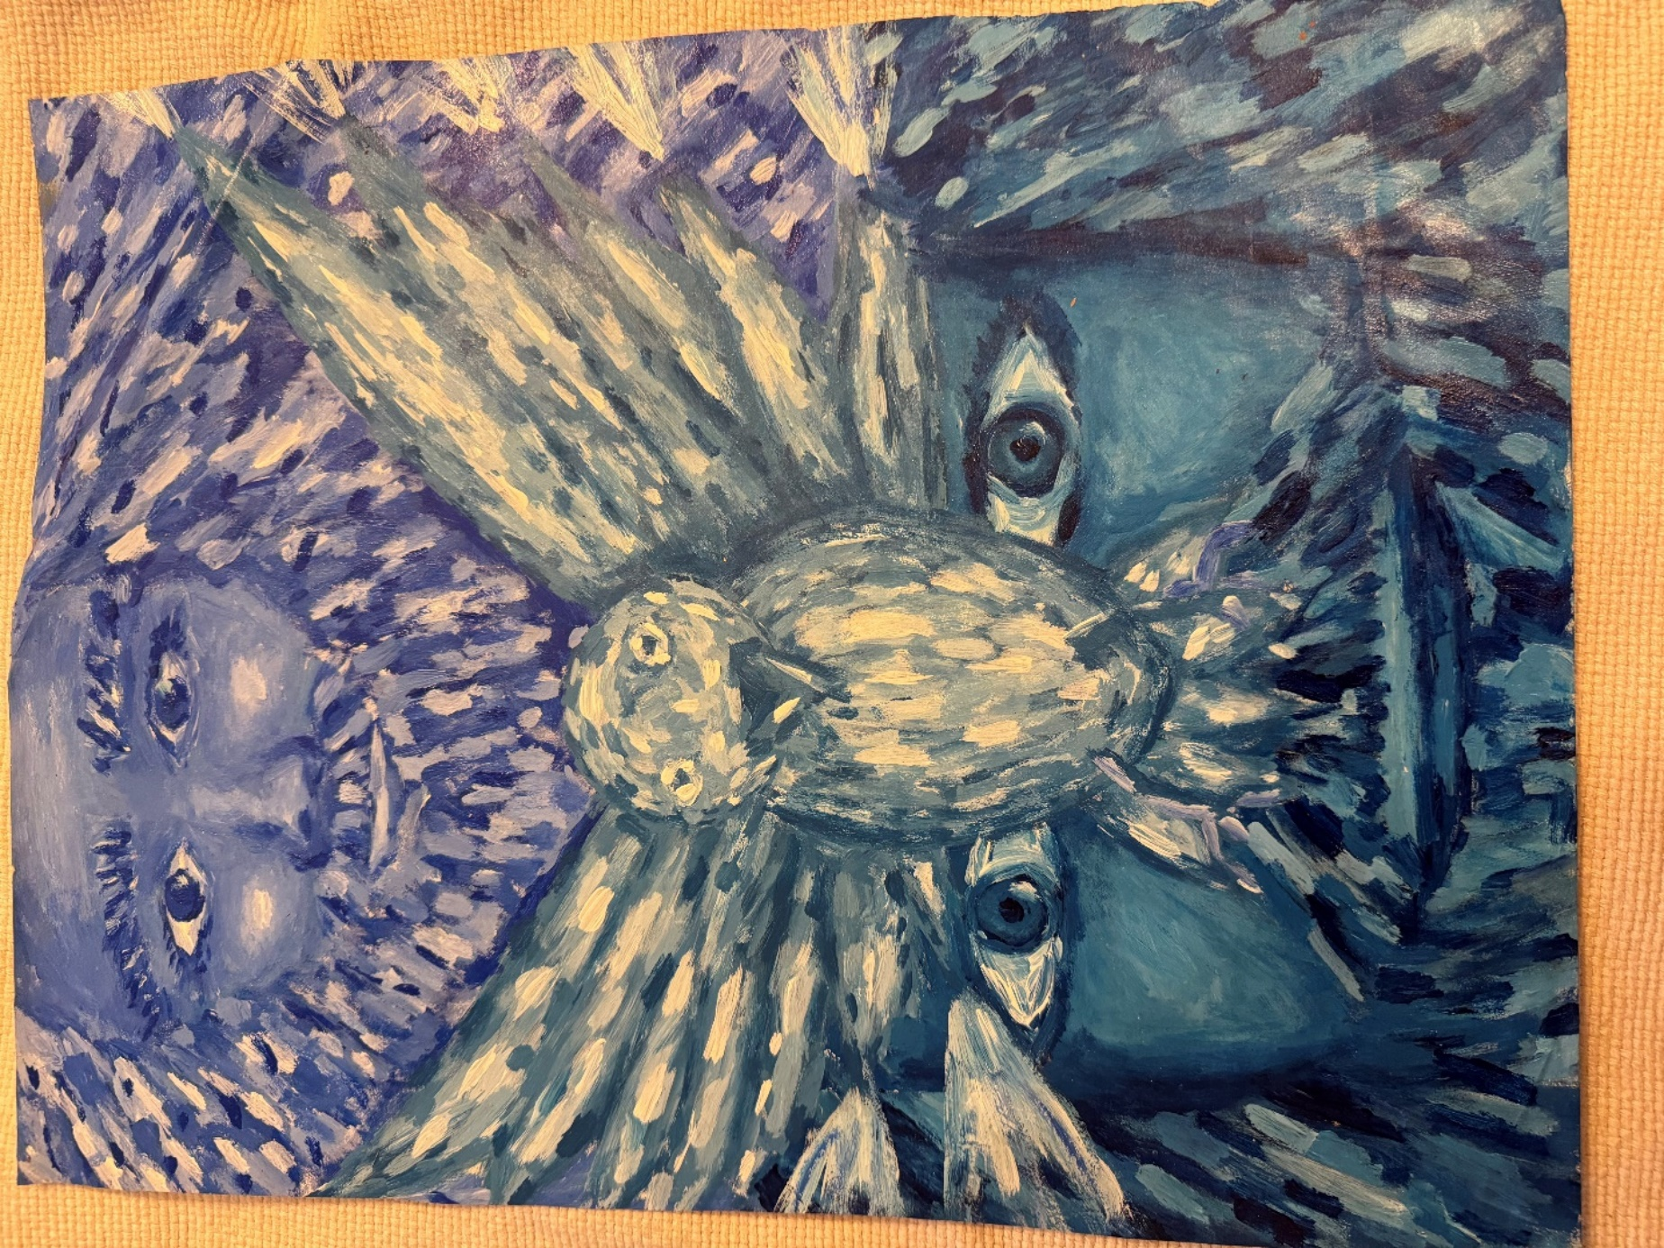

Here, you can see a self-portrait made around the age of middle school (12-14 years). It has very big, observant, and curious eyes, and I still was discovering the world (the globe doesn´t have continents) and learning how to write with my own words and voice (the vase has no pencils yet, not pens; it is supposed to be a pencil-case vase, a glass where you put pencils and pens, quite normal in the classroom teacher desk in our school settings). The spirals would later mean in my life, “growing together in communion, walking in communion direction, but that meaning was not developed or contemplated at all at that moment; I painted them then simply because I loved spirals). I painted myself in my school uniform (I loved to learn), and very bright colors were used: my life was seen as bright, and I felt very alive at that moment.
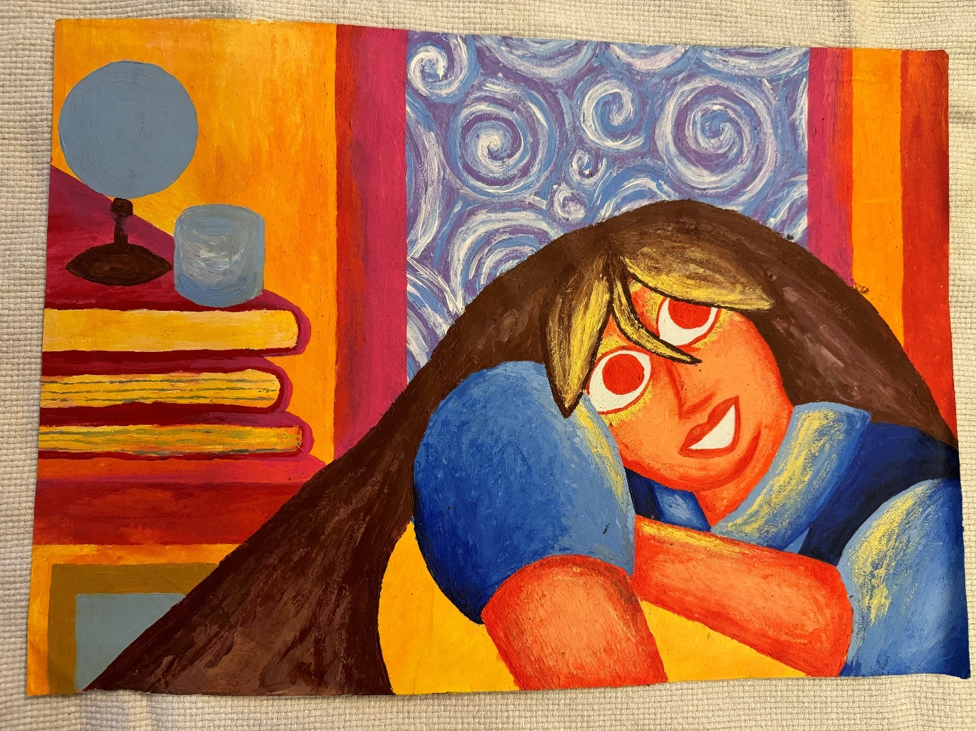

At this other self-portrait you can see me as I saw myself in grades eleventh and twelfth (16-17 years), through all the events I endured in the school in those two years, changing from group one to group two and clearly having authority-defying issues, besides having to be operated due “chronic sinusitis”. I always had serious allergies and headaches issue while in middle and high school, severe enough that my otorhinolaryngologist chose to operate on me as soon as it could be possible because I was using way too much medication to control them, and despite all the medications, I still had them, no matter how much they tried to control them with prescriptions, besides also using off the counter meds (I remember my otorhinolaryngologist being quite concerned about the number of medications I used for nasal allergies to be able to feel better, she didn´t want me to use so many meds, not even off-the-counter meds). Around age 13, it was already clear I needed to be operated because medication was clearly not having enough effects, no matter how much it was tried in varied ways, but the doctor had to wait until the end of the biological development of my nose to operate me, so I wouldn´t need another operation later… I was operated on at the beginning of grade 11. The otorhinolaryngologist didn´t want to wait longer, and after the operation —it was ambulatory, but I remained out of school for around a whole week; I had never been so much time absent in school since having chicken pox in primary school— I had a huge “secondary effect reaction” due to the general anesthesia it was used, or so they thought; I endured about eight hours of chest pain and not being able to breathe properly until I was finally taken to emergency room services. It was the first time in my life that I faced the possibility of dying (the second one would happen later, at the terrorist attack). My heart was way too fast, and I was breathing way too fast at home, too, and I had severe chest pain, too… but I was at peace through the pain and lack of breath because Jesus and Mikhael were with me. At the emergency room everything was taken very lightly, as if I invented it all. Eventually, I did need another nose operation around age 22. You can see in the painting that Jesus was embracing me tenderly —I already had a personal relation with Him, and I understood my faith as a personal relation with Him from a very early age, thanks to my guardian angel. The part of living faith merely obeying norms and instructions only happened in Opus Dei, way later than this— and he was literally my heaven and my whole future horizon at that moment (his eyes are blue). I painted myself in my school jacket (I felt cold) and with blonde hair (I only had blonde hair at grade 12):
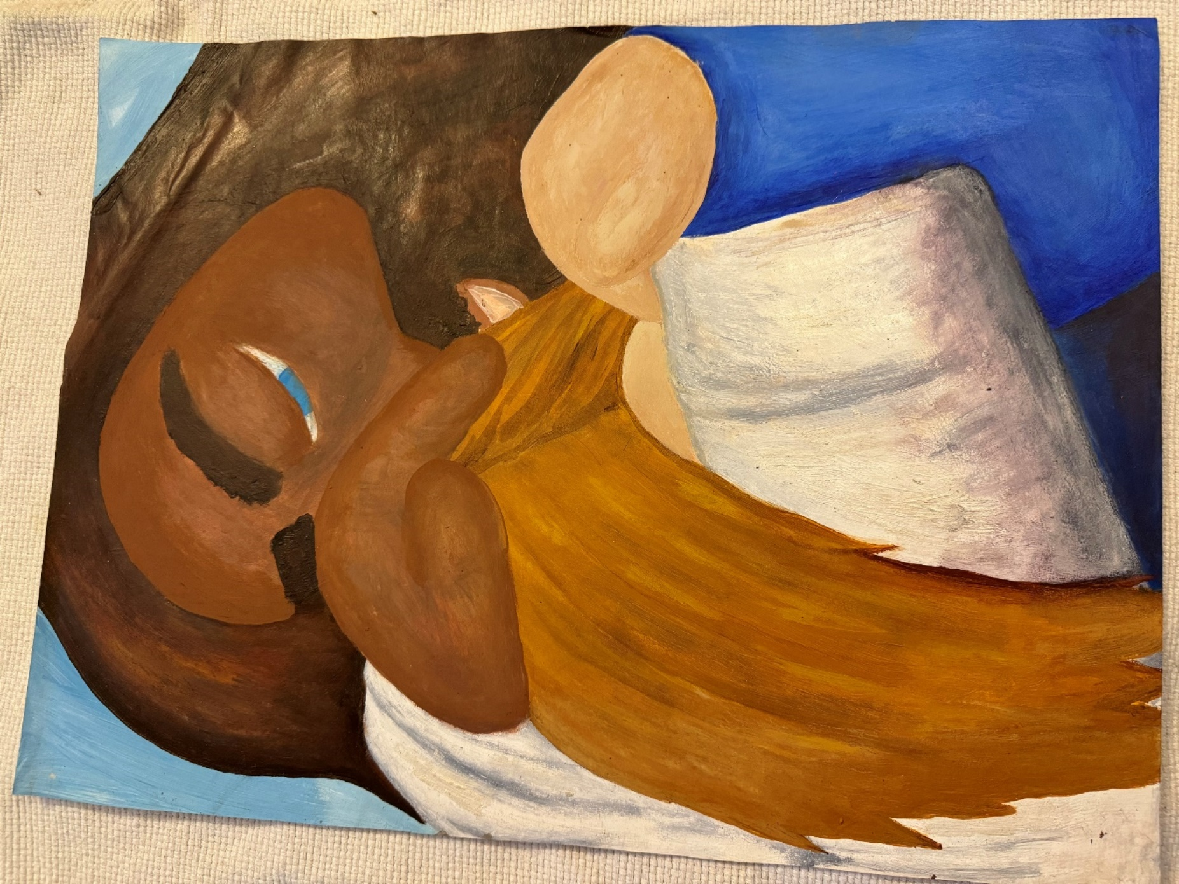

Here you can see is another painting painted before a Jesus Charity being contemplated, still in my teenage years: it was a sunflower. They were my favorite flowers way prior they began to have the contemplative meaning that they would signify later (sunflowers are living charity seeds that grow together in communion, following the Sun —Jesus Charity is a Morning Star— that is born above). I rarely used purple in my paintings, but I used it here. Purple would later get the meaning of being a princess of Heaven (a new heavenly royal bloodline). The interior of the house is darker: the brighter colors are in the sunflower itself, in the table where the sunflower is placed, and in the window that shows heaven (color blue):
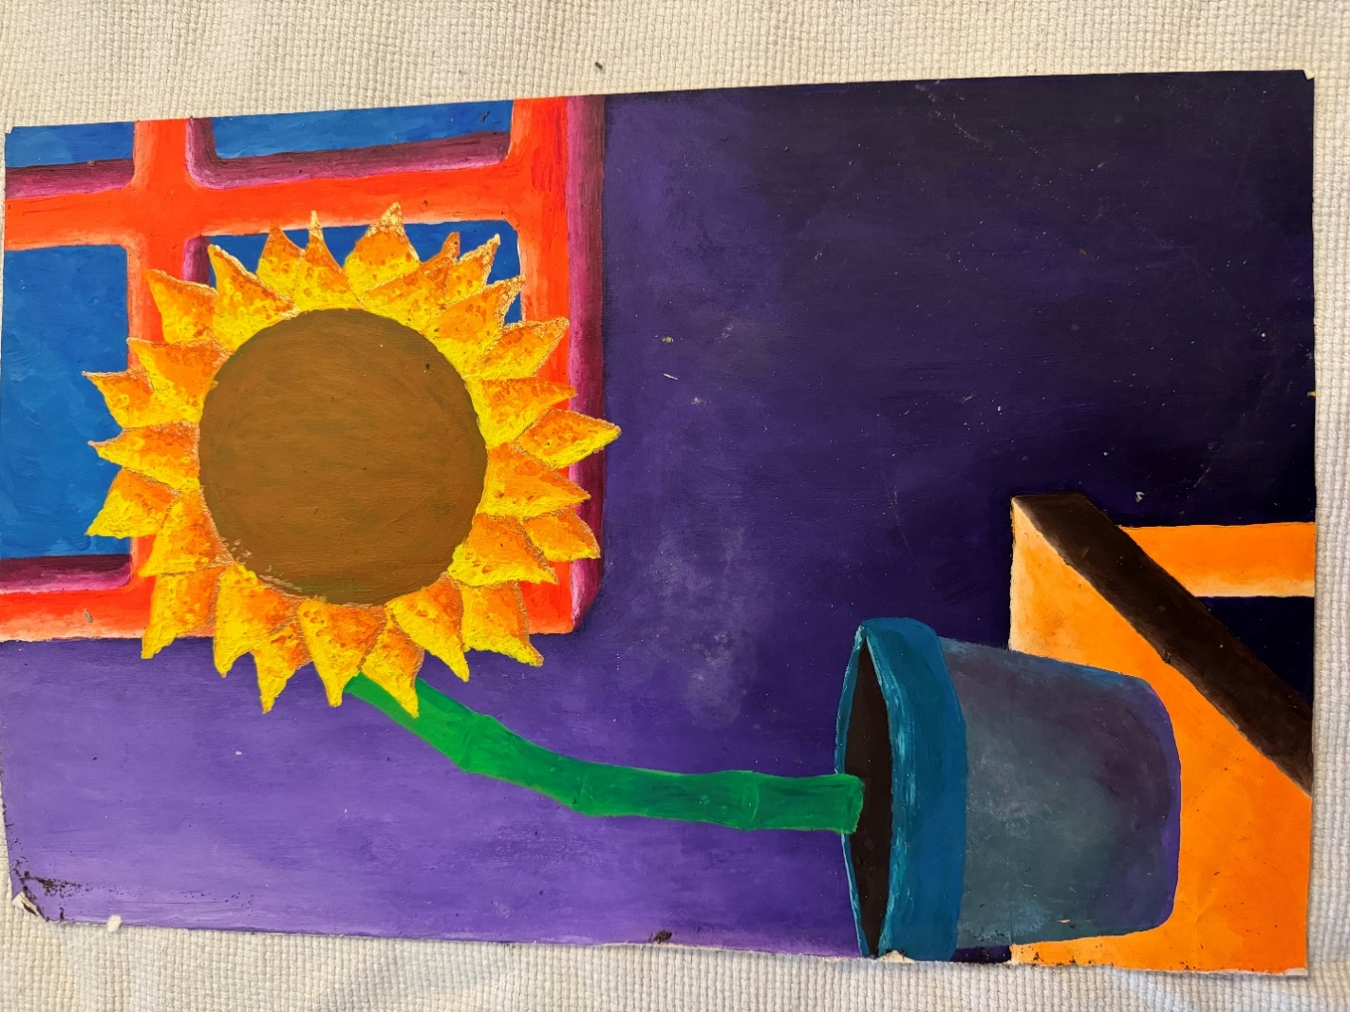

Here, you can see the painting I did just before Iesu Amor. It's another self-portrait. It was painted in Spain as a student at the University of Navarra. I painted it in the only apartment I was able to live in during all that time (the rest of the time, I lived either in rented bedrooms or in a student residence, in which I was able to live for a very brief time). That is why is so big: I had the space to paint a big painting at that moment. You must understand very clearly the context to understand the painting. The painting shows a puppet dancing, but notice that the puppet doesn´t get tangled with the threads at all: it is beautifully dancing with the Holy Spirit (seen in the fluidity of the fabric with which she is dancing) in such a way that no matter how others try to direct her movements as a puppet, she simply keeps dancing with the Holy Spirit. That is how I felt in the process of leaving Opus Dei and also as a student at the University of Navarra: I was tried to be forced to limit myself to be moved by institutional norms and instructions, like a puppet moved by threads, but well, in reality, I was dancing my own dance with the Holy Spirit as the princess of Heaven —not the infidel — I was according to how He knew me. As I explain in another part of this text, I would later know that the same situation that happened with Opus Dei —being “unfilially profiled”— really began way before, with my progenitors trying to enforce me since I was born a parallel reality that was not my own personal reality but their version of who I should be and who I should become. This painting is quite prophetic, as prophetic as the Desideratum poem written for my High School graduation. The blue-silver spiral means “growing together in communion” (with the Holy Spirit):
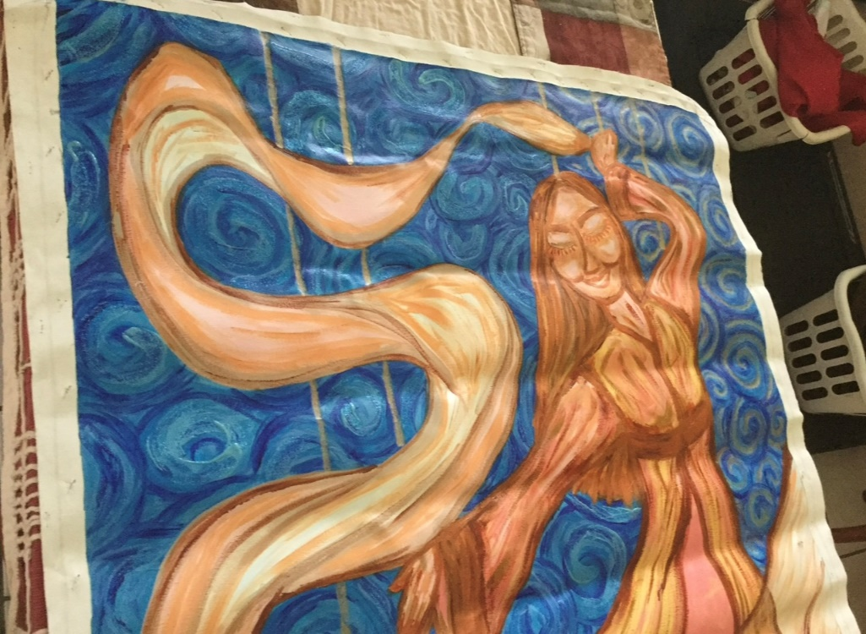
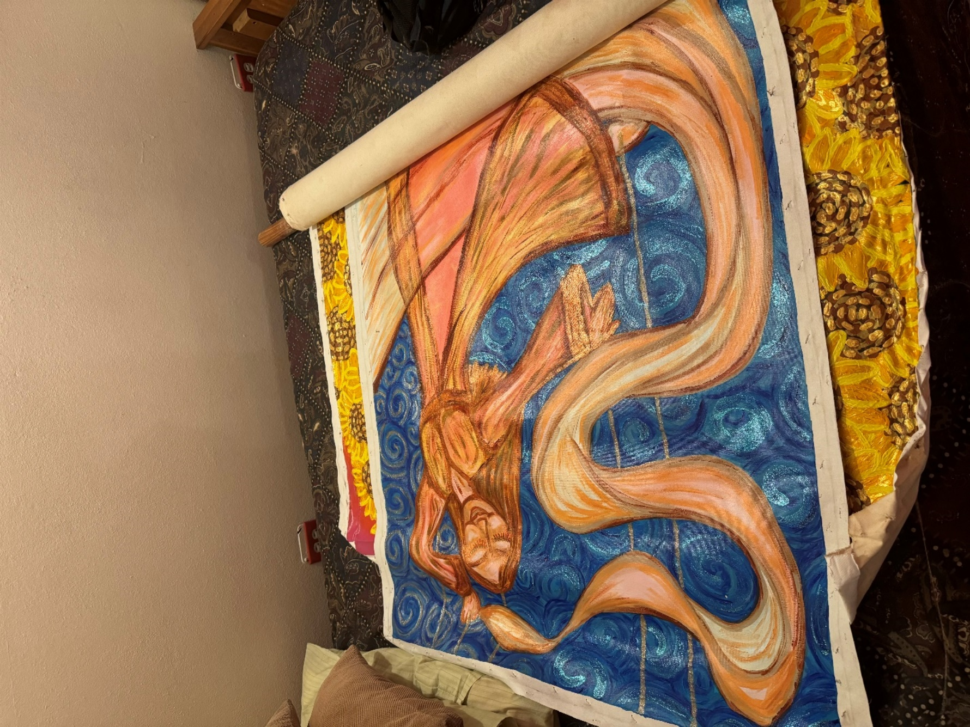
Now, let´s share some artistical works that were completed after a Jesus Charity was contemplated and painted.
The next painting you will see here is Fiat Amor. Explained in very few words, this painting plasmates the whole United States as 52 states consecrated to live charity; consecrated to make possible that everyone can grow as the best person she or he can be, as an equal brother and sister, walking together in brotherly Love; that would be a transformation of the American Dream, as I explain in the conclusion of this text. There are 52 states, one per state (including Puerto Rico and Washinton DC as states and equal citizens; the discrimination against Puerto Ricans in the island due colonialism is huge, we can´t vote for the president and don’t have equal education and health services funding, we have to receive every maritime cargo shipping through the port of Jacksonville (Florida) despite being an island that obviously would need to receive most of their cargo shipping through the sea, and that is directly caused by cabotage laws that literally doubles the cost of life in Puerto Rico despite being the poorest territory in the nation… among other consequences of the systematic inequality that colonialism implies in Puerto Rico). Of course, the butterfly, that means freedom, is in the sunflower that represents Puerto Rico; the whole painting plasmates the whole United States leaving all inequalities behind, including those of the slaving stage of the United States history and the colonizing era of the whole American continent; it plasmates the whole United States growing together in communion.
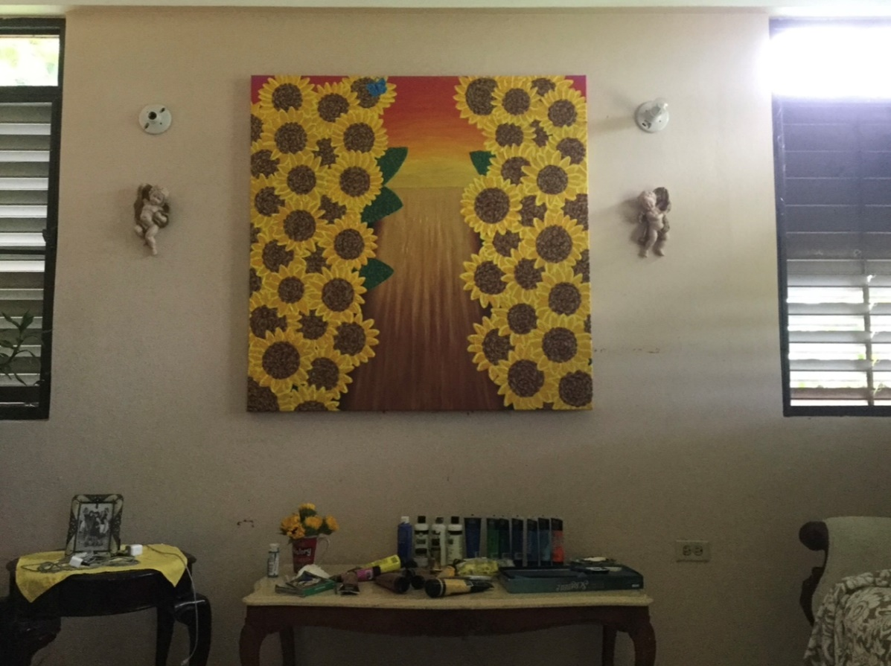
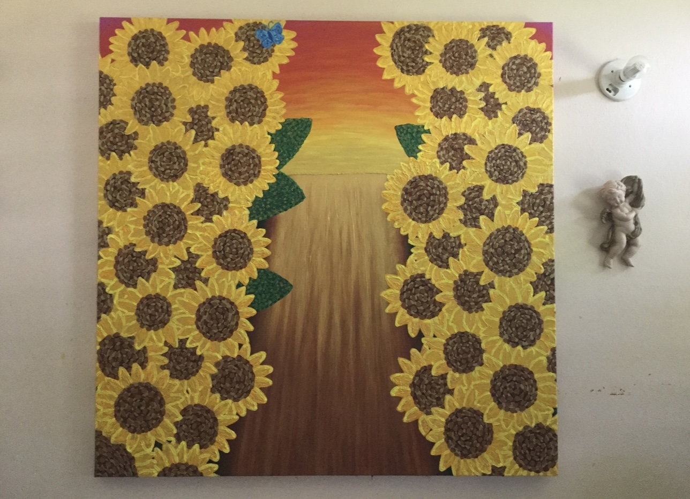
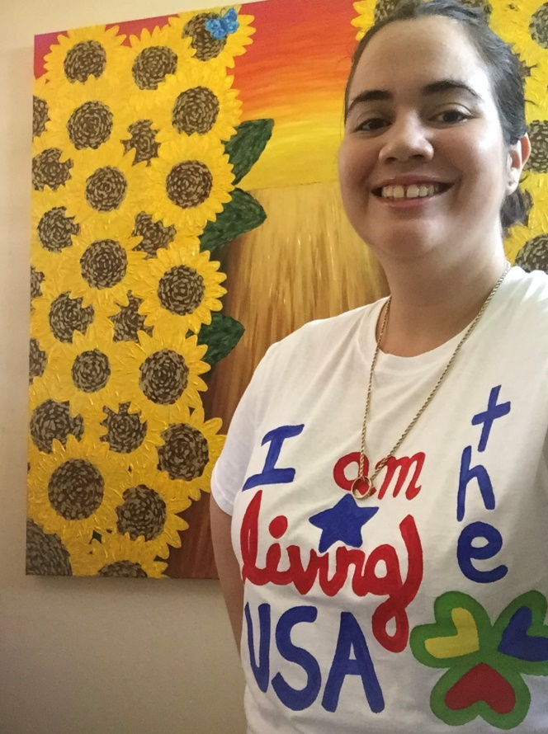
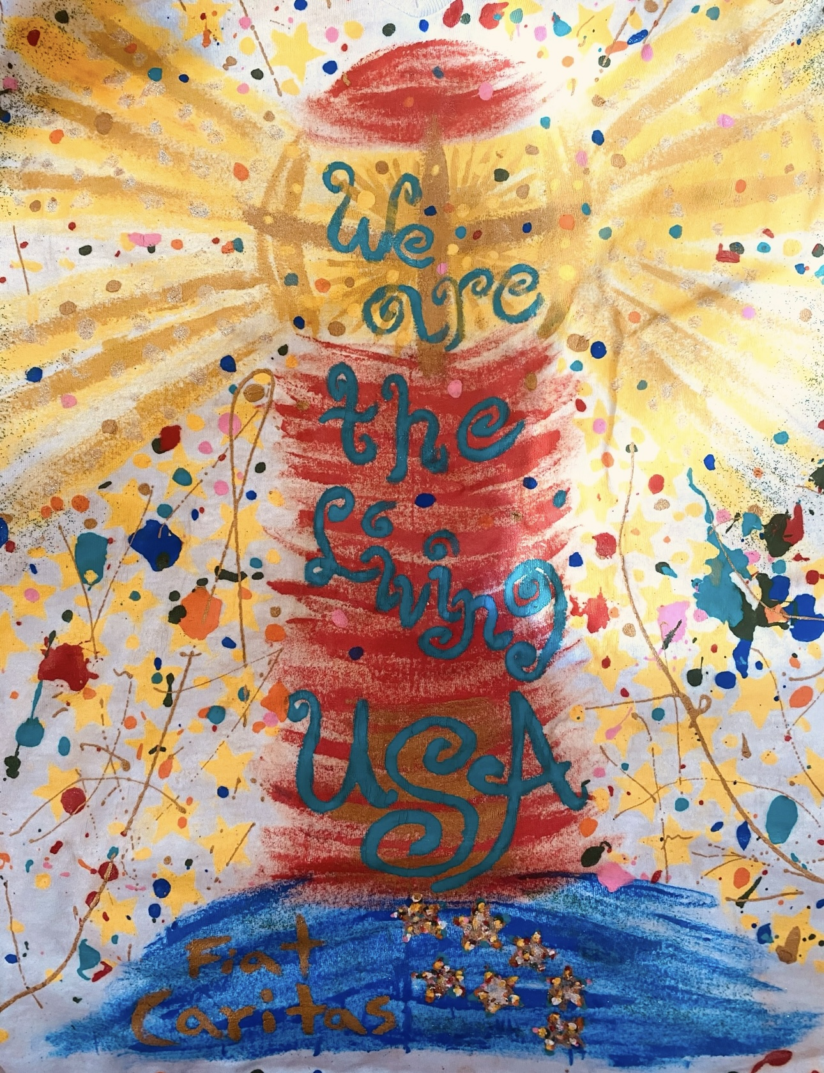
In the picture above you can see my conception of my nationality: we are the living USA as we keep radiating the light we are called to radiate, creating communion as we create home and create society that helps to be, helps to do, helps to grow and helps to glow (the four rays of the beacon) growing together in communion as a beacon of living communion. This was a painting in a t-shirt, with 52 stars, and clearly also plasmated the United States consecrated to Jesus Charity: fiat caritas, let there be done in us according to Your charity, leaving al violence, dignity violations and all inequalities behind.
In the following picture you can see how I conceive my Puerto Rican cultural identity: as a people of the new albor (we should even have a New Albor Fest to celebrate this), celebrating our natural multiculturalism as a beautiful expression of charity: we are all called to shine a unique like to help our nation to become the nation of Love is meant to be, like Jesus Charity and this text does with the United States, calling us all to be a nation of light, consecrated to live charity as jibaros luz.

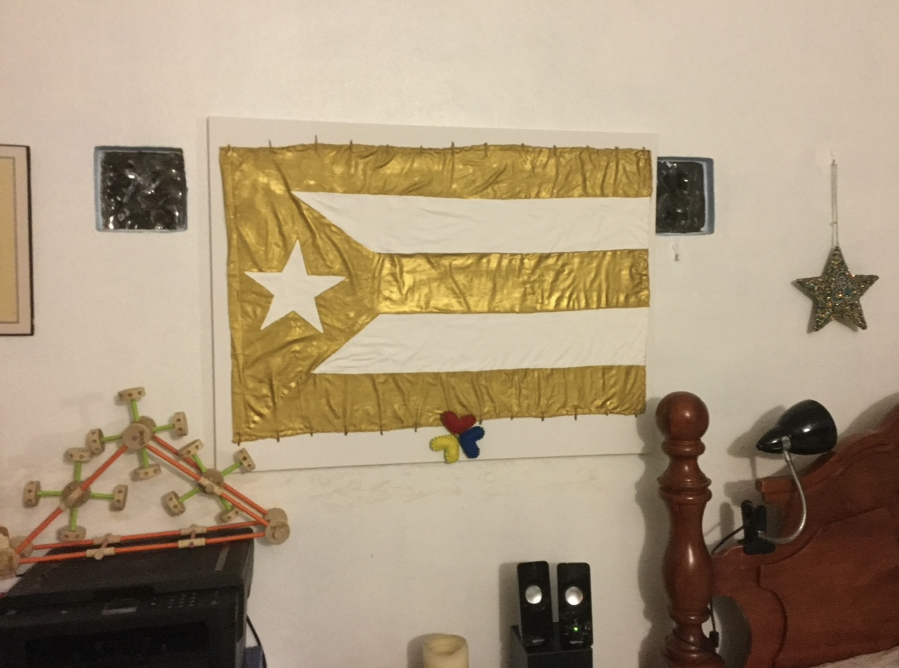

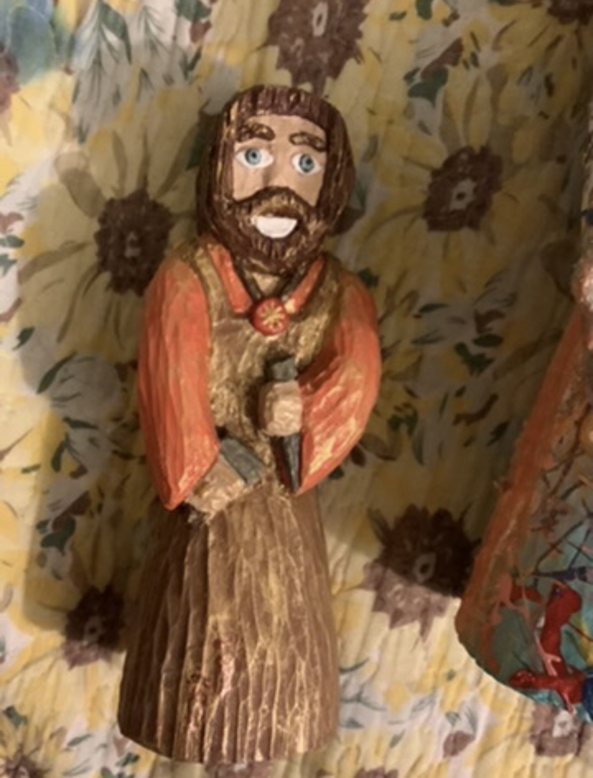

In the picture above you see a Saint Joseph of New Albor. I lost the Saint Joseph carving I did while studying wood carving as a teenager, so I needed a carving of a Saint Joseph to keep going through the process of conceiving a Jesus Charity. I lost the carving in the package I sent to Los Angeles, I included the carving in the package I gave to the Hollywood Star I used as “anatomical model” of Iesu Amor. So, I began to contemplate a Saint Joseph of New Albor and I carved it in wood; the picture above is the photo of that carving. The orange color means flaming Holy Spirit, and in the back part of the carving the mandatum novum is written, as written in the painting of Jesus Charity.
In the next two pictures you can see two different wood carvings of a Jesus Charity, almost the same iconography of the painting, but now it was done in carving. The most important meaningful difference between the carvings and the painting —besides the evident way to plasmate transconsecration: in the painting transconsecration is beginning to happen in the gold color of the tunic; in the carving, the transconsecration can already be explicitly seen in the color splashes in the tunics of both carvings— can be found in the eyes: the eyes of the carvings have very clear creating home sparks in the eyes.
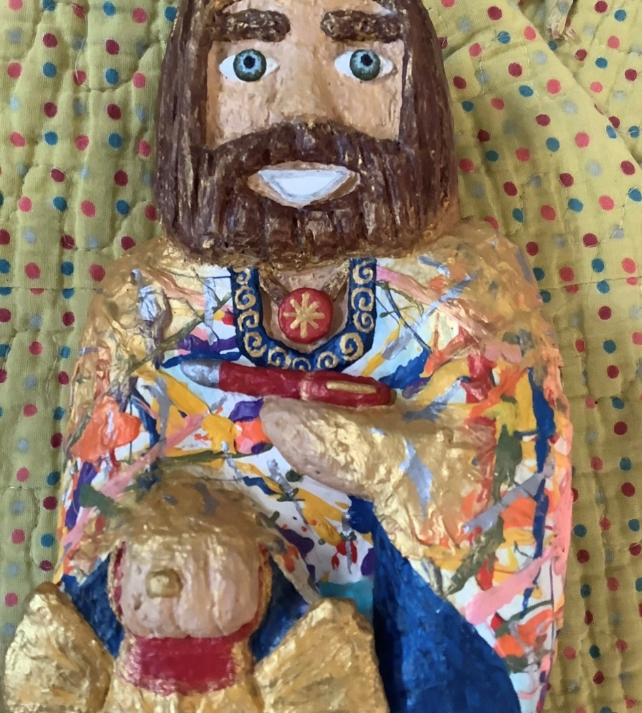

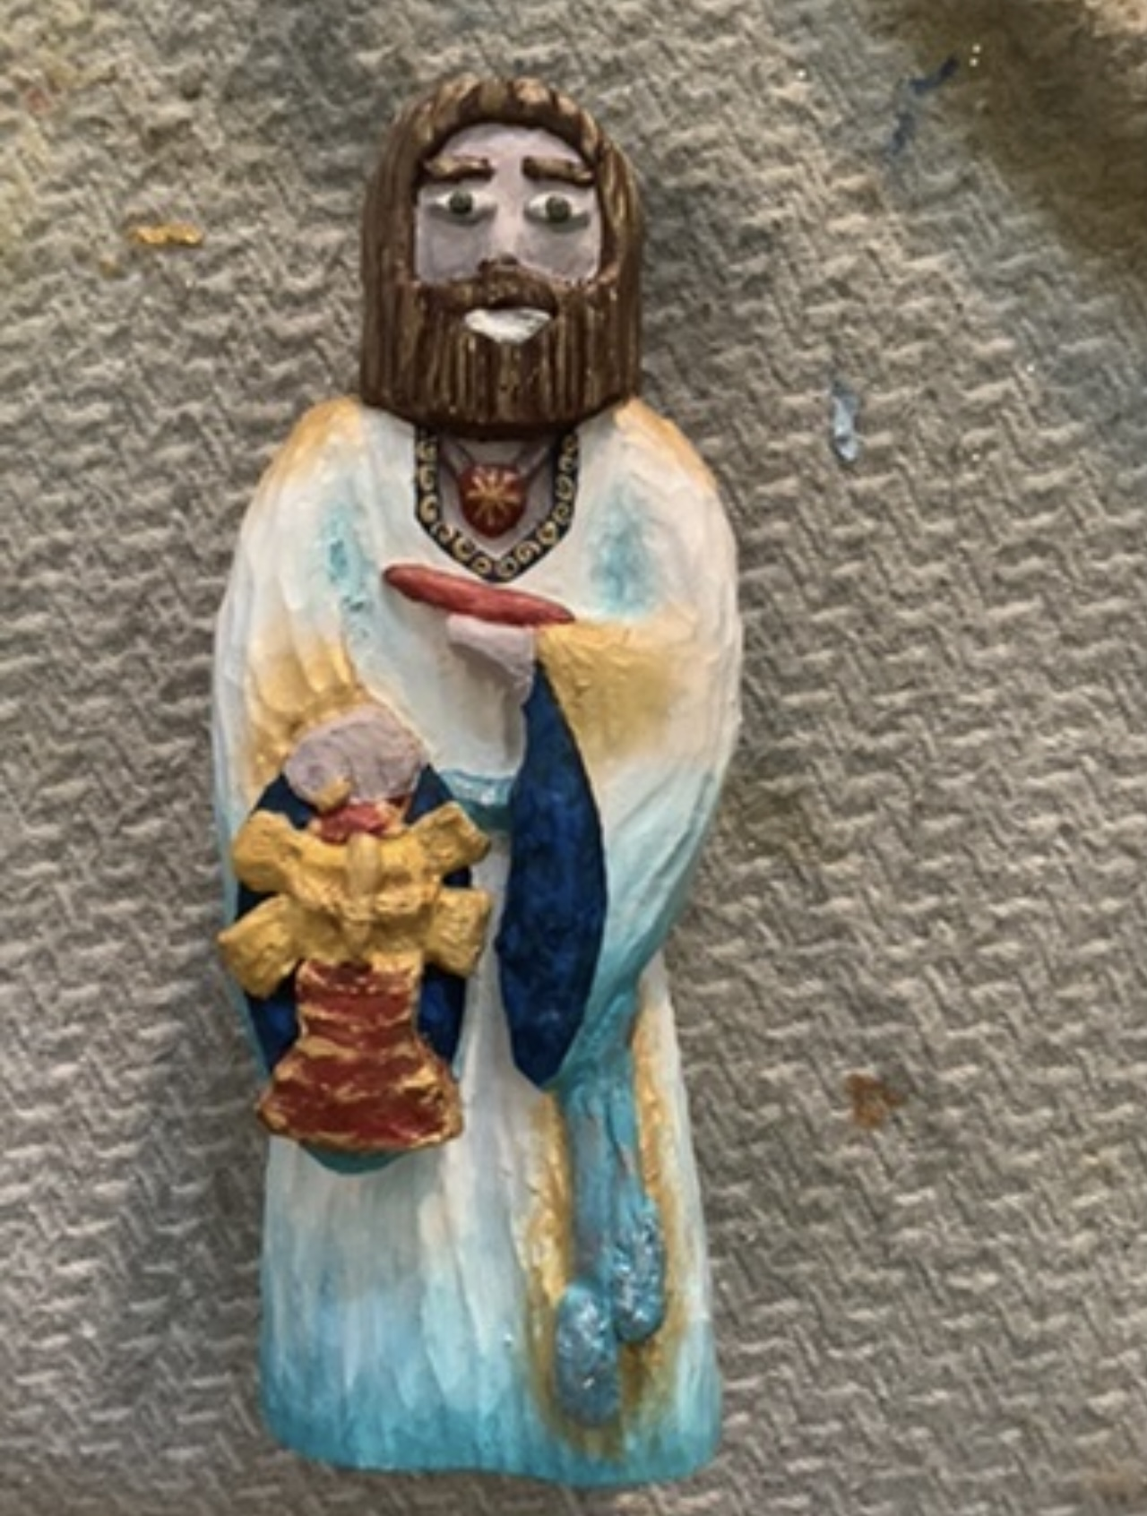
The painting that you will see next is a mosaic, a huge 7 feet tall and wide mosaic, and it is called Fiat Caritas. Once again, said in a few words, this time the whole world and the whole Church are being plasmated as consecrated to live charity. The living church is both the boat (like in Iesu Amor iconography) and in the woman dancing with Jesus, the two being the same silhouette, painted with living charity color (gold). That painting is still pending to be completed.
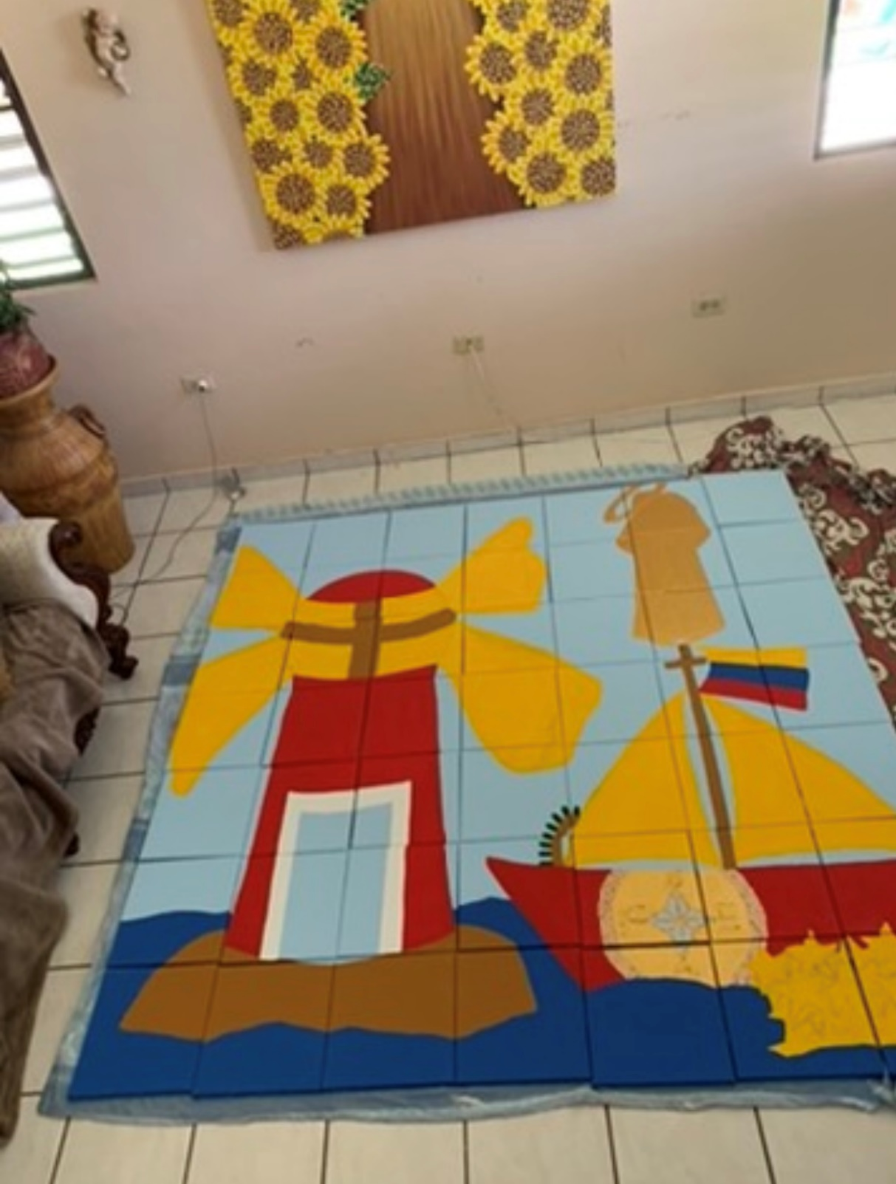
This next artistical work of Love is titled “Fiat Unitas”. It conceives being a family as I have learned it from contemplative prayer: as a domestic Church that incarnates His consecration of charity plasmating in the whole personal formation the living Eucharist we are called to be as growthful family ministry, incarnating together a family evangelization project according to the Word, forming our whole personal formation as a living icon of God Love as we keep learning to grow and form ourselves as living Eucharist, walking together like He walked, incarnating Lk 8, 21: “My mother and my brothers are those who hear the word of God [being] and act on it [action… and so, unity of being and action is essential to create home according to the Gospel]”.
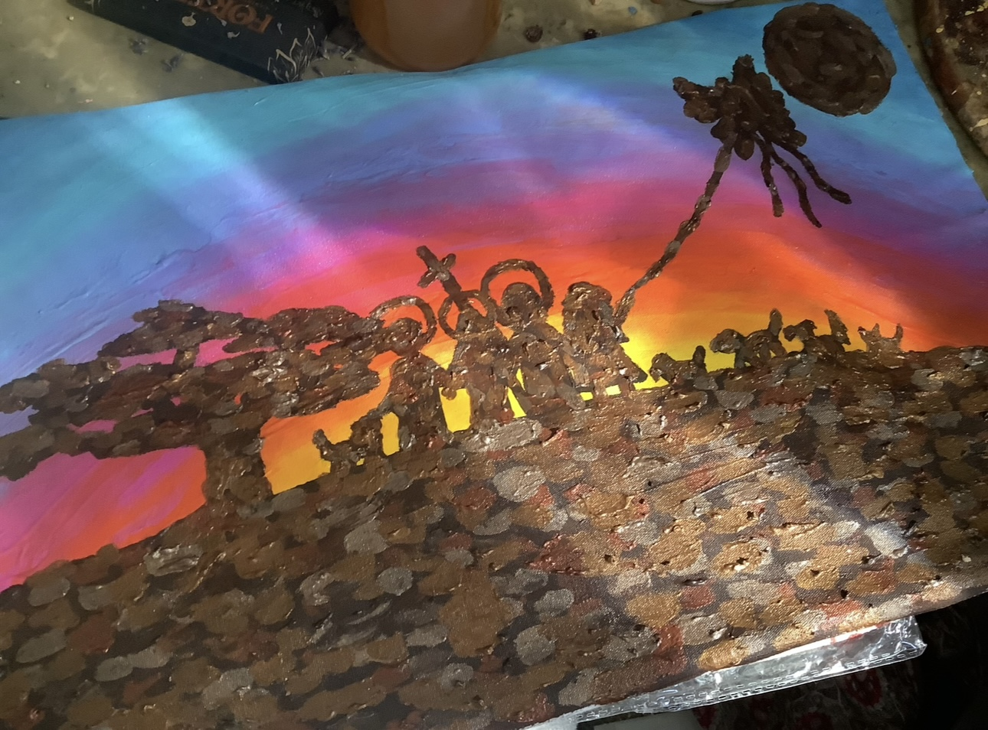

The next artistical work I a sculpture I created of Our Lady of New Albor: it is a pregnant our lady (like Our Lady of Guadalupe), dressed in flaming Holy Spirit dress (orange) with the stars of the whole United States (they are 52 stars) but she is placed in an altar with a star per each country in the World (the amount of countries in the United Nations). It is better understood in its proper context: with Fiat Amor as “horizon” above the sculpture. This sculpture plasmates the Virgin Mary as living Eucharist, how she, when she wants to shares His trinitarian communion, she literally incarnates it as living Eucharist with the consecration of charity (it should have a charity alliance if she would have a place to put it), so she is the one that makes possible with the transconsecration of the heart that Jesus can be formed as living Eucharist too (I explain this better further on, in the ontological nature of the human personal dimension, and also at the ecclesial personal formation nature part of this text). In the ribbon in the chest, color hope and new life, the mandatum novum is plasmated. The color of the altar tablecloth is both mercy color and creating home color and faith color (blue, merging the tones of creating home and mercy color, according to Iesu Amor iconography). Of course, this is also how you should contemplate the living Church, constantly “giving light” to God Love incarnated as Living Eucharist.

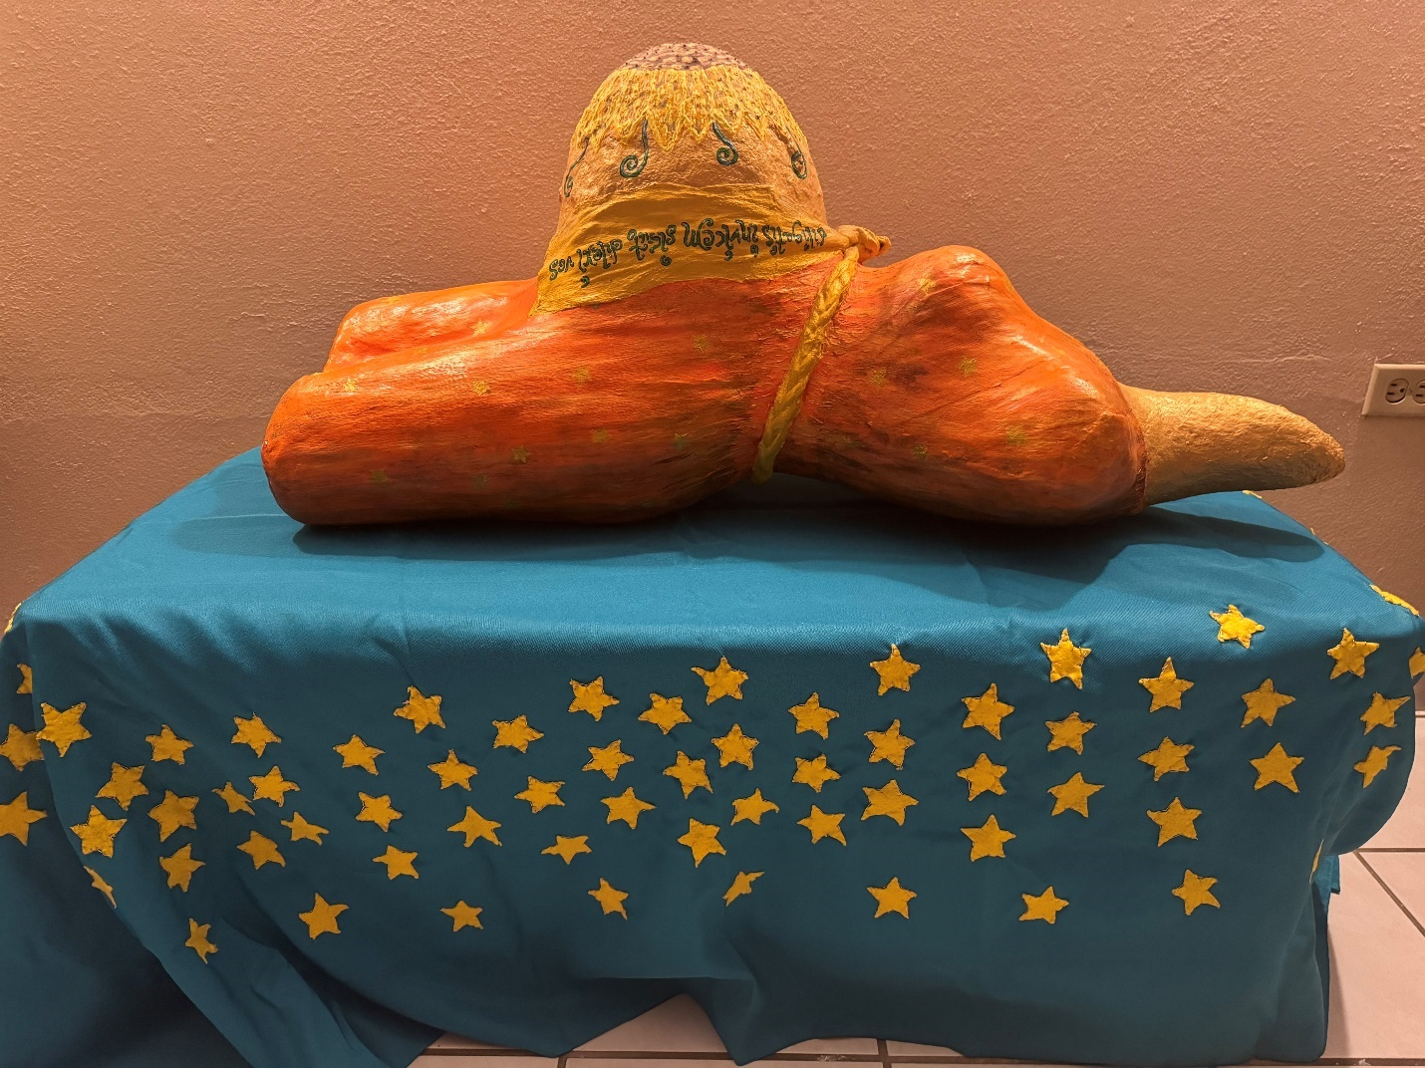
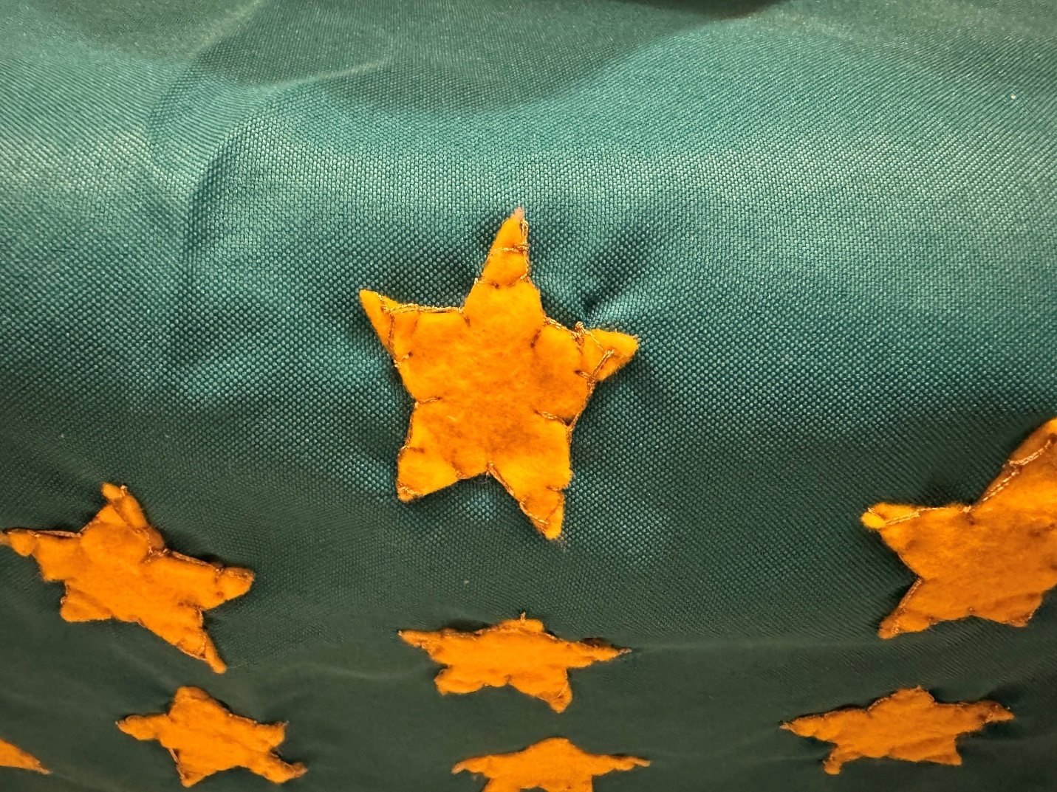

The last artistical work that I am going to share here is titled Fiat Pax: where are all “broken clay pots” healed by the power of the charity alliance of the Holy Spirit (color gold) and the “Sí-dar” (self-giving) of Jesus Charity that makes possible sacramentally that the Holy Spirit can act in such way that the clay pot is “healed” in a kintsugi style. The “clay pot” was sculpted with toilet paper that I used during a period of extreme severe allergy while I was living with my progenitors. I had to use huge amounts of toilet paper (is softer, so your nose skin is not “burned” with the paper) and so I transformed that into a Fiat Pax: as we let the Holy Spirit´s charity transform us into the living work of Love we are called to be, everything that must be healed is also healed by the Holy Spirit´s direct action, and that kind of healing —constant in its nature: the Holy Spirit is constantly transforming and healing the Church as living body that can keep growing thanks to that constant action— can be manifest in quite powerful and mysterious ways sometimes, as it has happened with me with the help of my family of Heaven: I had been told several times I shouldn´t have able to survive what I have survived, but here we are, adoring Jesus Charity with our whole growth. That is the true source of the peace that comes from Jesus Charity: the peace that makes possible that everyone can grow as an equal and dignified brother and sister, walking together as we are constantly healed and plenified by the charity of the Holy Spirit´s action.
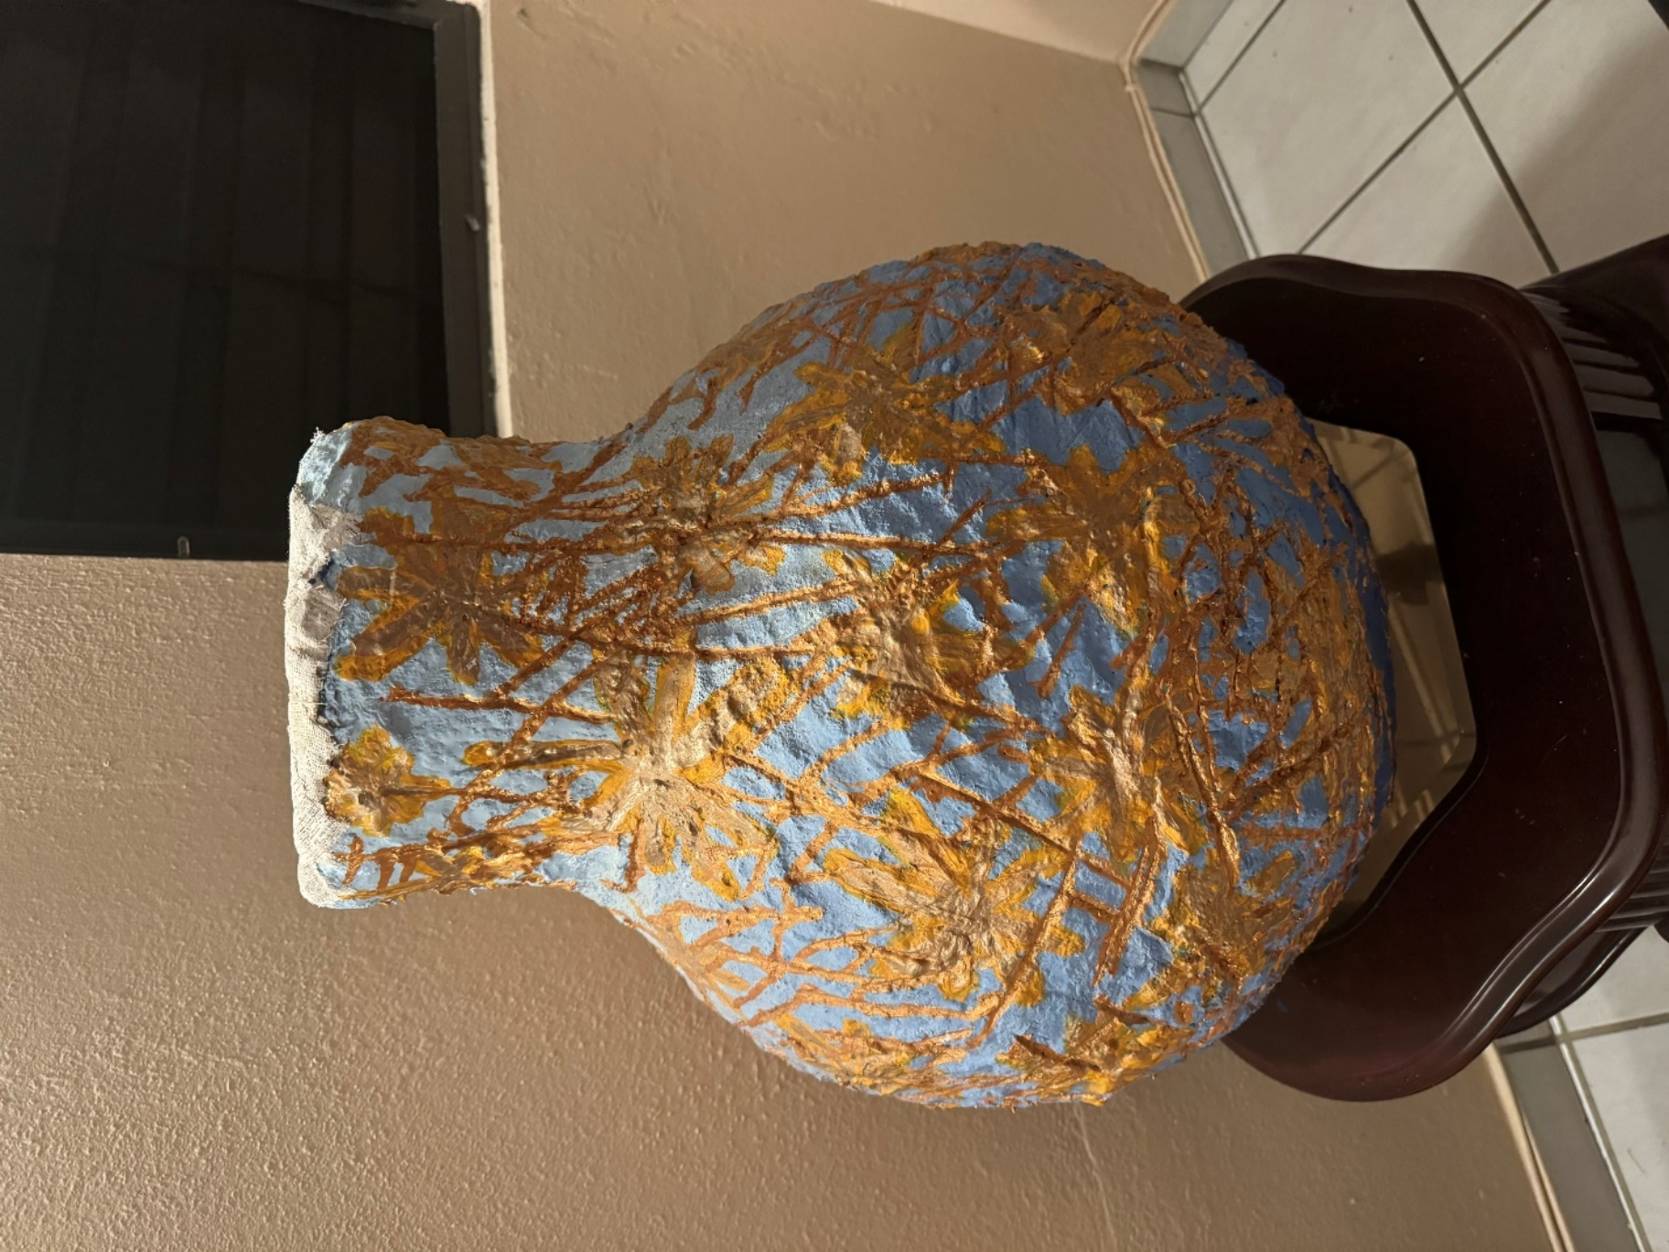
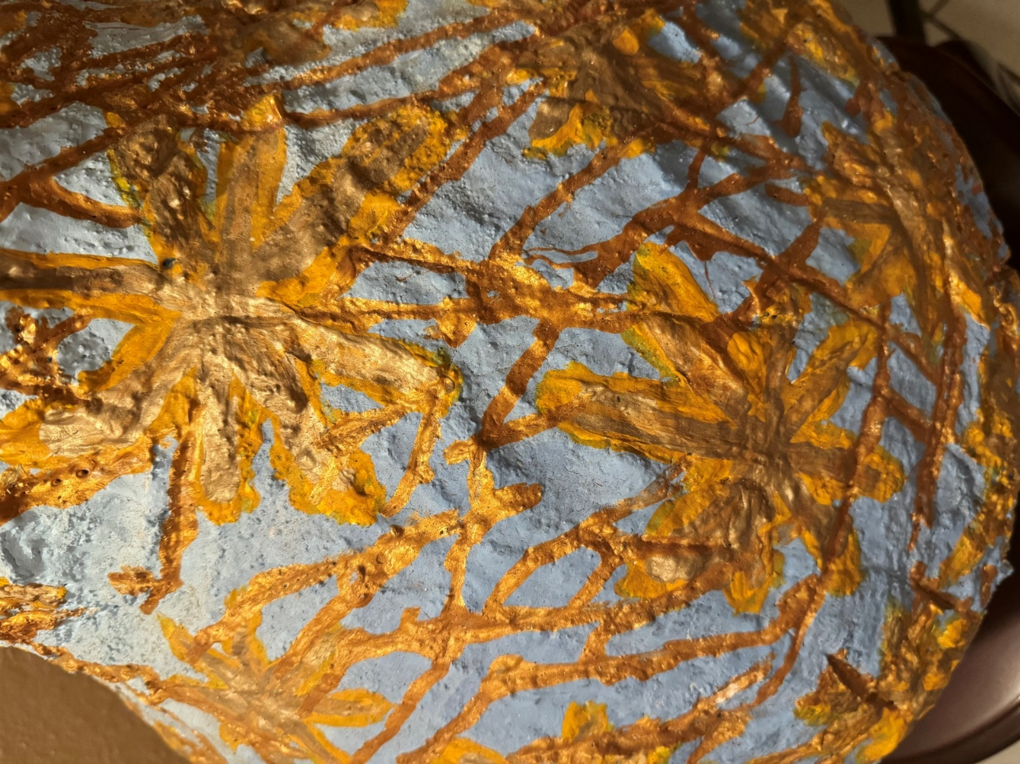

Any artist would understand the need for creative freedom to be able to function as a person. It was clear: I would not be able to function as I am here either, but not due to the lack of reasonable accommodation in the first place, but due to lack of creative freedom. All the leftist ideological issues I mentioned in the above paragraphs — before explaining the paintings— are another gruesome case of leftist academic and even artistic cultural dictatorship. I knew how to be an intellectual artist well before being at the Universidad Central of Bayamon; I simply wanted to be able to integrate arts and theology according to truth, something that would have been completely impossible at the University of Navarra: they had no artistic content at all, no creativity —all that was expected from students was following the given instructions and norms —, no painting classes, no student artists expositions, no socio-artistic style defined... But at the very end, In the Faculty of Theology of the Bayamon Central University, ideology counted way more than my talent —both artistical and intellectual-creative talent—. In that Theology Faculty, it was simply not convenient to have ideologically inconvenient people around, and I was highly ideologically inconvenient there, so they simply created a funding issue to cause my leave from the faculty. I even had to pay a debt in cash afterward, besides having to pay for my Adderall prescription out-of-pocket also at the same time. I know this is going to sound sarcastic, but this was real and not sarcastic at all: all that I just explained happened in a university that belongs precisely to the Order of Preachers, but it had a Dean of Theology who didn´t allow women to learn how to preach in his class of Preaching.
You may understand this very clearly now: the most revolutionary thing you can do to change the world —besides what I explain of Mother Theresa at the conclusion of this text— is choosing to stay loyal to the truth. I don´t have any tolerance for ideologies, whichever they are. Marxist, the ideology of gender, rightist or leftist ideologies, political ideologies… I have intellectual tolerance to no ideology at all, I have always tried to remain the most loyal possible to truth. I am so intolerant of ideologies that I have always been able to dismantle them with a few clicks of my hands, like I am doing in this text with the ideology of gender. I don´t have the space to dismantle Marxism, Communism, and Socialism now, but many have done it more brilliantly than I would, especially Saint John Paul II, with who I passionately and openly share —along Pope Benedict XVI— the extreme intolerance to ideologies and to whoever way is used to impose them to vulnerable people who don’t know the intellectual concepts or doesn´t have the social notions to defend themselves from the ideologization or to even know they are being ideologized, as intellectual predators do. Predators prey on innocent children the same way intellectual predators prey on innocent, still-intellectually-vulnerable thinkers who are unable to identify by themselves that an ideology is being imposed on them either via academic dictatorship or via cultural dictatorship. Not on my watch, people, not on my watch. Leave kids alone, leave people to learn to think on their own, and teach your class, without ideology of gender content.
In very few words: the ideology of gender and all ideologies does great deliberate harm to science, to academia, to medicine, and to people in many, many ways. Many other things can be said about the ideology of gender as academic and cultural dictatorship, like the highly illegitimate, immoral, and unethical move of some public school systems in the United States of denying parents their legally, moral, and legitimately earned civil parental authority to know if a child in their custody is being socially transitioned at school, but I repeat myself: all this has a lot of repercussions that —because I respect my reader´s capability of reasoning and thinking on their own— I will let the reader assume and establish on their own.
Finally, after everything that has been explained related to the importance of the synchrony between sex, sexuality, and gender and about the ideology of gender, why it is naturally wrong, why it breaks the human personal formation nature, and the extent of the damage that it can do to the human personal formation, also sharing a few personal experiences about how that ideology has caused a lot of harm through my personal narrative and how I am overcoming that ideology with this text… now I am going to give you a final example of integractive biology as I explain integractively the very basic Organic Biology concept of death.
Organically speaking, death is the stopping of vital signs and brain activity of the organic body. However, there is also a socio-filial sense of that concept, called decease: the social relations with that person cease because he or she is deceased. You may be surprised to know that because our ontological being is eternal, it doesn´t technically die, even if you deliberately try to destroy it. You can´t; no one can destroy their own ontological being, it passes on —what happens with the ontological being is a passing, not a death nor a decease— and then becomes on Earth a memorial: who you once were as incarnated body remains as a human being on Earth, remembered by those who loved you and knew you in life, your being is alive to them even if they remember you when you are presently dead. So, the equal concept of death and being deceased, in the ontological sense, is simply being forgotten; you are not a memorial anymore, and no one remembers you. That is why there is a beautiful traditional rule of making tombs, so whoever is there can be remembered for the years to come. As I will explain later, the Mass as an incarnated eternal memorial of the Love of Jesus to His living Church —His living body— has a beautiful way of keeping Jesus' Personal Nature alive in us since his ascension to these times, told in Lk 22,19: “do this in memory of me.” That means: ontologically, He is still living in us, His Living Church, His living body, as a living Eucharist.
This concludes my exposition of how an Integractive Biology would revolutionize how the integraction —very particularly, the nature of the human personal formation— is studied and developed in the years to come. As you can see, this is a totally new approach to biological sciences that is very necessary in our time, and its conception has all the potential to become an exceptional scientific share to humanity. Now we follow to the next part of this text: the exposition of the ontological dimension of personal formation nature.

The Ontological Dimension of the Nature of the Human Personal Formation

Ontological personal formation natural growth is called maturation. This growth is ruled by knowledge (in the sacramental sense, by grace) via reasoning, ordered to plenitude (meaningfully be who you are), and created by Love: by ontological communion with a Creator who gives you the eternal being. The ontological being has the seven properties, which are also known in Metaphysics as the transcendentals, written by Saint Thomas Aquinas in the Middle Ages, except beauty (pulchrum), which was written by Hans Urs Von Balthasar a few hundred years later. Those seven properties of the being, applied to the human being, can be stated as follows:
- Ens Property: every human entity is a being.
- Res property: every human entity is a thing.
- Aliquid Property: every human entity is something.
- Unum Property: every human entity is a unity.
- Verum Property: every human entity is true.
- Bonum Property: every human entity is good.
- Pulchrum Property: every human entity is beautiful.
The being of the human personal formation grows as a maturing infusion: we are all infused. There is no “evolution” in time in the being because our human being is eternal and timeless; you can know a person's being even if he or she is currently dead if there is a memorial of that person in history. That is the most significant importance of the biblical phrase “Do this in memory of me”, that I already mentioned a few paragraphs ago, in the previous part of this text: Jesus was, if you want to tell this very deep mystery in very simple words, eternally actualizing for His Church, plasmating Eucharist as the main sacramental action of the Church as being-living-body-women. Ontologically speaking, the male is the co-creator of the act, and the woman is the co-creator of being… and Jesus Charity, the fullness of both human and divine personal formation, eternally actualized the living Church as a living body, that is a she, that is, the Bride of the Holy Spirit… He eternally actualized His living Church as living Eucharist: as the fullest fullness of our human personal formation being, we are living Eucharist.
If you are unable to believe this in the supernatural way, you may try to understand it in the natural way: for a human being to be infused and keep maturing as a being, there must be, necessarily, a Supernatural Divine Being that infuses it. Some people call it “Allah”. Other people call it “Budha”. Christians call it “Yahve” in the Old Testament and “Jesus Christ” in the New Testament. I call it “Jesus Charity”. No matter which names you choose for this, it is evident to the observation of anyone that we can´t create our eternal being on our own, that there is a being in our human personal formation that is transcendental, that necessarily comes from a Creator, and that is necessarily infused by a “Higher-Being-than-us.” If you want to use this as rational evidence of the existence of God, you can. This is usually fully understood through grace and the direct action of the Holy Spirit´s wisdom, but it can also be seen, at least in sparkly glimpses, through reasoning, as the introduction of Fides et Ratio, by Saint John Paul II, affirms:
Faith and reason are like two wings on which the human spirit rises to the contemplation of truth; and God has placed in the human heart a desire to know the truth—in a word, to know himself—so that, by knowing and loving God, men and women may also come to the fullness of truth about themselves.
Yes, our ontological nature is meant for the contemplation of truth, for the intellectual contemplation of being, and what is what our knowledge natural capability (our intellect) does: understanding being more and more meaningfully and progressively. This means that although being is eternal, progress and evolution are required to understand it, according to the social progress of the filial dimension and, of course, according to our very own neurological capability of knowing being, which evolves according to the biological nature of our biological mind (the brain), along with our filial conscience´s progress (conscience is our social mind: every human personal formation becomes conscious in relation to others, no one is able to have a conscience without a “social mirror” to be known and to become a conscious mind, and that is why the ontological mind, the intellect, develops directly proportionally to the social mind, not only according to the biological mind).
Understanding the ontological nature is not easy because it is a mystery that can only be revealed by the Creator who gave us our transcendental being. In the Christian sense, our ecclesial personal articulation —especially the ontological articulation due to being transcendental by nature— is intrinsically organic, sacramental, and charismatic at the same time: as we progress and evolve in the contemplation of truth, in the knowledge of being, we also keep becoming a living Church that is both a living charism, a concrete grace given by the Spirit to help to be, help to do, help to act, help to grow, help to glow and help to bloom… and a living Church that also is a living sacrament of God-Love-with-us, a living Eucharist that incarnates in this here and in this now a Jesus Charity-with-us, both as being as an act in unity (integr-action). That key of unity of being and act is fundamental in understanding the ontological being, but I can only explain this from a Christian perspective because my own ontology is sacramental and charismatic, and I can only give what I have known according to how I had been known by God-Love. So, what I am going to expose in the next paragraphs is both science and theology, following the scientific style of great Medieval thinkers like Saint Thomas Aquinas. There is no other way to explain the being than this one, at least for a Christian thinker. I will follow again the most important reasoning line used in the exposition of the biological nature, gender (also known as sex and sexuality), but this time, I will approach my womanhood as femineity from a sacramental-ontological perspective.
It is not the same way at all being a she-Church than being a he-Church. The living Church is meant to be a she-Church, even biblically, as a living Church that is the Bride of the Spirit, in the words of Rev 22,17: “The Spirit and the bride say, Come.” I, also as a woman, as co-creator of being, am called to consummate that intrinsic womanhood orientation of the Church with all my ontological being and with all my ecclesial personal formation, letting the Holy Spirit spouse me as He did with the Virgin Mary in Lk 1,35: “The Holy Spirit will come upon you, and the power of the Most High will overshadow you.” When we let the power of the Holy Spirit act in us, the incarnation of Jesus keeps happening organically, sacramentally, and charismatically; that is how I intellectually conceived a Jesus Charity as a living icon of God-Love-with-us. With this sense of “organic,” we don´t mean biologically, like what happened with the Virgin Mary: in the ecclesial personal formation case, the organic joints, how you articulate your life organically as a sacramental living Church, are the seven gifts of the Holy Spirit, and that is what allows an ontological nature that is at the same time organic, sacramental and charismatic, along the seven sacraments of the Church, that would be the ontological joints that articulate the life narrative as Christian. That means: the first grace-given organic articulation of the ecclesial personal formation are the seven gifts of the Holy Spirit, completely freely given by God-Love-with-us as an infusion of the Holy Spirit that charismatically incarnates in a very concrete human society and civilization. That infusion of the Holy Spirit is parallelly sustained by the seven sacraments, which would be the ontological joints of the ecclesial personal formation. We will explain this further later, as we are able to understand and contemplate this better.
For now, the following must be said: the same way Jesus incarnates the Eucharist and consecrates His living Body, the living Church, through transubstantiation, using words of Saint Tomas Aquinas, the living Church, a she-living ecclesial organic body, a woman, is called to consummate that Eucharistical consecration as the Virgin Mary did, as a consecration of the heart, as transconsecration the Living Heart of the Church into His Heart, becoming together His incarnated Heart-with-us, not only a Church that is a living body. In the biblical notion. The living Church, without transconsecration, would lack a heart. In the Biblical notion, the heart is the being of the person. I won't quote a theological reference as evidence of that, but you may ask any theologian what the heart is in the Old Testament, and they will tell you for sure: in the Old Testament the heart is the being of the person. It’s a very well-known biblical notion. Well, guess who literally incarnated the heart of Jesus as living Eucharist in the first place? The Virgin Mary, simply due the infusion of the Holy Spirit that was specifically given to her, according to her immaculate nature, to be able to incarnate Jesus as both God and Man. This means: ontologically speaking, the first consecrator of the Eucharist as a sacrament incarnated personally —as an incarnated personal formation, that, in the case of Jesus, is both fully human and fully divine— as a living heart that beats, knows, and feels was the Virgin Mary —the person begins to be formed as he or she is with the formation of the heart, and not understand that biologically, but ontologically, but in the case of the Virgin Mary, she literally was who formed in all the senses possible Jesus´s heart—, so Jesus would be able to do it later too with his disciples at the Last Supper, when He consecrated the Eucharist as a sacrament incarnated constitutively —as an ecclesial constitution: the Church as constitution begins to exists with the Eucharist and the breath of the Holy Spirit— in the Living Church as an organic body, according to what the Virgin Mary did with him since the very moment of His incarnation in her by the action of the Holy Spirit. What the Son is —living Eucharist— the Virgin Mary —first living Church, first living Tabernacle— is also, and that has constant transformative and reformative consequences (we are talking about the process of transformation, that belongs to the Holy Spirit: help to glow… and also about the process of transformation, that belongs to the Trinity: help to glow) in the ecclesial formation as it keeps evolving, maturing and progressing as Living Church, and so we keep reforming as living Church in more faithfulness to the incarnation of the Word. Please notice the following: the action of the Church as she-co-creator-of-being is the Holy Spirit´s action, the Church is meant to be spoused with the Holy Spirit in a spousal charity alliance, the same way the Virgin Mary was espoused by the Spirit and not by saint Joseph. The unity of being and act, in the case of the ecclesial personal formation, consummates as constitutively and personal unity to the action of the Holy Spirit that incarnates in us His heart organically in the personal ecclesial sense (the gifts of the Holy Spirit, the sacraments and the charisms of the Holy Spirit), so we can also act sacramentally and charismatically as His living Church that incarnates His true being: being a living Eucharist according to an ecclesial charism, according to the order of charity given to our heart, given directly by the Holy Spirit. Our heart, as living Eucharist, must be ordered with Love, by Love, and in Love, as we say in mass, incarnating His memorial as an incarnated liturgy, incarnated with our whole personal formation, as He wants to be adored: Jesus Charity, we adore You with our whole growth.
The meanings of all these words are way deeper than I can explain, but I take them as they are: as a revelation of the Being-God-Love. That is how the ontological natural dimension works: our ontological nature is always revealed by the Creator who knew us first and who loved us first.
As you can realize after I explain what I just explained, my ontological femineity has a very concrete configuration as a being-she-Church-that-is-living-Eucharist constantly united to the action of the Holy Spirit. My womanhood is defined ontologically as a co-creator of Being, capable of forming His heart as living Eucharist as the Virgin Mary did, transconsecrating the Heart of His Living Church into a living Eucharist as my very own personal formation is being informed, conformed, reformed, transformed and performed according to the order of charity given by the Spirit.
All ecclesial personal formations should be able to conceive this; not only me as femininity, but females have a particular genius to understand this as no male could ever do it. Saint Thomas Aquinas contemplated the transubstantiation. He missed the transconsecration: there is no living body (organic body, constituted charismatically) without a living heart also (ontological being, also constituted charismatically). He wouldn´t be able to contemplate transconsecration: he is a man, and the socio-historical context made impossible for him to understand human personal formation properly. Only a woman could contemplate, at least for the first time, transconsecration. Paraphrasing Saint Therese of the Divine Child: in the Church, I will be the Love… in the Church, I will be the heart. Many before me have seen what I am exposing in these paragraphs, not only Saint Therese, but it is not until here and now that the Church has the proper social progress, organic evolution, and ontological maturity to understand the identity of women in the Church properly. There was a way a lot of progress, evolution, and maturity to reach the point we are reaching today in the history of the Church, as we are able to even and barely palabrize what we are palabrizing right now.
Now you see how sex, sexuality, and gender do influence the ontological nature, too, in the right way if properly understood according to the action of the Holy Spirit. Today, as I explained, women still are called to incarnate Jesus as the Virgin Mary did, incarnating with sacramental fraternity (the 14 charismatic joints incarnate His sacramental fraternity both organically and sacramentally) their whole personal formation as a living Eucharist that trasconsecrates the heart of the Church into the living sacrament of God-Love-with-us that is called to be, into the living icon of Jesus-Charity-living-and-incarnated-in-us that is called to be, allowing the Church to act as the living body that she is in the unity of being and action of the Holy Spirit.
After all this revealed mystery of the ontological being, let's go ahead and explain the last personal formation nature dimension: the filial dimension.

The Filial Dimension of the Nature of the Human Personal Formation

Filial personal formation nature´s growth is called progress. This growth is ruled by tradition via culture, ordered to freedom (success), and created in Love: in a social community where the person is unconditionally loved and can become who she or he is inherently called to be according to his or her equal fraternal dignity. The first of those social communities, the most basic one, is the family. Filial personal nature has seven principles that can be found in every human personal formation —in every integraction—, no matter who she or he is, how he or she was conceived, or where he or she is. The filial principles of filial nature are the same principles of social ethics, applicable to anyone who lives in a civilly constituted society.
These seven filial principles are:
- Humanization Principle: every human subject is called to become more human.
- Autonomy Principle: every human subject is called to determine by himself or herself.
- Equality Principle: every human subject has the same rights and duties.
- Complexity Principle: every human subject is called to act according to what is determined by his own or her own discernment, departing from what they know from reality.
- Totality Principle: every human subject is responsible for the totality of their personal being.
- Solidarity Principle: every human subject is called to contribute to the common good according to his or her possibilities.
- Subsidiarity Principle: every human subject is called to develop all his or her talents to the best expression possible, assuming everything that he or she can by himself or herself.
As I explained a few lines ago, the filiation of human personal formation grows as social progress: we all are progressive. This is also related to consciousness: we conceive ourselves as human beings and as human bodies not only according to a human brain capable of knowing a being and an environment, and not only according to a being that reveals itself as it… We also conceive ourselves necessarily in social relation, in filial communion, according to the socio-cultural context of our filial dimension. No one knows —not even himself or herself— by himself or herself: we need “social mirrors” that help us to understand our being, our bodies, and which is our home and purpose in the society we are.
Well, as a humanist and a scientist, I have always had problems finding “social mirrors.” I am a first-generation humanist: I have one uncle and six aunts from the biological relatives´ maternal side, and about 10 (I have never met them all; some are in the United States) uncles and aunts from the paternal side. In total, between both sides of my biological genealogic tree, I have around 75 cousins. Among all those cousins, I had always been the only one to love to read (among my biological relatives, reading had always been considered a loss of time), to love to write, to love to create in every sense, including artistically, I had been the only intellectual one in the WHOLE genealogical tree, including both sides simultaneously. Both sides come from extreme poverty socioeconomic profiles: my maternal grandmother never learned to read, and my parents went to schools on dirt roads, walking miles to their schools. There are precedents of more relatives graduating from university, including my own parents, who did it thanks to Federal Pell Grants that covered their studies; their families had no money to support their university degrees. As a matter of fact, there is no genealogical relative that could be able to study at the college level without some sort of federal aid to make that possible, and in that aspect, I am included too; everything I have studied has been supported with some sort of federal aid… But among all the professions chosen by my genealogical relatives, I had been the only one (and still am the only one) who chose to study humanities and who has a humanistic scientific sense. Yes, I do have scientific and number-gifted relatives: my biological female progenitor studied biology in the most fiercely competitive biology faculty on the whole island (I already explained how the environment in the Natural Sciences Faculty of the University of Puerto Rico, Rio Piedras campus, is), my biological male progenitor is amazingly good at numbers and studied accounting in the Business Administration faculty, completing the whole degree but unable to pass the accountant certification test to be a certified accountant. One of my biological sisters is an anesthesiologist and wrote one of the most quoted research papers of the Natural Sciences Faculties when she was an undergraduate biochemistry student at the same faculty my biological female progenitor studied. My other sister is a FEMA (Federal Emergency Management Agency) emergenciologist. The same intellectual pattern repeats on both sides of the genealogical tree: those few who study at the college level always have followed a scientific style that relies on natural sciences scientific methodology and a very numeric-based approach to their lifestyle. Well, I had always been awful with numbers and had never believed in natural sciences only as the only scientific methodology possible.
Well, I explain this to help you to conceive my wonder and awe when I finally was among people interested in my own interest (although with conflicts in the ideological sense) when I finally was admitted and began to study in the Faculty of Humanities of the University of Puerto Rico campus. My first interest was becoming a writer, so I requested admission to the Hispanic Studies Department of the Faculty of Humanities.
I don´t remember the exact number of my College Board test (the test that is given in Puerto Rico to get admitted to a university), but I do remember that even taking it at the beginning of the grade eleventh, my punctuation was the second highest of all students, even including the twelfth-grade students at the time in the school. At my school, only students finishing grade eleventh and beginning grade twelfth were allowed to take the College Board test. I deliberately skipped the school instructions and made the contacts and arguments to be allowed to take it at the beginning of grade eleventh, against the explicit consent of the school counselor, that had no other choice to approve my request because I was smart enough to know how to move by my own with College Board… but despite my brilliant result, I had a huge issue because I wrote my social number wrong, and then —after 17 years of life, I was able to memorize my social security number —. When I finally took the Advanced Placement tests (in Spanish: exámenes de nivel avanzado: these are tests that high school students can take to be granted advanced placement in university colleges and were considered the equivalent to basic classes at college level: if you pass the advanced placement tests, you were allowed to skip the basic classes at college and study more advanced classes), I was the second student in the whole school's history (it was a 50-year-old catholic PK-12 school, something like that; it could have been more years than that) who achieved a perfect score In the Spanish Class Advanced Placement Test. Although that test was very well known for being especially difficult, no one was shocked by that result: I was undoubtedly the best student in the Spanish class in all elementary school Spanish and Middle School Spanish (I created a journalism club in elementary school called “Jovenes del Mañana” and another journalism club in Middle School, besides being the president of the Library Club since seventh grade) and high school, although I was never unable to get the best grade in the class. Everyone studied of my study notes and book synopsis when a literature test was coming in that class.
I took the Mathematics Advance Placement Test as a logical game, assuming that I wouldn´t pass it because I am awful with numbers, but I completely followed logic when completing the test, and, surprisingly for absolutely everyone, I got a shocking 4 result in my Mathematics Advance Placement, of a possible perfect score of 5. Everyone was astonished by that result, because it was very well known by absolutely everyone in the school, at all levels (everybody knew me because I was the different one, the creative one, always painting and always doing something in the library), how fiercely I hated math. I had a huge conflict with the high school advanced math teacher, who taught the “smart group” of the high school (in grades eleven and twelfth, the student groups of each grade were divided according to who was the smartest and who was the less smart: the most smart would go to group one with more advanced contend, and the regular ones would go to group two, each with about 25 students. If you were in group 1, you were openly told you were in the “smart class”) because he wouldn´t allow me to take the Physics Class without pre-calculus, besides openly harassing me simply because he knew I was amazingly smart in the Spanish class but a complete mess in his class (except in the part of drawing geometrical figures Tri dimensionally: I was absolutely the best on the class on that) and I was the favorite teacher and even a friend of the Spanish class teacher. First of all: I was against the groups being divided among “smart” and “less smart” I knew that in normal circumstances, students who took Physics would also need to take Pre-Calculus, but I explained to the school that my interests were humanist: I was clear in going to the Faculty of Humanities, and I knew I would need the Physics class at college because I was required a Physics one year course, but I had no need to study Pre-Calculus at all, at that moment it wasn´t required for Humanities Faculty students to study a single class of Mathematics, they were only required to study Physics and Biology at the General Studies Faculties. So, it was unreasonable for me to study Pre-Calculus at high school, especially with a teacher who openly called me “bruta” (the Spanish word for “stupid”). All I was asking was being allowed to remain in group one, but instead of taking the Pre-Calculus class of group one I was asking to be allowed to take the math course of group two, which was a more basic math class, according to my educational profile I had already chosen for my university level. In the schedule aspect of the request, it was perfectly possible to switch me simply from that class to group two but remain in group one in all the other classes.
Well, the advanced math professor took my request to the school as a question of his personal authority —he was the one ordering the school to keep the Pre-Calculus and Physics classes together, and he had been doing it for many years — kept insisting I was an “irresponsible” student who simply needed to study more —besides insisting in that I was too consented by the Spanish teacher and too allowed to do whatever I wanted instead of following discipline— and if I wanted to get his Physics class the only way could be taking Pre-Calculus also, because you got to be in the smart group to be in his class, both of them. I was so enraged with him that I deliberately chose to change from group one to group two, against the counsel of all other teachers, not because I was less smart than group one but because I was totally opposed to that kind of classification, both in how and why he was doing it, and felt I had to prove my intelligence to no one. While I took math with that teacher at high school, my life was an intellectual hell because I was being constantly forced to be intellectually defined according to what I did worst, not according to my strengths, and that teacher was the most powerful teacher of the whole high school, very well-known of doing whatever he wanted and of giving the ride home every day to the school director, a religious sister, like the Spanish teacher was. When the result of 4 in the Math Advanced Placement test arrived, someone photocopied my results and put them on his desk simply to disturb him. Someone did the same with my Math College Board result in grade 12, which was astonishingly high also, a result of over 700 points of a possible perfect score of 800. He was deeply admired due to his huge discipline, but his discipline, as he understood it, was authoritarian, not fraternal at all. No one knew that another kind of authority was possible, except by the Spanish teacher style and most of the religious sister´s teaching style, I mean, some of them, because there was a particular nun who was terribly authoritarian also and was especially known to literally persecute me around the whole school to force me to be in the classroom I should be into, instead of being in projects or in the library or in the Spanish classroom “losing my time” being by my own (I always was reading or helping teachers or painting in a project, I was not causing behavioral discipline problems, I simply needed more freedom to learn according to my educational profile, and most teachers understood that).
I have ALWAYS had problems with authoritarian discipline; this one was the biggest one of all. In grade 12, I basically did my studies more on my own than according to the school curriculum: I went to the classes of grade 2, but I was usually awfully bored, so I did my own stuff and was constantly outside the classroom or helping teachers, especially the Spanish teachers of both Middle and High School, who I considered my friends and had a huge impact in my intellectual development with both their personal filial relation and also with their full intellectual formation they gave me in their classes. I wrote the poem for my graduation from High School. After being corrected in rhyme and syntax by the Spanish teacher, it was composed as a beautifully rhymed poem with huge prophetic connotations, titled “Desideratum” I will share it now in Spanish because it is very difficult to translate poetry:

Yo creo en mis sueños
Vivo, lucho por ellos.
Cada instante en vuelo
Me remonto alto al cielo.

Ser estrella es mi fin
Siempre seguir, vivir
Proseguir, feliz ir,
Cual el viento existir.

En mi ser tengo fe
Hallo fuerza y poder
Yo digo “lo lograré”
Todo, sé lo podré.

Me Abrazo a Su mano
Y de Él yo me fío
El camino trazado
Recorreré sin desvío.

Sea bueno, sea oscuro,
Será lección, será paso
Cuando llegue el futuro
No miraré el ocaso.

Mis ojos contemplarán
El albor de otros sueños
Y alas me surgirán
En pos de sus destellos.

Con el alma engrandecida
Y el espíritu aventurero
Emprenderé nuevas vías
Recorreré nuevos senderos.

Mas mi corazón aquí queda
Entre sueños y quimeras
Ya mi niñez se aleja
El futuro me espera.

Cuando mire hacia atrás.
Y vea el camino andado.
Mi alma con gozo gritará.
“Lo logré, he triunfado”.

Every teacher friend and the social worker of the school, who was also my friend —I had more filial relations with adults than with my own age peers — told me: “What you need is being in university, being allowed to choose your own interest and be independent to think on your own”. It was never suggested to me that I could become a psychologist, and my parents deliberately told me that psychologists die of hunger and are only needed by crazy people. I chose to request admission to the Faculty of Humanities with a score that was high enough to enter the natural sciences, eventually study medicine, and become a doctor. Everyone reminds me of that, but still, my choice of requesting admission to the Faculty of Humanities stood. I was admitted as early admission to the Hispanic Studies Department —I received my admissions letter directly from the Dean of the Faculty of Humanities at that moment— because I wanted to be a writer, but I needed a more practical approach to that interest, so I eventually chose to become a medieval studies professor and study Medieval Studies as a humanities interdisciplinary. I had always been fascinated by the Middle Ages, and at that time, Puerto Rico only counted on one medievalist: Fernando Picó, who was also part of my academic interdisciplinary studies committee. Due to the very particular nature of my interest, it was granted to me to follow my studies as an interdisciplinary humanities student: I was allowed to design my own BA degree specialization in interdisciplinary humanities, supervised by an academic committee. That was not granted to everyone; you got to have a very solid idea of what you wanted to design to be allowed to be an interdisciplinary humanities student, but it was usually granted from the third year and beyond of the undergraduate studies. I was granted it from year one. The most usual route of interdisciplinary humanities students was the pre-juridical: most interdisciplinary students were being prepared to become lawyers. That was going to be my route, either. I wanted to be a professor and dedicate my life to teaching and writing.
My first experience as I enrolled in my classes for the first time was fascinating. I made a huge line to actually reach the English Department academic counselor, who enrolled the classes according to the student´s request and placement profile. Well, I told her when it was finally my turn to be in her office that I wanted to be in the British Literature English course. I have a 3 in the English Advanced Placement test, and you require a 5, but I want to be in that class because I am interested in the Middle Ages (I wasn´t still part of a Medieval Studies interdisciplinary studies degree; it was still only an interest). The professor looked at me seriously but listened to me in a very respectful way: “With a 3, you should be in American Literature. Please explain to me, in English, why you should be allowed to attend British Literature”. I gave her a whole speech about believing in yourself and how I studied English, and I loved to learn and that I totally understood it would require me extra effort to get along in a second-year course when I was in the first year, but I was counting on having to grow up in the university, and that was part of the process of growing up, intellectual challenges… something like that I said in about a four minutes speech. She smiled very widely and eventually became another professor that I would consider a mentor; I saw her often in the English Department library, which I went to study when I wanted a small, quiet, and friendly place to study. After what I explained, she looked at me in awe and simply told me: welcome to my British Literature class; my name is Frances Bothwell; I am both the professor of that class and the English Department academic counselor; you are officially enrolled. The class will be… and she told me where and when the class would be given and how the class schedule worked in the University (it was my very first enrollment as a university student). I had no idea she was the professor; I was left speechless, and I would have a great learning experience in her class. I simply needed to perfect my grammar, but in the literature discussion, I was both amazed and amazing. I passed the class with an A in the first semester and with a B in the second semester; I had allergy medical issues with the fungus in the classroom.
Although I was told thousands of times in school that I only needed to be in university to become normal, I would very soon begin to need to be granted exceptions, over and over again, to be able to continue my studies in the Faculty of Humanities according to my educational profile and also according to the intellectual level of an undergraduate Arts degree.
The first dilemma with me was the Medieval interest itself. If I was going to have a degree specializing in the Middle Ages, I would need many classes specialized in the Middle Ages that were clearly not available in the Faculty of Humanities. I would need to go somewhere else to study those classes, and due to my educational profile, it was clear that the perfect place would be in Spain, not the United States, although I did try to request admission to a summer medievalist program in Harvard but got an awful letter of recommendation from the profession I asked for it, quite brilliant in her literature knowledge, but her ideological profile was quite evident too in the class: she was a lesbian and proposed that a woman wrote El Libro del Buen Amor. I have no personal issues with having homosexual professors. There was also a professor who was a travesty (drag queen), but I did have problems when their personal identity conflicted with the taught in class. I still needed a lot of maturation to understand the huge leftist ideological charge that was present in the Faculty of Humanities and in the whole University of Puerto Rico, but especially in the Rio Piedras campus. For me, the issue still wasn´t ideological, although many people warned me that I would have problems studying humanities there as a Christian. I didn´t confront the professor ideologically, I wasn´t able to do that yet. I limited myself, as it should properly be done in a Humanities Class debate, to demonstrate with evidence from the book it couldn’t be that way, and I did it in front of everyone, me, a first-year student, discussing with a Literature Professor with a PhD and undeniable academic reputation at the Hispanic Studies department. Later I would learn to understand the notion of how the professors, some more than others, were clearly ideologically biased. That was my first official ideological confrontation at the Faculty of Humanities, straight in the first semester of the course of Hispanic Literature (I wasn´t required to complete the Spanish Class of the General Studies Faculty, as it usually happens with first-year students, because I had a perfect score the Advanced Placement Test in Spanish, so I entered directly to Hispanic Literature). I admired her class despite the ideological confrontation because she knew how to teach literature if you were critical enough to think on your own and not according to the professor´s ideological agenda. I learned to interpret literature in her class and admired her enough to ask her for the letter of recommendation needed to go to Harvard to complete the medieval studies classes during summer sessions there. I knew entering Harvard wasn´t easy, but I was the only medieval studies student on the island, and being a Latina with that educational profile, that must count something. I even dared to go, as a high school student, to an orientation to be admitted to an Ivy League university. There were four of them, Harvard being one of them. I, being from a poor private high school, was suddenly surrounded by the kids, very wealthy people on the island —the admissions orientation was done in a very fancy and costly hotel — who had way more growth opportunities than me. I was told I hadn´t a chance, and I didn´t dare to challenge that while in High School… but as an undergraduate student, I did dare to suggest I could aspire to complete the medieval classes at summer sessions in Harvard and dared to ask that professor for a recommendation letter. She didn´t refuse to give me the recommendation later, and I didn't suspect yet something would be wrong.
We are told as students that we should not read the recommendation letters, but it was given in a way I could read it, and I did. She explicitly told me in the letter I was unfit to be at Harvard. She also gave me a B when I clearly had the best critical literature reasoning in the class. Then I began to understand ideological perspective matters, and a lot, in academia.
The Interdisciplinary Studies department didn´t let me stop dreaming high because of that. The clear option for me was studying in Spain, but before even daring to request to study there, I needed to know first if I could handle a Spanish professor because —as it was first told very innocently— Spanish professors had a very different perspective on how to teach a class. And here is the point where the exceptions begin to be needed to be granted for me in the Faculty of Humanities of the University of Puerto Rico, not yet ending the first semester of studies. Because I needed to know if I could handle the dryness of a Spanish professor's teaching style, as it was told in a few words, I should attend a doctoral degree class in the Hispanic Studies department that was given by a Spaniard professor. If I could handle a Medieval Literature Class a doctoral degree with a Spanish professor, clearly there would be no problem with me studying in Spain
All that I have explained before needed to be explained to you so that you could understand the moment when my filial relationship with the Dean of Students of the Faculty of Humanities is reached: to be granted such an extraordinary exception, I must be interviewed and assessed directly by the Studens´ Dean of the Faculty of Humanity. Although I won´t say her name, for reasons I will explain at the end of this text, it is important to clarify that she was a young adult woman professor, around her early thirties or late twenties, who has also made the arrangements to complete her doctoral dissertation in Spain. It is also important to clarify: the was a different kind of academic mentor. She believed in the students, and that was evident, and she defied the usual bureaucracy systems that are inevitably assumed to be normal inside the UPR University system. She believed that changes could and should be made to the system. We would eventually had great conversations about that during our mentorship academic filial relation.
This was the context of the beginning of our relationship, which would eventually turn into academic mentorship, as I will later explain: at that moment I needed to be granted an exception to attend a doctoral-level class as a first-year undergraduate student, and she was the one who was given the authority to grant such exception, under the context of the conflict I had in the Hispanic Literature class and that I was told to be unfit to go Harvard, so the Interdisciplinary Studies Department recommended me to choose to go Spain instead.
She considered the background of the ideological conflict a positive because I needed to be able to support my ideas independently if I was going to attend a doctorate-level class, and I clearly demonstrated I could, although it cost me a very high price… She never dealt with ideological issues; she limited herself to affirming that I was clearly able to stand for my own ideas with evidence, and that was a clear requisite for a doctoral class… but she was also quite clear: I was only a first-year undergraduate student, still needing a lot of background knowledge to be able to fully function at the doctoral level. After interviewing me, and being very sure I knew and understood what I was asking for and why I was asking for it, she did grant the exception to me being able to attend the doctoral level course… as an auditing student (in Spanish: estudiante oyente). That meant I would be able to attend the class, and there would be evidence that I attended the class, but it wasn´t counted for a grade because she considered it tremendously unfair to be expected to be graded at the doctoral level when you are only a first-year student. I should have “the right to fail” without having consequences in my transcript so that class wouldn´t count as a grade in my interdisciplinary studies degree, no matter how much I needed medieval content classes. She agreed with the interdisciplinary humanities department in the opinion that if I was going to make a medieval student's interdisciplinary degree, I would need more medieval content undergraduate classes, but she would not allow an undergraduate-level student to attend graded medieval content doctoral-level classes due to that reason. She agreed in proceeding to make possible an international exchange with a University in Spain, and the contacts and orientations with the International Exchange Students of the campus began right after it was clear I could handle that Spanish professor without problems, and I agreed to go to Spain to study. I did get the point of him being “dry”, but the evaluations were essays, and I was allowed to take notes on my computer, not by hand. I barely took notes by hand as an undergraduate student. Very soon after that, still finishing my first semester of undergraduate studies, I would need to be granted by her a second very notable exception: usually, second-year students are not granted permission to go to Spain or any other place as international exchange students. You must wait until the third year of your undergraduate studies. She authorized me being granted the authorization to request the international exchange student status as a second-year student (that means: the exchange would happen in the second year of undergraduate students), and I would eventually choose to request admission to which was known at the moment as one of the most competitive exchange student programs between any Spanish University and the University of Puerto Rico: the University of Granada, in Spain. They had a lot of medieval classes content, that was the main reason (I didn´t consider climate or other reasons, my main reasons were academic), but they were what was known in the University of Puerto Rico a “bilateral exchange”. That means: they sent one student to the University of Puerto Rico, and the University of Puerto Rico would send another student there, and that’s it. If you wanted to go to Madrid to student, there would not be any problem regarding the limit of students: anyone who wanted it could go to Madrid, the same happened with other international exchanges that were “open”. The Complutense was a very well-known choice; a lot of students went there, but I wanted Granada, despite only choosing one student. I wanted to be also in a small city, I felt I would feel lost in a city like Madrid. They did explain to me very clearly it was way harder to get into the University of Granada due to the bilateral nature of the exchange and that there were more candidates… but I asked for admission, and they let me go through the process after I properly assessed.
Well… Usually, the Spanish Universities —all of them— were very well known due to delaying sending their admissions letters to the University of Puerto Rico students. They were sent way late, almost in summer. I was told to be patient and wait to know the answer… but even the international student's mentor that was assigned to me was shocked when my admissions letter arrived way earlier than anyone else. I don´t remember exactly how early it was, exactly which date, but it was at least around two months before the other admissions letters that came from Spain. As a matter of fact, the University of Granada, although being a bilateral exchange program, chose that year to admit two students from the University of Puerto Rico, me being one of them, when they were sending to Puerto Rico only one student. The two students who were being sent to University Granada were both women: a student older than me who would go from February to June, and I, who would be going the whole academic year. So, my second year of undergraduate studies was spent studying as an international Exchange Student at the University of Granada, in Spain.
This detail of my educational profile is not minor at all, for four reasons. The first reason was that at the University of Granada, it was evident for the first time that I had some kind of “learning disability,” unseen yet at the University of Puerto Rico. Yes, I dared to take too many courses; I was quite unrealistic in how many classes I enrolled in, that is true, but it began to be quite evident too that I was completely unable to follow a class, be assessed, and learn a third language in an ordinary way. I learned the Arabic alphabet because I began writing notes in Arabic, not because I was able to understand Arabic grammar. I was unable to take notes by hand, and in the Spanish University System, going to classes and using a computer to take notes was very awkward; I was seen as a freak if I did it. The classes I did achieve to pass were because I gave extracurricular work to compensate for my evident lack of capability of memorizing everything for a single test per semester. I will give a very concrete example of this: I drew whole medieval Spain maps for the Medieval History of Spain class, and it was because I wonderfully made those maps that the professor passed me, not mainly due to the test, in which I confused dates. I explained to them I was not used to memorizing so much information at the same time, and it was understood as a reasonable reason to be evaluated by other means, too. It wasn´t known yet that I have ADHD, dysgraphia, and dyslexia, as I will explain later. I was let to think on my own, and for that, I will always be grateful because I would later understand how extraordinary that can be in a Spanish University System.
The University of Puerto Rico at Rio Piedras campus´s Registrar warned us that if we, as international exchange students, left a class while we were in Spain, it would be counted as an F, not as a withdrawal. I was supposed to have about four or five Fs in my official university transcript expedient from the University of Granada´s classes that I was unable to complete for unrealistic reasons. I did an amazing trick to get an official transcript paper from the University of Granada that only had the classes that I did complete and was evaluated for; it didn´t mention the classes that I left, so the Registrar at the University of Puerto Rico wouldn´t know they were there. I didn´t get any F from the University of Granada on my transcript, but they were supposed to be there. In my defense, I can only say that the University of Puerto Rico should recognize a “no presentation” from the Spanish University System as a withdrawal because that is what it is: a withdrawal. Technically speaking, I was not wrong at all in what I did; it was a bureaucratic issue of the Registrar, and it wouldn´t be the last time I would have a bureaucratic issue with them. I would have liked some of the withdrawn classes to appear in my official expedient, like medieval archeology (I actually collaborated in a real medieval excavation, and I enjoyed it as much as traveling around Spain from the Medieval Architecture class, seeing cathedrals and buildings from Romanic architecture personally… in Spain, you could really study medieval studies, but I had no time to be hours and hours in a medieval archeological excavation, I had far too many classes to be present)… but I said nothing about the “failed classes” to the Registrar officer who received my “official transcript” from the University of Granada.
How I passed all the classes of the University of Granada, the ones that I chose to attend? Well, I prepared independent projects (no one asked for them, I did by my own initiative) for each one of the classes, explaining to each professor that in the USA educative systems were not used to be evaluated with only one final test, and I knew I was awful rote-memorizing, so I prepared for them a project for showing my academic progress in an alternative way. No one refused to see my projects nor refused to count it as part of my evaluation, besides my final test, and this happened very naturally, very fraternally, I didn´t needed to request this “evaluative exception” with an “official” request (like it would happen later with the OAPI letter) but it was simply done with a fraternal chat between my professors and me, individually, because they knew my, I always made questions often in class, that is how I am, no matter if there are almost a hundred students in the classroom of if it was a smaller class, like Medieval Romanic Architecture. Well, in the following pictures you can six of about 15-20 maps I prepared as final evaluation for the History of Medieval Spain class. I remember the conversation I had with the professor (the professor was she, an older she) after the final test, explaining her exactly what I mentioned above. I explained the maps, explaining dates and battles and all their details verbally, explaining to her that I may not remember facts accurately in the test because I was awful with rote-memory, but I could do perfectly explain everything with the maps I prepared for her as a “complimentary evaluation”, if she wished to count them as evaluation… and I explained everything. She was deeply impresses: “you all students do this in Puerto Rico?” I explained that technically, well, yes, we have always been asked projects besides testing, and we were never tested only a single time per semester, it was a huge amount of information at the same time for us Americans. She was stunned for everything, in the good sense, and told me not to worry, I would pass with a good grade (I also explained to her that I needed a certain number, I don´t remember which one now, may be an 8 or a 9, to get a B in the American convalidation system). She understood me perfectly, and told me not to worry at all, I would pass the class with the grade I needed. Of course, I didn´t asked for the ten, that would have been highly inappropriate, but I did ask to be passed with the equivalent of a B, and I asked that because I felt I earned it with my alternative verbal-visual evaluation with the maps, I wasn´t asking a gift. Of course, study this way requires double time, but this is how I function, it is not optional for me taking double time to study like this. Because this happened so naturally in the University of Granada, I would have no idea at all of what would happen later in the University of Navarra when denied alternative evaluations: In Pamplona you must do things like thinks had always being done in Spain, you are not in USA. You can see the photos of some the maps I prepared for the Medieval History of Spain class in the University of Granada here:
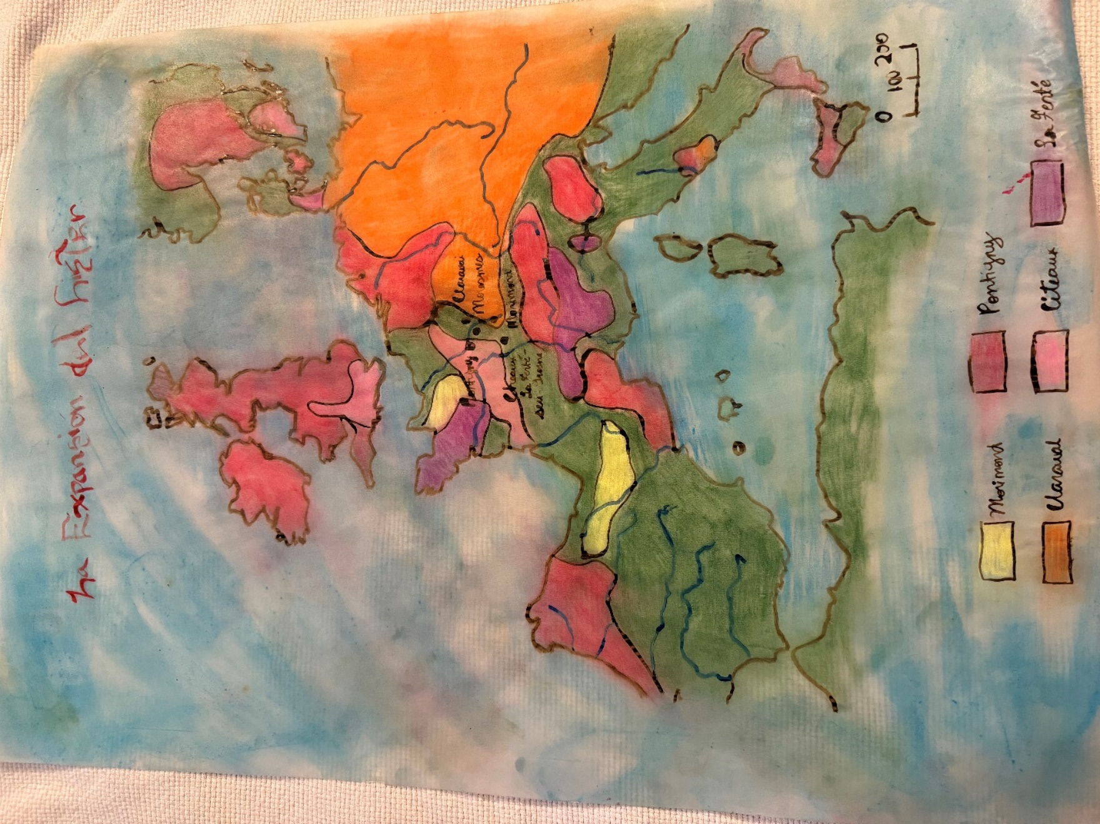

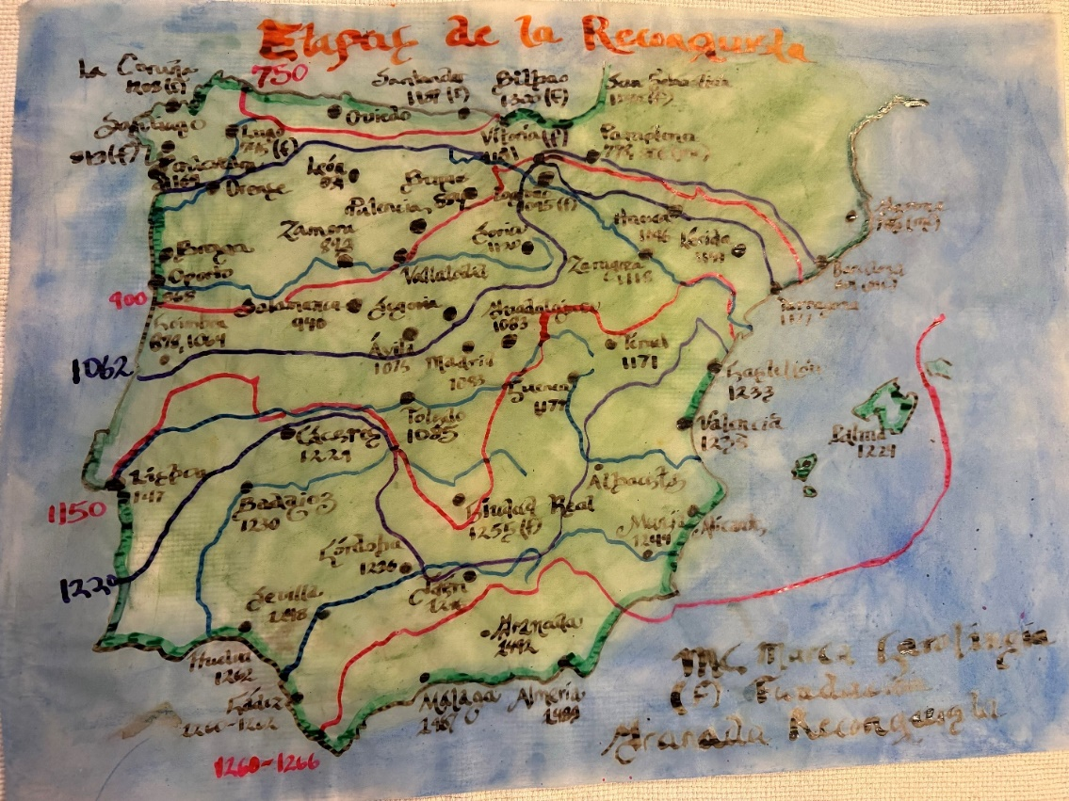
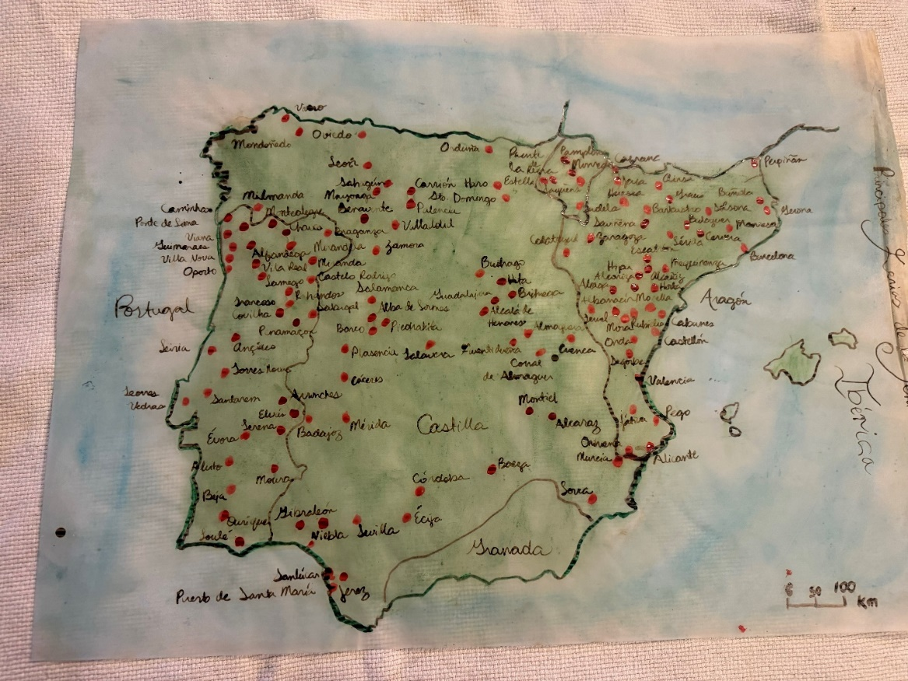
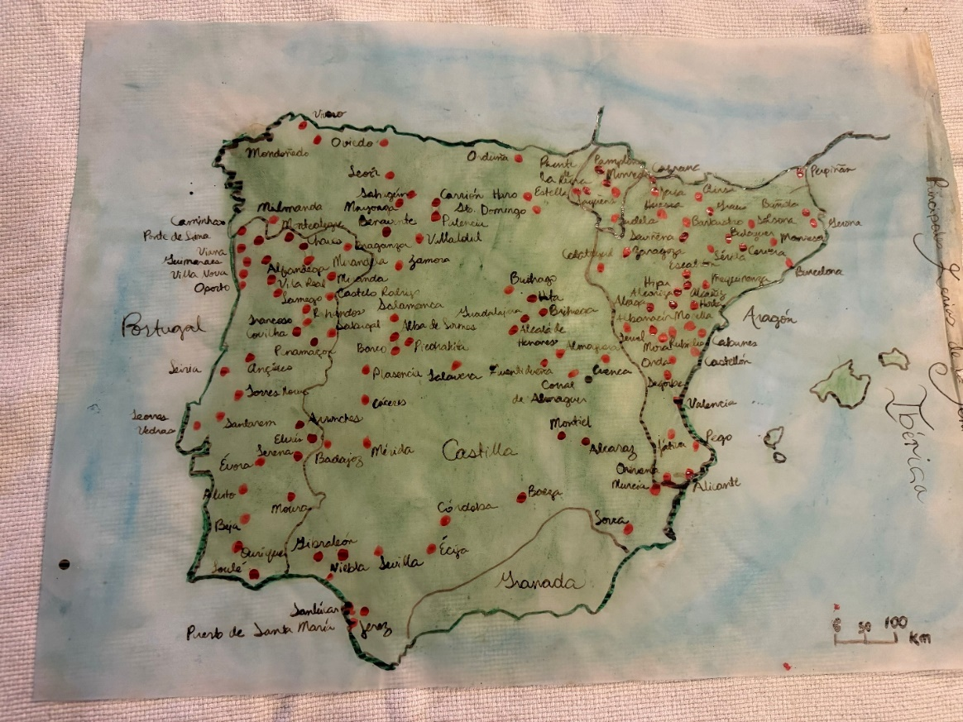
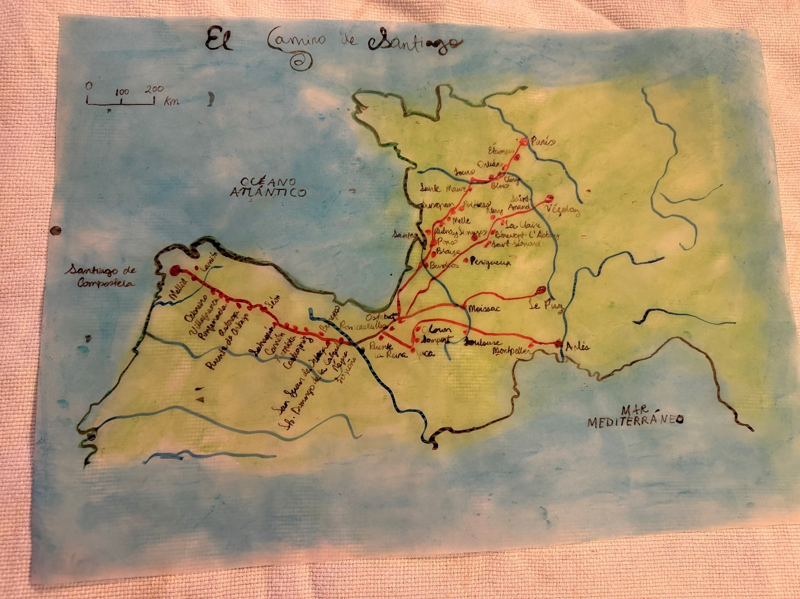

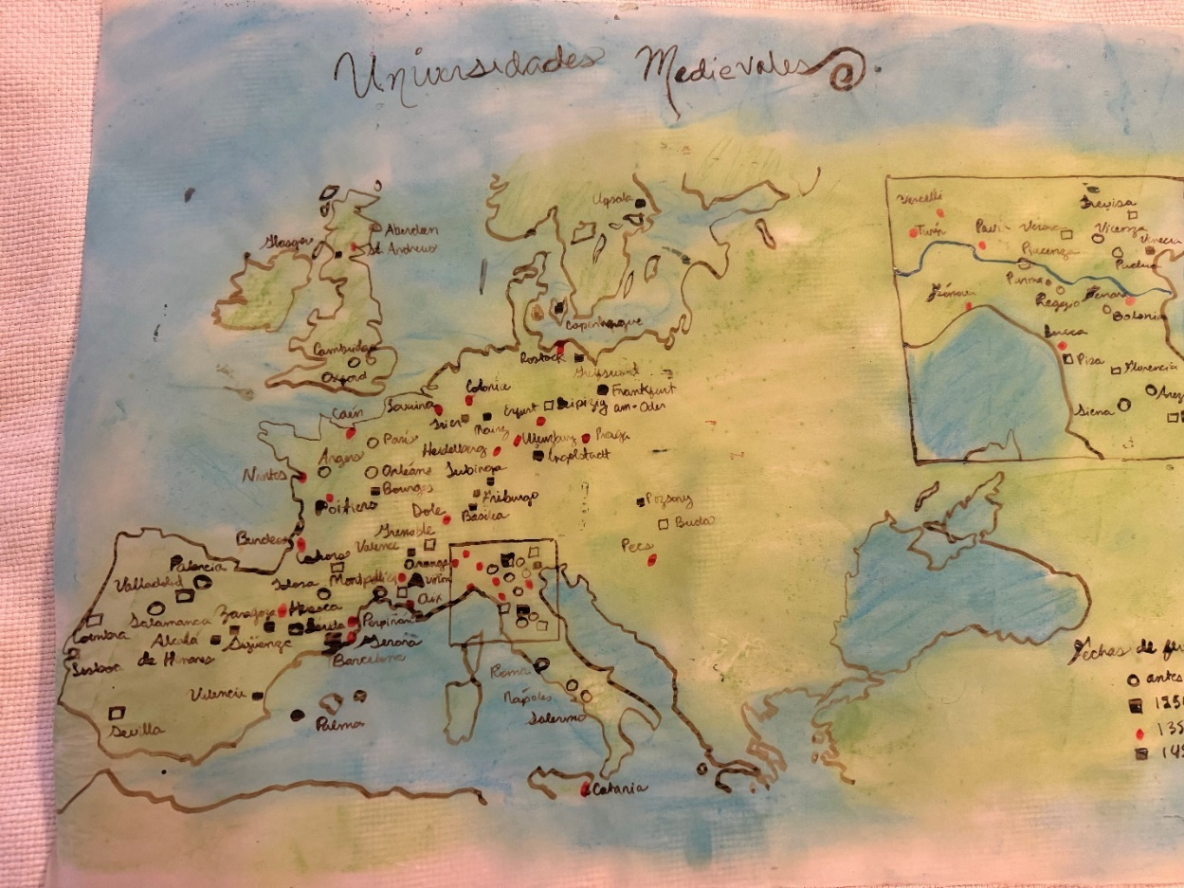
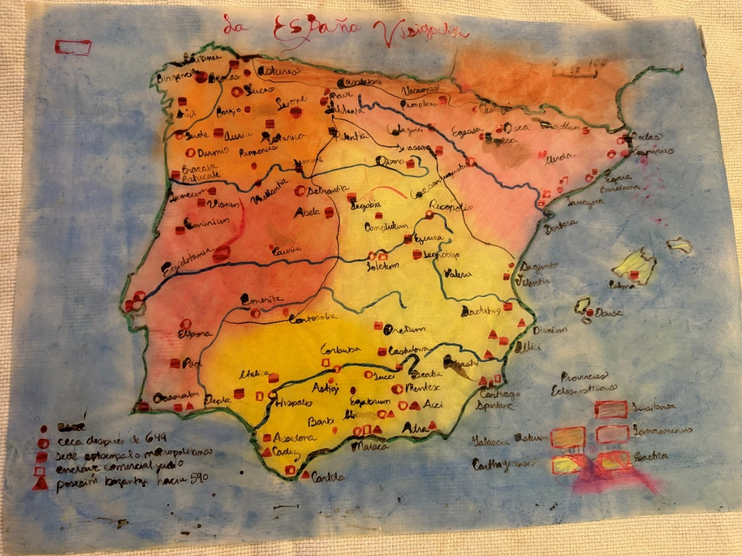
The second very important filial importance of the University of Granada was that it was the first time I was able to personally know a professor writer: the literature professor Luis Garcia Montero. I was absolutely fascinated by his class. He was a very well-known writer in Granada, he gave an amazing literature class —whose evaluation method was essay questions, not mnemotechnic information about the books we were assigned— and it was the first time ever I went to the presentation of a book, presented by its own author. I was “oriented” in Alfaguara that his content was “doctrinally inconvenient”— but he had an outstanding teaching and writing method, and I admired that.
Something that is told very clearly to all Puerto Rican exchange students who go to Spain is that we should not expect to get As in Spain and that is all right. In order to get the American equivalent of an A in Spain, as far as I remember, the student needed to get a 10 in the class. We are not talking about small classes: we are talking, in the case of the literature class and many others, of classes that were given in huge auditoriums, with tons of students, around 75-100 students, and only ONE student could get an evaluation of 10, that is how the Spanish system works, they only give one ten, two as maximum as an extraordinary measure. So, when a Puerto Rican exchange student goes to Spain, we are not expecting to get any A: all will be Bs or Cs, following the Spanish evaluation system. That is what we expected, and no one challenged that notion: we were not going to Spain to get As but for academic and cultural enrichment. That is why you rarely see a Natural Sciences international exchange student at the University of Puerto Rico: they are not interested in academic enrichment or cultural enrichment; they are only interested in getting the As. I truly enjoyed his class. I asked questions. I read, I analyzed. I thought independently, challenged notions, discussed freely, and heard everything openly. I went to his conferences and book presentation also.
I still remember the joy, the shock, the amusement, the awe, the rejoicing… I have no words to explain this… The moment when I saw I got a 10 in his class I was absolutely perplexed, in the best sense possible. I saw it several times before believing it. I got a 10 in his class, given in an almost full, almost hundred filled auditorium. I wrote the test by hand, but I explained to the professor I had to take my time writing things by hand, and he understood. I was the last one in the auditorium to give her test to him, barely able to write everything down (that was a constant problem to me: finishing the tests on time). I don´t remember right now if I was the only 10 in that literature class. I do remember that we were explicitly told by the University of Puerto Rico international exchange office that we should not be expecting As —that means, a 10— while studying in Spain because they usually gave only one 10 per class, so it was not reasonable to expect an A in such circumstances… so when I saw that 10 I lost my breath away, in the good sense. Yes, I enrolled in far too many classes (I passionately love to learn, and I knew I would have no other opportunity to have such learning possibilities, but I needed to be realistic), I began to realize I was psychologically different while at the same time I was unaware of the practical issues of the huge differences between the Spanish and American college systems, I had to adjust to realistic expectations and began to realize I was unable to learn and function academically like those around me… but I also realized for the first time that when the equal growth opportunities were given to me, when the space was given to me to function and studying according to my best capabilities and not according to my disabilities —they were not yet known, I was granted reasonable accommodation in a natural human way, it wasn´t an official request, I was not considered disabled, but from a different educative system with reasonable reasons to ask for extra evaluations besides my final test— I can do intellectual wonders. Of course, the international exchange students' office celebrated that 10, too.
The third reason was doing the Santiagos Way. The first thing I did right after arriving in Granada and finding a place to stay (there was no student support system at all at the University of Granada, as it is usual in Spanish universities: you needed to fend for your own) was going north, to Pamplona, and started doing the Santiagos Way from Roncesvalles. It took me a month to complete it, a month walking completely on my own, discerning which was the way my life was supposed to take. I contemplated there how I was supposed to walk as Jesus walked, gave him my first fiat, and chose to follow Him wherever he led me, always walking the way that, according to what I contemplated, would always be under my feet. My whole life began to be configurated as a growth process in Him, including my scientific notion: according to Him, my academic studies, reasoning, and creativity must follow the truth at all moments. Years later, I contemplated a consecration to live in charity; it happened in the Roncesvalles´s church, one of the most beautiful places I had ever seen in my life and one of the most special places in my heart. The formation processes, the contemplation of a Jesus Charity, the theology of light… and finally, the human personal formative model that I am sharing as integraction, all that and all this began at the Santiagos Way, which I did completely alone, although sharing with the people that was around me. I did it in the month of September 2004, during my 19-years-old birthday month. This pilgrimage was a before-and-after in all my notions. It was how I began to conceive my faith as a constant personal encounter with Jesus, although I still was way far away from being a mature catholic in spiritual terms. I have had to go through a lot of evolving, nature and progress since that moment to reach the personal articulation I am sharing in this text. I did contemplate a few very concrete details in Santiago´s way, like I was called to study philosophy and theology, ecclesiastical theology, to the graduate level until my doctorate. That detail would be key later.
The last very important filial-intellectual influence of my time at the University of Granada was knowing the Opus Dei: I first got into one of their centers on December 8, 2004. I remember the exact day because they were celebrating Our Lady of Immaculate Conception Day, which is very widely celebrated in Spain. As far as I remember, it is a national holiday there, known as “Puente de la Inmaculada.” This detail is not minor at all for several huge, very huge factors, but I at least try to limit myself to state those factors that are directly related to the intellectual-filiation aspects of the process of creating the integractive personal formation model that I am sharing in this text. For you to be able to understand these factors, you need to have some notions of my experiences profile as I found, knew, filiated, and eventually de-filiated from Opus Dei. This has been by far the most difficult part of writing this whole text, due to the huge trauma it implied when it happened. Here we go.
How did I know Opus Dei? While I was doing Santiago´s way, in the last week, I began to walk accompanied by a group of young people, four of that were also making the pilgrimage for religious reasons. You may be surprised how few people make Santiago´s way for religious conversion: most do it for cultural tourism. I was surprised to find young people who truly lived their faith, or so they attempted, like me. They mentioned nothing of the Opus Dei while walking together, we simply prayed together and went to mass together. But there… until I mentioned to them something I didn’t understand about my prayers, something I had never heard before: I contemplated that “Jesus was calling me to be a numeracy.” They were stunned: “Do you know anything about what a numerary is and what Opus Dei is?” I told them that I had no idea of what Opus Dei was and what a numerary was. Although I met them in Galicia, they were also students at the University of Granada, and they were what the Opus Dei call “members of San Rafael”, their apostolate with the youth. They promised to take me to their Opus Dei (one of them was a girl, so she would bring me to the university students center of Opus Dei in Granada, which was called Alfaguara, like the novel contest I always dreamed of winning. Well, it resulted that we parted ways after completing the Santiago Way, and we both lost our respective contacts: I lost their information, and they lost mine too. They lost track of me for a few months, but the girl had very good reasoning while trying to find me: if there was one Puerto Rican girl and she was studying at the Faculty of Letters, and she was the ONLY student from Puerto Rico at the whole University of Granada (I told them that while in Santiago´s way), SOMEONE must have known her in that faculty, she is the only one, everybody would know by her accent she is from Puerto Rico. She began to ask the people of the Faculty of Letters if they had met a Puerto Rican girl in the faculty…until she, as far as I remember her telling me, there was one of her friends who told her that she knew there was a Puerto Rican girl in the Arabic class. It was me, of course. She found me in December but had been looking for me all those months and even saw me once walking, but she was inside a bus, unable to stop, get off, and greet me. The first thing she did was bring me to her spiritual director, and I was fascinated by finally being able to have a spiritual director. I met her Opus Dei spiritual director in Granada parish on December 7, and he invited me to celebrate the Inmaculada in the Opus Dei center that my friend also visited. I arrived there with a lot of gratefulness for finally having found “my place” in the Church. Just to give you a hint of how shocking it was my arrival there, one of the first things I asked when I arrived at the confessionary, one of the first things I asked, without having any background knowledge of what I was saying and how they worked, was: it is possible for a normal person having an archangel as a guardian angel? The priest, God bless him, was prudent enough to say: “I don´t know, we will see.” And so, my Opus Dei journey began, first as a Saint Raphael member. They didn´t let me request admission as numerary in Granada, so I had to wait to return to Puerto Rico, where they also had a university center nearby the University of Puerto Rico, Rio Piedras campus. I was impatient, but I understood. That had to be discerned in my own culture.
So, I met Opus Dei for the first time in Granada, traveled with them to the UNIV in Rome, and there I saw John Paul II personally in the last Urbi et Orbi he gave. It was a huge example for me of giving his life for Jesus until the very end, even unto death, and it had a huge impact on me. By the way, I walked through the whole of Rome dressed as jibarita, the traditional Puerto Rican dress. I began to search everything about Opus Dei and, of course, found the critical website Opus Libros. I didn´t believe them at first, but I read and studied avidly the internal books and documents of Opus Dei that the very own members were forbidden to see as they were becoming available on that web page. I wanted to learn everything about Opus Dei, the critical perspective also… but I couldn´t believe many, if not most, of the critical aspects yet. I was still a Saint Raphael, knowing the best side of Opus Dei only, in a process they openly call proselytism. Yes, now I know all kinds of proselytism are wrong, but I didn´t know then. I was fascinated by finding, finally, my place, where I could be like people like me who loved the intellectual world and loved to live the faith fully. }. Here, you can see the only photo I have saved of my time in Opus Dei in Granada. It was taken in the UNIV in Rome, I am the one dressed as jibarita (you will immediately notice who is differently dressed in that photo):
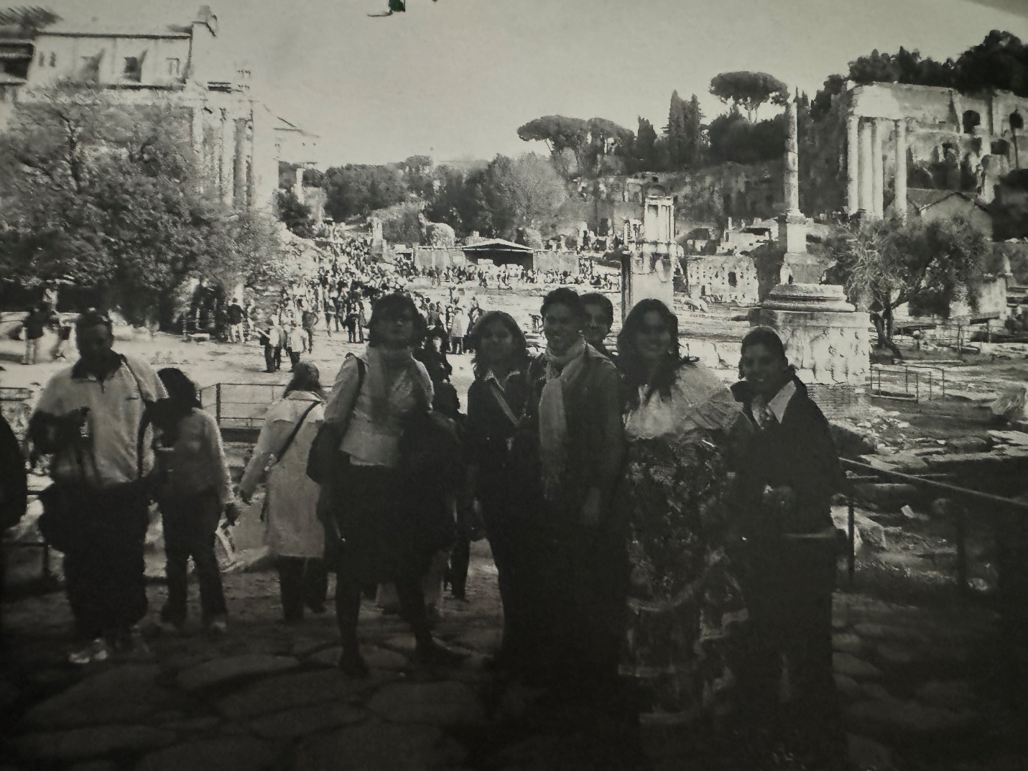

I left a card for the Father of Opus Dei (I think that is what they call them, I am not sure now) while in Rome, and months later, already in Puerto Rico as an already an aggregated member, would receive this note from Rome, directed to me in the name of the Opus Dei Father (in Opus Dei settings, members are delegated to manage the correspondence to the Father, he is said to read your letter, but anyone else will answer in his name):
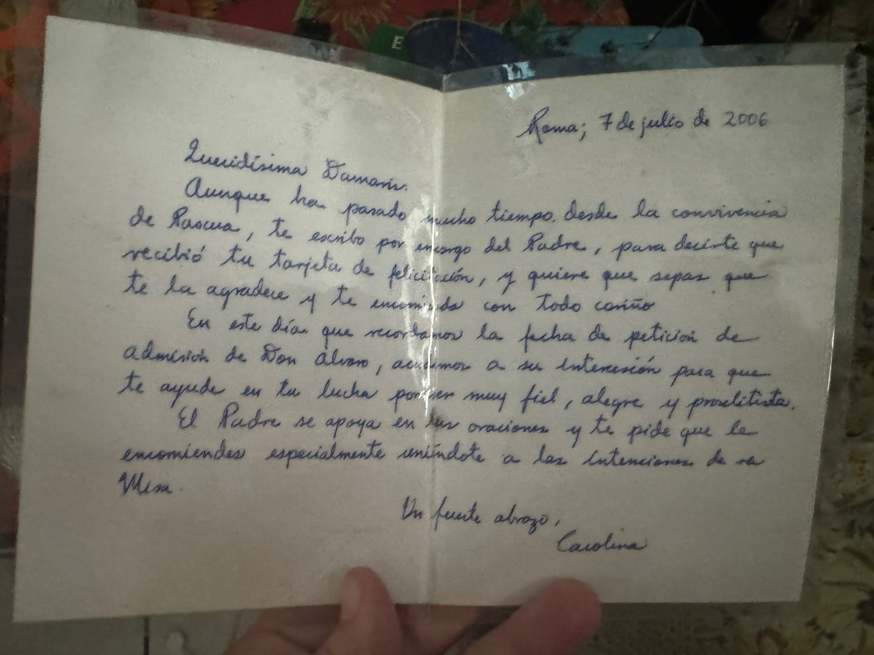

I don´t remember exactly when I arrived at the Opus Dei center besides the University of Puerto Rico, but it was quite shortly after coming back to Puerto Rico. I traveled with liturgical stuff that belonged to them. Right now, I don´t remember the exact name of that center anymore, but I do have an idea: it was related to the tower of UPR. Let's call it “Torrebella” for the purposes of this text. It’s a completely fabricated name, following the style of Opus Dei naming of their centers, and knowing for sure it had the word “torre” in the name. We need a name for that center to be understood.
Well, I arrived at Torrebella expecting that I would be able to request admission as numerary immediately. It was not so. They didn´t let me ask for admission as a numerary, and although it was not explicitly told so, it was very clear that I lacked the “socioeconomic profile” of a numerary. Told in other words: I was too poor nor have the prospective socioeconomic status in the future (like a medicine doctor would have) in the future to be allowed to ask to be admitted as numerary. They even went to my house to see how it was, how my lifestyle was, all this without being totally aware of what they were doing as a “socioeconomic assessment” more than a “spiritual assessment.” For the first time in my life, I knew that social classes existed, and in Opus Dei, there were clear socioeconomic distinctions. Numeraries were the best class. Auxiliary numeraries were treated clearly like second class; you needed to be poor to be among them —believe it or not, I asked if I would be admitted as an auxiliary numerary, and the direct answer was: no, you have a college degree. Auxiliar numeraries were not meant to have a college degree like me. Of course, you need to be poor to not be able to go to college… just to mention one of the socioeconomic aspects they clearly used to select their candidates to become a numerary. It didn´t felt a spiritual criterion at all. I remember that while I was in Canada working in a summer camp of Opus Dei there, a Spanish numerary explained to me that in Spain, they believed I was a numerary because in Spain if you can buy a car, you do have a numerary profile, (in Spain they knew my parents brought a car to my sister, a brand new Matrix that I would use later), but in Puerto Rican culture having a car of you own was not only completely normal but a necessity, it doesn´t mean that you are a numerary. I would allow a numerary to spend time on her own as you are doing right now (I needed my own space to process the fact I was officially not allowed to request admission as a numerary). I was shocked at how she understood the spiritual discernment of becoming a numerary that happened in Spain in strictly socioeconomical terms.
The spiritual discernment process wasn´t at all in that in Granada, or at least I didn´t feel it that way. May I be wrong? May these awfulness and conscience abuses that are happening in Puerto Rico also be happening in Spain, the biggest territory and foundational social context of Opus Dei as an institution? No matter how much critical information I read on the web, continuously, I had the hope that once I changed regions and moved to Spain to study, finally, philosophy and theology, as I contemplated in Santiago´s way, things would be better: I convinced myself that all these depersonalizing institutional circumstances were happening only in Puerto Rico because it is the smallest of Opus Dei region, and they don´t have enough numerary members yet. This wasn´t possible to happen in other regions, too. This won't be repeated in Spain; things will be again like they were in Opus Dei in Granada as a Saint Raphael member. An important detail should be mentioned here: Torrebella was the smallest Opus Dei center of the smallest and youngest Opus Dei regions (it was the last region to be founded before the death of Saint Josemaria, and for that, it was known as the youngest regions, besides being territorially the smallest). I considered it normal for huge mistakes to happen in such circumstances. We were the youngest and most inexperienced of the family, and it is widely known that the youngest brothers and sisters usually make the bigger mistakes in a family. It wasn´t until arriving in Pamplona, the biggest of Opus Dei regions around the world —the whole city of Pamplona was widely named inside the Opus Dei as an “Opus Dei center under the sun” (in Spanish: “Pamplona es como un centro del Opus Dei bajo el sol”) that I realized, shocked, that this wasn´t about a single small region: the problem was clearly institutional, not in the foundational spirit —there was an institutional charism there since the beginning, that can´t be denied— but in the praxis that developed that foundational spirit.
The problem I just described was highly structural, even in how the figure of personal prelature was configurated since the beginning: Saint Josemaria wanted it to belong to the Congregations of Bishops, and although de iure Opus Dei wasn´t supposed to function as a “parallel ecclesial hierarchy” the facto it was functioning like a parallel ecclesial hierarchy (I explained in a previous part of this text this further when I talk about civil prelatures), denying the Holy See the due access to their internal ruling documents, and so no one was allowed to correct them, internally or externally, everyone must obey or go. Of course, if the Holy See wasn´t allowed to correct them, neither would be a supernumerary —the lowest of their institutional vocational ranks, even lower than an auxiliary numerary— of the smallest center of the youngest and smallest regions of Opus Dei in the world. I should clarify this due to justice reasons: according to the proper context of the foundational spirit, there should not be “ranks” among Opus Dei members… but the facto, numeraries were undeniably functioning as the most important class of Opus Dei; they must be obeyed blindly and the formation given to a numerary was noticeably better in the institutional sense than the formation given to a supernumerary. De facto, in the praxis, there were different ranks among Opus Dei members, especially due to socioeconomic profiling reasons.
Things were so interwoven in Pamplona that I was invited once to go to the feminine delegation of the Opus Dei of Pamplona, one of them (Pamplona is such a huge delegation of Opus Dei that they have several delegations in the same city, something unthinkable to happen in a region like Puerto Rico) with my spiritual director, not to talk with someone there, but simply to accompany her to bring some correspondence to the delegation (they have the custom of send mailing issues by hand, hand to hand, they don´t use regular mail, never) and as I was entering to the delegation… one of my philosophy professors at the University of Navarra was going out of it. I was frozen when I saw him: I had all the evidence to believe all my professors knew what was happening to me internally, according to the internal profiling of the institution.
Lessons must be learned from this eclessially. No institution can be allowed to hide its internal documents and praxis, either from the Holy See or from its own members. A member of any ecclesial institution has her or his due right to know the rules that govern them and to make questions and even consult with the proper diocesan authority if there is any doctrinal or moral issue with those internal documents and praxis. I wanted to denounce Opus Dei's spiritual abuse, at least the one I saw happening in Puerto Rico. I witnessed how confessional information was clearly being given to the directors by the priest who confessed the sins, and how the director instructed the priest which topics to use in the “meditations of Saint Raphael” for proselytism purposes, also handling confessional information between each other. I even reached the bravery, huge in the circumstances I was in, of telling the secretary of the archbishop of San Juan while he was my professor of History of the Church in Puerto Rico: I had to tell the archbishop about serious irregularities I had seen happen in Opus Dei in Puerto Rico. The secretary told me in a very, extremely cold tone: “Opus Dei is an approved institution of the Catholic Church; no irregularities are happening there.” I wasn´t allowed to tell more, and if you understood correctly my circumstances in his class, my move was hugely courageous. In the eyes of God, I had my conscience very clear: I tried in every way possible to inform this, and I wasn´t allowed. I was simply seen and known as unreal, not valid.
As a well-formed Catholic —I was a catechist of pre-confirmation and confirmation level catechism in my parish for about seven years while I was a teenager, I knew about how things are supposed to be done in a diocesan way—, I knew the truth: Opus Dei was breaking de facto the seal of confession, telling their members to repeat the same information to the priest in the confessional, both before and after the confessional formula. They believed that if the person told whatever he or she told before the confessional formula, they were de facto liberated from their seal of confession duty as priests. It was a very legalistic move: the facto, they were breaking the seal of confession, and the Holy See was unable to see it, but I saw it, I saw written all the information the female directors and the male priest shared, including information told inside the confessionary. I knew that would mean de facto, Opus Dei, right now, is not in communion with the Church; they are functioning like a parallel ecclesial reality of their own. They were excommunicating themselves. In the words of the United States Congregation of Catholic Bishops:
The Code of Canon Law forbids priests from divulging information received in confession. The penalty for a priest who directly violates the seal of confession is excommunication.
It should be paraphrased this way to avoid that any other institution can make the legalistic move Opus Dei did:
The Code of Canon Law forbids priests from divulging information received inside the context of the sacrament of confession and inside a confessionary. The penalty for a priest who directly violates the seal of confession is excommunication.
Spiritual Direction must be given outside the confessionary, never inside it. That will make clear the distinction between institutional formation and governance, and ecclesial-sacramental personal formation. No one can use the spiritual jurisdiction for institutional governance jurisdiction, as it was being done systematically in Opus Dei, and not only in its smallest and youngest region —Puerto Rico was known as the “region Benjamina”— but also in its biggest delegation of its oldest and foundational region: Pamplona, Spain. The issue was institutionally wide, quite clearly and evident, as I have explained with the proper evidence.
After all this has been explained, I can now attempt to explain the huge factors that influenced my intellectual filiation while I was an undergraduate student of the Faculty of Humanities at the University of Puerto Rico. They can be stated in five important factors: the time factor, the index factor, the humanistic hate factor, the conscience abuse factor, and the personal formative conception. Let´s explain them.
As I said, the first Opus Dei factor that influenced my filiation at the University of Puerto Rico, Rio Piedras campus, and probably the most evident factor of all, was the time factor: de facto I was expected to have the disponibility of a numerary, but I de iure I was fist a member of Saint Raphael, then an aggregate member, and finally a supernumerary member. I lived in Torrebella full time, I barely went to visit my parents, something I had never done too often anyways, but I had no support system to also be considered as “family” in the center: I was explicitly told, many times, I was not a numerary… but at the same time, as I said, they expected a numerary disponibility from me. I worked in the Administration of the residence not exactly full time, but something else: almost wherever and whenever I was needed. I did have a regular “official schedule.”, I was supposed to be working in the mornings doing breakfast, the lunch boxes, the menus and the laundry, and morning cleaning, but de facto, if something was needed from Administration and the official Administrator —a numerary— wasn´t available, I was the one expected to handle the situation, whichever was. I was not only a full-time worker: you lived where you worked, so your availability must be total. If you add to that detail that my professional boss was also my spiritual director for a long while, and I was directly instructed to obey her professionally as my spiritual director also —professional, spiritual, and institutional government jurisdiction was assumed as the same jurisdiction— of course, my availability was expected to be absolute. I couldn’t say, as the Natural Sciences students said: I have a test, I need to study. Humanities was considered an easy career to study, so I didn´t need so much time to study; I was explicitly told that by the numerary secretary once, and implicitly, it was told many times (We will talk about the humanities hate later, but the allusion here is necessary). I had no time anymore to keep up with the assignments and workload of my college courses. I began to request Ws quite often, and not only due to ideological and due to what would later be discovered to be learning disabilities issues. The code “W” in a class in the University of Puerto Rico system means “withdrawal.” I couldn´t complete the class, so I chose to withdraw instead of getting an F for not being able to complete the class successfully. I was unable to research things related to humanities because I was focused on studying the institutional formation, and not only mean the required institutional formation: I secretly photocopied, annotated, and marked internal documents of the institution, that I knew they were not supposed to be photocopied, but I wanted to learn, and I couldn't mark and annotate the official documents, so I photocopied them. Years later, I returned all the intellectual annotations and photocopies, with an apology, along with all the books I stole from the University of Navarra, also apologizing for that, I wanted to learn and found no other way to do it, but it was wrong, and I was sorry. The professors at the University of Puerto Rico clearly noticed that the quality of my time was not being spent properly and that I could barely handle my humanities faculty class workload. In words I heard once from an English professor: she is not the same Damaris of the first year; something has changed after she came back from Spain. I couldn´t explain it, no one would understand it. Between the time that required the official institutional formation of Opus Dei, me being working in the Administration with absolute disponibility —as a matter of fact, when the Administrator was in spiritual retreat or annual convivence, I handled all the administration function systems on my own, including me being the one who went to Sams or Costco to do all the food shopping for a residence of about 12 persons— and also counting the fact I was totally avid to learn everything I could about the spirit of the institution by my own means… well, that left me with almost no time to handle my academic workload and studies properly, especially considering that during my first year and also during my stay in the University of Granada I was the kind of student that went not only to the main academic classes but also went to extracurricular activities regularly. Once again, I had to learn to be realistic: I had no time left to study humanities properly, and if I was able to pass, when I was able to pass a class, it was because I was intellectually gifted enough to handle way more intellectual load than most people and because exceptions were granted to me. I was absolutely frustrated by my inability to handle my humanities studies as I did before, and I even cried silently sometimes in class, when I realized I was unable to prepare properly, but that was not the main frustration issue, as I will explain later.
The second huge Opus Dei-related factor that influenced my filiation at the University of Puerto Rico was the index factor. I already began to have problems with this in Granada, but it became a fully blow problem in Puerto Rico. You see, Opus Dei had an index of forbidden books: you were not supposed to read certain books. The first issue with this was with Luis Garcia Montero. They clearly told me it was a doctrinally inconvenient author to read, but I chose to go to his book presentation and keep going to his classes anyway. In Puerto Rico, as I became an official member of the Church, things became more explicit and mandatory: there are certain books you can´t read, you need to give us your reading book list to see what you can read… and as you may expect of a leftist University, it resulted that almost all of my mandatory readings had some sort of doctrinal issue. How do you explain to a professor at the Faculty of Humanities that I cannot do the reading he or she assigned to me because I am banned from doing it by my spiritual director? You couldn’t say that, of course. It reached the point that I was either following the index or choosing not to follow it and actually be able to complete my classes and be able to graduate. I learned to totally ignore the institutional index, and I was constantly reminded: “You are being a disobeyer and need to be humbler.” Nobody among the directors of the center wanted to understand I needed to read everything to be able to graduate from the Faculty of Humanities; I was not studying in the Faculty of Natural Sciences and couldn´t be given the order of choosing not to read mandatory books for my humanities classes. Believe it or not, there are students in the University who actually are required to think, not only to memorize, like Natural Sciences were required. Of course, my fellow Opus Dei members at the Natural Sciences faculty had no problems at all with their readings. I was the one who was reminded that not following the index was being disobedient. By the way, I was the only one in the Faculty of Humanities around that center. I tried to bring classmates but never achieved it because I truly didn´t believe in proselytism but in friendship, but I had no friends; I was always inside the Administration. Well, the only person who I brought to any apostolic activity at the center was a lesbian. I was told, in literal words, to not do that again because they wouldn´t be able to grasp the “tone” of an Opus Dei center. I don´t remember what I did to her to make her stop coming to the center, but I do remember I didn´t dare to tell her what they told me in the center. I invented something to not hurt her.
There was another very important factor related to Opus Dei regarding my academic filiation to the University of Puerto Rico, Rio Piedras campus. Well, they put me with a person of my age to receive spiritual direction. The direct problem wasn´t she being of my age, it was that she was highly anti-humanities. She believed humanities didn´t require as much rigorous study as Natural Sciences, that we lost time in our classes, that it was hard to get “good proselytism” in that faculty because students were leftists, and that I should study in the library of the Faculty of Natural Sciences to know more “friends” to bring into the center. I hated the whole Natural Sciences Faculty environment. My favorite library was the Law Faculty library, but I spoke with no one. She literally hated humanities and, in an explicit sense, told directly in a spiritual direction, she wasn´t able to see any scientific in my approach to humanities. It was not that she was trying to hate me; we were the same age and dealt with the same kind of issues, as I would realize later in the most inconvenient way. What she hated was what I studied; it was a waste of talent. I couldn´t dare to say in front of her: I need time to read something from my classes, or I need time to study for a test. She simply didn’t believe humanities were worth it and repeated it repeatedly. My spiritual direction was hell, but in another sense (it was also hell when the one who was directing me spiritually was also my professional boss, but that was a different kind of hell; at least she made a sincere attempt to understand me, but our characters where highly different, she didn’t understand creativity because she had been simply obeying norms since she was 14.5 years old, she was an Administration Numerary, wholly dedicated to internal duties, she didn´t have the space, never, to be creative, so she wasn´t able the need to be creative and human with the residents and in the Administration as coworkers, for her norms were norms and they must be obeyed). Due to her anti-humanities bias, she was clearly unable to understand my spiritual direction properly, but there was literally no one else available to give it.
Now let’s talk about the most complex and gruesome of the five factors that clearly influenced my filiation with the University of Puerto Rico, Rio Piedras campus, and that also have direct relation with Opus Dei: the conscience abuse factor, that can be considered dual: I did a personal conscience abuse that made possible to discover with very solid and undeniable evidence a systemic institutional conscience abuse, or as I will describe it later, a whole institutional conscience control system.
I should begin explaining that as I began to be member of Opus Dei I had knowledge of the critical perspectives from the very beginning: I had access to Opus Libros, a web page jighly critical to the institution, since being in Alfaguara, using the very own Alfaguara computers, and they knew, and I made questions. In Alfaguara those questions were answered openly, never with an “you obey or you go”. Things work differently in a Saint Rafael Center, but Alfaguara was also what Opus Dei call a “studies centre” of young numeraries that were in their first years of formation. I never felt my questions were ignored or denied there. I read Opus Libros, but didn´t believed that everything they told could be true, especially inside the Catholic Church. My questions were so openly answered in Alfaguara that they even asked me if I wanted to see their cilicium, something Opus Dei members use as physical mortification during an hour per day, secretly. I realized later that I made tickes to a numerary with cilice while she was in the computer, and that was extremely painful for her, her face said all. That numerary would leave an eventually work in Aci Prensa.
Although I was aware of the critical perspectives of Opus Dei, well, what I was seeing in my experience was good… but quite very shortly after becoming an aggregate member things would change quite fast. The center in what I was living was clearly a center in crisis, although they didn´t realized it. The Opus Dei in Torrebella definitely wasn´t the Opus Dei I knew in Alfaguara. The joy was now a matter of institutional image, instead of being truly happy, or at least seeming to be truly happy and full of live, like it happened in Alfaguara.
I took the matter in my own hands. Anyone inside Opus Dei have an spiritual agenda were they take notes of their life plan and about everything going on in their spiritual life and also in their spiritual duties as spiritual directors of other members. They usually left the agendas in very specifi places, quite accesible if you were alone in the house long time enough. I began t oread those agendas, including the agenda of the director of the centre, who had written very specific information about absolutely all others in the house, including members of Saint Michael, members of Saint Gabriel and members of Saint Rafael.

That is how I realized that there was conscience abuse happening; it was not an invention of Opus Libros at all; it was quite real and being done quite covertly, especially covered by the Holy See. What they wrote in their agendas gave clear evidence that what was being told in the concessionary was being told outside, by the priest, to the directors, and the directors were also telling information of conscience to the priest in the confessionary, without the members of the center being explicitly consenting this or even knowing it. All the members were told was that they must repeat the very same information before the confession formula, after the confession formula (during confession) and to lay directors too, that was a sign of docility to the spirit of home (in Spanish: “docilidad al espíritu de casa”)… but the truth was: that instruction was given to hide the conscience abuse they were committing with the confessionary, as I have explained before when I mentioned the quote of the United States Congregation of Catholic Bishops.
Yes, what was being told in the confessionary was being divulged to the directors, including sins that could be clearly implied even when not directly written. Because I was seeing what they were writing, I was very sure they were totally unsuspecting of what I was doing and of what I was realizing as a systemic institutional issue, not as their personal fault. No one had any idea their agendas were being read… except the director, because her agenda was an electronic Palm (all the other agendas were physical, handwritten agendas). When you use a Palm, you really need to remember to leave it on the same screen it was when the director last used it. I forgot to do that once, and after that, the agenda began to be blocked with a password. She realized that someone had opened her agenda… but never guessed, not that I was aware, that it was me.
I sometimes also read the supernumeraries´ agendas If they left them in the center while at the university. It was quite common for me to be completely alone, or almost completely alone while doing Administration duties and the Administrator getting out in the morning to do her errands. I will explain now a struggle that was especially difficult for me to witness. There was a supernumerary, very tiny in the physical sense, that the directors wanted to convert her into a numerary because she had money, she had the socioeconomical profile of a numerary, it was explicitly told so. She had no idea of all the conscience control tactics she was being enforced: the priest shared her information with the director, and the director also shared information, and both coordinated everything, along with the other numerary directors, to make her think she had a numerary vocation, and she must be generous, they even gave Saint Raphael meditations in the front of the Tabernacle about how generous was following “God´s will” following what spiritual directors tell you… I saw the whole manipulation from Opus Dei side, but this was especially difficult to witness due two reasons: I saw and read in her agenda her despair because she truly believed she was meant to be married and clearly didn´t want to be a numerary, no matter how much times she was told and invited to request admission as a numerary simply due obedience to the directors, the struggle was very anxiety-causing to her… and, of course, this was very difficult to witness because I myself wanted to become a numerary, for very supernatural reasons seen even before knowing the Opus Dei, but wasn´t allowed mainly due my lower socioeconomic profile. While I wasn´t allowed to request admission as a numerary, I saw how someone who clearly didn´t receive a numerary vocation was tried to be inforced one with conscience control tactics. I realized again, broken-hearted, that things here were not like in Alfaguara: here, the socioeconomic aspects mattered more than true spiritual discernment. I truly believed in the Opus Dei I knew in Alfaguara, not here. That director in Alfaguara was even humanely and open enough to open herself in spiritual direction with me, telling me how she struggled with the fact she knew she was in her last biological years of being able to be a mother, and still choosing to stay as numerary, because she knew there she was meant to be by God —she was clearly in her “40 years crisis”, as I am now, I explain this as a comment text at the end—. That is what I felt was a true spiritual direction, an open fraternal dialogue, not an institutional imposition used for governing the institution. In Torrebella, spiritual direction wasn´t open at all: once I passed from the Saint Raphael labor to the Saint Michael labor and eventually to Saint Gabriel labor, you had to blindly say everything to whoever you were assigned, but they wrote everything in their agendas, so I knew all.
It is a tradition in Opus Dei that when a priest is in a female center, he is accompanied to and from the door by two women, usually members of the institution, but it can be a Saint Raphael also in certain circumstances. I did this thousands of times, but one of those times, when I did it along with the director of the center, they made comments one to another that clearly confirmed that one dictated to the other content of spiritual direction treated in the confessional: the next meditation or “charla” must be of topic “x”, it wasn´t about receiving true formation, they were also manipulating the formation for the institutional government use.
They knew I read Opus Libros but wouldn´t be able to suspect I was doing it to try to understand it all in the middle of my own grief because I wasn´t allowed to become a numerary, and knowing the reasons they were not told explicitly. They knew I read internal documents of the Opus Dei and critical information, but as I said, they had no suspicion at all that I was reading their spiritual agendas, I was very careful of leaving their agendas exactly in the very same they were left when last used by them, even taking care of leaving their pencil or pen in the exact place and position they left it. I used the internet connection of my own center to access Opus Libros most of the time. They didn´t block it, but it was very easy to know what was accessed and by who in your own router. There was a very curious circumstance that happened once, and I vowed not to do it again. Once, the secretary of the center, that was just coming out from her numerary studies center, did something awfully wrong, even according to their own institutional norms stated in their own internal vademecums. I explicitly corrected her: the vademecum X says you should do this and that, not what you are doing. That was the curious thing about knowing the vademecums: I knew they would manipulate their interpretation according to the convenience of the institution. I mean, the content of the vadecums in itself needed revision from the Holy See, that was clear, but because they were supposed to be hidden, they could openly violate their own praxis for the institutional purpose —always for the institutional purpose, they never did it for personal formation reasons—. Well, the secretary was jealous, and almost furious, of her being corrected in that way: she complained to the director that as supernumerary knew a vademecum she wasn´t allowed to read as numerary and secretary of an Opus Dei center. I got into huge problems for giving such a correction in that way and never did it again. Shortly after that, the vademecum I alluded to appeared inside the direction wardrobe, and she was able to read it during prayer time. Of course, I wasn´t officially allowed to read it, although it also talked about rules applied to Saint Gabriel members. Opus Dei members were systematically denied to have official access to the documents and rules that were being applied to them or referred to as their “formation,” which was an institutional formation, not a personal formation at all.
I had enough evidence to realize that what was happening was systemically induced by the institutional structure issues and that I was in a center in crisis. Without entering into specific details about the identities nor giving specific traits and notions of each one of the numeraries around me, it was clear the following: in that center, at the same time, there was a numerary who was extremely overworked (all of them had a huge workload, but she was especially overworked), one that was deeply depressed, one that was clearly overmedicated (that numerary leave the center shortly after my arrival… and she would not be the only example of overmedications, numeraries used psychiatric medication quite often, especially the visiting numeraries) and another numerary… that literally had NO IDEA of what she was doing, but she had the best intentions, they all had the very best intentions to be faithful to the God, but they were only able to see that inside the institutional context: either you obey or go. The lack of sleep was chronic in all of them, sometimes going to the extent of using pills (I assumed it was Adderall, but I never was able to confirm what they were used to remain away in a so unhuman way for such long hours, I did read they were using pills for that, but they didn´t mention if they were caffeine pills or something more professional like Adderall) to remain awake way longer times than any normal being would be able to, so they could deal both with the workload of the center and their respective professional or academic responsibilities at the same time.
I loved them, especially the director, who clearly understood me. I knew something was wrong with them, and so I chose to read their agendas to know how to help them. The intention was good, but as I have matured, I have realized even if I felt I did it because I had no other choice but to “help to save my family, whatever it takes”, that was a very good reason to do whatever you need to do (anybody would understand someone doing whatever it takes to save her family, no matter what it takes)… nothing, absolutely nothing, justifies invading the sacred intimacy of anyone in a non-consented way, literally reading they whole lives from inside out. I did it because I truly believed them to be my family at that moment, and I had to do whatever it took para sacarla adelante. As wrong as I was, I even prayed doing what I was doing and had the conscience clearance to do it: you want them to be saved. I was wrong in both considering them my family and also in how I chose to try to help them. I knew everything that was going on inside of them and said nothing; I wasn´t even able to openly recognize to myself what I was doing. If you read my Facebook notes from that time (I began to have a Facebook account while living in Torrebella, but not since the very beginning of my time there), the story will be told from a different perspective, way more immature and emotionally-biased, but my notes about what I contemplated of those agendas and internal documents were never written on Facebook, not even in a computer: I simply took notes about everything that was happening and everything I knew, taking them in Arabic so no one could understand them except me, taking them in front of the Tabernacle, processing everything, and trying my best to help each one to be a saint… because that was our common articulated life narrative, we all wanted to become saints.
A psychological factor must be mentioned here if I aim to remain loyal to the truth: I had a huge emotional dependence problem at that moment; I have had it my whole life due to parental negligence; I had never felt I had a home and had always been searching for my place in this world. When I finally thought I found it in Opus Dei, I wasn´t in the disposition to let that crumble so easily. My insistence on them being my home and my need to help them also had, very clearly, an emotional dependence component on my part. I was totally unable to see then: you need to help yourself first, in order to be able to then help others. I went way further than anyone should in my insistence on helping them to be, said in today´s perspective. Praying that you are called to do something like that, invade the intimacy of others because there is no other way to save them, and have the evidence to demonstrate the conscience abuse… also means I had the wrong notions of prayer at that time. I should have simply left and continued with my life. Savior complex was an issue before being in Opus Dei: I believed I could change my boyfriend of seven years, since age 14, who clearly had no interest in changing at all, and, once again, I was totally unable to cut things in a healthy way.
Then another thing happened that was a clear detonator of what was going on. I dared to take the pen drive of the secretary numerary of the center. I knew I shouldn´t do that, but it was perfectly accessible; it was in the front part of the computer (you know, if you want to hide a pen drive, you can put it in a USB port in the back part of the computer tower). Well, I took the pen drive and saved all the content on my computer to read it calmly. In that pen drive were saved ALL the conscience informs of ALL the center members, both currently present and that left the center recently. This was a key moment in this process of discovering how conscience abuse is unleashed systematically in Opus Dei as an institution. I dared to go further, and in the times when I was alone in the center, I opened the direction wardrobe and read absolutely everything they had there. The wardrobe had a key, but I knew where the key was; anyone in the house knew it; it was in the drawer of the director´s desk. The tremendous conscience control exercised by everyone, and systematically, was quite evident. I don´t mean with this to detail the type of them requesting me to give them my credit card —given by my parents— because, as an aggregate, I couldn’t have a credit card of my own; they must have it saved in another keyed wardrobe in the secretary room. Yes, that kind of stuff happened, but what the direction wardrobe contained was a huge, systemic social management system based upon conscience abuse: they relied on conscience reasons to exert controls that were not meant to be related, in nature, to the conscience at all. People are meant, even by God, to have free will and act according to a truly person-affirming formatted conscience. Details like which medications were being used or telling a supernumerary she must be more generous in her appropriation are a clear breach of the right due authority of a spiritual director. Medications are a medical decision biological nature issue, and the economic apportations were clearly supposed to be according to conscience; there wasn’t an official amount to give beyond “considering Opus Dei another son or daughter,”… but we were in no age of having sons or daughters yet. Of course, the most important apportation you always gave to Opus Dei was the economic. They never realized my being in Administration was an apportation of my life; they considered it my paid work, although I tried to also apport intellectualy, creating systemic lunch menu system that satisfied both the residents and the Administrator. They never asked for prayers to the supernumeraries or to us give any kind of formation as numerary did; all they asked from us as apportation was money. Intellectual or formative or any other kind of apportations were not expected, nor open to be accepted, except in very specific circumstances (for example: I wanted pizza for my birthday, so they, instead of buying the pizza, asked for the father of an Opus Dei member who was in Saint Raphael, whose father was a supernumerary, to gift to the center pizza for everyone, because he was the owner of a pizzeria).
The documents in the direction wardrobe didn´t had directly written the name of the alluded person, but it was quite easy to deduce they were talking about. The system to communicate all these thing with the delegation was sending a document with a key number and then sending another paper, way more smaller, with the same numeric key, usually also mixing letters, telling in the second smaller paper: “please greet… and then say the name”. If you matched the numeric keys of both documents, you could confirm who the person was.
They also had a whole numeric-letter key system for communicating sins between delegation and direction. For example: they may use the key “B14” to refer to purity sins (sexual sins), and although they did not explicitly mention the sin, at least not in clear words, it was way easy to deduce which sin they were talking about, if you deduced it from the context in the sentence where the code was. Knowing the sexual sins nature of fellow supernumeraries was an especially awkward position. Sexual sins were not the only numeric key that was way easy to deduce in those documents. It was a whole systemic institutionally-conscience-based issue. I read everything, half shocked, half scared, half wondering how all this was possible to happen in the nose of the Congregation of Faith and the Congregation of Bishops they belonged under canon law structure. Of course, I had a huge conscience guilt at the same time. They suspected nothing. I spent a lot of time alone at the center while numeraries were out.
Because I knew each of them from the inside, I made a great effort to help them all according to their own conception of sainthood… but I was having my own struggles too with emotional dependence, trying to live the celibate life I contemplated for me, but at the same time still completely emotionally dependent of my ex boyfriend, who I saw in secret because I knew they would approve. One night I had to sleep out of the center because they didn’t open the door late at night for me, they would only do it for medicine students because they were the ones meant to study hard until late at night at their libraries, but I needed to study until late… so I called my ex boyfriend because I had no one else to go… and we ended having sex in the Morro walls, and I am not exaggerating at all in this detail, as scandalous it my sounds. I had my scandals and struggles of my own. I needed to help myself first, but I was totally unable to see it due to the huge emotional dependence problem that I had, which would resolve many years later as the contemplation of a Jesus Charity began. That contemplation of a Jesus Charity would end also all my purity issues also: I today live a very happy celibate life, despite being explicitly told by the priest of the center that a person with my kind of sins in the past could not possibly receive a call to be celibate. Although all these years, I had never been an officially consecrated lay of the Catholic Church, de facto, I have lived like a consecrated lay, including in the factor of learning to live in chastity according to my proper ecclesial vocational profile. Learning to live chastity is something very beautiful to learn from contemplation of a Jesus Charity, but it has must be learned since Opus Dei, and it wasn´t. The sexuality conception of Opus Dei, totally organized to the procreation of as many kids as possible, denying your sexuality at all, was absurd. You need to see sexuality as a capability of self-giftedness, and celibate people do have a natural capability of self-giftedness, too; they simply don´t consummate it in the biological sexual way, but they do self-give as Jesus did. A celibate person who doesn´t consummate his vocation as an ontological and filial self-giving that is incarnated in a concrete Church apostolate… well, if you deny the person the very possibility of being who she or he is in the first place, you will also deny him or her the possibility of becoming who she or he is called to be. This is a very ontological dissonance issue; you can call it ontological castration the same way chemical castration also exists. This happened systematically in Opus Dei due to how the institution was structured: you were meant to be according to what the institution told you to be, not according to who you are as seen and known by God, and also according to who you are called to be, as seen and known by God. This ontological castration issue is not small at all and can happen in all celibate vocations for several reasons, not all related to institutional structure, but in this case, it was institutional and clearly caused a lot of mental health problems that were being treated psychiatrically instead of ontologically. They were totally unable to give an ontological treatment for this because they would need to change the ontology of the institutional structure too, but any kind of defiance to the structure was having a bad spirit: you had to obey or go. As a matter of fact, I don´t know this in the factual sense, but I have contemplated in prayer that there are way more ex-members of Opus Dei than actual members, and I have seen that the leaving rate is extremely high among young numeraries. By the way, in Opus Dei, they have an open aversion to psychologists, and this detail is not minor, as I will explain later.
I wasn’t able to palabrize this that way then, but what they were doing was what would be understood from Integractive Psychology as unfilial profiling. It is hard to explain this kind of profiling because I haven´t seen it in the civil sense yet, and filiation is essentially civil, at least in nature… I do have a clear example of what unfilial profiling is in the History of Puerto Rico: when independents were being carpeteados (no English equivalence for that, it’s a historical term) by the Federal Authorities for social control purposes, even going to the extreme of killing and torturing independentists to eradicate independentism from the island, including the gruesome physical and moral torture that Albizu Campos endured. As anyone who has taught the most basic History of Puerto Rico knows, that was called carpenteo: the federals recompiled all kinds of information of the independentists in order to control them, and in certain cases, leading to the extreme of killing and torturing them. That was AWFULLY WRONG, and independentists in Puerto Rico have all the reasons to be angry with the federal authorities, but at some point, the ideological bloodshed must stop.
Well, that aspect of recompilation of the information of the person —understanding information both as information-data and as an information-formative process— according to an unfilial reason —any unfilial reason at all— is unfilial profiling: you are trying to articulate the life narrative of another person according to your own purposes (institutional purposes, political purposes…), not recognizing the dignity of that person filially —you are not recognizing him or her as a brother and sister— and the fact that his or her life narrative must be articulated according to his or her inherent dignity, according to what the person is and according to what the person is called to be. Both examples —what the federals did with carpeteo and what Opus Dei did with conscience informs— are examples of unfilial profiling, but in the case of Opus Dei, the torture committed with the unfilial profiling was ontological, as I explained in the prior paragraph, according to their whole conscience control system. They had an ultimate phrase for everything: either you do what you are told, or you leave. This can be paraphrased in the following way: either you are as we told you to be, or you leave. As I will explain later, I almost lost my Catholic faith due to that, and there had been suicide cases inside Opus Dei, some of them known on the web page Opus Libros.
When I saw my own inform of conscience, I was initially grateful, then shocked, then angry, and then guilty of seeing it because I knew I wasn´t supposed to see it. It was the first time I read someone saying I was abused by my parents. I was also shocked by the “emotional immaturity” reason to be denied admission as aggregate (and so, implicitly, as numerary also). If only they knew all that I was going through silently… but I couldn't say.
I had such conscience guilt that I finally got the strength and a little bit of integrity to tell the director something like the truth: I went to the direction room and explained to her that I saw my own conscience inform me it was on the desk. I didn't say: I took the pen drive and read it. I said: it was your fault, it was accessible… at the desk. Didn't tell explicitly: it was at the secretary's desk, and it was in the pen drive. That is how you work in the Opus Dei, telling things, but not able to tell all. I will never forget her facial expression: shocked, scared, and livid, at the same time. She was totally unaware of what happened, and when I finally told her, it was way later than when it happened. As I saw her reaction, it took me seconds to realize I couldn´t tell the whole truth. I can´t. They won´t be able to handle it. They would see it as a huge breach of trust: they trusted me, and I did that.
I was still totally emotionally dependent on what I still considered my truest home. What they were doing was hugely wrong, as wrong as what I was doing, but I thought: this happens in Puerto Rico only because it's the Benjamin region. In Spain, this doesn't happen; there are more people, and they do things differently, everything will be again like it was in Alfaguara. So, I made all the necessary movements to come back to Spain for graduate studies as soon as I finished my BA in interdisciplinary humanities. They explicitly forbade me to study ecclesiastical philosophy and theology. They explained to me that in Opus Dei, you study ecclesiastical philosophy and theology only if you are told so by the directors, but I was determined to do it despite their explicit and directly ordered refusal. I contemplated that I was called to study ecclesiastical philosophy and theology way prior to becoming a member of Opus Dei, they should respect that. I knew the University of Granada had theology also, but I chose to request admission at the University of Navarra at Pamplona, after praying it. There was also an economic factor involved: in Pamplona, I could make United States federal loans to pay for my graduate and ecclesiastical studies because they had the system to make that possible. Really, I truly had hopes that things were different there, and due to my emotional dependence, I wanted to believe it that way, despite reading the evidence in Opus Libros that the same praxis problem that happened in Puerto Rico happened everywhere in Opus Dei. It was an institutional praxis issue.
You may ask: how did I receive the Eucharist during all that time without committing sacrilege, at least not intentionally? When I confessed at the center, I used a legalism used quite often in Opus Dei environments, using the following formula in confession: I confess of this and that… and also confess of all my sins of my past life. In that “past life,” I included silently what I was doing, both while seeing my ex-boyfriend secretly and also while reading and processing everything I was accessing but shouldn´t. I simply didn’t clarify explicitly to the priest how long time ago those sins were in the past that I said silently inside my head. The past could be years ago, as they assumed, but it could also be the same week, days ago, or last night. I decided how to define “past” in that formula, widely accepted institutionally, so they had no idea I confessed other things silently with that formula. You get it: it was a legalism. I sincerely tried to confess this to the nearest parish the whole thing. He understood NOTHING, and never tried again. If the numeraries got you confessing with a normal priest, the fraternal correction would be magnificent. As a matter of fact, I had never been able to confess this sin properly because you need to do it with a priest who understands the whole scenario and context. I have only confessed this in the context of confesión del deseo: because you are unable to confess due to very grave reasons out of your control, you confess in contemplative prayer upon the living Eucharist, and the confession is in conscience valid until the sacramental confession can be actually available.
At a certain point, I voluntarily stopped reading their agendas and everything. I was wounded myself. I didn’t want to do it anymore; I was unable to keep going with such a load in my heart. I was unable to recognize that the Opus Dei I knew in Alfaguara as Saint Raphael member… never existed. I felt responsible for helping them overcome all their issues without them noticing. I will put concrete examples of this, simply to be understood: the director was homesick because she was going to spend a holiday in the hospital (I don't remember now if Christmas or New Year). I proposed the sub-director, who was the administrator, go to the hospital (she was a pediatrician, and she worked there in 24-hour shifts) and bring to the director a feast meal (inside Opus Dei Administration, there is a system to classify feasts. The feast was an important one, A, that was a special meal). The subdirector thought it was my original idea. Well, not so, and I never have told it this way. I knew the director needed that cheering and special meal due to how her soul was. At another point, she wanted a beagle dog. I literally got her a beagle simply to cheer her up, which, of course, wasn't allowed to stay there. I brought it to my parents later; she was called “Rubita,” and when she grew up, it was clear she wasn’t a beagle at all; she was a lovely sato dog.
All this that I had described happened at the same time I was being systematically denied given the possibility of becoming a numerary. I was, de facto, functioning like one. I had information about everyone, and my availability to the Administration was absolute... but the difference with what I was doing was that I didn't want to use their information —understand information both as data and as the information formative process— to want to control them. I wanted to help them grow as saints, in words that are palabrized with today's perspective.
All this had huge repercussions when I began to study at the University of Navarra: as a student at the University of Navarra, I also felt I was being constantly profiled unfilially for institutional purposes, as happened inside Opus Dei centers. The fact is that the feeling of being unproperly profiled never left after what happened in Opus Dei, and later, in the Faculty of Education of the University of Puerto Rico, it could have been considered a post-traumatic effect after what I endured with my experiences related to Opus Dei. However, at the University of Navarra, this sense of being unfilially profiled was not only a feeling; I had all the evidence to think that and get to that conclusion by my own reasoning, like seeing a University of Navarra professor coming out from the delegation of Pamplona I depended upon, the only time I visited it. A delegation is the place where all the unfilial profiled of am Opus Dei region is being processed, and at least in Puerto Rico, it was highly uncommon to see a male coming out from the delegation or any center of women. Why did the professor have to get out exactly when I arrived? What was the context of that move? I wasn´t supposed to be in the delegation of Pamplona. I was invited to it… why did a male professor go out precisely when I arrived, and causally enough, it was from my faculty, among all the other possible faculties? That, for me, was clear evidence that I was being profiled by my professors, too, exactly as it is done in delegations of Opus Dei.
I wrote several very cruel and emotionally impulsive “anonymous” articles in the critical web Opus Libros, one of which was especially cruel and full of lies and accusations against the director of my center in Puerto Rico. The articles were related to a very serious situation at Torrebella that I handled remotely from Spain as best as possible. Who contacted me in Spain to inform me of what was going on and ask me what to do on was an ex-supernumerary. In Torrebella, there were two twins as residents: one was a numerary, and the other was having serious struggles because they were trying to force her to become a numerary, too. I knew them, but at that stage, I was no longer reading agendas. The mother was desperate to understand what was going on and what to do to “save” her daughters because the two evidently were having struggles. She called me to Spain, and I heard the whole story. Well, what no one told us at Torrebella was that the twin that was a numerary requested admission as a minor age without informing her parents or having parental consent. That was a clear breach of parental rights, and that, by itself, made her “numerary vocation” invalid according to ecclesiastical norms, as I explained to the mother in the best way I could, because I had to explain her all the appliable Opus Dei internal norms also. She needed to understand what their daughters were going through, and I explained to her in the best way I could, both from institutional aspects and also from what should be the ecclesial aspects that Opus Dei clearly violated and was violating. No one in the Church has the power to defy parental rights, nor has the power to fabricate a celibate vocation due to socioeconomic profiling. I explained to the mother that this was going to be a very difficult thing for her to do, but it was in the best interests of both twins: they (both parents) must appear by surprise at Torrebella, take themselves all her things (not letting the twins go through the gruesome process of moving themselves out), then they will take the twins from the University and take her home, without being able to contact Torrebella nor anyone at Opus Dei for a period of time, giving them the space to reason what was going on, because one important aspect of this was that they themselves were unable to understand fully what was going on. The mother had to explain to them: none of you have a numerary vocation; one was minor and didn´t ask her parent's permission, and the other was clearly being forced into a profile that wasn´t hers either; both were still minor age according to the laws of Puerto Rico, so they had all the parental rights to do what they were doing, especially because their generous economical support was the one making possible for them living at Torrebella and going to the University. Everything was carefully planned, and I had enough contacts in the University of Puerto Rico at Rio Piedras to inform the issue and tell the parents what to do in that aspect, too: they will probably need to leave the University for a time because if they go to the University, they will be contacted by Opus Dei, so they need to deal with the forced absence issue and the fact they would be able to explain those absences by themselves, they will have no idea of what was going on and, as I clearly warned both parents, they will hate you to death for what you are doing. A very particular issue was very important to be handled also: you need to stop all economic support until they are not seen as numeraries anymore. They noticed that the expensive clothing they gave to the numerary twin was no longer there, and I explained that it was very normal inside Opus Dei to switch your own clothes and give them to someone else; you weren´t supposed to have your own personal identity, your whole identity is institutional, including in aesthetical profile, as I would now name it. As soon they stop having economic support, they will stop being considered numeraries. I did all this according to my conscience: that wasn´t supposed to be allowed to happen in any ecclesial institution, and I knew it; they were hiding it from the Congregation of Faith, so I took the things into my own hands.
Everything proceeded according to plan; yes, the twins hated them to death, but they eventually understood, and the mother told me, calling me to Spain, how things were going on, and I explained to her the hell the twins were going through, “resetting” their life again after finally stopping being numeraries. Eventually, they grew on and had a very happy life, both of them, thanks to their parent´s help. All this happened while I was at the University of Navarra. I did have to handle a few other minor vocational issues related to Torrebella, like a numerary telling someone who was visiting the center as Saint Raphael that she must become numerary because her parents were divorced, and if she didn´t become a numerary, her parents would go to hell. It was gruesome, but I was the one known by the ex-supernumerary to know the internal documents and how to dismantle the lies in the appropriate ecclesial context.
Well, when I handled the cruel writings at Opus Libros, although they had some truths, they were very evident an emotional, impulsive reaction. I wrote some from a computer of the philosophy department of the University of Navarra, and the implicit rage around me after me doing that was evident. Yes, the web Opus Libros was accessible from the University of Navarra, and I was too naive to think yet that the profiling could also be done digitally (they were overseeing what I wrote on the computer). I tried to get answers from the informatic department of the University of Navarra about how the computer data of the University students was being handled… I didn’t achieve an answer, but the official website didn't rule out the possibility of profiling students' digital data, and I knew they knew —especially the professors around me— I wrote what I wrote to Opus Libros from the computer in the University of Navarra. The implicit rage around me among the department professors was very evident, especially in ecclesiastical environments. It was evident that the professors had a certain sort of access to the data of the computers that were allowed to be used by the students inside the University of Navarra grounds. I was both shocked and wounded, reacting more according to emotional rationality than to intellectual rationality: right now, I understand that it is quite reasonable for a university to know what the students are doing in a department computer, but it is still yet to be known what they did with the student´s computers data. I mean, with the data of the computers belonging to the students but that connected to the internet system of the University of Navarra during their classes, as I did. For example: Did the professors know what I wrote on Facebook while in class (I used the computer to take class notes, but also for simply connecting to websites like Facebook, where I wrote my whole life as I wanted it to be seen)? At a certain point, due to sporadic comments from the professors themselves, it seemed like they knew what I wrote on the computer because they were assuming information I hadn´t given to them. I even went to the extent of writing fake information on my computer simply to trick them. Of course, now you can understand: this was a highly disruptive issue during my stay as a student —both graduate and ecclesiastical— at the University of Navarra. Something like a parallel reality begins to be formed… and parallel realities —the reality you tell that is and the reality that truly is— are always exhausting.
Yes, what I did was conscience abuse, because I wasn’t ethically granted access to the conscience information that I accessed, but thanks to that breach, I could demonstrate a whole conscience control system —I didn't say “conscience formation system”: I am saying “conscience control system”, there is a difference— that was totally unapproved by the Church. The issue with the trafficking of the confessional/spiritual direction data, and possibly with digital data also, at least inside the University of Navarra grounds, was highly illegal also, at least in Spain, where there are Data Protection Laws. As I would realize later in my life, unfilial profiling is often related to unlawful, highly illegal, and dehumanizing stuff going on around you, as it clearly would also happen, for example, in the Psychiatric Department of the Medical Sciences Campus of the University of Puerto Rico, when they tried to enforce to me a life narrative that was not mine nor Christian at all. Well, at least according to Spanish Law, the University of Navarra is legally bound by law to notify their students how the information is being treated, and Opus Dei, as an ecclesial institution, is legally bound to inform which information they got and remain stored from each member if they request so. At least in Spain, this is law. They were clearly violating this law and hiding it. Through everything I went through, both in Opus Dei and at the University of Navarra, it was also very evident that there was no difference between the institutional governance jurisdiction and the spiritual direction jurisdiction: spiritual direction and conscience formation were being used simultaneously as an institutional government system. Both canon law and the Magisterium forbid this very strictly, and the institution hides that institutional issue deliberately, too.
What I did here was an intellectual honesty exercise in order for my filiation with the University of Puerto Rico to be properly understood in later paragraphs. I am simply informing now what I knew and saw systematically because what happened in the computer at the University of Navarra would confirm to me that the same thing that happened in Puerto Rico happened at Pamplona. It is a matter of the Church —not to me, nor anyone else in particular: this is an ecclesial conscience abuse issue— to determine how to correct this because it is an institutional issue as the one Legionaries of Christ had, but this time we are talking about gruesome conscience abuse, it is not related with sexual abuse this time… but conscience abuse can be as hurtful and damaging as sexual abuse, you are violating the person ontologically and filially.
The institution-centeredness was widely clear in the whole University of Navarra, including in their Admissions department, in which I worked in their call center, especially for international students seeking admission at the university. I observed everything. Prestige Image —institutional branding and image—was what mattered most. You needed high grades to be admitted, especially in medicine, but even that was in the service of the institution: they wanted the prestige image, and the image mattered more than the being, and that had consequences for me, too. I was constantly seeking to give a certain image to those around me because that was what was being done around me; that was the social criterion. The consequences of such systematic reality parallelism between the thing that truly is and the thing that is according to how it is wanted to be seen is quite harmful in all filial relationships around you. There is no real fraternity possible at all, simply mentioning one evident consequence of this.
It was while working at the University of Navarra in its Admission Department that Eduardo Verastegui came to give a conference at the University. He passed in front of the department (at that time, due to the terrorist attack, it was in the library) and saw him passing by, having pity and how everybody was… kind of idolizing his image. The furor in the admissions department was absolute; some people even bought special attires simply for Eduardo Verastegui’s visit and conference, with the idealizing idea of attracting him. He would later become the “anatomical model” of the painting of Iesu Charity, along with the Turin Shroud, and that was another monumental mistake of my life. The furor around Eduardo Verstegui's visit to the University of Navarra was absolute; everyone was following him, and he gave a very good image of the University.
As you may realize, I had my guesses about my mentor professor practicing profiling or not. Never spoke about that either. I didn’t dare to confront the issue openly… but I did have ideas.
After all this being said about the conscience abuse witnessed in Opus Dei, now we explain: articulating a life narrative of a Christian person for spiritual formation purposes is not wrong by itself; profiling can be done for the right purposes and in the right way, if done filially and with the consent of the person, with the data being accessible to the person it refers if requested and done in order to help her or him to be who he or she is upon God´s eyes and becoming who she or he are called to be upon God´s eyes. I did not mean to conceive a personal-spiritual formation plan, but integraction can be seen from that perspective, like integractive education, integractive psychology, integractive biology, integractive philosophy… and so on.
What is wrong is how Opus Dei conducted the profiling, which was clearly unfilial, and also its purpose: as I explained, it was used as an institutional-affirming social control tactic, not as a person-affirming project of life.
When I began to realize something was wrong with all of the Opus Dei numerary members in Torrebella —they were clearly unrested, although giving an image to be joyful and normal— I first tried to get the information through the normal means: asking what was going on and what was wrong. Well, they all denied something was wrong. For them, everything was completely normal… but it wasn’t, and they were telling it voluntarily and consciously for good reasons: Opus Dei teaches that the bonds that unite them are “stronger than blood” but at the same time forbids all kinds of fraternal gestures: you can't tell anything about your personal life to anyone —absolutely anything that is happening to you—, except the director, and it could happen, like the directors who took my “spiritual charla”, that due very natural character or personality incongruences, the assigned director were totally unable to understand you. The only one who was able to understand me at a certain point was the director, but she had too much work, and once I passed from the Saint Rafael labor to the Saint Gabriel labor, told in Opus terms, I stopped being important enough to be handled by the director itself. She knew what was happening to me, and I knew she knew, but she did what everyone was told in Opus Dei: obey or go. She was told to delegate my spiritual direction, and so she did, no matter how much spiritual damage that caused me.
Because we know the nature of Opus Dei's systemic denial of any critical perspective on their praxis, I am in the very hard position of revealing the only thing I remember of those agendas. I also remember to whom it belonged, but I won’t tell it now. She will know, and if she wants, she can reveal herself. I am doing this simply as evidence to confirm to institutional Opus Dei members: you know that what I am explaining is real, do not deny all this to ecclesial authorities longer than you have already done, wounding many souls along the way
After praying what I am going to share here very, very carefully, I will only share what is necessary for Opus Dei to be forced to recognize the real nature of the evidence of their systemic conscience abuse, with the strict order of being corrected. There is no intention at all of humiliating the numerary who wrote this in her agenda, and there should be no shaming in what she wrote. I think she endured this long time enough to remember that this happened and confirm, when she reads this, that this memory indeed happened, and it was, of course, written in her agenda because Opus Dei member writes their whole spiritual lives in their agendas. She never told me herself, and of course, she wasn´t supposed to. Of course, too, it is reasonable to expect that the Opus Dei delegation in Puerto Rico needs to know who I am referring to in order to take this evidence seriously and understand that the context also fits with the given circumstance of the time being remembered. Let´s name this numerary with the name “Diamond.” They will understand very explicitly and clearly what we mean by that name, but her identity is being kept very explicitly and clearly private to everyone else, and she can remain private if she so decides; she has every right to that privacy.
Well, Diamond went through a period of her life in which she craved to be touched, now I am quoting her agenda directly. She felt I am of flesh, I need to be touched, I am incarnated… She struggled a lot with that aspect of her numerary life at that moment. You need to understand this in the right context to do justice to her: she didn´t mean to have sexual sex, nor did she have any sexual desires. That is what she meant. What she meant was having fraternal physical contact… also best known as hugs. I have said enough to be understood.
Now, let´s explain this further. In Opus Dei environments, physical touching is strictly forbidden among members for purity reasons, which can also be called puritan reasons; they were more related to institutional convenience than to purity itself. Her spiritual director let her “heroically” struggle (that is how her spiritual director described the issue in her agenda; I had both perspectives, the one from Diamond and the one of her spiritual director) a lot with that when all that she needed was… hugs, as simple as that. Her struggle was not spiritual in nature at all; it was quite human; she needed natural and fraternal physical contact, as any human being needs it. Neither sex nor masturbation is a human need, as I mentioned before, but fraternal physical touch is needed indeed in every human being, even the unborn jump of joy when feeling their mothers in the womb. I prayed about how to deal with the issue in a different way than her spiritual director was doing it. She won´t let herself be hugged by a numerary or a supernumerary, but she would let herself be hugged by a Saint Raphael member due to proselytism reasons. So, I began to make a move with the Saint Raphaels… I was the one charged with putting the snacks (In Spanish: meriendas) at the designated place for that, especially when Saint Raphael's labor was ongoing, and the Administrator was busy with Saint Rafael's labor, so she delegated the duty of evening snack time to me, although there was another employee that could do it also, but it was better if someone from home does it. The residence´s snacks were usually shared with the Saint Raphael members. Well, as I placed amazing homemade cookies on the table (I loved to make cookies and fraternal details for everyone). Then, I said to any nearby Saint Raphael, very innocently: “Can you give this cookie to Diamond, along with a hug, so she can have a snack understairs, she can´t come upstairs now?” So, she got her hugs, and nobody realized what I was doing. She was usually very busy on the first floor when Saint Raphael labor was going on, while I was usually on the second floor, where the kitchen is, preparing the lunch boxes for the next day according to the lunchbox plan of the residence, that changed every day, not every resident needed lunchboxes every day… and if you don’t vary the lunches enough they would complain for what I considered fair reasons, so you couldn´t simply put leftovers and the same things every day to save money, as the Administrator did often if she was the one doing the lunchboxes of the residents. The numeraries never complained about her lunchboxes; they knew they were supposed to complain about the Administration; the Administration of an Opus Dei center is the one that is supposed to rule the center as home… but residents did complain a lot and made a whole war about the Administrator´s lunchboxes, so for the sake of peace, I was the one delegated to that duty.
I had my own nutritional dilemmas of my own while living in Torrebella. Both due to my genetic predisposition to diabetes and the severe stress I was going through, which no one knew about, I began to have severe reactive hypoglycemia and low sugar levels. I needed a low-carb diet, like the one I did in my first year of undergraduate studies when I lived on my own in a student´s room building in the library street of Rio Piedras (the street is full of bookstores, I loved it, I roamed around often). I even needed to begin to use a glucometer and medicines to stabilize my blood sugar. Well, the Administrator said I couldn’t have a particular diet like the director has (she was lactose intolerant) because it would be too costly. I tried to deal with the issue on my own, but I had no kitchen available to cook for myself, and I clearly began to gain weight due to simple carbohydrate excess in the diet (something the residents also complained about, but the Administrator did it to save money; she has a number that was a media to be spent per resident in food, given by the delegation). I had such extreme reactive hypoglycemia and low sugar levels that sometimes I kneeled and would be totally unable to stand up; my knees wouldn´t respond to my command. Some among the Saint Raphaels believed that I spent extra time kneeling in the meditations because I was so devout in adoring the Eucharist, but I didn´t clarify the issue with anyone because I knew nothing could be done about it. I was nothing related to spending extra time knelt in the meditations (I even went to the same internal meditations that numeraries went); I kneeled extra time, waiting for the moment my knees would finally respond to my command and be able to stand up. Residents didn´t notice my reasons for occasional extended kneeling either. I was totally unable to have strength in my knees to stand up. That was the extreme of my stress and low blood sugar issue, at the same time.
Said in a few words that the residents preferred me over the Administrator numerary to deal with the housing issues, including the lunches, and the Administrator felt awfully bad and unwanted for that because she was the Administrator, not me (she didn´t tell that, I read it in her spiritual agenda). I told her this directly in a spiritual direction (she was my spiritual director, besides also being my professional boss): you need to really listen to the residents and simply be more human… but she was a numerary since 14.5 years, coming from a family in which literally all the sisters became numeraries, and they were about six sisters, from very well-known supernumerary parents. She had no way to conceive “humanity” in any other way than the institutional given one. She did not want to be unhuman: she didn´t have any other notion of being who she was than the deformed notion of being human the institution gave to her: she was human according to the purpose of the institution, not according to her own inherent dignity. Simply instructing them to follow norms was not human reasoning at all to the residents; some flexibility is needed to approach housing functioning, they complained; not exactly said in these words, but generally speaking, this was their main complaint if the norm was that the lunches should be the same, they didn´t agree with that norm… and sure enough, they were right: the Administrator was highly inflexible, but not due to malice; she was literally a saint, one of the most saint persons I have ever met, but because the institutional personal deformation issues I mention in this text, she was totally unable to see it. I, being from the Humanities Faculty, understood perfectly what the resident meant by “she needs to be more human.” What the residents didn´t understand, and what I was beginning to understand, was that her lack of humanity was caused by institutional reasons, not due to a spiritual issue of herself as a numerary Administrator. As you may have realized, I was the reconciliatory ground between the student residents of Torrebella and the Administrator of the center, always receiving complaints from either side, and the situation could become exhaustive sometimes. I couldn´t openly defy the Administrator; she was both my boss and my spiritual director, and the center priest explicitly insisted that I obey her spiritually in both roles… but I recognized there was some truth in what the residents complained about, and I listened. You may realize at this point that the governing dynamics —using Nash's words in a very famous scene of the movie “A Beautiful Mind”— of an Opus Dei center as a home are very, very specific and ruled, not flexible at all. Opus Dei governing dynamics are always ordered to the group, not to the person and the group, as Nash explains.
As I mentioned, inside Opus Dei environments, all kinds of physical-personal contact are strictly forbidden among members, either between females or between males, and vert strictly forbidden in any kind of male-female personal contact. This was so true that after the terrorist attack, no one hugged where I worked in the Admissions Department, as it usually happens in any place after events of this nature. This issue was more of a personal nature: the institution forbids any personal contact among members, and you are only supposed to have “personal contact” with your spiritual director. In the faculty of ecclesiastical theology, there were professors who directly avoided looking at me in the eyes simply because I am a woman; it was instructed institutionally that way. It was not their fault; I was already able to realize that, not yet as fully as now, but it is a very uncomfortable situation for any human being when someone deliberately chooses not to look you in the eyes when establishing a personal filiation. It is true that most male professors did look me in the eyes, but there were some, the older ones, who didn’t. Of course, any physical personal touch was strictly forbidden among the Opus Dei members; it was one of the implicit rules of being at the University of Navarra, along with others, like dressing appropriately according to the institutional “tone” …
Well, when I say that my mentor professor was truly exceptional, this applies here, too. And I will tell this with “witnesses,” so anybody can´t understand this in the wrong way. My mentor professor was the only male professor in the whole University of Navarra who I ever saw doing this. I observed that when a woman was crying or in clear distress —if there was a well-established personal relation with the woman— he would sustain his hand over her hand at his desk, very gently as an empathy corporal language sign. It was a totally fraternal gesture that only he did very occasionally when it was appropriate, and I always feared a lot he would get a magnificent fraternal correction if one of his “brothers” at the Department of Philosophy got him doing that. He did not hide when he did it, and the doors, as you may have seen in the picture shown above, are of glass; there was nothing possible to hide from anyone, nor did he show signs of wanting to hide it. He did it very naturally, without seeming fearful at all (there is some kind of fear among male Opus Dei members to female Opus Dei members or females in general: they are forbidden to see, touch, or breathe anything); he was focused on the other person, on supporting the other person, and not on himself. He was able to show true humanity, and in that, he was a huge, very huge exception among all the professors there.
As a “witness” of this exceptional nature of my mentor professor, I can refer to someone who can perfectly testify this better than I can. Although I will not put her name explicitly here because I don´t know if she wishes to be mentioned in a text of this nature, I will tell her initials so my mentor professor himself and everybody else in the University of Navarra can know who she is: S.B. She was one of the heads of the Peircean Studies Group I belonged to as a doctoral student. She went through the awful process of conceiving a child after years of trying to conceive, to finally lose the baby at birth: the baby tangled in the umbilical cord and didn´t survive. I remember this detail very clearly… because it was supposed to happen to me. At my birth, I also tangled in my umbilical cord, and I was taken to an emergency c-section to be saved (it was detected at six or seven months in a third-semester pregnancy sonogram that was a normal sonogram schedule; no one suspected something was wrong, the medical team casually discovered I was already being asphyxiated, and my heart beats were already low, so my biological female progenitor was taken from the gynecologist office directly to the Saint Paul Hospital, that was nearby; my male progenitor wasn´t present at my birth because the emergency c-section was done to save me immediately after it was found my heart beats were already too low in the ultrasound, my female progenitor was sent directly to the hospital from the gynecologist office, there was no time to wait for him to arrive, the c-section proceeded immediately the team was ready, or so I had been told. My birthday is on the day that currently is known as the International Day of Charity: it’s the saint day of Mother Teresa). It shocked me to know what happened to S.B. and why she cried… because I could have died due to the same causes if that third-semester sonogram hadn´t been scheduled as usual standard prenatal care at the time of my birth. I wasn´t her friend, although we belonged to the same research group, but I knew her story and saw how my mentor professor supported her through the grief process. Everything I have told already happened when I arrived at the University of Navarra; I saw the after, not the before of this; that part of me was told, but I saw the complete trust and empathy my mentor professor had with her, and his humanity was absolutely outstanding, extremely highly exceptional in Opus Dei environments. S.B. even wrote a book about her experience (she was able to adopt a child from China, if I don´t remember it wrong), but my mentor professor was key in helping her to be through that grief process and keep growing on. It was a great example for me to have around people who wrote books like the one S.B. wrote (I was never able to read it; it wasn´t in the library, but it was described to me). I never asked or knew if S.B. was an Opus Dei member, and our relationship didn´t change at all in the Peircean Studies Group meetings when I stopped being an Opus Dei member, nor at any other moment. She was always cordial and intellectually bright, an awesome translator and author, and great at explaining complex things to a beginner philosopher like I was, especially if I asked something related to Peirce; I had never studied him before becoming a graduate student of philosophy. She can perfectly testify what I just described, the very human and even beautiful way my mentor professor sustained hands if a female he trusted and had a well-established very fraternal filiation was distressed or crying in his office, as it happened when I failed systematically my ecclesiastical faculty classes. He even put on the wall in front of him a schedule with all my test times so he could pray for me while working. Exceptions do happen in Opus Dei, very rarely, but they happen.
Well, inside Torrebella settings, there were many fraternal correction issues, that are supposed to be handled by the directors, but correcting the lack of fraternal physical contact (fraternal hugs, sustaining a sister´s hand fraternally if necessary, gently putting the hand on the shoulder if you are going to speak or greet someone…) was not a possible correction to be understood at that time, so I took the issue in my own hands and did what I did with Diamond´s issue. The most curious thing about this whole scenario is that I received two very common fraternal corrections constantly. The first one was stopping being a soberbia and learning to obey and do things as I was told. The second one was that… I had to learn to LET ME BE HELPED. You are supposed to receive fraternal corrections silently… but my silence was way deeper than they realized because I knew everything that was going on from the inside out, both from what I was reading in the agendas and in the internal documents in the direction, plus observing the environment… I breathed and kept silent, but the thought was unavoidable as I was trying to fix the whole mess and realized it was a systemic institutional issue: are you sure I am the one who must learn to let others help me?
I needed YEARS to actually be able to overcome emotional reactions and have the required emotional control and intellectual honesty to overcome anger, shame, also awe at what I sometimes read… that all this has generated in my life, and to stop “lying to myself” (I will explain this further later) and recognize that what was happening and that what I also did was wrong. For that, especially to those involved in what I am telling in this historical narrative, I ask public forgiveness, as public as this text may become someday. How I palabrize the term “profiling” in this text has been the fruit of maturing of the interpretation of what we all endured through our passing through Opus Dei. I didn’t palabrize or even see it in this way until very recently, with the help of our contemplative prayer.
Of course, the mere fact of overcoming the notion of being a failure and that you are an infidel simply due to choosing to leave the institution also required time to be overcome, but right now, it is overcome. I know I am unconditionally loved in Heaven as creative as I am and that I made the right choice because conscience is sacred, and it was a very clear and deeply prayed conscience choice.
To conclude the exposition of the factor of conscience abuse in Opus Dei, I will simply say that the whole Church must learn the lesson and write certain kinds of “instructions” applicable to all Catholic ecclesial institutions about general principles of how conscience information should be handled in the Catholic Church and how such information can be both ethically and eclessially handled, managed and stored. Once again, this is an issue that belongs to the whole Church to resolve; a conscience data breach of the nature I have described could have happened in many places along the Church. There must be ecclesial instructions or some sort of “Catholic Church Standards Regarding How to Manage Conscience Information in Ecclesial Institutions”, some sort of general ecclesial indications about what to do with that kind of data in an ecclesial way that is also ethical, embracing all the civil laws and human rights applicable, very particularly the human right of information being able to remain private when chosen to remain private, but handled necessarily in an electronic way that could evidently be hacked. There are several very practical measures that can be taken to prevent someone to reach and have access to life narratives or conscience information of another soul in an unconsented or nonfilial way, like placing cameras around the physical archives where they are being stored, or having specific informatic safety measures to avoid hacking in the storage or clouds where that data is being stored. These are only suggestions that we prayed, because, as we said, at the very end, it belongs to the Church to determine how to deal with this issue; this is a very ecclesial issue, and this can happen to any ecclesial institution, not only to Opus Dei, and as we are progressing today as human civilization, we can´t say as Church that computers or any other electronic device like iPad won´t or can´t be used to handle conscience information, because they can be extremely helpful and extremely necessary too. They do need to be used and can be used, but in the right way and for the right purposes. Of course, if an ecclesial institution is conscious that an informatic breach happened, it must be informed immediately both to the persons whose information was breached, to the central administration of the congregation or institution in which it happened, and to the competent dicastery at Rome.
I don´t know if there is currently a Dicastery for this in Rome. We have prayed that may be it is time to form a Dicastery of Informatics in Rome to handle all these issues in an ecclesial way, and naming Carlo Acutis as saint patron of that dicastery: he is the first saint that shows how helpful informatics can be for the Catholic Church if used in the proper way and for the service of the common good of the Church. This Informatics Dicastery would be responsible for overviewing all the issues regarding the informatic handling of data in the Catholic Church. All ecclesial institutions that handle either life narratives or any kind of conscience information of their members must inform this dicastery how they choose to manage and store such information in a safe and ethical way, according to the General Standards of Conscience Information Management given by the Catholic Church, as mentioned above. There are many other very helpful things that such kind of dicastery can handle centrally, from Rome, like creating an Online Eucharistic Adoration that is worldwide, integrating Eucharistic Adorations all around the world in a constant Eucharistic online prayer that can be accessible to anyone —even to those Christians that live in territories where they are unable to have public Eucharistic Adorations due being persecuted—. Also, certain modifications to the Vatican Web are clearly needed. For example, ecclesial documents must be accessible in pdf also, and in all languages available on the same page, like Wikipedia does, instead of being separated. When they are separated, like now, it is way more difficult to handle translations and intellectual work. As the documents become available in more languages, they will be clearly seen on the same screen instead of needing to make an additional search in Google to see if someone translated the ecclesial document.
I will show visually how Wikipedia handles its information multilanguage system. This is how you can find an article that I use quite often to copy-paste the dash and use it (I don´t know where the dash is in my keyboard, so I need to copy-paste it every time I use it, and you may notice that I use it a lot). Please notice how Wikipedia helps you to find the same concept in several languages in a very easy way (even if I don´t know it is called “dash” in English, I can easily find the concept “dash” if I choose the English option of the same article in Spanish. Please also notice in the following pictures how the language options of Wikipedia are handled centrally: all the language options are available on the same web page:
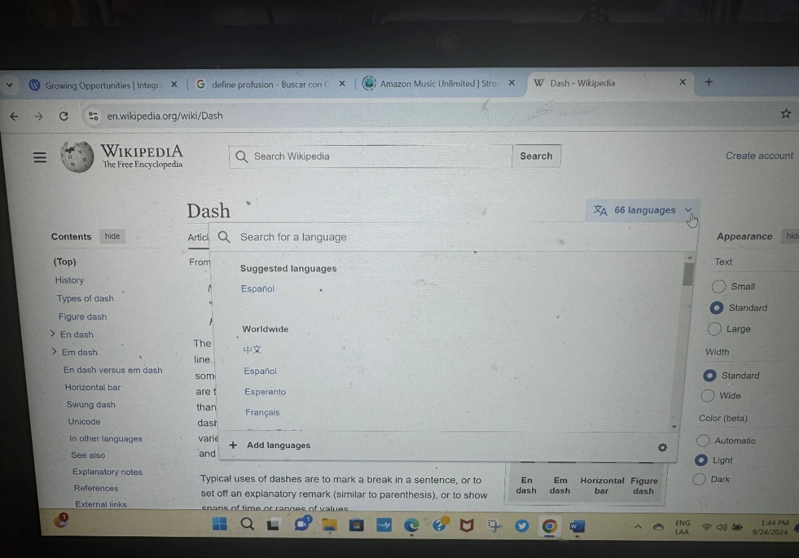
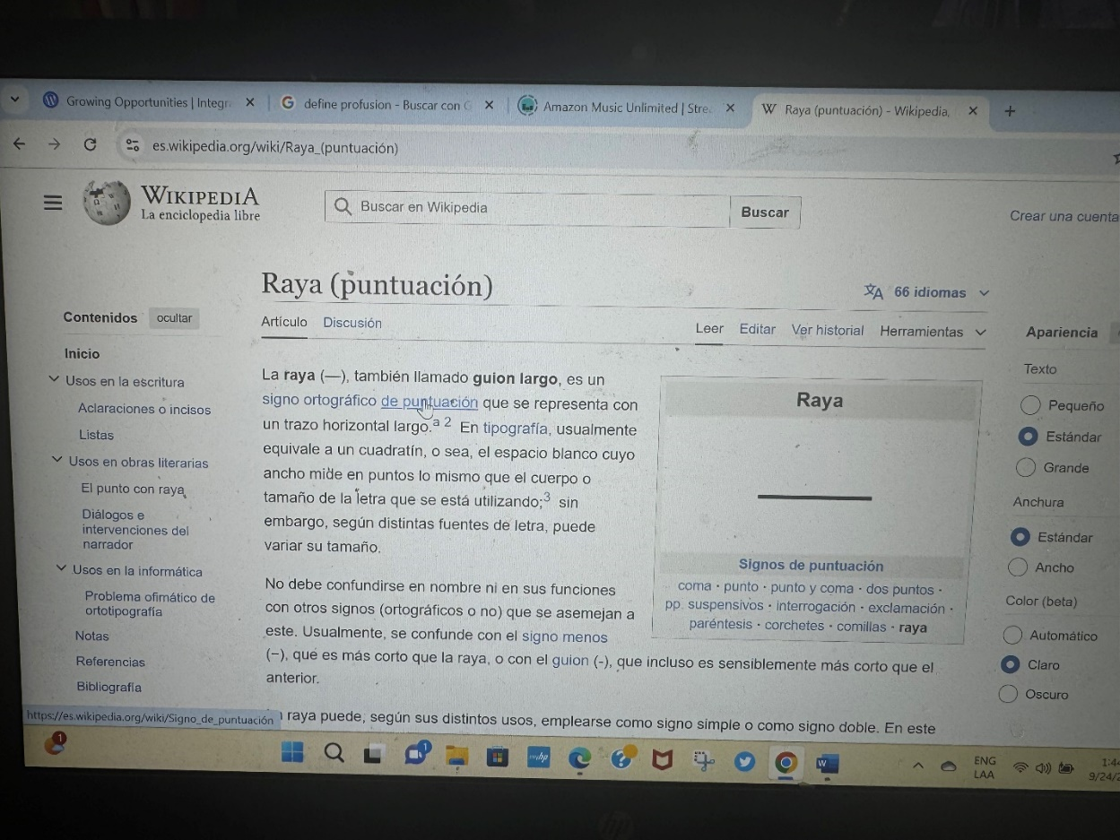

All this stuff we are describing now is supposed to be handled by a very professionally well-equipped, centrally located, and efficiently functioning Informatics Dicastery centrally functioning for Rome. Due to the nature of informatics, this Dicastery may have several offices around the world (each archdiocese or nunciature may be determined to have one person or an office handling this) or even have its biggest physical presence in a place other than Rome itself because informatics can work and function remotely. They don´t have to be necessarily physically in Rome only to work centrally for Rome, but they must function centrally and in an ecclesial way. Your friends at Anonymous can give you clear experiences about how to avoid hacking of sensible conscience information inside the Catholic Church. Yes, I may be considered the first informatic ethical hacker of ecclesial history, but as I said, I had very serious reasons to do it: what I discovered was a very serious and systematic conscience abuse that was happening institutionally, and I wouldn´t be able to have evidence of the abuse without the hacking happening. There is another very clear exceptional notion involved in this: this new Informatics Dicastery may be the first-ever Catholic Church Dicastery that is not physically located in Rome as central see, and that talks a lot about how the Church is called to evolve, mature, and evolve apostolically (following Rome as the first apostolic see) and also universally (embracing the whole world). If someone must do an ethical hacking of any ecclesial institution information in order to get evidence of conscience abuse going on and they are deliberately trying to hide, it must be this Dicastery of Informatics who handles it, not a person like me who is totally unexpert in informatics issues, nor any other ecclesial-external hacking entity like Anonymous. I did what I did because I had to do it in conscience, not because I professionally knew how to do it. The Pope does have the authority to authorize an ethical hacking of any ecclesial informatics conscience information storage device, cloud, or system if he, as Head of the Catholic Church on Earth, determines that there is very solid evidence of a possible ecclesial conscience abuse going on —this can also have economical abuse connotations: finding out informatically that an ecclesial institution is committing any kind of economical fraud and they are deliberately hiding it— and that the ecclesial institution is deliberately hiding it from the due ecclesial authorities that are supposed to oversee and correct the situation. Wherever, whenever, and however this may happen, it belongs directly to the Pope to authorize the ethical hacking against the ecclesial institution that is suspected to be committing the abuse, and must inform it publicly once the investigation of the Holy See has a definitive conclusion regarding the conscience abuse allegations —or any other possible kind of abuse— going on. The Catholic Church has all the due responsibility —upon God and upon civil authorities— to act ethically and take active measures to keep their ecclesial members safe from any kind of possible abuse. This is a very grave ecclesial responsibility that must be taken very seriously: no kind of abuse —sexual, conscience, economic…— can be tolerated anymore in the Church, and it must be the same Church that gives all the civil authorities all the due evidence of a crime once it is well established eclessially that what they found is also evidence of a civil crime happening in an ecclesial institution or with the collaboration of an ecclesial institution. The time of acting in the first place for safekeeping the good image of the Church is over. Now, we have evolved, matured, and progressed enough to affirm as Church that the well-being of the person and the ethical duty of acting according to all applicable laws comes first than keeping a “good institutional image”.
This perspective evolutive change towards ecclesial abuse is called to be so deep inside the Catholic Church that right after what is being contemplated as Solemnity of Divine Love, on February 14, the very first Sunday of Lent, it is also contemplated a Day of Remembrance of Ecclesial Abuse Victims and Survivors, a Sunday of Dignity, celebrating the human dignity of everyone and making ecclesial penance for the damage done through all the ecclesial abuses committed through the history of the Church —some very well known, like what happened with Joan of Arc, but we don´t need to go as far as Middle Ages to understand this: there are thousands of living victims of sexual abuse committed in an ecclesial context in our generation— until our days. That is a day to the life narrative victims be unconditionally heard and embraced —sometimes after years of being invalidated by the very own Church itself—, no matter if they choose to remain Catholic or not. That is a Sunday to recognize unconditionally the inherent dignity of all human persons, healing the hugest ecclesial body wound right after celebrating the feast of Jesus Charity on February 14, which is also celebrated as Saint Valentine´s Day —a day to celebrate Love and friendship— in the United States. Every archdiocese must have a person, a lay person very well formed in law, designated to be the one to who the lay or any religious person goes to inform any kind of ecclesial abuse going on in the archdiocese. They can have delegators if the territorial jurisdiction of the archdiocese is big enough to justify it: this dignity apostolate lay people who are designated to receive any information of any violation against human dignity being committed inside the Church must be reachable to anyone in the archdiocese, not longer than a few hours in a car. If it is truly not possible for the informant to go to the layperson formed to be a dignity apostle, the lay dignity apostle must go to the informant, but the Church must always remain reachable to receive confidentially, organically-systematically and safely any claim of abuse happening in any one of its ecclesial jurisdictions and institutions, and proceed accordingly the gravity of the alleged happened abuse and the provided evidence of such abuse happening, informing themselves to the civil authorities if it is necessary to be done, at the same time or right after the responsible ecclesial authorities of the jurisdiction or institution are also informed appropriately according to the circumstance (for example: if the abuse evidence is regarding a bishop or a regional head of a religious congregation, the lay dignity apostle won´t go to the bishop of the diocese he is serving, or to the regional head of the religious congregation to which the informant belongs, to report the abuse allegation and evidence. In that case, he has all the authority to inform it to the next organic hierarchical level, informing the abuse allegation and found evidence directly at the nunciature to which the bishop belongs, or to the central house at Rome of the congregation to which the religious informant belongs). Official evidence must be provided to the informants of what they informed the Church and of what the Church concluded about it: if it is proven that the Church doesn´t act upon an abuse, the informants have all the rights and even all the due civil and Christian duty —if they determine in conscience that the abuse happened and there is evidence to prove it — to act by themselves according to all the applicable civil laws and civil measures, like publishing and exposing everything in social media. The time of covering up ecclesial abuses for the sake of keeping a good image is over. The Church is meant to be the ecclesial family and home for everyone to be respected and embraced as an equal brother and sister with inherent human and ecclesial-sacramental dignity: we are all called to become a unique living sacrament of God-Love-with us, an irreplaceable living icon of God-Love-incarnated-in-us. When it doesn´t happen that way because the Church violates human or ecclesial dignity, so abuse happens, and it must be informed and handled appropriately to the circumstances of each case when it happens. These allegations are grave and cannot be taken lightly: if it is truly happening due to the nature of human and ecclesial dignity, evidence will be there to examine, even in circumstances in which what is happening is not exactly a civil law violation, or it is not yet, but it clearly already is a human or ecclesial dignity violation being committed in ecclesial environments. We will give a clear example of this: denying unjustifiably or improperly a sacrament to someone is an ecclesial dignity violation, although not being by itself a civil law violation, except if it can be proven that it happens as part of a social scheme of discrimination happening in the parish against the person that is being denied the sacrament: discrimination is indeed a civil law violation and must be informed to civil authorities as soon as it is proven that it is being committed in a parish. This is the reason that a rightly-formed persecuted Christian who is not allowed to receive sacraments and formation in an ecclesial way due to persecution or any out-of-his-control reason —like lack of priests to give the Eucharist as often as it should be given— is especially given the state of grace (in Spanish: gracia de estado) to receive ecclesial formation and incarnate ecclesial communion in other supernatural ways, like dreams or contemplative prayer: you will never see God Love denying ecclesial sacraments and ecclesial formation to anyone in an unjustified way, He will always make possible that the ecclesial dignity is as respected as the human dignity is currently understood to be respected by all the applicable laws, including human and civil rights and what would later will be the fraternal rights.
You, beloved reader, may not realize now why all these details are important. Trust me, all this needed to be understood to help me reach the point of standing tall and proud of all that I am years later on the University of Puerto Rico, Rio Piedras campus. That comes way later, but for now, let´s explain the last factor regarding Opus Dei and my civil filiation to the UPRRP.
After all that I have humbly told, making clear all the mistakes involved, not only the institutional ones but also my own personal sins, so the whole circumstance could be understood in the clearest way possible, a last factor regarding Opus Dei and its relationship with my filiation with the University of Puerto Rico, Rio Piedras campus, must be told. I had never had a filial relation with my own blood relatives, because I had always been the “different one”. So, I had never accessed the “interior world” of no one. As I did what I did, although it was done with the right intentions, it was awfully wrong… it was the first time I was able to know people from the inside, and I knew it was sacred ground. As a matter of fact, as far as I remember, I NEVER repeated what I read over those years, and I only wrote about it in Arabic in my notes so no one could understand me, and I was VERY SURE to destroy all those notes before leaving Torrebella. Well, the fact is: that was the very first time I was faced with the fact that there are “certain common elements” in the “inside life” of people, inside of what we would later become more defined as a “personal formation process”. I prayed that in that Tabernacle, people —if seen from inside— have como elements in their formations, and that was not an institutional nature at all. That was the very first root —not yet conception, but the first intellectual trace— of my beginning to articulate that personal formation is systemic in its nature, because, from those readings, I began to realize that there are common grounds in all personal formations, but you need to know people from inside to know and see that. The rest is history. As I said before, there must be highly ethical standards to research human beings regarding their integraction, because they have dignity, and that has serious repercussions in how you study integraction. You can´t simply dissect personal formations; you would destroy the person from the inside… but if you are quite enough observer and are able to observe people from inside out during a relatively long period of time, you will see it clearly: there is a systemic common ground in how all persons are being formed and becoming who they are called to be. In this case, these women believed they were called to be saints and, despite all the institutional issues, truly strived for that ideal according to the institutional praxis, which they were totally unable to see as wrong due to the very same nature of cult that articulated the Opus Dei praxis. It wasn´t her fault what was going on. They also had issues, like me, with the institution but thought that the problem was in them because the institution told everyone.
When I have prayed about this topic, when I have contemplated this topic, I have contemplated that even if I wasn´t properly a priest or a spiritual director, the same confidentiality ethics of a confessionary should be applied, because what they wrote was meant to be discussed in a confessionary or in spiritual direction or was the fruit of those discussions. Blessed be God, there was no social media for me yet, or because I was beginning to use it, I didn´t use it for that purpose. I never wrote down on a computer or digital device what I read, and I never repeated anything again. I barely remember one single thing of all that I read, the one single thing I shared for strict evidence reasons as a warning sign to Opus Dei, so they are unable to deny what I am telling in this text. The intimacy of people is sacred ground. I played with fire and got burned. The lesson was learned and served me well later: when I became a teacher, I NEVER played with my student´s intimacy. They had the right to remain silent and simply not answer something to me but to God, and if I kept a record of something, I was always under the strict circumstance of needing evidence to demonstrate what the students were being through their own kind of abuse, like it indeed may happen to any teacher… but in my circumstances, I already knew what to do.
After I have explained all these prior factors related to Opus Dei, my social filiation with the University of Puerto Rico can be properly understood. I was not the same student in year one and year two of my undergraduate studies. From year three and beyond, I became a completely different student, mainly due to the changes that were a consequence of my new ecclesial filiation with Opus Dei. I began to get all kinds of fails in my grades and evaluations, and needing to get Ws to avoid them being in my registrar transcript as an F. I began to go to class totally unprepared sometimes. I began to be lost intellectually. I began crying with frustration and impotence, and professors saw me crying. I was so unstable emotionally sometimes that someone, at some point —I don’t remember who or where, but someone suggested it among the professors—suggested, due to my very particular interest in the Middle Ages (nobody else cared about Middle Ages around me), that I was Asperger. From that point, a whole parallel reality was configured, defining me as Asperger and creating a whole psychological struggle issue, trying to explain what was going on without being able to realize yet that what was wrong was not only in me; there was an external institutional issue, too, that I was totally unable to speak about not only I wouldn´t be understood if I spoke in the Faculty of Humanities of what I was going on through in Torrebella… I would be severely reprimanded in Opus Dei's environment for doing so. They had a very concrete way to say this. In Spanish: “los trapos sucios se lavan en casa”.
There was an issue that clearly wasn´t psychological in its nature at all, and it began to be seen clearly in year three, although in the University of Granada, it began to be evident: I was absolutely unable to learn a third language grammar. I tried it repeatedly and failed consistently, no matter how hard I tried, even taking time from where it was none to actually study for my language classes, which were five days per week, including the mandatory laboratory. The issue began to reveal itself as something way more complex than a simple lack of time; something else was going on. I clearly had a learning diversity. I won´t say I have a learning disability, because ADHD can only be considered a disability where there is no flexibility, like in Opus Dei environments. At that moment, at the University of Puerto Rico, I was considered different; I learned in a diverse way. I was not considered to have ADHD, nor told to be disabled and that I have ADHD, which was done in Pamplona later, but it was clear even to my Student Dean mentor that something was going on with my learning style when learning languages. I had never been professionally assessed for this, but I confessed it was lifelong; as good as I was in Spanish High School, I had always mimicked way good what others around are doing, even if I myself am aware of not being able to understand “a very basic grammar function” right. I had a hell of a time in high school with grammatical trees in the Spanish class, and I could never understand that part of the class, but I mimicked what people around me did and passed everything without problems. Just to give you a hint of how severe this is on me, I was able to understand the function of direct objects fully when I became an ESL teacher. That is a very basic grammar notion, but I had been totally unable to grasp it all this time. I have told way a lot of times through my life, from my teenage years and especially during my English language learning period at the University of Toronto at Mississauga (I spent a summer in Toronto learning English; I asked that instead of a quinceañera party) that people around me feel I am not listening to them, that I am ignoring them, but I wasn´t aware of that. It was true; I would eventually know it: sometimes I completely lack auditive attention, although I do hear the sounds perfectly. The issue will become quite clear with what happened in the terrorist attack at the University of Navarra: I worked inside a building about 25 feet away from where the bomb car exploded. As a matter of fact, less than 5 minutes before the blast, I was right beside the window that was located exactly beside the bomb car, it was a glass window. I have never forgotten that, I was processing a graduate admission of someone I knew at a desk of the registrar´s office and went right back to my Admissions department exactly in time to avoid being directly beside the car bomb and harmed by the blast: I was seated in my desk when the blast happened, and it was the hardest explosion and the hardest sound I had ever been exposed in my whole life. The fact that no one died in that terrorist attack was a true miracle, and no one realized it fully. Well, after the blast, I clearly had post-explosive tinnitus and had a huge problem processing auditively. It was not normal; only I was having the problem. Then it was seen: my auditive processing —not my audition— seems to have some sort of dysfunction. I got myself into Tomatis Method therapy for a while in Pamplona, and it helped a lot, but I was unable to afford that for too long, especially in Puerto Rico, where it cost thousands of dollars. Parallel to my auditive processing dysfunction —my auditive processing capability is clearly way below my visual processing capability— there is something that I now call dysgrammatism.
Dysgraphia is the dysfunction in handwriting, which was revealed at the University of Navarra, but I had always had difficulties with “writing like a girl,” as my teachers said, from my primary school years to high school, way consistently. Handwriting requires a great effort, and quite often, I end up scribbling ideas; instead of properly writing them, I am thinking too fast. Writing with a computer is essential for me to process ideas properly, according to my intellectual speed. Do you know how frustrated you feel when you write on a computer and begin to write way slower than your physical keyboarding pace? That is how dysgraphia feels, and it is a very anxiety-inducing issue when you are intellectually creative and need to find words to define your ideas, but you are losing most of your valuable intellectual energy dealing with your lack of writing speed and physical clarity. Dyslexia is the confusion of letters of place, which would also be revealed at Pamplona, I never manifested it before. Dysgrammatism is not being able to grasp the grammar functions if not explained very visually and with colored concepts, which also takes an awful amount of time and energy; besides the intellectual energy you already need simply to learn something new, to establish a new synaptic connection in your neurons and grasp the concept intellectually. One of the reasons I am able to write this text, besides finally being properly medicated with Adderall for my ADHD, is because I am using the app Grammarly, and the grammar is not an issue for me now, thanks to that app. It costs the whooping 30 USD dollars per month subscription, a huge amount of money to pay for a single app (my music app costs only 12 dollars, Twitter costs me 25 because I don´t want apps, Canva costs 15… and way a lot of the people of the world have a monthly wage of less than 30 dollars), paying 30 dollars for a single subscription of a single app is a lot) but due my agrammatism, Grammarly is literally an intellectual lifesaver. That app makes a huge intellectual difference for me.
So, besides the dysgraphia, the dyslexia and the dysgrammatism, it is quite suspected that I also have Auditive Processing Dissorder, something pending yet to be more studied by Psychoeducative Sciences. In my circumstances is not so clear and evident to distinguish, and I will try to explain in short words why.
Throughout my life, everyone has been able to see my evident intellectual giftedness, especially in relation to highly extraordinary verbal skills and creativity. That is unquestionable. But no one saw my ADHD because gifted girls, especially twice exceptional girls, are awesomely good at masking their disabilities and making everything appear normal. Twice-exceptionality is not studied often, and it refers to students who are both gifted and disabled at the same time, as happened to me. What happens quite often with very bright, twice-exceptional girls is that they mask the disability with their giftedness until a point of “no compensation” is reached: the girl can´t be gifted enough to compensate for the disability for longer than that point. For me, that point was reached when I arrived at the University of Navarra. There were clear signs prior to that point, but due to my also very highly exceptional filial circumstances, no one was able to see it. No one, absolutely no one around me in the Faculty of Humanities, suspected I had ADHD; what was suggested was that I was Asperger. No one understands a very simple premise: ADHD manifests differently in girls. In me, hyperactivity is intellectual hyperactivity, not physical hyperactivity like boys. In me, the motor that doesn´t stop working is my mind, not my body. In me, impulsivity is emotional impulsivity, not physical. No one was able to identify me as ADHD because… I was a highly twice-exceptional girl, also in highly exceptional filial circumstances.
In the case of twice-exceptionalities, what often happens is that there is a spectrum of diversity in cognitive skills, and you see that there is a huge asynchrony among them due to the twice-exceptionality. No one can know for sure if my Auditive Processing capability is indeed disabled or if there is simply a natural developmental cognitive asynchrony: my visual-spatial processing and creative reasoning are so, so, so gifted, that a normal auditive processing capability is seen as a disability, simply because it is not at the same gifted level than my visual-spatial and creative cognitive capabilities. Whatever the reason for such asynchrony between my auditive processing capabilities and the rest of my cognitive capabilities is, it is clear that I am deficient in auditive processing, which may be due to an asynchrony —as I just explained —, or may be due to lack of auditive stimuli around me when I was a baby and in early ages, no one spoke to me, and I simply heard sounds around me instead of processing them as filial relation. I do remember hearing a lot of TV around me while I was growing up in my early years, and I remember I loved to sing from a very early age, especially in the parish. I sang in the chorus of my parish for almost my whole childhood and my whole teenage years until I left to study at the university… but I was always totally unable to read music sheets from very early. I never went to music classes. When I was finally able to get a psychometric cognitive test, I got an IQ of 140. I searched for some words on the iPad, not because I didn’t know them, but because I was a perfectionist enough to want to corroborate the information. I joined MENSA, but it meant nothing to people around me; no one understood was being intellectually gifted, besides the fact that you are always getting yourself into trouble and not finishing degrees instead of simply doing what you are being told to get the degree. MENSA doesn´t have a chapter in Puerto Rico; their nearest chapter is in Miami. I didn´t renew my subscription; it meant nothing to those around me, and what I needed was an intellectual community to learn together what I am exposing in this text. Well, being a member of MENSA did mean something around me, and the word was used quite often around me during a period of time. In Puerto Rico, when you tell a girl you are a mensa, you are telling her you are stupid.
Here you have a photo of my Mensa membership card, untouched; I never was able to use that… I think we would be talking about a “connection”, according to the integractive model of personal formation.
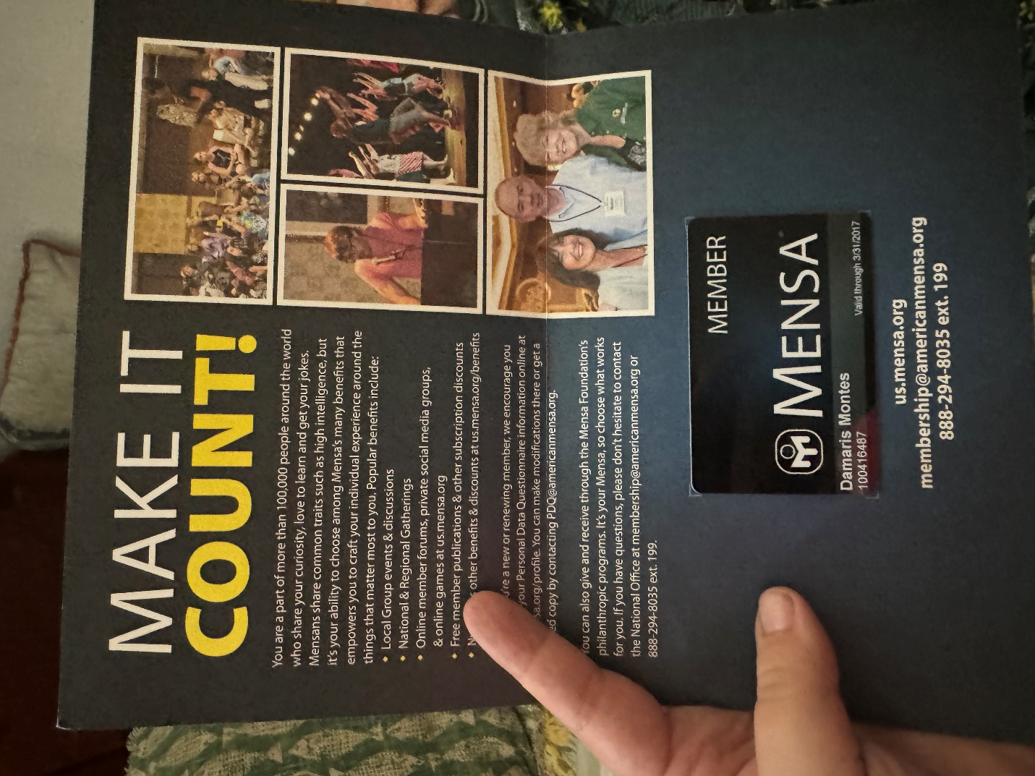

All that I just clarified about the nature of my cognitive twice-exceptionality is now clear, but at the moment of my third, fourth, and fifth year as a student of the Faculty of Humanities, I was simply considered by the Student Dean —who was also part of my interdisciplinary students committee, she was also my mentor— a learning diverse student: we all have the right to learn in a different way, and I was clearly bright, especially after what she knew me from year one and two in my undergraduate studies. Of course, she noticed that something was going on with me. She asked me thousands of times, and she truly trusted me when she asked me for the reasons for what was being commented about me. We talked a lot about academic development and Spain, she herself was in the process of completing her doctorate there. We had a clear personal affinity, and she was truly an outstanding academic mentor and student dean in every sense; she sought to understand students, and for her, every student was different; she literally told so and lived what she preached. The University of Puerto Rico is hugely bureaucratic, but she made it way less bureaucratic. It was a huge load for her not knowing what was going on with me and having nothing to say from my side about the reasons for my clear decline in academic progress, beyond what I was able to say without lying and compromising Opus Dei, who I still considered my family: “all what is happening right now is due a family crisis issue that I cannot explain, but they will cease if I move to Spain.” She had the huge bravery to let me remain silent, although it could be required for me, as someone else suggested, to receive a professional psychological assessment at my own campus facilities; the campus had a psychologist and a whole office for providing psychological support to the students who needed it, and I was clearly having a huge psychological issue, especially due the frustration and crying issues. She trusted me and respected my choice of remaining silent without making me feel guilty for remaining silent, nor did she make me understand that she felt less trusted due to my silence. She only wanted what was best for me; she let me know that, and I won´t ever have enough words to thank her for that.
Here is my official proposal for Individualized Studies. Every student of the Individualized Studies Program of the Interdisciplinary Studies Department of the Faculty of Humanities had to prepare a proposal like this, signed as each committee member approved it, and the Students Dean of the Faculty of Humanities was a mandatory signature, that was the reason she was also an academic mentor for me, besides the evident personal-academic affiliation that connected us both as intellectuals because we both were in the process of completing PhD/requesting admissions in/to universities in Spain. The approved individualized configuration of my interdisciplinary humanities studies would be considered an official undergraduate BA degree curricular configuration to the Registrar's Office of the University of Puerto Rico, once officially approved by the whole committee. The process of informing the Registrar that such configuration was achieved and that the Registrar processed it was managed by the Student Dean's office; they were the ones who informed me through my department that everything was approved and in order to go ahead with each step of the process. Of course, I also had to expose my reasons for such a proposal and my vision for approaching such a configuration of a BA. When the proposal process was over, it would be seen as an official change in my enrollment status, showing my new status as an individualized student. My degree was configurated with the following free electives, guided directives, and concentration courses (AP means “Advanced Placement”, “UGR” means “University of Granada”, and “UPR-RP” means “University of Puerto Rico, Rio Piedras Campus”:
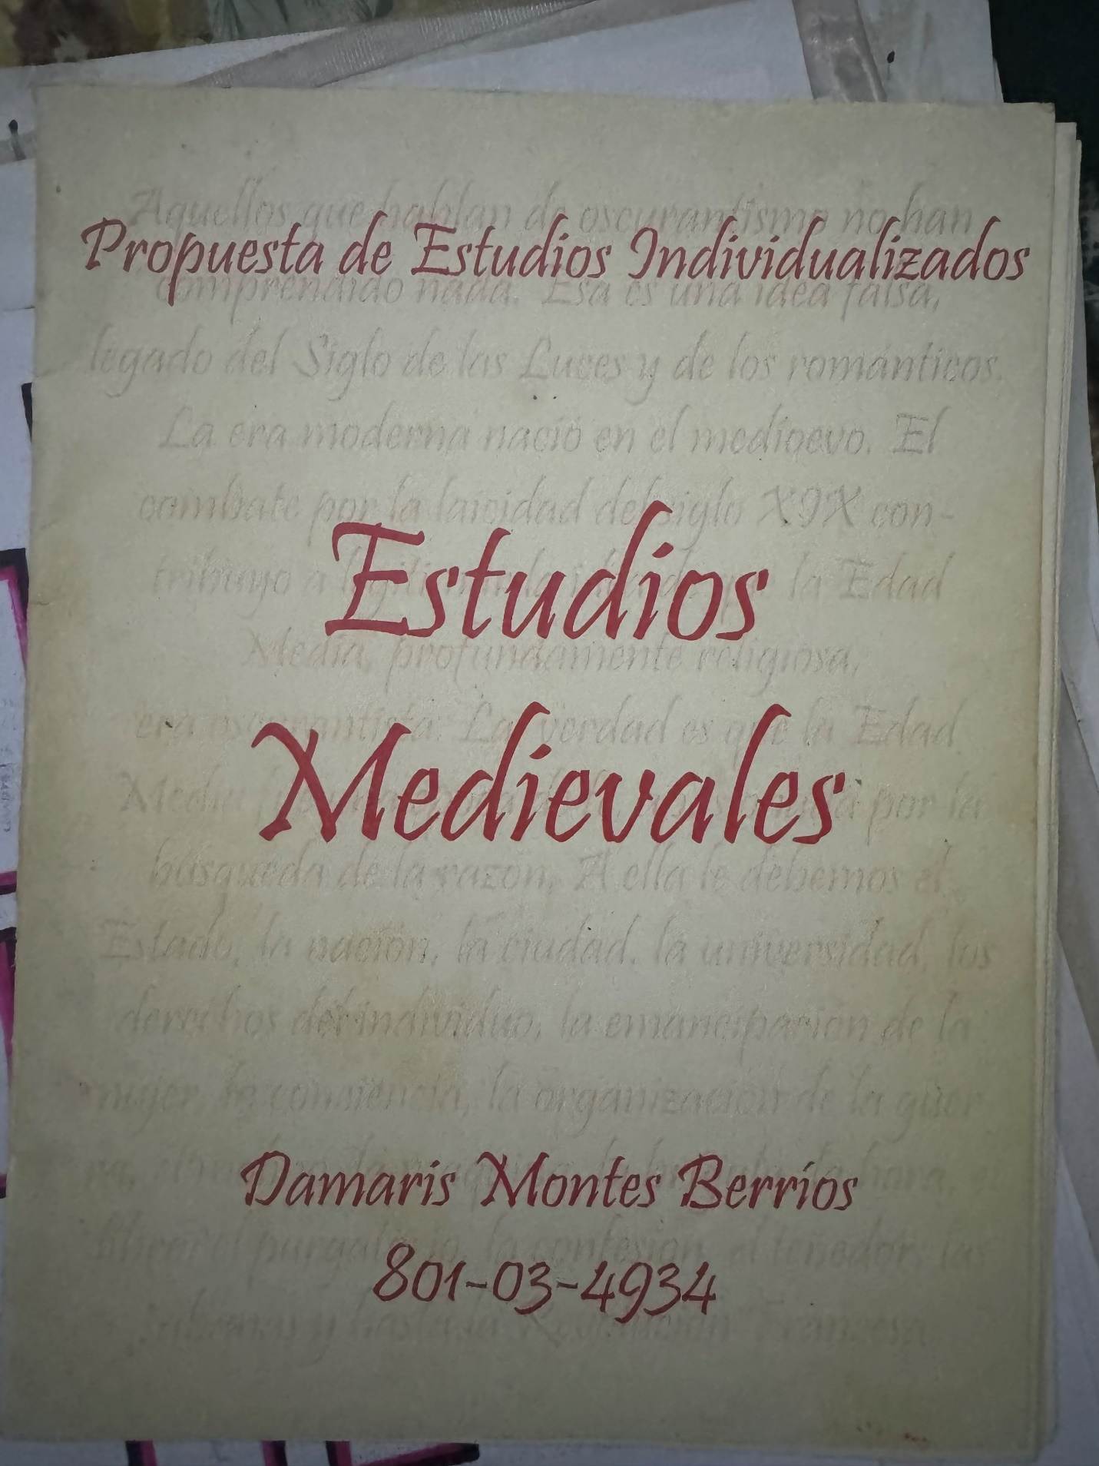
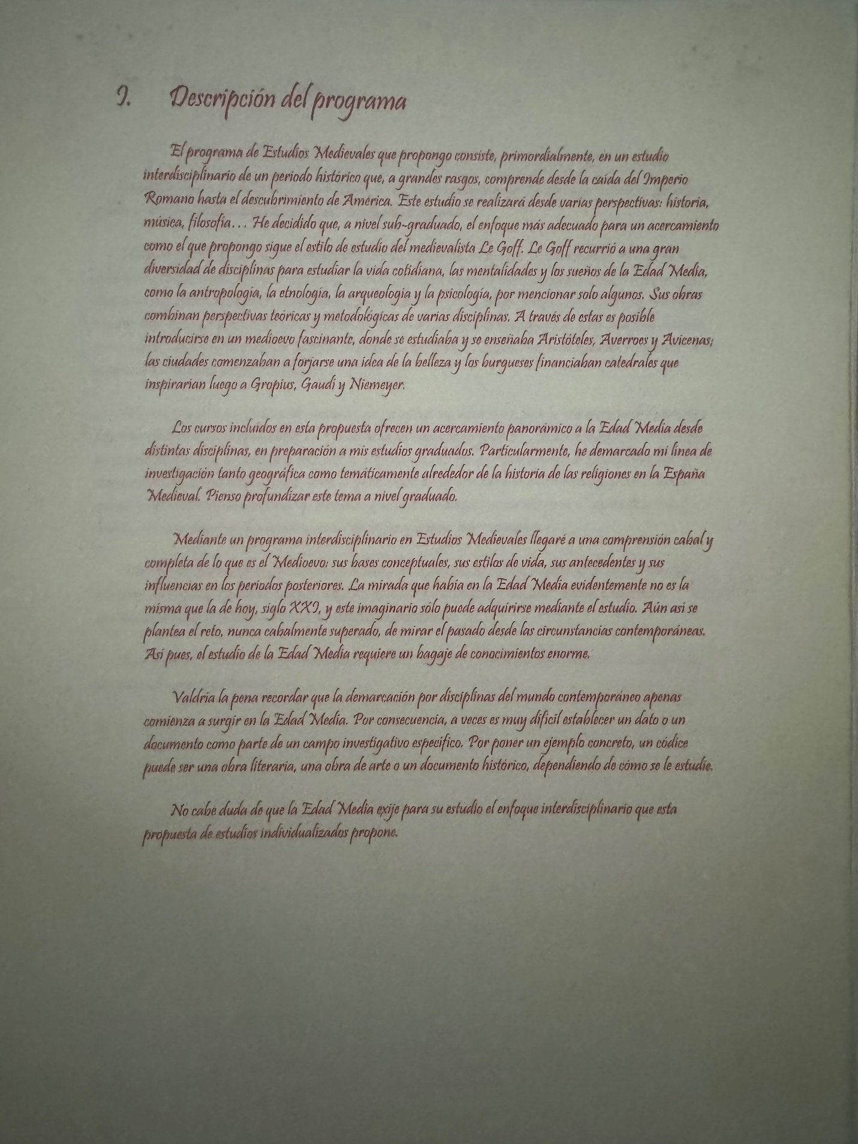
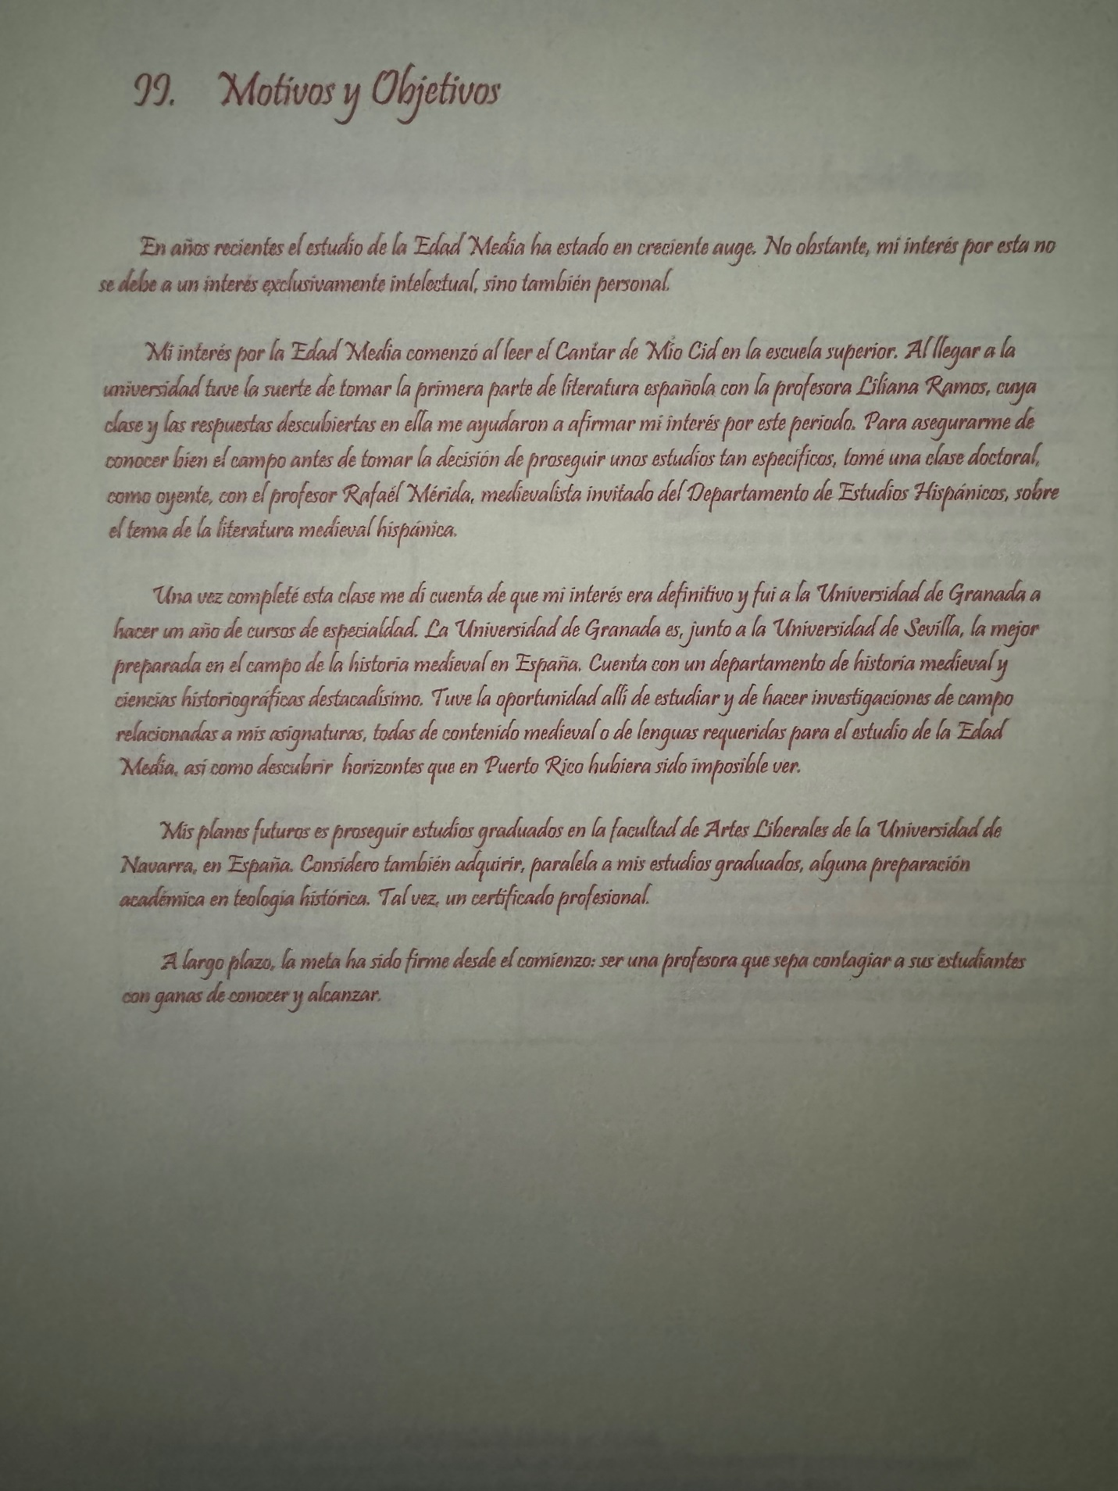

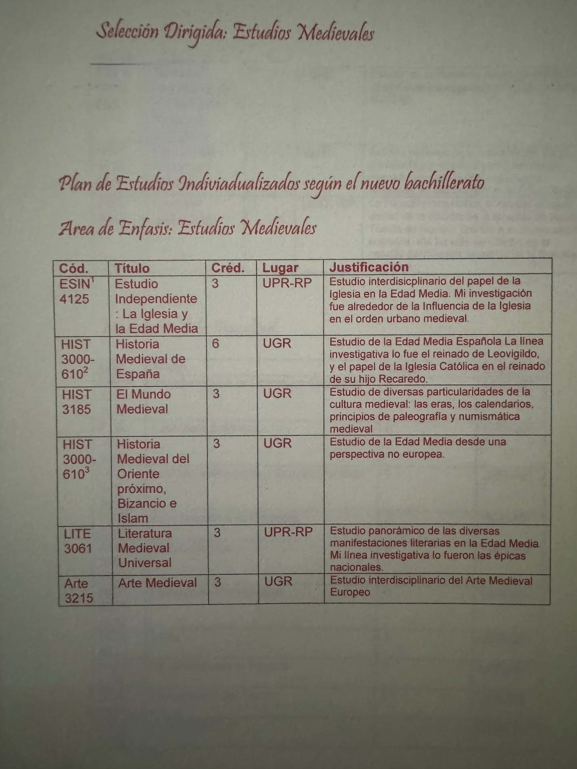
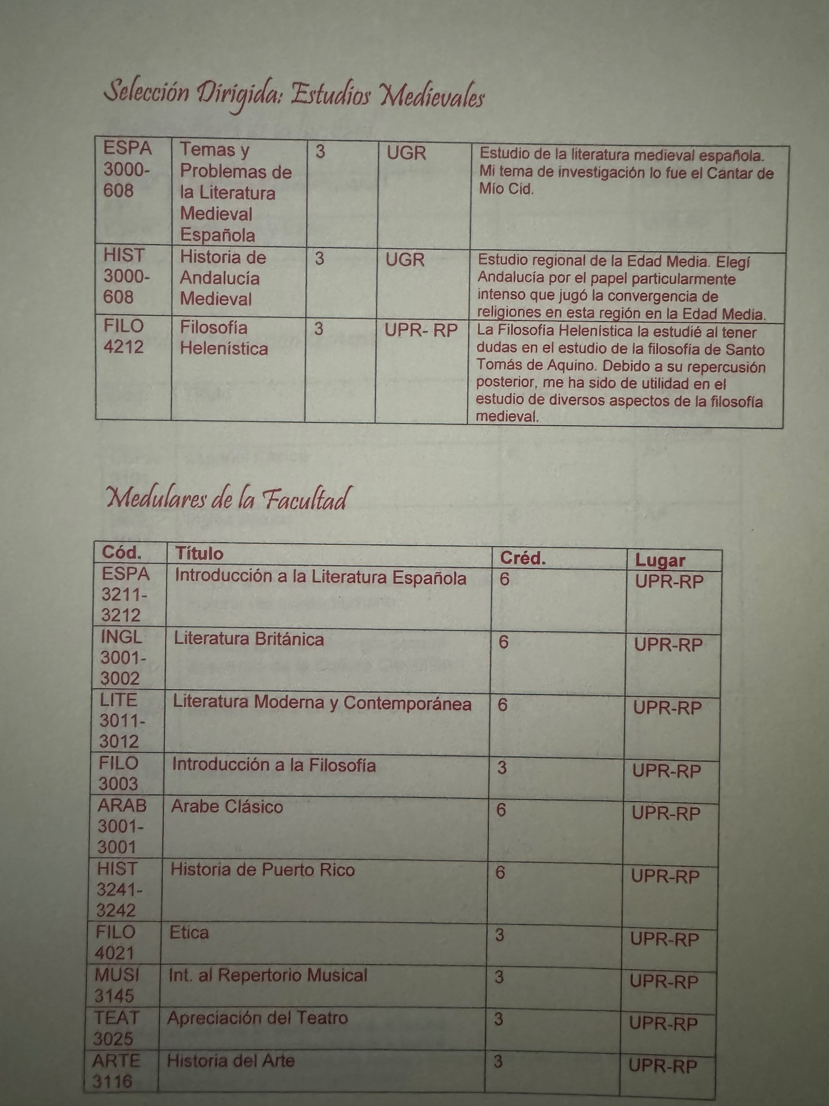
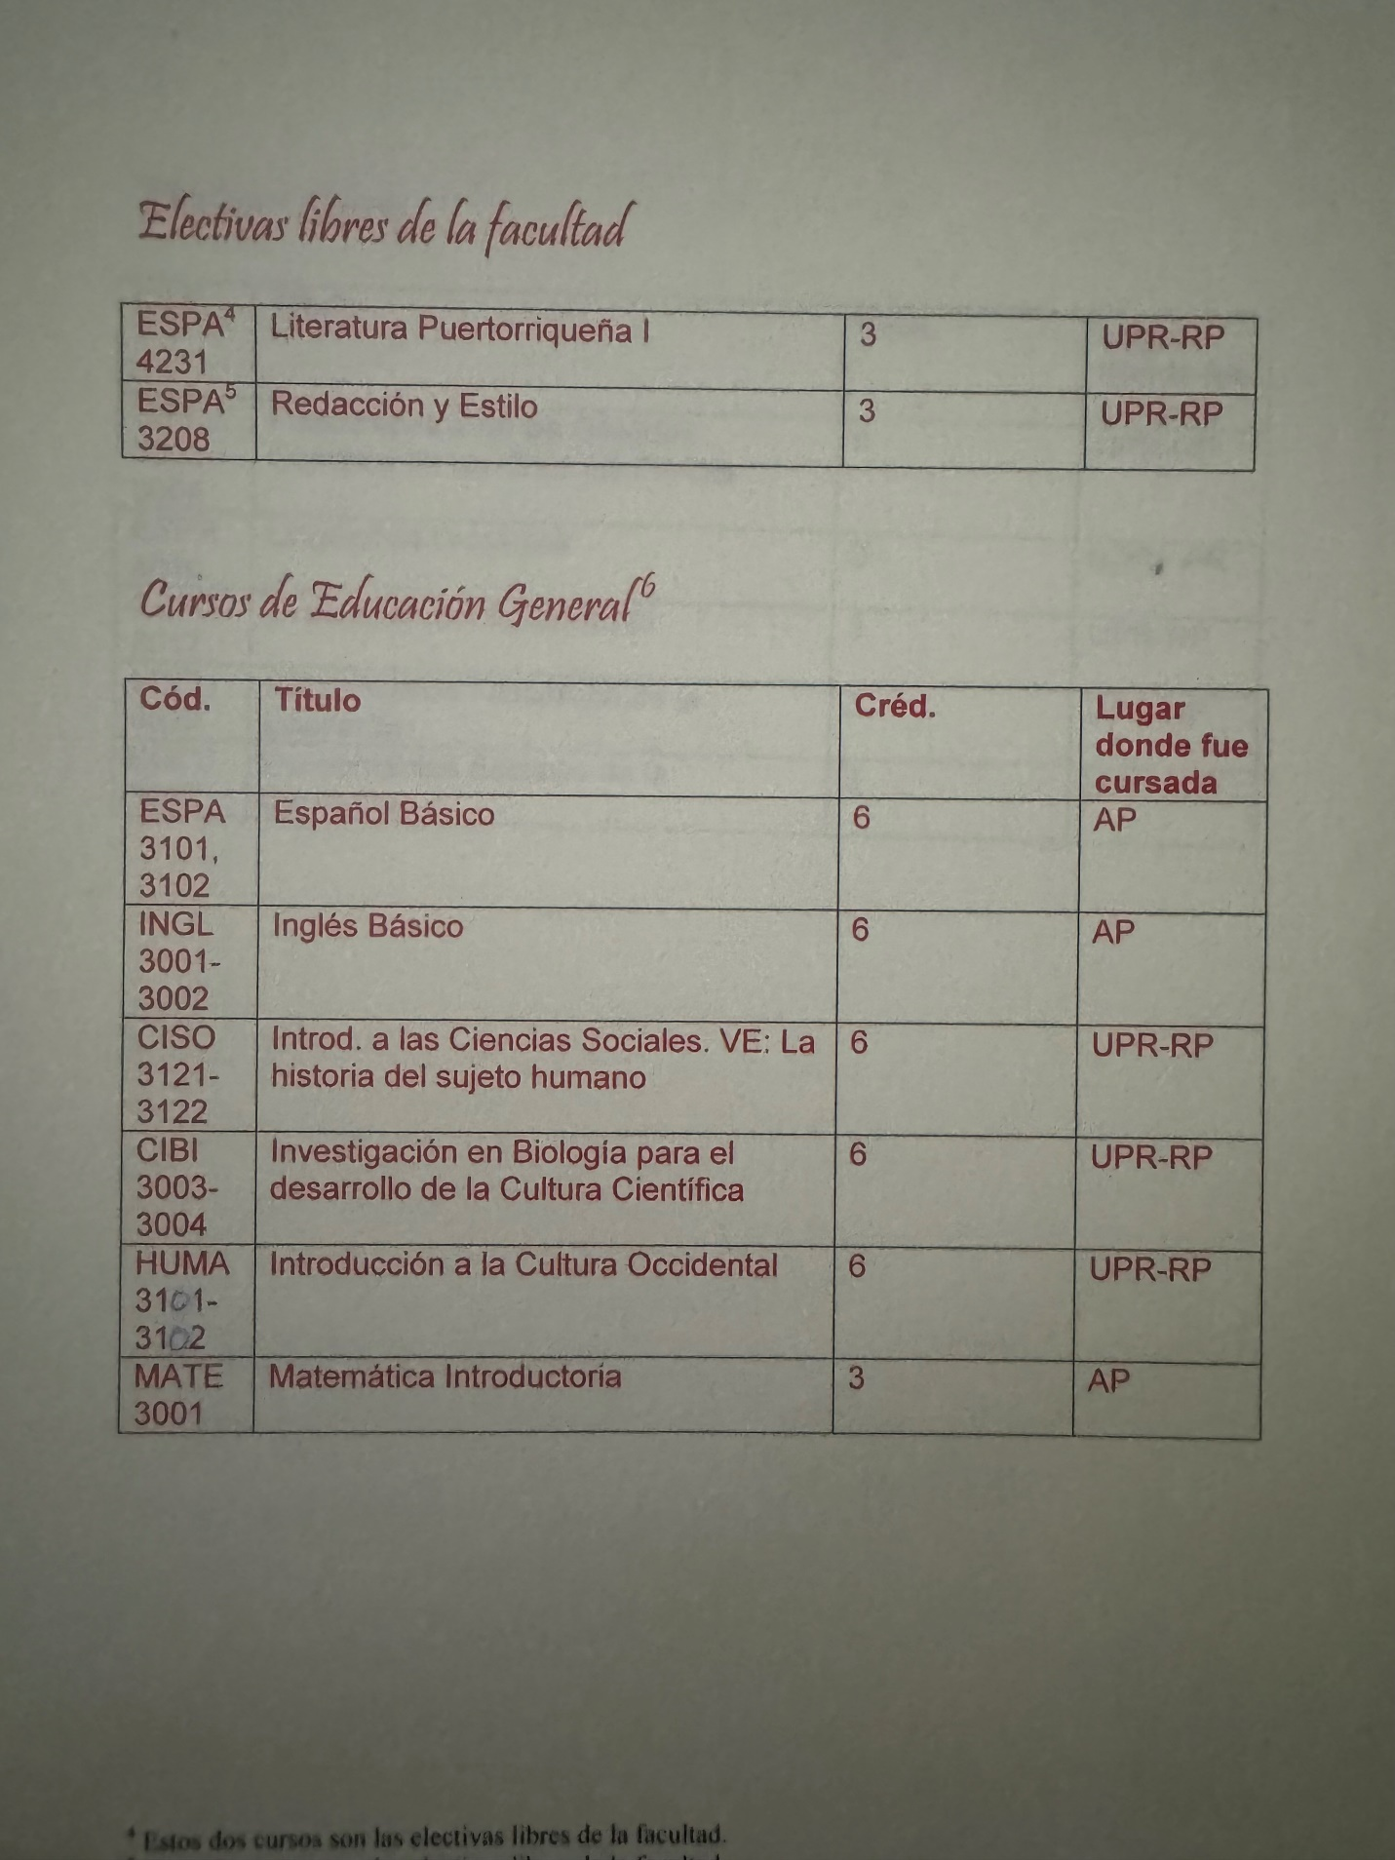

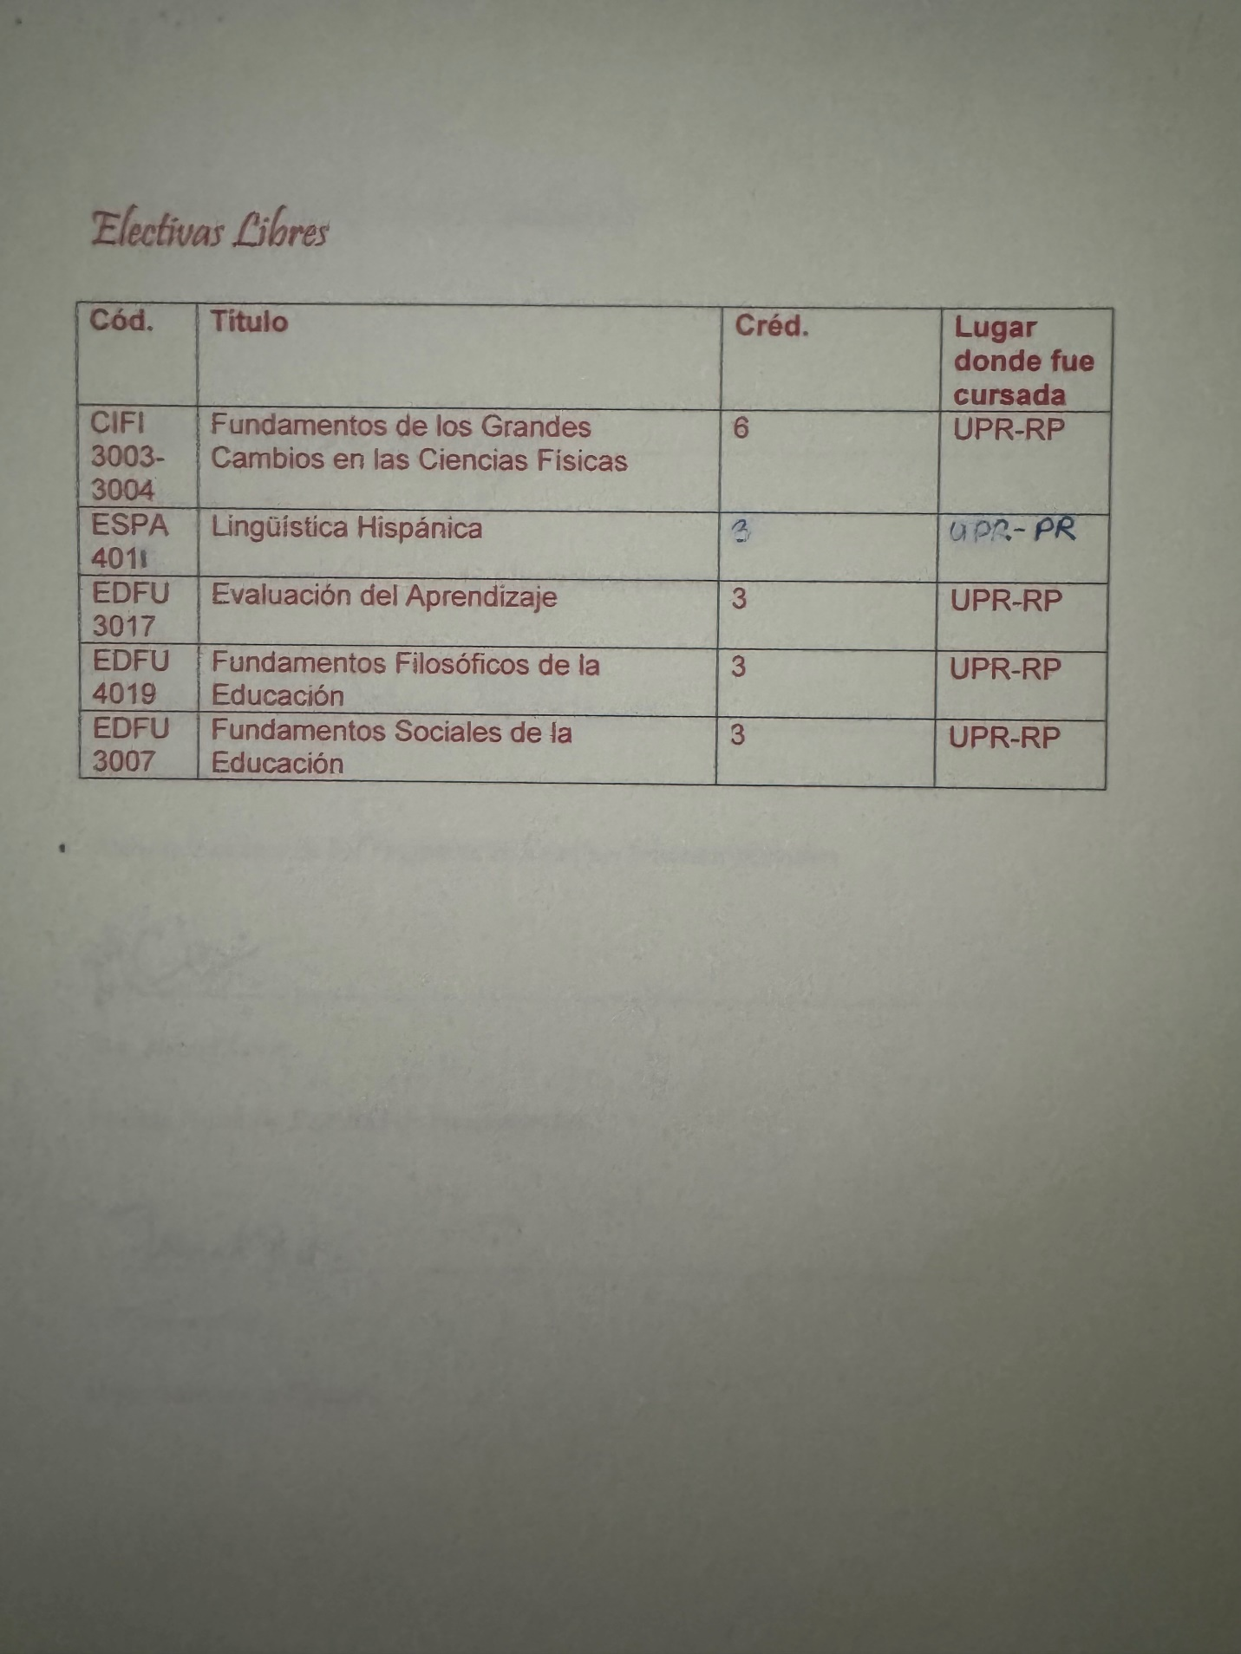

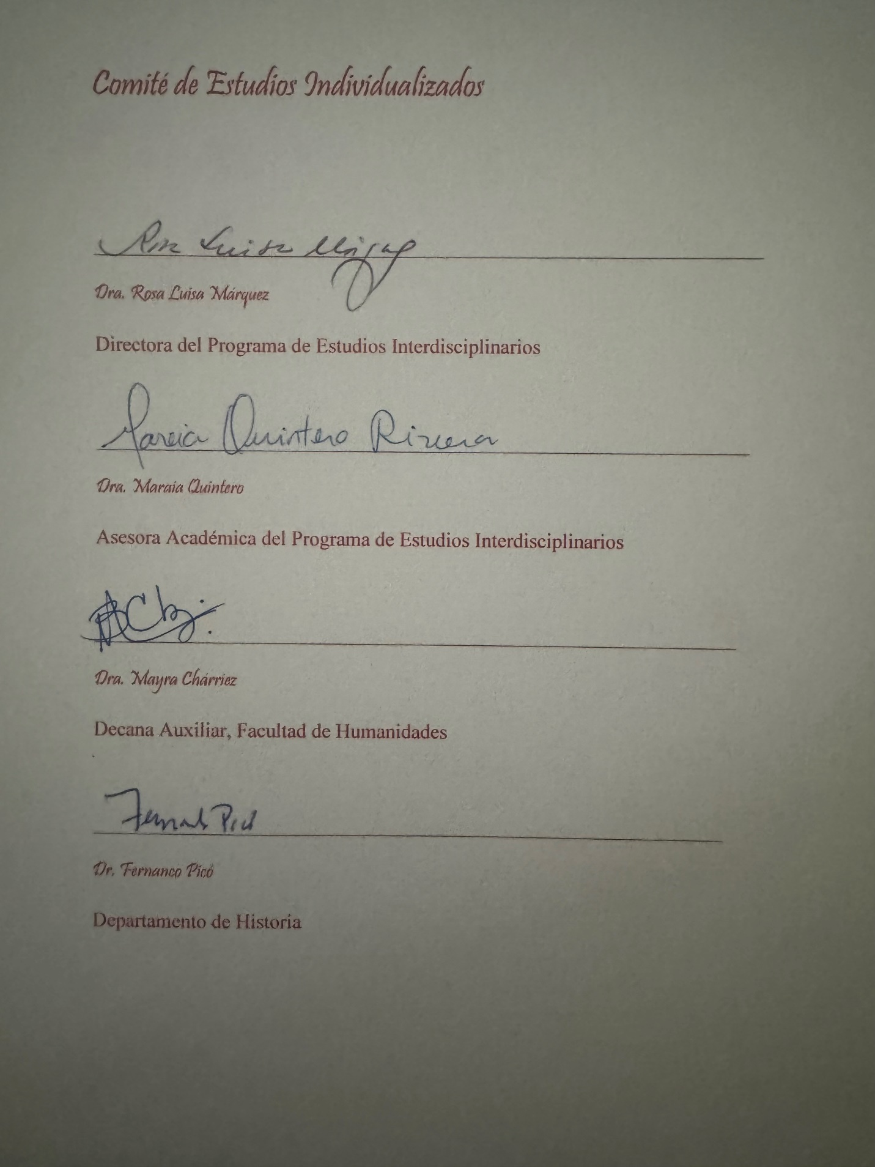

You may have noticed that I had to reconfigure the whole proposal again according to the New Bachelor; my proposal was not originally that way; it evolved, and through the whole process, I remained in contact with the Student Dean, consulting and asking as I needed. Besides that, you need to understand this clearly: I got like about two or three Ws in some semesters, maybe even more, at least one per semester… and and each withdrawal request form had to be personally signed, by hand, by the Students Dean of the faculty. And besides all our mentoring time, each of those times I requested a withdrawal, when she saw my name on the form, she sighed, because she knew I was a bright student and shouldn´t be failing like that.” What is going on, tell me, please tell me, something is going on, we have help to provide, we have counselors, we have psychologists, we can work this out in other way instead of keeping Ws…” I had no way to tell her at that moment. I don´t remember exactly which semester was, but there was one that she literally told me: go inside the office, let’s talk, in a very serious-still-filial tone, before signing the authorization of those withdrawals: “this is not you, you are not like this, what is happening”. She never got tired of trying to know what was going on, but still respected what I chose not to say. She signed my W requests because it was her duty as a student dean to do it, not because she believed she should grant me them. When it was suggested that I should be required to go to psychological therapy, I told it so in Torrebella. The answer from the directors at Torrebella was cold and severely unflexible: “If you need to go to a psychologist, you can only go to a psychologist that is “from home” —that means: it is a psychologist designated by the institution, possibly a supernumerary — and that is in Ponce.” That was two hours away from San Juan, and I had no car of my own, nor time to spend in that. The Student Dean didn´t force me to go to psychological assessment in order to remain in the faculty and eventually graduate —although I didn´t tell it that way in Torrebella, I needed to fabricate a whole parallel reality narrative to deal with what was going on and give them a reason to be so distressed, that wasn´t clearly exactly the university, as they believed, but I was supposed to be happy as a member of Opus Dei, and everything was meant to be perfect to the institution, so you have to fabricate a whole parallel reality frame in order to the narrative being able to fit everything— but she clearly stated that she agreed with me going to psychological assessment if I wished to, she highly recommended it, and it could be done within the own campus. I won´t ever be grateful enough to her for her unconditional understanding and human and academic support through a period of huge crisis in my life. She never shortened my wings. She always helped me to aim high. She truly inspired me to become a better student and person, and her filial influence is key in my personal growth: I have only been able to graduate from faculties that have a student dean like her.
At the fourth year of my undergraduate studies, it became evident that I was totally unable to pass a third semester of a third language, as it was required of all students of the Faculty of Humanities. The Faculty granted me several exceptions to help me pass Arabic III, even with individualized measures (the test was granted only to me; I was the only student at the Faculty attempting Arabic III in an individualized way, according to the individualized nature of my department at the Faculty of Humanities, named Individualized Studies), but it was futile: no matter how much I tried, and not even in a one-to-one learning environment, and no matter how good I did write in Arabic, I couldn´t grasp the grammar functions. I also failed Latin and French. There was no way I could graduate with three courses in the same third language; I was only able to pass two courses. I shouldn´t keep trying because it was clearly frustrating me in an unhealthy way.
The brilliant and pro-student Students' Dean was the one who figured out what to do with me: a new curriculum configuration was coming for new incoming students of the University and Faculty of Humanities, at that moment called “nuevo bachillerato” (in English: new bachelor). That new curricular configuration required only two courses in a third language for Humanities Faculties students. She proposed to ask the Registrar for an exception to make it possible for the new curricular configuration to be applied to me so I would be able to graduate with the BA I was supposed to get from the beginning, but with a different configuration. I would be the first student to be applied the New Bachelor. Due to the individualized nature of my degree, I was a perfect candidate to be granted such an exception, that can be precedent for other students. I also had a huge luck, pure luck in the whole process: the new bachelor did require a math course for Humanities Faculty students, and I would be totally unable to pass a math course at this time, after years of studying absolutely nothing of math… but because I passed the Math Advanced Placement Test in high school, that test could be counted as the equivalent to the Math course in the General Studies Faculty that I would be required in the New Bachelor. This means that due to pure luck, I wasn´t required to study the Math course in order to request the exception to be applied to the New Bachelor: I had a 3, the minimum grade required, in the Math Advanced Placement Test I took in high school
All was set to the Student Dean's request for me the exception of applying for me the New Bachelor's configuration. No one knew how long the process would take, and the University of Puerto Rico is very well known for how bureaucracy makes things way more complicated than they should be. The student dean was totally determined, like me, to request the exception from the Registrar simply because that was the best for me as a student. I shouldn´t keep trying to pass a third language class, but I do need to deal with my lack of proper academic progress issues after finally reconfiguring everything again as a new individualized studies proposal, reconfigured according to the new bachelor's. She trusted I would get the approval, so I officially began arranging to study graduate study in Spain. She dealt with the issue of me being granted the New Bachelor's by the Registrar; I really made an effort to pass the classes that were left to graduate instead of getting Ws. The exception that was being requested for me was not small, but not impossible either. Eventually, two factors were determined for the Students Dean and the Registrar in the whole exception request process. The first factor was that it was clear, quite clear, that I tried to pass the language courses several times, in several languages, and I wasn’t able to due to my learning diversity, not due to lack of effort in trying to pass the classes. It wasn´t fair to request me to pass a class that I wasn´t able to pass due to a learning difference; if it could be avoided, and it could be avoided if I applied for the New Bachelor, the exception would clearly be in my best interest as a student. The second factor would appear eventually: I would be accepted into the University of Navarra Liberal Arts master’s degree, specializing in the Middle Ages. The Student Dean argued with the Registrar that I was already granted admission to a graduate school; all that I needed was to be granted the BA in order to leave.
The process took way longer time than expected, but no one lost faith, nor me nor the Students Dean. We kept communicating regularly as I kept completing the last requisites for graduation and took a few extra classes, especially in the Faculty of Education, simply to have something to study. I was granted the status of candidate of graduation without yet knowing if the Registrar would officially grant the exception. I was trying very hard to do my best in my circumstances and kept organizing everything in order to begin graduate studies at the University of Navarra in January. In the University of Puerto Rico systems, graduations are granted either in December or in May. My graduate studies began in February, so I should be traveling to Spain in January. I must graduate in December to be able to go. December passed by and neither the Student Dean nor I knew if I was granted the exception. I was so stressed that I chose to buy the flying tickets to Spain and leave no matter what the Registrar chose to do, whenever they chose to do it, after such a long time waiting for an answer. I was already in year five, and all this began to be seen in the fourth year. For dealing with the Registrar of the University of Puerto Rico, you need a lot, a lot of patience due to their extreme bureaucracy: everything needs a paper, a form, a meeting, and a process. I didn´t have to pay anything for this, but the wait was extremely exhausting. We were literally making the impossible happen.
I don´t remember in which day of the week before departure it happened. Maybe it was the day before departure. At the very end, the Registrar informed the Faculty of Humanities that I was granted the exception and was officially graduated from the Faculty of Humanities… in January, around a day before my departure to Spain to begin graduate studies. Literally, I knew I graduated about a day prior to my departure to Spain to begin my graduate studies. That meeting with the Students Dean was a monumental triumph: go, girl, go to Spain…
It was then that I realized I am truly leaving, I am truly leaving this whole issue with Opus Dei behind; what happened in the region of Puerto Rico won´t happen again there… Well, as I already explained, it repeated again, and even in a more systemic way, because a whole University system was involved this time. I was initially granted admission to the University of Navarra as a Liberal Arts graduate student. I would later switch directly to the Doctoral Degree of Philosophy —at that moment, it was possible to be admitted to a doctoral degree in Spain without a master's— and also be admitted to study in the evenings in the ecclesiastical faculty of theology, whose first two years are philosophical classes. I wasn´t able to graduate at a real university graduation ceremony: the graduation ceremony that I was supposed to attend was in the summer, and I was in Spain at that moment. I gifted my graduation tickets to the secretary numerary, who graduated the same year as me, but in May, as everyone else, as it is supposed to be, especially for Natural Sciences students, who usually follow the Medicine School route and need to graduate in time for their summer research internships (I always had complained of the lack of summer research internship programs for humanity students and what would later be known “integractive sciences”: Natural Sciences students had plenty paid research options, like RISE and others, but we had none). They only gave two per student, and she wanted all her family (of about seven or eight brothers and sisters, plus mom and dad: they were a supernumerary family) to attend, so she was seeking tickers desperately. So, the only graduation I had been present is my high school graduation.
There was a very particular experience that would be determinant in my process of leaving Opus Dei. During my last summer as a Humanities Faculty student at the University of Puerto Rico, I was required to attend full-time summer courses to complete my requisites to graduate on time. I was already considered a candidate for graduation—although it was not known yet if I would be able to graduate according to the new curriculum or not—and it was easy to enroll in the courses. That clearly meant I would only have about two weeks to rest between finishing my second semester and beginning my summer semester, and that I wouldn´t be able to go to the young supernumerary convivence I was supposed to be going because I would be studying full time, and at the same time, working on the Administration of the residence. There were too few numeraries in the center during summer, and the house could never be “left alone”: I was needed for that reason also. I was completely exhausted physically from everything that was going on, and I needed to rest urgently, but I was told the only way I could complete my required annual convivence as a supernumerary was by doing the convivence with the older supernumeraries. I would pay the youth supernumerary fees (the economic details are always important in Opus Dei), but I would be attending a full older supernumerary convivence.
I was also completely exhausted physically from my workload in the Administration of Torrebella, and they clearly didn´t let me rest in the convivence either. They didn´t even come to give me spiritual direction; they were too busy at Torrebella to do that. But I realized something very shocking while being there: how older supernumeraries were and what I would become in my older years if I remained a supernumerary. They saw their husbands as a charge (a “carga”), not as a blessing. I was graphically described by one of them how she had no other choice than to have sex with her husband because “he had headaches and needed sex”, she could deny him the sex even if she had no desire at all. Sex was not a communion act at all for older supernumeraries, sex was simply, said in Opus Dei's words, a matter of conjugal debit, like it would be a transaction with a debit card in the nearest bank ATM. I was also shocked how the auxiliary numeraries made extraordinary efforts to show home details to these ladies, especially during meals, but not few of them brought their own food to eat, including Jenny Craig frozen food, instead of eating the food that was being so evidently lovingly prepared to them. I, as an Administration worker myself, realized the huge efforts and tenderness that implied what the auxiliary numeraries were doing silently.
The” theology class” during the conference was a very boring conference, told straight from a text. I was even corrected for asking questions; I was interrupting. I chose to take internal documents available to the supernumeraries during the convivence, sit in the very last seat in the back of the place where the theology class was given, and simply study those documents on my own while the priest gave the boring-no-questions-allowed class. But… I made a mistake, and so they discovered what I was doing. I accidentally left a document out of its proper place (something like a wardrobe with keys). Usually at night, a numerary count of all the documents in the wardrobe to verify that all are there. A numerary, one of the directors of the convivence, realized there was an internal document missing. It was as Noticias volume, the official internal publishing of the feminine section of the Opus Dei, which I left very near my theology class spot (I didn´t take it with me outside the convivence site; what I did at that moment was an accident). As a matter of fact, I was the only supernumerary reading internal documents during the convivence, I never saw anyone else studying internal documents.
I went straight to the directors of the convivence, gave them the missing internal document, and explained what happened: I was reading and studying internal documents on my own because the theology class was extremely boring, and I was learning nothing; I was not allowed to even take notes. I forgot to put the document back in its proper place after using it, but it had always been there; I never took it outside the convivence site grounds. Two of the directors were furious and told me in a very rude tone I should not be doing that, that I must learn to do things as I am told, I must learn to obey. They were repeating something I was being told constantly in Torrebella, my spiritual information was clearly being shared. I was so shocked by that angry reaction from such a situation that I was left speechless; I simply began to cry and went out of the convenience house to the Ermita that they had there and stayed a long time with the Virgin. Finally, the other director of the convivence that wasn´t the other two (usually convivence has three directors: a director, a subdirector, and a secretary), a very old numerary that had difficulties walking, that was from the center where I belonged as an aggregated member, had enough spiritual delicacy to walk to the Ermita simply to talk with me. I immediately apologized because I knew walking long distances caused her pain, but she was not bothered at all by that; she was worried about me and came to talk to me with a very tender smile, not angry at all, very calm, and very motherly. It was the most beautiful conversation I had ever had with an older Opus Dei member. She was absolutely beautiful in everything she did and spoke. Said in short words, she thought the other two directors were exaggerating the issue. I explained to her I wanted to leave the convivence immediately, but she convinced me with her gentleness and soft voice to stay, although the other two directors remained quite vigilant to me not doing the same at the theology class again. Her wisdom was outstanding, and she clearly was an exception among all the blind obeyers in that convivence and, generally speaking, along all the older members of Opus Dei, who truly… scared me. Really I didn´t see myself in any of the older members of the Opus Dei I knew, especially I didn’t see myself in the older supernumeraries I was seeing around me in that convivence (it was my first contact with older supernumeraries)… but that older numerary with her natural gentleness had always was —since my times as aggregate, when I knew her for the first time— one of the very few exceptions of that rule. Later, in Spain, I would know a supernumerary with fidelity —she was one of the founder supernumeraries of Chile— and about 10 children, which would clearly be also an exception to the rule.
I stayed, exhausted and crying, but stayed, vowing myself I would never allow an Opus Dei director sending me to the wrong convivence again simply due institutional convivence. They could have sent me to a youth supernumerary convivence in another nearby territory, like the Dominican Republic or Mexico, as I told them, or grant me the exception, let me rest that week preparing myself for the summer semester and let me go to a convivence at Spain (it was already known at that point that I would be leaving to Spain at January), or in any other place had wider scheduling options —Puerto Rico, due to being the smallest of Opus Dei regions, only had ONE youth supernumerary convivence per year, in summer, either you got to that one, or you missed it—, but I wasn´t a numerary, and they only did those things for numeraries who needed another date for their annual convivence.
My last day in Torrebella was the saddest day of my whole life. Those to which I tried so much to help were going along with their lives, totally ignoring me. No one helped me to pack my things; I had to pack everything on my own. No one talked to me. So much time spent there, working in the Administration, doing apostolate, supposedly “receiving formation” to end like that, again, totally alone, like I had been my whole lifetime, totally misunderstood and not being able to find people who were like me, not able to find my place. After all that time with those women… it was finally clear: we were not family at all. I considered them my family, but there they were, doing their stuff as if I did not exist and as if I wasn´t crying, and they knew I was leaving the residence to which I dedicated the best energies of my young adulthood. After all the help I gave, or at least I tried to give… at the very end, I had to do it all on my own. I realized then that I simply was an object to be used for institutional reasons and then discarded. I had “a very funny way” (in Spanish: “una forma graciosa”, entendiendo “graciosa” tanto como “funny” como también “llena de gracia”) of expressing the same as an ecclesiastical student of the University of Navarra: I said I was the OVNI of the faculty. In Spanish, an OVNI is an UFO. What I meant by being an OVNI was: here I am an Objeto Volitivo No Identificado. I was an object to be discarded or used according to institutional purposes. I wasn´t considered a person with an identity and purpose of her own, as every human being is entitled to by nature, as I have explained with integraction.
I remember very vividly my last moment in Torrebella. The last thing I did was go to say goodbye to that Tabernacle, one last time. He asked something very beautiful: did you love Me while you were here? I answered: “Yes, beloved, I confess that I have loved you. I did everything here to love you; you were my deepest reason to remain here the time I had been here. Jesus smiled at me from the Tabernacle: this time was not lost; the time spent loving is never lost. You have loved me, and I have loved you too.” I came out of that residence completely devastated and crying, but with a lot of peace in my heart: I loved Him while I was there, and now He himself was telling me it was time to go. In such circumstances, very shortly after, I arrived at the University of Navarra, already in the middle of the process of leaving Opus Dei, although the decision became quite evident when I came back from Spain to Puerto Rico simply to go to a youth supernumerary convivence and they wanted to force to go again to an old supernumerary convivence, knowing how much harm it was done to me before in such convivence. I only traveled to Puerto Rico to go to the convivence that belonged to me, and now, already in Puerto Rico, they were forcing me to go to a convivence that was clearly going to make me more spiritual and even psychological harm than the already done. I was told a very, very famous phrase inside Opus Dei environments, used almost as a life-or-death sentence: “Either you obey, or you go”, I was told completely in a cold tone, as if my personal or spiritual formation truly didn´t matter, what matters was that I was ready to do whatever I was told, no matter what, like a Nazi. Obedience was so absolute that it mattered more than conscience. In conscience, I could not stand what was happening anymore: I have studied the internal documents and foundational writings very well, both from the inside of the institution and also from the critical perspective. I knew what I was doing when I stood firm: what they were doing was absolutely wrong, both in what should be the true institutional spirit and also according to the ecclesial sense, if the Congregation of Faith was conscious of what was going on, Opus Dei would be in huge troubles, but they had the contacts to hide and divert ecclesial attention with nice paraphrasing and other tactics that deliberately attempted to hide what was the problem: a huge praxis institutional problem. The problem was not in the spirit of the institution itself, but in how it was being practiced institutionally. They not only deliberately denied that, but they also tried to hide it from the ecclesial authorities who were supposed to stop this kind of situation.
“O obedeces o the marchas”, I was told in Puerto Rico. I never stepped back to the center and went to no convivence at all. I stopped speaking to them, and they stopped speaking to me. As soon I came back to Pamplona, I gave my lay spiritual director my final choice: I would remain in the institution according to the word I gave Him until March 19. On March 19, I will leave, for conscience reasons that are wide clear. I remained going to all the formations they gave to supernumeraries until March 19. In Pamplona, they even arranged quite easily for me to go to the annual retreat during my last months as a supernumerary member. As far as I remember that year, I didn´t go to the annual convivence all supernumeraries were supposed to complete each year because of what happened in Puerto Rico. That was the only thing I didn’t do that last year.
I left the next March 19. All this leaving process was as hurtful as a divorce, and it required months of waiting until it was finally over… all this happened when I began studies at the University of Navarra, which belongs to the Opus Dei. I felt very, very alone, in the human sense. I do remember which was the loneliest day of my life. Right after March 19, I called several times to my lay spiritual director simply to talk and to remain “friends”. She stopped answering my calls again, and I understood perfectly: now I was an infidel to them, I had no institutional interest anymore, so there was no friendship at all; I simply stopped existing for them. I was completely over; I was completely gone, and once again, I must find a place of my own. That day when I realized my call was being deliberately ignored and I was not nonexistent to them anymore… was the loneliest day of my life. It is not causality that it was in Pamplona that I began going to adore Jesus Eucharist in night adorations.
I already told you what happened at the University of Navarra at the beginning of this text. As I explained, my mentor was an exception among the professors. He clearly knew I left Opus Dei; everybody knew without telling me, but I had so many things to tell him and explain to him that due to institutional barriers that I knew were there, I was totally unable to tell aloud. I chose not to be open to him about what was going on for two reasons: the first one was that I believed there was “non-filial profiling” also happening at the University of Navarra, and I had very good evidence to prove it. It was evident in the whole University of Navarra that what mattered most was the institution: either you obey, or you go. They all were obeyers,, including my mentor, who was a numerary, probably since his teen years. I never knew for sure: he never, never told me the story of his vocation, he even never mentioned being in “curso anual” when it was very evident, he was in his annual numerary convivence, he told us he was on “vacations.” He chose not to disclose to me his vocation openly, so I also chose not to disclose my vocational issue and my “institutional des-filiation either. I always respected that boundary, but he always seemed to be an exception, and I always wanted to ask him: is this supposed to be this way? Can you really say that all this is according to the spirit seen in the foundational writings, or this is simply, as I was seen, something strictly related to the praxis, that was even non-ecclesial (the Congregation of Faith wasn´t given the praxis book to check them, and they were tried to remain deliberately hidden from them, that was quite evident… can you say all these non-filial and institutional practices of the “spirit of Opus Dei”, as they were being presented and obeyed blindly without any space for critical perspectives… is truly institutional and even truly ecclesial? That was the conversation we never had. I never knew how much he knew, but he could have known a lot. I chose not to speak, and he didn´t speak about it neither. He didn’t even dare to criticize openly his fellow professors, who clearly did things wrong, with very few exceptions, like Professor Llano, who my mentor deeply admired; he simply chose to show that there were other ways to teach and did it differently. For that reason, for daring to be different in a world where everyone was supposed to obey the same praxis or leave, he always earned my respect, both as an intellectual and as a person. His reasoning style and knowledge, both philosophical and cultural, about how to teach a class properly and about the art of writing to think better, were amazing. In the intellectual sense, he was my Dumbledore, but I knew that there were boundaries I should not dare to cross, like asking him about his vocation and if the Opus Dei he knew when he joined was the same as the one he knew now that he was older if things had always been the same, and if he thought things could be changed in a world of blind obeyers to an awfully wrongly articulated praxis. I wasn´t clearly called to be a blind obeyer. I was called to be a reason-driven, creatively-Holy-Spirit-driven formator, not an obeyer. It took years for me to eradicate the notion that I was a disobeyer of God.
No need to repeat myself at this point. What I have done now was clarify more about the extremely difficult situation in which I arrived at the University of Navarra, especially because I was leaving Opus Dei but remained in a university that belonged to them. While being in Navarra, I had a huge faith crisis: could I be creative and remain in the Catholic Church? Could I be who I am and remain in the Catholic Church as I am? The de-filiation process that I endured at that time was gruesome, and it would have cost my faith (it almost became a de-filiation process from the Catholic Church, too— if it hadn´t been due to the contemplation of a Jesus Charity that I began in the night adorations of Pamplona. I already explained what happened there… so let's move on. Using the words of Dumbledore (my mentor professor at the University of Navarra was a genius writer and a genius with words):
“Let´s walk…
I think if you so desire, you will be able to board a train.
And there it would take me?
On…
Help will always be given at Hogwarts, Harry, to those who ask for it. I always priced myself on my ability to tell a phrase. Words are, in my own not-so-humble opinion, our most inexhaustible source of magic, capable of both inflicting injury and remedying it. But I would, in this case, amend my original statement to his: help will always be given at Hogwarts to those who deserve it.
Do not pity the dead, Harry; pity the living and, above all, those who live without love…”
At the very end, they were right, I had no numerary vocation. I would later discover I clearly have a marriage vocation, but they tried to shove me through the throat by force and did not allow me to evolve, mature, and progress enough to understand it on my own, not force. There are other ways to be a numerary, I would later know, like being a numerary professor (I don´t know what the equivalence in the United States to a Spanish “numerary professor” is, but there is an equivalence of that in the United States). I was completely wrong —and it was the mistake of a lifetime— assuming I had a numerary vocation, and that Opus Dei was my family, my place to be as who I am and as who I am called to be… and that mistake had huge filiation and de-filiation implications in my natural filial dimension.
I asked for a few months' leave from the University of Navarra to be spent practicing/implementing educational philosophy (I was supposed to create a philosophy of education according to Peirce’s line of thought, so I wanted to observe real classroom dynamics to do so) in Puerto Rico, in the school I graduated from High School (Holy Family School). Although Iesu Amor’s iconography began to be contemplated in Pamplona’s Eucharistic adoration, at the same time I struggled with leaving the Catholic Church due to not finding how I could be Catholic and creative at the same time —I felt I couldn’t be able to be myself as Catholic after what happened with Opus Dei— well, the painting began to be plasmated in a February 14 and kept being painted in the school, while I have classes as I gave as an art class (painting) as voluntary teacher (I was not paid to do what I was doing, nor I asked for it or not it was expected to: all that I asked was observing learning dynamics and have a social impact related to my graduate research, so I was allowed to teach voluntarily middle and high school students, given during their lunch break, and I was also allowed to observe classes if the teacher allowed me to, and I knew perfectly which kind of teachers would allow me to do so. I spent most of my graduate student loan there because I felt that creating a concrete social impact with my philosophy of education research should be part of my graduate degree process, so part of my graduate degree funding should be spent creating a social impact with my degree. It was there, as I taught arts to teenagers, that I realized I couldn’t be myself at the University of Navarra, and if I remained there, I would eventually lose both myself and my faith. I wasn’t able to hold “parallel reality” for more time. So, I chose to leave the University of Navarra, not due to believing myself I would not be able to write a PhD thesis and study also an ecclesiastical degree if I was given the creative freedom, the learning freedom, and personal space to do so… but due personal integrity reasons: because I needed to do a PhD that also implied how to learn how to be myself as the best person I could be, but in the first place I needed to be possible to articulate myself according to who I am and who I am called to be, and after what happened in Puerto Rico Region and as part of my filiation and eventual de-filiation process with Opus Dei, that was totally impossible for me in the University of Navarra. It was the bravest choice I have ever made, truly. I also began to articulate my Christian vocation as “giving light” to a Jesus Charity as an incarnated icon of God's Love, plasmated incarnated in my whole personal formation. I will never forget how one very tiny middle school student saw how huge my painting of Iesu Amor was, and he told an expression that would be used quite often in my class: “This is epic!”. I managed to put all their paintings in an exposition whose gallery night was on March 19, as you may see in the following poster I prepared as an invitation for everyone, especially parents —I gave to the family of each of my students an invitation for that night, given personally—, to come:
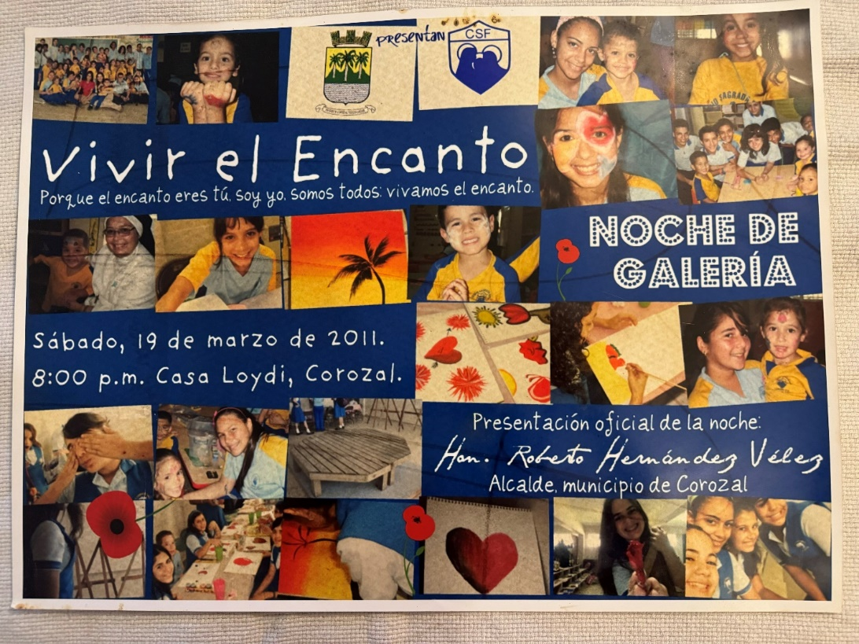
The exposition was called “Vivir el Encanto” (Puerto Rico is called “Isla del Encanto” in Spanish, and I taught the biggest lesson of all my class in the presentation of that exposition: you, students, youth of Puerto Rico, are the ones called to become the living enchanted of this island, aiming to always keep growing until becoming the best person they can be, that is how we build together a better Puerto Rico. The mayor of Corozal, where the school is located, was there, and the students’ work done in my class was properly recognized in the civil sense: there was the social impact of my graduate degree. Iesu Amor was supposed to be there: it was broken “accidentally” by my progenitor male, and so it was unable to be exposed there along with the student’s artistic works. Iesu Amor would finally be exposed and shared for the first time, as I already explained, at a February 14 in the theology faculty of the Universidad Central of Bayamon. The Theology Dean allowed it despite our clear ideological and intellectual differences. It would take me a whole engineering project to repair Iesu Amor structurally, but I did it in order to be presented at the WYD Youth Arts Festival in Brazil.
I already was contemplating, but not yet polarizing, the theology of light then, as an observing teacher and voluntary teacher who still was a graduate student of the University of Navarra, but the theology of light would officially begin to be consciously and explicitly palabrabrized as such on a December 8, in travel to Los Angeles. I was in Hollywood, literally walking in the Wall of Fame; I saw with my own eyes how futile it is to simply aim to be famous and have a good image, and I explained in a letter to Eduardo Verastegui how I used him as an anatomical model of my painting, including all the context of that choice. I traveled to Los Angeles to deliver the letter personally at his Metanoia production company (I think that is the name of those things in Hollywood) in Los Feliz, but I was told they received no personal packages; everything they received was through postal mail. So, despite being personally in Los Angeles, I had to send the package with the letter the very next day, December 9. It arrived shortly after. The package also contained the painting of an ascending star (I contemplated him as a “Stella Coeli”, not merely as a Hollywood star, for reasons I won’t explain now) and my handmade rosary as “payment” for his time reading the letter (it was a truly valuable rosary, it was handmade with silver and lapis lazuli stone, that I would later know, is new fraternity color), that was extremely long. Theology of light began to be conceived as such in that letter. I never got an answer, and he had plenty of ways to answer it if he chose to. I also left that emotional dependence behind after understanding he was simply someone playing the “parallel reality”, but I was not in the disposition to play that game with anyone, at least not voluntarily, anymore.
Integraction as a personal formation model articulated systematically would begin to be articulated around the same time I was both an observant teacher (I was named “research teacher” in the school in which I was, or something like that because that was my intention, although not recognized officially as such by the University of Navarra) and a voluntary teacher. It had not yet begun to be a whole natural system on the University of Navarra grounds, but during the social ethics class in the Universidad Central de Bayamon, immediately after I came back to Puerto Rico from Pamplona.
I was clear in how I wanted to do a PhD creatively and with a social impact also like I was doing in that Catholic school as a “research teacher.” I don’t think that humanities and philosophy PhD should be only sitting at a desk writing: it must have a social impact also, and it should be truly an integractive research project. Could I do that at the University of Navarra? No. Could I continue with Iesu Amor and attempt to keep contemplating, developing, and eventually presenting a painting of a Jesus Charity in the ecclesiastical faculty of the University of Navarra? No, especially due to my Opus Dei de-filiation process being already consummated. All that I was expected was following norms and instructions; personal growth was not involved, and… above all, I didn’t want to need to have longer a parallel reality to be able to reconcile the cognitive dissonance between who I am and how people around me see me (in the University of Navarra social context, I as an infidel due to leaving Opus Dei, and I was also not-bright enough due systemically failing to follow simple instructions and failing “very basic philosophy classes”…).
So, after four years at the University of Navarra, I left it with more than 100,000 in graduate federal subsidized loans and without a degree at hand at all, not even a graduate certificate. An economic factor is important to mention here: I was totally unable to handle a real living budget on my own; I was still functioning in “Administration” settings. Despite having well enough money to spend on my academic and living expenses at Pamplona, I always got short of money. At the very end, I had for a few months an economic dependence on my ex-boyfriend, who paid for my housing and had to steal to eat (the University of Navarra doesn´t have meal plans for students to pay for the whole semester, as it is usual among United States Universities of their intellectual caliber. When I got short of my student loan money during the semester, I had to steal to eat). That was enough for me, too. I had to cut that emotional dependence relation in order to be able to mature as a person, and eventually, I did; I cut all contact with that ex-boyfriend whose emotional dependence-inducing behavior caused me so much harm and at a certain point made me to think the unthinkable: as I was pending to know if I actually was or not pregnant of him (that I would eventually find out I wasn´t) I did consider abortion. If I hadn´t sinned more because Heaven didn´t allow it to happen, I should have left him behind way years ago instead of using emergency contraceptive pills and having unfilial sex simply because “that was the way he showed love”, but I needed to overcome the emotional dependence issue to choose to leave him behind, and I finally was able to do so as I began the process of contemplating a Jesus Charity; it was grace who saved me and gave me the initial strength to do what I knew it must also be done, besides leaving the University of Navarra. That choice of leaving him behind was another personal integrity choice that made a huge difference in my life.
At the University of Navarra, intellectually speaking, although I didn’t get an academic degree, I did get the beginning of the integraction: the biological nature and the ontological nature (the transcendentals discussed in Metaphysics class, that revealed a whole new world to me, the content was pretty good and quite intellectually rigorous, the problem was the teaching methodology and the evaluation methodology), that I already knew and contemplated that were “parallel”, but I had still no idea of how to join that parallelism intellectually. I literally had no social intellectual notions at all and the University of Navarra. The issue was not only a matter of complete lack of interest in social impact in the University of Navarra academic research style, at least in philosophy and ecclesiastical faculties: in what was being discussed in classes, the social implications were not discussed or even assumed at all, and due that, I was still unable to “see” the socio-filial dimension of integraction there. Only one lasting filial influence remained from there through the years: I remained in occasional email contact with who was my thesis mentor professor, and he was kind enough to send me one of his books as a gift. That has been the only filiation that has remained from all my years related to Opus Dei, either as an institution or as a student of their biggest corporative work worldwide, the University of Navarra.
All that happened at the University of Navarra had already been told, but I haven´t told yet everything that happened after coming back to Puerto Rico from the University of Navarra. I already told you about what happened at the Universidad Central de Bayamon, which was the University I enrolled directly after arriving from Spain. In due justice, I should highlight again, for a third time, the tremendous importance of my social ethics professor at that University, who I also asked to be my confessor and who helped me a lot. Integractions owes him the seven principles of the filial dimension: I studied them in his class. There were exceptions also among the Order of Preachers, and he, as a friar of the Order of Preachers —like the Dean of the Theology Faculty— was clearly the exception, truly heroically loyal to truth and Magisterium. He is the most brilliant friar or religious person I have ever met, and he knew how to teach and preach with true intellectual rigor and ecclesial faithfulness. He completely disagreed with what was happening in the Theology Faculty and what I had already described. He actually allowed me to preach —me, a woman— in the pulpit of his parish (he also was a parish priest in the Holy Cross Parish belonging to the Order of Preachers, to which he belonged), but I was awfully prepared; I lacked preaching technique, although I did my best. It was a Holy Friday, if I don´t remember wrong. This was the first time I had ever preached eclessially. He would later leave the Order of Preachers and become a diocesan priest; I would find him again in a diocesan Catholic School in which I worked as an ESL Pk-4 English teacher, but he was leaving the parish as I was arriving at the school that belonged to the parish (Holy Spirit Parish). Yes, eventually, I became a teacher, professionally certified to be so.
Becoming a teacher would also resolve a very practical issue: if I worked as a teacher, I had the option of repaying all my federal loans through an income-based repayment plan (due to my extremely low salary, my payment had always been 0), and after 10 years working in a public school, or working in a public service ONG myself, that would be called “Goeiz” (in Taino language, that word means “living human spirit, the spirit of a living person”… and we as Puerto Ricans are meant to be a living Puerto Rico). It is very well known in the United States that after 10 years of paying your federal student loans —and my income-based repayment plan counted as repayment— you can be granted a public service federal loan forgiveness for the full amount remaining of the student loan. That was the practical plan as I began my endeavors as a student, again, of the University of Puerto Rico, Rio Piedras campus, but this time belonging to the Faculty of Education. That means: years after leaving the Universidad Central of Bayamon, and because I needed a job and a humanities degree won´t get you by itself, I requested and was granted readmission to the University of Puerto Rico, Rio Piedras campus, but as a student of the Faculty of Education, I was going to study all the required courses to get the teaching certification in ESL English, Elementary level. The teaching certification is granted by the Department of Education of the Government of Puerto Rico. The Faculty of Education doesn´t grant the teaching certification by itself: all that the Faculty of Education does is let you study and pass the courses required to be granted the teaching certification by the Department of Education of the Government of Puerto Rico, including a final teaching practicum in your last semester as a student of the Faculty of Education. This means that although you only get the teaching certification, to be certified, you are required to pass all the courses that would normally equal an undergraduate degree in Education, but the University of Puerto Rico won´t grant you a second degree from the Faculty of Education simply because it is impossible to do so, the University of Puerto Rico system doesn´t grant second undergraduate degrees. The time of making the impossible happen was over, or so I thought: I was very explicitly told by the Registrar I would be simply attending the courses that I needed for the teaching certification; I wouldn´t be able to make student loans nor to get a second degree. My studies were partly financed by the Vocational Rehabilitation Services of the Government of Puerto Rico: this time, I was being officially considered disabled, or as the Faculty of Education taught us to see it, I have a medically diagnosed functional diversity. I already had a few classes required for my teaching certification as elective classes I took during my undergraduate degree studies in Interdisciplinary Humanities. Completing all the courses for the professional certificate of teaching would take me, according to the planned time, about two and a half years as a full-time student. There were a lot of classes to be taken, especially considering that it was only for a professional teaching certification, it was not conducing to a second undergraduate degree, as I was very, very, very explicitly explained by the Registrar when I began my readmission process, but I was truly brave enough to attempt a new vocational profile, after all the experiences in my previous two universities. I still didn´t realize how important this would be, both for myself and for the development of integraction as a personal formation model.
This is the point I wanted to reach about the importance of my social filiation with the University of Puerto Rico, Rio Piedras campus. However, you wouldn´t understand what happened in the Faculty of Education if you didn´t have the background information I had given you prior to this point. Now, let´s talk about what happened in the Faculty of Education because it has been a hugely crucial influence in the fraternal-civil filiation of my personal formation nature. Here it was where I was allowed to begin to be as integractive as I am now and to discover my true capabilities fully, both as an intellectual and as a human person. So, let´s begin to share the most amazing part of this intellectual adventure of a lifetime.
The first very important fist important factor with my filiation as a student of the Faculty of Education was what is known at the UPRRP system as “OAPI Student status”. That means, as a student of the Faculty of Education, I was granted the services of the Oficina de Asuntos de Personas con Impedimentos (in English: Office of Disabled Persons Affairs) as part of my academic enrollment in the University. That meant that I had an official medical diagnosis that was considered officially a disability by the OAPI office, so they were in the position of requesting for me to the professors the equal opportunities of education that belonged to me, making it possible for me to receive all the appropriate reasonable accommodations medically requested from the professors at UPRRP to get such equality. Due to the nature of the OAPI office for doing this, the professors never had to know my medical diagnosis to get my reasonable accommodations: they simply received an official letter from the OAPI office that I would give to them on the first day of class. They would sign the letter as evidence that they received the letter and keep a copy of it for their own records as professors. This was normalized institutionally, and no one saw disabled students as a “different student” at all. As a matter of fact, it is quite usual in any professor of the UPRRP system that on the very first day of class, besides everyone filling in an index card with their personal information requested as students —it was usually done also to have a tracking of the assistance of the student to class through the semester: in UPRRP, class assistance is required, the most usual thing is that a professor doesn´t allow more than three absences— they also ask in that very first day of class if any student has an OAPI letter for them to sign and keep. They know it is their duty by law (the ADA law that I have mentioned before) to give equal opportunities for learning to disabled students. OAPI students also were granted priority in enrollment placement: I would be able to choose my classes and be enrolled before anyone else, along with the honors students, the graduating candidates’ students, and the athletes' students, so I could have all the chances to get the classes I needed for my reasonable accommodations be able to be fully applied. I have an example of the reasonable accommodations letter I was given by the OAPI office; you can read all my reasonable accommodations in the following photo:
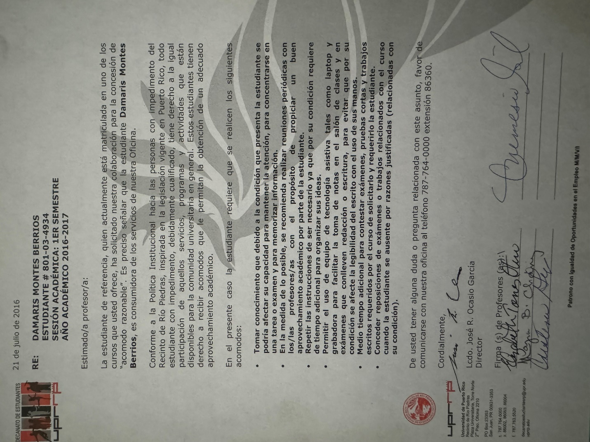
There is a single reasonable accommodation that is not in that official OAPI letter because it was explicitly granted only in the last semester when I had to do my practicum, although it can be implicitly understood if you realize the implication of technological assistance already stated in the letter you just read: I must be allowed the use of technological assistance (an electronic chalkboard) to complete my practicum as a student teacher, due to my difficulties with handwriting in a regular chalkboard (my hand would get tired if writing by hand a whole chalkboard and the students would not be able to understand what I was teaching simply due the illegibility of my handwriting). Because only the UPR Elementary Laboratory School had such technological assistance available at the moment, it was very well known by my English teaching mentor and by me since the very beginning that I would be doing my teaching practicum in the UPR Elementary School Laboratory. The common situation is that too many students want to do their practicum in the UPR Laboratory Schools or in the School of San Juan, the two most prestigious schools to make your practicum, so there is a kind of “friendly fight” among the student teachers to be able to get into anyone of those two schools to make you student practicum. I was lucky enough to be assured a spot among the most prestigious schools available due to my OAPI status (let´s give an intellectual wink to that move, because I really wanted to be in a research elementary school and actually know how to be a research teacher; I didn´t want the School of San Juan, as equally prestigious it sounded, nor any other school).
There was an issue with the psychiatric diagnosis used to prepare that OAPI letter. The psychiatric diagnosis that was used to give me the reasonable accommodation of the OAPI office was not a real psychiatric diagnosis; it was a psychiatric diagnosis given based on my progenitors' best interest and according to their own versions of facts that would later be revealed themselves as a gruesome abuse, especially psychological abuse. They fabricated the whole psychiatric diagnosis to use it to cover the tracks of the abuse they were doing covertly: they are a malignant narcissist, and they know very well how to manipulate facts and turn them into a “parallel reality” according to their own purposes. The psychiatric diagnosis I received from the Psychiatry Department of the University of Puerto Rico Medical Campus never corresponded or answered to my own best interest as a person and patient, nor to my clinical profile; they even invented facts in their reports, like saying I was having religious delirium simply for reading the daily gospel: that false diagnosis was used, and they knew it well, to enforce the parallel reality my progenitors had been fabricating from a very long time, and also as an ad hominem argument to me not being able to defy my progenitors at court due my lack of juridical personality caused directly by their false diagnosis. That Psychiatric Department, as I had explained before, was highly leftist and had a clear pro-ideology of gender agenda bias. I tried to do things the scientific way, designing a symptom observation system to demonstrate clinically that my real diagnosis was not the one they were saying, and they also refused.
This lesson must be learned as the Holocaust lesson had also been learned: Never Again. An integractive medicine clinical context is needed to avoid the mental health tragedy that happened in that Department of Psychiatry. Integraction revolutionizes a lot of disciplines, but especially all the mental health sciences —with integraction, you begin to understand the person from within, embracing the whole nature of the person, too, instead of limiting your medical/psychological practice to the behavioral-external perspective only— and all medicine specialties: integraction makes the doctor consider a patient not only according to a specific clinical criteria, but also as a person with a life articulation and a nature of their own, whose inherent dignity must be respected at all moments by all doctors that are involved in his or her clinical care, defining medical treatment according to the best interest of the patient’s growthfulness, not merely seeing or treating a patient as a blurb of cells or as a biochemical imbalance only (I just made allusion to two very clear depersonalizing misconceptions in the medicine of our days).
That Department of Psychiatry totally denied me access to ADHD treatment; they even used their position to invalidate my very just claim that I had ADHD and needed to be properly medicated and treated for it, denying me the very possibility of even being clinically diagnosed with any other thing that wasn´t convenient to their ideological purpose. At this point, I would realize that the “parallel reality” issue was truly a problem that began with my relationship with my parents, not with Opus Dei. Because a parallel reality was already normal with my progenitors, it took me an awfully long time to realize that what was happening in my life in Torrebella and the parallel reality I was being forced to fabricate to articulate my life according to a narrative that agreed with the institutional praxis —they couldn’t be the problem, the problem could only be me, the institution was literally made from heaven, so my whole life narrative was articulated with me being the problem (I had to be Asperger; it was false), or the university being the problem (they were forcing me to get psychological assessment to graduate; it was false, it was only suggested), but never according to the truest version: the institution was the problem, and I was taking my time to process it, with a huge emotional dependence issue involved— was literally psychological abuse, not only conscience abuse. It took me very long to realize that what was going on in Torrebella was also psychological abuse by nature… because my progenitors had been doing the same during my whole life, without me beginning to realize it… until this point in my life.
What I just said means: I had always been forced to “make my life narrative fit” according to my progenitors´ parallel reality purposes, and now the abuse was becoming quite evident. My progenitors had always tried to determine how I articulate my life according to a life narrative of their own —that would finally be manifested as a mentally sick narrative—, not of my own, but they had done things covertly: as narcissists with very well proven experience with manipulation, gaslighting, mimicking, and love bombing, they know how to cover their systemic cruelty traces very well… but besides being narcissist, they also have what is named in psychiatry as Munchausen syndrome (also known as factitious disorder imposed on self; in their case, they imposed it on me, and in the dogs too). That means: all the allergies and several health dysfunctions I have had during my life were really caused or even fabricated by them, for example, the severe allergies I had during my whole childhood and also later, when I sculpted Fiat Pac with all the toilet paper I had to use due the severe allergy that they were toxicologically causing to me… Now that toxicologically the evidence was undeniable, after so many years later of enduring their torture —both psychological and physical — covertly, their abuse was finally being seen. Besides the consequences of their psychological abuse, they had been originating in my biological nature all kinds of dysfunctions with ways of denying my body control that had never been seen before in contemporary criminology. It is still yet to be known medically how this will affect my future, but how things are right now, it is truly a miracle that I had not died or had a catastrophic pathology, especially in the neuroendocrine aspect of my biological nature, during childhood. It is even more miraculous that I have survived with biological integrity what they did since around age 28 to the present age, 39. What they had done is horrendous, and nobody saw it due how good they had been manipulating medical facts and me being denied to stand by my own life narrative: I was always being treated according to what they said about me, and they knew how to fake a parallel reality quite well, they had been doing it since my birth. They are forgiven, in the same way Jesus Charity have forgiven me very great sins, but my life can only keep growing on socially de-filiated from them, and that social transition is so huge in my case that as soon as I can I will change my name to the name I had been given in prayer: Victoria Magdaluz. I have the right to be identified in society according to who I am, not according how my abusive progenitors attempted to denigrate and reduce me to be their sociopsychological and biological puppet.
Because I had no juridical personality at the moment, I couldn’t defend myself from them totally… but finally, as I began studies at the Faculty of Education, I would begin to have, at least in the vocational-academic aspect, a life articulation of my own. This means: I truly began to articulate myself as who I truly am as a person thanks to my filiation to the University of Puerto Rico’s Faculty of Education. I began to be able to live to a certain point a sincere life, with correspondence between who I am and who I am seen. Now how I was seen and being began to become one. It happens that the reasonable accommodations I was granted due to the “parallel reality psychiatric diagnosis” were EXACTLY the same that I would have been granted if those reasonable accommodations had been given according to my true “disability”: ADHD, dyslexia, and dysgraphia. So, I began to break the “reality parallelism” in my life and began to share openly that I had ADHD, dyslexia, and dysgraphia, which are my real “learning disabilities,” medically speaking. I was very well aware at this moment of the dangers of having parallel realities in your life and deliberately chose to begin to break every and each of them. I have to learn to be and to be seen articulated in the same way, without any dualities between who I am according to myself and according to how I am seen by others.
No one asked in the University, nor among the professors nor among the students, which was my medical diagnosis to get the OAPI student status. But, as I just explained, there I chose to openly disclose what my real medical diagnosis was: I told ADHD and dysgraphia, and also dyslexia sometimes, and that was the reason that I was allowed to take all the tests on my own computer and send them by email, trusting that I wouldn´t be copy-pasting anything (I did that personal honesty compromise with the professors), it was harder to me to write by hand, and I would need the reasonable accommodation of using a computer to write at all moments, including during tests and evaluations. Well, I was totally embraced and accepted as I am. Anxiety levels began to decrease a lot as I began to be allowed to openly be myself according to my own life articulation. My classmates knew I could forget things and be aware of telling me without making me feel unresponsible, “You forgot this in the classroom,” and such things, without being a fuzz, everything was done normally and fraternally. The professors and even my teacher mentor would grant me exceptions with a very filial tone, sometimes without me needing to even ask for them: because I had all the open freedom and intellectual freedom to discuss the progress of my writings and assignments continually with my professors, they themselves would notice I would not be able to finish on time as I explained my progress of the work and extend the deadline by their own initiative, for my best interest, without any complaint of me being irresponsible or lazy, I simply needed more time to develop my ideas doing truly my best. I wasn´t totally an outsider anymore. True: when I talked about integraction, no one understood fully, but that was expected; I would still remain some sort of intellectually isolated due to developing intellectually on my own… but no one rejected me for thinking “differently”. Even my English teaching mentor professor did let me develop my own creative ideas as a student teacher despite my being a beginner Education student and they heard me with interest and corrected me when necessary.
Being able to share openly for the first time my real medical diagnosis (ADHD) and receiving the fraternal support to be normal among the faculty students was crucial to stopping the systemic reality parallelism that has been normalized around me my whole life. For the first time, I was accepted and seen in a social context as I am, not according to how others see me… and I was actually able to be how I am also, both factors are equally important. In the Faculty of Humanities, I wasn´t able to be who I am from year 3 and beyond, due to what I have explained before related to Opus Dei. Now that barrier has been demolished also. Yes, it was a huge change, despite me being clearly the older of the pack among the Faculty of Education´s undergraduate studies and still having some post-traumatic effects, a quite natural psychological issue to be expected from my Opus Dei experience, and which I dealt alone, because I knew I wouldn´t be understood if I went to a psychologist on campus, and at the Medical Sciences Department of Psychiatry they totally refuse to deal with the Opus Dei issue in my past or to even recognize my faith as fundamental part of my personal articulation. If I was going to receive psychological treatment for what happened in Opus Dei, I needed to leave the Psychiatry Department and look for a Christian psychologist. I was explicitly told so, and eventually, that was the “official reason” to discontinue their services. The truth was that they were doing things ideologically; I was being denied even very basic memory assessment tests to demonstrate something was going on besides what they were telling me… and they were literally forcing me to depend on my progenitors in every sense possible, including psychiatrically. I wanted to be considered a patient according to my own best interest and life articulation, not according to my progenitor's best interests and being forced to articulate my life according to the life narrative imposed by my progenitors. I am an adult; there is no issue of parental rights involved here. I should have the medical freedom of an adult and the body control of my own body. I should be heard by my own voice and be treated for what I say I am, not according to what other people say I am.
A whole new world began to be seen around me in the Faculty of Education, a world where I could be who I am as an equal member of the society around me. I was not an infidel anymore. I was not seen as disabled neither, as I would explain later. I clearly had a juridical personality at the university; my voice was heard, and it mattered. I would be able to connect, discuss and debate intellectually and fraternally according to my best intellectual capabilities, and so I began to discover who I truly am, besides the process of learning to know me according to Jesus Charity´s eyes. The Faculty of Education would be a huge factor in my ability to be and discover who I am due to another very important reason: its Dean. The Dean of the Faculty of Education was the same Student Dean I had in the Faculty of Humanities. She completed her doctorate and now she was in the Faculty of Education as Dean of the whole faculty. I knew her; I knew how she worked with students and how she expected the professors to teach their students. As I expected, I didn´t have a single ideological or any other issue with any professor with her being there as an academic leader. Please understand this in the right context. No one knew in the faculty that we knew each other, nor I ever told so until the very end of my studies at the Faculty of Education, as I will explain later. Things were not right for me because I had a contact in a powerful position; things were right for everyone in the faculty because there was the right person in the leadership position, a professor who believed in the students as persons. There was a Dean who believed in our dreams and aspirations, not interested in ideologies at all; I knew that perfectly.
I never went to her office as Dean of Education except to leave the letter and gifts I will show later; I thought it would be highly inappropriate. But we do talk in her class about the psychology of education. She was my professor of psychology of education, and I was another student among the others, never treated differently with any kind of preference. When I saw her as my professor, I was speechless: I had no idea how to explain both my huge silence as a student of the Faculty of Humanities, which I never explained to her before leaving for Spain, nor how I was back from Spain without a PhD. I was still unable to tell her, and she, once again, respected what I said in a very cordial and fraternal way and welcomed me to her class. That is how she was. I studied her class avidly, and from what I learned there, the action formative processes and beyond would begin to be palabrized according to their more concrete forms, not yet fully defined because I haven´t studied psychology any further from that psychology of education class, but there was already a psychological notion´s beginning, and I understood in her class that the formative processes of action and beyond were actually psychological, they did not belong to the nature at all, their characteristic was clearly according to what was being discussed in that class. The way we studied the psychology of education in that class was truly a broad spectrum of psychological frames. She taught Freud, but not only Freud but all the other most important psychologists along Freud, always allowing us to get to our own conclusions. She had never been, as far as I know her, ideological at all, and that is also a huge exception inside the UPR system academic environment context. That allows the students to truly learn to think on their own and be creative. I was totally relieved about the Faculty of Education environment with her as a leader there. She truly let us, both as professor and as Dean, incarnate the motto of the Faculty of Education: Aprender a ser, Aprender a aprender, aprender a enseñar y aprender a emprender. I breathed fresh intellectual air: no more ideological harassment would happen, nor from left, nor from right, with someone like her where she was. I never shared integraction with her in her psychology of education class, but I did grow up intellectually there, and it was evident. When I studied for my teaching certification test, the psychological concepts were quite clear thanks to that class… but I remained once again silent to her, this time about integraction. I was still developing my concepts and didn´t want to… let her think I was expecting preferred treatment due to developing a personal formation model on my own. She let us make our own conclusions —not only to me but to everyone— and so I did as I kept developing integraction as I applied what we discussed in her class. We never talked about the past, although I did need to explain my silence as her student in the Faculty of Humanities, but at that moment, I was still totally unable to find a way to explain everything that happened in that past in a way I would be understood.
I had a perfect English teaching mentor professor whose only sin was always being too busy and overworked because she was so pro-student that she was always in the disposition to help us all, so her mentoring time would be limited but precious. I helped her to bring her things to her car to have more contact with her and keep developing my own concept as we kept discussing the materials of the classes. One of the first things she told me as we met as student-teacher mentoring was: “If you have any problems with your reasonable accommodations, before going to the Dean of Students or OAPI office, you come directly to me first; you won’t have any problem in the Faculty of Education with this, but if you have them, let me know immediately. You have all the right to have a learning difference and to be allowed to be you; you are not considered “disabled” here; the OAPI office is the one who used the term “disabled”, not us in the Faculty of Education. We use the term functional diversity, not disability”. She had very clear experience in dealing with diverse students, and in all her classes, she truly tried to teach us how to embrace diverse learning styles according to our students´ needs, exactly like she did with us. The other English student mentor and professor was also amazing, truly pro-student, and learning, and that was seen not only in how she taught but also in how she taught it. Both were a great, well-experienced college teaching team for us. The English teaching department was in very good mentoring and professional hands. They were so person-affirming in their teaching styles that we never called them by their last names, because their teaching style was clearly a personal style; we students always called them by their names directly: Christina and Elizabeth. That can happen in the UPRRP, but not too often. The usual thing is calling the professors by their last name. They had tremendous authority —our graduation as teacher students relied upon their signatures— without needing to lose an inch of their person-affirming style, and that was truly an aspect to admire from them.
Christina, who was my academic mentor as an elementary-level English student-teacher, quite often explained terms integrating personal experiences along the way. We had an idea of her life history and plenty of examples of her experiences as a teacher herself. We could connect personally, besides all the due respect any student has for her or her academic mentor. She was clever enough to give very accurate information about other professors that, without being a personalism (she was not aiming to us focus on the personal traits of any professor; she was simply limiting herself to observe our characters and match us with the best learning choice according to our own personality and the professor style), would be way very helpful, like “choose to take this specific class with that specific professor; or choose this teacher to observe his class and not the other, you will get along better with him or her than with the other professor who gives the same class.” Personality and how you are as a person mattered here. She was the one who matched me with my mentor teacher at UPR Elementary Laboratory School, and she did it amazingly well; we did get a lot amazingly well, as she said. I would get disturbed sometimes seeing my fellow student teachers dealing with the other teacher mentor in my same classroom, a female whose name I don’t remember, for good… she even dared to scream at my students. My mentor teacher never had to do that, and Christina knew me well enough to warn me: don’t dare to choose that female teacher as your teacher mentor; you won't get along; choose Richard. Her intention was not to criticize the female teacher; she limited her to stating that she knew our characters wouldn't get along, and she was totally right in helping me to make that choice according to my best interests, both as a person and as a student. She totally respected our way of being and let us find our own ways to be, too. Who you were both as a person and as a student counted in this faculty a lot. The faculty has a very ontological approach to learning and teaching, even if that is not told in an explicit way, using the expression “ontological aspects of education”… Well, the consideration of what I call “ontological implications of education” was quite evident in the whole Faculty of Education, and that also was crucial in my success there, the ontological dimension of nature was clearly being considered in the whole faculty, systematically, I was no longer the outsider in that aspect neither, and that was also crucial to be able to keep developing integraction, because integraction needs ontology (the Universidad Central of Bayamon lacked ontology totally, and the University of Navara de facto lacked it too due institutional de-personalization issues: no matter how intellectually rigorous the metaphysics class was, the implications were not discussed nor lived consequently in the University as a system, the class was not meant to matter personally but simply aimed to expose facts).
Although I did not share yet integraction directly with the Dean of the Faculty (it could be seen in the questions in her psychology of education class, but as far as I remember, I didn’t mention integraction explicitly in her class), I did begin to discuss it with Christina, in a casual way, as we walked together through halls and to her car (she always had a ton in things to move). As I mentioned before, her only sin was being way too busy as a professor, so I had to find time. She did hear me, and she was the responsible one for me starting my own integractive blog to keep developing my own ideas, but she was also very realistic: I was a beginning teacher and I would be evaluated with the teaching planning method of the Department of Education because I was supposed to be prepared to know how to deal with that planning method first. She didn’t say: don’t develop integraction as integractive education (as person-affirming education, an education that aims to learn by forming) teaching planning methodology. I could do it my own, and we could discuss it (if I found the time for her to be available to do so, besides all the roles she managed simultaneously) but for all the Education faculty purposes, my planning method must follow the Department of Education official planning method first because that was the planning method I should learn first as a beginner student teacher. She was the first person who told me that I was “very Montessorian” in my teaching style —the first among several classmates, professors, and teacher mentors who commented the same without calling my attention particularly— and she who gave me the curiosity to know more about Maria Montessori by my own (I never was able to attend a Montessori education course). She would also be highly strict in her evaluations in the sense that if she allowed us to consult references, she expected a very high-quality job. She wasn’t a pro-memorizing-all professor at all, and her evaluations were purposedly diverse, so she could learn to evaluate in a diverse way also. Her class on preparing materials for the classroom was amazing; everyone would enjoy preparing stuff for their future classrooms as teacher practitioners. She also taught the class Children’s Literature; she even lent us her own books so we could complete the assignments, and she had a huge Children's Literature collection. In that class, I would know a very particular book character that I would often use later as an English teacher: Pete the Cat (you may find several sing-along stories of Pete the Cat in YouTube, it was a huge success among my younger students, but even fourth graders loved the songs and books), besides Shel Silverstein. We (Christina and I) totally loved Pete the Cat; she was the one who transmitted my love for Children's Literature, and I began to form a library for my own future classroom. I totally believe Children´s Literature must be integrated into English learning, even at younger ages when they still don’t know how to read on their own. Clearly the benefit of being read stories they love. I also learned in the Faculty of Education the importance of integrating manipulatives (another aspect for which I was told I was very Montessorian) in younger age education, and the importance of letting the students build their knowledge. Despite being integractive and believing in learning by forming, not in learning by building, I do recognize the incredible importance of constructivist learning theory: knowledge in the students is scaffolded upon prior knowledge, and Christina taught that well. There were certain difficulties observed in our students —we discussed evident observations quite often, we didn’t discuss the class book content only, and we had living content in the classes to apply theories according to our observed student´s best interests, it was done in a very ethical way— that were not related to them being unable to grasp what was taught, but related with what they still don’t know and needed to know first in order to the desired new learning be able to happen. Learning is built as “scaffolds”.
I had amazing learning experiences as an Education Faculty teacher that I was unable to have as a Humanities Faculty student due to my circumstances, especially from year three and beyond. The full stop of ideological content in the taught content in the Faculty of Education was also great, but there was another huge change also: now I was able to make teamworking without any problems. As a student of the Faculty of Humanities, team works were hell, not only due to the usual dissent vision in ideological terms, but also because I really didn’t have the time to fit team meetings whenever they wanted, and I literally failed one English class work due simply not being able to meet my team as I was supposed to, humanely I had no chance to have enough time. Well, now I can function perfectly in teamwork, and Christina would assign them often. I even visited classmates in their homes to complete teamwork, a complete no-no in my circumstances as a humanities student. This time, I also had enough time to study properly for my class load, studying as I am. I finally was able began to learn how to be at peace with who I am and accept peacefully that I could do things as well as anyone else, but in my own way, and there was no problem with that if the context was properly handled, like having enough time to do both Faculty assignments and integraction reflections on my own.
I only had a serious difficulty in one single class of the Faculty of Education, and Cristina warned me well and explicitly that I would have problems there; everyone warned me, and I still enrolled in it in the only time schedule that fitted my whole enrollment schedule, so I had no other choice than to get along with that particular professor. I won’t say her name; she was bright and wrote her own classwork; everybody knew that… but didn’t know how to evaluate properly, and absolutely everyone knew it, too. She was famously known for her huge mnemotechnic-only tests of all the laws, and everyone hated her tests. As I have said before, there are always exceptions. Well, this was an exception also, but on the opposite side of the spectrum.
The class I am talking about was Education of the Exceptional Child (also known as Special Education, a required course for absolutely all the students of the Faculty of Education). Well, technically speaking, I didn’t need the course. I already studied Special Education at the Universidad Central de Bayamon. I simply didn’t want to come back to that university for anything, nor did I believe I was rightly formed there. If I were going to use the class I got there, I would need to make the process of “class equivalent” (processing at the Student's Deans of the faculty the equivalence of a class taken in Universidad Central de Bayamon to a class given at the University of Puerto Rico. It was a one-by-one evaluation process in which I had to provide the description of the course taken at the Universidad Central de Bayamon and also if it was possible, the class program, also known as the class syllabus). Students Dean then will process the equivalence with the Registrar if the class content was actually equivalent. Well, I didn’t want to endure more exceptional processes with the Registrar in my whole lifetime after what I lived as a humanities student; I wanted to be as normal as possible. I chose to repeat the class instead of processing an equivalence; I love to study exceptional education anyway as a twice-exceptional myself… what harm could a single exceptional (in the wrong sense) professor do?
I made the wrong choice, everyone tried to warn me, and I didn’t listen. The problems began on day 1. Well, I was very well aware, thanks to my faculty classmates, of her very long mnemotechnic tests. I, since day 1, asked her for a very specific reasonable accommodation: I wanted my tests to be evaluated by reasoning, not by rote memory. The way she gave the class, she made us memorize all the laws applicable to special education and then test. I know the laws but don’t ask me the dates they were created, who created them, and why by rote memory. Please ask me to compare critically one law with another. That is reasoning. I could do the second, not the first. And I clearly had reasonable accommodation that said that it should be considered that I have memorization difficulties.
She was quite clear since day 1: no way I agree to do that; you will be evaluated as anyone else; I will simply let you use the computer and give you extra time if needed, as your OAPI letter explicitly says. I complained: the letter also says I have memorization difficulties, so I should NOT be evaluated by memorization only (that was what precisely happened in the intellectual massacre of the University of Navarra´s ecclesiastical faculty). She argued that having reasonable accommodations didn’t mean that I would receive a unique evaluation for me; I should be evaluated as anyone else. My heart sank. Gosh, she was a professor of exceptional education; how could she do something like that? I really expected she would take into account the implication of my reasonable accommodations regarding memorization difficulties, but she clearly didn´t take that into account: she would only do what the OAPI letter explicitly said. I immediately went to talk with Christina, who, besides telling me, “I told you so,” told me to complain to the OAPI office. I went to OAPI, and OAPI defended the professor: reasonable accommodation wasn’t supposed to mean I should receive a different evaluation method than anyone else. Can you at least make her give shorter tests so the memorization can be more manageable? Nope, your evaluation must be like anyone else. Even Christina disagreed, and the fact that that kind of issue was happening precisely in the Exceptional Child class was astonishing… but… well, I chose to manage the issue with my own hands, so I told her not to worry. “What are you going to do?” I didn’t tell her; I simply told her, “Don't worry”.
As I told you, I had a personal honesty compromise with all my professors: I was allowed to use the computer according to my undeniable needed reasonable accommodation (it was highly evident for everyone that using a computer made a huge difference for me), but they were counting on me to use it properly and do not copy-paste information for my tests. I never did it… except for that class. Technically speaking, it wasn’t exactly copy-paste, but de facto, it was. If the professor wasn’t in disposition to evaluate me honestly, I shouldn’t be expected to complete the evaluation honestly either, no matter how good she was teaching those laws mnemotechnically. Learning is a two-way street. Well, what I did was simple: prior to each test, I would write the most important numerical and analytical data (that is the information that is hardest for me to memorize) in the upper part of the Word document page I was supposed to use for the test. I arrived at the classroom with the Word page already configurated with the key data (I wouldn’t “copy-paste” totally everything, only what I knew it would be harder for me to remember; I did know the laws' interpretations and implications and didn’t need help on that); I would simply scroll down the Word page so when I arrived to the classroom and opened the computer in a way it seemed that my Word page was totally blank. It wasn’t: I simply needed to scroll up, and there was what I needed. The teacher was so mnemotechnic she literally said exactly what she was going to ask in the test, but I had never been the kind of student that can learn only by memorizing information. I wasn’t interested in having another battle like the one I had in the ecclesiastical faculty of the University of Navarra: I let the professor be as wrong as she wanted in her evaluation methods, and I chose to use my own wrong methods to compensate the wrong evaluation methods. As simple as that. As I did in all my classes, I sent each evaluation by email at the time it was supposed to be sent and from inside the classroom (all the classrooms had internet connection in the Faculty of Education and also in the UPR Laboratory High School, where that class was being taught due reasons I will explain later). She simply didn’t know I was not interested in fighting this kind of fight anymore after everything I had been through. I tried the honest way, and it didn’t work. Well, I’ll do it as dishonestly as you do force me to do it in order to be able to pass the class according to my equal right to receive a proper education (that is a very basic notion of the Exceptional Child Education: everyone has the right to receive an appropriate education). I passed it with A. I already mentioned the only other issue I got with a class evaluation, but this time, I got into the class unwarned because it was from the Faculty of Humanities (Christina only knew professors from the Faculty of Education, and we were free to choose the Faculty of Humanities electives that we wanted, and I needed another English literature class so I got into Latino Literature in the United States, it seemed an interesting topic and the class fit in my enrollment schedule. I got a B in that class because, once again, mnemotechnics were involved where they shouldn’t and how they shouldn’t: the professor OF A LITERATURE CLASS only evaluated through multiple-choice tests in which he asked things like “what color was the dress of the secondary character in chapter 2?” or “what number was the street in chapter 7?”I got completely lost with that kinds of questions and didn’t believe literature should be evaluated that way, but I wasn’t willing at all to get more Ws in my transcript than the ones I already had from my humanities faculty degree, and I didn’t lost time complaining with OAPI office neither. I boasted my only B very proudly; anyone who knew me from 1,000 km of distance could be very sure that you gotta have a very terrible evaluation method for a student like me to get a B in your literature course at this stage of my learning development. Getting a B or even a C in an English grammar course could be understandable in my circumstances, and I chose to be an elementary-level teacher precisely to avoid conflict with grammar complexities: in elementary English, I wasn’t asked to pass a grammar class. But a B in a literature course, me? Sorry if I got a B in your literature class, but the problem is your evaluation methodology, not my lack of literature reasoning capability. Be sure of that. I began to know and trust myself and also began to test my limits, and all that is a very healthy thing to do as a student teacher. It is also a reality for a teacher that sometimes you will need to take the issues into your own hands because the school administration won’t handle it or will even try to cover the issue. I think that learning how to deal with issues with our own hands —when if it is strictly necessary, doing it in the most ethical way possible— is an undeniable part of learning how to be a teacher, and I didn´t become frustrated at all about needing to take issues by my own hands sometimes. Two are needed for a fight, so choose your battles very carefully; your energy, well-being, and time are valuables.
In the Faculty of Education, I would begin to configure an integractive teaching planning methodology following a project-based learning style very nearby. Why? Because projection is a very necessary part to be assumed if you want to achieve a person-affirming education, as I would finally be able to implement later as a Pk-4 English teacher. Integractive education proposes the following steps in order to person-affirming integractive learning be able to happen:
- Information: let the student grasp the concept according to his dominant processing information style, embracing all learning styles in the classroom. The student should also become conscious of how her or his learning style is. I wouldn´t be wrong at all to give students at the beginning of each learning academic stage (primary school, elementary school, middle school, high school, college, graduate studies…) a full psychoeducative assessment before beginning their new academic learning stage so they can know appropriately: this is how you learn, and these are studying method for you.
- Action: the concept would be implemented with an activity.
- Realization: it will be discussed how to realize cognitively the concept according to real socio-cultural settings.
[These three steps are repeated daily as needed in the first weeks of the month]
- Projection: There would be a project per month that applied the concepts learned in the three prior weeks. It would get a graded evaluation with a rubric, integrate the student’s dreams and interests, and be pertinent to his personal formation.
[This step is done in the last week of the month]
- Connection: the best works will be exposed and shared with the school and community.
[This step is done once per semester, as an exposition or fair]
I don’t know if it is noticed, but this limits the grading issue to a one-per-month quantitative evaluation that is project-based, instead of constantly grading everything. The other evaluations are progressive and formative. They should get used to that if they will be thinkers and citizens of good: no one will tell them to do their best; you got to aspire on their own. What society tells you is the minimums (the laws to be obeyed), but no one is called to live according to minimums; you are called to be growthful and live according to your maximum growth possible, your best growth possible.
Growthful discipline is an important aspect of integractive learning too: the students must learn to order their learning according to their dreams and how they determine to grow and become the best persons they can be (objectives-goal-dreams mentoring system). They simply need to be helped to be, helped to do, helped to grow, helped to glow, and helped to bloom in the appropriate way according to the characteristics of their personal formation. You guide them and inspire them; you only command when necessary —instead of constantly or always, they must learn to progressively become independent and self-assess their progress as they would in the middle of society as citizens of good —, and you don’t force them to be who they are not, nor who they are not called to be, you let them know who they and who they are called to be giving the appropriate mentorship given parallel to academic learning.
If we as Americans want a growthful society where everyone can grow as the best person they can be, the change begins in the schools right now: we need to teach our students to live a life of maximums, instead of forcing them and assessing them to live a life of minimums only. Traditional punitive discipline is not enough; it even can become denigrating. Teaching and making children know themselves only according to what they can’t do is not enough: they also need to know how to behave to be the best person they can be, according to their strengths and talents, not merely according to their disciplinary faults and what they need to correct to obey the authority. We can’t teach our children to limit themselves to obey as the Nazis did: they need to think and reason by themselves and make reasoned choices according to what they believe is the best growth choice possible. If they are well formed in their nature —especially in their life articulation— those growth choices will lead them to become, progressively, according to their appropriate age and growth stage, the best person they can be. That way we become together the growthful society we are meant to be. That is how growthful discipline works: a growthful society begins at our schools, with how we teach our kids to live a life of maximums and aspire to be the best instead of merely limiting themselves to obey laws and pay debts (credit score is also another widely known minimum in our society: you got to have a good credit score to be able to function properly… but what if instead of simply forcing people to limit themselves to work for barely being able to pay debts, we also choose to invest in our society and create social incomes that would make people able to sustain a family with dignity, so we can all realize as the best person we can be, everyone growing as part as a family where he or she is loved unconditionally, as our dignity inherently requires to?). Yes, there is an integractive economy vision too, although right now, let´s stay in growthful discipline, the change that begins all the other changes in society.
According to growthful discipline, parents should not receive notice of the wrongdoings or deficits of the child only, like it usually happens; they should also receive periodically, along the academic progress inform, a growthful discipline inform that let both the student and the parents know regularly what the student did best and how their strengths are developing as the students progresses. Parents are awfully tired of getting only the bad news, and it is wrong to define a student socially according to what he does worst. Strengths and progress must also be necessarily informed and assessed. Maybe the grades of the two kids are exactly the same, but one has progressed way more than the other since the last evaluation, and that must be assumed systematically too as part of an integractive learning assessment that aims to embrace the whole personal formation according to their maximums, but also assuming the natural limitations of the student. Of course, for this to be possible, we need growthful mentors at the school; you can´t add another kind of assessment to already overworked and too-low-paid teachers. For me, the growthful discipline aspect of my teaching style had been the most fascinating aspect of my professional teaching career, and it truly was what distinguished me most from other teachers around me.
As you can see, I had a lot of learning experiences as a student teacher at the Faculty of Education —growthful discipline began to be conceiver there: although not yet palabrized in that way then, it can already be seen in the medals you will see later—. One of those experiences was going together through the post-effects of Hurricane Maria. The Faculty of Education needed air conditioning to function, and there was no electricity, so all the students were moving around the accessible faculties to be able to keep going to their classes in the middle of the social chaos that came after the hurricane. All English teaching students, both elementary and high school levels, were moved to the language laboratory of the UPR Laboratory High School. We learned to know each other well, to be together in a small place, and to support each other through the crisis, sharing Chef Boyardee and MREs to eat in our breaks or in the classroom (usually, there was no issue at all with eating in the classroom, but that was especially true during hurricane Maria: as long as it didn’t have a strong smell, you would munch whatever you wanted, no matter how crunchy it sounded). We all celebrated together when the electricity finally came back to campus, and we could be able to charge everything on campus while not having electricity at our homes yet. We got along with the UPR High School environment, which was totally unknown for the elementary-level students who had no reason to be there ever before; we didn’t need to observe classes there at all. We remained there for a while.
Finally, my last semester as a student of the Faculty of Education came. Thanks to Elizabeth, Christina, and everything I implemented in her academic mentorship and formation, I finally felt confident in myself. I was ready for that final adventure at the UPR Elementary Laboratory School. As Christina suggested, the assigned teacher mentor would be Richard, and he agreed. He was cordial and personal enough to give us (there were two students and teachers in the same classroom) his personal phone number so we could call him if we had problems arriving on time; we didn’t have to call the school office for that. His teaching style was as personal as Christina's style was: he let us make our own choices and knew how to correct us in a filial, nonhumiliating way, and also knew to tell us what we were doing the right way. I got the third and fourth grade, along with a classmate, but all the students' teachers overlapped often and even had their own period to be in the teacher's lunchroom of the school (student teachers were given a specific time in the lunchroom, so we could chat without being heard by their teaching mentors being there too at the same time). Among the things I did, my favorite one was designing a book with my students: It's Hard to Be a Sentence (inspired by the book “It’s Hard to Be a Verb”). We explained the sentence parts as we created a book. I learned a lot, especially on the topic of implementing research in the classroom. You can see the protagonist of the story in the following picture:
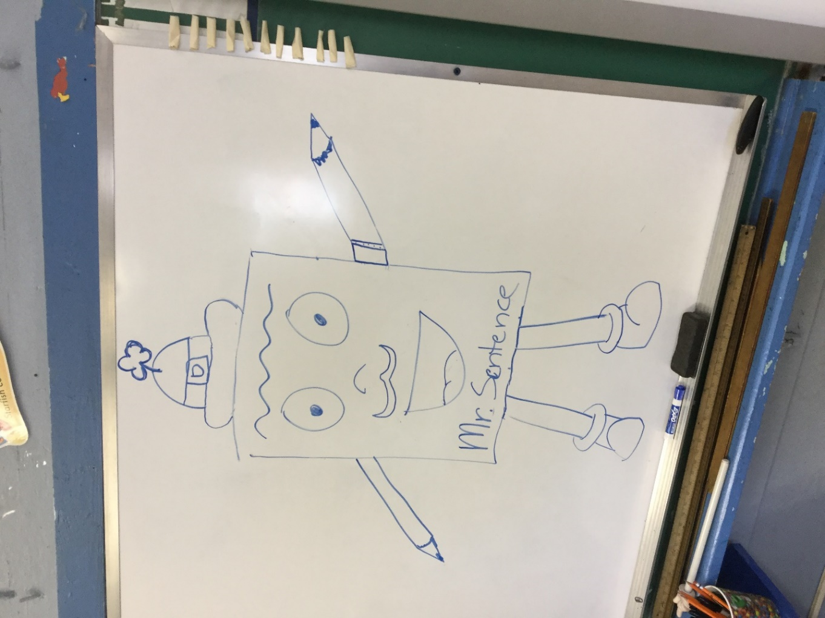
I was given the choice of not explaining to my students that I have learning and functional diversity and simply keeping things going normally with the electronic board because they wouldn’t strictly notice that I needed it; everyone used it there. I chose to openly explain my learning and functional diversity to them in an appropriate way for their age. I believed in a relationship of trust with my students no matter how young they were, and my choice was respected. I explained it to them with the short movie “The Butterfly Circus”: we all have giftedness and talent, and we should all be known according to our gifts and not according to what we can´t do, as it happened with Nick Vujicic in that movie. I explained to the students that although it was true that I was unable to write legibly on the board by hand for too long and that I also had ADHD and dyslexia, I was also very creative and very able to give an amazing non-boring class with my giftedness, and I should be seen according to my giftedness, not according to what I can´t do, as it happened in the Butterfly Circus. My fourth graders understood perfectly and even liked what I did, especially those who had ADHD or attention issues themselves, so they were able to see how far they could reach being themselves as they saw me becoming a teacher with ADHD. The only thing I was expected to write by hand was the date, and they were even amazed when I chose to write something by hand on the whiteboard occasionally.
So, as you can see in the following photo, my adventure as a student-teacher began amazingly well:
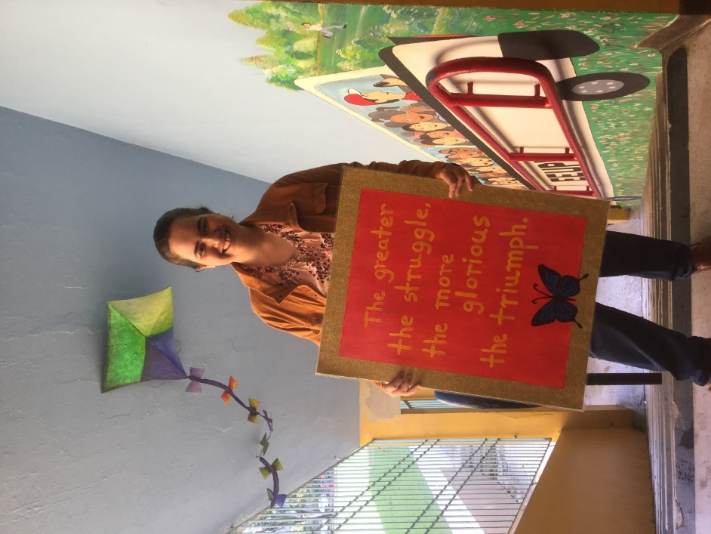

I had another great experiences as a student teacher at the UPR Elementary Laboratory school, as you may see in the following pictures. We had a field day. We had sleeping overs in the school, done in a very appropriate context for their age. We had a water-inflatable activity for the students in their Games Day. They even had a camping activity on the school grounds, inviting the Astronomy Society of Puerto Rico to teach them how to use a telescope and how to observe and find stars and planets. I prepared for them for English week a poetry recital with a Shel Silverstein poem (The Voice) that they were able to memorize brilliantly, although still being young English learners (I aimed high for them, and they were up to the challenge) competing among themselves for who recited it best (there was a jury to determine that, we did that in the library of the school):

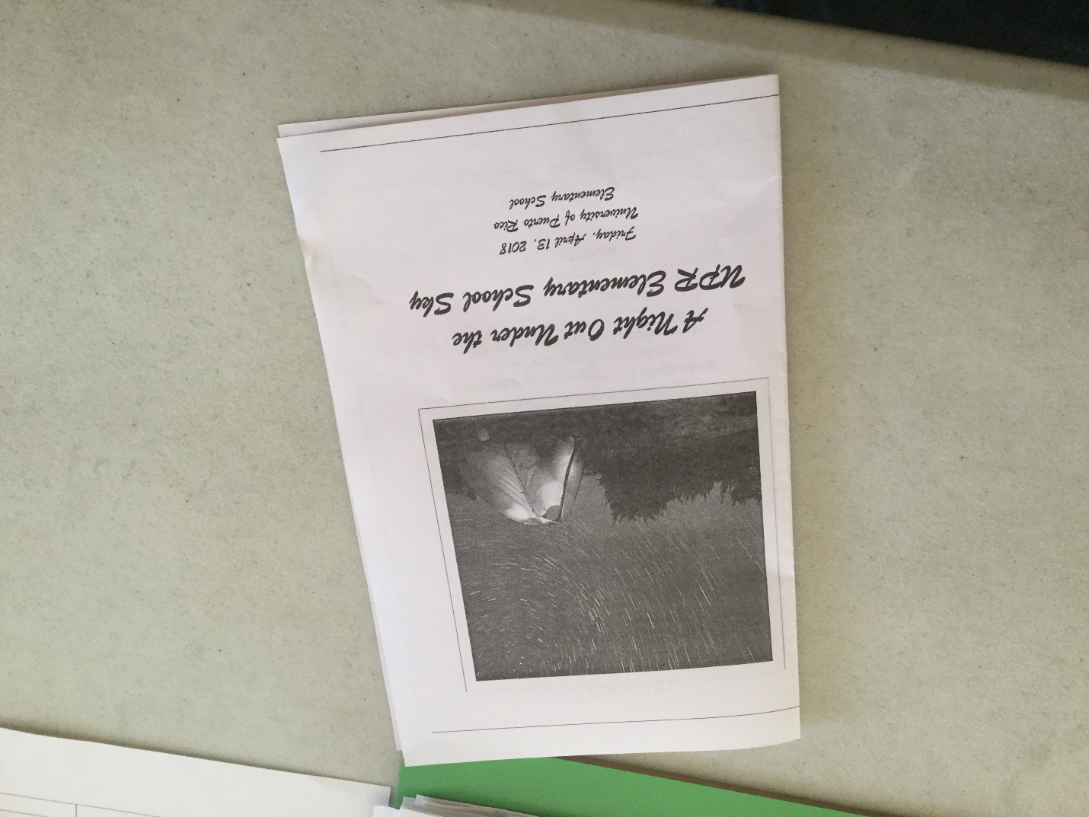

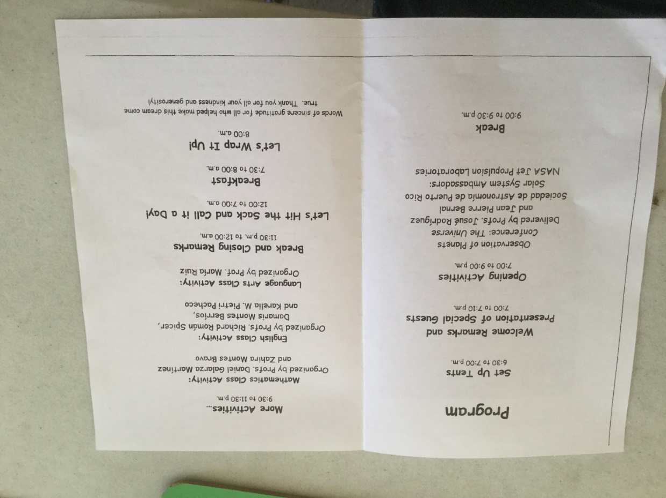
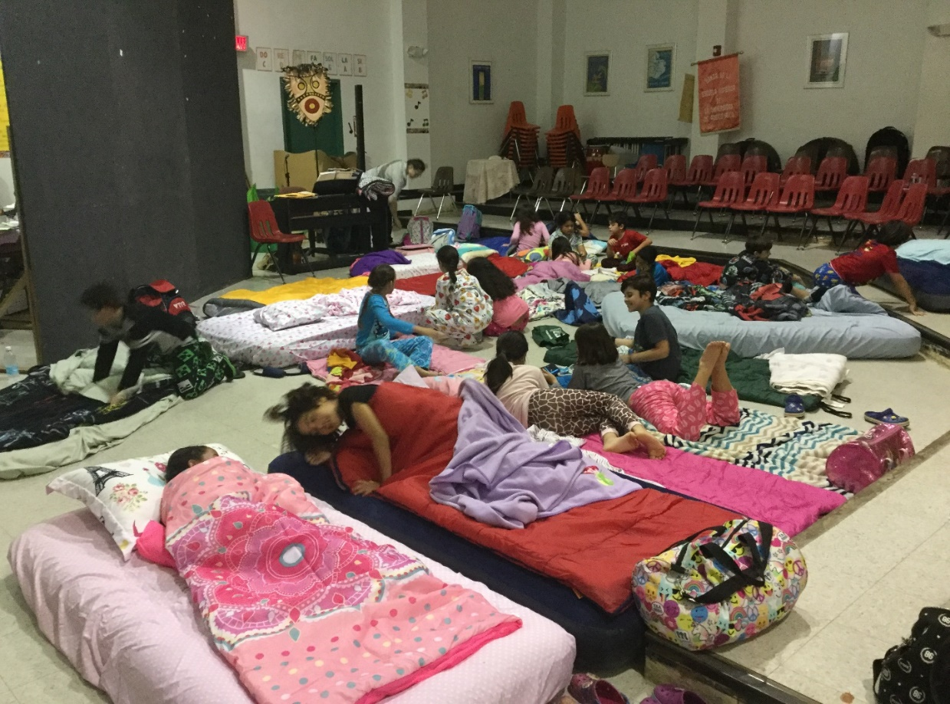


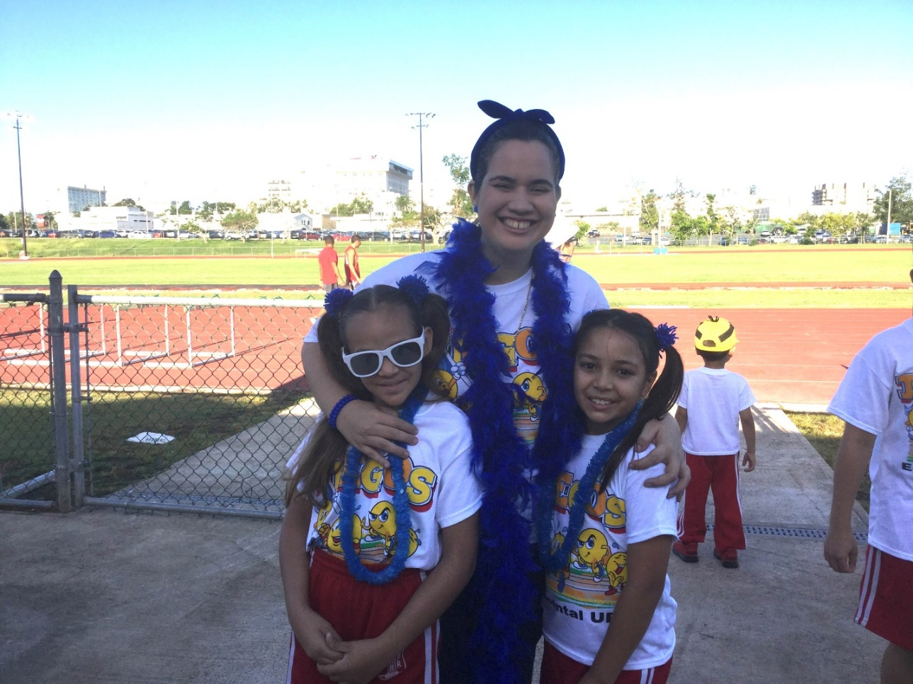
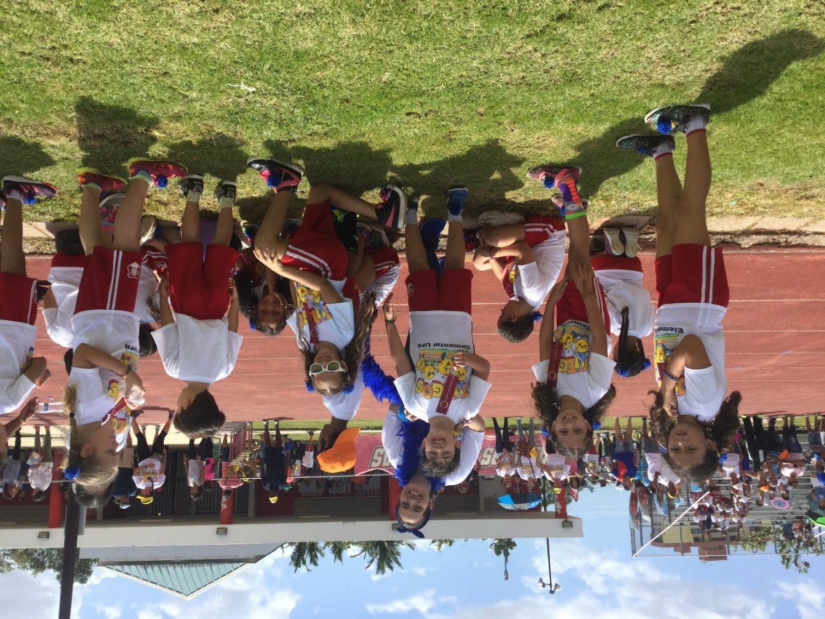

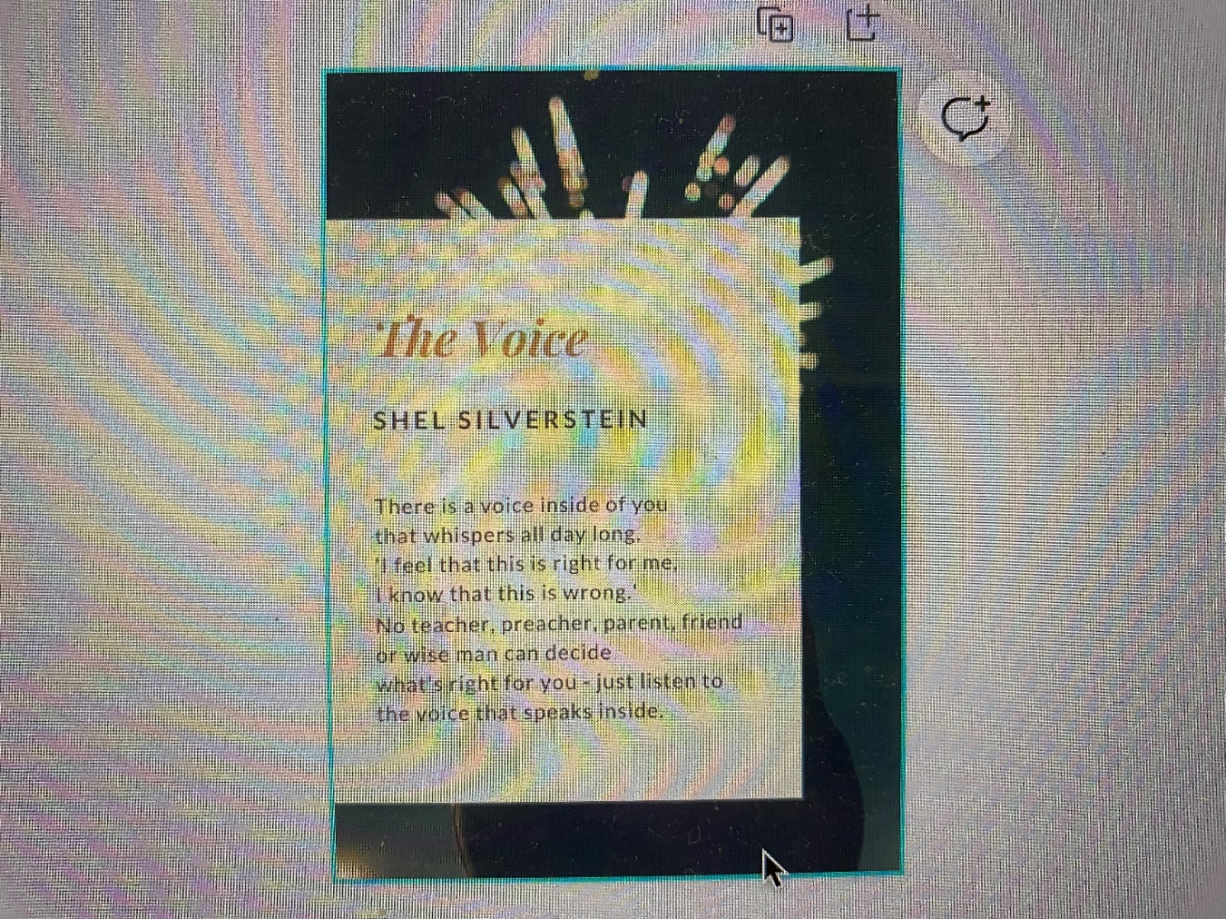

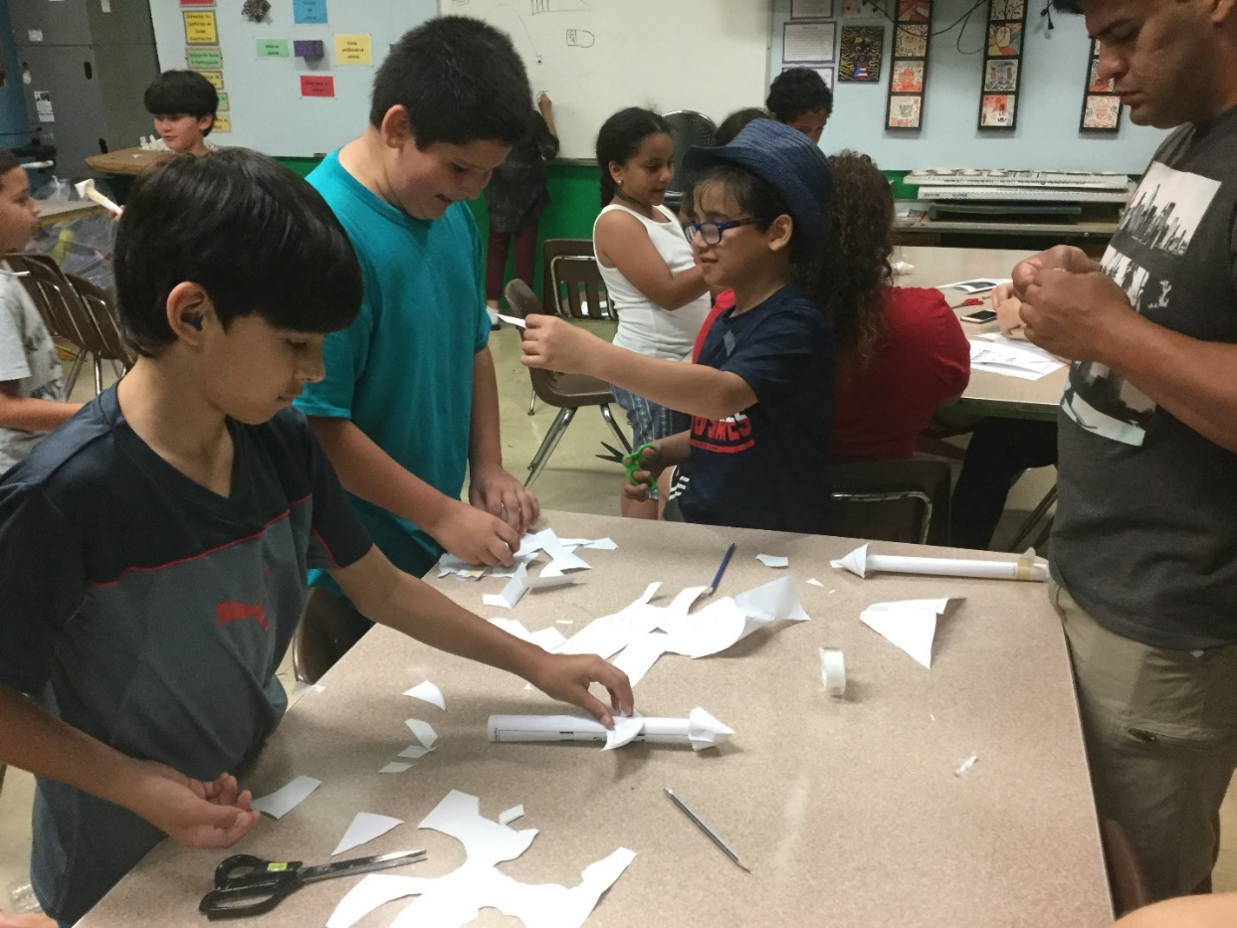
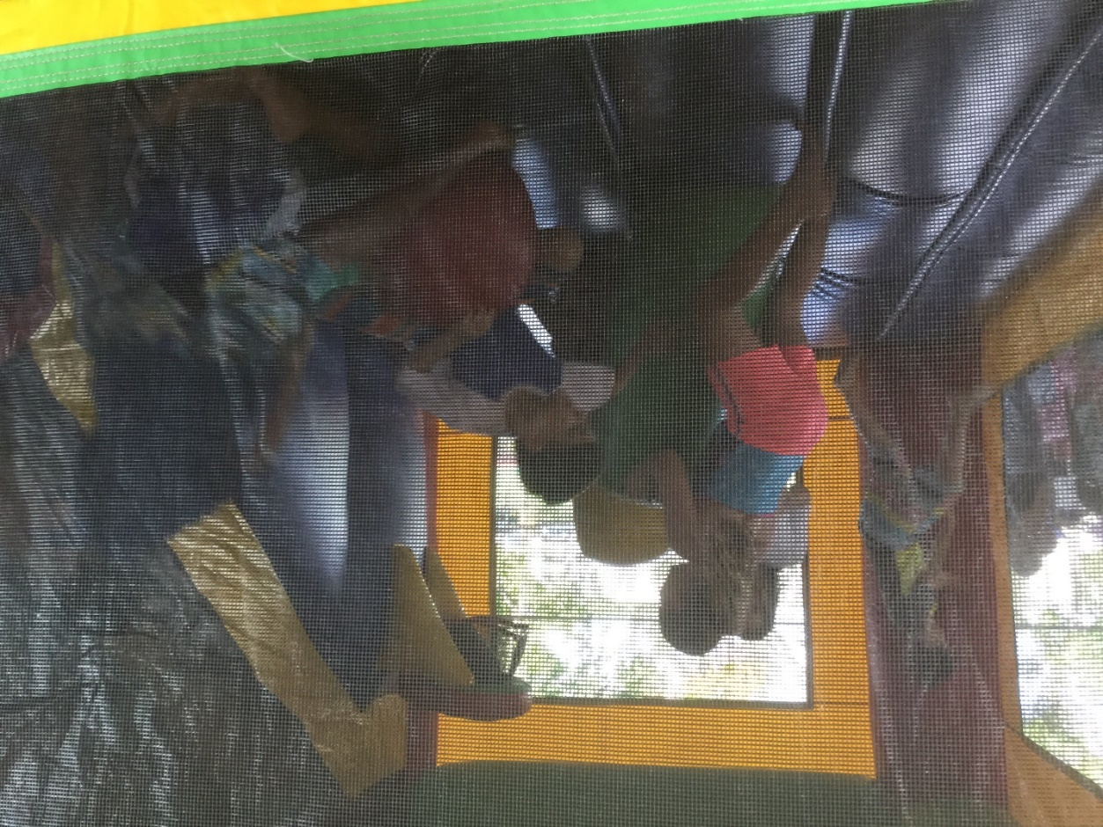
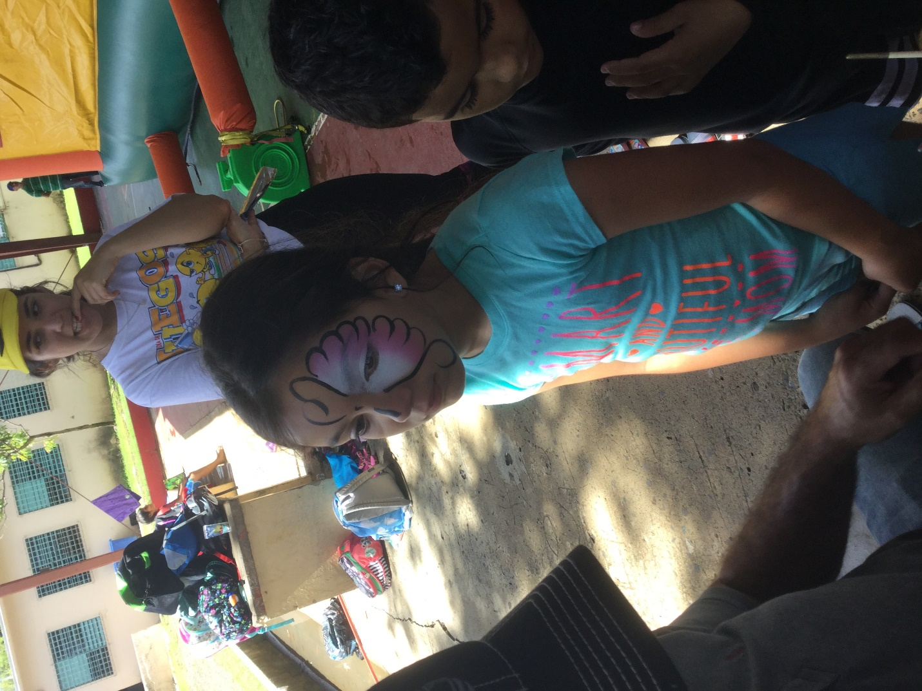
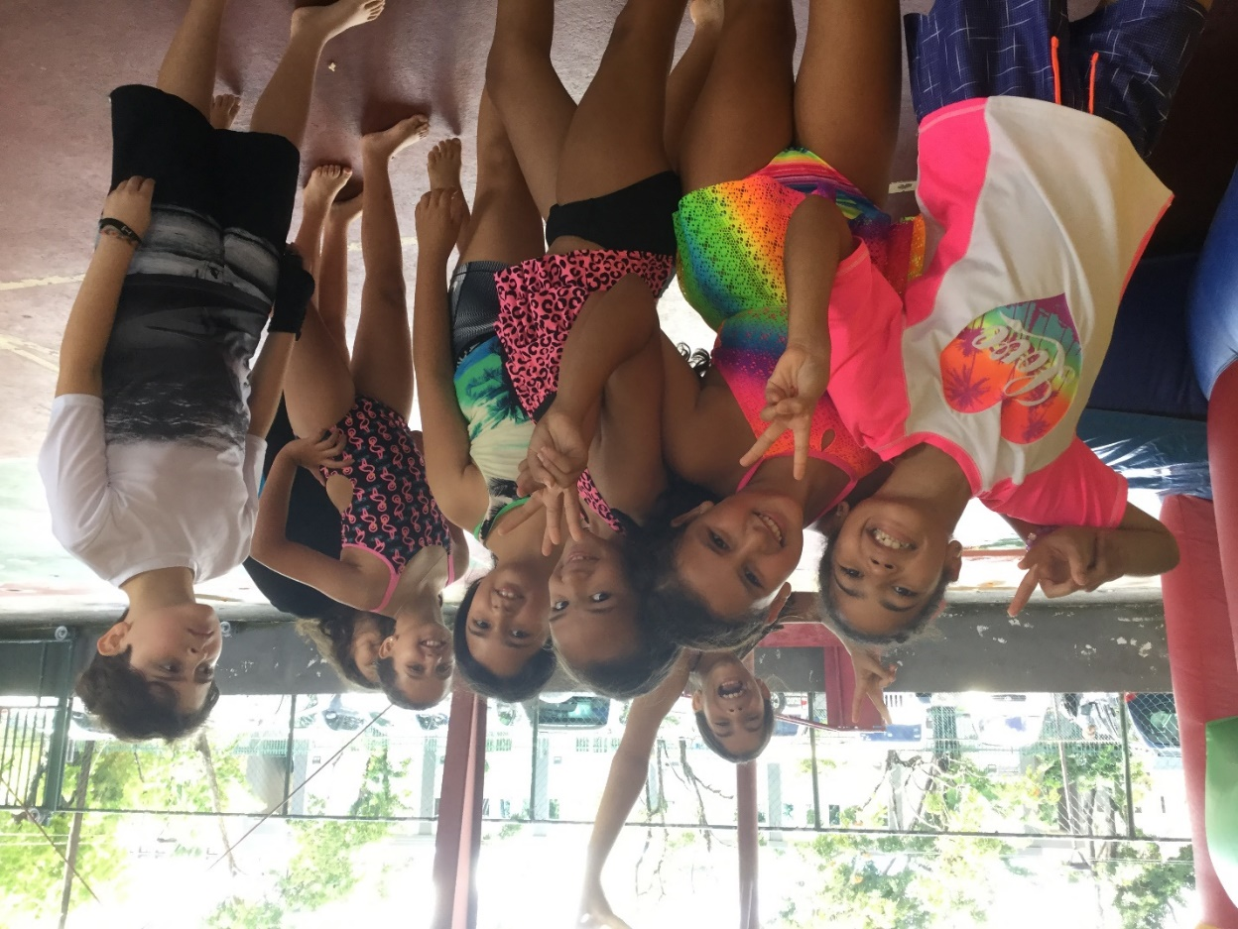
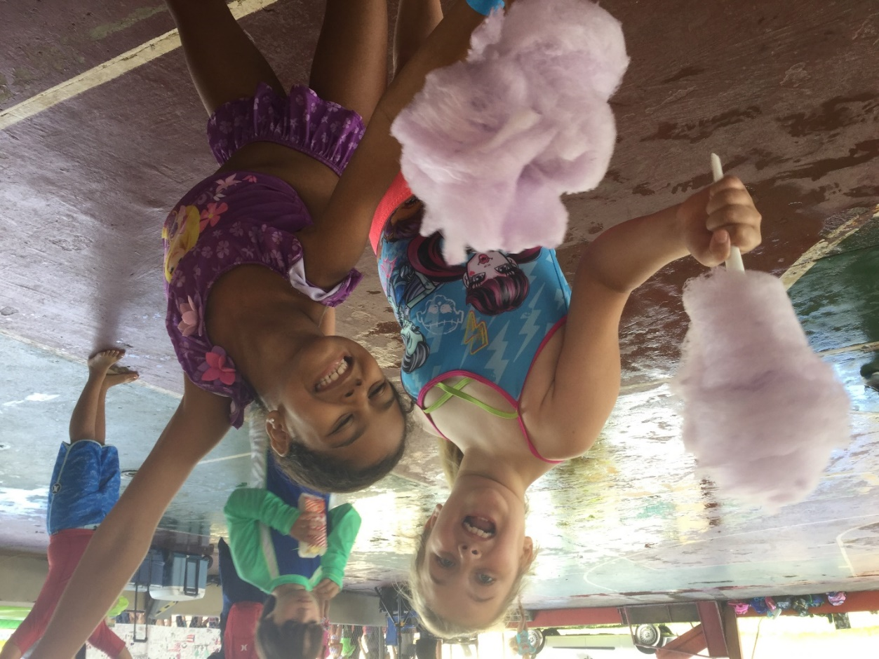

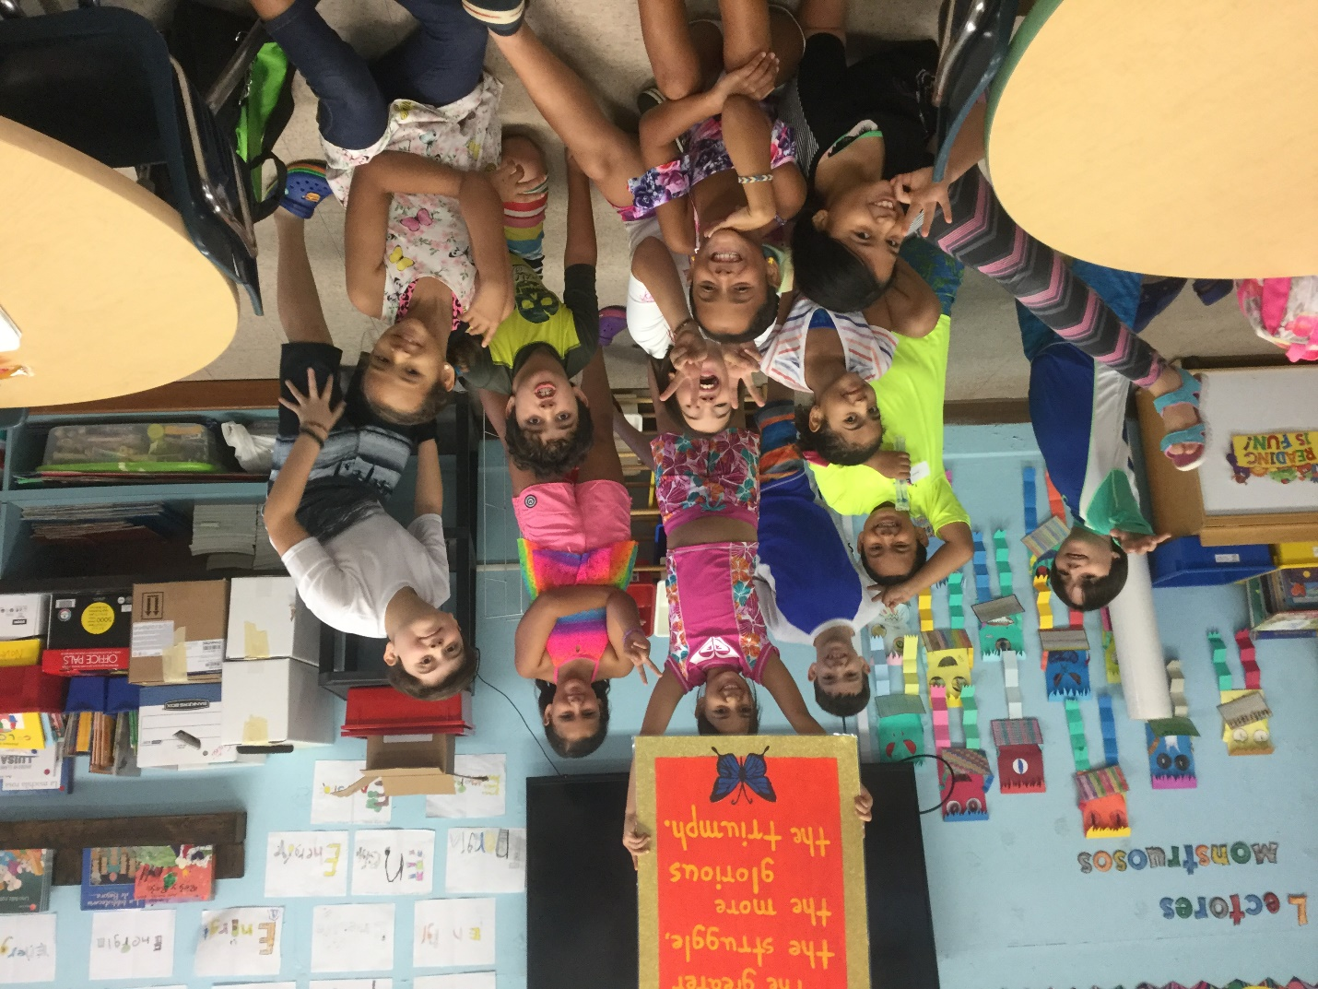

In the UPRRP, students who are highly prone to stress or who are creatively skilled (and I got both simultaneously) are often suggested to take a BEOF class as an elective. A BEOF class is the university code for the university department that in Spanish is called “Bellos Oficios”. It is a department of the University that literally teaches students several Bellos Oficios: ceramics, macrame, mundillo, raku, and torn pottery… simply to enrich the students culturally with traditional arts. Natural Science students are especially prone to be seen around there because they are always looking for “easy pass” electives. I took some BEOF courses as a humanities student, and in one of them, I was quite exceptional: ceramics. It also helped me to strengthen the same motor skills I need for handwriting, besides helping me to cope with the possible stressors of the practicum (eventually, I would know I could cope with the teaching practicum experience quite amazingly well with the proper reasonable accommodations) so along my teaching practicum it was provided to me to study on Saturdays a BEOF ceramics course, again, this time as an education faculty student. I had the time of my life there. The only “complaint” of my ceramic´s professor was that I needed a table of my own due to the nature of my projects, so I couldn´t share my table as all others were doing. It was not really a complaint but a realistic joke: I did need plenty of space of my own for my projects, and I was given such space.
We think that everyone in the UPRRP University System should be required to complete a BEOF course of their choice in order to be able to graduate (it could be chosen between wood carving, painting or ceramics), because EVERYONE must be able to see their professional profile as a Bello Oficio that forms a better society for everyone, and they will also be able to understand —if the class properly explains integraction as they keep forming their artistical works— how they form themselves as persons as they learn how to form their “work of Love” (their artistical project of the class). At the end of the semester or at the graduation the best works can be exposed as an exposition of the whole University. An University must aim to graduate not only well formed professionals, but also well formed persons and citizens of good that are conscious that an University degree is also a call to make a positive impact in society with their Bello Oficio, no matter which profession (oficio) they chose as vocational profile. If the University of Puerto Rico, Rio Piedras campus, needs a new department of BEOF be built for this to happen, that can be worked out, there are plenty federal funds and people of good able to be a force of good in our society.
I made beautiful creations as a BEOF student and enjoyed the creative time, and I truly needed that creative space as I was going through the practicum; I was assessed correctly when I was told to take a BEOF course during the practicum because the teaching for me was a beautiful job (un bello oficio), I was learning to form students like the Jesus Charity I was forming with clay in that class… I also “formed” ceramics as gifts for the Dean of the Faculty (who also was the Students Dean when I was a student of the Faculty of Humanities, for Christina (my academic mentor as a student teacher), and Richard (my teacher mentor as a student teacher), given along a thank you handwritten card. Of course, I did a gift for my students too, but in the case of the students, I did what I was supposed to do as their teacher: I simply formed the basic medal form with clay, and they themselves were the ones who formed inside each medal —with a wood stick that was safe for them to use— for which giftedness they were earning their medal, what was the best thing they could do to keep growing as the best person they could be. They formed the medal themselves during the extracurricular activity at the school of which I put the brochure above, and in the very next day, I went with the freshly “formed” medals to my ceramics class on Saturday (I slept at campus in the camping of the activity) to give them the finishing touches (their yellow enamel) to be fired as part of my ceramics class projects… It was important to me that the students themselves formed the giftedness part of their medal; they needed to know they all had a unique giftedness, and I recognized them for that as their teacher (eventually, that is how growthful discipline would work out). You can see the pictures of the ceramics I created as a gift here. Once again, if I share here the students’ pictures, it is because they are quite grown up right now; they won’t be recognized… these pictures mean a lot to me, so I want to share them. I was finally able to be allowed to be who I am and to connect with others as I was seen by God's Love, according to our giftedness, each person with a unique giftedness to be celebrated:
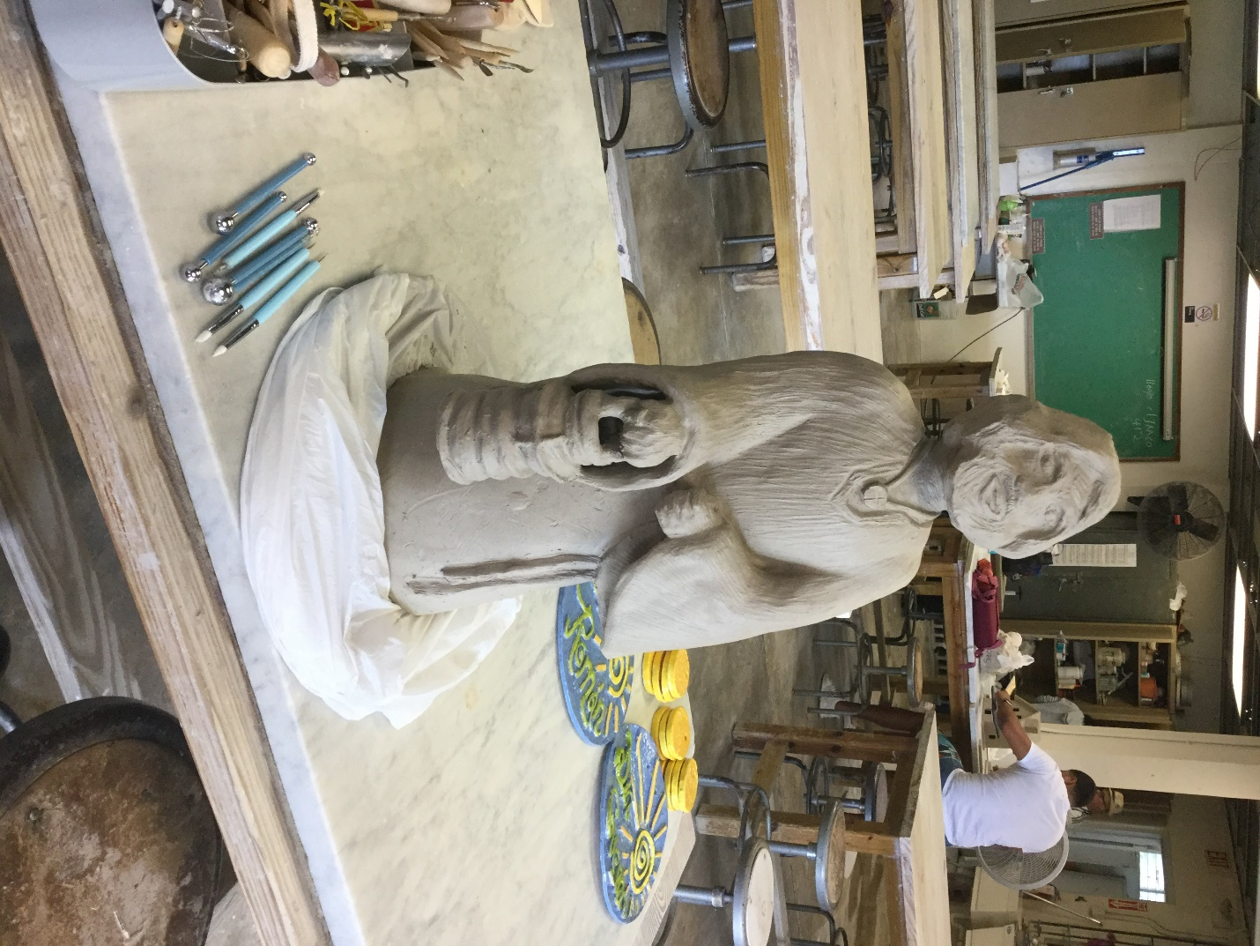
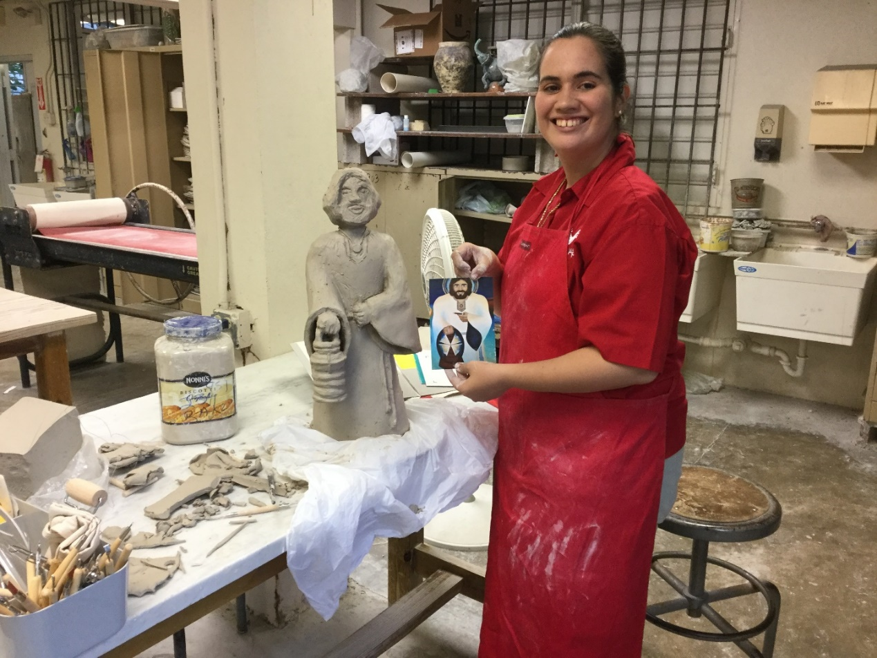
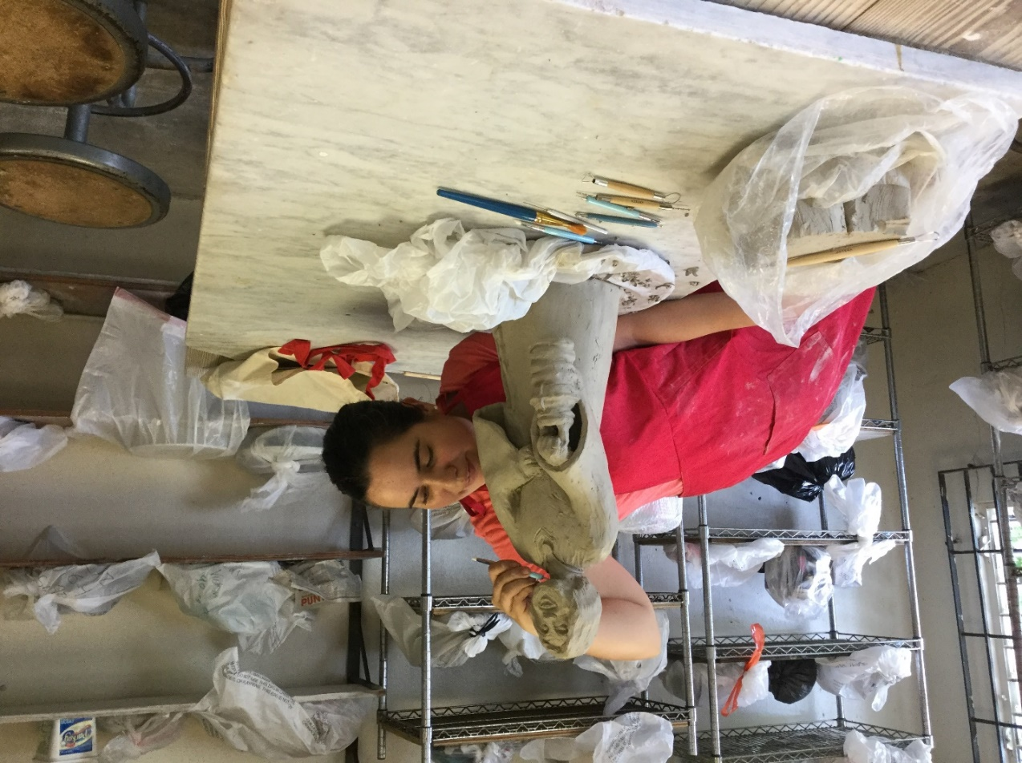
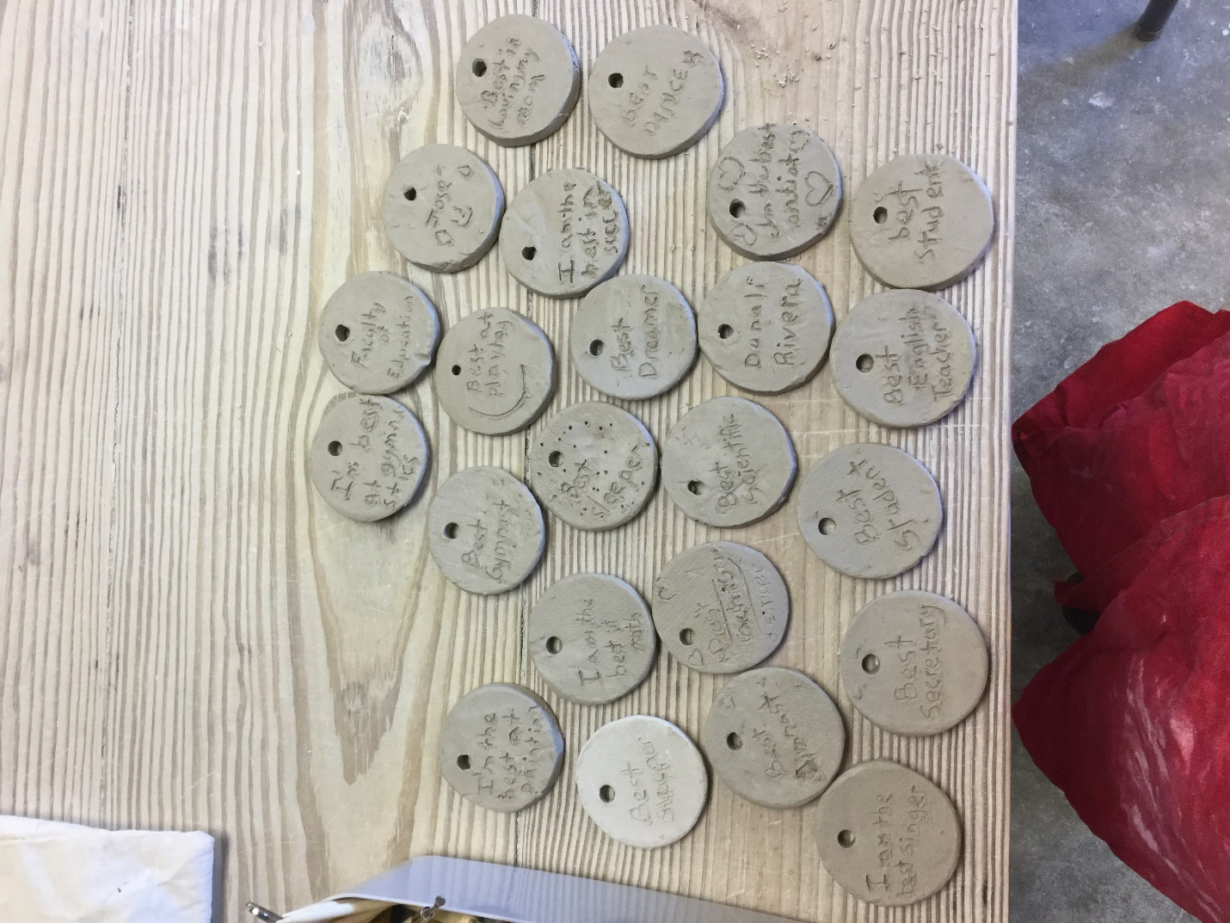
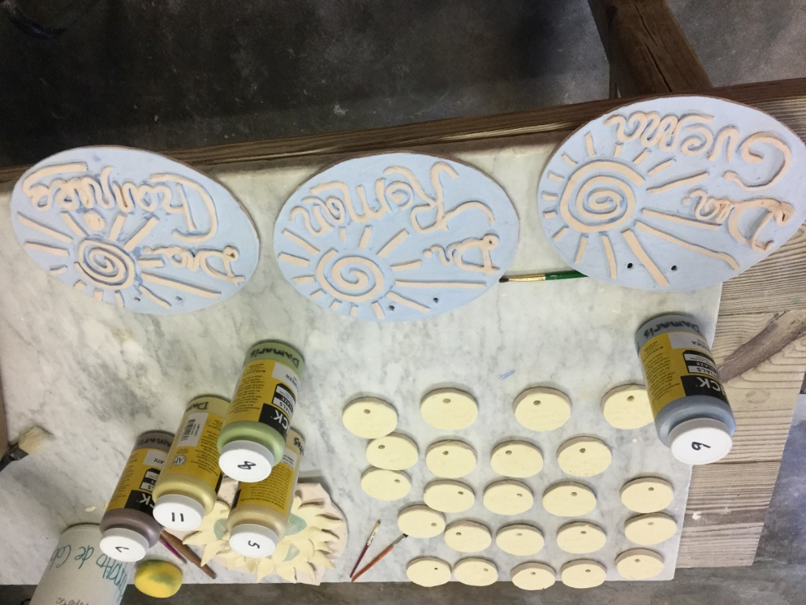
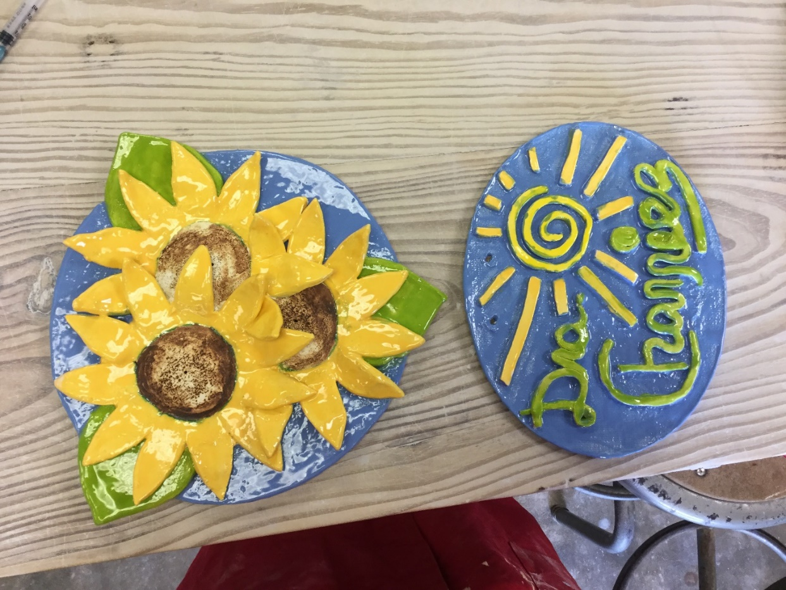

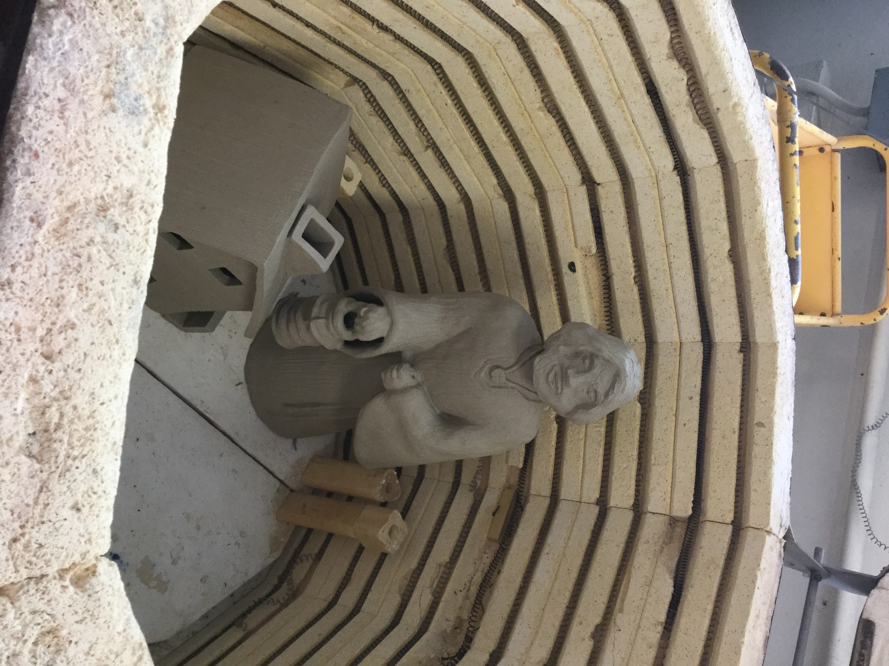

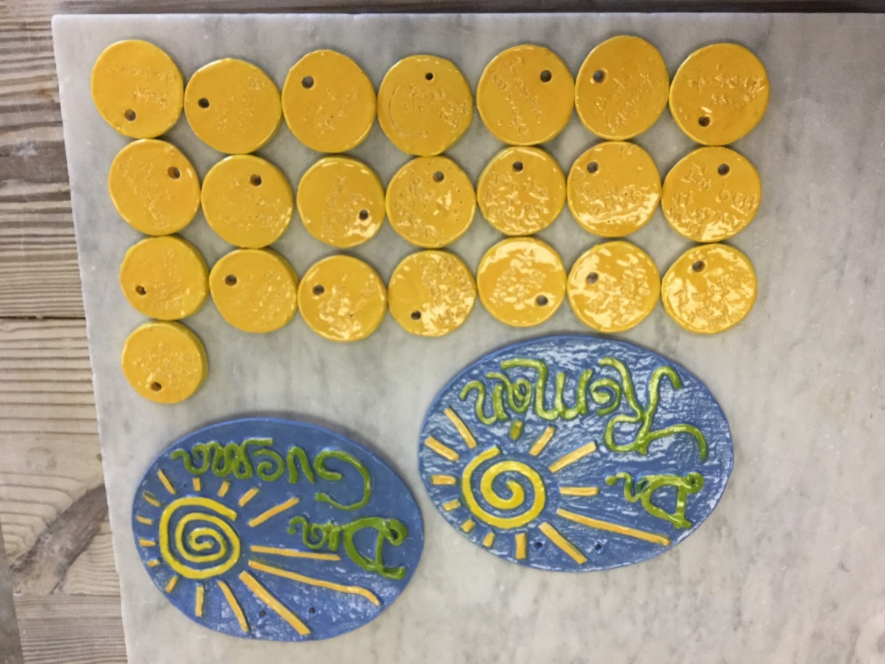
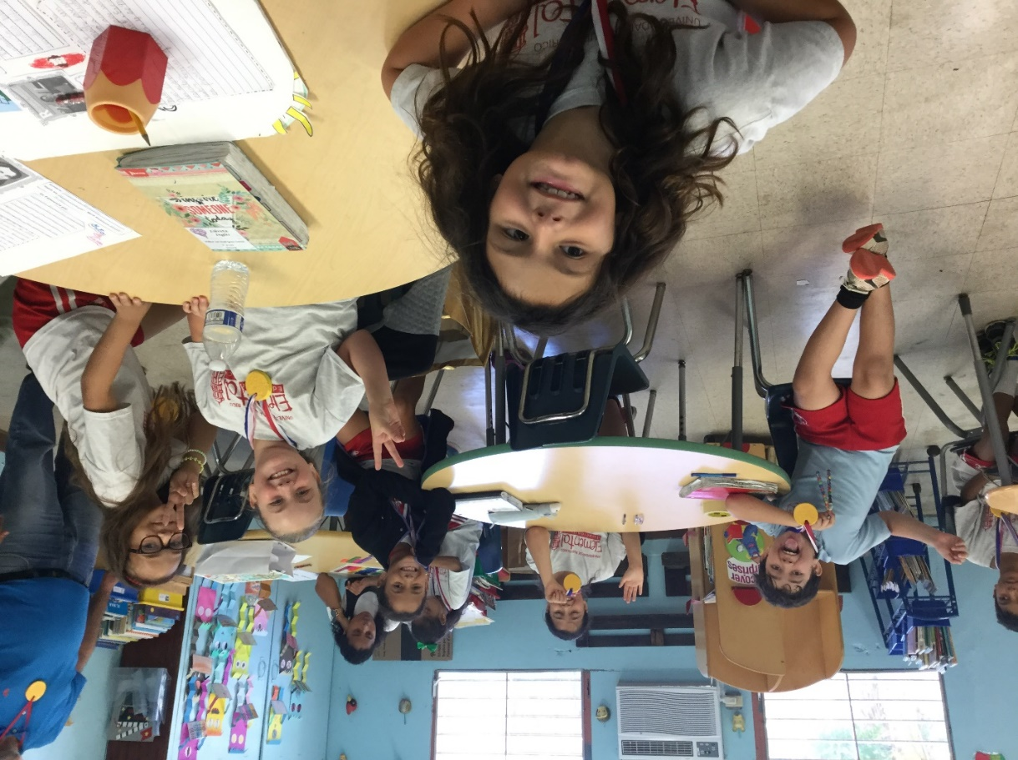
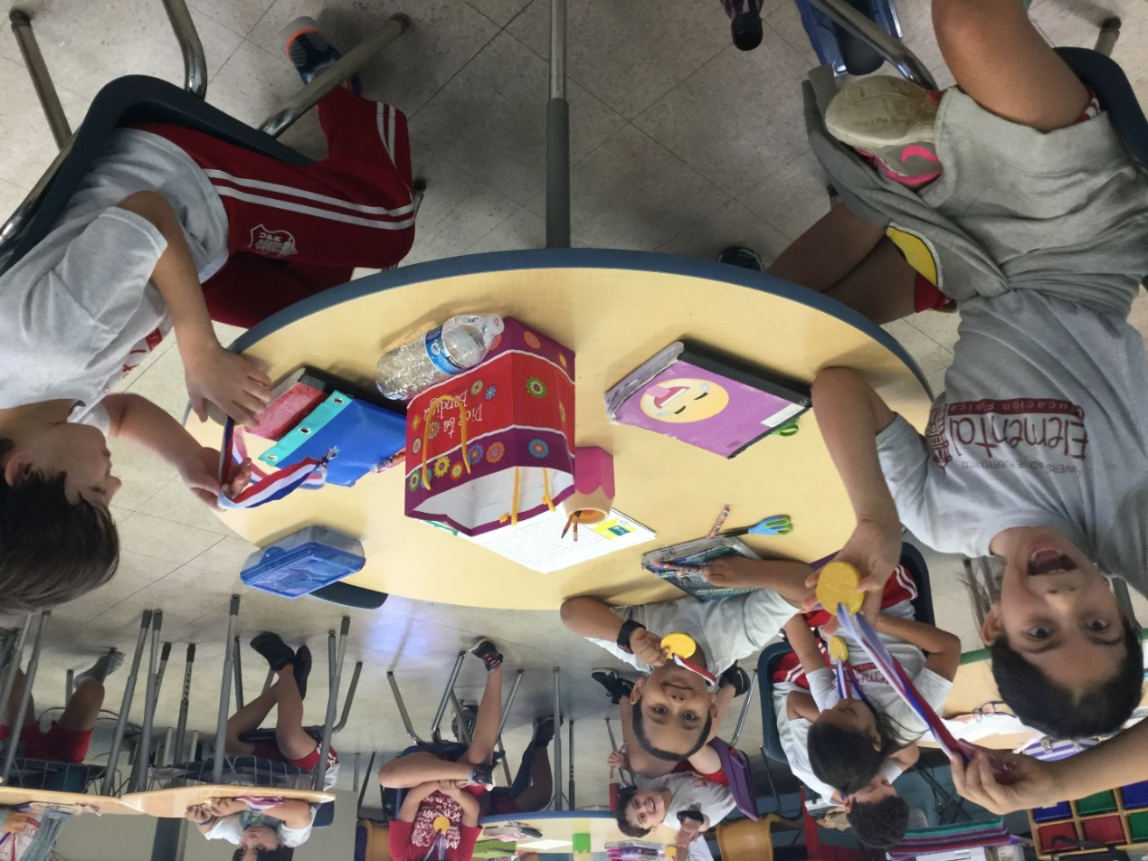
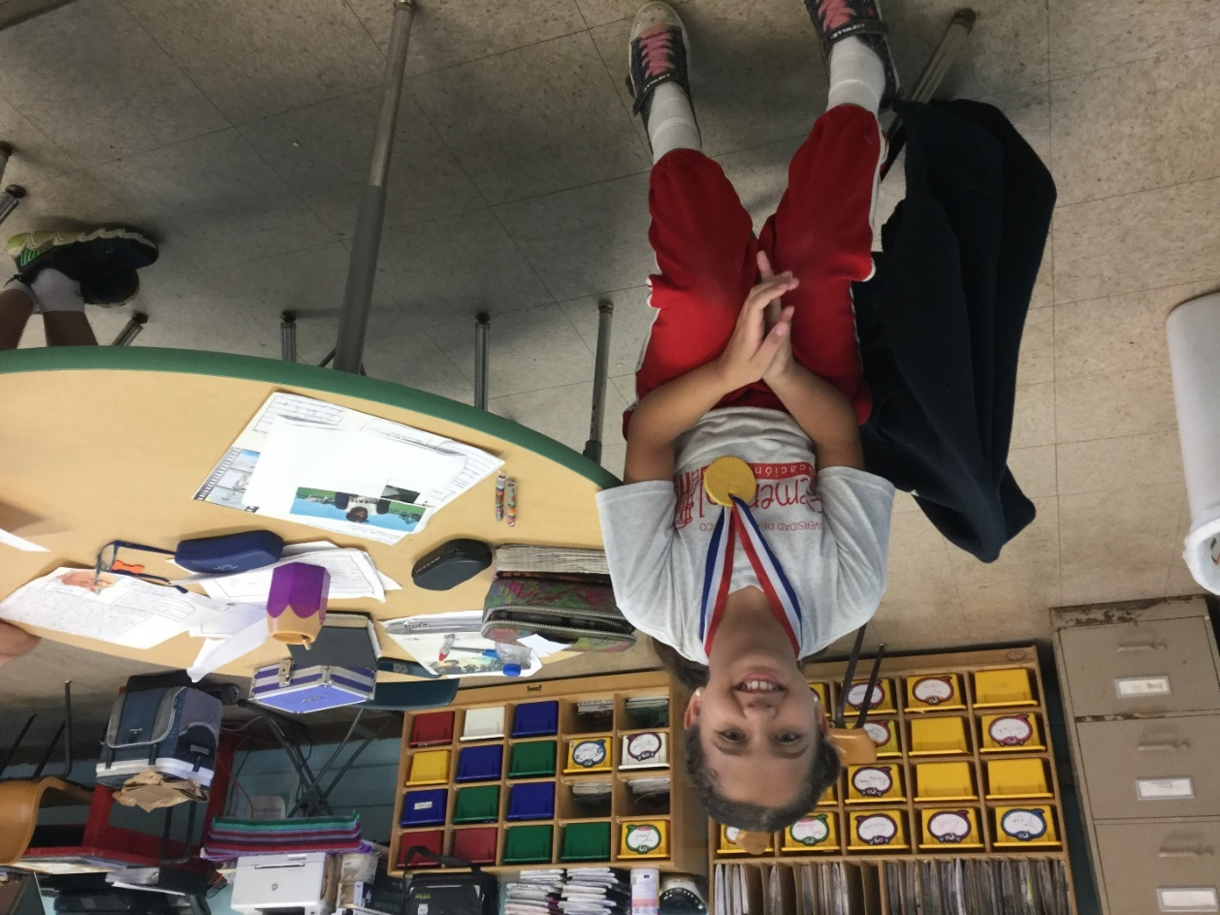
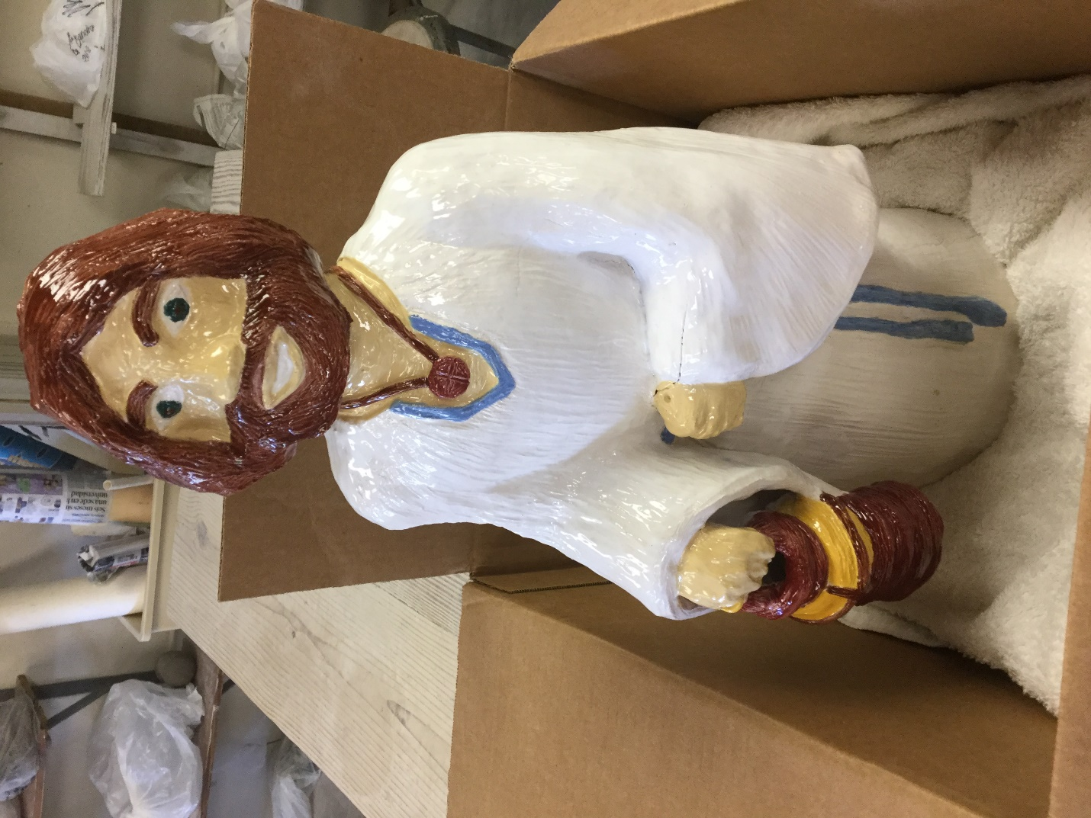

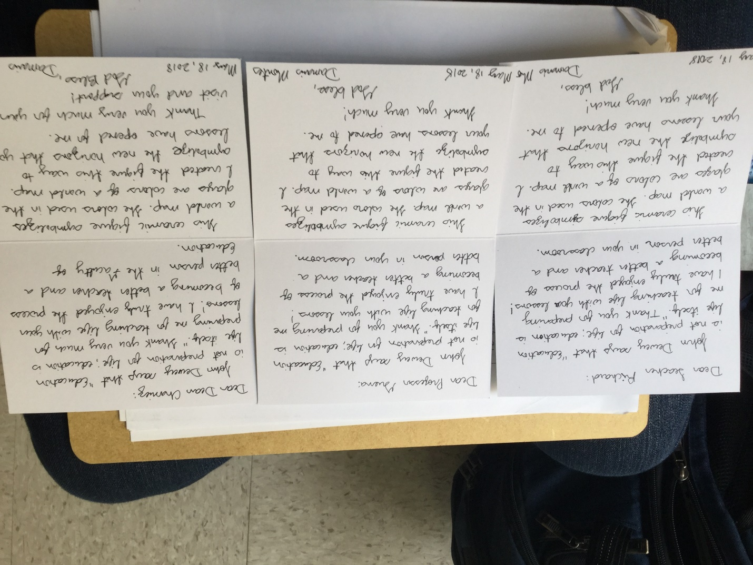

My time as a student teacher at the Faculty of Education of the University of Puerto Rico at Rio Piedras campus was coming to an end, and I knew I had a very difficult task that, in conscience, I had to do. I sat down, and in the clearest way I could, I explained in a letter to the Dean of the Faculty what was what I had kept in silence since my time as a student of the Faculty of Humanities and why I ended up as a student of the Faculty of Education, what happened in Pamplona and with Opus Dei. I did it with the same trust she had always given me… and, besides doing that and leaving the ceramics gift (I think I gave the ceramics gifts along the letter, which, as far as I remember, was a several pages letter), I dared to invite her for my final evaluation as teacher-student, which would be my also last evaluation and class as a student of the Faculty of Education. In the final evaluation of a student, the teacher student is usually accompanied by his teacher mentor —as every day— and also by his academic advisor, who will be the evaluator of the student. It's the most important class of a student teacher and the most important moment for a teacher-student through their whole years as students of the Faculty of Education. I knew she should be terribly busy as Dean, but if she could make it, I would feel amazed that she is there two, along with my other two biggest filial influences (as I would call them now), as a student teacher of the Faculty of Education. I also thanked her for everything I could finally learn and be thanks to her, both as Faculty of Humanities Student Dean, who made my graduation possible, and as Dean of the Faculty of Education, who made possible my teaching certification.
Well, after I left the letter, I felt it was the right moment to reveal to Christina in the first place that the Dean was for me and that I invited them to my final evaluation if she, as an evaluator, had no problems in allowing so chose to come. I needed to explain in the clearest way possible why I invited the Dean, but without telling all yet. It was still difficult for me to talk about everything that happened. She understood, but she was totally unaware we knew each other and seemed a little bit surprised I didn't tell all that before; I think she couldn’t imagine me as the Humanities students of years 3, 4, and 5 I was describing, I was always able to be a great student at the Faculty of Education. She understood the reasons for which I invited the Dean and told me that of course she would not be opposed at all, she was the Dean... I would later inform Richard also, without mentioning so many details about the why, besides telling them that she was my Student Dean at the Faculty of Humanities and she made my graduation possible then. I never knew if she was coming until someone from the school faculty told me verbally a message from her: she would try to come, but she wasn’t sure. I was warned by everyone: she must be so busy, I don´t think she could make it. At that moment, all my fellow student teachers at the Elementary Laboratory School were asking why the Dean was coming to my final evaluation; they understood nothing… so I had to make the proper explications, and everybody knew the same I said to Richard, that was enough to explain everything properly, although Christina as my academic counselor knew far more about the why.
That last day and last evaluation day came. I was totally prepared to do my best, as it should be. I was told I could begin. The Dean wasn’t there, so I thought she couldn’t make it and began my final class. It was about three or five minutes after I began when she arrived by surprise. She was presented to my students (they had difficulties grasping what the concept of Dean is; it was quite amusing); she took a seat and simply observed my whole class in awe. She didn’t look at her phone or anything else for a single moment; she looked only at me. And she seemed… well, what I can say, it's difficult to express. She was not serious, but neither distant. She was fully there and was in silent awe, literally. Due to what I wrote in the letter, I had no idea to how to interpret that silent awe. I had no problems giving a great class, and the proper observations were given. I got an A as the final evaluation grade. This is who I was meant to be since my years as a Humanities student, and finally, as the motto of the Faculty of Education, I was learning to be. She clearly saw me being who I am this time.

I expected to be able to talk to her about my letter after the evaluation, but she chose to remain silent about that and leave. She didn’t explicitly tell me, “I don’t want to talk about the letter”. She simply left after the evaluation and remained silent about that. And this time, it was me who respected her chosen silence. I never knew what she thought about it, nor did I go to her Dean's office to ask her; I simply chose to respect her silence, as she had done with me as a student of the Faculty of Humanities, but if it were me, my hands would have trembled reading such letter and imagining how a person can endure that without telling nothing to who she was supposed to trust more at that moment. I asked myself what she would think as an educational psychologist about integraction as a personal formation model (she was the professor of the only psychology course I had ever attended), but once again, I will respect her chosen silence.
I think it is good for a Faculty of Education Dean to attend some of her student teachers´ final evaluations. It shows respect and admiration for their students, as she did with me. I did cry a little bit, of awe also and joy for my achievement, on my own for everything that was happening; I think I did it in the bathroom or somewhere else where no one could see me. This is how it was supposed to happen from the beginning of my undergraduate studies as a Humanities Faculty student. Now, I was finally able to learn to be who I am, along with my own students’ learning to be who they were (at the elementary level, the part of learning “who I am called to be” still is very immature, but they do need to learn who they are, and they are perfectly capable of being doing so at the elementary level). In the end, celebrating together the amazing persons we are is also part of learning:
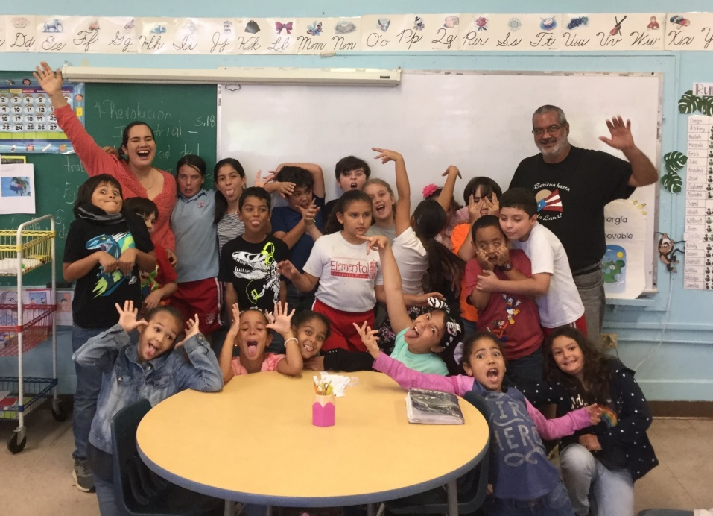

I do believe in reasonable accommodation to learning diverse and functionally diverse students. I did believe in the Faculty vision: “No student is unable to learn, but some are learning diverse and functionally diverse enough to need a reasonable accommodation for being able to learn at their best, according to their own strengths (notice that they teach us to see the students according to their strengths and not according to their disability: all students have strengths and you need to know and observe which they are) and you will see that often in your teaching careers, either as an official reasonable accommodation or as a reasonable accommodation that you must do on your own initiative for the best interest of the student” (I am remembering Christina's words regarding this, she discussed it). It should be clarified —and I observed this quite often among my peers who didn’t have an official reasonable accommodation from OAPI but were granted a reasonable accommodation by either the very own professor's initiative and/or the own student's reasonable request, as it happened in my time in the University of Granada— that in the Faculty of Education, the official designation of reasonable accommodation was not strictly needed for make a reasonable accommodation: evident observation of a teacher/professor and/or proper student justification was reason enough to make a reasonable accommodation to a student, with all the exceptional learning consequences it could imply.
That was exactly what happened with what my Student Dean of Humanities —now Dean of the Faculty of Education, which I belonged to as student teacher— did with me as student of the Faculty of Humanities when she argued with the Registrar that I should be granted the exception to be applied the New Bachelor to me due my evident learning diversity in third language learning, besides eventually already been admitted to graduated studies and only needed to be declared graduated to be able to go and pursue my best academic interest, it was evident she took the student’s dreams seriously and cut the wings of no one. She didn’t require me to get a reasonable accommodation to ask the Registrar for the exception to be granted to me: she knew me, she observed my academic progress, she observed that I evidently had a learning diversity issue with my language learning style and thar observation was enough for her to proceed to request the exception to be granted by the Registrar. I already mentioned that although she did recommend that I receive a psychological assessment for the frustration and crying issues, she NEVER suggested I must get reasonable accommodation given by a psychologist or doctor to proceed with the process of requesting to the Registrar the exception of me being applied the New Bachelor. As I said before, her evident observation as student dean of my learning diversity was enough to proceed with the exception-request process with the registrar. She NEVER saw me as disabled in the Faculty of Humanities despite my evident lack of stable academic progress after year three, nor was I ever seen as disabled in the Faculty of Education by anyone around me, with her as Dean of the Faculty of Education. I can humbly witness that with all the due intellectual rigor of evidence: I was always as equal as any other student despite my clear learning difference. I can also witness that the Dean —both as the Student Dean in the Faculty of Humanities and as the Dean of the Faculty of Education— did tried to act according to my best interest as a student and as a human being (it was not mainly an institutional or ideological interests as it happened both in Universidad de Navarra and Universidad Central de Bayamon), granting me exceptions (in the Faculty of Education my most usual learning exceptionality was granting me extended deadlines for projects and assignments) when I needed for reasonable reasons, and I explained to them which were those reasonable reasons. My problem with deadlines was no longer related to procrastination or lack of time to be properly prepared, like it happened in the Faculty of Humanities after year three: now it was related with that I really wanted to do my best, and sometimes I needed extra time for doing that, and so I was given the extra time when needed to let me do in conscience the best work possible, and for that, I will always be grateful. Being able to do in conscience what I myself consider my best work possible was —and still is, as I write this text— truly important. As a matter of fact, self-assessment was a required part of our academic progress as students of the Faculty of Humanities: we were required to create an online professional portfolio with our best academic work available along with our years of study, self-assessing our own work and reflecting in why that work applied the principle where it was being located in our professional student portfolio, according to each principle that the Faculty required the students to apply as student teachers. Our final evaluation as student teachers of the Faculty of Education in our practicum would be based on those ten principles. No matter which school was assigned to the student for making the practicum, the very same ten competencies of evaluation would be used for the final evaluation, as you can see in this photo of my final evaluation as a student teacher at the Laboratory Elementary School of the UPR:
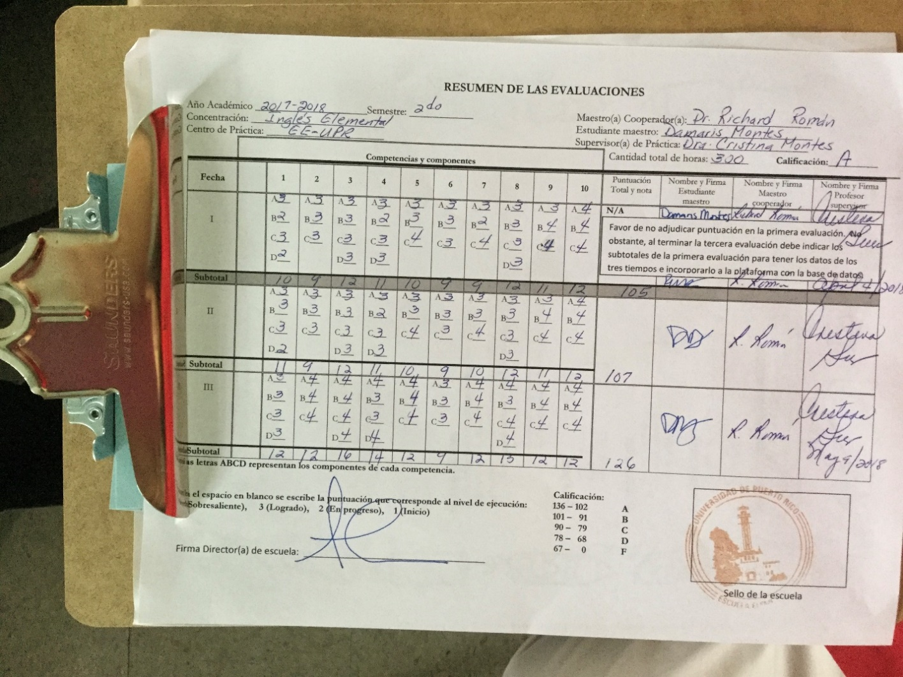
My only critique of my degree in education is that it should include an official Class Management undergraduate course. How you deal with discipline as a teacher is something to be dealt with as a whole course, instead of discipline and class management being only discussed as part of other courses.
The ten competencies we were required to achieve as students of the Faculty of Education, as you may have seen in my final evaluation sheet, were:
- Knowledge of the class subject (in my class, the English class).
- Knowledge of the students and their learning process (how we integrated the diverse learning styles of our students and how we saw and knew them as persons)
- Learning planification (how we were able to plan our classes as student teachers)
- Implementation of learning and research (we needed to research our methodologies, that's how integraction began to function as a teaching methodology).
- Creating a learning environment (how we created a classroom environment where the best learning was possible, including knowing how to deal with discipline issues).
- Communication (how we dealt with all communication issues: communicating with the community, with students, with fellow teachers, with the director, and with our blog)
- Technology Integration (in my case this was quite easy because I naturally need technology to do my best work possible. We needed to do an electronic registrar book, not only a physical one (I was not required to make a physical registrar due to my learning diversity; I was only required to make an electronic one). The use of the electronic board, at least in the Laboratory Elementary School in which I made my practicum, was mandatory).
- Learning Assessment (we were required to use varied methodologies of assessment to embrace the learning styles of all students, and it must be both formative assessment (not necessarily an officially graded evaluation, but it was considered part of their intellectual formation), continued assessment (aka known as progressive assessment, how the student progressed) and quantitative assessment (the graded assessment that almost everyone knows as official assessment of a class). It was while I implemented this competence that I realized why what happened in the University of Navarra ecclesiastical faculty was literally an intellectual massacre waiting to be consummated: they only assessed students in a single way and in a single time per semester), and no progressive assessment was done at all to let the student be conscious of how he or she was progressing if progressing at all.
- Community Relations (establishing community relations was required for us as students. That usually involved a communion-based relationship with the parents of our students; we saw each other as a team. I never had a single problem with any of the parents of my students as a student teacher, not even with the very same Writing Professor of the Faculty of Humanities whose course I had to withdraw from years before due to her mocking my Christian beliefs. I never knew if she remembered me, but I had no problems at all as a student teacher of his son, and we talked personally about the learning of her son with total normalcy).
- Professional Development and Performance (we needed to demonstrate the capability of keep our professional development actualized according to our own initiative and interests, especially according to our research interests and the best interests of the students (for example, developing evidence-based teaching strategies for exceptional students, I had to do that as a student teacher, I had a very gifted student whose whole disciplinary issues were based in his brightness. Although it seemed to be an oppositional authority problem, it wasn’t at all; I saw it clearly: he was a very bright fourth grader who needed more intellectual stimulation, not more discipline). Here integraction played a huge role for me: I actively developed it progressively as a teaching methodology until finally reaching to begin to implement it as my own planification methodology in the Holy Spirit School years later)
The time came for me to do the teaching certification test, also known as PC-MAS, administered by the College Board. Without passing those tests, I wouldn’t be able to be certified as a teacher; it is as needed as the practicum itself. Once again, what seemed impossible was possible to happen: I was the first ever student teacher to be allowed by the College Board to use a computer to complete the hand-written parts of a test, according to my reasonable accommodation stipulations. They placed in a classroom a laptop programmed by them, that had a word processor like Word, but the spell-checker capability was totally disabled. The computer belonged to the College Board and was opened only at the stipulated time (as far as I remember, I didn’t require extra time, but I did have that reasonable accommodation, too), so there was no way of doing de facto copy-paste tricks of any kind: the thoughts and expressions would be totally my own, but I was granted to develop my ideas with a computer instead of by handwriting, and I was totally relieved and thankful for that. I was also placed in a one-to-one classroom to complete the test that was given at Interamerican University. I was the only one in the classroom, and there wasn’t a single sound around distracting me from doing my best on that test; it also had multiple choice parts. I aced the test with an amazing result, way higher than expected. I don’t remember my exact score, but it was a very high score. Everybody knew it in the faculty, and we celebrated our successes together. I completed my mandatory review for the PC Mas in the Asociacion de Maestros de Puerto Rico. There wasn’t a single ideological connotation in what they taught us there, which amazed me because knowing how much they love strikes, I was expecting ideological connotations. There was none.
So, if I counted only the courses that I did with the proper reasonable accommodation and medicated with Adderall for my ADHD, I “graduated” technically from the Faculty of Education teacher’s certification courses with a summa cum laude, with only one B. That was an amazing achievement, finally getting academic progress according to my full intellectual and creative capability. You can read the amazing letter of recommendation my mentor teacher wrote at the end of my studies at the Faculty of Education here:
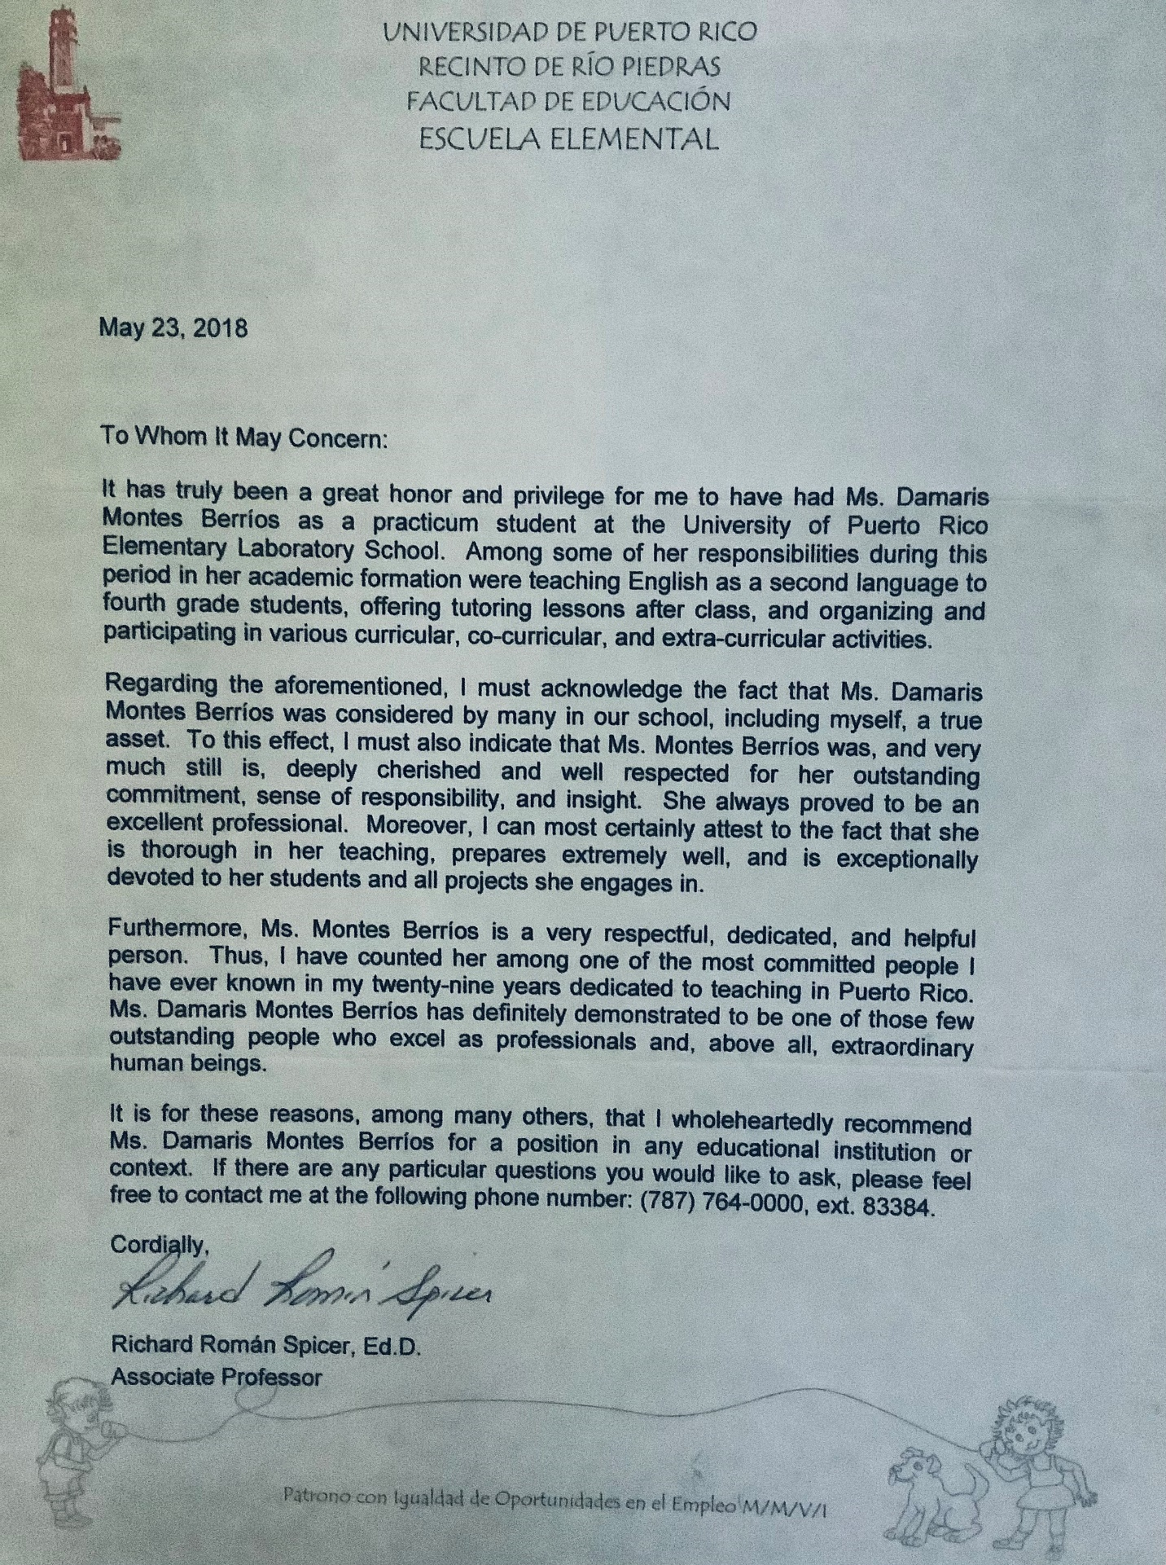
Now I realize that the real impossible that the Faculty of Education made possible was me being finally able to learn to be. Not a small impossible at all in my circumstances, and I wouldn’t be able to proceed to be able to become who I am called to be if I don’t learn how to be first. As I was becoming a teacher —Jesus was also a teacher— I was also learning to be according to my own life narrative, articulated according to my own inherent dignity, according to my own personal identity. Now, I was an equal student in all the senses possible. As I kept working as a teacher, integraction kept developing as a personal formation model. The integractive blog that I began as a teacher student would later work as my writing block about integraction… that kept developing as it is seen now in this text, with a very solidly grounded nature structure, although still developing psychologically.
What I sang in the ninth-grade “graduation” (it technically wasn’t considered a graduation either, as it happened now with the ending of my studies at the Faculty of Education, technically there is no graduation) began to be true now at that Faculty of Education (in ninth grade I sang the parts of Alejandro Fernández in my Día de Logros):
Soñar con lo que más queremos
Aquello difícil de lograr
Es ofrecer, llevar la meta a su fin
Y creer que la veremos cumplir
Arriesgar de una vez
Lo que soy por lo que puedo ser
Puedes llegar... lejos
A las estrellas alcanzar
Hacer de sueños realidad
Y puedes volar... alto
Sobre las alas de la fe
Sin más temores por vencer
Puedes llegar
Hay días que pasan a la historia
Son días difícil de olvidar
Sé muy bien que puedo triunfar
Seguiré con toda mi voluntad
Hasta el destino enfrentar
Y por siempre mis huellas dejar
Puedes llegar... lejos
A las estrellas alcanzar
Hacer de sueños realidad
Y puedes volar... alto
Sobre las alas de la fe
Sin más temores por vencer
Puedes llegar
Puedes llegar... lejos
A las estrellas alcanzar
Hacer de sueños realidad
Y puedes volar... alto
Sobre las alas de la fe
Sin más temores por vencer
Puedes llegar
Puedes llegar
Quieres llegar
Sobre las alas de la fe
Sin más temores por vencer
Puedes llegar
Al más allá
Puedes llegar
In ninth grade, I dreamed of becoming a writer, and I adored helping teachers without suspecting that I would become one. Teaching is truly a vocation, the giftedness of a lifetime. Eventually, I would not be able to continue to work professionally as a teacher due to—among other very serious reasons— the extremely low wages of all my teaching jobs…, but my life narrative is already articulated vocationally as a teacher and writer of living words, and that vocational articulation won’t change. A true vocational teacher is always a teacher, no matter where she or he is. You can see my professional teaching certificate here:
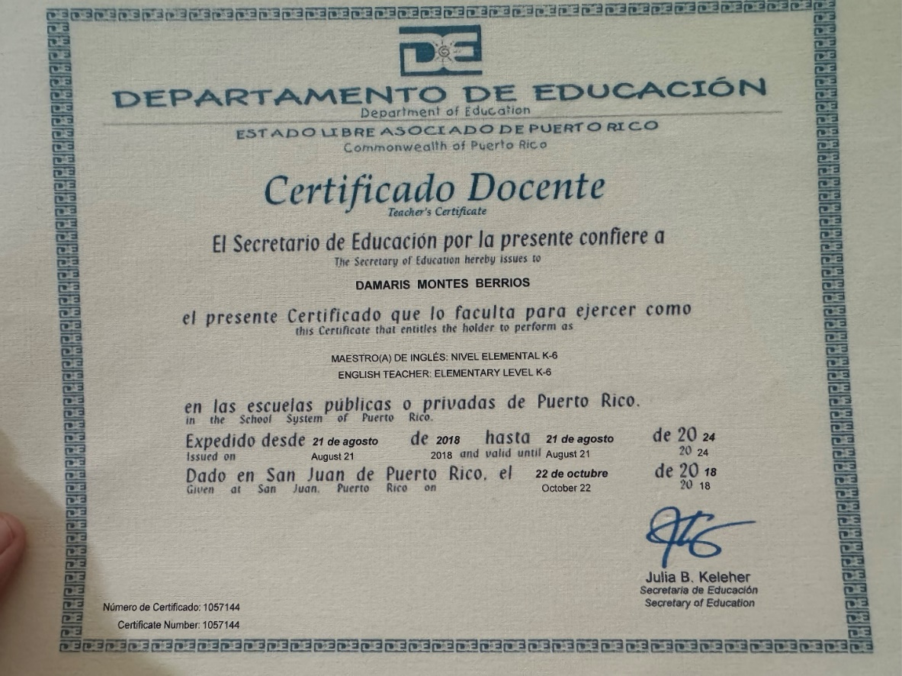
As I was totally accepted as I am in the whole faculty system —except for the Exceptional Child class, and it truly was an extraordinary exception—despite the posttraumatic issues I was dealing with on my own after what I endured before being admitted there, the Faculty of Education truly helped me to learn to be… and for that, I will always be grateful for how that filiation began to transform my life into who I am today as a person. As you can fully understand now, my life wouldn´t be the same without my filiation with the Faculty of Education of the University of Puerto Rico, Rio Piedras campus. Besides that, it allowed me to almost complete all the approaches possible to integractor from the integractive sciences. The Integractive Sciences are the sciences related to the study of personal formation, and they are Humanities (including theology and philosophy), Education, and Social Sciences. I have my degree in Humanities and now I have a teaching certification. The only thing I need now is to study psychology to have, in all the academic sense, all the needed academic interdisciplinary vision to approach integraction from all its perspectives possible. If I am given the choice, I would like to continue graduate studies in psychology and finish integraction as a personal formation model, and I had a very good example set by this Dean about how psychology should be taught.
I finally realized that feeling in my place —finding my place— was not so related to finding a place as to finding who I am and accepting who I was meant to be. Feeling like home was being allowed to be myself, fully myself, for the first time in my life. Creating home was also being allowed to “create myself,” not in the sense of taking the place of my Creator, but in a sense of allowing me to be formed as I truly am upon God´s eyes and as I am called to be upon His always-eternally loving gaze. Paraphrasing a phrase that is a wall in the room, I am writing this, in which I also dream God´s dreams: Life isn´t about finding yourself; it's about forming yourself.

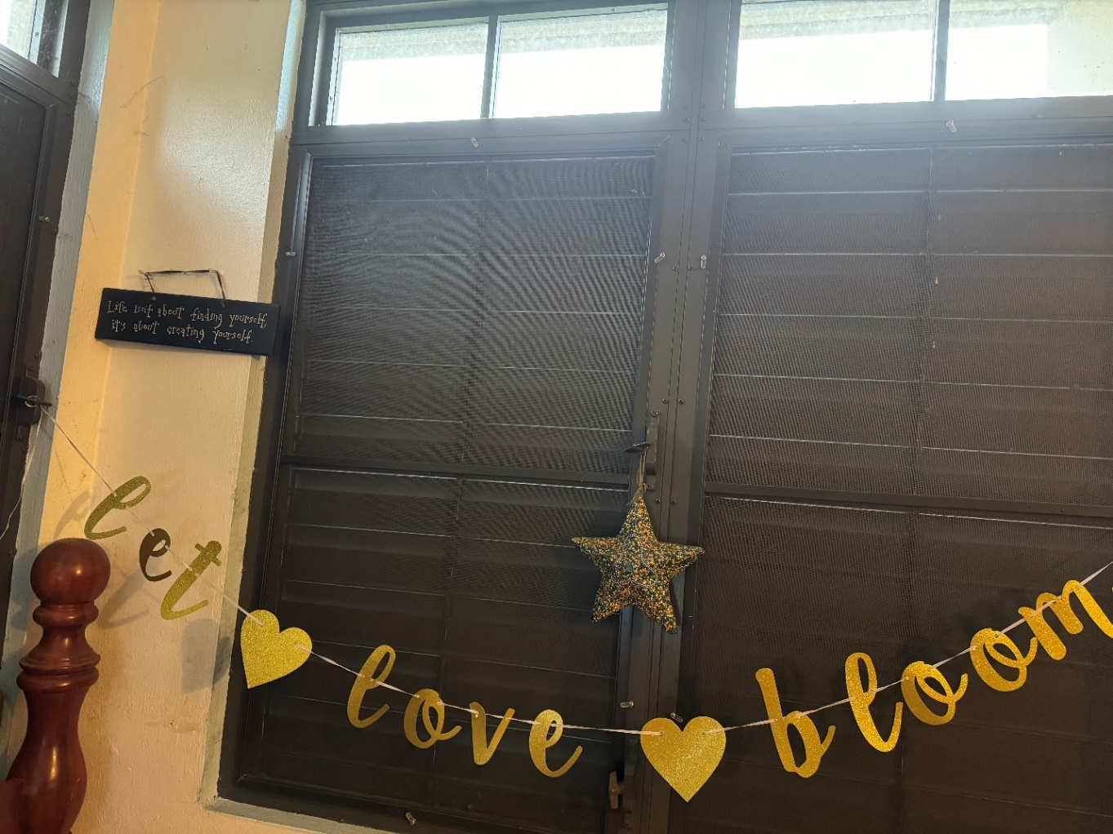

Yes, what was the truly impossible made possible with my filiation with that Faculty of Education was my learning to be, standing tall and proud of all that I am… and ready to learn how to become who I came called to be. That is the very next step after finally learning to be in an organic, intellectual, and filial way… learn to be and become who you are called to be…according to my own dreams, articulating my personal formation as God has granted me to do it: according to my inherent dignity as human person who is unconditionally and infinitely loved and known by Him.
Here, you can see my earned BA degree from the University of Puerto Rico, Rio Piedras campus.

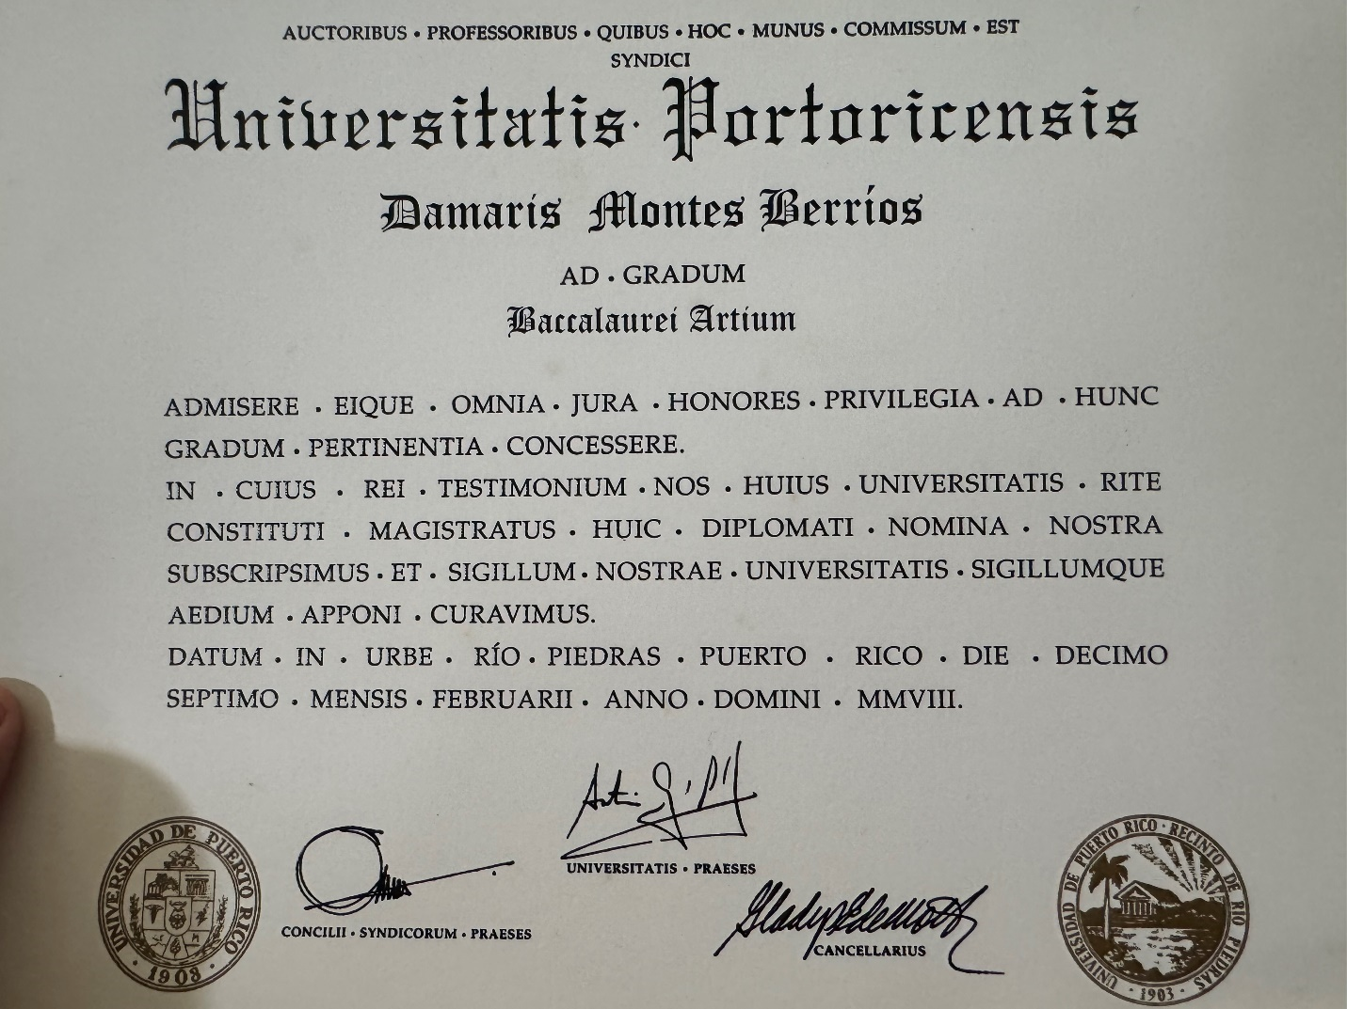

Despite the ideological conflicts I faced in the Faculty of Humanities, I will always be grateful for what I learned at the University of Puerto Rico, Rio Piedras campus, and for the impossible they made possible.
This is the end of my long but amazingly beautiful exposition of the importance of the filial nature of human personal formation.

The Laws of the Nature of the Human Personal Formation
So, as we have stated above: Biological natural growth can be called evolution; ontological natural growth can be called maturity; filial natural growth can be called progress. Biological growth is ruled by natural selection via instinct; maturity is ruled by knowledge via reasoning; progress is ruled by tradition via culture. Biological growth purpose is survival (health); ontological growth purpose is plenitude; filial growth purpose is freedom. Biologically, we are created with Love (sexual intercourse). Ontologically, we are created by Love (communion). Filially, we are created in Love inside a concrete social community, usually called “family,” in which we are loved unconditionally as we are and as we are called to be according to our inherent dignity as a part of a “we, the people.”
As you can see, certain common characteristics are implied in the growth of the integraction of information, in the personal formation of all human persons. Besides the common classifying concepts I just mentioned, there are common characteristics in the information of all human personal formations. These common characteristics can be considered the laws of the nature of human personal formation.
The first of these laws can be called the Triadic Law, which states that all human personal formation nature dimensions must be present simultaneously for a human person to be formed and remain being formed. You can´t be a human person without being, without body, or without filiation; you necessarily need all three to be present for a human personal formation to happen. In the case of neurological death, in which the brain is dead, and the person is kept breathing and living without any brain activity present, it can be said that the triadic law is broken and there is no human personal formation there, so you can ethically disconnect the person without committing murder: there is no personal formation possible without brain activity, you need the brain to have personal formation, the brain is the biological mind. You need the potentiality of the “three minds,” the brain, the intellect, and the conscience, to the personal formation be able to happen, and there is no potentiality at all in a no-activity brain. That is why it can be said that every human being can have a certain degree of neuronal activity, learn to some degree according to his or her intellectual traits, and have a certain notion of conscience, no matter how minimal it is.
The second human personal formation nature law can be named the Natural Influence Law, and it states that all human personal formation natural dimensions necessarily influence each other, and they can´t contradict each other. That means the ontological being will necessarily influence the biological organism and the social filiation; the same can be said for each dimension.
I am going to give a very concrete example of this: if there is a person that has Down Syndrome in the genetic configuration (DNA) his biological being, that will also necessarily influence how his ontological being matures and how his social filiation progresses, but as we know now, with the proper social and intellectual extra stimulation in early ages, and so, despite the Down Syndrome natural organic trait, it doesn´t define the person according to a specific “predestinated design” simply due having Down Syndrome in their DNA: the social filiation and the intellectual maturity does also influence a lot how a Down Syndrome person is formed and keeps growing, showing us that people with Down Syndrome are capable of amazing things too, and of course, no matter in which degree their genetic extraordinary configuration influences their ontological maturity´s capability or their social progress´s capability, their formative processes are there, and also their inherent dignity as human beings (we will talk more about the inherent dignity of all persons later).
Because they influence each other proportionately, human personal formation natural dimensions can´t contradict each other: that will lead to death, suicide, or restraint of civil authority [potestad civil] (via legal restraint of freedom due to being unable to act according to the social notions of a civilization). The most gruesome and heartbreaking example of this in our days is the transgender phenomenon: the attempt to manipulate biological nature exclusively according to social-ideological notions, creating a huge contradiction between social dimension and biological dimension (due to their wrong social notions, they believe intellectually that they are in the wrong biological body) that often leads to suicide and even to healthy bodies´ mutilation. Here is the empirical evidence: a study done in 2023 from the Williams Institute at UCLA School of Law finds that 81% of transgender adults in the U.S. have thought about suicide, 42% of transgender adults have attempted it, and 56% have engaged in non-suicidal self-injury over their lifetimes. In another study of 2022, around 85.5 percent of transgender people assigned female at birth had considered suicide, compared to 77.2 percent of transgender people assigned male at birth. Approximately 42.7 percent of transgender people assigned female at birth had attempted suicide, compared to 37.2 percent of transgender people assigned male at birth. These were the most recent studies available. What is being done to transgenders is personal formation mutilation, the same way that in Africa the feminine mutilation is still being practiced due to the wrong social notions, pretending to inform those wrong social notions by force (that is a personal formation violation) into the feminine biological nature of extremely vulnerable African woman. Information as a human personal formation process doesn´t happen by force; you can´t manipulate nature; it is given. Information happens naturally, with the constant integration of the three dimensions constantly influencing each other. The difference between feminine genital mutilation and gender-affirming surgery is that the first one happens among the poor, so it is openly called mutilation, and the second one happens among the rich and makes astonishing profits to be completed and sustained, so it is called “medicine” instead of being openly called according to what it is: mutilation also. The social notion of economics influences a lot. As a matter of fact, among African people, especially among the poorest, it was believed and sometimes still is believed that feminine mutilation is “medicine”.
Here you got two very clear examples of contradiction among dimensions of the nature of human personal formation. Let this be clearly stated: all human personal nature dimensions’ contradictions eventually will lead to organic death if you let them progress long enough to cause it. Natural death is an ineludible “natural personal formation contradiction” for all: at a certain point, our living organism will cease to exist as a living body, but our ontological being remains contemplated as a living memory, it goes beyond death as a living eternal being.
The third human personal formation nature law can be named the Evident Growth Law, and it states that there is always clear evidence of growth in every human personal formation, from conception to natural death. As we keep growing, we keep forming as persons, on and on, in a never-ending evolution, maturation, and civilization, from conception to natural death. The problem here is that typically, growth is only understood in the physical-biological sense. There can also be a beautiful ontological maturity growth and love-knowing capability in the person who is waiting for his or her natural death instead of choosing euthanasia (that is also a violation of human personal formation, as abortion is), and that is also the growth of the human personal formation, even upon the doors of death. There is growth in the unborn, even if science still doesn´t yet have the capability of physically seeing and detecting the exact moment of a conception. Sometimes, the growth can be of social notions: how a person humanizes us all with their presence in our society. That is the beautiful growth that you see in those disabled brothers and sisters unable to live independently due to severe disabilities caused by their biological and/or ontological traits. Where there is human growth, there is love; there is life, and there is inherent human dignity… as we will expose in the next paragraph. In human personal formation, growth is not only how you grow yourself and the process of becoming who you are, but also the progress you cause and the social growth you cause as you help to be with your sole existence as a human being. We don´t grow on our own, and we don´t grow alone: we always grow together in communion. As a person keeps growing, there is social growth also… and there are human beings whose most beautiful personal formation growth is how they humanize us all with their sole presence in this world, no matter how short their life is, no matter how disabled and dependable of others they are.
The fourth human personal formation law is probably the most needed of these laws in our time, but to understand it, you need the context of the four previous laws. This one can be named the Dignity Law. It can be stated as follows: all human personal formations have inherent dignity simply because they are a human person by nature, fully capable of forming growthfully and keep growing either in the biological, the ontological, or the filial sense no matter in which growth stage they are, from conception to natural death. Because of the inherent dignity that unconditionally belongs to their human personal nature, all human personal formations are unconditionally entitled to human, fraternal, and civil rights, constitutionally, no matter in which growth stage they are. Usually, in our times dignity is something that is believed to belong and be founded solely in the acting capability: if a person can act on his own or her own, she or he has dignity, according to how capable they are of being independent both biologically and ontologically (there is no possible thing as “independent ontology: you will always depend to the Being of your Creator, no matter how much you try to be Satan and be by your own… but that is not to be explained right now, but in the biological sense this is very evident: you need others to survive and reproduce as a living organism) or how capable they are to be socially successful, according to the given frame of social notions of each society and civilization.
This social notion must be changed because it is completely wrong, since the very root of the premise: dignity doesn´t belong to human action, it belongs to human nature, and in an inherent way, it is there for the sole reason of being a human personal formation that grows, that evolves, matures and progresses, each one according to their unique ontological and biological traits, and also according to the social notions (the civil context) of the time.
In the name of a “human dignity” that is gruesomely wrongly understood, gruesome violations of human dignity have been and are being committed. Two are especially common nowadays: abortion and euthanasia. I have already mentioned both, but now it can be understood why both truly are a gruesome violation of human dignity: both inherently violate personal formation nature. As I will explain further on in the last part of this text, no one can steal or deny another the inherent growth potentiality that every human personal formation has, from conception to natural death, no matter which the circumstances are, no matter how dependable a person is of another to survive. Both abortion and euthanasia are systemic denials of the universal potentiality of growth of every human being. What people at the end of life need are choices to keep growing until the last natural breath and the last natural beating, and growth, as I mentioned before, is not always biological: it can also be ontological or social. There is no surprise at all that suffering can be considered one of the most powerful “fertilizers” of ontological maturity, but for that, you need to be unconditionally loved and unconditionally receiving person-centered care until the end of your life. The fact is: right now, medical care is seen more in economic terms than in person-centered notions, and some people have very solid reasons to feel they are alone, unloved, without growth choices, and without any truly human support, so they consider that their most “dignity-filled” choice is killing themselves or letting other to help to kill themselves. There are also people who, despite having overflowing love around them at their end-of-life process, they feel that they can´t be a burden to others, so they choose to kill themselves instead of letting themselves be cared for and loved when they are unable to live on their own terms: they don´t understand the notion of social growth and how humanizing can be to others the process of helping to be a brother and a sister in his or her last months or days on Earth truly according to their human nature inherent dignity.
The hardest and most difficult cases of euthanasia are the cases in which there is a huge physical or emotional pain involved in the end-of-life process. Palliative care has greatly improved the aim of making it possible to alleviate both emotional and physical pain in every end-of-life process, and it should always be available to all human persons, no matter in which growth stage they are —even perinatal palliative care exists right now—. No matter how much palliative care has advanced, yes, there are still cases in which huge pain is still involved in the end-of-life process… but pain is a natural part of life from the very moment of the beginning of life and should be dealt with as part of the natural process of dying. Unavoidable suffering can have enormous fruits in the ontological growth of a person, making possible a maturity that wouldn´t be possible without it. Cancer patients know this very well… but I will state again what I said: UNAVOIDABLE suffering can have enormous fruits in the ontological growth of a person. No one is called to tolerate suffering deliberately, and proper medical research must be done to properly alleviate the biological roots of dealing with unavoidable extreme pain in the natural process of dying. Maybe someday we will find a medicine that blocks the neurological receptors of pain if that is possible to happen… but the fact is: no matter what, suffering is a natural part of human existence, and we must deal with it in all growth stages. Suffering by itself is not a reason to kill someone or to kill yourself because suffering doesn´t steal your growth potential. NOTHING can steal the growth potentiality of a human being, not even extreme pain or lack of control over your own body. Everyone deserves to be unconditionally given the chance to keep growing, no matter what, from conception to natural death. In the case of suffering, the exceptional growth opportunity there is in ontological maturity.
I have always had difficulty in explaining the sense of suffering without using Christian notions, but I tried. After what I have said, it is necessary to mention the following Christian sacramental-ontological notion: for a Christian, unavoidable suffering is highly redemptive and implies a deep and very special grace-filled and mercy-filled participation in the Passion and very own self-giving of Jesus as incarnated God-Love-with-us. Only God knows how many souls had been saved thanks to those who, upon unavoidable emotional or physical suffering, chose — or learned how to choose during the suffering period— to embrace a redemptive ontological maturity process. There are many examples of extraordinary ontological-sacramental maturity reached through unavoidable suffering among saints who embraced fruits of the Holy Spirit that would have been impossible to embrace without enduring such suffering in a holy way, especially at the end of their lives, but I will mention only one example, quite actual, the first millennial saint: Saint Carlo Acutis. At age 15, Carlo was diagnosed with untreatable leukemia. He offered up his suffering for others coping with illness and said, “I offer all the suffering I will have to suffer for the Lord, for the Pope, and the Church.” Carlo died from his illness on Oct. 12, 2006. His body is incorrupt, a clear supernatural sign of holiness.
He had a gift for empathy and was known for defending kids at school who got picked on, especially disabled kids. Carlo loved soccer and video games. He tried to stay disciplined and only played games for an hour a week even though he really wanted to play much more. He also bought computer programming books and taught himself computer coding and animation. He had a great devotion to Mary loved to pray the rosary. He went to Mass and confession as often as he could. He loved the Eucharist and was fascinated by Eucharistic miracles. He asked his parents to take him on pilgrimages — to the places of the saints, and to the sites of Eucharistic miracles. Using his research, he began creating what would eventually become a website to catalog and share the information with others. Carlo was concerned by people growing distant to the Church and the sacraments and desperately wanted to bring them back. On the site, he told people that "the more often we receive the Eucharist, the more we will become like Jesus, so that on this earth we will have a foretaste of heaven."
Yes, Carlo suffered extreme unavoidable pain in his end-of-life process due to his leukemia, but he matured in such an extraordinary ontological way during that suffering period that he became a saint and led many others to a life with purpose, a life with faith, a life understood a becoming the Living Eucharist I am adoring right now as I write this whole text, because for me, writing this, no matter how scientific or contemplative can be the observations, facts and laws that I am sharing, is an act of adoration: Jesus Charity, we adore you with our whole growth.
Imagine that everyone chooses to kill themselves simply because they are suffering, no matter how simple or how extreme the suffering is. There would be no one on Earth because at some point in our lives —not only in the process of death— we all suffer. What must always be given according to our inherent human dignity, but especially when we are through extreme emotional or physical suffering, are growth choices, not death choices. We are not animals who don´t have ontology to grow in maturity, so they are simply killed to avoid their suffering, as happens with dogs. We are people, with unconditional potentiality of growth and entitled to equal growth choices according to the characteristics of each one of our growth stages, no matter in which one we are, even at the end-of-life process. The ever-lasting possibility of growth choices that are the fruit of being unconditionally loved and of being considered an unconditional and unique part of “we the people”, worthy of being loved and unconditionally helped to be from the very moment of conception until the natural end, without treating anyone as a blurb of cells —we are all blurb of cells, since the moment of conception, but some “blurbs” are supposed to be more developed and mature, also known as “adult human beings”—, as a burden or as an economic cost, is what avoids what euthanasia truly is: suicide, assisted or not. I personally would love the growth choice of adopting a person who is in the process of dying and doesn´t have a family or someone to care for him or her needs in that final growth stage, so he or she can know himself or herself unconditionally loved and he or she can choose to keep growing on and on as he or she is helped to be until the very end. That was usually something that belonged to the very nature of being a family: caring for those who could not care for themselves, especially at the beginning and at the end of their lives. Now, there must be an apostolate of dignity that affirms the whole human personal formation as a charism and forms what they preach, making it possible to create a joyful and luminous home in such a way we build a fraternal society in which everyone can choose to grow on. That is what the consecration to charity essentially is: the God-given grace and call to dedicate yourselves to live charity making possible the growth of everyone as an equal brother and sister, from conception to natural death, letting the Holy Spirit consecrate you to help to be, to help to do, to help to grow, to help to glow, and to help to bloom everyone according to their inherent dignity, growing on and on until becoming together the best person we, the people, can be, according to our constitution of Love.
There is a very special need in our time of living charity making possible the funds to provide dignity houses to help to be in both the extreme cases of crisis pregnancies and lonely and suffering at-the-end-of-life people, the most “socially stoned-to-death” populations of our time, both needing unconditional love and help to choose to keep growing on as who they are and as who they are called to be, from conception to natural death, instead of being forced due the circumstances (due to the social context of both our time and their concrete historical circumstances) to choose abortion or euthanasia.
There are other cases of suicide —beyond the biological suicide that euthanasia implies— that are also a grave violation of the dignity law. There can be an ontological suicide if a person chooses deliberately to have an empty existence, surviving without any purpose that incarnates who he or she truly is and who he or she is truly called to be. This happens much more often than you may realize, and it is quite sad to see because when it happens, usually these people won´t always let others help them to be in a more dignified way, according to their given personal formation nature. Of course, this ontological suicide can influence the organic dimension and cause a biological suicide, like euthanasia is. This is why not all cases of depression and mental health issues have an initial root in a neurochemical biological imbalance in the brain like current psychiatry believes: there can also be mental health disorders whose primary cause is ontological, a dehumanization —than can also be a systemic dehumanization, as we are going to explain in the next paragraph— with biological imbalances repercussions, because all the three natural dimensions of the human nature influence each other, as we explained before. That is why not all depression cases and mental health issues can or need to be treated with medication to be cured: some people also or simply need to know and be known as they are and as they are called to be in a more dignified way to correct the ontological imbalance that causes suicidal ideation. Sometimes, what is needed is not medication, or not only medication, but help to be, help to do, help to grow, help to glow, and help to bloom as you are and as you are called to be according to your natural human dignity.
There are also other cases of suicide —beyond the biological suicide that euthanasia implies and beyond the ontological suicide I just described in the prior paragraph— whose roots are not biological or ontological but social. That is the case of social slavery, which is a concrete form of social abortion, also known as systemic dehumanization: when a person´s growth potential according to their nature is reduced or even denied in a systemic way by other people who act as another person could be owned, instead of respected. This, of course, implies the systemic dehumanization seen in circumstances like the Holocaust, Holodomor, the Apartheid, and some relatively recent Latin American dictatorships, among other dictatorships along the history of the world. Social slavery is not exactly suicide, because it is not something voluntary: it happens when your growth is socially slaved, and so you are only allowed to grow in a certain way if you are going to be a part of that society —everyone needs a society that helps them to be, but in this case, society slaves you to be—, being allowed to grow only according to the criteria of those who slave you socially… instead of being allowed to grow naturally as you are and as you are called to be, as the best person you can be as an equal dignified part of a “we, the people”. The name is no causality at all: this is what precisely happened with all American slaves during the colonization era, they were forced to only grow in a certain way, deforming the purposes of their lives to simply limit their whole life purpose to do what others told them to do, instead of being, act, realize, project and connect always seeking their fullness of personal growth —their growthfulness— naturally and freely, as it should happen to every human being according to their inherent dignity.
Thanks to social progress and to God, right now there are no places in the world where legal slavery is allowed, like it was until relatively very recently in United States —that social wound still exists and must be closed constitutionally, with a change of the federal constitution that affirms the inherent and equal dignity of all persons, from conception to natural death—, but there are still many forms of modern social slavery around the world: chattel slavery in Mauritania, the kafala system in Saudi Arabia, slave markets and trafficking in Libya, and child labor and caste system in India, the sabiyyas [sexual slaves] of ISIS, like Nadia Murad tragically described in her book The Last Girl, how Christians are being massacred and forbidden socially to be who they are and who they are called to be in Nigeria... The reality is that social slavery still exists. It must be ruled out as socially and legally unacceptable in the conclusion of The Universal Declaration of Human Fraternity —the denial of universal fraternity will ALWAYS result in some kind of social slavery—, and a lot of social progress is yet to be achieved to eradicate it completely from our human civilizations and societies, both from the ones that exist now and the ones that are yet to come. Yes, you can consider slavery as the social equivalent of biological suicide and ontological suicide. Slavery is social suicide, not voluntary, but you are socially forcing people into suicide. It is described in historical chronicles how my own cultural and biological ancestors, the Tainos, killed themselves in mass suicides simply for not consenting to become slaves of the Spanish colonizers. It is also very well documented how Jews often killed themselves in the electrified fences of Auschwitz simply because they could not bear being forced to such a dehumanized existence anymore. That is, technically, a social suicide that eventually was also consummated as biological suicide: a society that doesn´t let a person or a people be who they are and who they are called to be, and that leads to biological suicide because all the dimensions of the social personal nature influence one another. Sadly, that is also how many homosexual people have been driven to suicide, even by their own families —family is the first society of a person, so yes, if you are rejected by your own family as you are and as you are called to be, this definitely can be considered a social suicide/social slavery instance— who don’t accept them as who they are and who they are called to be. Another case of modern social slavery, rarely seen, is the case of the embryos that right now are being treated as biological discards, remaining frozen forever. They are enslaved socially by our civilization, socially forbidden to grow according to their inherent dignity: currently, there is an acceptable social notion that it is all right to treat human embryos as spare parts and to leave them frozen forever. They should be adopted, and scientists must be forbidden from making “spare embryos” that they deliberately know won´t be conceived in a womb.
I wrote about socially-stoning-to-death in one of the prior paragraphs. I retake that very gruesome image now to explain another grave violation of the dignity law of our time that has rarely been considered as existent. Think for a moment about all the aborted, murdered, suicided, euthanized, frozen as embryos, socially slaved people who should have been there and were, who should have been given a unique and irreplaceable share to our social progress as humanity with their sole existence, but they weren´t able to give it simply because they were denied existing according to their dignity. Those dignity violations are there, in the first place, for God-Love-with-us, even if most of the time, they are unseen by the society of the time when these violations happened and still happen. I will give a very concrete and actual example of this: right now billions of people —I didn´t say millions, I said billions— are being denied their right to grow according to their inherent dignity because they are denied, —due to poverty and other socially accepted growth opportunity inequalities of our time— the very possibility of receive the basic intellectual formation —the education— and the basic cultural notions to actually being able to know themselves as they are and as they are called to be according to their inherent dignity. Right now, there are billions with bare resources to actually being able to conceive themselves as persons, or with no resources at all to conceive they are persons with rights and exist according to their inherent dignity, entitled to unconditional fraternity. How do you expect human dignity to be understood properly if, in the first place, a person-centered intellectual formation and communion-centered cultural notions cannot occur? There are other ways for this to happen, unrelated to poverty. There are billions of dollars spent in United States public education systems, but sometimes —and it has not been a few, this has happened and still is happening plenty of times, and only once is needed to be far too many times— teachers use their formative power to instruct ideologically-centered education instead of instructing person-centered education. A clear example of this is using schools to teach the ideology of gender, especially if done in a way that the student accepts the ideology as social normalcy —this is called “social transitioning” in school— instead of as the ideology it truly is. This happens when you use school materials that frame the ideology as the only accepted social norm of the present time, perverting the human personal formation according to the ideology that is being taught to be seen as social normalcy of the time, without giving ANY information to let the student form his or her own criteria and critique and chose not to follow the ideology that is being forced in the school as social norm. This is wrong, awfully wrong, and it is a very grave violation of human dignity.
Promoting “social transitioning” in schools, understanding “transitioning” according to the ideology of gender, is awfully wrong and it is even open child abuse committed by intellectual predators, very especially if parents are not being told about this, openly denying their all due parental rights of being the first responsible ones in all the senses —including the social sense that happens in the school— of forming their children properly. Using the verb “transitioning”’ as ideology of gender uses it is awfully wrong and even denigrating, because it disintegrates and breaks the nature of the personal formation. The correct context of understanding the verb “transition” inside a frame of a growthful personal formation —a personal formation that is ordered to the plenitude of the whole person, so he or she can become the best person he or she can be— is a transitioning that means making possible that there are less and less incongruences and cognitive dissonances between who we are and who we are called to be without contradicting without actions the undeniable influence of all the properties and principles of our whole personal formation nature. If you understand “transition” from an integractive perspective, all personal formations are constantly “transitioning” to become the best person they can be, according to who they are and who they are called to be. A healthy “transitioning” will always “plenifies” the nature, instead of opposing to any of its natural dimensions, like the ideology of gender does with its open defiance to the biological dimension of the human personal formation nature.
In the most real sense, anyone —literally anyone— who wants to “transition” into their personal formation in order to becoming the best person she or he can be should receive the proper help to do so —even in the medical aspects if necessary—, is such transition does not create a contradiction between the nature —the whole personal being, now I am not only meaning the ontological entity of the human nature— and the action —the processes of action and beyond— of the personal formation processes, and if it doesn’t defies the natural properties and principles of the personal formation. It is clear that understanding “transitioning” as the ideology of gender does not only defy the natural biological dimension properties of the person: it also creates an evident personal growth incongruence between being and act. In human personal formation that is formed with integrity, there should be no deliberate incongruence between being and act. That is why gender dysphoria is a psychiatric mental health diagnosis: it is enough to have an asynchrony in the act (action process and beyond) to have a mental health disorder, but when such mental health disorders also defies nature, originates from the natural dimensions or originates a dysfunction in the nature of the personal formation, it is also a psychiatric mental health diagnosis, not only a psychological mental health diagnosis.
I will show a very graphic example of how ideology of gender is being also used to “transition society” —the whole society— to a toxic ideologic parallel reality that destroys the natural personal being. This has happened thousands of times in the United States, but I will show an example of Britain. This book was designed to be used in schools for EIGHT-YEAR-OLDS, implying that is completely normal —among other human personal formation perversions— to voluntarily change your gender, as gender ideology affirms. Using this book, the school, which should be the most sacred place after home where a kid learns who he is and how to become who she or he is called to be, clearly creates a contradiction with the organic nature of the students' natural being that can even lead to suicide, not only to gender dysphoria, that is a mental health issue, in this case with social notion roots:


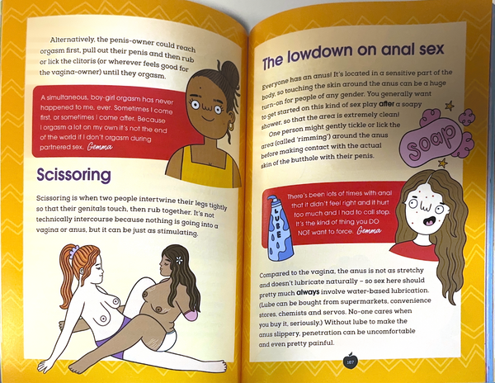
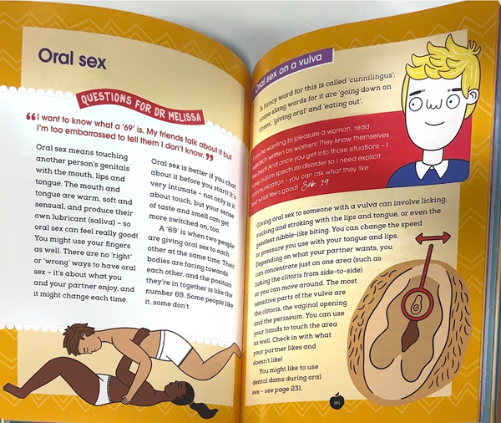
There are many issues here. First, the duty of explaining sex to an eight-year-old belongs to the family, not to the school. Second, you are perverting your students' human personal formation by letting them assume that an ideology—in this case, the ideology of gender—is a totally social normalcy to be followed and believed by everyone. That is totally unacceptable, especially in a public school system. Parents have the human right to be able to provide their children with a proper education centered on the person and not on ideologies, nor the ideology of gender, or anyone else. Yes, this has also happened in political dictatorships and can be considered a cultural dictatorship: you are using education as a cultural dictatorship system, imposing on vulnerable human beings —at eight years old any human person is still in his very early personal formative stages, he or she will blindly believe whatever he or she is told by his or her teachers— as social normalcy an ideological way of being to human beings that are entitled to be and become who they are called to be according to their inherent dignity, not according to any ideology. Yes, that is a very cruel perversion of human personal formation and a very, very grave violation of the dignity law. There is also a third thing here to be considered: have you noticed that there are no transgender boys and girls among the poor in Africa? Transgenderism always happens where there is an economic, cultural apparatus to support it: money to pay for sex-changing hormones, sex-change surgeries that cost a lot of money, and so on and so on. There is a lot of economic equality being denied when the ideology of gender is enforced, and they are unable to see it. You are not only perverting personal human formations: you are also attempting to pervert a whole civilization into accepting an ideology as a social norm… even to the extent of openly normalizing discrimination against those who oppose the ideology of gender, as it happens when women are denied equality in sports simply because they are forced to compete against transgender biological males that have clear biological advantage over them, no matter how much they “identify themselves” as a woman. They don´t choose to compete against biological males: they are forced to, even to the extent of putting their lives in danger while competing, like what happened in the Paris Olympics with the Italian boxer Angela Carini, who had to leave the fight due to being tremendously hardly hit by a transgender biological male competitor and also happened to the Turk Olympian athlete Esra Yildiz Kahraman, who made an X sign a protest of being forced to fight against a transgender biological male. The sign alludes to the female X chromosome, as you can see in the following picture:


Gender is not fluid, and this must and can be understood properly if you asses the whole nature of the personal formation integractively, according to its own natural laws, traits, and notions. Nothing in the human personal formation is “fluid”, including gender: everything is given according to natural principles and properties. The “fluid” aspect of integraction —if you want to call it that way—can only be seen in the coordinated movements of the action that necessarily radiate a projection that eventually will connect with other living articulations around, like neurons connecting in the brain; we are always connecting, because that is how we are… but connecting ideologically and not according to true nature has serious depersonalization consequences like the ones I have just explained. Suddenly, women stop being persons and begin to be “menstruators” if you let the ideology of gender go further on. No, we women have an identity of our own; we are not “fluid.” Sex, biological sex, does matter —as all other organic natural properties of the human personal formation— and can´t be changed at will or by any other human personal action, no matter how much you spent in “gender-affirming surgery” (aka known as gender mutilation, quite similar in the social acceptance context to genital mutilation in Africa, as it has been told)
All the violations of human dignity that I just described are very grave. Yes, all the human personal formation laws are important, but the human dignity law is the most misunderstood human personal law of all in our time, which is quite evident. There is a lot to be done to let people know their inherent dignity and to make it possible for everyone to grow according to their inherent dignity. From a Christian perspective, this is a dignity apostolate yet to be fully developed as human personal formation begins now to be developed as a charism, both institutionally and according to the Holy Spirit. All offenses against human dignity can be considered not only a violation of fraternal rights but also a very grave mortal sin that should scandalize everyone more than sexual sins: no one can be able to receive the Eucharist if he or she deliberately chooses to not incarnate that communion with his or her brothers and sisters also, and all dignity violations are highly deliberate, they all require an action of the will. The Gospel is very clear on this in John 13,34: “I give you a new commandment:* love one another. As I have loved you, so you also should love one another”.
The fifth law of human personal nature is stated as the following: Ontological properties, biological properties, and filial principles have an “equal growth” importance in the human personal nature: they are all equally required to the conception (information) of a human person to be able to happen. The properties of both dimensions are joined in the informed integration of the integractor by the social principles: both organic properties and ontological properties equally need social progress to be informed and to grow together, to evolve and to be known (to mature) as part of a civilization… and both the evolution of the organic body and the knowledge of the revealed being happens progressively, inside a social context with concrete social notions. This human personal formation law is called the Equal Growth Law: all the dimensions of human personal formation nature are equally needed for a human personal formation to grow, either in the organic, ontological, or filial sense.
At the moment of conception, there is both a natural action (what is usually understood as biological conception, because of sexual intercourse) and there must be an ontological conception also at the same time, revealed through growth according to the filial dimension. It is evident to mere historical observation, not only to mere biological observation, that the understanding of the conception of human life has progressed hugely along history: now we understand the biological nature of pregnancy, but there is yet way a lot more to contemplate-discover (you don´t really “discover” the being: it reveals himself and we progressively contemplate it more and more according to the fullest growth possible) in the ontological sense. All this means that in the conception of a human personal formation —both as an organic body as an eternal being that is called to an incarnated existence in a very concrete moment of history that is never merely a product of biological evolution and the law of the strongest: we are called to be who we are by the Being, there is also the action of the Creator, or the I-AM-WHO-I-Am, if you want to call it that way, for the human existence be able to actually be originated like it is described in On the Origin of Species. This is not easy to explain, but I will try my best: this being that is being infused into the human personal formation by the Creator-Being is eternal. As beings, we have existed since forever and forever, but it is through the powerful act of love that it meant to imply sexual intercourse that a being is called to incarnation, in a concrete time and space of human history, exactly as Jesus Christ did and keeps doing through the living of His living Church, right now doing it as Jesus Charity. Yes: Jesus Charity keeps growing in us, sacramentally, as we become progressively into the living Eucharist and the living Church by the infusion of the Holy Spirit.
The sixth and last law of human personal formation nature can be named the Integractive Influence Law, and can be stated as the following: All processes of integraction beyond the information will necessarily be influenced by the biological and ontological traits of the information. Those processes will also necessarily be influenced by the social notions of the information. The information necessarily influences all the other processes of the integraction, all the other processes of the human personal formation, from action to beyond (realization, projection, and connection). Although I can´t explain this with its whole intellectual depth because I can´t properly express yet the characteristics of action, realization, projection, and connection (only a contemplative sketch of those characteristics will be given in the next part of this text), I can use one of the same examples I have used in prior laws to explain this in a very basic way: if a human being has the trait of Down Syndrome in their DNA, that concrete trait of their organic dimension of his or her nature will necessarily influence not only his or her whole personal formation nature dimensions (organic, ontological and filial), it will necessarily also influence all the others human personal formation processes (action (how you act), realization (how you realize), projection (how you project), and connection (how you connect to other people as part of a whole society and civilization). That DNA trait will manifest not only in who he or she is but also in how she or he acts, realizes, projects, and connects inside a civilization; the same can be said of each one of the given ontological and biological traits of the human personal nature, and the same can be said of each one of the given social notions of the human personal nature.
So, these are the six laws of human personal formation:
- The Triadic Law: all human personal formation nature dimensions must be present simultaneously for a human person to be formed and remain being formed.
- The Natural Influence Law: all human personal formation natural dimensions necessarily influence each other, and they can´t contradict each other.
- The Evident Growth Law: there is always clear evidence of growth in every human personal formation, from conception to natural death.
- The Dignity Law: all persons have inherent dignity and are inherently entitled to all human, fraternal, and civil rights, no matter in which growth stage they are, from conception to natural death.
- The Equal Growth Law: all the dimensions of human personal formation nature are equally needed for a human personal formation to keep growing, either in the organic, ontological, or filial sense.
- The Integractive Influence Law: the biological traits, the ontological traits, and the social notions of information will necessarily influence all the other processes of integraction, from action to beyond (realization, projection, and connection).
As you can see, we are always growing, we are always forming, always according to these natural personal formation laws, because they happen in the nature of EVERY human personal formation on Earth, they are common laws of all human personal formations’ nature. All these human personal formation laws balance the movements (action and beyond) of integraction: they make the personal formation remain person-centered. If these laws are not respected, a natural imbalance will happen in the whole integractive personal formation model, whose consequences will necessarily manifest from action and beyond.

On the Growth of Human Personal Formation: A Sketch of the Integractive Model of Personal Formation, from the Human Action Formative Process and Beyond

The very same way Darwin called his revolutionary text On the Origin of the Species, I have titled this text On the Growth of the Human Personal Formation, which in fewer words can also be titled On the Formation of the Human Person, because that is straightly forward what integraction is: a whole model of personal formation. I have scientifically explained the nature of that integractive personal formation model to the best of my intellectual and contemplative capabilities…, but from this moment on, in this part of the text, we are still in uncharted waters, in the scientific sense.
In this part of the text, I can only share what has already been contemplated, not as an act of “intellectual imprudence”—the proper warnings about my intellectual limitations are clearly stated—but as a gesture of intellectual humility and true scientific spirit: I won´t be able to go further without a community to discuss and study what I currently lack and what I have already known through prayer and adoration, but needs further intellectual rigor, proper of true academic knowledge.
I will share the current sketch of the formative processes of action (conformation as help to do), realization (transformation as help to grow), projection (reformation as help to glow), and connection (performation as help to bloom) simply to show the proper structural context of the integration (information as help to be) that I just explained in the earlier parts of this text. The information formative process doesn´t happen alone, ex nihilo, or only by itself: it is properly understood as part of a whole integractive model of personal formation. Nature is not what completely determines us nor completely defines us, but it does influence us greatly as human persons, and recognizing that necessary human influence is vital in the following human personal formative processes, as I state in the Integractive Influence Law: all human personal formative processes are necessarily influenced by the nature of the human personal formation, all and each one of them, no exceptions. The traits and notions of our triadic human personal formation nature have very evident and observable consequences in everything we act, in everything we realize, in everything we project, and in how we connect with everybody.
In this part of the text, I will simply sketch what has already been contemplated as the human formative processes of action, realization, projection, and connection. This is a sketch; this is not meant to be a definite and ultimate pillarization of how these processes will be conceived in the integractive personal formation model. As my knowledge in psychology develops further, the palabrization of the content and definitions of all these four processes will deepen way further than in their current neo-intellectual state.
Let´s proceed to share the sketch of integraction, from action to beyond.

Action
Our action is what determines how the will is conformed, so there can be a realization and a projection of who we are and whom we are called to be as a person whose action is constantly conformed with certain common elements: factors and expressions. If you want to call “action” the anatomy of human will, you can. The factors of the actions are elements that conditionate the action. The expression of the action are “generations” of our conformation. Yes, our actions constantly conform us as we are, as we are meant to be and as we intend to be. For Christians, the role model per excellence of our actions is Christ: we conform all our actions more and more Christcentrically as we mature. For those who are not Christians, there are many and plenty role models to choose as conformation models.
Here is the table that enumerate the factors and expressions of the action.
Action (Personal Behavior) (The movement of the integractivators)
 | Factors (conditions of conformation) [3 centers of integractivators, constantly moving] | Expressions (generations of conformation) [four green sticks joined to each factor]
Factor 1 | Thoughts: originating action according to your ideas. | Expression 1 | Motivation: generating an action with a purpose.
Factor 2 | Emotions: originating actions according to your sentiments. | Expression 2 | Disposition: generating an action with an attitude.
Factor 3 | Skills: originating actions according to your abilities. | Expression 3 | Signification: generating an action with a meaning
 |  | Expression 4 | Volition: generating an action with a will

You can see the action in the integractor in the following image. Each one of these three pieces is called “integractivator”. There are three integractivators in the integractor:
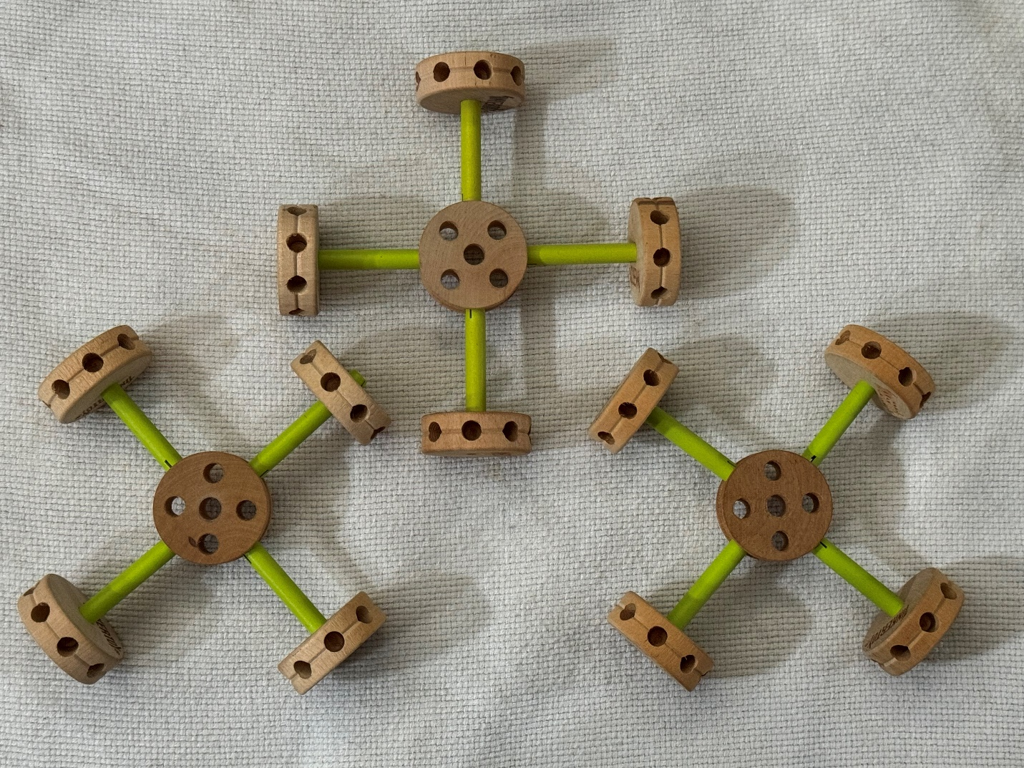
You can see the action more carefully inside the integractivator in the next picture. The center wood pieces are the factors, and the green sticks are the expressions of each factor, and the piece is constantly moving:
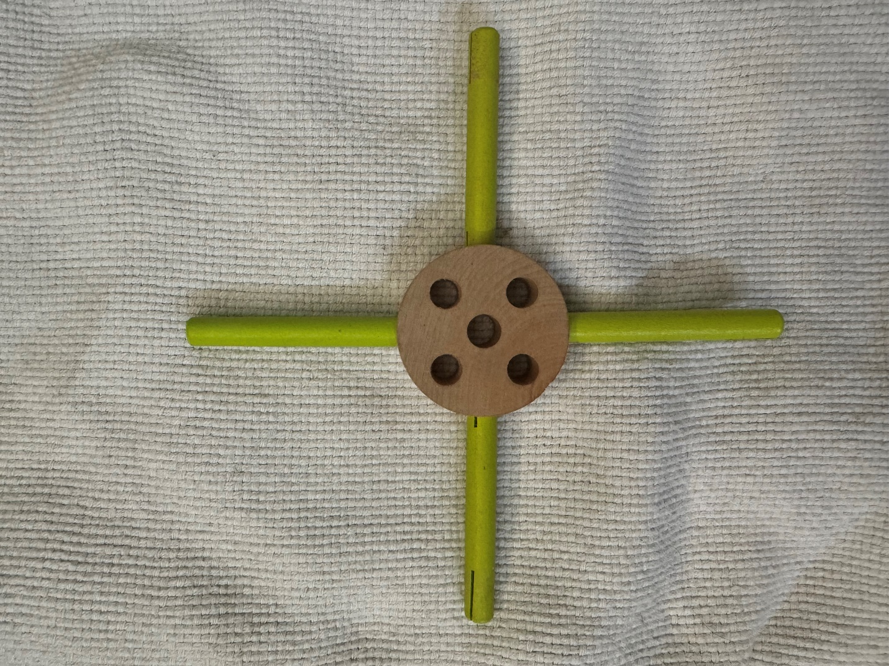

Realization

The next formative process in the integractive personal formation process is realization: after the action, we are realizing ourselves constantly as we keep transforming ourselves in who we are and who we are called to be, each one according to their own natural dispositions. The study and application of the implications of this formative process help to grow a new fraternization: a reality where everyone is recognized as a brother and a sister, called to radiate as a person a unique light that no one else will be able to radiate. The realization of every human person has certain common elements: it has causes whose coordinated movements in unity have an impact on the reality context where the person is, and it has emanations whose directions keep transforming action. For a Christian, the realization of our personal formation is clear: becoming more and more the image and likeness we are, the living image of God-Love-with-us we are called to be and do intend to be with a holy life, being humble instruments of grace, growing together in direction communion.
This is the table with all the impacts and emanations of the realization.
Realization (Personal Reality) [coordination of the movement of the action, each integrativator must move in unity so the integractivators can move properly]. The integractivatos can only emanate in three directions: horizontally, vertically, or circularly, due to the nature of the integractivator movement when it is properly coordinated)
Causes (impacts of transformation) [organized movement of the three integractivators moving coordinated in unity] |  | Emanations: directions of transformation.
Cause 1 movement | Creating Communion: generating gifts through sharing who we are. | Emanation 1 (horizontal direction) | Actuality: grow as who we are
Cause 2 movement | Creating Family: generating bonds through engaging ourselves as we are. | Emanation 2 (vertical direction) | Potentiality: grow as who we are called to be
Cause 3 movement | Creating Fulfillment (Creating happiness): generating values through inspiring growthfullness through how we are. | Emanation 3 (circular direction) | Intentionality: grow as we are intended to grow, together in communion, as “we, the people”.

You can see more clearly where the causes are in the next picture. The causes, also called “realizators”, are the wood colored piece in the extreme of each green stick of the integractivators, and the emanations would be the only possible directions in which this piece can emanate light (that will be seen in the projection) in the integraction: circular, vertical, or horizontal:
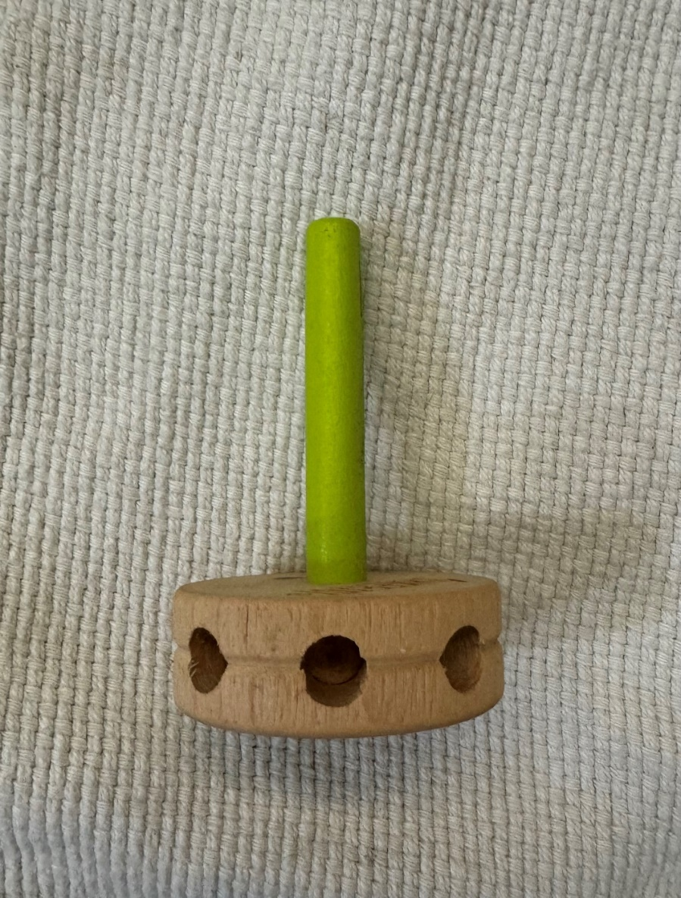

Projection

The next formative process of the integractive personal formation model is the projection: creating a project of life that reforms us constantly as we become more and more who we are and who we are called to be as part of “we, the people”. Our life project is in constant reformation as we keep maturing, evolving and progressing, and so it keeps projecting more and more as we reform more and more as persons. We will be reforming until our last breath, according to our inherent dignity. As we study and apply more and more the implications of the human person projection, we help to radiate a new civilization of Love, or seen with an ecclesial view, a new evangelization. The common elements in the reformation of every person are the keys, which are the objectives of the reformation, and the emissions, which are the criteria of the reformation.
Here, you have the table with the objectives and emissions of the realization that keeps reforming more and more throughout life.
Projection (Personal Vitality, Personal Project of Life)
Keys (objectives of reformation) [the radiation of the emanations of the realizators in the four extremes of each of the three integractivators] |  | Emissions (criteria of reformation) [cardinal points of the direction of the radiation that happens as action and realization happens both actually and coordinately]
Key 1 | Vital Identity: cultivating yourself as a project according to what you love and dream | Emission 1 | Primacy of Beauty: esthetic criteria, arts
Key 2 | Vital Vocation: cultivating freedom projected as you serve in a concrete way | Emission 2 | Primacy of the Right: ethical criterial, moral
Key 3 | Vital Communication: cultivating self-giving that projects new life. | Emission 3 | Primacy of the True: rational criteria, logic
Key 4 | Vital Perfection: cultivating profusion projected joyfully | Emission 4 | Primacy of the Good: benefit criteria, pragmatics

I do not put here a picture of the projection because it can´t be literally seen in the integractor: you need to imagine a radiation from the integractors that are moving actually (action) and coordinately (realization) as the personal formation is being projected.

Connection

Finally, you have the fifth formative process: connection. Connection is tricky to see, but it can be seen if you see two integractors literally connected: the connection happens when the integractors share joints (articulations of the nature of the personal formation). When you connect with someone integractively, you connect through the joints: there is something in both life narratives that is being connected, they connect in common articulations of their life narrative. Connection is related to connecting everyone in a new era of new fraternity as we perform the new fraternization we are called to perform in our own personal formation in the first place, and as we perform it that way, we necessary connect with other brothers and sisters, becoming together in the best person we can be, so the dignity of every person is affirmed and bloomed constitutionally. This fifth formative process literally connects all the formative processes in a way that every person can achieve to become the best person they can be, walking together as “we, the people”, harvesting together a new culture of the person, a new culture of life. As we embrace these formative tasks as formative duties, we connect society as a communion of persons. It's our duty to develop a more fraternal society as we become the best persons we can be.
Connection can be seen in the following picture:
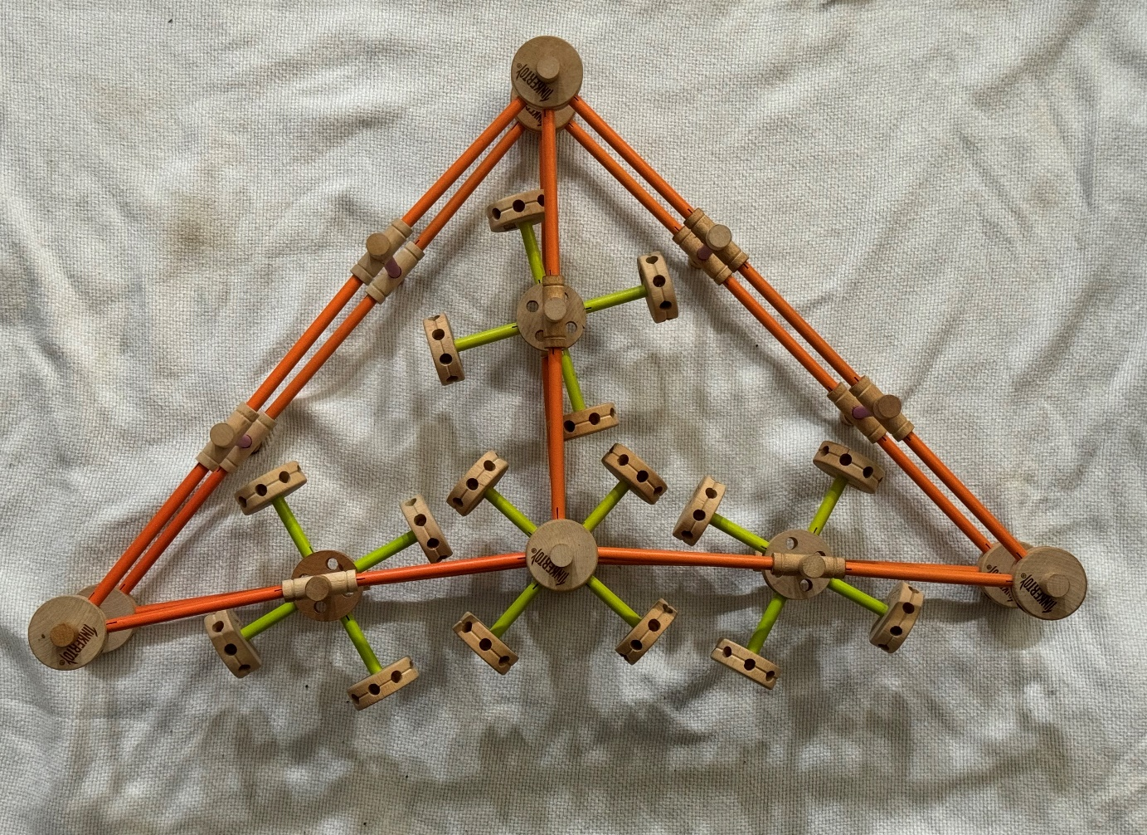
This is the sketch of what has currently been contemplated about the personal formative processes of action, realization, projection, and connection.
Approaching this from a psychological point of view, a person-affirming psychological therapy or a person-affirming human mentorship should be aimed to help to do the action, help to grow the realization, help to glow the projection, and help to bloom the connections conforming so the personal client can be able to transform more, reform more, project more and perform more perfectly as who he or she is and as who she or he is called to be according to his or her and inherent dignity as equal and a fraternal part of “we, the people”.

On the Growth of Ecclesial Personal Formation: A Sketch of the Articulation of the Human Personal Formation as a Christian Person

This will also be shared simply to give a whole-scenario view of human personal formation as it is supposed to be articulated Christianly. For those who are not Christians, only the natural articulation of human personal formation applies.
As I mentioned before, the human personal formation has 7 organic joints, 7 ontological joints, and 14 filial joints that narrate, as a life narrative, how that personal human personal formation articulates human existence as a concrete human personal story.
In the case of a Christian articulation of human personal formation, what is being perfected supernaturally are those 28 joints, all of them. The natural joints are not annulled by the supernatural joints: in the case of a Christian personal formation, the natural joints are still there, but they articulate both in a supernatural way (due to the grace given by the infusion of the Holy Spirit) and also in a natural way. Saint Thomas Aquinas was able to understand this according to the knowledge of his time:
"Since therefore grace does not destroy nature but perfects it, natural reason should minister to faith as the natural bent of the will ministers to charity." Thomas maintains that the truth of human nature finds total fulfillment through sanctifying grace since this is "perfection naturae rationalis create."
So, the 7 organic joints that articulate the Christian life organically are the 7 gifts of the Holy Spirit: wisdom, understanding, counsel, fortitude, knowledge, piety, and fear of the Lord. The Living Church exists organically as an institution, as a living body, thanks to the action of the Holy Spirit, and this is quite literal in an ecclesial personal formation. This is also a reality of the Church in its civil constitution: in the civil sense, the Church begins to be Church in Pentecost.
The 7 ontological joints that articulate the Christian lifestyle sacramentally are the seven sacraments: Baptism, Reconciliation, Eucharist, Confirmation, Marriage, Holy Orders, and Anointing of the Sick. There is no way to avoid that the ontological nature of a Christian is necessarily sacramental too, as you may have realized in what I wrote in the exposition of the Ontological Nature of the Human Personal Formation. I can only give what I have been given.
The 14 filial joints that articulate the Christian lifestyle charismatically are the 14 fruits of the Holy Spirit. This is why the consecration of Charity can be both social and Christian: in the Christian sense, charity is always overflowing in our very own social constitution, and we can´t avoid it to live it both in the human personal sense and in the ecclesial personal sense, with clear social connotations, like the 14 universal fraternal rights are also clear social connotations too. If you live charity properly in the filial sense, you will consummate the 14 universal fraternal rights as a progressive incarnation of all the Holy Spirit´s fruits. As the Gospel says in Mt 7, 16: “By their fruits, you will know them.” We are called to be known as His disciples according to how we love each other as brothers and sisters, making it possible for everyone to grow as an equal and dignified brother and sister who keep growing until he or she becomes the best person he or she can be according to his or her own personal articulation, according to who he is and who he or she is called to be. This is why Mother Teresa was content to show Christ's love to Hindus and help them to be unconditionally as they were and as they were called to be, seeing them depart still Hindu, without pushing for a conversion… and this is why proselytism —any kind of proselytism — has no place inside a properly understood Christian charity apostolate or any other kind of Christian apostolate.
The 14 fruits of the Holy Spirit are: Charity, Joy, Peace, Patience, Kindness, Goodness, Generosity, Gentleness, Faithfulness, Modesty, Self-Control, Chastity, Fraternity, and Creativity.
The first twelve fruits are told by the Catholic Church tradition; this servant of the Holy Spirit added the last two. There is nothing more charismatic than the fraternity and creativity that come as a fruit of the Holy Spirit to unite us more to His Heart and to perfect us as we keep learning how to articulate a life narrative that follows our Teacher of the Heart more perfectly.
There is also a huge concept that must be understood in order to understand ecclesial personal formation with Jesus´s mind: dignity. A Christian has an inherent ecclesial dignity, both organically and ontologically, the same way that he or she has an inherent human dignity according to who he or she is and according to who she or he is called to be. The organic ecclesial dignity law can be stated as the following: God's Love can´t violate human dignity; God Love can´t violate integractive human nature in any sense; God Love will always respect human nature. That is why the Virgin Mary was asked for explicit consent to be the mother of Jesus. The ontological-sacramental ecclesial dignity law can be stated as the following: God will never deny the necessary state of grace for a Christian to be able to be formed as a living Church, so the Church is sacramentally-missionary bound to provide all the necessary formation to all its members so it can be possible to everyone receive and incarnate all the sacraments and become the living Eucharist they are all called to be as living Church. This is the most evident reason why any correctly formed and well-formed Christian articulation, articulated through the power of the Holy Spirit in the same way the action of the Holy Spirit incarnated Jesus, of life is necessarily a personal story of Love, a story of a personal encounter with God´s Love that keeps saving humanity as we keep articulating His history of salvation as an incarnated story of Love, each person with a unique story of love that keeps incarnating Jesus in every here and now of the history of humanity, since Pentecost to our days. All Christians need the Holy Spirit to be formed as a living ecclesial body that incarnates God´s Love as a living icon of a Jesus Charity, and that is why the gifts of the Holy Spirit are the organic constitution of the Church as a living institutional body and why the Holy Spirit is related with the most important personal formative process of all: help to grow. If you want to resume all the personal formative processes in one, you can simply say “help to grow” instead of saying “help to be, help to do, help to grow, help to glow, and help to bloom.” The Church has a long way to implement the proper measures to make it possible for all Christians to receive a proper formation according to what the Holy Spirit is telling us now, but as we have prayed, we are saints not because we are perfect, but because we are humble enough to let ourselves be transformed by the Spirit and reformed as we participate more and more in Trinitarian communion to connect each other as the ecclesial community we are meant to be as living Eucharist. What we are showing in this text is, according to Heaven, the humblest correction among saints that the Church has ever been granted to receive. When a saint is mistaken, another saint will correct the issue through the communion of saints; that is how the Church keeps being transformed and reformed from within, not due to ideologies nor any other sociological external reason.
In other words, I, as a Christian, have all the right to receive all the proper formation and be helped to grow to become a living Eucharist according to my vocational-educational profile; I have all the right to receive the proper formation to be according to how God created and loves me, and to become who I am called to be according to how God knew me since forever and ever in His mind, according to how He loves me and sees me. The Church is obliged to form all its members — not only seminarians, but everyone— appropriately, and when it doesn´t happen, it must be corrected, as it is happening right now with this text. If someone can´t receive a sacrament, it's because of their own nature or will or lack of priests to give the sacrament, not due to a lack of ontological potentiality to receive the sacrament. Ontologically speaking, all members of the Catholic Church have the potentiality to receive all the sacraments if appropriately and properly prepared to receive them, and all members of the Catholic Church have the right to be appropriately formed to receive and incarnate all the sacraments properly is an inherent part of their ecclesial dignity. This is why it can be said as dogma that the Virgin Mary must have been the first living Eucharist in order to be able to form Jesus as the Living Eucharist also, ordered to be so by the very exceptional state of grace she received in her immaculate conception so she could incarnate later Jesus as Living Eucharist.
Both ecclesial dignity laws have the very same biblical foundation: Mandatum novum do vobis, ut diligatis invicem sicut dilexi vos, as it is painted in Jesus Charity´s halo. As John 13:34 says: “I give you a new commandment:* love one another. As I have loved you, so you also should love one another”. We are meant to be created with God´s Love, by God´s Love, and in God´s Love, as He has loved us first, as I have loved you; that is the biblical foundation of our inherent organic ecclesial dignity. We are also meant to become living incarnated sacraments of God´s Love: as I have loved you, so you also love one another, so we are called to be eclessially formed as His disciples according to how we love each other, as living sacraments of God´s Love, and this is why the second law is called “sacramental ecclesial dignity law”, it's literally sacramental dignity, in all the senses possible, and it is core to understand sacramental fraternity correctly: we are all equally called to become the living sacrament of God Love, each one according to his or her unique vocational profile. Please notice: loving as I have loved you and loving one another are intrinsically united to understand ecclesial dignity properly. In the iconography of Jesus Charity this is seen in a very particular way: the halo only says “mandatum novum do vobis sicut dilexi vos”. The other part of the mandatum novum, and love each other as I have loved you, can be seen through the whole process of plasmating the paint and the theology of light and the integractive personal formation model that came after it. That second part is not explicitly written in the painting (the reason is that there must be only ten words in the halo. At first moment, I had no idea why only ten words, and later, I learned the huge connotation that the use of ten words has regarding the ten commandments): it is incarnated through the whole process of Jesus Charity´s conception, which can be said that was immaculate in the social sense: neither of my parents understood now knew at all according to how I am and how I am called to be who I am called to be. Due to my personal nature circumstances, the way I conceive the concepts of person, family, and human personal formation comes directly from the Holy Spirit, so socially speaking, the conception of Jesus Charity was immaculate.
Understanding this integractive ecclesial personal formation structure has several implicit and explicit consequences that have to be discussed properly as a Church. These consequences will imply many changes when the evolution of the Church as an organic living body allows them and when there is also the proper socio-cultural context to make those changes possible.
I will mention only one of the necessary changes that this articulation of Christian Life as human-ecclesial formation implies:
As I just explained, every Christian must have the ontological potentiality to receive ALL the sacraments, because the sacraments, all of them, are the joints that articulate the ontological nature. This means: no Christian can exclude themselves from sacraments deliberately, and no Christian can be denied a sacrament if he or she are properly prepared and formed to receive them. The role of the Church simply is certifying that a Christian does have the proper preparation and formation to receive a certain sacrament, but she can´t deny the sacrament explicitly to a Christian that is properly formed and prepared to receive it.
This means: at least ontologically, woman do have all the potentiality to become priests in a future when the Church can understand this and there is the social-cultural context required to make that happen. The Church can´t deny a sacrament due gender reasons, because sacraments ontologically articulate the very own ecclesial personal formation of all persons, women and man equally.
I do not mean to defy Magisterium here. All I am saying is that Magisterium has evolved through the hundreds of years of the Church's history, is still evolving as the tradition of a living organic body, and will evolve later in order for this to happen. It will happen; be sure of it.
As a matter of fact, the denial of a sacrament by the Church has a very concrete name: excommunication. If you cease to receive the sacraments, you cease to be ecclesial personal formation, and there is HUGE importance in making it possible that everyone can receive the sacraments, especially the Eucharist, is properly prepared and formed to do so: we do need more priests, way a lot more. As some may have realized on their own already, the ontological ecclesial joints and the organic joints are parallel: both are equally needed; you won´t have the gifts of the Holy Spirit if you don´t articulate your life sacramentally, living the sacraments, especially the sacrament of Eucharist. The Church can´t deny the Eucharist, nor any other sacrament, except for very grave reasons directly connected with a process of excommunication, a word whose literal connotation means that you are being denied the Eucharist because you are not in communion with the Church.
This ecclesial integractive personal formation model is still a sketch, and as I will warn again at the very end of this text, right before Nelson Mandela´s quote in the conclusion: I am in the grave obligation to warn that this doesn´t have a nihil obstat —that is the name for the proper ecclesiastical revision and approbation of a text, certifying that it complies with current Catholic teaching—, not because I don´t want to get one but because I have no authority right now to ask for it, as I have explained before. All the ecclesiastical aspects shared in this text, including this integractive ecclesial personal formation model, are merely contemplative, not official Catholic Church teaching. I may be corrected in the future, as the theology of liberation was corrected also at its beginnings, and after that became a very healthy theology at the service of the growth of the whole people of God.
This would finally end the whole exposition of the integractive personal formation model, both human and ecclesial. Only the conclusion is ahead of this; there are no more observations to be shared of the integractive model.

Conclusion: Formed with Love, by Love, and in Love

Growing as a person is the most amazing adventure of our lives, and we all go through it in this mighty journey called “personal formation.” The growth of our biological body is called evolution. The growth of our ontological being is called infusion. The growth of our social filiation is called progress. We are constantly ever-growing until we reach the fullest growthfulness possible throughout our lives, from conception to our natural death. As human persons, we are not only defined by the biological evolution that Darwin so brilliantly exposed. As human persons, we have been granted the power not only to exist as organic bodies, as all animal species do, but also to be who we are and to become who we are called to be. I will humbly rephrase an On the Origin of the Species quote, included at the beginning of this text, to explain this amazing wonder: “There is a beautiful and a mysterious grandeur in this view of human personal life, from so simple a beginning, endless human formations, most wonderful, had been and are being… grown, until reaching, everyone, their fullest growthfulness”.
We do not grow merely as an animal species like Darwin described in his evolution theory: we keep growing as people, as persons, as human personal formations, according to the personal nature given by our Person-Creator. Each person that exists and that has existed is unique; each personal formation has an undeniable potentiality of unrepeated contemplation of beauty, of unrepeated contemplation of truth… There is grandeur in this view of life, from so simple a beginning, endless persons, most wonderful, had been and are being… formed. We are all being formed as a person according to the very same integractive personal formation structure, but each person is being formed in a unique and mighty way, everyone called to a growth that no one else will be able to reach, each one called to radiate a unique light in the history of humanity, a unique spark that no one else will be able to kindle.
There is a deep awe and mystery beyond words, a beautiful mystery, in all this what I am writing. We as human persons are not merely byproducts of natural selection: we have been chosen and called, since forever and forever, to shine as we shine in this very today, to form as we are forming as persons in this very here and now. Yes, natural selection does happen and is still happening… but as human persons, we are SO MUCH MORE than the “biological dictation of some natural selection genetic traits”. We have free will, and we have communion: we are all called to grow together in communion, standing tall and pride of who we are and who we are called to be, like the song of Tarzan, composed by Phil Collins, “Everything that I am”, sings. I am paraphrasing it a little bit: with the word “one” I refer to finally being able to be a whole one, unified personal formation, without fragmentations nor forced parallel realities breaking me down from inside; to finally being able to be as I had been known by God Love since forever and ever… Also, the meaning of the paraphrasing of the word “His” at the end refers to the truest, deepest foundation of how I configure the personal identity of my whole personal formation: I am His, I belong to Jesus Charity as the heart of His living body, of His living Church, we are one —in full unity of being and act through the action of the Holy Spirit that has helped me to grow until becoming I am today by Love, with Love and in Love— as incarnated living Eucharist:
Is this my past here before me
Is this my story unfolding?
It`s all here to discover
Everything that I am
Can this be what I`ve been seeking?
All my life I`ve been waiting for this
And now these memories
Will they make me see more?
Ooh I want to know where I belong
I want to know where I came from
I want to know the reason why I`m here
The way I am
Feeling the things I feel
And I want to know the reason why
It will be hard but I must try
I wanna understand just who I am
And why I'm here
Feeling my things I feel
Is this my family?
Can it really be them that I see?
My father and mother
And in their arms can it really be me
All these emotions
I can barely control
Cause the family I had
Is not the family I know?
Ooh and I got to know where I belong
I got to know where I came from
I got to know the reasons why I`m here
The way I am
Feeling the things I feel
Ooh and I got to know where I belong
I got to know where I came from
I got to know the reasons why I`m here
The way I am
Feeling the things I feel
These spirits calling me
Familiar voices haunting
Disappearing taunting me
This is the choice I must make
Cause I know where I belong
I know where I, I came from
I know the reason why
I must decide
And leave here
The man I am inside
The future is clear for me to see
To be the one I`m meant to be
Like my Father with my head up high
Standing tall
And proud of all
That I am
I am His!
If you use the word “Father” with the meaning of Creator-Being, as Christians do, the meanings that this song conveys are deep, way deeper than mere words and a mere song. It describes the very process of growth of a person human being, discovering himself and herself, who we are and who we are called to be, both as living human persons and as living civilized humanity. Who we are and who we are called to be are not only the consequence of biological traits and social notions inherited from a male progenitor or a female progenitor. I am not defying the sacred importance of a mother or a father; let´s be clear on that: we are meant to grow as human personas inside a family of a mother and a father who love us unconditionally; that is the very foundational cornerstone of every human civilization until today. There would be no human civilization without a mother and a father, and I don´t mean it only in biological terms… but it is true also that as the growth of the human personal formation evolves, matures, and progresses, we begin to question, challenge and sometimes even discard the maternal and paternal personal formation notions and traits and begin to form the human personal formation of our very own personal identity: “Is this my family? Can it really be them that I see? My father and mother… And in their arms can it really be me…” Every human personal formation, according to their very own growth stage and also according to their very own unique combination of developmental capacity of social progress and biological evolution, at some point will begin to reach their point of no-return ontological maturity and begin to behave and evolve according to their own freedom of will, leaving, at least ontologically, their father and mother behind, to begin to form themselves according to the Father-Being above. That is especially intensely seen through adolescence years, and it is even mentioned in the Bible in Luke 2,49: “Why were you looking for me? Did you not know that I must be in my Father’s house?” … Even the Bible wanted to give evidence of the process of ontological maturity of Jesus as a human person, in the very own new albor of the growth stage that we know today as adolescence. He knew who He was. He was the fullness of God and Man according to all the properties and principles applicable to the evolution, maturity, and progression of any human personal formation, which, in His very extraordinary case, also was a Divine personal formation. You can only imagine, contemplate, and even undeniably and unavoidably adore upon your knees in the heart (your legs are not literally on their knees: the heart is the one constantly “on its knees” contemplating and adoring Him) the fullness of the growthfulness of such very extraordinary ontological circumstance once He lets you know that because He is always the one who reveals Himself. This is not a matter of will but of grace.
The deepest truth is that as we keep evolving, maturing, and progressing, we keep growing on and on, from conception to natural death. As one of the laws of human personal nature says: there is clear evidence of growth in every human personal formation. If you are a person, you are growing; you can choose to grow, no matter what. If you are a person, you have dignity and full human, fraternal, and civil rights, no matter what. Whoever is a living person will necessarily keep growing on and on. It, simply said, is a natural human personal formation law, as we explained before. Whoever doesn´t see undeniable growth potential in every person, unconditionally, no matter how small or how sick, is blind in his or her own notions of personal growth, and they need a good “social mirror” to correct themselves, the same way Jesus Charity, my New Albor Holy Family and my spiritual family of Heaven had always been the “social mirror” that has allowed me to contemplate the body, the being and the filiation as I do… so, also allowing me to contemplate and co-conceive the human personal formation as integraction, as I do.
Denying the unconditional human personal growth potential of people systematically is called social abortion: you systemically deny the recognition of the growth potential of a people as it happened in the Holocaust, and as it currently happens in our present times with the unborn when biological abortion is allowed. It is called social abortion because it needs a whole society to allow it to happen. It must be reminded here that the family is the first society of any human being, you don´t need a society of a huge number of people to allow a social abortion: the natural family, if deformed enough, suffices to consummate a social abortion, as happens usually with biological abortions, but there are many ways to a social abortion to happen in the context of family, like a domestic family denying a child the proper unconditional love that is entitled as a human being, and so, social abortion can be progressive, it is not necessarily instantaneous like a biological abortion, it can happen through a very long period of time until consummated as biological death, as it happened with the victims of the Apartheid and the Holocaust, who endured gruesome social systemic denial of their rights and humanity —this means: they endured systemic dehumanization and systemic depersonalization that eventually would become systemic defraternization: you are considered an “other” in your society, you are not treated as an equal part of “we, the people”, you are not known by those around you a brother and sister with equal dignity— before the mortally-wounded or mortally-tortured victims were finally deceased. NO ONE can be allowed to steal or deny the growth potentiality nor the love vocation of any human being; we are all brothers and sisters, with equal dignity, from conception to natural death; we are all called to be who we are as known when we are unconditionally loved, and to become who we are called to be according to an unconditional vocation of Love, becoming together the best person we can be, the best “we the people” we can be.
That very basic fraternal notion should be clearly stated in the preamble of The Universal Declaration of Fraternal Rights, also known as The Universal Declaration of Love, which —as I explained before— is still pending to be written. It should also be stated constitutionally as the American Dream in both the constitution of the United States as it is transformed and realizes (realization is the integraction process related to “help to grow,” and it’s also related to transformation) its consecration of charity as a nation consecrated to a Jesus Charity that is a Morning Star can make all things anew, including a whole nation… It should also be stated clearly in what would eventually —as our social progress as a continent keeps going on and on— is called to become a continental American constitution that what will eventually be an American Alliance (una Alianza Americana), uniting a whole continent in one new alliance: the alliance of charity, understanding the act of being consecrated to live charity as a social order in the constitutional sense. That means: we are not only constituted with love (biologically), by love (ontologically), and in love (filially) intrinsically, according to the very own evolved, infused, and civilized nature of our human personal formation… we are also meant to be civilly constituted as a nation of Love —with a federal constitution that allows us to love each other as equal dignified brothers and sisters: “we, the people… we, the brothers and sisters of the United States of America…” —as also as a new civilization of Love —"we, the people… we, the brothers and sisters of the American Alliance…”— Of course, it is also extremely beautiful to paraphrase the Mass Eucharistic memorial here: with Him, by Hum and in Him… with Christ Love, by Christ Love and in Christ Love… Yes, we are called to incarnate according to Love —and so, to incarnate ourselves as living Eucharist— in a very constitutional way, and that also applies in the civil sense, as we keep becoming the “we, the people” we are called to be, the new civilization of Love we are called to be, socially organized as a nation of Love also, constitutionally formed to affirm the inherent dignity and equality of every personal formation.
This is the consecration to live charity as a social order: we are all called to make it possible for everyone to grow as the equal brother and sister that we are called to be, recognizing everyone´s dignity unconditionally in all the growth stages of human existence, becoming together the best person we can be, the best “we, the people” we can be together, walking as the same human family. In the words of Martin Luther King Jr: "We must learn to live together as brothers, or we will all perish together as fools". No one realizes this, but systemic defraternization is the very root of every war and human sociological tragedy that has ever happened and still is happening. Defraternization can kill us as humanity —understand “humanity” both as animal species and as human civilization— way faster than any climate change can extinct us all… and so, helping you, dear reader, to understand the human personal formation in an integractive way is also an amazing and humbling way to promote peace in the whole humanity, beginning with the unconditional affirmation of the dignity of the person and its universal fraternal call to belong to a family, to grow unconditionally loved and unconditionally called to have all the equal growth opportunities to become together the best people we can be. This can be said in many, many ways, everyone incarnating those words in a unique and concrete way that no one else will be able to realize again in the whole history of humanity. Said in Mother Theresa´s words in her Peace Nobel acceptance speech, in which she proposed changing the world by loving our families and the poor first, understanding “poor” here as those who lack most the equal opportunities for growth we are all entitled as human persons: “And so, my prayer for you is that truth will bring prayer in our homes, and from the foot of prayer will be that we believe that in the poor it is Christ. And we will really believe, we will begin to love. And we will love naturally, we will try to do something. First in our own home, next door neighbor in the country we live, in the whole world.” This has been paraphrased many times as the following words that she had never said literally in that way, but she did say the very exact meaning in her Peace Nobel Prize acceptance speech, paraphrasing the very exact quote I mentioned before: “If you want to bring peace to the whole world, go home and love your family.”
That peace notion is in the very core of a new fraternization of our human personal formation, of our family, of our nation, our continent, our humanity, and consequently of our Catholic Church as a living body whose vocation to love incarnates as becoming together the living Eucharist we are called to be. This is Jesus Charity´s way of reigning and calling us to build a kingdom of heaven on earth, a kingdom of new albor in which He is a morning star. As a society, we are also called to become together a living communion, growing together in communion, both as persons as a family, both as persons as a society, becoming together the best person we can be, the best “we, the people” we can be.
I truly believe that helping others better understand the amazing growth potential of their personal formation, beginning with making them aware of their own nature as persons, can revolutionize the world as a revolution of new albor that will pave the way for a new era of new fraternization that will bring us the peace we craved and needed as human civilization after two world wars… if such revolution is pursued for and through the right reasons: with Love, by Love and in Love. This text directly aims to help you, beloved reader, to be more aware of your own nature as a person, so you can be more able to understand your own growth as a human person, the same way I had been able to articulate more and more the growth of my formation during the process of completing this text, that took me two weeks to be completed, but it clarifies whole decades of my evolution, maturity and progress before becoming who I am today. That becoming was necessary for completing integraction as a personal formation model. The story repeats itself: the same way I began a whole process of conversion as I plasmated a Jesus Charity, I also began a whole process of evolution, maturity, and progress as I keep completing the conception of the integractive personal formation model that is now being shared in this text. As a philosophy of the person philosopher —or said in other words: as an integractive philosopher—, I can´t simply expose the process of personal formation philosophically, I must also incarnate such evolution, maturity, and progress. The same way the Virgin Mary incarnated the Word when she wanted to share it… I do the same as an integractive philosopher: as I do integractive philosophy, I also incarnate it. Being able to incarnate everything is clearly a woman trait in a profession —philosophy— where the most developed thinkers had always been considered the analytical men. Although it can be said that from action and beyond psychology is needed to complete the integractive personal formation model fully, it can be said that the study of the growth of the natural dimensions of the human personal formation belongs to integractive philosophy, with clear integration of the disciplines of ethics and metaphysics, some epistemology and… integrating biology and philosophy of science too, as you may have noticed in the organic dimension. As I explained before, the nature of human personal formation is not fluid at all… it does belong to integractive philosophy to study its fixed yet constantly-influencing-each-other natural information process, and due to that, this text can also be considered the philosophy thesis I should have given as doctoral dissertation to my philosophy thesis director years ago, to whom I will always be grateful for the intellectual formation that he gave me despite being unable to obey his instructions. There would be no integraction possible to be developed if you don´t have the naturally “fixed” philosophical foundations of the human personal formation very clear before proceeding to the next “fluid” personal formation processes: action, realization, projection, and connection. Of course, I am not writing this as a thesis now; I am simply doing it as a work of Love, as a bello oficio, and writing this has not only been the achievement of my dream of becoming a writer but also has been the giftedness of a lifetime. My aim as a philosophy doctoral student was to create a philosophy of education departing from the thought of Charles Sanders Peirce —to whom I owe a lot of my intellectual conception of how to be an integractive scientist—, and I absolutely failed in that… but I failed for the right reasons. Now that integraction that should have been clear then can finally be seen systematically, yes, a philosophy of education can be created from integraction… but the trues and most meaningful achievement of integraction goes way beyond of merely being able to create an integractive philosophy of education: integraction helps people to understand who they are and who they are called to be, it helps persons to be able to achieve a more meaningful existence and a more growthful personal formation, and so it also builds a more growthful society as the new civilization of Love we are called to be… and I humbly confess that being granted by God Love having such social impact in any other person is truly the giftedness of a lifetime.
So, this text, “On the Growth of the Human Personal Formation: the Nature”, can be considered philosophy, if you understand that my philosophical style is integractive and that I can´t avoid incarnating in my personal formation what I learn and teach. The next text that will come after this one, “On the Formation of the Human Person” —a title that clearly follows Darwin´s “On the Origin of the Specie”— will be clearly a psychology of the person after all the philosophical grounds of integraction have been clearly defined through the intellectual growth process I have described in this text.
Right now, on September 29, 2024, this text is just finished and printed —in an Office Max, because I don´t even have a printer of my own— for the first time. This means it probably needs a few revisions more until a more final definitive form is achieved, although essentially, it's quite complete right now, today, on the feast day of the Archangels; it only needs a few final touches. If the truth about what I had exposed in this text is finally recognized publicly and this becomes published as a book, I would like the following persons to write a preamble for it, exposing their comments about the growth stage they witnessed and their opinion about integraction and what I wrote here. Their words would be read as a preamble before people read my own words:
-the ninth-grade Spanish teacher who did the Dia de Logros (Achievements Day) that I talk about in this text. At that period of my life, on Saturdays, I was either giving catechism at the parish or studying arts at the Escuela de Artes Plasticas in San Juan or in the Liga de Arte of San Juan (I studied painting and “talla de santos”; in English, it would be said as “wood carving of saints”, a traditional Puerto Rican art), as a teen student. During that time, I also studied in Berlitz to be able to learn English I was not able to learn as grammar-based in school (this is an important detail about my English learning: I learned it because I studied it on my own and read a lot and used the dictionary to search words and conjugations, and eventually began to see movies in that language and also practice speaking it in Berlitz… I never learned it grammar-based). As I told you before, I eventually asked to travel to the University of Toronto to study English instead of having a quinceañera party, that happened in the summer of ninth grade to tenth grade. She knows the beginnings of my innate creative talent quite well. On that Achievements Day, I “graduated” with honors (around a 3.50 GPA) and won the medal of citizenship (ciudadanía), also granted by the mayor of the city where the school is, Corozal… besides also getting a special recognition due to my journalism club presidency during Middle School.
- the high school Spanish teacher who helped me write the “Desideratum” poem. At that time in my life, I was also a missionary, and at my graduation, where I graduated again with an honors GPA (around a 3.50 GPA again, like Middle School). In that graduation, I was granted the medals of the best student in the classes of Spanish and Religion —my medal of best student was granted along with the medal of best student granted to the best GPA in both classes— because I undoubtedly was the best student in those two classes, although I didn´t have the highest GPA of the class in either. It was truly heroic for the Religion teacher to give me such a medal because I clearly disagreed with how the religion class was being taught — I had never believed a true “Faith Education” class should be only limited to memorize Church history facts or Church Magisterium facts, you need to live what you learn too— and fought with her way more than would have been reasonable to tolerate to any student in the high school. Any other student would have been sent to the disciplinary direction office to handle with my “indiscipline” in her class, but I wasn´t sent there, she had to tolerate literally as a saint my immaturity, despite being considered the most mature student among all (I was a huge big mouther, as a High School student my mouth was way bigger than my head, being perfectly capable to insult a teacher or even the own school director when I had a direct conflict with her related with my College Board test at eleventh grade, using words like “antipedagogic” — I didn´t used words like “cabrona” or any foul language as my classmates did, I used way another kind of words — without them themselves noticing I was technically insulting them if I thought they were teaching or doing something the wrong way and relying upon their authority to do so. If my classmates did the same thing I did, but using their normal foul language, it would meant to them a direct disciplinary suspension, especially if done to openly defy the authority of a teacher). She also had to tolerate my “indiscipline” in her class simply because I was a catechist and clearly knew everything she taught and she also knew I was the best friend of the Spanish teacher. Both were religious sisters of the same congregation… and yes, my Spanish teacher did knew the meaning of my words and how wrong I was in the how I was doing the things sometimes, she also understood that my direct intention was not defying authority although it has that clear connotation, and tried to reason with me about not fighting the religion teacher, but I hated how the class was taught, limited to learning ecclesial facts only, but that was how the curriculum was configurated and she couldn´t do nothing about that, the religion curriculum is given by the Archdiocese of San Juan and they had to obey it as a religious congregation in good standing with their bishop… Later, as a religion teacher myself at Saint Thomas Aquinas School, I would clearly see a whole curriculum reform is needed in what should be a “Faith Education” course, integrating spiritual formation properly, so Catholic Schools students can graduate fully formed both intellectually and as Christians (if the parents choose a Catholic School for their children, they should not only expect their children to get a more rigorous intellectual formation, but they should also expect their children to receive a more meaningful and deep spiritual formation, according to the Catholic Church teachings). I would later had this same kind of conflict again in the same school, but this time was a teaching style conflict, I was now a voluntary teacher and she believed I was no teaching properly and was creating disciplinary problems because she still believed —like she believed when I was a student of the school and persecuted me through the whole school to make me obey my class schedule as all other students instead of being in the library or in creative projects —that students I simply needed to learn to obey, openly screaming at them constantly to make them obey by fear of authority instead of creating a respectful teacher-student relation with them. Well, at this stage of my life I didn´t had time, the big mouth nor energy to openly fight her like I did in my school years. This time I went the creative way, and I simply designed silicone wrists for the students with the following message: “El Amor no se grita, se practica”. My art students, of course, were amazed of my way of handling the issue, found it quite original and used their wrist bands proudly. She didn´t dared to mess with me directly again, and of course, I never dared to ask to observe none of her classes —she was the Middle School religion teacher at the moment— not I was interested on that happening neither,
In my High School graduation I also won again the medal of citizenship granted by the mayor of the city of Corozal (like in Middle School) and I also received a special recognition again, this time for my presidency in the Library Club from seventh grade up to high school (I remained president of the Library Club for six years straight forward, that says a lot about how much I loved reading and being in the library, that was quite big to be a school library, I began reading a lot of Readers Digest and Barco de Vapor books and from that point on I simply always had time to spend reading something in the library through all would be doing creatively and academically during all my school years. My classmates went to the library only when they needed it for assignments; I went to the library because I always needed it due to my intellectual giftedness: my mind had always been a “reasoning motor” roaming on and on, always seeking to learn as much as I could, and you can´t shut it down).
-Luis Garcia Montero, simply commenting on this text in the context of the education given at the University of Granada —not in the context of the growth he would have witnessed in me there—, if he can’t personally remember me (I wouldn’t be amazed if he doesn’t remember me, Spanish professors have hundreds of students per year and I was a student of the University of Granada in the academic year 2004-2005. A lot of time has passed by since then. He can comment on the text only, without commenting on my growth as a student at the University of Granada).
-my social ethics professor at the Universidad Central de Bayamon as a friar of the Order of Preachers, who I would later encounter again as a doctoral student of the History Department of the University of Puerto Rico, Rio Piedras campus, then I would find him again as I explained before, and now a diocesan priest in the Archdiocese of San Juan.
-the Dean of the Faculty of Education of the University of Puerto Rico, who also was my student dean and academic mentor when I was a student of the Faculty of Humanities.
-my thesis director mentor at the Philosophy Department at the University of Navarra, who was also my Philosophy of Language professor at the ecclesiastical faculty of the same university. He is currently retired and lives in Barcelona.
They have all the right to be allowed to comment on my text in their own words before anyone reads my own words because their words shaped mine in the first place: they have witnessed the growth of my personal formation through the years, how I had evolved, matured, and progressed. They had been the most important intellectual influences and role models who made this possible and who formed who I am intellectually and as a person today, as I share these words and choose to keep growing integractively. As I have already said before, quoting Newton: “If I have seen further, it is by standing on the shoulders of giants”.
If the king or princess of Spain, the king or prince of England, the president of the United States, the Governor of Puerto Rico, the president of the ONU, and the Pope want to comment on this text, if this becomes public enough and if they actually read it… a statement from each one of them can be added. We think they have plenty of explications to give.
It is literally impossible for me to share this in the format it was originally meant to be shared: as an integractive blog post. When the “blog post” was finished, it was a more than 250 single-spaced Word document, a very long document, way larger than a single post text length limit. So, for now, it is being shared as a Word document for everyone to read freely, simply as a gift to make possible the best growth for everyone as a person. As a humble retribution for this intellectual contribution, everyone can feel free to leave their comments in the integractive blog post that I share in this Word doc and make it the most commented blog post in WordPress history. That is all I ask right now.
In the future, as the implications of understanding the person integrative become more understood and an integractive scientific research methodology becomes more clear, you may expect that Inter-Faculties (integrated interdisciplinary faculties) will begin to exist. This means: what is now known in academia as the Faculties of Humanities, Education, and Social Sciences will begin to exist as Integractive Sciences Inter-Faculties (they will become the Interfaculty of Social Sciences, the Interfaculty of Humanities and the Interfaculty of Education, all belonging together to the Faculty of Integractive Sciences, all with their own respective Deans and academic configuration as it is known now, but integrated to each other, as the human personal formation integrates all of them and you need all of them to research and understand the human personal formation—, each one studying integractively certain interdisciplinary aspects of the human personal formation… and even both disciplinary (one interfaculty discipline only) and interdisciplinary (integrating several disciplines of Integractive Sciences) undergraduate and graduate degrees in Integractive Sciences will begin to exist. But as far as academia is right now, if I want to keep developing the “fluid” aspects of integraction (action, realization, projection, and beyond), I need a broad and truth-based intellectual formation in the last of the integractive sciences I still haven´t studied: psychology. I don´t expect a degree in Integractive Sciences to be able to exist yet, but I would be fascinated to find a Social Sciences Faculty with a Psychology Department with enough research resources, research funding, and creative freedom to keep developing integraction as part of a learning community, that is an essential part of doing science, as Peirce clearly explains in words way better than mine, no need to explain that further.
A very important clarification must be done here: if I do choose to keep pursuing academic studies again, but this time in psychology, besides that it must happen in a learning diverse environment in which I can be evaluated as I am, like it happened in the Faculty of Education… well, I also know now, I can only be academically successful if there is an explicitly non-ideological context in the academic environment I am in, if I am in an academic context where truth matters most. As I have explained, a huge part of me being able to successfully complete my teaching certificate courses relied upon I knew who the Dean of the Faculty of Education was. As her Humanities Faculty students I already knew she respected all points of views, so I knew clearly “the intellectual tone” that was going to be expected by her in all the Education Faculty professors. As I said, I had no ideological conflict at all at the Faculty of Education, not even one, and that is a huge accomplishment in a faculty of the UPR system. While completing my teaching certificate courses, when I was completing some of the required courses of the Faculty of Humanities I did had some post-traumatic clear connotations sometimes, especially when I encountered — walking in the halls of the Humanities Faculty— the very same Theology Dean whose ideological bias would eventually force me to stop attempting studying theology: now he was a Portuguese professor in the Faculty of Humanities at the UPRRP, and the mere fact of he being there had huge post-traumatic connotations after all what I went through in the Universidad Central of Bayamon… but, well, because I felt very safe in the Faculty of Education, that kind of ideological discrimination fear issues didn´t affected my academic progress at all anymore. I now belonged to the Faculty of Education, not to the Faculty of Humanities, I was quite clear in that distinction at all moments.
So, now I know: if I am going to pursue any kind of academic studies in psychology, it must be somewhere where truth matters and all intellectual positions are equally considered, like it happened in my class of psychology of education. I need a truth-based academic environment to function as I am. It is a reality that right now in most American academic scenarios there is a huge problem with leftist ideological bias. There should be direct disciplinary actions against professors whose ideological bias forbids the students to get a truth-based learning or who even dare to openly discriminate students due ideological bias, lowering their grades simply if they defy, do not agree with or are not interested to learn his or her ideological bias. At this stage of my intellectual development and personal growth, I have no interest in loose precious time and energy forcing to be engaged in any ideological war at all. I will simply let anyone think whatever she or he wants, as long as no one attempts to force me to believe the same he or she believes without proper evidence (for example: don´t try to teach me with “sociological contexts” that a creature a fish if the creature doesn´t had gills and it evidently doesn´t correspond to the definition of a fish according to biology, I will simply leave the class and drop the course, I won´t lose my time fighting sociological context ideological wars), but I also know now who I am, and that I need a truth-based academic environment function with the needed intellectual rigor to integraction be possible to be developed psychologically. It doesn´t have necessarily to be a Catholic University, but of course a Catholic vision must be respected, and it must be a place where truth matters, no matter which intellectual vision or theoretical frame you embrace or confront through your learning process.
A final, very serious and grave warning must be made before concluding this text. I had been always perfectly aware of my proper place, and in how the “governing dynamics” — using Nash´s words again— in both the Church and the whole Opus Dei function: the ones who have the proper authority to correct the issues I have confronted in relation to Opus Dei as ecclesial institution are the correspondent Congregations in Rome (especially the Congregation of Faith) and the Pope himself. In this text I am limiting to state what happened in Opus Dei mostly in relation to my filiation and my intellectual formation, not because any other reason, but because the process of conceiving integraction as personal formation model would undeniably not be able to be understood in the truest sense possible if that Opus Dei context wouldn´t be given in this text.
I have chosen to share for the first time this text with my text mentor, who is a numerary member of the Opus Dei, but the proper context of my choice must be understood. And for explaining that choice, I will use another example that I have shared before.
When I invited the Dean of the Faculty of Education to my final evaluation and final class as student teacher, I didn´t do it due her institutional role in the Faculty of Education. I let her know that very clearly in the letter: I am inviting you here because who you have meant to my personal growth and due how you did this possible to happen since being your student of the Faculty of Humanities. My reasons for that petition were not institutional at all, they had no relation to her institutional role, they were related to my personal growth and what my filiation with her she meant to me. Of course, when asked her what I asked I also assumed the evident institutional reality: she was now the Dean of the Faculty of Education, and she may not be able to do what I asked, and I would totally understand if she refused my petition. Eventually, as I already told, I also chose to respect her evidently chosen silence towards what I told her in my letter.
Exactly the same thing applies to my choice of sharing this text for the text time with the person who was in my past my thesis director at the University of Navarra. I am not doing this because his institutional role, either in the University of Navarra —he is now retired, but evidently keeps being related to the university, he still uses the institutional university email— or as numerary member of the Opus Dei. I am sharing this text with him for the first time for what he meant for my personal growth and due how my mentoring relationship with him did make possible for me to this text being able to happen and made possible a huge personal growth to happen too. Of course, I assume his institutional roles as well, I know he still is related with the University of Navarra and that he is a numerary member of Opus Dei. I know very well how the institution denies all kinds of critical visions, like the ones I am being sharing here. I still chose to share with him the text for the first time, due his tremendous influence in my intellectual formation and rigor, and due the personal meaning he has to me, not due any other reason at all, including institutional reasons. I am very well aware that due his institutional circumstances he may even be not allowed to complete reading this text, or not allowed to comment it pr acknowledge that things like the ones I tell here can be possible to happen in Opus Dei and have happened indeed. I know he will understand it, he is an older member of Opus Dei, and I know nothing of what I mention here will surprise him at all. But he can choose to remain silent, and I will totally respect that choice too, still tremendously grateful to him for what he meant in my personal growth and how he made possible a deeper signification of my personal growth when he mentored me. As you can realize at this final stage of this text, both the meaning and the signification process he as my Peircean philosophy mentor brought to my life were essential to grasp integraction as personal formation model, and that is the reason this is meant to be shared with him first —it was a well-prayed decision—. He had been professor of both logic and philosophy of language. I know he is very well aware — even more aware of my own intellectual capability to palabrize these concepts— of the intellectual connotations of the words “meaning” and “signification”.
I have tried to share a text in an “Opusdeian” related environment before, in the context of sharing how post-traumatic growth is possible after leaving Opus Dei. I tried to share “Walking like He walked”, the text of the theology of light, in Opus Libros, and the coordinator of the web told me they didn´t share those kinds of texts there, and I respected that choice. Now I am going to humbly self-critique myself, and let the reader know: I do need to learn to become more responsible of my words, of my meanings and significations. So, I am deliberately choosing to share this text for the first time personally —assuming the personal consequences of my act, this is not merely a text openly shared in internet, it is also shared personally, with a concrete person in mind, he himself taught us that importance as professor of philosophy of language: we must write with an interlocutor in mind to clarify our ideas better; he has an amazing intellectual giftedness and even grace to teach how to write better in order to think better, as I have done in this text. Although I wasn´t the best grade in his philosophy of language class, it was my highest grade as ecclesiastical philosophy faculty, as I have explained before— with someone who will understand perfectly the philosophical and the socio-institutional contexts I am sharing here. My thesis director even understands both English and Spanish, and that is another very important aspect that helps anyone to understand this text according to its trues meaning and signification possible. Right now, one will be able to understand this text better than my thesis director, and I should learn to be responsible enough with my words to learn to share them where I know they will be most clearly understood, even if it may cause some confrontation, like in this case may. Intellectual confrontation is a natural healthy part of the process of learning how to remain the most loyal possible to truth.
Once again, as I said, he can choose to remain silent, and I will totally understand and respect that, as I did with my Dean as student of the Faculty of Education. I should explicitly clarify here: he, as the amazing logician he is, taught to the students in his Philosophy of Language quite well about how to reason with well-formed premises and what fallacies are. Although I didn´t memorize them all, I had never forgotten what an ad hominem fallacy is, and I won´t commit an ad hominem fallacy against the very professor who taught me what that is: if he is the person who is meant to understand all this better than anyone, he is the one who is meant to receive this first, no ad hominem arguments, of any nature, will be tolerated in relation to my reasoning behind this choice… although, as I said, he can choose to remain silent too, and I will totally respect that too.
I can only end this text confessing that I have loved and I had been loved immensely in all this process of conceiving a Jesus Charity, along the integractive personal formation model that I am sharing in this text… and also along the theology of light that strives to plasmate the whole personal formation as His incarnated Living Eucharist icon. When I began to paint that Jesus Charity, my students —some of them still tiny, they were beginning middle school— wanted to be like that huge six-feet-talk smiling Jesus Charity when they grew up, they had never seen a smiling Jesus, He was epic to them, what we were doing there was epic, and that was one if the objectives of painting a Jesus Charity with them: I wanted them to inspire them to accomplish wonders, and there is nothing more wonderful in a Christian life than growing up and becoming like Him, forming our whole personal formation according to His image and likeness, plasmating Him more and more progressive in our whole personal formation as a God Love-with-us. Paraphrasing the words of the father of Super Man as he learns how to fly for the first time in the movie “Man of Steel”: “You will give the people of Earth an ideal to strive towards. They will race behind you, they will stumble, they will fall. But in time, they will join you… In time, you will help them accomplish wonders”.
With the help of Jesus Charity —help to be, help to do, help to grow, help to glow, help to bloom—, with the help of integraction… not only my students will accomplish wonders: the whole American Alliance and the whole humanity will accomplish wonders in a new era of new fraternization… but the only way to do this is keep testing my intellectual limits. That is what will happen next, in the text that is meant to be written after this one: “On the Formation of the Human Person”. There is no more humbly prouder moment to a teacher —nor to Jesus Charity— than when our students —and with them the whole humanity— believe that can learn how to fly by their own and learn to “fly” forming themselves according to who they are and who they are called to be, as Superman does in that scene. Jesus Charity was meant to give those kids a new hope, as Kal is told in the same scene I mentioned before: “Embodied within that hope is the fundamental belief the potential of every person to be formed to become a force for good”. Besides his epic proportions, Jesus Charity had a beautiful icon of his iconography to plasmate his ideal of hope: hope was plasmated in the green color of the eyes, that meant “new life”. Jesus Charity, as a beacon to the world (he has a beacon in one of his arms) was supposed to bring the hope of a new life to those kids, and he eventually did, teaching them a “Vivir el Encanto” of becoming together the best person they could be. My students respected me enormously, but not because I screamed at them and made them fear authority. I already began to understand discipline as Jesus Charity teaches it: “in order to a student respect you as teacher, you need to teach them to respect themselves first, they need to learn first how respect themselves as they are, as a person, and as they are called to be… they need to learn to love themselves as I love them, respecting themselves enough to learn one of the most important growth choice among all: choosing every day to be a “force for good”, as you are all —including the teacher— called to be.” Yes, that process was truly an epic growing process to witness for such a short time, each student plasmating an “living enchantment” of Puerto Rico as they also learned how to incarnate Puerto Rico’s enchantment in their “living story”, becoming a living Love story as they learned to become citizens of good, each one according to their own vocational profile and life articulation, each one according to their own call to call the light they are called to radiate to our society and human civilization as we learn to assume progressively the fullest “authorship” of our growthful story, becoming more and more responsible of our words, what the mean and how we mean what we mean, how we signify our lives as the incarnated Love story we are all called to be.
In the trailer of the movie Creation I quoted in the very beginning of this text, the daughter of Charles Darwin begs him: “tell me a story… about everything!” Integraction is also a story… a story of everybody. All human persons share “integraction” as the same “personal story”, as the same “literary structure” of a “Love Story”, each one with unique content, but following the same personal formation structure, which is an integractive structure. We all are constantly integracting, since conception to natural death, each one with a unique giftedness, each one growing by Love, with Love and in Love, in a unique way… Each one radiating an irreplaceable light solely with their very own life articulation —we all simply need to be helped to be to begin to be a light in this universe, a “living new fraternity star” with inherent dignity—, each one a living star of heaven in this via lucis that the whole humanity forms as a constellation of civilizations that is brighter than the Milky Way… and so, as we have explained you the story of everybody, I have also shared my own growthful story, my own Love story, as a first witness of the truth and hope that this living God Love that still walks among His people brings to the whole world: He is Jesus Charity that makes all things anew.
The day I have chosen to share and print this text for the first time is not causality at all: today is September 29, 2024, twenty years after me completing that Santiagos’s way and beginning to incarnate that first fiat what would change my life forever. Learning to embrace His charity alliance and to “Walk Like He Walked” —that is the tittle of the text of the theology of light and that is also related with my way of starting contemplative poetry verses through many years: “night of light, night of grace, night of new adoration, that gives witness of you resurrection…”— until reaching this growing-together-in-communion ministry, this growthful ministry, this help-you-to-grow from the Holy Spirit… has truly changed my life forever, since the very concept of “helping to grow” began to be conceived with the book “Ayudar a Crecer”, of Leonardo Polo, to the present. That book was the beginning of the conception of integraction as “help to be, help to do, help to grow, help to glow” and “help to bloom”. I found that book while I was in the University of Navarra. I wasn´t part of any of my class readings, I simply found it out by myself, wandering around.
After all the years of evolution, maturity and progress that have brought me to this time in the story of my life… I can only humbly confess I have been loved… I humbly confess, like Saint Paul in Ro 5,20, that “where sin increased, grace overflowed all the more”. I humbly confess that I have been formed by Love, with Love and in Love… I confess that my personal formation has grown by Him, with Him and in Him, since my conception, to today, the day we celebrate the angel who was the first formator who has formed me through my whole life according to how Jesus Charity has known me and loved me since forever and for ever, preparing me to be able to incarnate all what I am plasmating in this text, in this “bello oficio”, in this work of Love.
Today is not only the day I celebrate how I completed my Santiago´s way, the day this whole personal formation adventure began, as I deliberately chose let the Holy Spirit act and helping me to grow as I began to learn how to walk like He walked, now knowing that, no matter what happened, the way would be under my feet (I prayed that as I ended my Santiago´s way in 2004, because I had no idea of what to do next). Anyone who has done the Santiago´s way the right way knows: this ultreia and suseia never ends, you keep going more and more higher and more and more beyond of yourself, and so, that Santiago´s way is truly still happening in my life, with the company of an amazing Holy Family of New Albor: our Lady of New Albor, saint Joseph of New Albor, Jesus Charity, Mikhael and the “New Albor Holy Family pet”, “Caramelo” (a beloved dog that was killed poisoned by my progenitor´s narcissistic monkeys in a tremendously cruel way), besides three saint priests in Heaven and Saint John Paul the II, which I have contemplated in dreams that act as my family of Heaven, granting me the ecclesial-sacramental context needed to achieve what I am doing and contemplating as I contemplate personal formation not merely as an “integractive model” but also as a charism of the Holy Spirit, a charism that had never been seen ever before in the whole Catholic Church history…
The way I had always called my guardian angel since very early childhood —no one explained to me what a guardian angel was, I simply learned that by my own in prayer, I had always need to pray in order to be who I am and to discover who I am called to be: the same way I had never been able to socialize like my progenitors and immediate relatives did (and because of that it was said to me I was an antisocial), I had never lived my faith as people around me did, I had always needed to learn how to incarnate what I contemplate in prayer— is Mikhael, exactly with that wording (as a child I was very curious about the “h” being there, I had no idea of why that was important). I would know, way later in my life —half scared of what that could mean, and half amazed as I realized the extraordinary grace that had been granted for me since the beginnings of my reasoning age — that that name is the Latin name of the Archangel Michael, who we celebrate today, September 29. So, the archangel Mikhael, as I contemplated it, had been forming me through my whole life until today as the person I am now. The whole Holy Family of New Albor and my whole family of Heaven —especially Jesus Charity —, had been directly responsible of the personal evolution, maturity and progress that had formed me as who I am and as who I am called to be possible at the time I am been granted both the intellect and grace to be able to write this text as I have done it, with living words, incarnating the model that I am exposing, I am not merely doing theory, I am incarnating a personal formation model, I am doing philosophy in a very feminine way, the same way the Virgin Mary incarnated the living Eucharist in a way only a woman could have been called and granted to do it… Yes, the whole Holy Family of New Albor and my whole family of Heaven had been directly responsible of my personal formation… but Mikhael, as I had always known him, had always been my first personal formator… and so we have chosen to share this text for the firs time in the day of his liturgical feast: September 29, 2024.
I confess that I am amazed by the mercy God had shown me. I can confess that I am deeply and humbly amazed for the grace I had been granted through the whole process of completing this text, that I consider my biggest achievement besides painting the Jesus Charity paint I shared before and the theology of light that clearly needs revision now, as I keep understanding and contemplating the ecclesial personal formation structure in a way more and more correspondent to Truth, as it has happened through the Hole Church History with the Gospel, we keep evolving, maturing and progressing as we keep learning through the Holy Spirit how to incarnate the Gospel more faithfully according to Revelation, so Magisterium as part of the social dimension of the Church keeps progressing more and more, we don´t live today the Catholic way in the same way we lived it in the Middle Ages, we had grown, and we will keep growing forever…Like the Virgin Mary in Lk 1, 47-55, I can also humbly sing:
My soul proclaims the greatness of the Lord;
my spirit rejoices in God my savior.
For he has looked upon his handmaid’s lowliness;
behold, from now on will all ages call me blessed.
The Mighty One has done great things for me,
and holy is his name.
His mercy is from age to age
to those who fear him.
He has shown might with his arm,
dispersed the arrogant of mind and heart.
He has thrown down the rulers from their thrones
but lifted up the lowly.
The hungry he has filled with good things;
the rich he has sent away empty.
He has helped Israel his servant,
remembering his mercy,
according to his promise to our fathers,
to Abraham and to his descendants forever.
So, as an honor to the first true personal formator of my whole life, and also honoring the whole Holy Family of New Albor and the spiritual family of Heaven that has also formed me, I now end this text thanking them for making possible that I am who I am, both as person as an author of this amazing text.
I now end this text —On the Growth of the Human Personal Formation: the Nature— paraphrasing once again the words of professor Nash, but this time I am using his words at of the ending scene of the movie A Beautiful Mind, dedicating my words to Mikhael, to the whole Holy Family of New Albor and to the spiritual family of Heaven that have granted me the grace and the very possibility of getting all the intellectual, social and even biological formation needed to be able to form what I had been incarnating through this whole text not only as an intellectual work, but as a bello oficio also; as a living work of Love also. I am only here, where I am standing intellectually to be able to conceive, palabrize and share this text, because of You, Jesus Charity, Mikhael, the whole Holy Family of New Albor, my whole spiritual family of Heaven... they are the ones who have formed as I am, besides all the socio-filiative influencers that I have mentioned through this text.
So, as Professor Nash says:
I've always believed in persons; and in the truth and logics that lead to their formation.
But after a lifetime of such pursuits, I ask,
"What truly is logic?"
"Who decides how a person is formed?"
My quest has taken me through the physical, the metaphysical, the suicidal —and back.
And I have made the most important discovery of my career, the most important discovery of my life: It is only in the mysterious personal formations of Love that any logical reasons can be found.
I'm only here tonight —in this night of Light— because of You.
You are the reason I am.
You are all my reasons.
Thank you.

Text comments

-The video of the trailer of the movie Creation, from where I took the quote from On the Origin of the Species that I use at the beginning of the text and that I paraphrase at the end of this text can be found here: https://www.youtube.com/watch?v=knH9vK4zgGw. I can´t recommend a streaming app to see the whole movie because it is unavailable in all the streaming apps that I have access to (Apple TV, Amazon). I highly recommend seeing this movie for a better understanding of how I conceive what the theory of evolution is and what a scientific discovery is. You can see the whole movie for free in Spanish at the following link on YouTube: https://www.youtube.com/watch?v=siGh0bo2Dow&t=493s
-The video where I found the quote regarding Darwin's travel in the Beagle can be found here: https://www.youtube.com/watch?v=33IDUk6MVLw&t=228s
-The article by my thesis director that I quoted can be found here: https://www.unav.es/users/CSPTheLifeofScienceRoma.pdf
-The whole data of the study of the transgender suicide rate that I refer to can be accessed here: https://williamsinstitute.law.ucla.edu/press/transpop-suicide-press-release/. The study that presents the data according to sex can be found here: https://www.statista.com/statistics/1377568/us-trans-suicide-rate-by-sex/.
-The information about Saint Carlo Acutis that I quoted in this text can be found on the following web page: https://www.lfparish.org/parish-activities/youth-ministry/blessed-carlo-acutis
-The encyclical Fides et Ratio, from which I took a quote from the introduction as reference in the ontological nature part of this text, can be found on the Vatican website at https://www.vatican.va/content/john-paul-ii/en/encyclicals/documents/hf_jp-ii_enc_14091998_fides-et-ratio.html It is also available in other languages.
-The document of the United States Congregation of Catholic Bishops from which I took the quote about the seal of confession can be found here: https://www.usccb.org/committees/religious-liberty/religious-liberty-backgrounder-seal-confessional#:~:text=The%20Code%20of%20Canon%20Law,his%20robbery%20to%20his%20priest.
-The scene of the movie “A Beautiful Mind” that I am referring to when I use the expression “governing dynamics” in this text can be found here: https://www.youtube.com/watch?v=5ITWl7CBzSA&t=2s
-The source of the sexual education book for eight years old that I showed in this text can be shown here: https://www.gbnews.com/news/childrens-sex-book-guide-controversy-welcome-to-sex-yumi-stynes
-The source of the image of the Turk Olympian making and X sign can be found here: https://sports.yahoo.com/second-boxer-embroiled-olympic-gender-221338181.html?guccounter=1&guce_referrer=aHR0cHM6Ly93d3cuZ29vZ2xlLmNvbS8&guce_referrer_sig=AQAAANpjiHscDXxzPvFml_VWQFRteBVcpQq18kSvzY9-uwKLcxpT0uVSqnGju6u3PWiaPH6akbKV-kAB9AXU88me6snn89UYKdfI9gM7ayS0XPVXnWAFNYkoQtLXIkDxUc9gRWs5yKlcqJHj1qoYn9NotJ_9OVDGSJ9jGbm3DXOO1xis
-The quote I used from Saint Thomas Aquinas in the explanation of the ecclesial personal formation can be found here: https://en.wikipedia.org/wiki/Gratia_non_tollit_naturam,_sed_perficit#:~:text=%22Since%20therefore%20grace%20does%20not,%22perfectio%20naturae%20rationalis%20creatae%22%20(
-The video of the extremely beautiful song of Phil Collin quoted in this text, titled Everything that I am, from the Disney movie soundtrack Tarzan, can be found here in a Live version: https://www.youtube.com/watch?v=2J5ZLjY31dw
-The Martin Luther King quote used in the conclusion is from its address at Oberlin College and can be widely accessed on Google, it is a very widely known quote.
-The Mother Theresa quote used in the conclusion can be seen as I read it in the following blog: https://blessedisshe.net/blogs/devotions/things-mother-teresa-never-actually-said?srsltid=AfmBOooHQ5ddoojWzDunZsdeVubK4tWbKFzBvcJITUGf_dq_evPX5dzt.
-The scene that I mention at the end of the conclusion, where Super Man learns to fly in the movie Man of Steel, can be seen here: https://www.youtube.com/watch?v=76GpM2OVbYo
-The scene with which I end this text, quoting what professor Nash says at the ending scene of the movie A Beautiful Mind, can be seen here: https://www.youtube.com/watch?v=i82jqGq_tio.
-I have deliberately chosen not to mention explicitly —if I can avoid it without losing the meaning of what I am expressing— the name of any person alluded to in this text as an unconditional respect-to-the-person gesture: all persons have the right to their privacy. If anyone consents to me mentioned by their name, I am sure I will be told so in the due proper moment. Among the very explicit names that are being mentioned are the names of King Charles and Prince William —both from England— because you necessarily need to know those names to understand the context of what I was explaining about a civil prelature of the Church of England —also known as Anglican Church—, and they are already very well-known public figures. I mentioned the name of my English professor as a first year student because the meaning I was expressing wouldn´t be understood without that context: she presented herself personally to me, using both her name and her last name when presenting to me, presenting herself both as a person and as the amazing professor she was, and we would talk thousands of times after that very first conversation; she was almost a friend, not merely an English Department mentor. In that very specific circumstance, I deliberately made an exception and mentioned both her name and last name. In other circumstances, only the name of the respective mentor is mentioned. In most circumstances, names are not used at all, or only the initials are used for the sake of loyalty to truth.
-When I mention the expression “new albor” in the conclusion, it alludes to a bilingual expression that, as a bilingual person myself, I use very commonly as a contemplative symbol of uniting Anglo-American and Hispanic America as a single American Alliance, uniting the whole American continent under a single continental constitution, at least ontologically for now (this needs years of development to be concreted in a social way and finally in a national way along the whole continent, embraced by every nation of the continent as living organic political body with their own national constitutions reformed to embrace a new single continental constitution that unites them all). “New” is a word in English, and “albor” is a word in Spanish that means the beautiful light just before dawn. In Portuguese —the third most spoken language in the American Continent — the word “albor” would be “alvorecer”; they share the same Latin root and the same Hispanic heritage if you consider that both Portuguese and Spanish come from Latin as lingua franca. The word “albor” is meant to embrace the whole of Hispanic America, but I “palabrize” that meaning in Spanish not mainly because it is my first language but because Spanish was the first common language of Hispanic America after the discovery of America began. Before that, each person spoke a different language in the American Continent.
-When biblical quotations are used, the Bible version used is the online and free Bible that can be found on the website of the United States Conference of Catholic Bishops. It can be found and searched at the following link: https://bible.usccb.org/bible
-As I warned through the text, and want to warn again as a text comment, this text doesn´t count with a nihil obstat. What is being affirmed here, especially in the contemplative sense, can´t be considered properly Catholic Church teaching or properly Christian teaching until a proper ecclesiastical authority gives the proper nihil obstat or the proper approbation. The organic body of the Church is also hierarchical, and I do not mean to defy the authority of ecclesial hierarchy by sharing this writing without the proper nihil obstat: it is simply inaccessible to me right now to consult what I am sharing, so I am sharing it according to my conscience, which I am had made the effort of forming the best I could under my circumstances. You should consider what I am sharing here a personal revelation; it can´t be considered or seen as ecclesial teaching until it is properly revised by the competent authority, who, under my circumstances, I have no idea of who could be.
-Several very conscious, rigorous and humble examinations of conscience and memory had been done through the process of writing this text, deliberately avoiding any parallel reality I had committed through my life writings, especially in my writings in Facebook. I have eradicated now, at least intellectually, all parallel realities that were committed in the past. When a memory blank happens in my head, the memory has been left as blank as it is remembered, without filling the blank with “a story that fits what I remember” (I have that cognitive bias and had done a great effort to not commit it). When words of the past are quoted, what I try to express is the most loyal expression to the meaning I remember; the literal words can vary through my life articulation in the past, but the same meaning remains. This text doesn´t intend to be a “historical novel” but a historical life narrative: it tells events as it happened, remaining the most loyal possible to the memory of each event that is being told.
-There are no conscious plagiarisms committed in this text. I have done sometimes very general searches in Google, like when searching for modern slavery examples around the world, whose source were not explicitly quoted because what was being searched in Google was very general information. But, as far as my conscience and memory can remember, no intended plagiarism has been committed here. In the past I have copy-pasted the words of other authors in certain expressions of my texts because I felt their words were better than mine. That didn´t happen in this text: the words that you are reading now and the ideas that are being expresses are totally mine, as I am learning to assume the responsibility of my words with the help of the Holy Spirit´s grace who inspires them according to my intellectual formation and socio-cultural context… and with the help of the AI app Grammarly also. Grammarly doesn´t change my ideas as I write them, it only helps me with my dysgrammatism and corrects my grammar mistakes. If there is found any unconscious plagiarism (an idea I took from an author in the past and now I don´t remember that idea wasn´t mine) in this text, it will be corrected in posterior versions of it, but as far as I am conscious and according to what I am remembering, all notions of integraction that had been shared here were contemplated or studied in classes through my lifetime. When movies scenes or texts quotes are used deliberately, the references had been explicitly added to this text comments. I didn´t do foot notes for a very simple reason: it had been SO MUCH TIME I haven´t used Microsoft Word in this way that I literally don´t remember how to make footnotes like I did know at graduate school, besides the fact that this text was supposed to be a blog post In the first place, and when I write blog posts I don´t do footnotes, I simply add text comments at the end. If you find incredible to something as creative as this being written with almost no references at all, all I can say is what I had contemplated in prayer about that: paraphrasing Albus Dumbledore, when he is talking about horcruxes, “creativity, like magic, leaves traces”. If someone examines my writings in social media and other sources the “traces” of the creativity shown in this text will clearly be manifested. I had taken me about 15 years of maturity process to grasp and palabrize what I was already beginning to contemplate as “Charlie” (a robot) during my graduate studies in philosophy, and what should had been my doctoral philosophy thesis in the creative sense, not in the analytical sense as everyone was doing it around me. Charlie would eventually become the integractor… and through my whole decade of 30´s the concept of integraction kept being seen abductively more and more clearly, until finally reaching —both naturally and supernaturally— the clarity seen in this text.
-I feel I should comment a very demographical profile articulation context to this text be understood in its truest way possible, for intellectual honesty purposes. I am 39 years old. I am beginning what is usually called “the 40 years crisis”. I am finally grasping about a whole decade of not understanding exactly —or sometimes not understanding nothing at all— what I was contemplating and observing as what is presented as “integraction”. How I have palabrized this text is part of an intellectual maturity that is directly connected to my “40 years crisis”, especially to the fact that I know that my biological clock for conceiving a child is almost over, and I will probably remain biologically childless. I would love to adopt, of course, but the 40 years old have a clear connotation in the conception of this text: I am literally incarnating the Iesu Amor painting I had been contemplating for years and whose personal formation model I am finally able to begin to understand… and that is the biggest achievement of the decade of my 30s. In a certain sense, for me, the process of conceiving a Jesus Charity as a painting and now as an integractive personal formation model had been equal to the ordinary biological conception of a child that I would had done through my 30s if I would had found a spouse to be married according to God´s plan during that decade, and I don´t regret that my time for having a biological child is over and I spent my whole 30s “conceiving” a Jesus Charity: I can adopt later. So, the process of conceiving this text has a very feminine concept of “giving light” to a Jesus Charity as a living personal formation, as any biological mother would do if conceiving a biological child. You can consider me a “single mother” in this sense: there is no father support involved here.
-My last text comment are the words of Nelson Mandela: "It always seems impossible until it's done."

